Figure S1.
Number of visits to health care in the past 2 months (total in top left panel) and by type of service (other panels) at baseline and 8-week follow up.

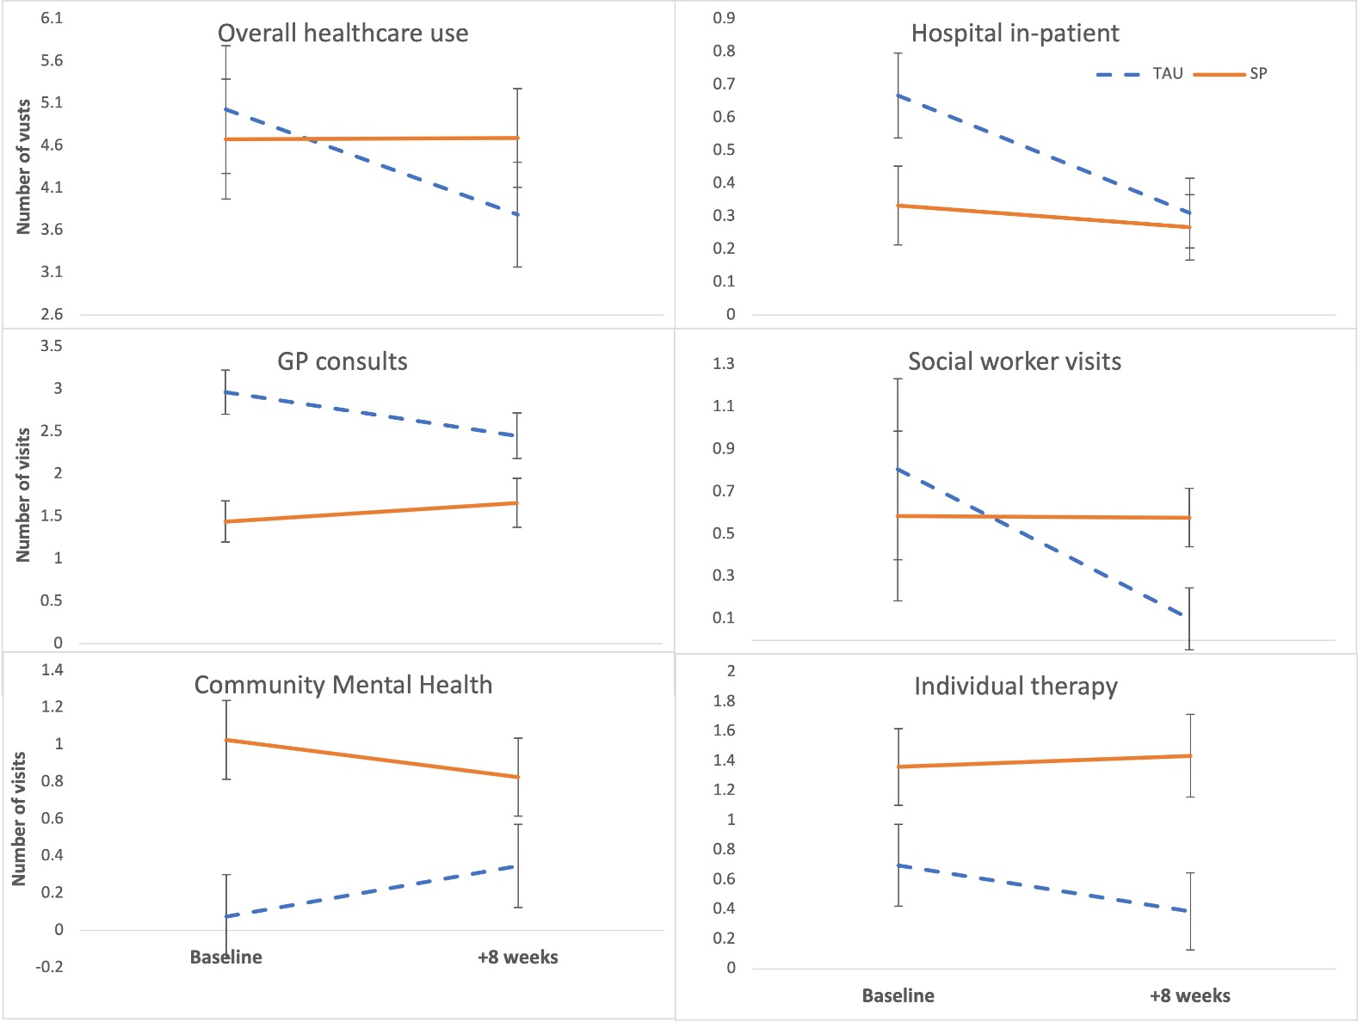
Legend: y-axis is number of visits past 2 months, with means shown for participants in the Social Prescribing condition (orange) and GP Treatment-As-Usual condition (blue); bars are standard deviations.

