Supporting Information (SI) - Is Fucus a Suitable Biomonitoring Organism for Polycyclic Aromatic Hydrocarbon Contamination? A Study from the Faroe Islands

Authors:
Ida Huusmann Knøfler*a
Kirstine Evald Andersson*a
Richard Leonard Becker*a
Sigurd Christiansen b
Nikoline Nielsen a
Jan H Christensen **a

a Department of Plant and Environmental Sciences, University of Copenhagen, Thorvaldsensvej 40, 1871 Frederiksberg C, Denmark
b Faculty of Science and Technology, University of the Faroe Islands, Vestara Bryggja 15,
FO-100 Tórshavn, Faroe Islands
*First authors. Contributed equally to this work
** Corresponding author:
Jan H. Christensen
jch@plen.ku.dk
Thorvaldsensvej 40,
1871 Frederiksberg, DK

S1.Sampling locations

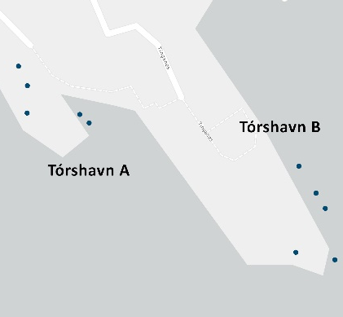 | 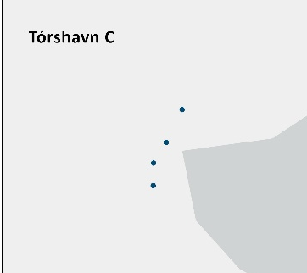
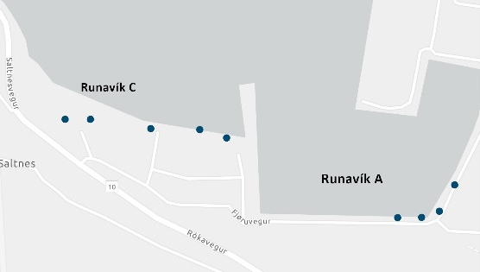 | 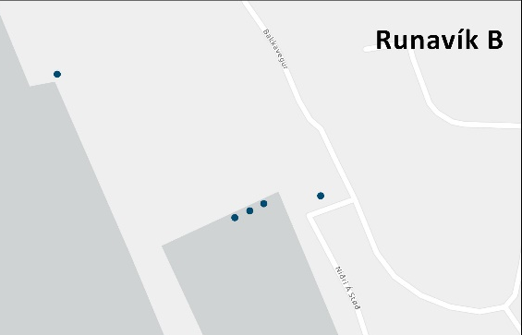
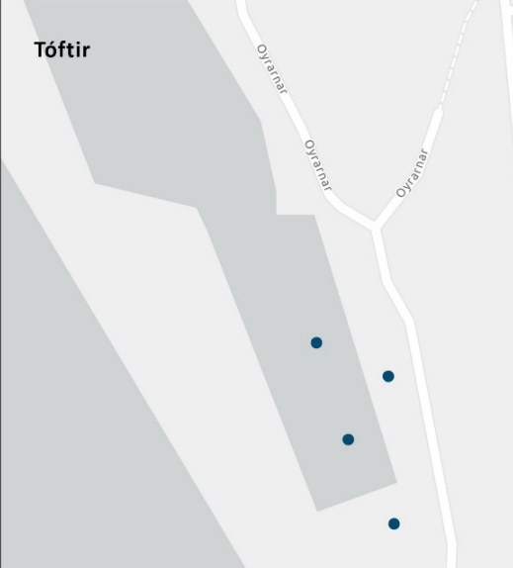 | 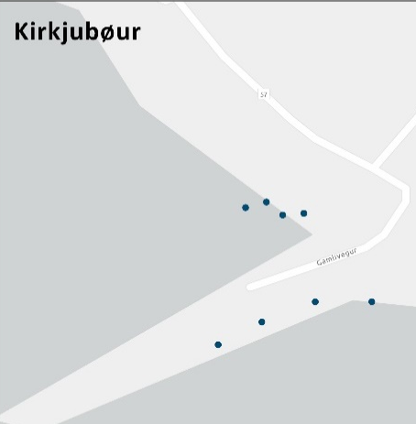
Figure S1: Sub-samples taken at each sampling location

S2. Species of seaweed
a)  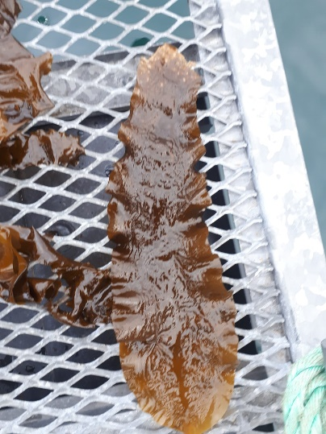 | b)  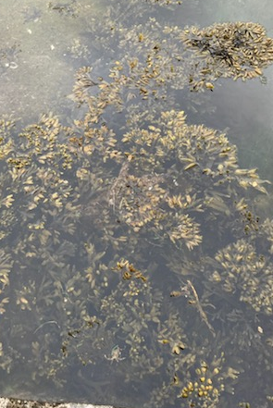 | c)  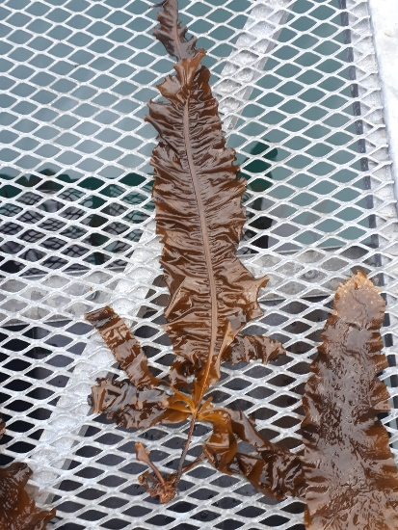
Figure S2: seaweed sampled in this study: a) Saccharina latissima, b) Fucus c)Alaria Esculenta

S3. Method validation, QC and detection limit (DL)

S3.1 Recoveries of internal standard, precision, and accuracy
Loss of analyte during sample preparation was corrected for by the internal standard.
The low recoveries of the internal standards (IS) in figure S3 did not lead to a systematic over- or underestimation of the PAH concentrations. The accuracy was >90% for the PAHs >DL. This reassures the quality of the internal standard correction (figure S4). The inter-day precision reflected by the RSD values of the QC 1 is between 2% and 7% as shown in table S1.

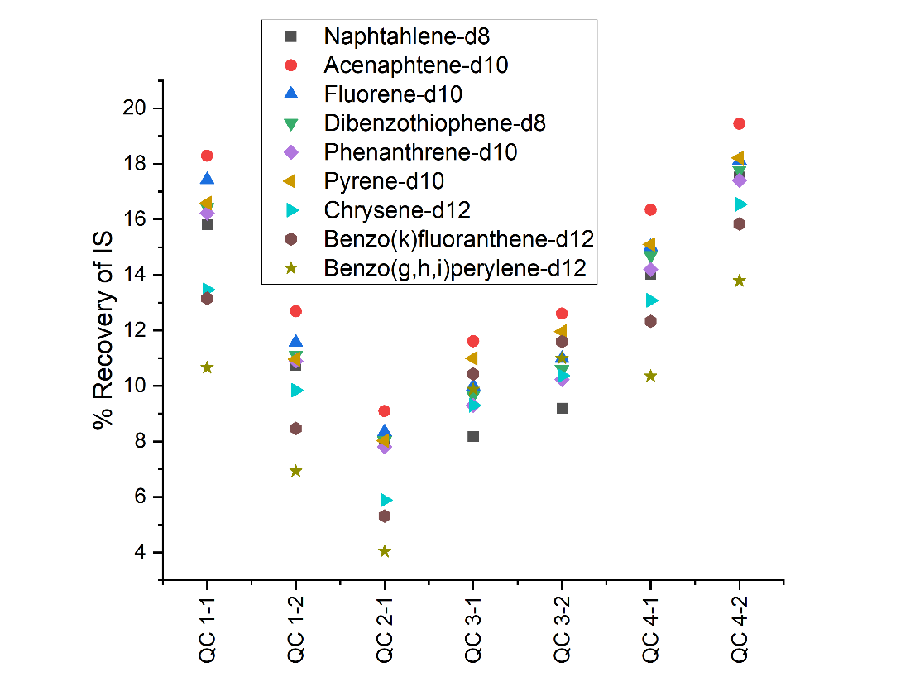
Figure S3: Recovery of IS in QC1 samples
The recovery might be higher for the alkylated PAHs, as they are less polar, and thereby has a higher solubility in hexane compared to the non-alkylated homologues. Thus, the concentration of the alkylated PAHs may be slightly overestimated due to overcorrection by the non-alkylated PAH internal standards.

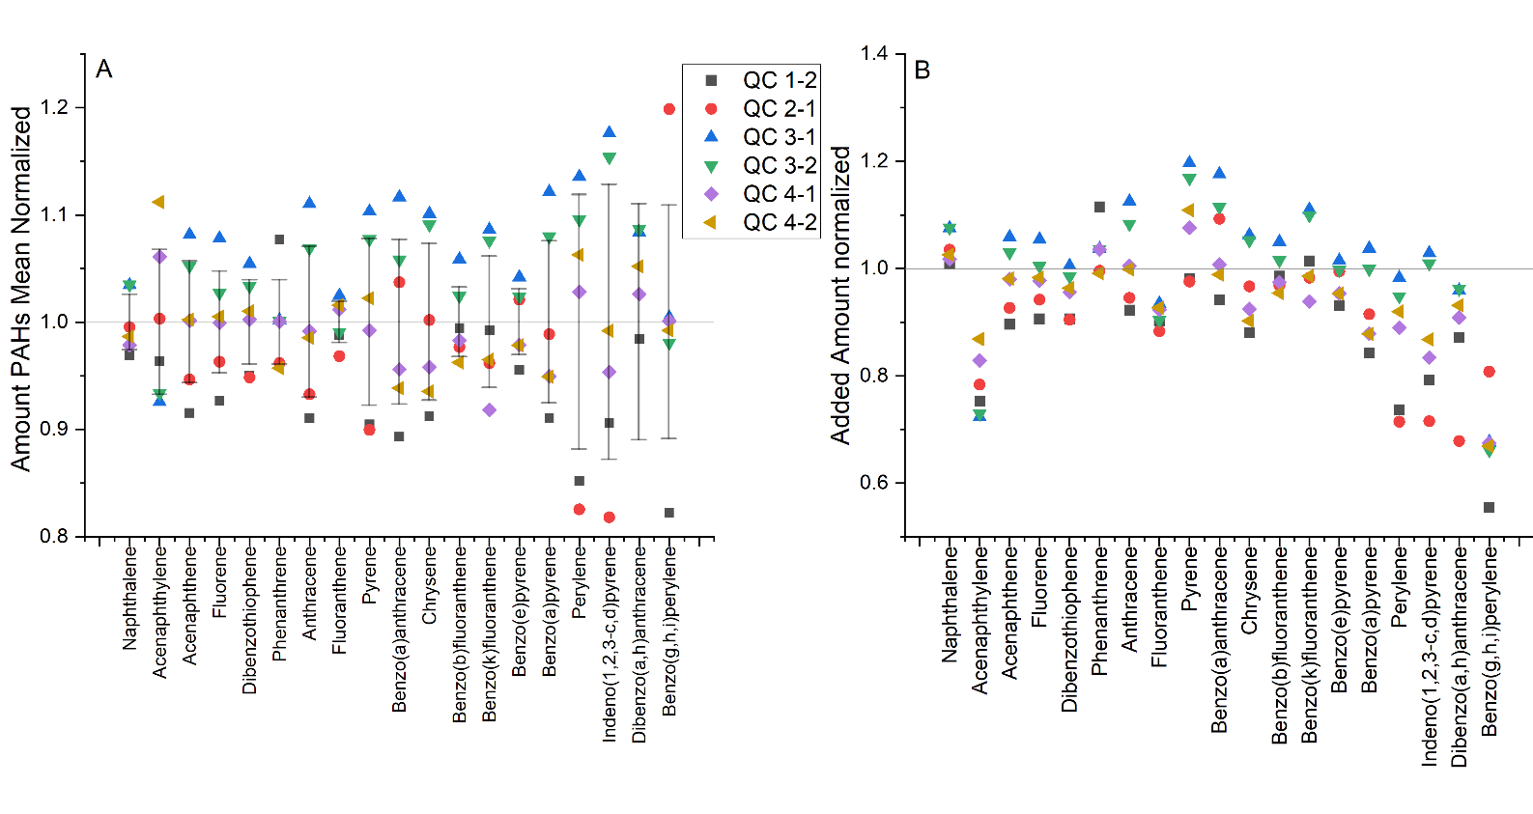 Figure S4: Recovery of spiked PAHs in QC1 samples corrected for losses using the corresponding internal standards.

Table S1: Accuracy, standard deviation (Stdev) and relative standard deviation (rStdev) for selected PAHs measured in the spiked QC 1 samples
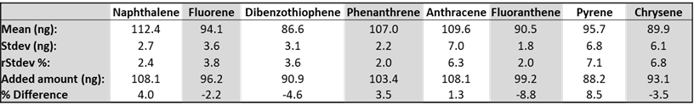Even though the recovery is observed to be low, there are therefore strong indications that it does not lead to an over- or underestimation of the analysed PAHs. The loss of recovery is likely due to the back-extraction method using hexane, which may not be as suitable as dichloromethane. However, it is not expected to have any significant influence on the final quantification of PAHs.

S3.2 Detection Limit (DL) and Limit of Quantification (LOQ)
The five samples of Fucus spec. used for intra-day precision were also used to calculate DLs and LOQs. The standard deviation for each of the PAHs in the five samples was multiplied with the average concentration of the respective PAH in the method blanks of batch 4 (eq. (1) and (2)).

DL = x̄[MBl] + s(QC) ∗ 3 (1)
LOQ = x̄[MBl]+ s(QC) ∗ 10 (2)

DL and LOQ values perform comparable or better than a method used for measuring PAHs in tree leaves which states an average accuracy of 86% and method detection limit (MDL) of between 0.1 to 4.9 ng/g dry weight (Jin et al., 2020). Since the DL is given per g WW in this study and with an approximated water content of 82% in the samples the MDL is most likely lower for this method.

S4. Determination of water content - method
Dry weight was determined for selected samples. Two samples of each genus were weighted and dried in an oven at 100°C for 20 hours and the weight was measured. The dry weight is not measured for all samples and therefore not used for weight correcting measured concentrations.
Table S2: water and dry matter content in percentage
 | Mean water% | SD water | Mean dw% | SD dw%
Fucus | 83 | 1.8 | 17 | 1.8

S5. PAHs in standard solutions

Table S3: Calibration standards
Calibration standards
Parent PAHs | Alkylated PAHs
Naphthalene | 1-Methylnaphthalene
Dibenzothiophene | 2-Methylnaphthalene
Anthracene | 2,6-Dimethylnaphthalene
Phenanthrene | 2,3,5-Trimethylnapthalene
Fluoranthene | 1,4,6,7-Tetramethylnapthalene
Chrysene | 1-Methylfluorene
Pyrene | 1,7-dimethylfluorene
Benzo(a)anthracene | 2-Methylphenanthrene
Benzo(a)pyrene | 3,6-Dimethylphenanthrene
Perylene | 1,2,6-trimethylphenanthrene
Benzo(g,h,i)perylene | 1,2,6,9-Tetramethylphenanthrene
Benzo(k)fluoranthene | 4-Methylchrysene
Dibenz(a,h)anthracene | 6-ethylchrysene
Fluorene | 1,3,6-Trimethylchrysene
Benzo(e)pyrene | 1-methylpyrene
Acenaphthene | 4,5-Dimethylpyrene
Acenaphthylene | 3-Methylbenzothiophene
Benzo(b)fluoranthene | 2-Methylthianaphthene/2-methyl-benzothiophene
Indeno(1,2,3-c,d)pyrene | 4-Methyldibenzothiophene
 | 4,6-Dimethyldibenzothiophene
 | 4-Ethyl-6-methyldibenzothiophene

Table S4: Internal and recovery standards
Internal standards | Recovery standards
Naphthalene-d8 | Acenaphthylene-d8
Dibenzothiophene-d8 | Anthracene-d10
Acenaphthene-d10 | Fluoranthene-d10
Phenanthrene-d10 | Benz(a)anthracene-d12
Pyrene-d10 | Benzo(a)pyrene-d12
Fluorene-d10 | Indeno(1,2,3-c,d)pyrene-d12
Chrysene-d12
Benzo(k)fluoranthene-d12
Benzo(g,h,i)perylene-d12

Table S5: PAHs and their corresponding internal and recovery standard
PAHs | Internal standard | Recovery standard
Naphtalene  C1-Naphtalene  C2-Naphtalene  C3-Naphtalene  C4-Naphtalene | Naphtalene-d8 | Acenaphtylene-d8
Acenaphtylene | Acenaphtene-d10 | Acenaphtylene-d8
Fluorene | Flourene-d10 | Antracene d-10
Dibenzothiophene | Dibenxothiophene-d10 | Antracene d-10
Anthracene  Phenanthrene  C1-Phenanthrene  C2-Phenanthrene  C3-Phenanthrene  C4-Phenanthrene | Phenanthrene-d10 | Antracene d-10
Pyrene  Fluoranthene | Pyrene-d10 | Fluoranthene-d10
Chrysene | Chrysene-d12 | Benzo(a)anthracene-d12
Benzo(b)fluoranthene | Benzo(k)fluoranthene-d12 | Benzo(a)anthracene-d12
Benzo(bk)fluoranthene  Benzo(e)pyrene  Benzo(a)pyrene  Perylene | Benzo(k)fluoranthene-d12 | Benzo(a)anthracene-d12
Dibenzo(a,h)anthracene | Benzo(g,h,i)perylene-d12 | Ideno(1,2,3-c,d)pyrene-d12
Benzo(g,h,i)perylene | Benzo(g,h,i)perylene-d12 | Ideno(1,2,3-c,d)pyrene-d12
Ideno(1,2,3-c,d)pyrene | Benzo(g,h,i)perylene-d12 | Ideno(1,2,3-c,d)pyrene-d12

Table S6: mean concentration of analytes, internal standard and recovery standard in the quantitative standard
 | µg/mL
 | Std1 | Std2 | Std3 | Std4 | Std5 | Std6
PAHs | 0,0039 | 0,012 | 0,024 | 0,048 | 0,079 | 0,16
Alkylated PAHs | 0,0040 | 0,012 | 0,024 | 0,048 | 0,079 | 0,16
Internal standards | 0,0081 | 0,024 | 0,049 | 0,081 | 0,16 | 0,24
Acenaphthylene-d8 | 0,34 | 0,34 | 0,34 | 0,34 | 0,34 | 0,34
Anthracene-d10 | 0,28 | 0,28 | 0,28 | 0,28 | 0,28 | 0,28
Fluoranthene-d10 | 0,29 | 0,29 | 0,29 | 0,29 | 0,29 | 0,29
Benz(a)anthracene-d12 | 0,31 | 0,31 | 0,31 | 0,31 | 0,31 | 0,31
Benzo(a)pyrene-d12 | 0,30 | 0,30 | 0,30 | 0,30 | 0,30 | 0,30
Indeno(1,2,3-c,d)pyrene-d12 | 0,30 | 0,30 | 0,30 | 0,30 | 0,30 | 0,30

Table S7: concentration of PAH₁₉ in the standard solution
Compound | Concentration [mg/mL]
Dibenzothiophene | 0,095
Anthrancene | 0,113
Phenanthrene | 0,108
Fluoranthene | 0,103
Chrysene | 0,097
Pyrene | 0,092
Benz(a)anthracene | 0,095
Benzo(a)pyrene | 0,113
Perylene | 0,093
Benzo(g,h,i)perylene | 0,107
Benzo(k)fluoranthene | 0,044
Dibenz(a,h)anthracene | 0,095
Fluorene | 0,100
Benzo(e)pyrene | 0,088
Acenaphthene | 0,110
Acenaphthylene | 0,093
Benzo(b)fluoranthene  Naphthalene | 0,097  0,113

S6. Method development
For the method development Fucus vesiculosus sampled in Svanemøllen Harbor in Copenhagen was used. The homogenisation was carried out using a small kitchen blender (Køkkenchef minihakker, 500 mL, 300 W, item no. 10069036).
Extraction and clean-up were conducted based on the QuECHERS method (Anastassiades et al., 2003) but modified to fit analysis of PAHs in highly pigmented fruits and vegetables with a 20-80% water content (Słowik-Borowiec et al., 2022). To examine the most efficient extraction solvent acetonitrile and n-hexane:acetone 4:1 (v/v) were tested. Four samples were prepared; two with ACN and 2 with n-hexane:acetone 4:1 (v/v). One of each was placed in an ultrasonication bath, and blended with an Ultra Turrax (IKA, T 25 digital ULTRA-TURRAX®) to test the most efficient extraction method. The results showed that the ultrasonicated samples extracted with ACN had the highest PAH concentration.

The extracts had a bright green colour, due to co-extraction of pigments from the seaweed. To sufficiently clean up the sample from pigments without removing PAHs an experiment was conducted where three sorbents (C18 fused silica, Graphitised Carbon Black (GCB) and FlorisilⓇ were tested on extracts with both ACN and n-hexane:acetone 4:1. The remaining extracts from the previous experiment were spiked with 50 µl of a PAH stock solution, and an aliquot of 0.66 mL was transferred to a centrifuge tube, and added either 3 mg GCB, 60 mg FlorisilⓇ or 10 mg C-18. After mixing, the colour of the extract was examined to determine if pigment clean-up was sufficient. If the extract was not colourless the treatment was repeated in a total of three times. The samples were analysed on the GC-MS and the results were evaluated. C-18 was not successful at removing pigments, it only removed the PAHs. GCB was effective at removing pigments but in the process more than 80% of the four and five rings PAHs were also removed. FlorisilⓇ was efficient at removing pigments without affecting the PAH concentration, but mainly in the hexane:acetone 4:1 (v/v) extraction solvent (Figures S5, S6 and S7). Based on this knowledge, it was concluded, that FlorisilⓇ was the most efficient sorbent for the removal of pigments.

Figure S5: Visualisation of pigment clean-up. The graphs show how much of the initial pyrene and benzo(a)fluoranthene was lift in the extract after 1, 2 and, in case of GCB and C18, 3 times addition of sorbent

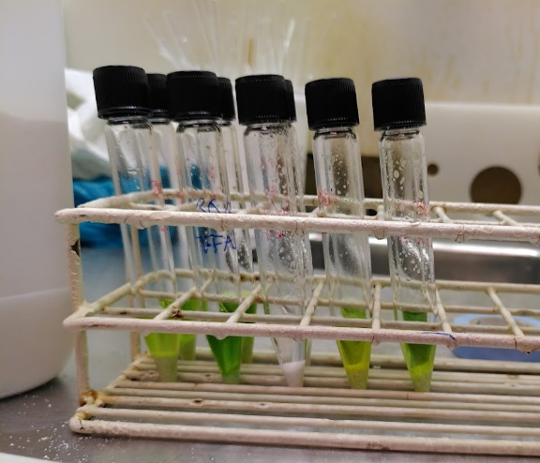  Figure S6: Before FlorisilⓇ clean-up | 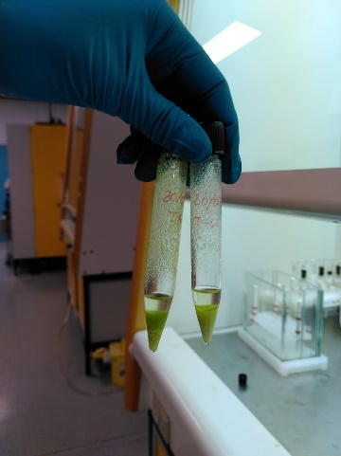  Figure S7 After FlorisilⓇ clean- up

Samples were pre-concentrated to increase the sensitivity of the PAH analysis. One sample was extracted using 12.5ml n-hexane:acetone 4:1 (v/v). After extraction and clean-up the 12.5ml was evaporated to approx. 1mL at 40°C without nitrogen-flow and PAH were analysed in the extract using GC-MS. Another sample was extracted using 12.5ml acetonitrile, but before the clean-up was conducted, the ACN-fraction (approx. 10 mL) was mixed with 1 mL hexane and 10 mL milliQ water, and vortexed for 1 min. The n-hexane phase was transferred into a 15 mL centrifuge tube, cleaned up with FlorisilⓇ and PSA, and analysed on the GC-MS. The conclusion from the pre-concentration experiment was that the back extraction with n-hexane in ACN resulted in the most efficient pre-concentration The theoretical up concentration factor of 12.5× based on the volume ratio was not observed when examining the amount of internal standards present in the final volume. The observed pre-concentration ranged from two to five times depending on the number of aromatic rings with lower pre-concentration of the PAHs with more aromatic rings. This should be accounted for in the quantification of the PAHs by the internal standard corrections. However, considering the high stability of the system, the last clean-up might have been unnecessary.

Simultaneously an exhaustive extraction was performed, to see whether one extraction was sufficient for the extraction of PAHs. 12.5g of homogenized seaweed was mixed with 12.5 ml of either acetonitrile or hexane:acetone 4:1 (v/v) in 50 ml glass centrifuge tubes with 80 µL internal standard and ultrasonicated for 30 min. After sonication the supernatant was transferred to another 50 mL centrifuge tube, and the experiment was repeated for a total of three times. All extracts were analysed on the GC-MS, and the results showed that the largest fraction of PAHs was extracted in the 1st extraction where the rest would be corrected for loss by the internal standard.

S7 Chemical analysis
Table S8 Start times and m/z values for the SIM groups.
SIM group | Start time (min) | m/z values
1 | 6.69 | 83, 85, 105, 123, 128, 134, 136, 138, 148, 152, 166, 180, 194
2 | 7.70 | 83, 85, 105, 123, 142, 148, 152, 154, 162, 166, 168, 180, 194
3 | 8.74 | 83, 85, 105, 123, 152, 154, 156, 160, 162, 164, 168, 180, 194
4 | 9.75 | 83, 85, 105, 123, 154, 164, 168, 170, 176, 182, 184, 190, 196
5 | 10.74 | 83, 85, 105, 123, 166, 170, 176, 180, 182, 184, 190, 192, 196
6 | 12.56 | 83, 85, 105, 123, 178, 182, 184, 188, 192, 194, 196, 198, 208
7 | 13.42 | 83, 85, 105, 192, 194, 196, 198, 202, 206, 208, 212, 220, 226
8 | 15.02 | 83, 85, 105, 202, 206, 212, 216, 217, 220, 226, 234, 240, 244
9 | 16.49 | 83, 85, 105, 191, 202, 206, 216, 217, 220, 226, 230, 234, 240
10 | 17.18 | 83, 85, 105, 191, 217, 218, 228, 230, 232, 234, 240, 242, 248
11 | 19.09 | 83, 85, 105, 191, 217, 218, 231, 242, 248, 252, 256, 264, 270
12 | 21.99 | 83, 85, 105, 191, 217, 218, 231, 252, 264, 270, 276, 278, 288

S8 Naphtalene C0-C4 distribution for all samples
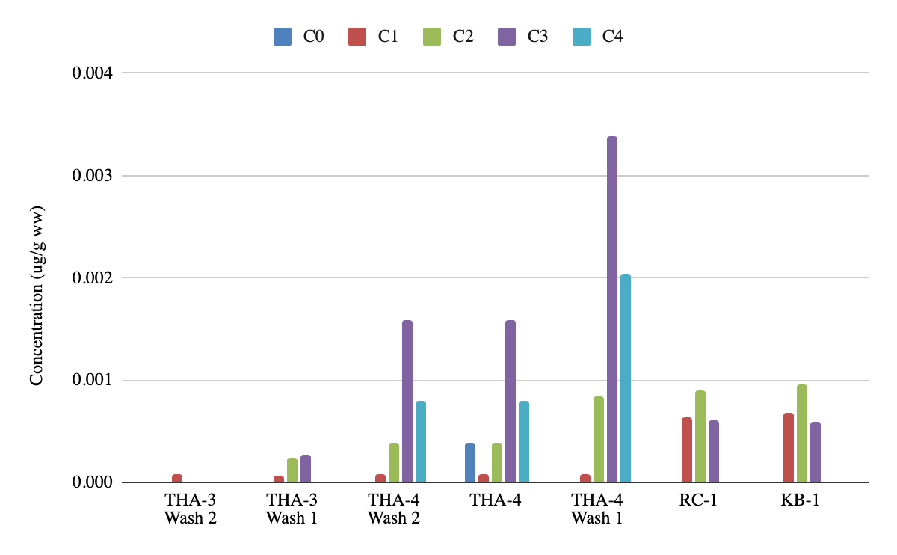
Figure S8: distribution of C0-C4 alkylation in the samples THA-3 Wash 2, THA-3 Wash 1, THA-4, THA-4 Wash 1, RC-1 and KB-1. Concentration is in μg/g ww

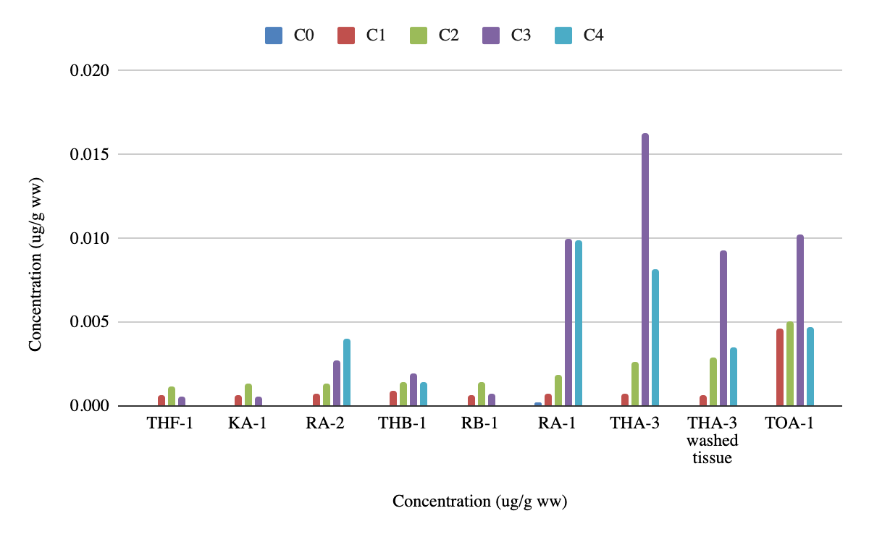
Figure S9: distribution of C0-C4 alkylation in the samples THF-1, KA-1, RA-2, THB-1, RB-1, RA-1, THA-3, THA-3 washed tissue and TOA-1. Concentration is in μg/g ww
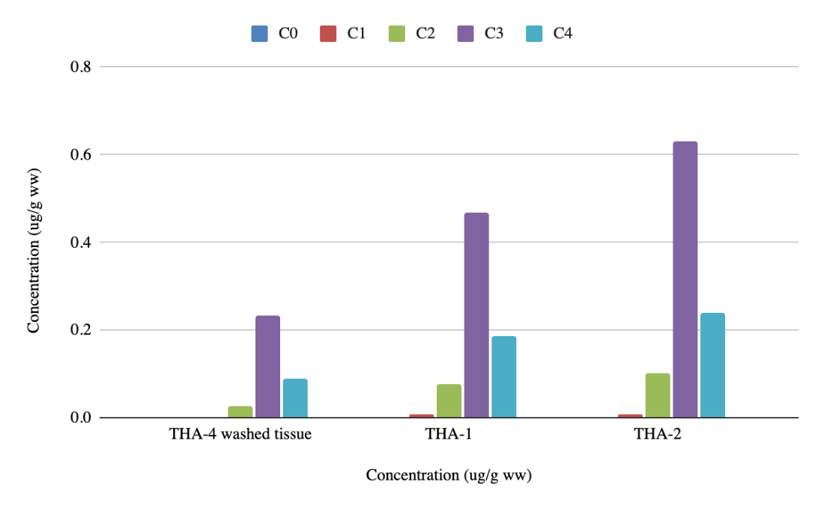
Figure S10: distribution of C0-C4 alkylation in the samples THA-4 washed tissue, THA-1 and THA2. Concentration is in μg/g ww

