Effect of Anionic and Cationic Surfactants on the Rheological Properties of Human Serum Albumin Hydrogel

Tochukwu Olunna Nnyigide¹, Osita Sunday Nnyigide¹ and Kyu Hyun¹*

School of Chemical and Biomolecular Engineering, Pusan National University, Busan 46241, Korea
Email：kyuhyun@pusan.ac.kr
Supporting Information

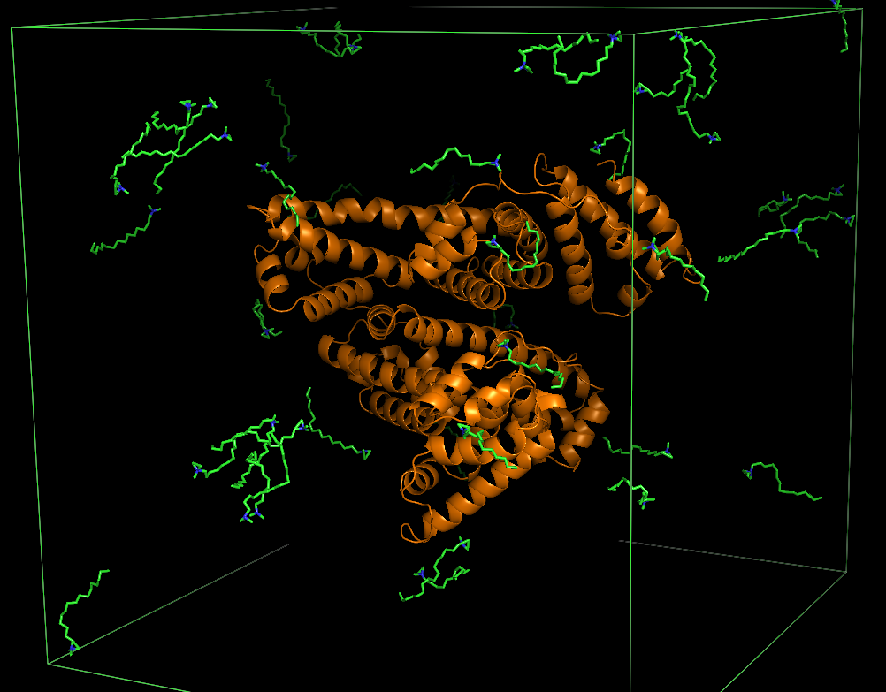

Fig. S1. Simulation box of HSA in 0.05 M CTAB. Cartoon structure of HSA is shown in orange and ball/stick representation of CTAB is shown in CPK colors with. Water molecules and counter ions are hidden for brevity.

Table S1. Contents of HSA/CTAB solutionª simulation box

Table S2. Contents of HSA/SDS solution^{b} simulation box
SDS [M] | N_{water} | N_{SDS}
0.00 | 43897 | 0
0.01 | 43801 | 8
0.05 | 43335 | 42
0.20 | 42792 | 165
0.30 | 41685 | 248

Table S3. Comparison of average molar ratios of surfactant in experiment (10wt% HSA) and simulation
CTAB [M] | N_{water} | N_{CTAB}
0.00 | 43897 | 0
0.01 | 43801 | 8
0.05 | 43335 | 42
0.20 | 42792 | 165
0.30 | 41685 | 248
Experiment surfactant concentration [M] | Simulation concentration [M] | Surfactant/HSA molar ratio [-]
0.000 | 0 | 0
0.008 | 0.01 | 5
0.038 | 0.05 | 25
0.075 | 0.20 | 100
0.150 | 0.30 | 150

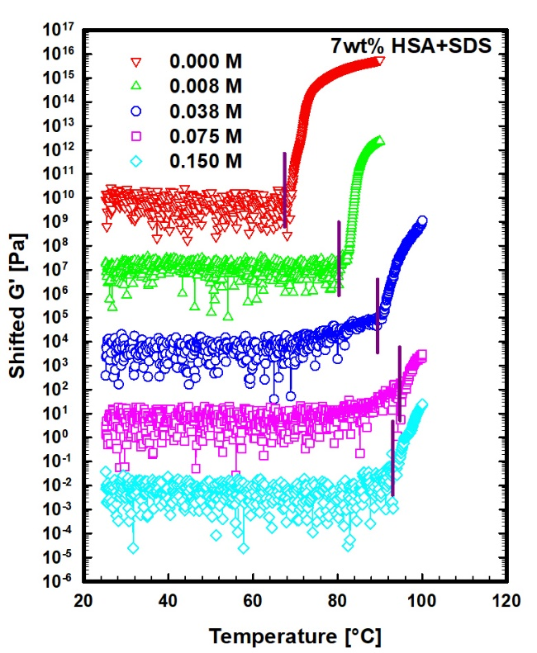
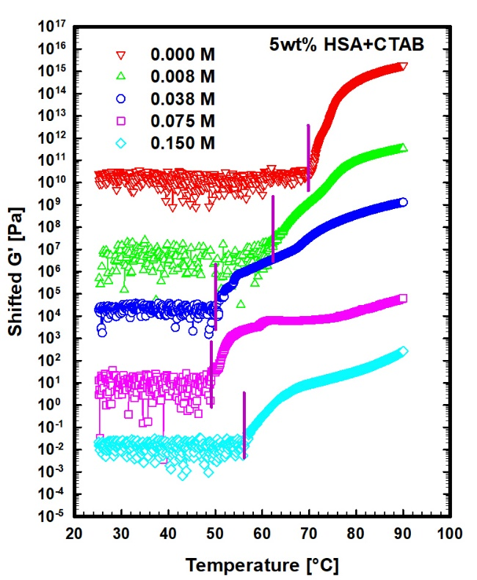
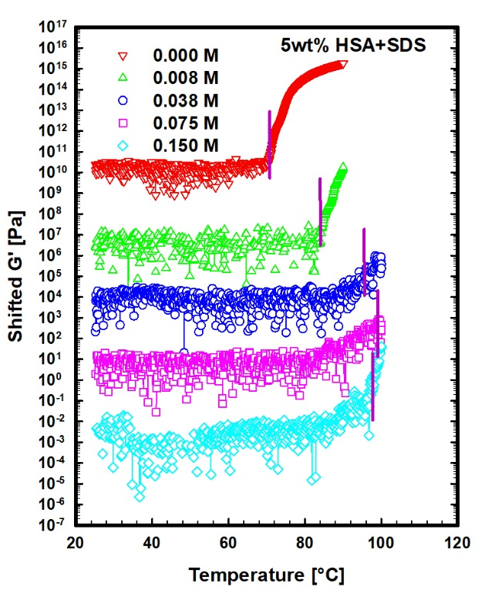
(a)
(b)

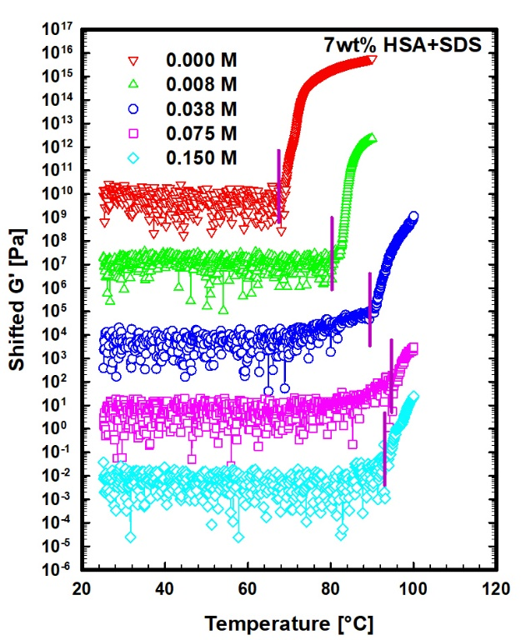
(d)
(c)

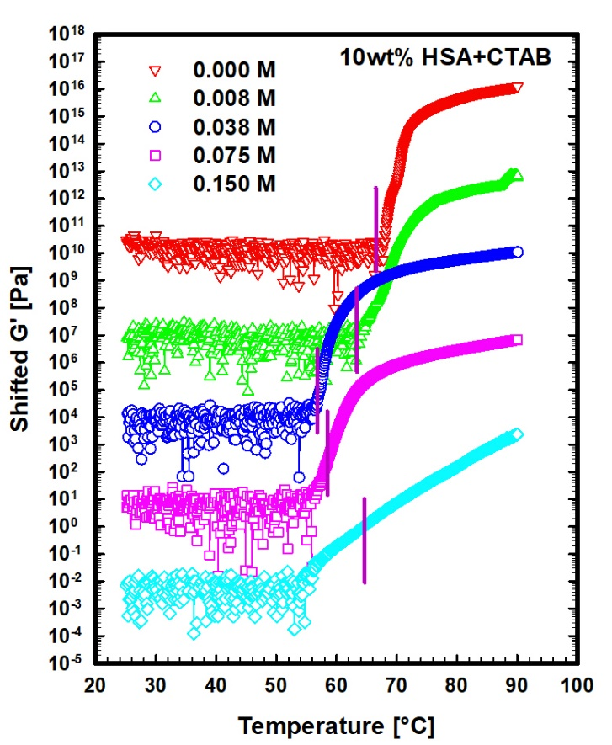
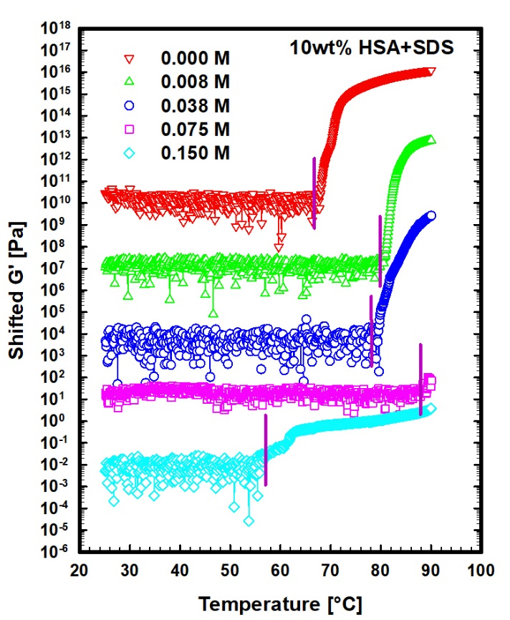
(f)
(e)

Fig. S2 (a-f). Temperature ramp results of 5, 7, 10 wt% HSA in different CTAB/SDS concentrations.

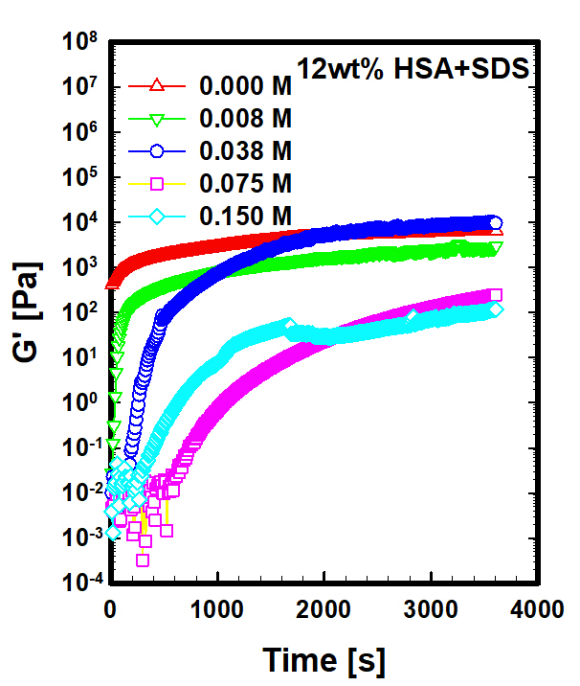
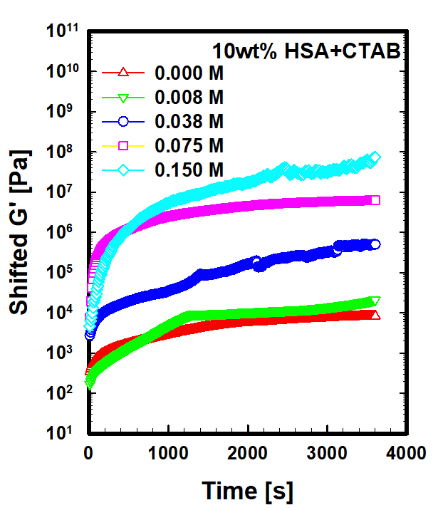
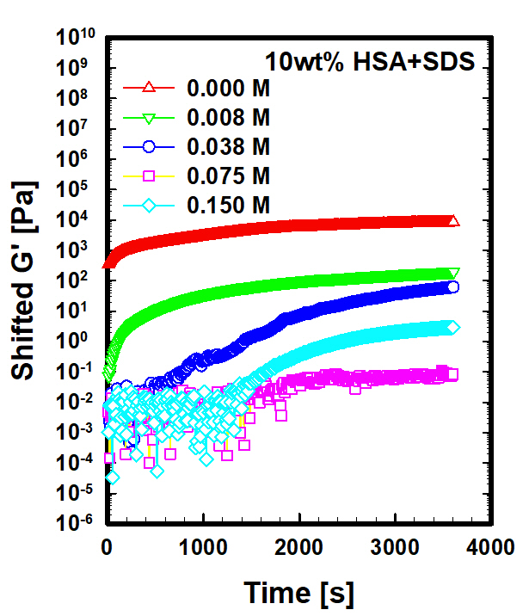
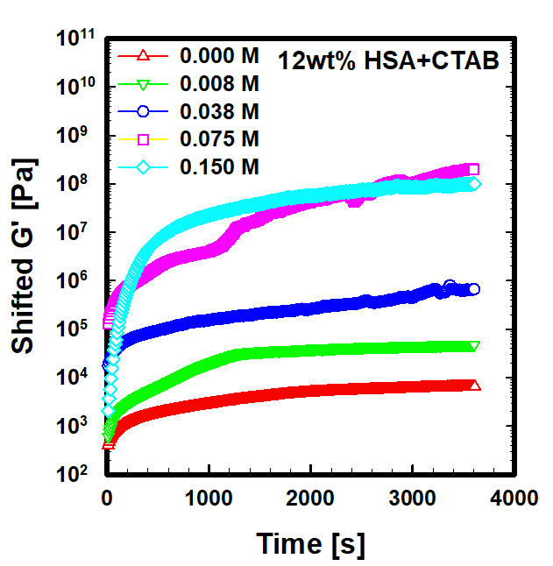
(b)
(a)

(d)
(c)

Fig. S3 (a-d). Time sweeps of 10 and 12 wt% in different CTAB/SDS concentrations.

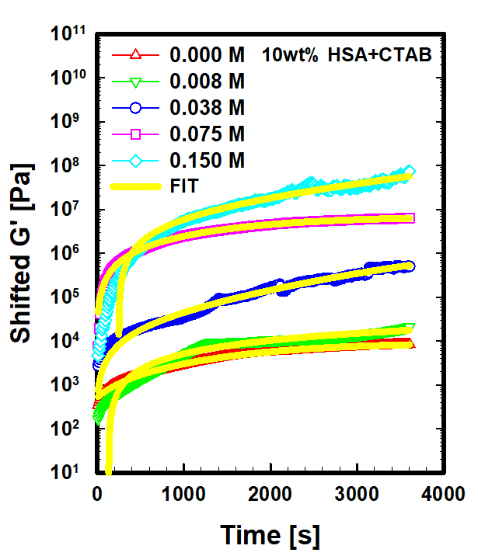
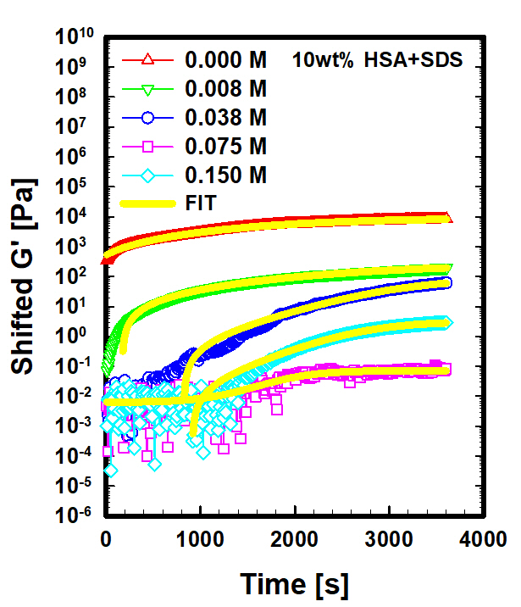
(b)
(a)

Fig. S4 (a-b). Fitting for the determination of plateau modulus G⁰

