Supplemental material:
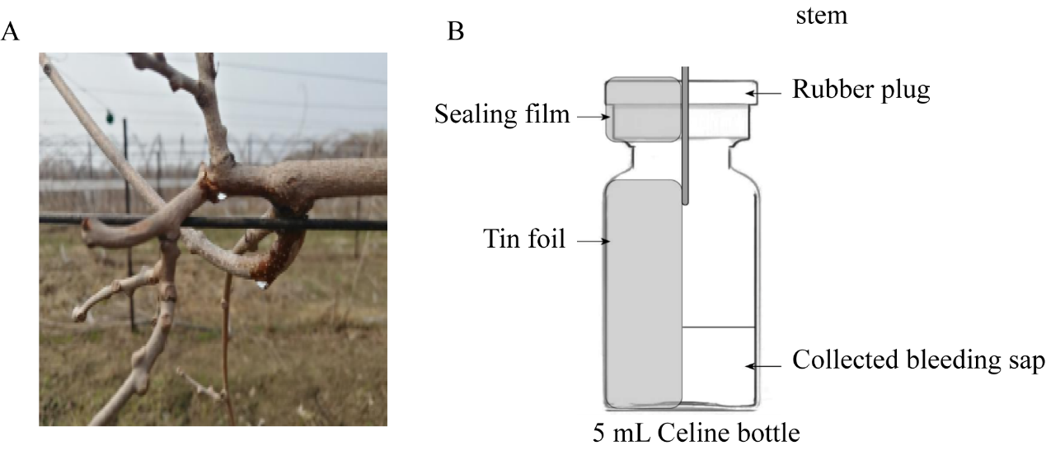
Fig. S1 The collection of bleeding
Note: A: The bleeding treatment method, B: The specific structure of the bottle of celine

