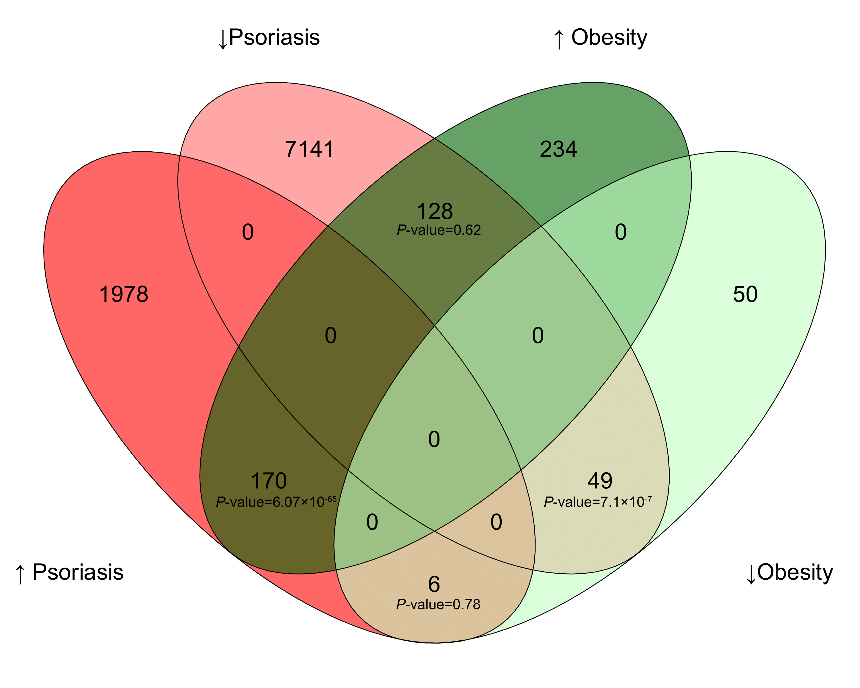
Fig S1. Venn diagram of the overlapping genes and the corresponding P-values.

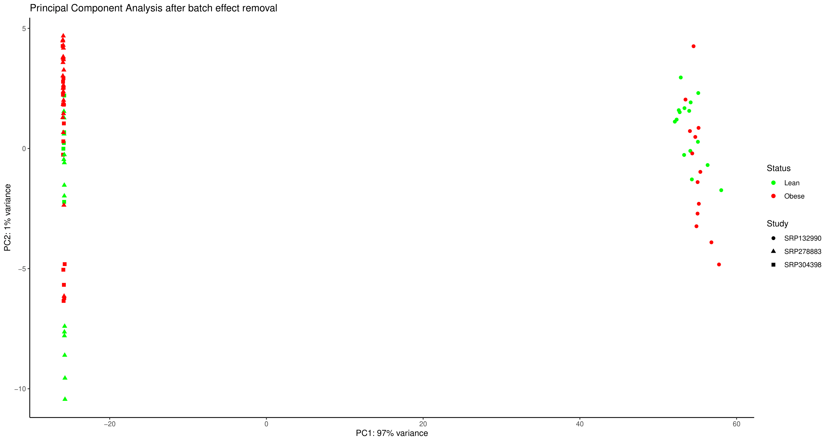
Fig S2. Obesity PCA visualization after batch effect correction including the SRP132990 dataset.

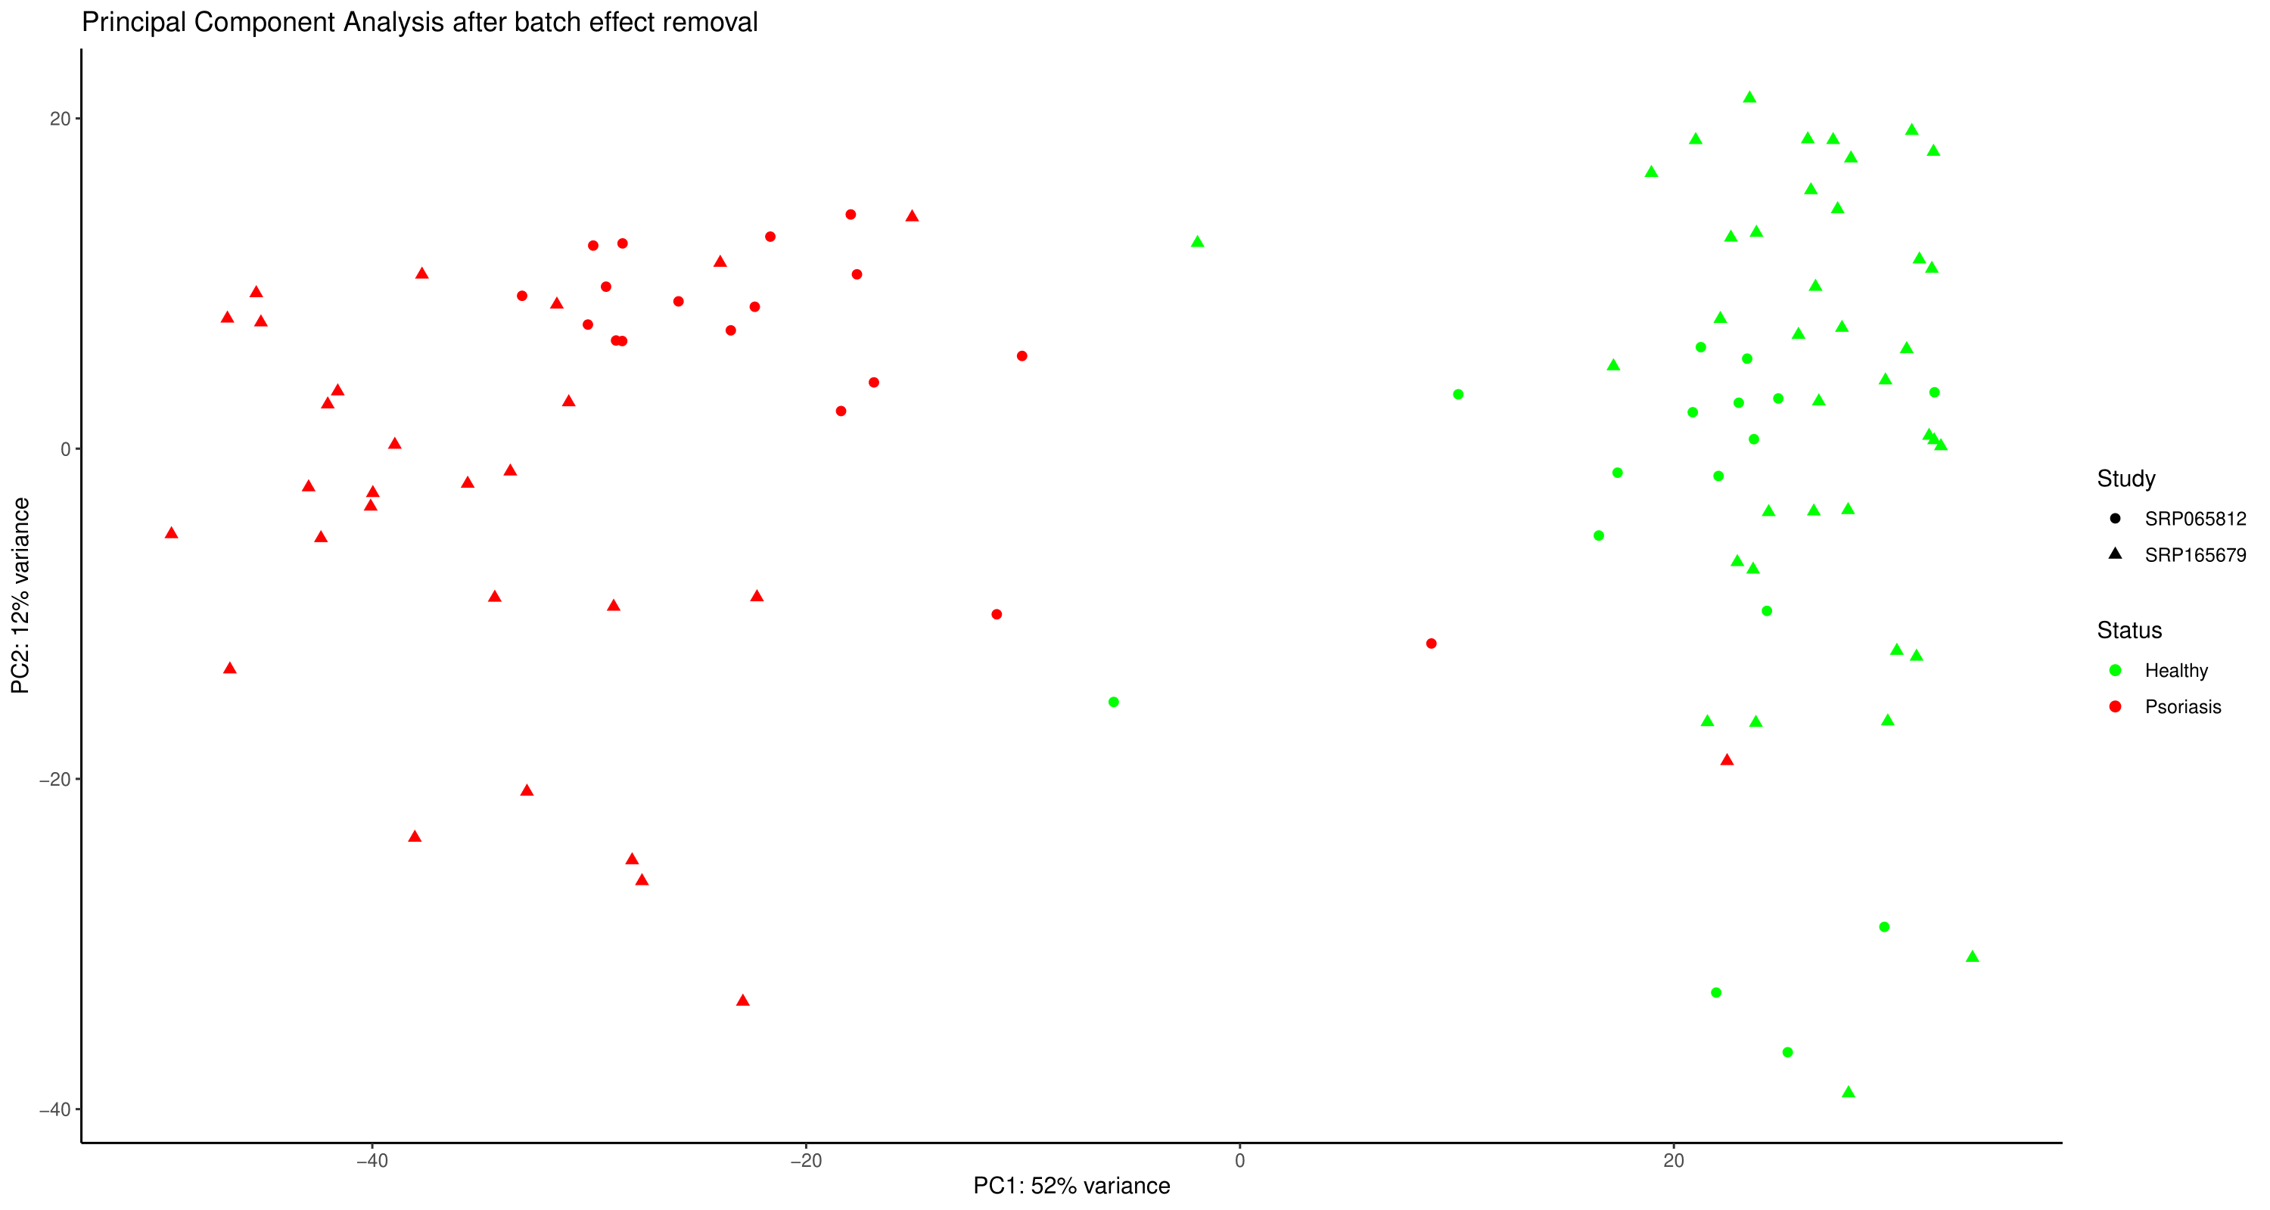
Fig S3. Psoriasis PCA visualization after batch effect correction.

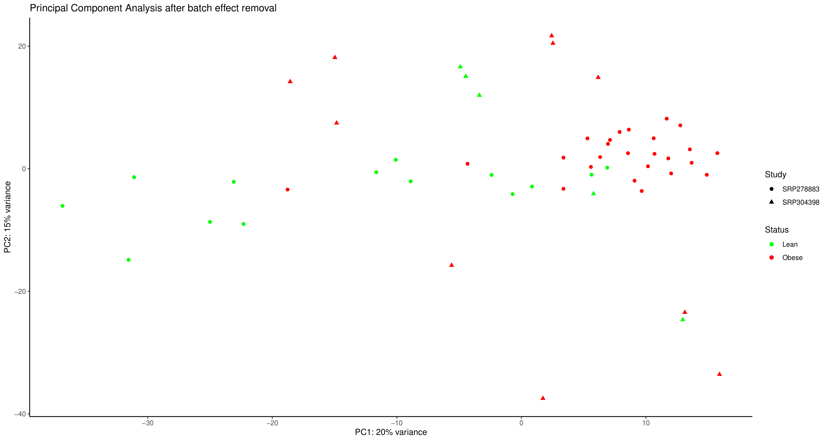
Fig S4. Obesity PCA visualization after batch effect correction including the SRP132990 dataset.

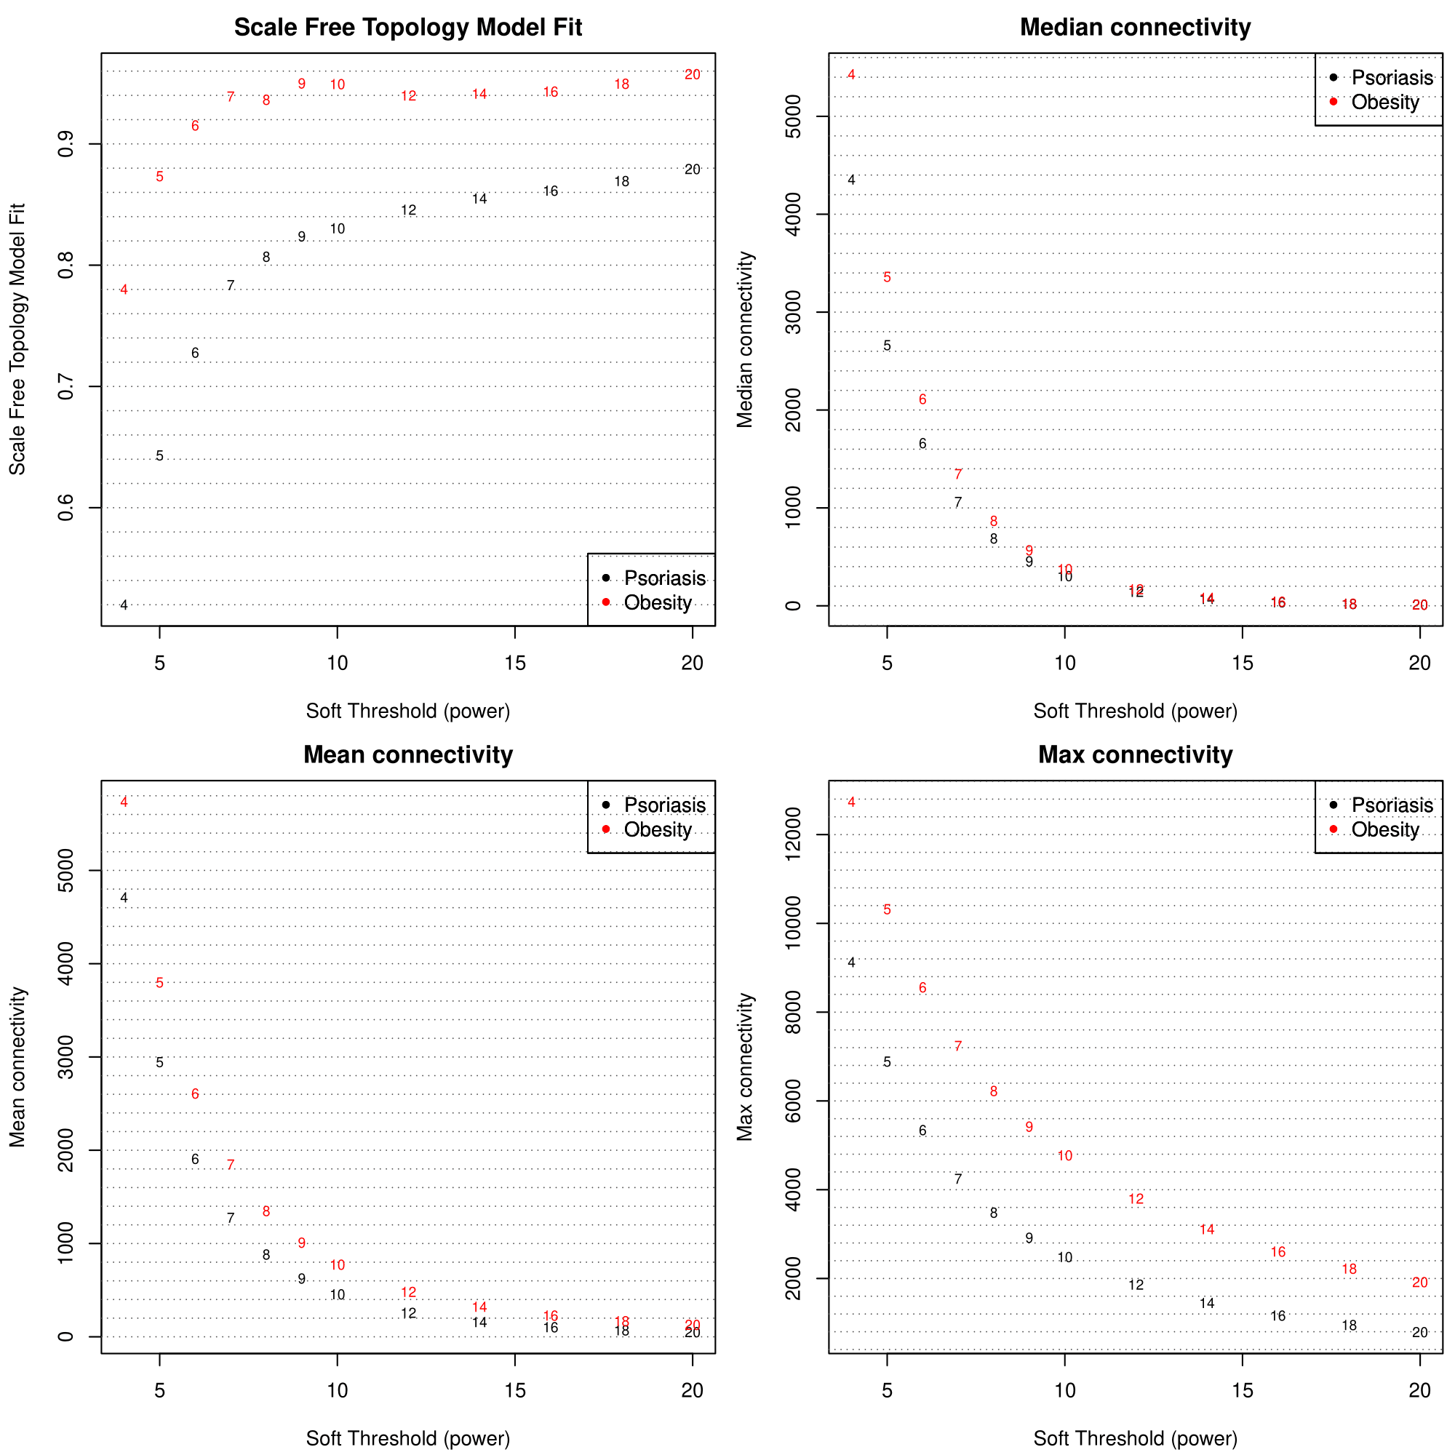
Fig S5. Determination of soft-thresholding cWGCNA power.

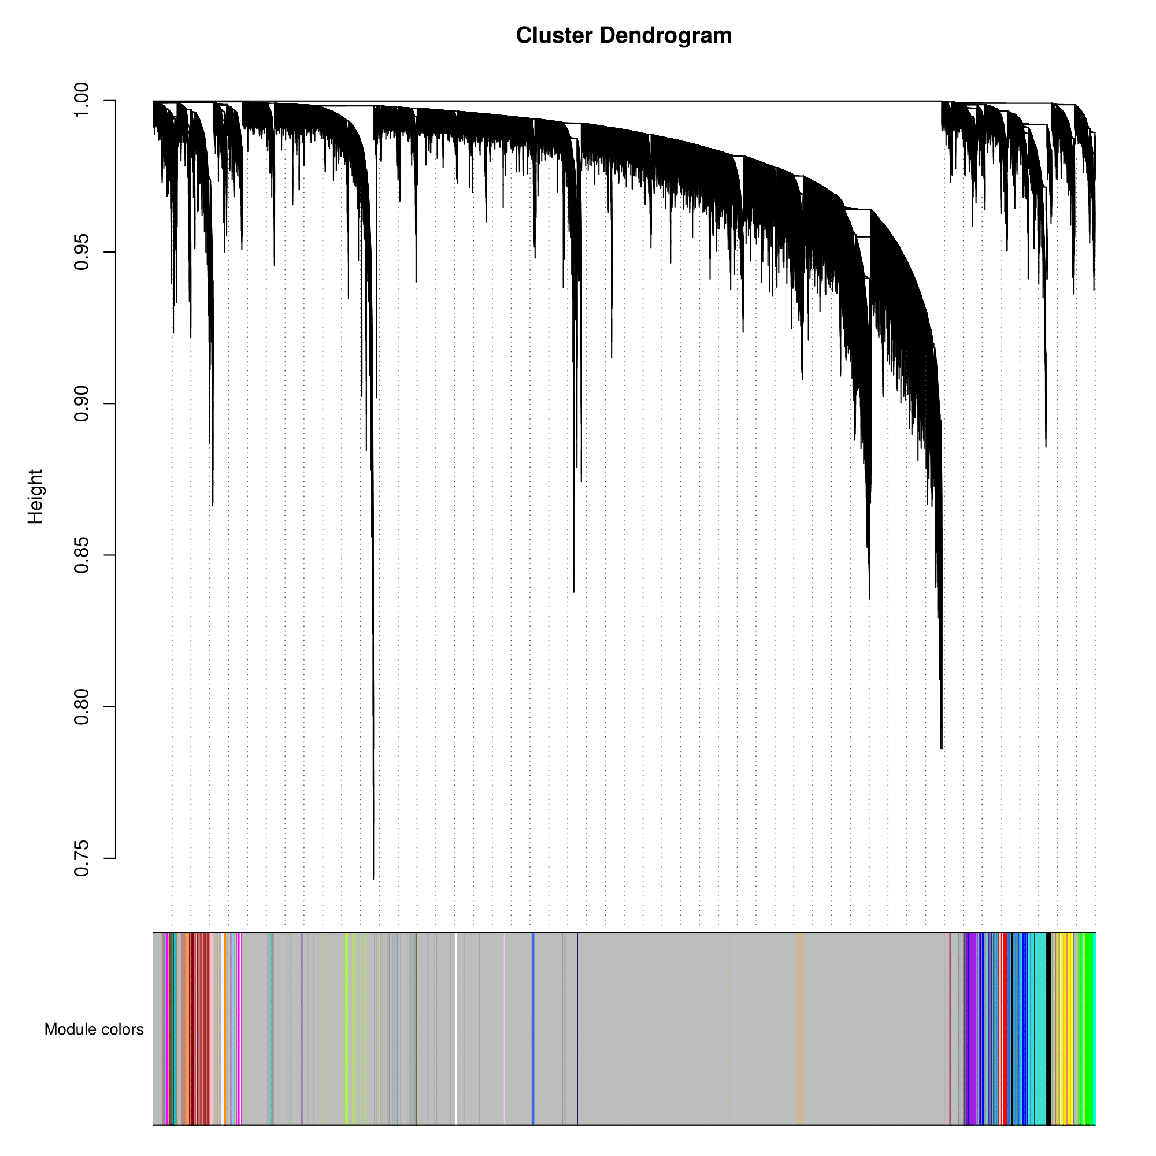
Fig S6. Cluster dendrogram and colored co-expression consensus modules derived from the cWGCNA approach.

