Phase I: First four stages of the ADDIE model

Phase I of the study designed the digital teaching method of surgical procedure cognitive skills using the first four stages of the ADDIE instructional design model. The first four stages of the ADDIE model include the analysis, design, development and implementation stages. Phase I of the study addressed the first two objectives, which sought to design a digital teaching method for surgical procedure cognitive skills using 3D animation videos and embedded continuous assessments with instant feedback. 3D animation videos with embedded assessments will be created for four surgical procedures, namely: open appendicectomy (OA), mastectomy and axillary clearance (Mx & ANC), below-knee amputation (BKA) and inguinal hernia repair (IHR).
The last stage of the ADDIE model, the evaluation stage, will be covered under phase II of the study.

Analysis stage
The analysis stage sought to provide an understanding of the current situation and the gaps that must be filled with regard to surgical procedure training. This was carried out as outlined below:
- Problem identification: There is increasing concern in the literature, over the inadequacy of the traditional teaching method for surgical procedure cognitive skills, under the apprenticeship training model (1-4). Surgical procedure cognitive skills are described as the ability to make critical decisions before, during and after a surgical procedure. It is a core competency for surgeons(5, 6). The literature suggests the following reasons for the inadequacy of the traditional teaching method in covering surgical procedure cognitive skills: limited time for teaching cognitive skills in the operating room, ethical concerns(7, 8), dependency on available clinical opportunities (8-10), and unconscious competence(9, 10) which limits cognitive skills transfer from experts to novices when teaching is carried out in the operating room. Consequently, the traditional method of teaching surgical procedures under the apprenticeship model may be liable for producing surgeons who are not fully proficient in cognitive decision-making. Therefore, there is a need for a reproducible, systematic, and sequential approach to teaching surgical procedure cognitive skills to address the inadequacy of the traditional teaching method. Currently, there is very limited research that investigated reproducible, systematic, and sequential methods of teaching cognitive skills for surgical procedures(8, 11). The assumption is that teaching surgical procedure cognitive skills would lower surgical morbidity and mortality rates and consequently improve surgical outcomes (1, 4-6). Therefore, the literature suggests a systematic and sequential approach to teaching surgical procedure cognitive skills. The following broader scope of topics for teaching surgical procedure cognitive skills was recommended: introduction, indications, contra-indications, pre-operative preparation, and illustration of the technique (positioning, exposure, operative steps, closure, postoperative management, and complications) (8, 10, 12). The researcher conducted a learner needs assessment survey to determine the following:
First, whether learners thought there was a need to develop a systematic and sequential method for teaching surgical procedure cognitive skills and secondly, whether they considered covering the mentioned topics relevant to teaching surgical procedure cognitive skills and to what extent they wanted each of them to be covered.
The survey was conducted to give surgical trainees a degree of choice and a voice. It was conducted online using the Moodle survey tools. The survey results were captured on the Moodle backend database and accessed under the participant's grade book. All participants indicated a need to develop a systematic and sequential method of teaching surgical procedure cognitive skills. Table 2.1 shows the survey results. Participants unanimously indicated that operative steps should be covered in detail. Additionally, over 90% indicated that pre-operative preparation, postoperative management, and complications should be covered in detail.

Table 2.1 Needs assessment questionnaire results.
 | Relevance |  | Extent of coverage
TOPICS | Yes | No | Detailed | Brief
Introduction | 23 | 0 | 11(47.8%) | 12(52.2%)
Indications | 23 | 0 | 18(78.3%) | 5(21.7%)
Contra-indications | 23 | 0 | 11(47.8%) | 12(52.2%)
Pre-operative preparation | 23 | 0 | 22(96.7) | 1(4.3%)
Positioning | 23 | 0 | 11(47.8%) | 12(52.2%)
Exposure | 23 | 0 | 15(65.2%) | 8((34.8%)
Operative steps | 23 | 0 | 23(100%) | 0(0%)
Closure | 23 | 0 | 10(43.5%) | 13(56.5%)
Postoperative management | 23 | 0 | 21(91.3%) | 2(8.7%)
Complications & management | 23 | 0 | 21(91.3%) | 2(8.7%)

- The goal of the design: The goal of the instructional design were:
  - To design a digital method for teaching surgical procedure cognitive skills using 3D animation videos and continuous assessments with instant feedback.
  - Outcomes of the study.
- The following outcomes were to be assessed at the end to compare the traditional and digital teaching methods:
  - Whether the digital teaching method led to better knowledge gain and retention than the traditional teaching method, and
  - whether the digital teaching method was favoured based on participants' satisfaction level and procedure clarity.

The above outcomes were used during phase II to assess the effectiveness of the digital teaching method compared to the traditional one.

Design stage
During the design stage, an outline of a learning intervention was created and mapped. The learning intervention was the digital teaching method of surgical procedure cognitive skills. The digital teaching method was to be designed using 3D animation videos and embedded continuous assessments yielding an educational video.

The educational videos consisted of two main parts, The introductory slide presentation and the 3D animation illustration of the steps of the surgical procedure. Each of the two components of the educational video had sub-topics, and the outline is provided in Figure 2.2. The educational video proceeded in the direction of the arrows, as shown in Figure 2.2. The location of the embedded assessments in the educational video timeline is shown as quiz 1-3. The educational video was developed following the 3D animation video production process defined under the ‘Definition of terms, models and processes in Chapter 2. The development process is presented under the development stage of the ADDIE model in the next section.

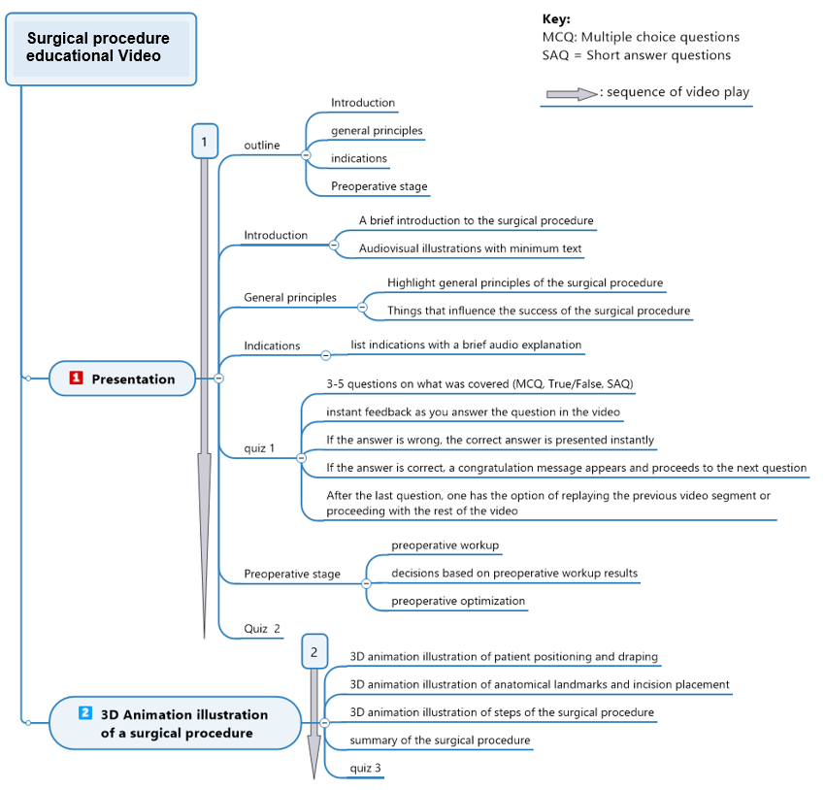

Figure 2.2 The outline and mapping of the educational video.

The digital teaching method for surgical procedure cognitive skills was delivered in a video format. The educational videos for surgical procedure cognitive skills were availed to participants online through a LMS.

Development

During this stage, 3D animation videos were developed, followed by the creation and embedding of continuous assessments in the educational video. A run-through of the complete education video was conducted.

- 3D animation video production.
The 3D animation videos for teaching surgical procedure cognitive skills were produced following the three main stages for the production process of 3D animation videos: pre-production, production and post-production processing. The process was adapted to the researcher's available resources and animation style. This chapter explains the 3D animation video production process which was explained under the ‘definition of terms, models and processes’. Its explanation is also available as a video at https://youtu.be/0ZzaDxJk5oM

Pre-Production:
Ideate / The Idea. The traditional method of teaching surgical procedures covers surgical procedure cognitive skills inadequately(9, 10, 13, 14). There is a need to develop new teaching methods for teaching surgical procedure cognitive skills. The idea was to design an alternative digital teaching method for surgical procedure cognitive skills using 3D animation videos, with embedded continuous assessments and linked instant feedback. The teaching resource was hosted on the University of Botswana’s Moodle LMS. During the pre-production stage, the idea was developed through several processes: the storyboard, animatic and previsualization, design and modelling, rigging, texture, layout, animation, and lighting and rendering. These are considered individually.

- Storyboard. The educational video produced using 3D animation consisted of two components, the introductory slide presentation and the 3D animation illustration of the surgical procedure.
PowerPoint was used for storyboarding the two components of the educational video. The steps followed during the storyboarding are outlined below. The storyboarding for the introductory slide presentation was created using Microsoft PowerPoint. The brief introductory slide presentation was reviewed with departmental colleagues and Supervisors. The Supervisors approved the introductory slide presentation for the four surgical procedures after multiple reviews and refinements. Two to three quizzes with 4-6 questions (MCQ, Fill in the blank, True/False) were created regarding critical points of the presentation that needed emphasis and were quality checked by four subject matter experts in the Department of Surgery.
The storyboard for the 3D animation illustration of each surgical procedure was also created using Microsoft PowerPoint. The technical steps of each surgical procedure were outlined in a PowerPoint presentation. The operating room setup, camera positions, and lighting were described. The presentation was reviewed with four colleagues in the Department of Surgery and my Supervisors. After multiple reviews and refinements, a final PowerPoint presentation was approved. One to two quizzes with 4-6 questions (MCQ, Fill in the blank, True/False) were created regarding critical points of the 3D animation illustration that needed emphasis.
The two PowerPoint storyboards were merged into one storyboard representing an educational video. Slides of the first part of the merged presentation that could be reduced to audio with mostly pictures or illustrative 3D animation video clips were identified. Placeholder sketches for the video clips and pictures were made on the PowerPoint slide content area, and the audio script was on the notes area of the slide. Slides of the second part of the merged presentation were reduced to placeholder animations sketches, and the audio script was stored in the notes area of the slides.

- Animatic and Previsualization. Camtasia software was used to generate the animatic of the whole presentation. Camtasia can record the computer screen during a PowerPoint presentation and also record the presenter through an input microphone producing a video with an audio overlay. The animatic video acted as a blueprint for educational video production. It helped determine how much actual animation needed to be produced.
- Design & Modelling. The operating room, theatre table, trolley, lights, surgical tools, drapes, the surgeon, and the patient were created through 3D modelling and computer sculpting. Autodesk Maya, 3DS Max and Zbrush software were used for 3D modelling. Zbrush was used mainly for organic modelling and sculpting. Zbrush is a software which works the same way one would mould a human figure from a ball of mud. Computer sculpting is an extensive back-and-forth process which starts with a primitive shape, such as a sphere or box, which is then beaten down and built up repeatedly to the desired shape. The final structure was refined using high-resolution sculpting to add detail. The final product was then exported to another software, Autodesk Maya, where the next rigging process was carried out. Rigging means adding the bone system to a model so that it can be manipulated during animation. The researcher also used Autodesk Maya software to produce hard-edge models using box modelling. These models included theatre tables, surgical tools, and trolleys. The process also starts with a primitive shape, such as a box or sphere, and its hard edges and faces are pulled in and out to the desired shape of the model. Finally, the box model was refined at high resolution.
The modelling process is an iterative process involving the use of two or more software to achieve the final functional product that can be animated in a more realistic way. A sample of the 3D models of a male patient and other operating room equipment is shown in Figure 2.3 below.

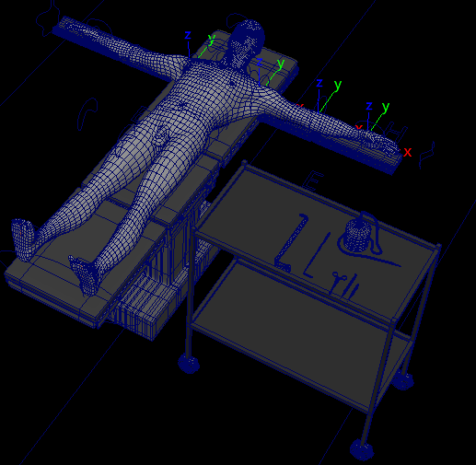
Figure 2.3 3D model of a patient and other operating room equipment.
- Rigging. After completing the modelling of characters and scene objects, the models were rigged using bones and other rigging systems to allow their manipulation during animation. For the human model, this involved creating a bone system within the model and assigning parts of the body to corresponding bones. The result is a skeletal system that moves body parts as in real life. A similar rigging system is available for solid-edge models such as theatre tables. For instance, the system allows the table to be rotated, tilted or the head-rest elevated. Figure 2.4 shows a rigged patient model with bone elements used to flex at the knee in the subsequent picture. The bone rigging systems can be seen through the solid patient model. The rigging process is a time-consuming iterative process involving a back-and-forth fine-tuning of bone influences on the body parts or model parts. The objective is to finally achieve realistic movements of the models during animation.

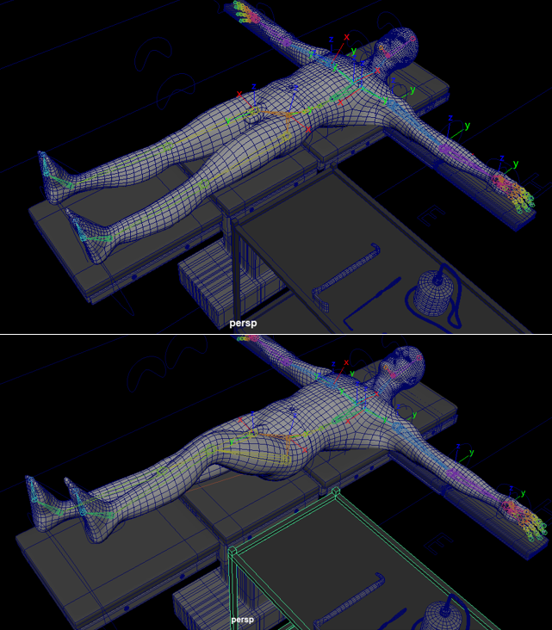
Figure 2.4 An example of a rigged patient with bone elements flexing at the knee.
- Texturing. Digital models were textured to give them a realistic appearance. The texture maps were extracted from the models using 3D modelling software (Maya, 3DS Max and ZBrush) as 2D Maps and exported to Photoshop for texture painting. Extracting texture maps of 3D models is almost like peeling off and flattening the skin of the parts of the 3D models and exporting it to a 2D graphics software to colour in a more realistic texture and colour. Texturing and colouring were done on Adobe Photoshop software. The complete 2D texture maps were then reimported and reapplied to the 3D model. A back-and-forth corrective and fine-tuning of the texture map resulted in a more realistic map. Figure 2.5 demonstrates the 2D texture map and the patient model with the 2D texture map applied. Note that the operating room equipment also looks more metallic and realistic because the textured materials were applied. It took me two days to arrive at the final refined texture of a human model.

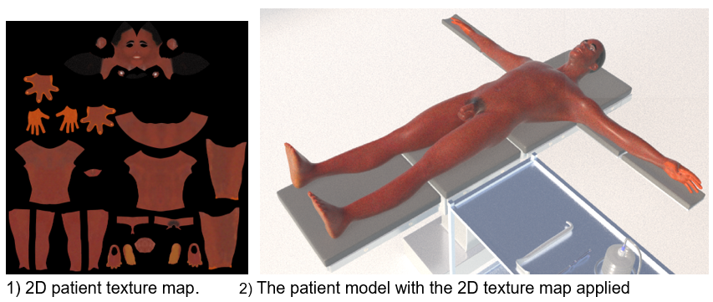
Figure 2.5 A demonstration of the 2D texture map and the patient with the texture map applied.
The pre-production process took 2 months to complete all the required models. The production stage is presented in the next section.

Production:
The production stage started with the preparation of the animation stage through 3D animation to the output of the final product as a video. It consists of the following substages: the layout, animation, lighting and rendering. The substages are explained next.

- Layout. A scene was set up as per the specific surgical procedure. All required models such as the patient, surgical tools, surgeon, and anaesthetic equipment were loaded on the scene. Cameras were positioned to create a complete composition for the researcher to animate. Figure 2.6 shows the operating room layout setup with the 3D models. This is a realistic virtual environment with objects casting shadows and the patient being able to move after rigging. Figure 2.7shows the layout after the draping of the patient in the operating room.

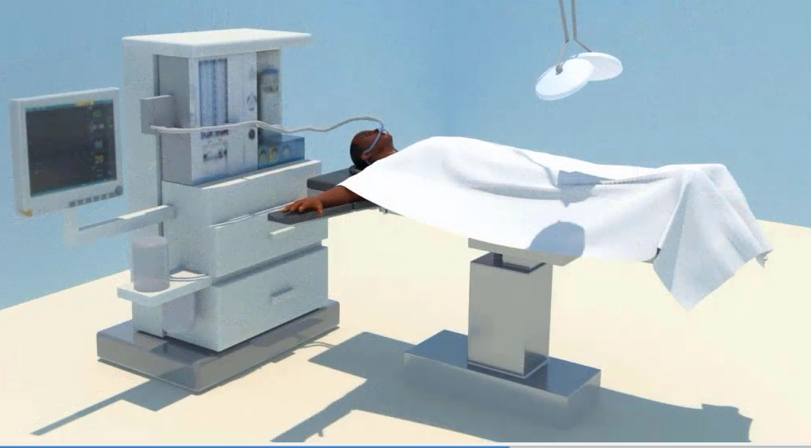
Figure 2.6 Operating room layout with 3D models, including the anaesthetic machine.

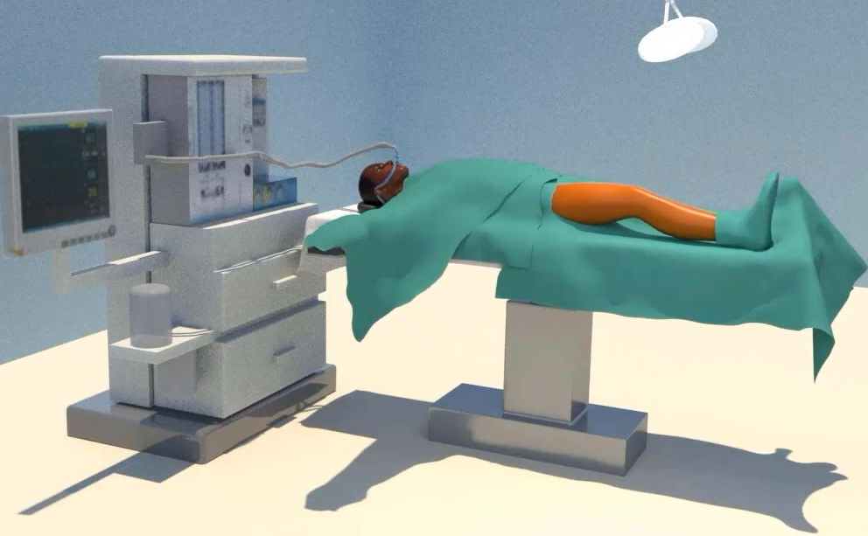
Figure 2.7 Patient in the operating room after draping.

- Animation. I used the rigged 3D models to create motion by manipulating it and storing sequential poses of the model over time until a complete action is achieved on a software timeline. Furthermore, I used advanced sub-model element animation to achieve the more organic refined parts of the animation such as the surgical procedure steps. The sub-model element animations included vertex, face, and edge animation systems. All steps, from the positioning of the patient through to skin incision, access, tissue manipulation, closure, and surgical wound dressing, were animated. Autodesk 3D Studio Max and Autodesk Maya software were largely used for animation. Multiple shots of individual surgical procedure steps were animated, refined, and output as video. These were later merged into one surgical procedure animation scene. For one surgical procedure animation, up to 30 shots were animated, refined, and output as video over a period of one month. The shots were finally composited into a single scene showing the whole surgical procedure technique. Figure 2.8 shows snapshots of the animation of the skin incision for below-knee amputation. One can appreciate the bleeding incisions as well as the markings for the incision placement. The gloved surgeon’s hands, the blade, the leg and the drapes are all 3D models that were rigged and textured to look realistic.

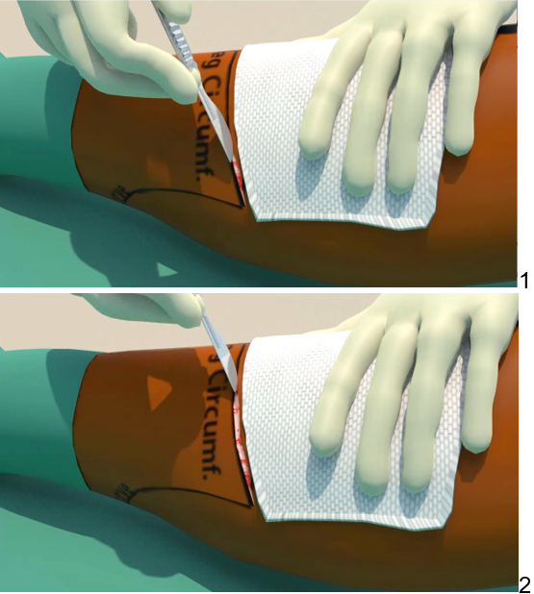
Figure 2.8 A snapshot of skin incision animation.

- Lighting / Rendering. Scene lights were adjusted to the desired final render. The light intensity, focus, position and even the type of light source were chosen to suit the desired scene appearance. The lights were virtual and could be deployed onto the scene from the 3D animation software. The software can adjust the light source's attributes to the desired appearance. The shadows cast by models in the above figure are computer generated and result from an adjustable attribute on the light source. The final product of the animation was output as a video, ready for post-production processing and enhancement.

Post-Production:
Final finishing touches were added to enhance the video. This included image enhancement and colour correction, which was done using the Adobe AfterEffects software. Sound and audio overlay was added to the video using voice-over recording on Camtasia software. The pace of the animation was also adjusted on Camtasia to optimise learning. An audio overlay of the introductory slide presentation was added and synchronised with the 3D animation scene for the best impact. The audio was further edited by removing background noise, adjusting the volume, and splicing out unwanted parts in Camtasia. To complete the educational video, the sketches in the introductory slide presentation part of the educational video were replaced with illustrative pictures and 3D model renderings. Figure 2.9 shows some of the slides of the presentation part for the below amputation with illustrative 3D models and images inserted to replace sketches.

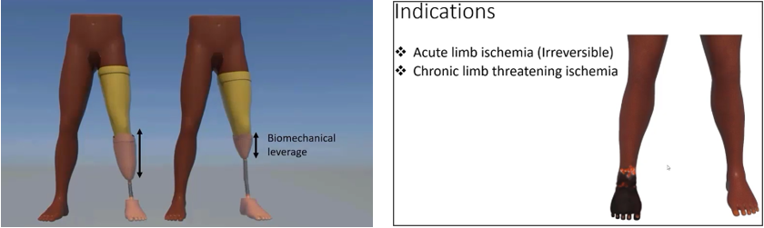
Figure 2.9 snapshots of the presentation part of the video with images and 3D illustrations.

After completing the refinement, the final product was output as a complete educational video for surgical procedure cognitive skills training. Snapshots from the educational video for below-knee amputation are shown in Figure 2.10.

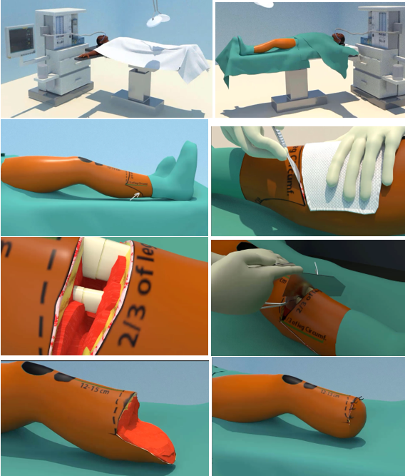

Figure 2.10 Snapshots of the completed educational video for below-knee amputation.

- Assessments development
The educational video was to have embedded assessments linked to instant feedback to support learning. The design of the continuous assessment questions aimed at assessing levels 1-5 from the six levels of Bloom’s Taxonomy of the cognitive domain. This meant that the questions assessed the participants' remembering, understanding, application, analysis and evaluation abilities using multiple-choice (MCQ), True/False and Fill in the blank. The ability to embed MCQ, True/False and Fill in the blank with instant feedback was made possible by using the Camtasia quiz tool. The questions were quality-checked and moderated by four members of the Department of Surgery for their appropriateness for the level of assessment. As part of the University of Botswana quality assurance initiative, all academic staff have received formal training from the Department of Medical Education and other certified bodies for their accreditation as assessors and moderators. Therefore members of the Department of Surgery have received such formal training. The training includes levels of cognitive skills and their assessment using learning taxonomies such as Bloom’s taxonomy, Miller and SOLO, among others. Outcome-based approaches to teaching, such as constructive alignment, form part of the training. Academic staff apply the skill every year during the creation and moderation of final-year examinations. Each educational video for cognitive skills of a surgical procedure had 12 questions embedded throughout the video and linked to immediate feedback. They were mapped and confirmed on the taxonomy by an Educationalist. The following conditions were to be implemented for the embedded continuous assessment events:
- Assessments were to be interspersed within the educational video between a set of topics.
- Each educational video for the four surgical procedures was to have at least three such assessment events, each containing four questions.
- Embedded questions were set in an adaptive release mode.
- The participant had to complete watching the preceding educational video segment before an assessment event was made available.
- Additionally, the participants needed to answer all the questions to watch the next segment of the educational video. Therefore, they could not skip an assessment event and continue watching the rest of the educational video.
- The candidate needed to score above 50% for each embedded assessment event to proceed to the next segment of the educational video.
- Participants could revisit the viewed segments of the video.
- On answering the embedded assessment questions, the participants received instant feedback, giving the correct answer and explaining the rationale for the answer, creating another teachable moment.
- The LMS learning analytics captured the completion of watching the educational video, which also implied that the participant scored more than 50% for each embedded assessment event, The instant feedback functionality linked to each question in the embedded assessment events was achieved via the Camtasia software quiz tool shown on the snapshot of the software on the Figure 2.11. This tool allows one to create four types of questions: MCQ, True/False and Fill in the blank, True/False and Fill in the blanks as shown on the annotated snapshot. It also provides the following options for each question:
    - Ability to set the correct answer for all types of questions.
    - Ability to instantly display feedback when the answer is correct or wrong.
    - An option to choose an action after answering, as shown on the snapshot.
      - Continue to the next questions
      - Go to a URL
      - Jump to a point in the timeline

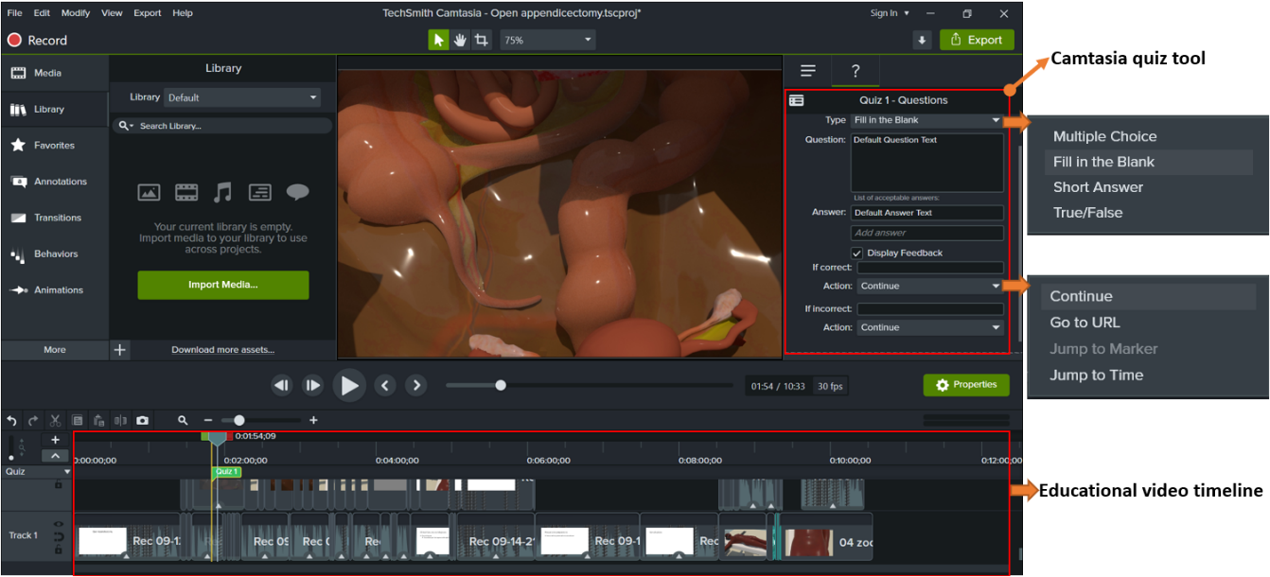
Figure 2.11 Snapshot of Camtasia software showing the quiz tool and timeline.

Thus, the educational video was used as the digital teaching method for surgical procedure cognitive skills in the Moodle course. Thus an educational video was produced for four surgical procedures. Figure 2.12 shows an annotated snapshot of the complete educational video for mastectomy and axillary node clearance, with the location of embedded assessment events shown along the video timeline.

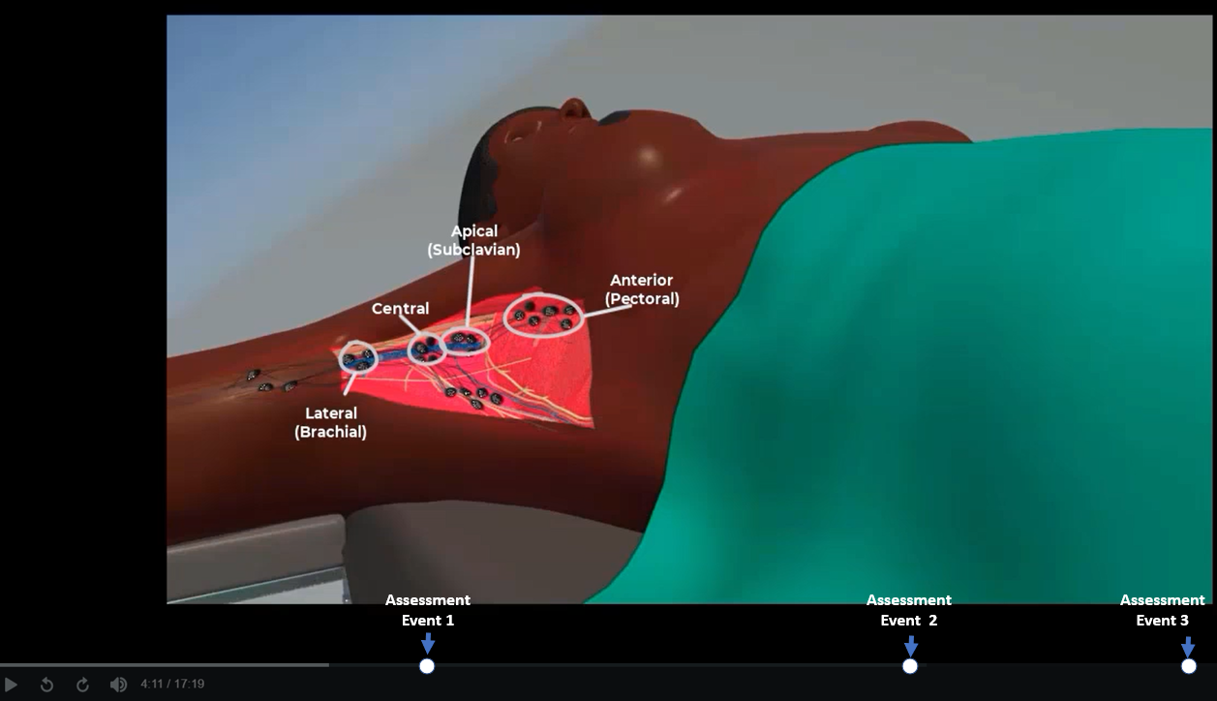
Figure 2.12 Snapshot of the educational video showing assessment events.

The educational video production process required the use of eight software. Although I had used most of the software before, the complexity and size of this project required me to learn new techniques for using the software. Learning such techniques involved a steep learning curve and the final product, an interactive educational video of 17 minutes or less. It took me approximately a month to produce one educational video and four months for the four surgical procedures. In future, an improved familiarity with the software will probably decrease the production time by about 30%. In addition, the time taken to produce an educational video was getting shorter with each subsequent production process.

- Conduct a run-through.
The four educational videos were reviewed with the supervisors and three members of the Department of Surgery and approved. Two senior residents tested the videos and the embedded assessment events. The following review comments and amendments were made: minor clerical errors were picked in the assessments and were amended, and distracting background noise was also identified and edited out using Adobe audition® software.
Four educational videos were completed to teach surgical procedure cognitive skills. Thus, the digital teaching method was produced using 3D animation videos and embedded continuous assessments with instant feedback. The design of the LMS course layout and the uploading of the educational videos on a LMS will be discussed under phase II. This is because the layout design needed to conform with the crossover repeated measures study design used for comparing the digital teaching method and the traditional teaching method. The comparison occurred during phase II, the evaluation stage of the ADDIE model.

Implementation
The Supervisors approved the educational videos for the four surgical procedures. The educational videos were ready for uploading after the LMS layout design during the study's evaluation stage (phase II). The evaluation stage was conducted solely online.
The researcher chose to deliver the course on MoodleTM LMS in a course format. Moodle is the official LMS used by the University of Botswana. In addition, the university recommends using local but not alternative platforms for one to receive full support from its Information and Technology (IT) department.

The researcher applied for permission to create a course on the University of Botswana’s (UB) Moodle LMS. The notification by the University of Botswana Information and Technology department that the course was created on Moodle and that the researcher was given the teacher role is attached in the Appendix as Figure 1.1. Additionally, the researcher sought permission to enrol non-UB student candidates on the course. The University of Botswana's Information & Technology department granted the permission as per the above-mentioned communication.
Phase II of the study was conducted during the last stage of the ADDIE model, the Evaluation stage.

Reference

1. Flin R, Youngson G, Yule S, et al. How do surgeons make intraoperative decisions? J BMJ Quality. 2007;16(3):235-9.
2. Hall J, Ellis C, Hamdorf J. Surgeons and cognitive processes. J Journal of British Surgery. 2003;90(1):10-6.
3. Flin R, Yule S, Paterson-Brown S, et al. Teaching surgeons about non-technical skills. J The Surgeon. 2007;5(2):86-9.
4. Yule S, Flin R, Maran N, et al. Surgeons’ non-technical skills in the operating room: reliability testing of the NOTSS behavior rating system. J World journal of surgery. 2008;32:548-56.
5. Crebbin W, Beasley SW, Watters DA. Clinical decision making: how surgeons do it. J ANZ journal of surgery. 2013;83(6):422-8.
6. Madani A, Watanabe Y, Feldman LS, et al. Expert intraoperative judgment and decision-making: defining the cognitive competencies for safe laparoscopic cholecystectomy. J Journal of the American College of Surgeons. 2015;221(5):931-40. e8.
7. Roberts KE, Bell RL, Duffy AJ. Evolution of surgical skills training. World J Gastroenterol. 2006;12(20):3219-24.
8. Grantcharov TP, Reznick RK. Teaching procedural skills. J Bmj. 2008;336(7653):1129-31.
9. Tirapelle LA. The effect of cognitive task analysis based instruction on surgical skills expertise and performance: University of Southern California; 2010.
10. Sullivan ME, Ortega A, Wasserberg N, et al. Assessing the teaching of procedural skills: can cognitive task analysis add to our traditional teaching methods? J The American Journal of Surgery. 2008;195(1):20-3.
11. Whimbey A. Teaching sequential thought: The cognitive-skills approach. J The Phi Delta Kappan. 1977;59(4):255-9.
12. Roberts KE, Bell RL, Duffy AJ. Evolution of surgical skills training. J World journal of gastroenterology: WJG. 2006;12(20):3219.
13. Franzese CB, Stringer SP. The evolution of surgical training: perspectives on educational models from the past to the future. J Otolaryngologic Clinics of North America. 2007;40(6):1227-35.
14. Sachdeva AK, Bell Jr RH, Britt LD, et al. National efforts to reform residency education in surgery. J Academic Medicine. 2007;82(12):1200-10.

Appendix

Figures

Figure 1.1 Notification of course creation by UB IT Department. Click to go back
