Contents
Supplementary Information 1
Isolation and identification of pneumococci 1
Whole-genome sequencing 1
CAP-IT trial 1
Selection of isolates 1
Acquired resistance genes 2
Core genome MLST (cgMLST) 2
Penicillin-binding proteins 2
Within ST recombinations might facilitate vaccine escape 2
Supplementary Figures 3
Supplementary Tables 8

Supplementary Information

Isolation and identification of pneumococci
50 μL of NPS STGG was plated on streptococcal selective agar COBA (Oxoid, UK) and incubated overnight at 37ºC in 5% CO2. Positive cultures were sub-cultured on blood agar in the same conditions, and species identification was performed by colony morphology, optochin susceptibility test (Sigma-Aldrich, Germany) and bile solubility test (Sigma-Aldrich, Germany). When two different morphologies were observed in the positive culture, both isolates underwent sub-culture and phenotypic identification.

Whole-genome sequencing
Pneumococcal isolates were inoculated in 4 mL of Todd-Hewitt broth and incubated overnight at 37°C in 5% CO₂. DNA was extracted using MasterPure™ Complete DNA and RNA Purification Kit (Epicentre, USA) according to manufacturer’s instructions with few modifications. Briefly, 1 mL of the overnight culture was pelleted and resuspended in 150 µL TE buffer. Ready-to-Lyse lysozyme (Epicentre, USA) and mutanolysin (Sigma-Aldrich, Germany) 5000 U ml⁻¹ were added, and the solution was incubated at 37°C for 30 minutes. 150 µL of Tissue and Cell Lysis Solution containing Proteinase K (50 µg µl⁻¹) was added, after which the manufacturer’s protocol was followed.
After DNA extraction, an additional cleaning and concentration step was performed using DNA Clean & Concentrator™-10 (Zymo Research, USA) according to the manufacturer’s instructions. DNA concentration was determined using Qubit Fluorometer 3.0 (Thermo Fischer Scientific, USA).

CAP-IT trial
One of the secondary endpoints of the trial was phenotypic penicillin non-susceptibility or resistance in nasopharyngeal S. pneumoniae. Penicillin non-susceptibility in patients with a culture positive for S. pneumoniae was 17% at baseline and 16% 28 days later, and no significant differences were observed between the different arms of the trial, indicating that the treatment had no effect in pneumococcal non-susceptibility levels, or this effect had been lost before the follow-up visit. Finally, serotypes were evenly distributed across the different arms (Table S3). For all these reasons, it was decided to study the overall isolate population instead of focusing on differences between the trial arms.

Selection of isolates
In total, 497 isolates were obtained from 346 patients. Of these, 21 were identified as non-pneumococci. By rMLST. Species identified included S. mitis, S. parasanguinis, S. pseudopneumoniae and S. australis. Furthermore, when after MIC determination, serotyping and core genome alignment, 86 isolates were found to be phenotypic and genotypically identical to isolates obtained from the same patient, leaving 390 unique pneumococcal isolates obtained from 335 patients.

Core genome MLST (cgMLST)
cgMLST analysis yielded a total of 1391 core genes and an average distance between isolates of 1161.9 (3-1318). As observed in the phylogenetic tree, some serotypes, such as 15B/C or 35B, were spread across the tree, but, in general, isolates presenting the same serotype clustered together (Figure S1A). On the other hand, clustering by GPSC was more robust, and all isolates assigned to the same GPSC clustered closely (Figure S1B).

Penicillin-binding proteins
Based on the phylogenetic analysis, PBP1a variants formed two distinct clades, the first one containing four divergent variants corresponding to non-typeable isolates, and the second one presenting a differentiated sub-clade containing the rest of divergent variants, where the distances increased along with the increase in the number of amino acid modifications (Figure S3A). Interestingly, PBP1a variants from non-typeable isolates consistently showed more divergence compared to the reference protein sequence (7.8-15% divergence, 56-108 amino acid modifications).
In PBP2x variants, no clear division was identified. However, it can be observed that a higher number of total modifications correlates with a higher accumulation of the seven mutations previously described to confer resistance (Figure S2B).
Usually, when a PBP variant presented a high number of amino acid changes, it was accompanied by other PBP variants also with a high number of changes, further reflecting the recombination origin of these changes (Table S1).

Supplementary Figures
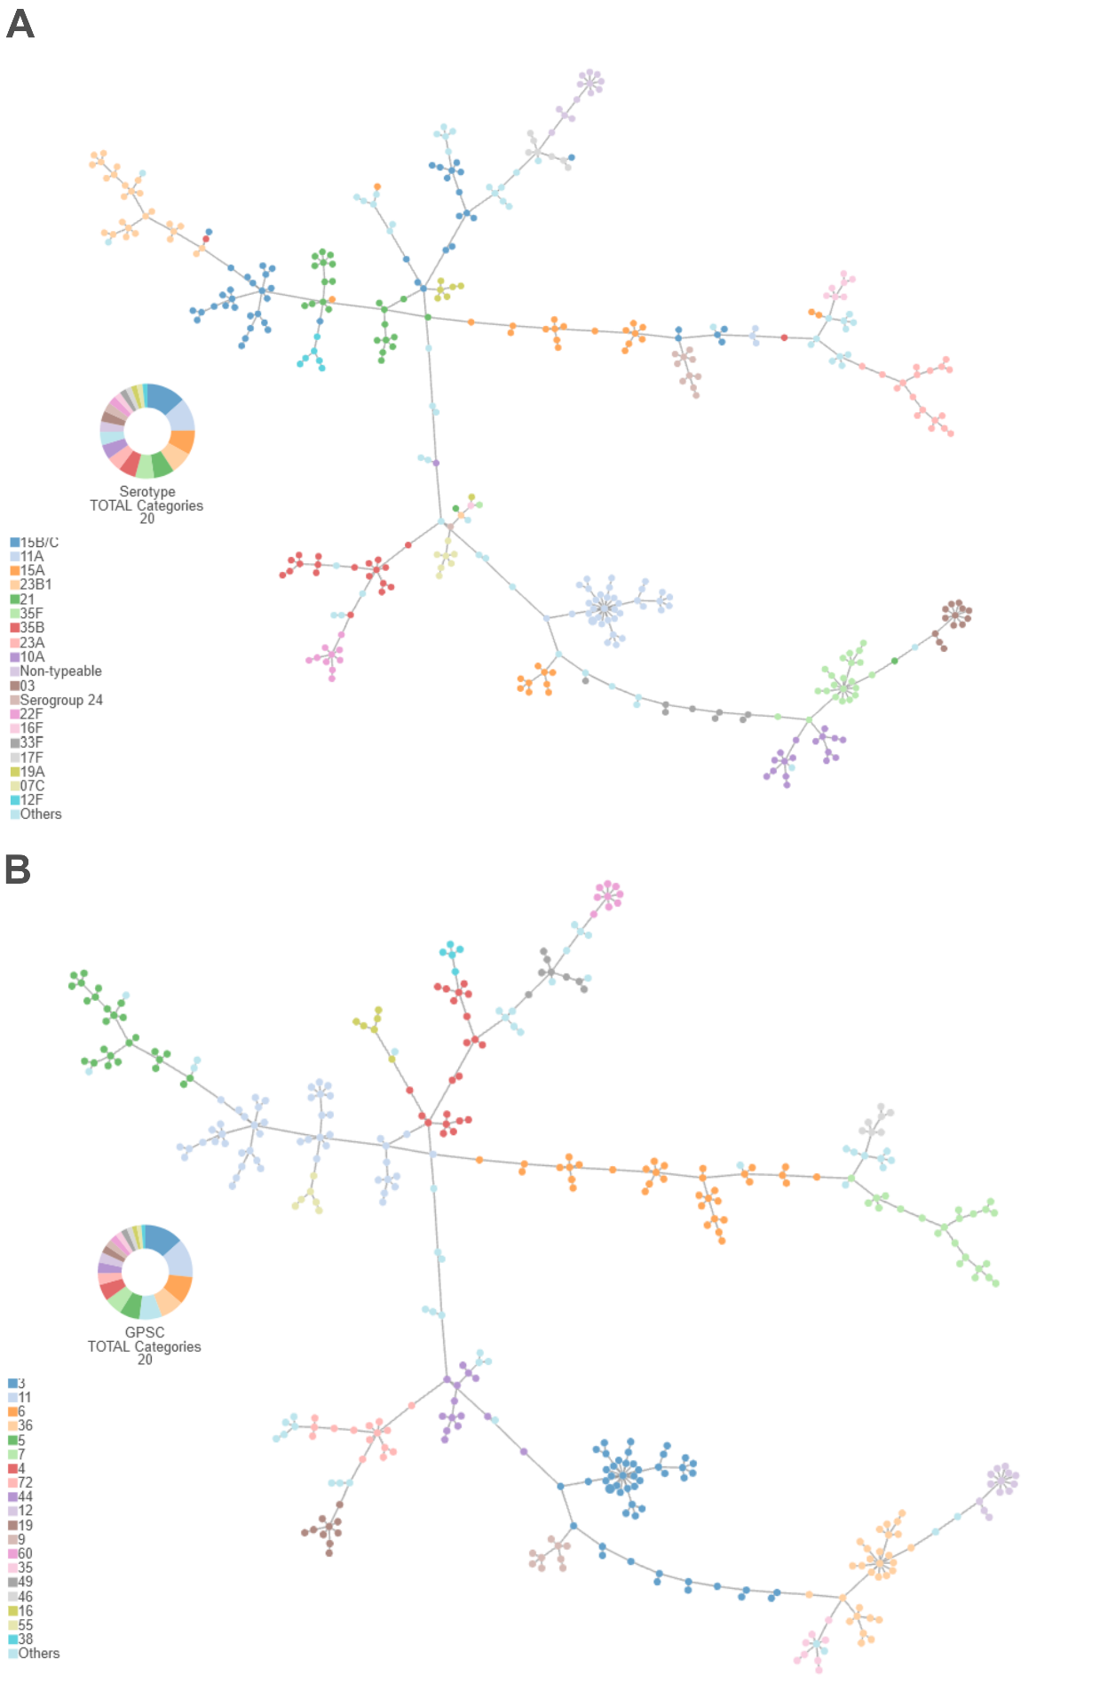

Figure S1. Tree generated form core-genome multi-locus sequence typing analysis. Nodes are coloured according to (A) serotype and (B) Global Pneumococcal Sequence Cluster. Due to restrictions from Phyloviz, only the 20 most prevalent serotypes and GPSCs are represented.
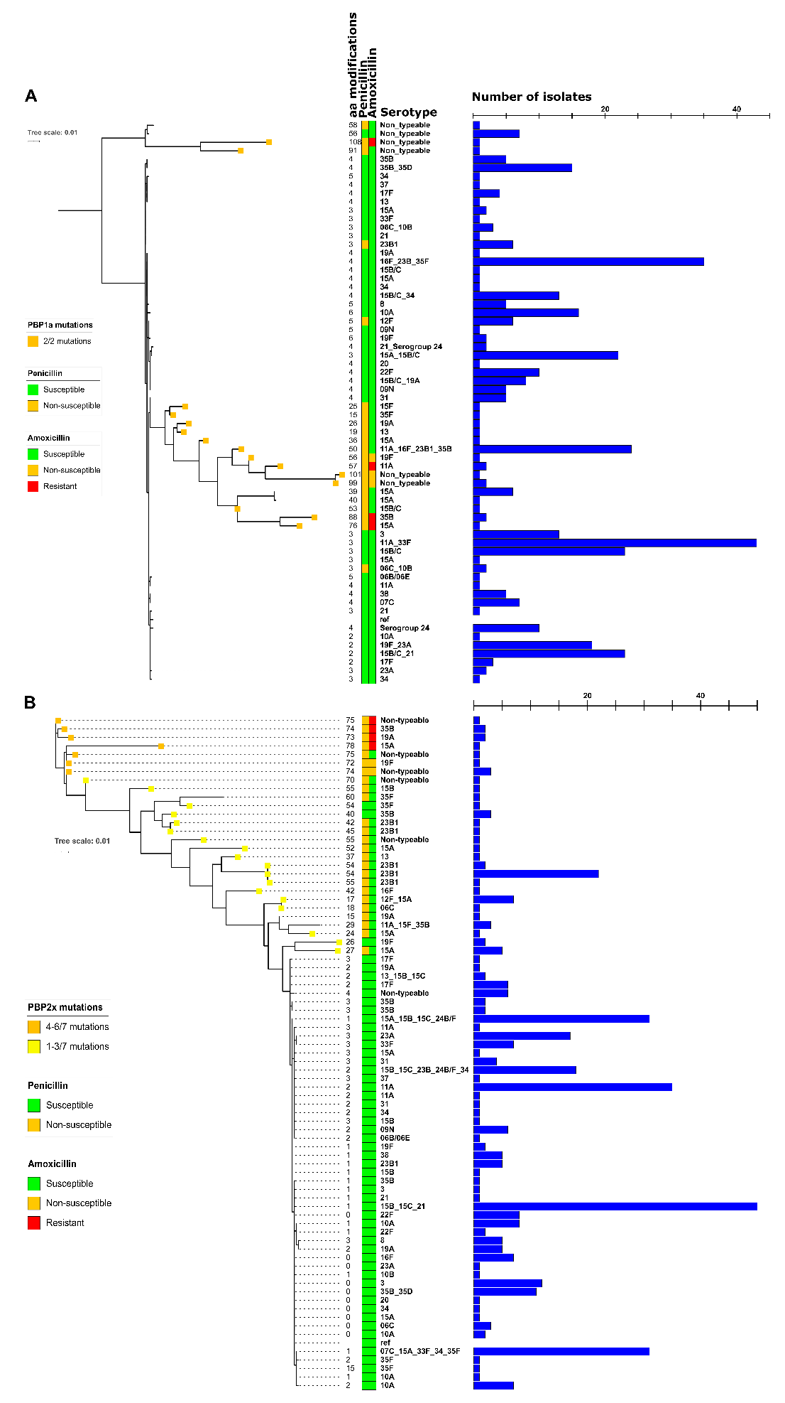
Figure S2. Phylogenetic trees generated from penicillin-binding protein (PBP) 1a (A) and PBP2x (B) amino acid sequences. Coloured squares represent the presence of mutations previously described to confer non-susceptibility. Number of total amino acid modifications, penicillin and amoxicillin susceptibility, serotype, and number of isolates are also depicted.
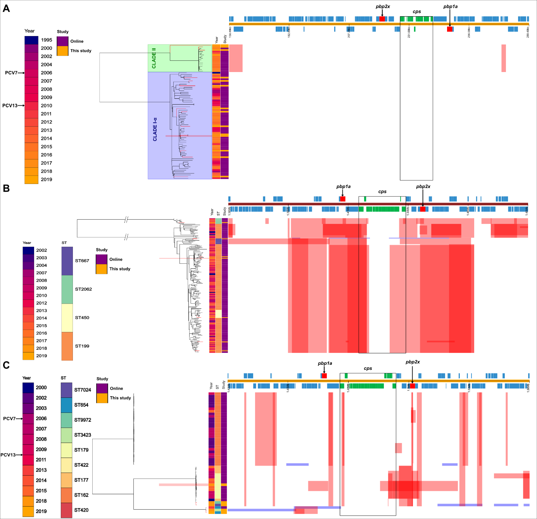
Figure S3. Phylogenetic trees generated from the cps locus region of serotype 3 (A), serotype 19A (B) and serotype 19F (C) isolates derived from this study (orange shading) and older isolates from the same serotypes. References used were CAPIT119_D1-1, CAPIT226_D1-1 and CAPIT214_D1-1 (marked in red shading), respectively. In red are shown the recombination events predicted to have occurred earlier in evolution, thus being present in a cluster of isolates. In blue, recombination events predicted only in the branch leaves, that is, in only one isolate. The position of the cps locus is indicated with green boxes, and pbp genes with red boxes. For serotype 3, the clade to which the isolates belong is also depicted. All serotype 3 isolates belonged to sequence type 180.
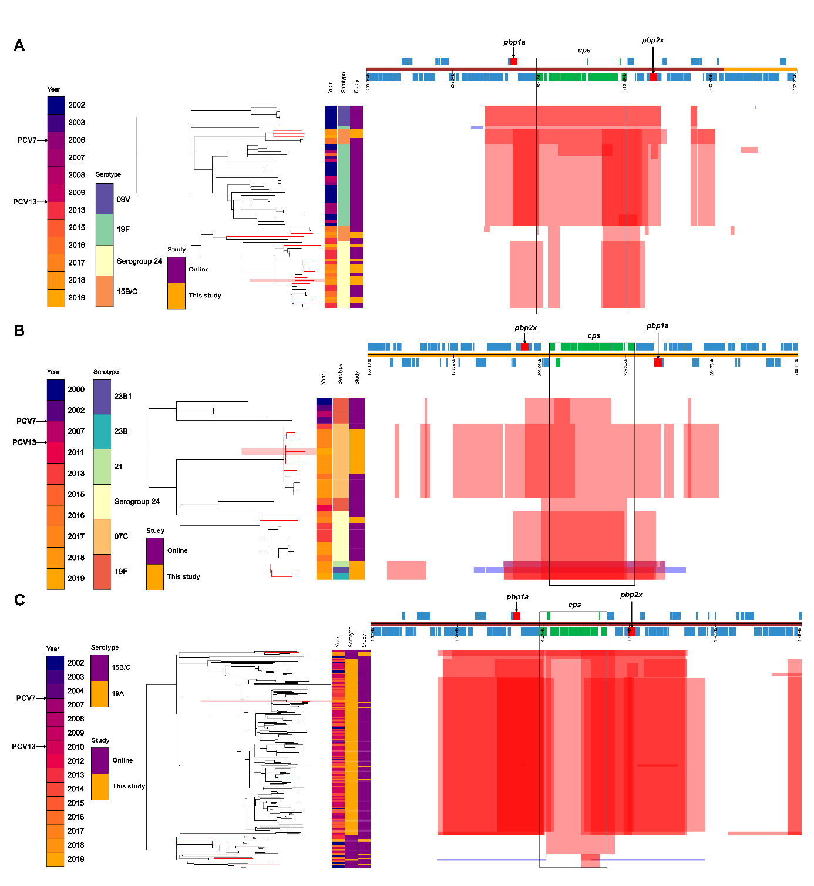
Figure S4. Phylogenetic trees generated from the cps locus region of sequence type (ST) 162 (A), ST177 (B) and ST199 (C) isolates derived from this study (orange shading) and older isolates from the same serotypes. References used were CAPIT086_D1-1, CAPIT292_D1-1 and CAPIT226_D1-1 (marked in red shading), respectively. In red are shown the recombination events predicted to have occurred earlier in evolution, thus being present in a cluster of isolates. In blue, recombination events predicted only in the branch leaves, that is, in only one isolate. The position of the cps locus is indicated with green boxes, and pbp genes with red boxes.

Supplementary Tables

Table S1. Collection of isolates obtained in this study. In blue, isolates long-read sequenced.

Table S2. Collection of isolates included in the recombination analysis. As every long-read sequenced isolate presenting serotypes 19A and 19F belonged to a different ST, all isolates belonging to those same STs were retrieved.

Table S3. Serotype distribution across the different arms of the trial.
Arm | 15B/C | 11A | 15A | 23B1 | 21 | 35F | 35B | 23A | 10A | 03 | Sg 24 | 22F | NT | 33F | 16F | 17F | 07C
Higher + longer | 14 | 8 | 11 | 4 | 5 | 6 | 7 | 5 | 3 | 3 | 4 | 6 | 3 | 2 | 3 | 3 | 1
Higher + shorter | 14 | 12 | 6 | 9 | 7 | 4 | 3 | 3 | 5 | 4 | 3 | 1 | 4 |  |  |  | 5
Lower + longer | 8 | 10 | 7 | 6 | 7 | 8 | 7 | 4 | 6 | 2 | 2 | 2 | 1 | 2 | 3 | 1 | 1
Lower + shorter | 12 | 10 | 6 | 8 | 6 | 5 | 4 | 6 | 4 | 4 | 2 | 1 | 5 | 4 | 2 | 3
Total | 48 | 40 | 30 | 27 | 25 | 23 | 21 | 18 | 18 | 13 | 11 | 10 | 13 | 8 | 8 | 7 | 7
Arm | 19A | 23B | 12F | 09N | 34 | 38 | 31 | 08 | 19F | 06C | 13 | 35D | 20 | 06E | 15F | 10B | 37
Higher + longer | 1 | 2 |  | 1 | 2 | 2 |  |  |  | 2 |  | 1 |  | 1
Higher + shorter | 2 | 3 | 2 |  |  | 1 | 1 | 1 | 2 |  |  |  |  |  |  | 1
Lower + longer |  | 1 | 4 | 3 | 2 | 2 | 3 | 3 | 2 |  | 1 | 1 | 1 |  |  |  | 1
Lower + shorter | 4 |  |  | 2 | 1 |  | 1 | 1 | 1 | 2 | 1 |  |  |  | 1
Total | 7 | 6 | 6 | 6 | 5 | 5 | 5 | 5 | 5 | 4 | 2 | 2 | 1 | 1 | 1 | 1 | 1

