Supplementary information
Mass Fabrication and Smart Deployment of “Calibration-free" Miniature Solid-State Potentiometric Sensors towards Digital Water Infrastructure
Yingzheng Fan^{1,}, Zheqin Dai¹, Zhiheng Xu², Xin Qian³, Wenjun Xiang¹, ﻿Samuel J. Lounder⁴, Cole McNamara¹, Jeffrey McCutcheon³, ﻿Ayse Asatekin⁴, Baikun Li^{1,5} *

¹Department of Civil and Environmental Engineering, University of Connecticut, Storrs, Connecticut 06269, United States
²Department of Industrial & Systems Engineering, Rochester Institute of Technology, Rochester, New York, 14623, United States
³Department of Chemical and Biomolecular Engineering, University of Connecticut, Storrs, Connecticut 06269, United States
⁴﻿Department of Chemical and Biological Engineering, Tufts University, Medford, Massachusetts 02155, United States
⁵Center for Environmental Science and Engineering, University of Connecticut, Storrs, Connecticut 06269, United States

(*Corresponding author: baikun.li@uconn.edu; Phone: 860-486-2339)

Supplementary Note 1. The detailed description of electrospray process
In the electrospray process, the electrode substrate (AJP silver-nanoparticle-based electrode) was attached to the drum that rotated at 14 rpm (Fig, 1e). The MWCNT-based solid contact cocktail that had been already put in the syringe of the electrospray device was sprayed at a fixed flow rate of 3.9 mL/h onto the electrode substrate to form a MWCNT-based solid contact membrane (Fig, 1e). Then, the PTFE-contained ISM cocktail was put in the syringe to spray at a fixed flow rate of 3.9 mL/h onto the solid contact membrane to form the PTFE-based ISM. Finally, the cocktails of PTFEMA-r-SBMA and isopropyl alcohol were put in the syringes, respectively, and then simultaneously sprayed at a fixed flow rate of 3.9 mL/h onto the PTFE-based ISM to form the anti-fouling membrane (thickness: 100 nm). The cocktail was extruded out of the needle tip that was mounted on the plastic holder with a tip-to-drum distance of 4.5 cm. The positive voltage applied on the needle tip was set at 6.6 kV provided by a high-voltage power source. Through forming the spray pattern in the cone and jet mode, the spray comprising the finest droplets was deposited onto the sensor surface as a circular deposition area, which finally integrated into a thickness-controllable thin layer (Fig. 4g). The stage carrying two needles was mounted on a code-driven screw slide to move back and forth along the drum axial direction. The needles were rastered along the length of the drum by a Velmex controller at a speed of 350 μm/s for 16 cm and then returned to the original position if more than one layer was required. The electrospray process was conducted at 23 ◦C and 16% relative humidity to maintain the uniform solution viscosity. Each membrane was dried at room temperature over 24 h under N₂ and a lightless environment after finishing the electrospray process.
Supplementary Note 2. The detailed description of characterization tests for CF-MSP-ISM sensors
The water layer test has been used as the indicator to assess the potentiometric sensor stability by alternately immersing into primary and interfering ion water solution. In this study, it was used to verify the water layer formation into the sensor matrix. At the beginning of the tests, the NH₄⁺ sensors to be examined were simultaneously immersed into the primary ion solution (NH₄Cl, 0.1 M) for ~60 min to obtain an equilibrium with the solution. Subsequently, the sensors ﻿were switched into the interfering ion solution (NaCl, 0.1 M) for ~60 min to ensure the interfering ions (Na⁺ in this case) to transport through the membrane and achieve a new equilibrium. Finally, these sensors were put back to the primary ion solution (NH₄Cl, 0.1 M) and submerged for another ~60 min to equilibrate with the solution. The entire process of water layer test was continuously recorded using a multichannel electrochemical workstation (CHI 660D potentiostat) to obtain the potential readings (mV) of these sensors at the interval of 10 s. The EIS measurement was conducted in 0.1 M KCl solution. The results were recorded in the frequency range from 100 kHz to 0.1 Hz using an excitation amplitude (ΔEac) of 10 mV. These data were fitted based on the equivalent circuit models in the ZsimpWin software.

Supplementary Note 3. The evaluation process for achieving NS and E⁰
In this study, five pieces of MSP-ISM sensors and CF-MSP-ISM sensors were randomly selected from a fabrication batch, and then were individually submerged into the water solution (100 mL) of 1 mg/L NH₄Cl continuously stirred at 100 rpm via a Thermolyne Cimarec-top stirring plate. The NH₄⁺ concentration solution was sequentially increased from 2, 4, 8, 16, 32, to 64 mg N/L every 50 s by adding the concentration NH₄Cl solution. The readings (mV) of these sensors were individually recorded at 0.1 s intervals using a multichannel electrochemical workstation (CHI 660D potentiostat). The sensor readings (mV) were converted to the calibration curve based on the Nernst logarithmic dependence ($E=E^{0}+NS×logC_{0}$) between potential readings (E, mV) and concentration (mg N/L). According to the calibration curve, the values of NS and $E^{0}$ for each sensor could be obtained, and then the consistency of NS and $E^{0}$ among these five sensors were calculated based on the standard deviation (STDEV) of these results.

Supplementary Note 4. Geometric details of this PF-AO system and the influent characteristics
Assumptions: (1) The influent quantity and quality to the PF-AO system are constant; (2) The anoxic tank and aerobic tank are ideal plug-flow reactors (PFRs); (3) The mix liquor biomass through the system is stable.
Influent characteristics: The quantity of the wastewater is 9,600 m³/day, and the quality of wastewater influent qualities is 180 mg-chemical oxygen demand (COD)/L 35.0 mg NH₄⁺-N/L, 0.1 mg-DO/L, and 0.1 mg-NO₃⁻-N/L.
Geometric and operational details of the AO system: The AO system of the PF-AO-FC model consists of an anoxic tank, an aerobic tank, and a pumping line for mixed liquor backflow (Fig. S1a). The dimension of the anoxic tank (hydraulic retention time (HRT): 2.0 h) was 5.0 m in depth, 8.0 m in width, and 20.0 m in length. The dimension of the aerobic tank (HRT: 6.0 h) was 5.0 m in depth, 8.0 m in width, and 60.0 m in length. The ratio of backflow from the outlet of the aerobic tank to the inlet of the anoxic tank was set to 200 % of the influent flow (Fig. S1a).

Supplementary Note 5: Detailed descriptions and equations of biochemical and physical processes in the simulated plug-flow anoxic/oxic (PF-AO) system.
(1) Activate Sludge Model (ASM) kinetics:
Assumptions: (1) The primary biological activities are the growth of aerobic and anoxic heterotrophs and the growth of aerobic autotrophs; (2) The biomass reaches the stationary phase (growth-decay equilibration).
The dynamic biological processes were simulated using the activated sludge model No.1 (ASM, No.1), as described below¹:
(i) Aerobic autotrophic nitrifiers
$$v_{o,nitri}=μ_{A}∙\frac{S_{NH}}{K_{NH}{+S}_{NH}}∙\frac{S_{O}}{K_{O,A}{+S}_{O}}∙X_{B,A}$$ | (S1)
where $v_{o,nitri}$ is the reaction rate of aerobic autotrophic nitrifiers (mg/(L·s)); $μ_{A}$ is the maximum specific growth rate for autotrophic nitrifiers (s⁻¹); $S_{NH}$ is the soluble ammonia concentration (mg/L); $K_{NH}$ is the ammonia half-saturation coefficient (mg/L); $S_{O}$ is the dissolved oxygen concentration (mg/L); $K_{O,A}$ is the oxygen half-saturation coefficient for autotrophic biomass (mg/L); $X_{B,A}$ is the active autotrophic biomass (nitrifiers) (mg/L). The values of the parameters are listed in Table S1.
(ii) Anoxic heterotrophic denitrifiers
$$v_{a,denitri}=μ_{H}∙\frac{S_{S}}{K_{S}{+S}_{S}}∙\frac{S_{O}}{K_{O,H}{+S}_{O}}∙\frac{S_{NO}}{K_{NO,H}{+S}_{NO}}∙η_{g}∙X_{B,H}$$ | (S2)
where $v_{a,denitri}$ is the reaction rate of anoxic heterotrophic denitrifiers (mg/(L·s)); $μ_{H}$ is the maximum specific growth rate for heterotrophic biomass (s⁻¹); $S_{S}$ is the soluble organic carbon concentration (mg/L); $K_{S}$ is the organic carbon half-saturation coefficient (mg/L);$K_{O,H}$ the oxygen half-saturation coefficient for heterotrophic biomass (mg/L); $S_{NO}$ is the soluble nitrate concentration (mg/L); $K_{NO,H}$ is the nitrate half-saturation coefficient for heterotrophic biomass (mg/L); $η_{g}$ is the correction factor for $μ_{H}$ under anoxic condition (dimensionless); $X_{B,H}$ is the active heterotrophic biomass (denitrifiers and common heterotrophs, mg/L). The values of the parameters are listed in Table S1.

(iii) Heterotrophic bacteria
$$v_{hetero}=μ_{H}∙\frac{S_{S}}{K_{S}{+S}_{S}}∙\frac{S_{O}}{K_{O,H}{+S}_{O}}∙X_{B,H}$$ | (S3)
where $v_{hetero}$ is the reaction rate of common heterotrophic bacteria (mg/(L·s)). The values of the parameters are listed in Table S1.
The biochemical processes of Eq. S1-S3 involved four main contents in wastewater: NH₄⁺, NO₃⁻, DO, and organic carbon. In terms of NH₄⁺, it was mainly consumed as the electron donor in the nitrification, and also assimilate by the three types of bacteria, which can be described as below:
$$v_{NH}=-\left(\frac{1}{Y_{A}}+i_{XB}\right)∙v_{o,nitri}-i_{XB}∙\left(v_{a,denitri}+v_{hetero}\right)$$ | (S4)
where $v_{NH}$ is the reaction rate of NH₄⁺ (mg/(L·s)); $Y_{A}$ is the yield for autotrophic biomass (dimensionless); $i_{XB}$ is nitrogen content in biomass (dimensionless). The values of the parameters are listed in Table S1.

As for NO₃⁻, it was generated in aerobic nitrification process and subsequently reduced by anoxic denitrify bacteria in anoxic process, which can be described as below:
$$v_{NO}=\frac{1}{Y_{A}}∙v_{o,nitri}-\frac{1-Y_{H}}{2.86Y_{H}}∙v_{a,denitri}$$ | (S5)
where $v_{NO}$ is the reaction rate of NO₃⁻ (mg/(L·s)); $Y_{H}$ is the yield for heterotrophic biomass (dimensionless). The values of the parameters are listed in Table S1.

In regard to DO, it was consumed as the electron acceptor in the aerobic biochemical processes including nitrification and aerobic growth of heterotrophs, which can be described as:
$$v_{O,b}=-\frac{4.57-Y_{A}}{Y_{A}}∙v_{o,nitri}-\frac{1-Y_{H}}{Y_{H}}∙v_{a,denitri}$$ | (S6)
where $v_{O,b}$ is the reaction rate of DO in biochemical processes (mg/(L·s)). The values of the parameters are listed in Table S1.

Towards organic carbon, it was consumed as the carbon source for the growth of heterotrophic bacteria (e.g., anoxic denitrifying bacteria and aerobic heterotrophic bacteria), which can be described as below:
$$v_{COD,b}=-\frac{1}{Y_{H}}∙\left(v_{a,denitri}+v_{hetero}\right)$$ | (S7)
where $v_{COD,b}$ is the reaction rate of organic carbon in biochemical processes (mg/(L·s)). The values of the parameters are listed in Table S1.

(2) N₂O emission processes:
Assumptions: (1) Low DO and high NO₃⁻/NO₂⁻ present in aerobic nitrification process triggers the N₂O generation²; (2) High DO, high NO₃⁻/NO₂⁻, and low C/N ratio in anoxic denitrification process triggers the N₂O generation³; (3) The ratio of NO₂⁻ to NO₃⁻ throughout the AO system is constant.
The N₂O emission was estimated in both nitrification and denitrification, described as below:
(i) N₂O emission from aerobic nitrification process
$$v_{nt}=\left(μ_{NE}∙X_{B,A}\right)∙\frac{K_{O,NE}}{K_{O,NE}{+S}_{O}}∙\frac{{χS}_{NO}}{K_{NO,NE}+{χS}_{NO}}$$ | (S8)
where $v_{nt}$ is the N₂O emission rate during nitrification (mg/(L·s)); $μ_{NE}$ is the maximum specific growth rate for nitrification emission of N₂O (s⁻¹); $K_{O,NE}$ is the oxygen half-saturation coefficient for nitrification emission of N₂O (mg/L); $χ$ is the correction factor for $S_{NO}$ during N₂O emission (dimensionless); $K_{NO,NE}$ is the nitrate half-saturation coefficient for N₂O emission during nitrification emission of N₂O (mg/L). The values of the parameters are listed in Table S1.

(ii) N₂O emission from anoxic denitrification process
$$v_{de}=\left(μ_{DE}∙η_{g}∙X_{B,H}\right)∙\frac{K_{S,DE}}{K_{S,DE}{+S}_{S}}∙\frac{S_{O}}{K_{O,DE}{+S}_{O}}∙\frac{{χS}_{NO}}{K_{NO,DE}+{χS}_{NO}}$$ | (S9)
where $v_{de}$ is the N₂O emission rate during denitrification (mg/(L·s)); $μ_{DE}$ is the maximum specific growth rate for denitrification emission of N₂O (s⁻¹); $K_{S,DE}$ is the organic substrate half-saturation coefficient for denitrification emission of N₂O (mg/L); $K_{O,DE}$ is the oxygen half-saturation coefficient for denitrification emission of N₂O (mg/L); $K_{NO,DE}$ is the nitrate coefficient for denitrification emission of N₂O (mg/L). The values of the parameters are listed in Table S1.

(3) Aeration kinetics:
Dissolved oxygen (DO) in the aerobic tank is controlled based on aeration kinetics to assure NH₄⁺ oxidization. The rate of DO recovery due to aeration intensity can be described as below.
$$v_{O,ae}=\left(K_{La,max}∙\frac{i_{ae}}{K_{i_{ae}}+i_{ae}}\right)∙({S_{O}^{*}-S}_{O})$$ | (S10)
where $v_{O,ae}$ is the change rate of DO due to aeration (mg/(L·s)); $K_{La,max}$ is the maximum total mass transfer coefficient for oxygen transfer (s⁻¹);$i_{ae}$ is the aeration intensity (vary along the aerobic zone, m³/(m²·h)); $K_{i_{ae}}$ the half-saturation coefficient for aeration intensity (m³/(m²·h)); $S_{O}^{*}$ is the saturated DO concentration (mg/L). The values of the parameters are listed in Table S1.

Supplementary Note 6: Comparison of the traditional scenario (“single-point” sensor) and smart deployment scenarios (multiple CF-MSP-ISM sensors).
(1) Traditional scenario
(i) Uniform aeration
In the aerobic tank, the uniform aeration intensity is determined by the worst-case that is the highest NH₄⁺ concentration (from the influent) and the lowest oxygen utilization efficiency (Fig. S1b), as below:
$$i_{ae,tr}=\frac{n_{NH}∙Q_{w}∙S_{NH, in}∙V_{m}}{p_{air}∙η_{o}∙A_{o}}$$ | (S11)
where $i_{ae, tr}$ is the uniform aeration intensity in the traditional scenario (m³/(m²·h)); $n_{NH}$ is the mole number in NH₄⁺ oxidation (mol/mol); $Q_{w}$ is the influent flow (L/h); $S_{NH,in}$ is the influent NH₄⁺ mole concentration (mol/L); $V_{m}$ is the mole gas volume (m³/mol); $p_{air}$ is the oxygen portion in the air (dimensionless)); $η_{mt}$ is the worst-case oxygen utilization efficiency (dimensionless); $A_{o}$ is the surface area of the aerobic tank (m²). The values of the parameters are listed in Table S1.

(ii) Single-point carbon dosage
In the anoxic tank, exogenous carbon was dosed at the inlet of the anoxic tank (i.e. increasing the influent organic substrate) in order to provide enough carbon source for denitrification (Fig. S1b), which is determined below.
$$Q_{cd, tr}=m_{NO}∙Q_{w}∙\left(S_{NO, in+}S_{NH, in}\right)$$ | (S12)
where $Q_{cd, tr}$ is the single-point carbon dosage in the traditional scenario (kg/h);$m_{NO}$ is the mass ratio of C/N (kg/kg); $S_{NO,in}$ is the influent NO₃⁻ concentration (mg/L); $S_{NH,in}$ is the influent NH₄⁺ concentration (mg/L). The values of the parameters are listed in Table S1.

(2) Smart deployment scenarios
(i) Multi-zoning aeration control policy
Step 1: In the aerobic tank, the NH₄⁺ reaction rate distribution was monitored by the NH₄⁺ sensor deployment (Step 1 in Fig. S1c).
$${\tilde{ν}}_{{NH}_{4}^{+}}^{i}=\frac{S_{{NH}_{4}^{+}}^{i+1}-S_{{NH}_{4}^{+}}^{i}}{{Δx}_{i}{∙A}_{l}/Q_{w}}, i ϵ [1, n]$$ | (S13)
where $n$ is the number of the NH₄⁺ sensors deployed in the aerobic tank, which was 3-25 in this study (Step 1 in Fig. S1c); $i$ is the sequence number of the NH₄⁺ sensor; ${\tilde{ν}}_{{NH}_{4}^{+}}^{i}$ is the monitored NH₄⁺ reaction rate (mg/(L·h)); $S_{{NH}_{4}^{+}}^{i+1}$ and $S_{{NH}_{4}^{+}}^{i}$ are the NH₄⁺ concentrations detected by the $i$+1 and $i$ sensors (mg/L); ${Δx}_{i}$ is the distance between $i$+1 and $i$ sensors (m); $A_{l}$ is the sectional area longitudinally (m²);$Q_{w}$ is the influent flow (m³/h);. The values of the parameters are listed in Table S1.

Step 2: The aeration intensity is controlled by the monitored NH₄⁺ reaction rate distribution (Step 2 in Fig. S1c):
$$i_{ae}^{i}=α_{ae}^{i}∙{\tilde{ν}}_{{NH}_{4}^{+}}^{i}=\frac{Q_{w}∙i_{ae, tr}}{A_{l}\sqrt{{\tilde{ν}}_{{NH}_{4}^{+}}^{i}∙\max\left({\tilde{ν}}_{{NH}_{4}^{+}}^{i}\right)}}∙{\tilde{ν}}_{{NH}_{4}^{+}}^{i} , i ϵ [1, n]$$ | (S14)
where $i_{ae}^{i}$ is the multi-zoning aeration intensity (m³/(m²·h); $α_{ae}^{i}$ is the tuning factor for aeration (m/(mg/L)); $\max{({\tilde{ν}}_{{NH}_{4}^{+}}^{i})}$ is a function to find out the maximum value of the monitored NH₄⁺ reaction rates (mg/(L·h)). The values of the parameters are listed in Table S1.

(ii) Multi-point carbon dosage control policy
Step 3: In the anoxic tank, the NO₃⁻ reaction rate distribution was monitored by the NO₃⁻sensor deployment (Step 3 in Fig. S1c).
$${\tilde{ν}}_{{NO}_{3}^{-}}^{i}=\frac{S_{{NO}_{3}^{-}}^{i+1}-S_{{NO}_{3}^{-}}^{i}}{{Δy}_{i}{∙A}_{l}/Q_{w}}, i ϵ [1, n]$$ | (S15)
Where $n$ is the number of the NO₃⁻ sensors deployed in the anoxic tank, which was 3-25 (Step 3 in Fig. S1c); $i$ is the sequence number of the NO₃⁻ sensor; ${\tilde{ν}}_{{NO}_{3}^{-}}^{i}$ is the monitored NO₃⁻ reaction rate (mg/(L·h)); $S_{{NO}_{3}^{-}}^{i+1}$ and $S_{{NO}_{3}^{-}}^{i}$ are the NO₃⁻ concentrations detected by the $i$+1 and $i$ sensors (mg/L); ${Δy}_{i}$ is the distance between $i$+1 and $i$ sensors (m). The values of the parameters are listed in Table S1.

Step 4: The dosage density is controlled by the monitored NO₃⁻ reaction rate distribution (Step 4 in Fig. S1c):
$$m_{cd}^{i}=β_{cd}^{i}∙{\tilde{ν}}_{{NO}_{3}^{-}}^{i}=\frac{Q_{w}∙Q_{cd, tr}/A_{a}}{A_{l}\sqrt{{\tilde{ν}}_{{NO}_{3}^{-}}^{i}∙\max{({\tilde{ν}}_{{NO}_{3}^{-}}^{i})}}}∙{\tilde{ν}}_{{NO}_{3}^{-}}^{i} , i ϵ [1, n]$$ | (S16)
where $m_{cd}^{i}$ is the multi-point carbon dosage density (kg/(m²·h)); $β_{cd}^{i}$ is the tuning factor for carbon dosage (kg·L/(mg·m²)); $\max{({\tilde{ν}}_{{NO}_{3}^{-}}^{i})}$ is a function to find out the maximum value of the monitored NO₃⁻ reaction rates (mg/(L·h)). The values of the parameters are listed in Table S1.

(3) Variation of the NH₄⁺/ NO₃⁻ concentrations monitored
To quantitatively evaluate the accuracy of the NH₄⁺ reaction rate (${\tilde{ν}}_{{NH}_{4}^{+}}^{i}$), the variation of NH₄⁺ concentration was calculated based on Eq. S13:
$$ω_{{NH}_{4}^{+}}=\frac{1}{n-2}\sum_{i=1}^{i=n-2}{\left(\left|\frac{S_{{NH}_{4}^{+}}^{i+2}-S_{{NH}_{4}^{+}}^{i+1}}{{Δx}_{i+1}}-\frac{S_{{NH}_{4}^{+}}^{i+1}-S_{{NH}_{4}^{+}}^{i}}{{Δx}_{i}}\right|\right)} , n ϵ [3, 25]$$ | (S17)
where $ω_{{NH}_{4}^{+}}$ is the variation of NH₄⁺ concentration (mg/(L·m)) when $n$ pieces (3-25) of NH₄⁺ sensors were deployed in the aerobic tank. A smaller value of $ω_{{NH}_{4}^{+}}$ indicates a higher-resolution and a higher accuracy of the NH₄⁺ reaction profile. The values of the parameters are listed in Table S1.

To quantitatively evaluate the accuracy of the NO₃⁻ reaction rate (${\tilde{ν}}_{{NO}_{3}^{-}}^{i}$), the variation NO₃⁻ concentration was calculated based on Eq. S15:
$$ω_{{NO}_{3}^{-}}=\frac{1}{n-2}\sum_{i=1}^{i=n-2}{\left(\left|\frac{S_{{NO}_{3}^{-}}^{i+2}-S_{{NO}_{3}^{-}}^{i+1}}{{Δy}_{i+1}}-\frac{S_{{NO}_{3}^{-}}^{i+1}-S_{{NO}_{3}^{-}}^{i}}{{Δy}_{i}}\right|\right)}, n ϵ [3, 25]$$ | (S18)
where $ω_{{NO}_{3}^{-}}$ is the variation of the NO₃⁻ concentration (mg/(L·m)) when $n$ pieces (3-25) of NO₃⁻ sensors were deployed in the anoxic tank. A smaller value of $ω_{{NO}_{3}^{-}}$ indicates a higher-resolution and a higher accuracy of the NO₃⁻ reaction profile. The values of the parameters are listed in Table S1.

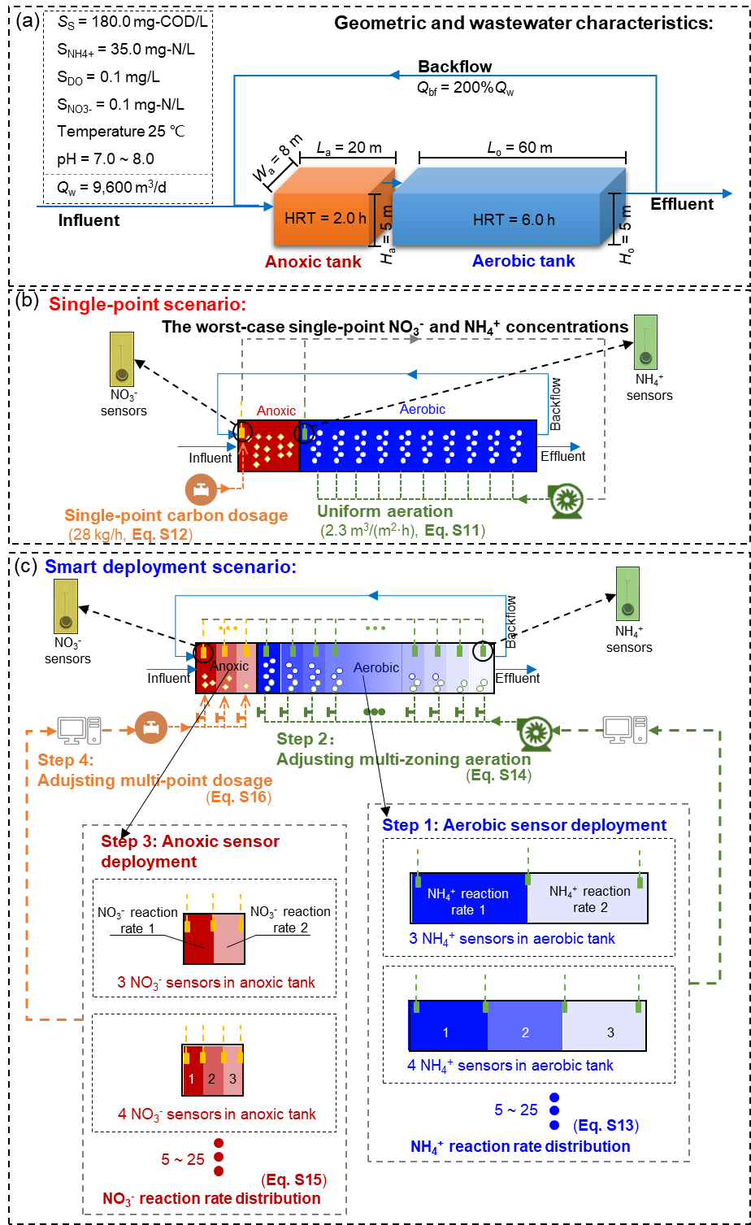
Fig. S1. (a) The geometric details of the PF-AO system; (b) The traditional scenario (single-point sensor) using the worst-case (NO₃⁻ and NH₄⁻ concentrations) to determine uniform carbon dosage and uniform aeration; (c) The smart deployment scenarios (multiple pieces of CF-MSP-ISM sensors) acquiring gradient high-resolution profiles for flexible aeration and carbon dosage.
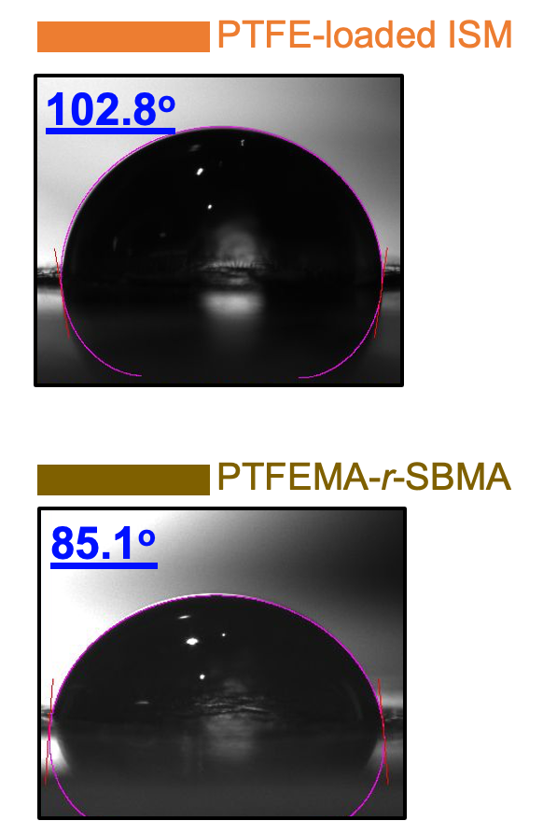
Fig. S2. Water contact angle test for the PTFE-loaded ISM and the PTFEMA-r-SBMA-based anti-fouling membrane.

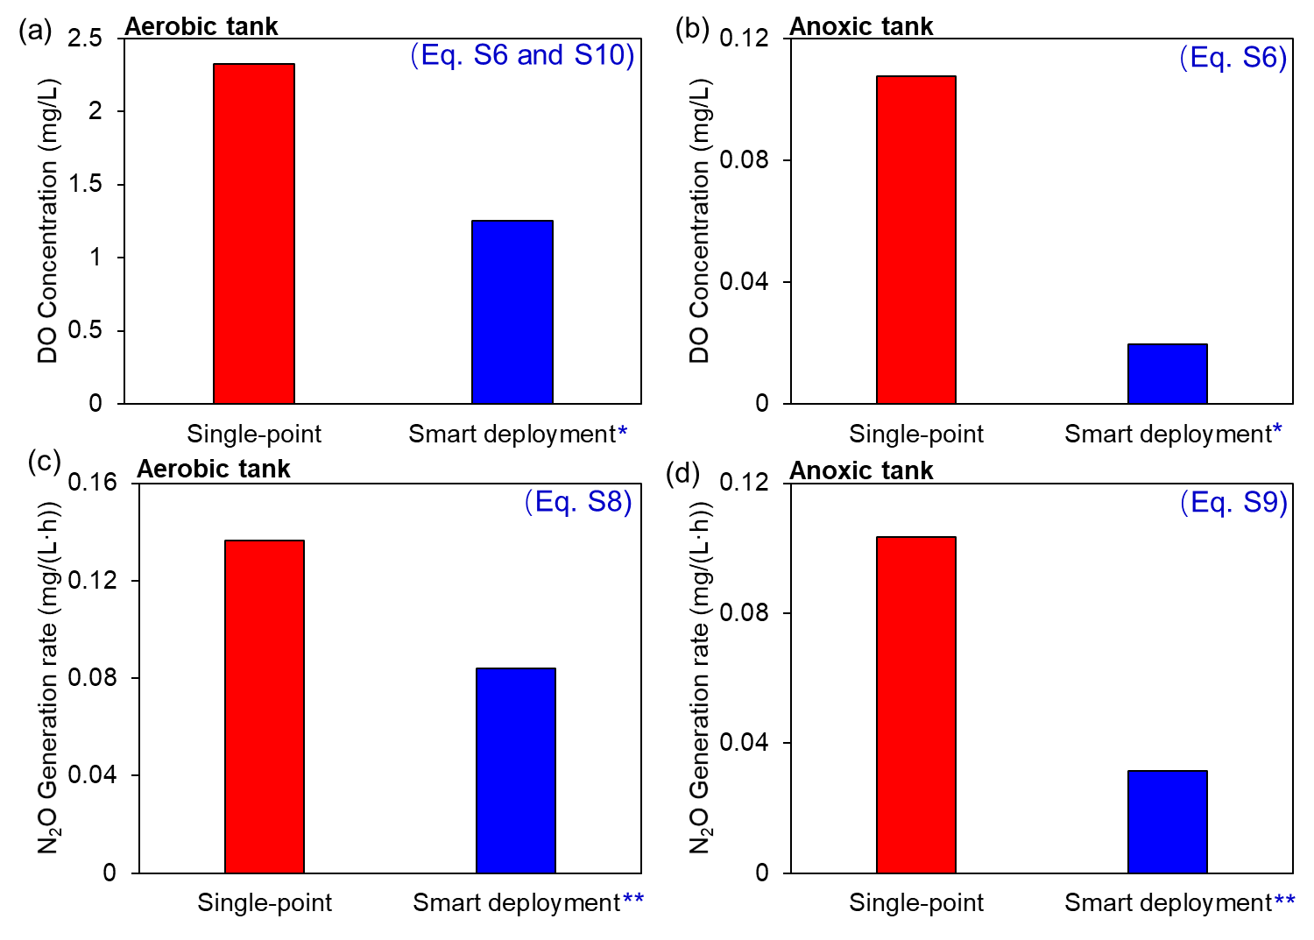
Fig. S3. Comparison of the key performance parameters in the aerobic and the anoxic tanks under the “single-point” monitoring and “multiple-sensor monitoring” scenarios. (a) the average DO concentration (mg/L) in the aerobic tank; (b) the average DO concentration (mg/L) in the anoxic tank; (c) the average N₂O generation rate (mg/(L·h)) in the aerobic tank; (d) the N₂O generation rate (mg/(L·h)) in the anoxic tank. (* denotes the smart deployment of 14 NH₄⁺ sensors in the aerobic tank and 10 NO₃⁻ sensors in the anoxic tank; and ** denotes the smart deployment of 14 NH₄⁺ sensors in the aerobic tank and 3 NO₃⁻ sensors in the anoxic tank.) (NOTE: The equations used for these calculations are listed in the figure.).

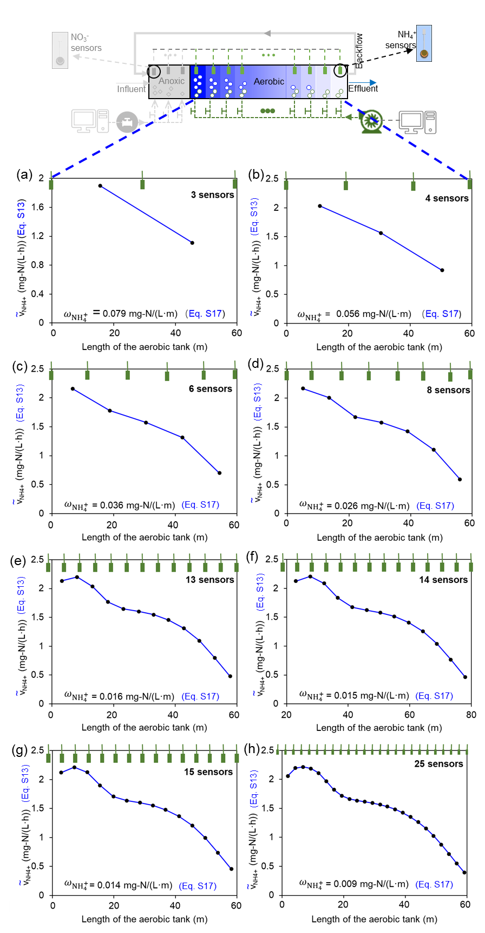
Fig. S4 Profile of the variation of NH₄⁺ reaction rate monitored along the length (60.0 m in this study) of the aerobic tank under different sensor numbers (3-25 pieces). (a) to (f): With the sensor number increasing from 3 to 14, the profiles of the variation of NH₄⁺ reaction rate become clear with more details being captured; (g) to (h): The profiles remain almost the same at the sensor numbers of 15 and 25. The variation of NH₄⁺ concentration monitored ($ω_{{NH}_{4}^{+}},$mg-N/(L·m), listed in each subfigure) along the aerobic tank becomes subtle (e.g., from 0.015 to 0.009 mg-N/(L·m)) at the higher sensor numbers (e.g. from 14 to 25). (NOTE: The equations used for these calculations are listed in the figure.).

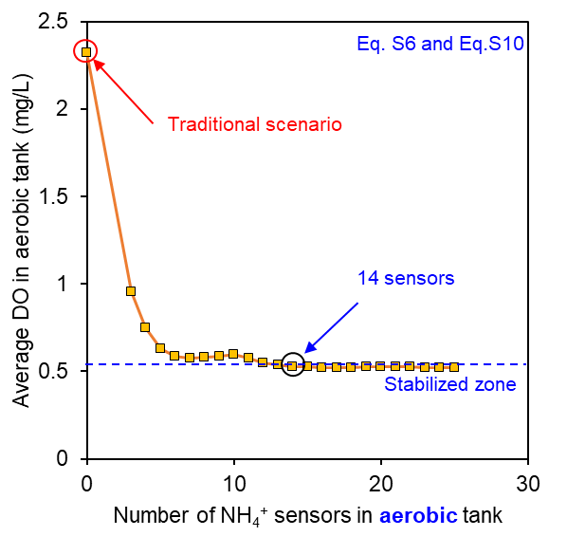
Fig. S5. Simulation of the average dissolved oxygen (DO) in the aerobic tank under smart deployment of multiple pieces of NH₄⁺ sensors (NOTE: DO concentration stabilizes along the aerobic tank after the sensor number goes beyond 14. The equations used for these calculations are listed in the figure.).

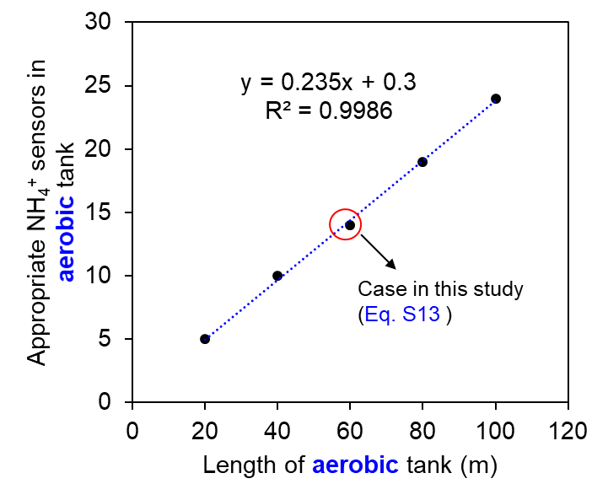
Fig. S6 The optimal sensor number in the aerobic tank as the function to the length of the aerobic tank (60.0 m in this study). (NOTE: The equations used for these calculations are listed in the figure).

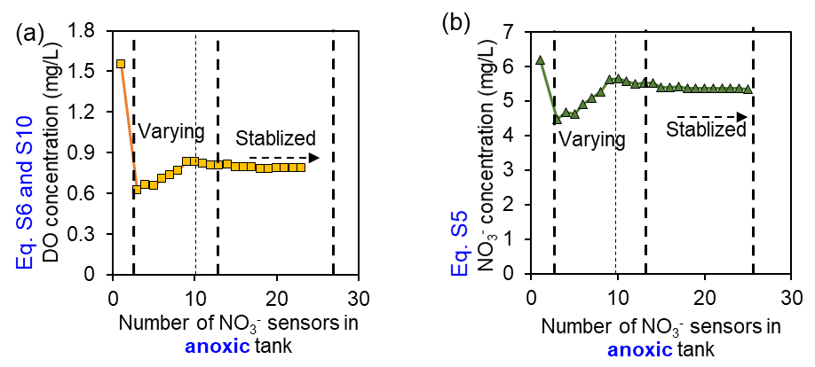
Fig. S7. The impacts of the NO₃⁻ sensor number (1-25) in the anoxic tank on the variations of (a) DO and (b) NO₃⁻ concentration from the backflow. (NOTE: The equations used for these calculations are listed in the figure.).

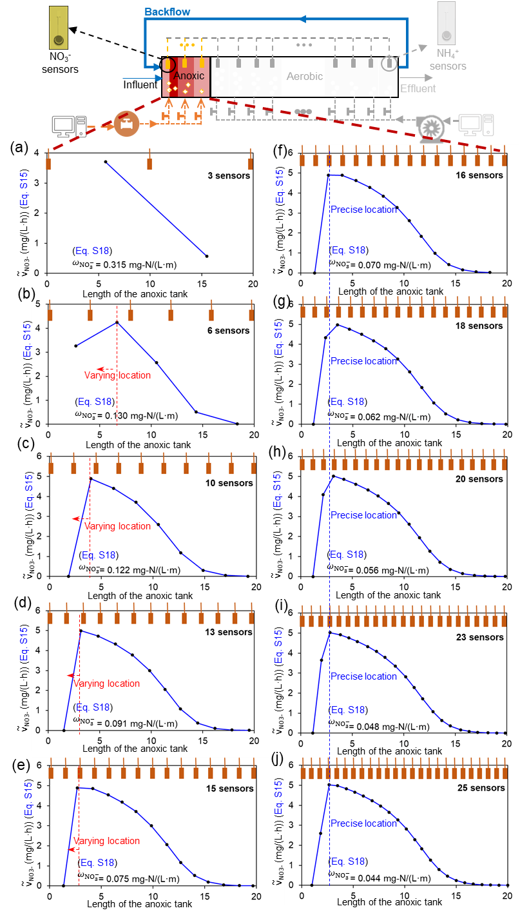
Fig. S8. Profiles of the variation of NO₃⁻ reaction rate monitored along the length (20.0 m in this study) of the anoxic tank under different sensor numbers (3 to 25 pieces). (a) to (e): The precise location (red dashed line pointing at the peak) of the fluctuation of NO₃⁻ reaction rate (caused by the backflow from the aerobic tank) could not be fully captured (varying in the figure) by the sensors (sensor number: 3-15), varying from 6.67 m to 3.00 m; (f) to (j): The variation of the NO₃⁻ reaction rate could be fully captured by the sensors (sensor number 16-25), with the precise location (blue dashed line pointing at the peak) of the fluctuation of NO₃⁻ reaction rate becoming stable at 2.67 m. The monitored variation of NO₃⁻ concentration ($ω_{{NO}_{3}^{-}}$, mg-N/(L·m), listed in each subfigure) along the anoxic tank becomes subtle (e.g., from 0.048 to 0.044 mg-N/(L·m)) at the higher sensor numbers (e.g. from 23 to 25). (NOTE: The equations used for these calculations are listed in the figures.).

Table S1. Values of the parameters used in Eq. 2-4 and Eq. S1-S10.
Row No. | Symbol | Equation sequence number | Description | Unit | Value
1 | $$S_{NH_{4}^{+},in}$$ | Eq. 2, S11 and S12 | Influent concentration of NH₄⁺ | mg-N/L | 35.0⁴
2 | $$S_{NO_{3}^{-},in}$$ | Eq. 2 and S12 | Influent concentration of NO₃⁻ | mg-N/L | 0.1⁴
3 | $$ϵ_{ae}$$ | Eq. 3 | Aeration-power factor | kWh/m³ | 0.03⁵
4 | $$A_{o}$$ | Eq. 3, S11 and S14 | Surface area of the aerobic tank | m² | 480.0⁵
5 | $$ϵ_{cd}$$ | Eq. 3 | Carbon dosage-power factor | kWh/kg-COD | 0.05⁵
6 | $$A_{a}$$ | Eq. 3 | Surface area of the anoxic tank | m² | 160.0
7 | $$V_{o}$$ | Eq. 4 and S16 | Volume of the aerobic tank | m³ | 2400.0
8 | $$V_{a}$$ | Eq. 4 | Volume of the anoxic tank | m³ | 800.0
9 | $$μ_{A}$$ | Eq. S1 | Maximum specific growth rate for autotrophic nitrifiers | d⁻¹ | 0.4¹
10 | $$K_{NH}$$ | Eq. S1 | Ammonia half-saturation coefficient | mg/L | 1.0¹
11 | $$K_{O,A}$$ | Eq. S1 | Oxygen half-saturation coefficient for autotrophic biomass | mg/L | 0.4¹
12 | $$X_{B,A}$$ | Eq. S1 and S8 | Active autotrophic biomass (nitrifiers) | mg/L | 100.0¹
13 | $$μ_{H}$$ | Eq. S2 and S3 | Maximum specific growth rate for heterotrophic biomass | d⁻¹ | 3.0¹
14 | $$K_{S}$$ | Eq. S2 and S3 | Organic carbon half-saturation coefficient | mg/L | 20.0¹
15 | $$K_{O,H}$$ | Eq. S2 and S3 | Oxygen half-saturation coefficient for heterotrophic biomass | mg/L | 0.2¹
16 | $$K_{NO,H}$$ | Eq. S2 | Nitrate half-saturation coefficient for heterotrophic biomass | mg/L | 0.5¹
17 | $$η_{g}$$ | Eq. S2 and S9 | Correction factor for $μ_{H}$ under anoxic condition | Dimensionless | 0.8¹
18 | $$X_{B,H}$$ | Eq. S2, S3 and S9 | Active heterotrophic biomass (denitrifiers and common heterotrophs) | mg/L | 1300¹
19 | $$Y_{A}$$ | Eq. S4-S6 | Yield for autotrophic biomass | Dimensionless | 0.24¹
20 | $$i_{XB}$$ | Eq. S4 | Nitrogen content in biomass | Dimensionless | 0.086¹
21 | $$Y_{H}$$ | Eq. S5-S7 | Yield for heterotrophic biomass | Dimensionless | 0.67¹
22 | $$μ_{NE}$$ | Eq. S8 | Maximum specific growth rate for nitrification emission of N₂O | d⁻¹ | 0.12⁶
23 | $$K_{O,NE}$$ | Eq. S8 | Oxygen half-saturation coefficient for nitrification emission of N₂O; | mg/L | 4.2⁶
24 | $$χ$$ | Eq. S8 and S9 | Correction factor for nitrate during N₂O emission | Dimensionless | 1.17×10⁻⁵ ⁶
25 | $$K_{NO,NE}$$ | Eq. S8 | Nitrate half-saturation coefficient for N₂O emission during nitrification emission of N₂O | mg/L | 0.088⁶
26 | $$μ_{DE}$$ | Eq. S9 | Maximum specific growth rate for denitrification emission of N₂O | d⁻¹ | 3.38⁶
27 | $$K_{S,DE}$$ | Eq. S9 | Organic substrate half-saturation coefficient for denitrification emission of N₂O | mg/L | 0.91⁶
28 | $$K_{O,DE}$$ | Eq. S9 | Oxygen half-saturation coefficient for denitrification emission of N₂O | mg/L | 4.9⁶
29 | $$K_{NO,DE}$$ | Eq. S9 | Nitrate coefficient for denitrification emission of N₂O | mg/L | 0.03⁶
30 | $$K_{La,max}$$ | Eq. S10 | Maximum total mass transfer coefficient for oxygen transfer | s⁻¹ | 12⁷
31 | $$K_{i_{ae}}$$ | Eq. S10 | Half-saturation coefficient for aeration intensity | m³/h | 5.5⁷
32 | $$S_{O}^{*}$$ | Eq. S10 | Saturated DO concentration | mg/L | 8.0⁷
33 | $$n_{NH}$$ | Eq. S11 | Mole number in NH₄⁺ oxidation | Dimensionless | 2⁸
34 | $$Q_{w}$$ | Eq. S11-S16 | Influent flow | m³/d | 9600.0
35 | $$V_{m}$$ | Eq. S11 | Mole gas volume | L/mol | 22.4
36 | $$p_{air}$$ | Eq. S11 | Oxygen portion in the air | Dimensionless | 0.21
37 | $$η_{mt}$$ | Eq. S11 | Worst-case oxygen utilization efficiency | Dimensionless | 0.2⁹
38 | $$m_{NO}$$ | Eq. S12 | Mass ratio of C/N | Dimensionless | 2.0¹⁰
39 | $$A_{l}$$ | Eq. S13-S16 | Sectional area of the tank longitudinally | m² | 40.0
40 | $$i_{ae, tr}$$ | Eq. S14 and S11 | Traditional aeration intensity | m³/(m²·h) | 2.3*
41 | $$Q_{cd, tr}$$ | Eq. S16 and S12 | Traditional carbon dosage | kg/h | 28.0*
* obtained by calculation.

Table S2. Calibrated NS results (mV/dec) for Material-wise advancements and calibrated standard potential results (mV) for Devise-wise Advancements.
Material-wise Advancement
Piece Number of sensor | MSP-ISM sensor | CF-MSP-ISM sensor | Sensor A | Sensor B | Sensor C | Sensor D
#1 | 54.4 mV/dec | 59.6 mV/dec | 54.9 mV/dec | 56.4 mV/dec | 58.4 mV/dec | 54.7 mV/dec
#2 | 50.3 mV/dec | 59.4 mV/dec | 53.4 mV/dec | 53.3 mV/dec | 57.6 mV/dec | 55.8 mV/dec
#3 | 53.5 mV/dec | 58.9 mV/dec | 52.4 mV/dec | 51.3 mV/dec | 58.5 mV/dec | 51.4 mV/dec
#4 | 52.6 mV/dec | 59.1 mV/dec | 49.8 mV/dec | 52.5 mV/dec | 56.4 mV/dec | 55.9 mV/dec
#5 | 48.6 mV/dec | 59.3 mV/dec | 50.6 mV/dec | 51.6 mV/dec | 55.9 mV/dec | 51.9 mV/dec
Standard deviation (mV/dec) | 2.38 mV/dec | 0.27 mV/dec | 2.07 mV/dec | 2.05 mV/dec | 1.17 mV/dec | 2.15 mV/dec
Improvement (%) |  | 88.65 | 13.16 | 14.02 | 50.77 | 9.66

Devise-wise Advancement
Piece Number of sensor | MSP-ISM sensor | CF-MSP-ISM sensor | Sensor E | Sensor F
#1 | -80.43 mV | -86.64 mV | -86.34 mV | -88.43 mV
#2 | -87.7533 mV | -87.96 mV | -83.12 mV | -90.23 mV
#3 | -92.97 mV | -89.03 mV | -80.42 mV | -76.81 mV
#4 | -90.825 mV | -90.26 mV | -88.54 mV | -80.32 mV
#5 | -101.205 mV | -87.64 mV | -83.43 mV | -78.21 mV
Standard deviation (mV) | 7.58 mV | 1.39 mV | 3.14 mV | 6.12 mV
Improvement (%) |  | 81.72 | 58.64 | 19.21

Table S3. Performance improvement of the aerobic nitrification tank with different numbers of CF-MSP-ISM NH₄⁺ sensors (3-25 pieces). (Key performance parameters: aerobic tank TN removal efficiency (N, %), energy for aeration ($E_{o}$, kWh/d), N₂O emission from nitrification ($G_{o}$, kg/d), improvement percentage of energy saving for aeration (P($E_{o}$), %) and improvement percentage of N₂O emission from nitrification (P$(G_{o})$, %)).
NH₄⁺ sensors in aerobic tank | $N$  (%)  (Eq. 2) | $E_{o}$ (kWh/d)  (Eq. 3) | $G_{o}$  (kg/d)  (Eq. 4) | $P(E_{o})$  (%)  (Eq. 5) | Variation of $P(E_{o})$ per sensor* | $P(G_{o})$  (%)  (Eq. 5) | Variation of $P(G_{o})$ per sensor**
Traditional scenario
1 (single-point sensor) | 81.82 | 825.00 | 7.86 | 0 | - | 0 | -
Smart deployment scenarios
3 | 89.79 | 696.09 | 3.01 | 15.63 | 5.21 | 61.66 | 20.6
4 | 89.45 | 662.01 | 2.88 | 19.76 | 1.03 | 63.34 | 0.420
5 | 89.05 | 641.84 | 2.71 | 22.20 | 0.489 | 65.59 | 0.450
6 | 88.83 | 634.09 | 2.64 | 23.14 | 0.156 | 66.45 | 0.142
7 | 88.78 | 632.17 | 2.62 | 23.37 | 0.033 | 66.69 | 0.035
8 | 88.78 | 632.30 | 2.62 | 23.36 | -0.002 | 66.73 | 0.005
9 | 88.81 | 633.57 | 2.63 | 23.20 | -0.017 | 66.60 | -0.014
10 | 88.85 | 634.63 | 2.63 | 23.07 | -0.013 | 66.50 | -0.010
11 | 88.74 | 631.06 | 2.60 | 23.51 | 0.039 | 66.94 | 0.040
12 | 88.61 | 627.20 | 2.56 | 23.98 | 0.039 | 67.43 | 0.041
13 | 88.52 | 624.78 | 2.54 | 24.27 | 0.023 | 67.75 | 0.025
14 | 88.48 | 623.62 | 2.52 | 24.41 | 0.010 | 67.91 | 0.011
15 | 88.45 | 622.86 | 2.51 | 24.50 | 0.006 | 68.02 | 0.007
16 | 88.44 | 622.48 | 2.51 | 24.55 | 0.003 | 68.08 | 0.004
17 | 88.44 | 622.45 | 2.51 | 24.55 | 0.000 | 68.09 | 0.000
18 | 88.44 | 622.44 | 2.51 | 24.55 | 0.000 | 68.09 | 0.000
19 | 88.45 | 622.78 | 2.51 | 24.51 | -0.002 | 68.05 | -0.002
20 | 88.47 | 623.27 | 2.52 | 24.45 | -0.003 | 67.99 | -0.003
21 | 88.47 | 623.46 | 2.52 | 24.43 | -0.001 | 67.96 | -0.001
22 | 88.46 | 622.98 | 2.51 | 24.49 | 0.003 | 68.03 | 0.003
23 | 88.43 | 622.21 | 2.51 | 24.58 | 0.004 | 68.14 | 0.005
24 | 88.42 | 621.98 | 2.50 | 24.61 | 0.001 | 68.17 | 0.001
25 | 88.41 | 621.79 | 2.50 | 24.63 | 0.001 | 68.20 | 0.001

* Variation of $P(E_{o})$ per sensor is equal to the difference of neighboring $P(E_{o})$ divided by the sensor number;
** Variation of $P(G_{o})$ per sensor is equal to the difference of neighboring $P(G_{o})$ divided by the sensor number.

Table S4. Performance improvement of the anoxic denitrification tank with different numbers of CF-MSP-ISM NH₄⁺ sensors (3-25 pieces). (Key performance parameters: TN removal efficiency (N, %) , energy for carbon dosage ($E_{a}$, kWh/d), N₂O emission from denitrification ($G_{a}$, kg/d), improvement percentage of energy saving for carbon dosage (P($E_{a}$), %) and improvement percentage of N₂O emission from denitrification (P$(G_{a})$, %) (NOTE: The evaluation was conducted with 14 NH₄⁺ sensors (the optimal number) being deployed in the aerobic tank.)
NH₄⁺ sensors in aerobic tank | NO₃⁻ sensors in anoxic tank | $N$ (%)  (Eq. 2) | $E_{a}$ (kWh/d)  (Eq. 3) | $G_{a}$  (kg/d)  (Eq. 4) | $P(E_{a})$  (%)  (Eq. 5) | Variation of $P(E_{a})$ per sensor* | $P(G_{a})$  (%)  (Eq. 5) | Variation of $P(G_{a})$ per sensor*
Traditional scenario
1 (single-point sensor) |  | 81.82 | 33.6 | 5.95 | 0 | - | 0 | -
Smart deployment scenarios
14 | 3 | 85.24 | 23.66 | 1.82 | 29.58 | 9.86 | 69.47 | 23.2
14 | 4 | 84.75 | 22.31 | 2.03 | 33.61 | 1.010 | 65.93 | -0.885
14 | 5 | 84.83 | 22.53 | 1.99 | 32.94 | -0.135 | 66.54 | 0.121
14 | 6 | 84.16 | 20.74 | 2.29 | 38.29 | 0.892 | 61.57 | -0.829
14 | 7 | 83.72 | 19.56 | 2.49 | 41.77 | 0.498 | 58.13 | -0.491
14 | 8 | 83.26 | 18.40 | 2.71 | 45.25 | 0.434 | 54.54 | -0.449
14 | 9 | 82.36 | 16.16 | 3.14 | 51.90 | 0.739 | 47.25 | -0.810
14 | 10 | 82.31 | 16.03 | 3.16 | 52.28 | 0.038 | 46.82 | -0.042
14 | 11 | 82.49 | 16.49 | 3.07 | 50.91 | -0.125 | 48.34 | 0.138
14 | 12 | 82.69 | 16.99 | 2.98 | 49.43 | -0.123 | 49.95 | 0.134
14 | 13 | 82.67 | 16.94 | 2.99 | 49.57 | 0.011 | 49.79 | -0.012
14 | 14 | 82.66 | 16.91 | 2.99 | 49.68 | 0.008 | 49.67 | -0.009
14 | 15 | 82.95 | 17.65 | 2.85 | 47.48 | -0.147 | 52.03 | 0.157
14 | 16 | 82.94 | 17.64 | 2.86 | 47.49 | 0.001 | 52.01 | -0.001
14 | 17 | 82.91 | 17.55 | 2.87 | 47.78 | 0.017 | 51.71 | -0.018
14 | 18 | 83.05 | 17.92 | 2.80 | 46.65 | -0.063 | 52.90 | 0.066
14 | 19 | 83.05 | 17.92 | 2.80 | 46.66 | 0.000 | 52.89 | -0.001
14 | 20 | 83.02 | 17.83 | 2.82 | 46.92 | 0.013 | 52.61 | -0.014
14 | 21 | 83.02 | 17.83 | 2.82 | 46.93 | 0.000 | 52.61 | 0.000
14 | 22 | 83.00 | 17.79 | 2.83 | 47.05 | 0.005 | 52.48 | -0.006
14 | 23 | 83.01 | 17.82 | 2.82 | 46.98 | -0.003 | 52.56 | 0.003
14 | 24 | 83.01 | 17.82 | 2.82 | 46.98 | 0.000 | 52.56 | 0.000
14 | 25 | 83.11 | 18.07 | 2.78 | 46.22 | -0.030 | 53.35 | 0.032
* Variation of $P(E_{a})$ per sensor is equal to the difference of neighboring $P(E_{a})$ divided by the sensor number;
** Variation of $P(G_{a})$ per sensor is equal to the difference of neighboring $P(G_{a})$ divided by the sensor number.

Supplementary Code 1: MATLAB codes of the model simulation.
MATLAB code for smart deployment in aerobic zone compared to the traditional scenario.
% Infinitesimal method of time and space
N_sec = 240 + 1;
n_ANOXIC_AEROBIC = 2 / (8 / (N_sec - 1))+1;
V = 8.0 * 1000; % L,(= 1 m3 ) Volume of reactor
V_o = 6.0 * 1000; % L,(= 1 m3 ) Volume of aerobic tank
V_sec = V / (N_sec - 1); % L, Volume of each section
Q_in = 1.0 * 1000 / 3600; % L*s-1 (= 1 m3*h-1 ); Inflow
Q_bf = 2.0 * 1000 / 3600; % L*s-1 (= 2 m3*h-1 ); 200% of backflow
Q_tr = Q_in + Q_bf; % L*s-1 (= 3 m3*h-1 ); transportation between sections
dt = 1; % s
T_RUN =7 * 24 * 3600; % s ( = 30 days )
t = 1 : dt : T_RUN; % s, ( from 1 s to 1 month )

X_BH = 1300; % mg-COD*L-1; = X_BH + X_BA
X_BA = 100; % = X_BH / X_B
miu_H = 6.0/24/3600 /2; % s-1 ( = 6.0 day-1)
K_S = 20; % mg-COD*L-1
K_OH = 0.2; % mg-O2*L-1
K_NO = 0.5; % mg-N(NOX)*L-1
eta_g = 0.8;
miu_A = 0.8/24/3600 /2; % s-1 ( = 0.8 day-1)
K_NH = 1.0; % mg-N(NH3)*L-1
K_OA = 0.4; % mg-O2*L-1

Y_H = 0.67; %
Y_A = 0.24;
i_XB = 0.086; %
a_P1_S_S = - 1 / Y_H;
a_P2_S_S = - 1 / Y_H;
a_P1_S_O = - (1 - Y_H) / Y_H;
a_P3_S_O = - (4.57 - Y_A) / Y_A;
a_P2_S_NO = - (1 - Y_H) / Y_H / 2.86;
a_P3_S_NO = 1 / Y_A;
a_P1_S_NH = - i_XB;
a_P2_S_NH = - i_XB;
a_P3_S_NH = - i_XB - 1 / Y_A;

eta_g1 = 0.9;
K_S_g1 = 0.9055;%
K_OH_g1 = 4.894;%
r_NO = 1.167e-5;%
K_NO_g1 = 0.03050;%
eta_g2 = 0.3;
K_OA_g2 = 4.153;
K_NO_g2 = 0.08817;

% Index Initialization
S_S = zeros(T_RUN/dt, N_sec); % mg-COD*L-1
S_O = zeros(T_RUN/dt, N_sec); % mg-O2*L-1
S_NO = zeros(T_RUN/dt, N_sec); % mg-N(NOX)*L-1
S_NH = zeros(T_RUN/dt, N_sec); % mg-N(NH3)*L-1
v_N2O_dn = zeros(1, N_sec);
v_N2O_nt = zeros(1, N_sec);
%v_N2O = zeros(1, N_sec);
% Influent
for i = 1 : dt : T_RUN
S_S(i,1) = 180;
S_O(i,1) = 0.1;
S_NO(i,1) = 0.1;
S_NH(i,1) = 36;
end

%Multi-zoning aeration initialization /uniform aeration
K_LA_max = 12; % h-1
K_Qg = 5.5; %
S_Os = 8;
K_LA_0 = 4.0;
K_LA = zeros(1, N_sec);
for jj = n_ANOXIC_AEROBIC + 1 : N_sec
K_LA(jj) = K_LA_0/3600;
end

%Multi-point dosage initialization /single-point dosage
S_S_dosage_0 = 70 * Q_in;
S_S_dosage = zeros(1, N_sec);
S_S_dosage(2) = S_S_dosage_0;

nn = 1; R = zeros(1, 1);
for i = 1 : dt : T_RUN - 1
for n = 2 : 1 : N_sec
if n == 2
v_P1 = miu_H * (S_S(i,n)/(K_S + S_S(i,n))) * (S_O(i,n)/(K_OH + S_O(i,n))) * X_BH;
v_P2 = miu_H * (S_S(i,n)/(K_S + S_S(i,n))) * (K_OH/(K_OH + S_O(i,n))) * (S_NO(i,n)/(K_NO + S_NO(i,n))) * eta_g * X_BH;
v_P3 = miu_A * (S_NH(i,n)/(K_NH + S_NH(i,n))) * (S_O(i,n)/(K_OA + S_O(i,n))) * X_BA;
v_N2O_dn(n) =miu_H * eta_g1 * (K_S_g1/(K_S_g1 + S_S(i,n))) * (S_O(i,n)/(K_OH_g1 + S_O(i,n))) * (r_NO*S_NO(i,n)/(K_NO_g1 + r_NO*S_NO(i,n))) * eta_g * X_BH;
v_N2O_nt(n) =miu_A * eta_g2 * (K_OA_g2/(K_OA_g2 + S_O(i,n))) * (r_NO*S_NO(i,n)/(K_NO_g2 + r_NO*S_NO(i,n))) * X_BA;

dS_S = dt * ((Q_in * S_S(i,n-1) + Q_bf * S_S(i,N_sec) - Q_tr * S_S(i,n) + S_S_dosage(n)) / V_sec + a_P1_S_S * v_P1 + a_P2_S_S * v_P2);
S_S(i+1,n) = S_S(i,n) + dS_S;
if S_S(i+1,n) < 0
S_S(i+1,n) = 0;
end

dS_O = dt * ((Q_in * S_O(i,n-1) + Q_bf * S_O(i,N_sec) - Q_tr * S_O(i,n)) / V_sec + a_P1_S_O * v_P1 + a_P3_S_O * v_P3 + K_LA(n) * (S_Os - S_O(i,n)));
S_O(i+1,n) = S_O(i,n) + dS_O;
if S_O(i+1,n) < 0
S_O(i+1,n) = 0;
end
if S_O(i+1,n) > 8
S_O(i+1,n) = 8;
end

dS_NO = dt * ((Q_in * S_NO(i,n-1) + Q_bf * S_NO(i,N_sec) - Q_tr * S_NO(i,n)) / V_sec + a_P2_S_NO * v_P2 + a_P3_S_NO * v_P3);
S_NO(i+1,n) = S_NO(i,n) + dS_NO;
if S_NO(i+1,n) < 0
S_NO(i+1,n) = 0;
end

dS_NH = dt * ((Q_in * S_NH(i,n-1) + Q_bf * S_NH(i,N_sec) - Q_tr * S_NH(i,n)) / V_sec + a_P1_S_NH * v_P1 + a_P2_S_NH * v_P2 + a_P3_S_NH * v_P3);
S_NH(i+1,n) = S_NH(i,n) + dS_NH;
if S_NH(i+1,n) < 0
S_NH(i+1,n) = 0;
end
end

if n > 2 && n <= n_ANOXIC_AEROBIC
v_P1 = miu_H * (S_S(i,n)/(K_S + S_S(i,n))) * (S_O(i,n)/(K_OH + S_O(i,n))) * X_BH;
v_P2 = miu_H * (S_S(i,n)/(K_S + S_S(i,n))) * (K_OH/(K_OH + S_O(i,n))) * (S_NO(i,n)/(K_NO + S_NO(i,n))) * eta_g * X_BH;
v_P3 = miu_A * (S_NH(i,n)/(K_NH + S_NH(i,n))) * (S_O(i,n)/(K_OA + S_O(i,n))) * X_BA;
v_N2O_dn(n) =miu_H * eta_g1 * (K_S_g1/(K_S_g1 + S_S(i,n))) * (S_O(i,n)/(K_OH_g1 + S_O(i,n))) * (r_NO*S_NO(i,n)/(K_NO_g1 + r_NO*S_NO(i,n))) * eta_g * X_BH;

v_N2O_nt(n) =miu_A * eta_g2 * (K_OA_g2/(K_OA_g2 + S_O(i,n))) * (r_NO*S_NO(i,n)/(K_NO_g2 + r_NO*S_NO(i,n))) * X_BA;

dS_S = dt * (Q_tr * (S_S(i,n-1) - S_S(i,n) + S_S_dosage(n)) / V_sec + a_P1_S_S * v_P1 + a_P2_S_S * v_P2);
S_S(i+1,n) = S_S(i,n) + dS_S;
if S_S(i+1,n) < 0
S_S(i+1,n) = 0;
end

dS_O = dt * (Q_tr * (S_O(i,n-1) - S_O(i,n)) / V_sec + a_P1_S_O * v_P1 + a_P3_S_O * v_P3 + K_LA(n) * (S_Os - S_O(i,n)));
S_O(i+1,n) = S_O(i,n) + dS_O;
if S_O(i+1,n) < 0
S_O(i+1,n) = 0;
end
if S_O(i+1,n) > 8
S_O(i+1,n) = 8;
end

dS_NO = dt * (Q_tr * (S_NO(i,n-1) - S_NO(i,n)) / V_sec + a_P2_S_NO * v_P2 + a_P3_S_NO * v_P3);
S_NO(i+1,n) = S_NO(i,n) + dS_NO;
if S_NO(i+1,n) < 0
S_NO(i+1,n) = 0;
end

dS_NH = dt * (Q_tr * (S_NH(i,n-1) - S_NH(i,n)) / V_sec + a_P1_S_NH * v_P1 + a_P2_S_NH * v_P2 + a_P3_S_NH * v_P3);
S_NH(i+1,n) = S_NH(i,n) + dS_NH;
if S_NH(i+1,n) < 0
S_NH(i+1,n) = 0;
end
end

if n > n_ANOXIC_AEROBIC && n <= N_sec %
v_P1 = miu_H * (S_S(i,n)/(K_S + S_S(i,n))) * (S_O(i,n)/(K_OH + S_O(i,n))) * X_BH;
v_P2 = miu_H * (S_S(i,n)/(K_S + S_S(i,n))) * (K_OH/(K_OH + S_O(i,n))) * (S_NO(i,n)/(K_NO + S_NO(i,n))) * eta_g * X_BH;
v_P3 = miu_A * (S_NH(i,n)/(K_NH + S_NH(i,n))) * (S_O(i,n)/(K_OA + S_O(i,n))) * X_BA;
v_N2O_dn(n) =miu_H * eta_g1 * (K_S_g1/(K_S_g1 + S_S(i,n))) * (S_O(i,n)/(K_OH_g1 + S_O(i,n))) * (r_NO*S_NO(i,n)/(K_NO_g1 + r_NO*S_NO(i,n))) * eta_g * X_BH;

v_N2O_nt(n) =miu_A * eta_g2 * (K_OA_g2/(K_OA_g2 + S_O(i,n))) * (r_NO*S_NO(i,n)/(K_NO_g2 + r_NO*S_NO(i,n))) * X_BA;

dS_S = dt * (Q_tr * (S_S(i,n-1) - S_S(i,n) + S_S_dosage(n)) / V_sec + a_P1_S_S * v_P1 + a_P2_S_S * v_P2);
S_S(i+1,n) = S_S(i,n) + dS_S;
if S_S(i+1,n) < 0
S_S(i+1,n) = 0;
end

dS_O = dt * (Q_tr * (S_O(i,n-1) - S_O(i,n)) / V_sec + a_P1_S_O * v_P1 + a_P3_S_O * v_P3 + K_LA(n) * (S_Os - S_O(i,n)));
S_O(i+1,n) = S_O(i,n) + dS_O;
if S_O(i+1,n) < 0
S_O(i+1,n) = 0;
end
if S_O(i+1,n) > 8
S_O(i+1,n) = 8;
end

dS_NO = dt * (Q_tr * (S_NO(i,n-1) - S_NO(i,n)) / V_sec + a_P2_S_NO * v_P2 + a_P3_S_NO * v_P3);
S_NO(i+1,n) = S_NO(i,n) + dS_NO;
if S_NO(i+1,n) < 0
S_NO(i+1,n) = 0;
end

dS_NH = dt * (Q_tr * (S_NH(i,n-1) - S_NH(i,n)) / V_sec + a_P1_S_NH * v_P1 + a_P2_S_NH * v_P2 + a_P3_S_NH * v_P3);
S_NH(i+1,n) = S_NH(i,n) + dS_NH;
if S_NH(i+1,n) < 0
S_NH(i+1,n) = 0;
end
end

if n == N_sec
v_P1 = miu_H * (S_S(i,n)/(K_S + S_S(i,n))) * (S_O(i,n)/(K_OH + S_O(i,n))) * X_BH;
v_P2 = miu_H * (S_S(i,n)/(K_S + S_S(i,n))) * (K_OH/(K_OH + S_O(i,n))) * (S_NO(i,n)/(K_NO + S_NO(i,n))) * eta_g * X_BH;
v_P3 = miu_A * (S_NH(i,n)/(K_NH + S_NH(i,n))) * (S_O(i,n)/(K_OA + S_O(i,n))) * X_BA;
v_N2O_dn(n) =miu_H * eta_g1 * (K_S_g1/(K_S_g1 + S_S(i,n))) * (S_O(i,n)/(K_OH_g1 + S_O(i,n))) * (r_NO*S_NO(i,n)/(K_NO_g1 + r_NO*S_NO(i,n))) * eta_g * X_BH;

v_N2O_nt(n) =miu_A * eta_g2 * (K_OA_g2/(K_OA_g2 + S_O(i,n))) * (r_NO*S_NO(i,n)/(K_NO_g2 + r_NO*S_NO(i,n))) * X_BA;

dS_S = dt * ((Q_tr * S_S(i,n-1) - Q_bf * S_S(i,n) - Q_in * S_S(i,n) + S_S_dosage(n)) / V_sec + a_P1_S_S * v_P1 + a_P2_S_S * v_P2);
S_S(i+1,n) = S_S(i,n) + dS_S;
if S_S(i+1,n) < 0
S_S(i+1,n) = 0;
end

dS_O = dt * ((Q_tr * S_O(i,n-1) - Q_bf * S_O(i,n) - Q_in * S_O(i,n)) / V_sec + a_P1_S_O * v_P1 + a_P3_S_O * v_P3 + K_LA(n) * (S_Os - S_O(i,n)));
S_O(i+1,n) = S_O(i,n) + dS_O;
if S_O(i+1,n) < 0
S_O(i+1,n) = 0;
end
if S_O(i+1,n) > 8
S_O(i+1,n) = 8;
end

dS_NO = dt * ((Q_tr * S_NO(i,n-1) - Q_bf * S_NO(i,n) - Q_in * S_NO(i,n)) / V_sec + a_P2_S_NO * v_P2 + a_P3_S_NO * v_P3);
S_NO(i+1,n) = S_NO(i,n) + dS_NO;
if S_NO(i+1,n) < 0
S_NO(i+1,n) = 0;
end

dS_NH = dt * ((Q_tr * S_NH(i,n-1) - Q_bf * S_NH(i,n) - Q_in * S_NH(i,n)) / V_sec + a_P1_S_NH * v_P1 + a_P2_S_NH * v_P2 + a_P3_S_NH * v_P3);
S_NH(i+1,n) = S_NH(i,n) + dS_NH;
if S_NH(i+1,n) < 0
S_NH(i+1,n) = 0;
end
end
end
end

S_NH_1 = S_NH;

R(nn, 1) = nn;
R(nn, 2) = S_S(T_RUN, N_sec);

R(nn, 3) = 0;
for jj = n_ANOXIC_AEROBIC + 1 : N_sec
R(nn, 3) = R(nn, 3) + S_O(T_RUN, jj)/(N_sec - n_ANOXIC_AEROBIC);
end

R(nn, 4) = 0;
for jj = n_ANOXIC_AEROBIC + 1 : N_sec
R(nn, 4) = R(nn, 4) + K_Qg / (K_LA_max / (K_LA(jj) * 3600) - 1) / V_o * V_sec;
end

R(nn, 5) = S_O(T_RUN, N_sec);
R(nn, 6) = S_NO(T_RUN, N_sec);
R(nn, 7) = S_NH(T_RUN, N_sec);
R(nn, 8) = R(nn, 6) + R(nn, 7);

R(nn, 9) = 0;
for jj = 2 : N_sec
R(nn, 9) = R(nn, 9) + v_N2O_dn(jj) / (N_sec - 1);
end

R(nn, 10) = 0;
for jj = 2 : N_sec
R(nn, 10) = R(nn, 10) + v_N2O_nt(jj) / (N_sec - 1);
end

R(nn, 11) = 100 * (R(nn, 9)+ R(nn, 10)) * V / ((S_NO(1,1) + S_NH(1,1) - R(nn, 8)) * Q_in);
R(nn, 12) = 0;% total number of sensor
R(nn, 13) = 0;% number of sensor in aerobic

R(nn, 14) = 0;
for jj = 2 : n_ANOXIC_AEROBIC
R(nn, 14) =R(nn, 14)+ S_S_dosage(jj)*3.6;
end
nn = nn + 1;
msgbox('Operation Normal Completed!');

for n_sensor = 3 : 25 % first deployment of aerobic NH4+ sensors
% NH4+ sensor in aerobic zone for aeration
zone_sensor = zeros(3, n_sensor);
zone_sensor(1, 1) = n_ANOXIC_AEROBIC + 1;
zone_sensor(2, 1) = S_NH_1(T_RUN, zone_sensor(1, 1));
zone_sensor(1, n_sensor) = N_sec;
zone_sensor(2, n_sensor) = S_NH_1(T_RUN, zone_sensor(1, n_sensor));
for i_sensor = 2 : n_sensor - 1
zone_sensor(1, i_sensor) = n_ANOXIC_AEROBIC + 1 + round((N_sec - n_ANOXIC_AEROBIC - 1)/(n_sensor - 1) * (i_sensor - 1));
zone_sensor(2, i_sensor) = S_NH_1(T_RUN, zone_sensor(1, i_sensor));
end
for i_sensor = 1 : n_sensor-1
zone_sensor(3, i_sensor) = -(zone_sensor(2, i_sensor+1) - zone_sensor(2, i_sensor))/(zone_sensor(1, i_sensor+1) - zone_sensor(1, i_sensor));
% if zone_sensor(3, i_sensor)<=0
% zone_sensor(3, i_sensor)=exp(zone_sensor(3, i_sensor))/10;
% end
end
[~,MaxiRow] = max(zone_sensor,[],2);
zone_sensor(4, MaxiRow(3)) = K_LA_0;
for i_sensor = 1 : n_sensor-1
if zone_sensor(3, i_sensor)<=0
zone_sensor(4, i_sensor) = 0;
else
zone_sensor(4, i_sensor) = zone_sensor(4, MaxiRow(3))*sqrt((zone_sensor(3, i_sensor)/zone_sensor(3, MaxiRow(3)))) ;
end
end

K_LA = zeros(1, N_sec); tag_K_LA = 1;
for jj = n_ANOXIC_AEROBIC + 1 : N_sec
K_LA(jj) = zone_sensor(4, tag_K_LA)/3600;
if jj == zone_sensor(1, tag_K_LA + 1)
tag_K_LA = tag_K_LA + 1;
end
end

%Multi-point dosage initialization /uniform dosage
S_S_dosage_0 = 70 * Q_in;
S_S_dosage = zeros(1, N_sec);
for jj = 2 : n_ANOXIC_AEROBIC
S_S_dosage(jj) = S_S_dosage_0 / 20;
end

% Index Initialization
S_S = zeros(T_RUN/dt, N_sec); % mg-COD*L-1
S_O = zeros(T_RUN/dt, N_sec); % mg-O2*L-1
S_NO = zeros(T_RUN/dt, N_sec); % mg-N(NOX)*L-1
S_NH = zeros(T_RUN/dt, N_sec); % mg-N(NH3)*L-1
v_N2O_dn = zeros(1, N_sec);
v_N2O_nt = zeros(1, N_sec);
%v_N2O = zeros(1, N_sec);
% Influent
for i = 1 : dt : T_RUN
S_S(i,1) = 180;
S_O(i,1) = 0.1;
S_NO(i,1) = 0.1;
S_NH(i,1) = 36;
end

for i = 1 : dt : T_RUN - 1
for n = 2 : 1 : N_sec
if n == 2
v_P1 = miu_H * (S_S(i,n)/(K_S + S_S(i,n))) * (S_O(i,n)/(K_OH + S_O(i,n))) * X_BH;
v_P2 = miu_H * (S_S(i,n)/(K_S + S_S(i,n))) * (K_OH/(K_OH + S_O(i,n))) * (S_NO(i,n)/(K_NO + S_NO(i,n))) * eta_g * X_BH;
v_P3 = miu_A * (S_NH(i,n)/(K_NH + S_NH(i,n))) * (S_O(i,n)/(K_OA + S_O(i,n))) * X_BA;
v_N2O_dn(n) =miu_H * eta_g1 * (K_S_g1/(K_S_g1 + S_S(i,n))) * (S_O(i,n)/(K_OH_g1 + S_O(i,n))) * (r_NO*S_NO(i,n)/(K_NO_g1 + r_NO*S_NO(i,n))) * eta_g * X_BH;

v_N2O_nt(n) =miu_A * eta_g2 * (K_OA_g2/(K_OA_g2 + S_O(i,n))) * (r_NO*S_NO(i,n)/(K_NO_g2 + r_NO*S_NO(i,n))) * X_BA;

dS_S = dt * ((Q_in * S_S(i,n-1) + Q_bf * S_S(i,N_sec) - Q_tr * S_S(i,n) + S_S_dosage(n)) / V_sec + a_P1_S_S * v_P1 + a_P2_S_S * v_P2);
S_S(i+1,n) = S_S(i,n) + dS_S;
if S_S(i+1,n) < 0
S_S(i+1,n) = 0;
end

dS_O = dt * ((Q_in * S_O(i,n-1) + Q_bf * S_O(i,N_sec) - Q_tr * S_O(i,n)) / V_sec + a_P1_S_O * v_P1 + a_P3_S_O * v_P3 + K_LA(n) * (S_Os - S_O(i,n)));
S_O(i+1,n) = S_O(i,n) + dS_O;
if S_O(i+1,n) < 0
S_O(i+1,n) = 0;
end
if S_O(i+1,n) > 8
S_O(i+1,n) = 8;
end

dS_NO = dt * ((Q_in * S_NO(i,n-1) + Q_bf * S_NO(i,N_sec) - Q_tr * S_NO(i,n)) / V_sec + a_P2_S_NO * v_P2 + a_P3_S_NO * v_P3);
S_NO(i+1,n) = S_NO(i,n) + dS_NO;
if S_NO(i+1,n) < 0
S_NO(i+1,n) = 0;
end

dS_NH = dt * ((Q_in * S_NH(i,n-1) + Q_bf * S_NH(i,N_sec) - Q_tr * S_NH(i,n)) / V_sec + a_P1_S_NH * v_P1 + a_P2_S_NH * v_P2 + a_P3_S_NH * v_P3);
S_NH(i+1,n) = S_NH(i,n) + dS_NH;
if S_NH(i+1,n) < 0
S_NH(i+1,n) = 0;
end
end

if n > 2 && n <= n_ANOXIC_AEROBIC
v_P1 = miu_H * (S_S(i,n)/(K_S + S_S(i,n))) * (S_O(i,n)/(K_OH + S_O(i,n))) * X_BH;
v_P2 = miu_H * (S_S(i,n)/(K_S + S_S(i,n))) * (K_OH/(K_OH + S_O(i,n))) * (S_NO(i,n)/(K_NO + S_NO(i,n))) * eta_g * X_BH;
v_P3 = miu_A * (S_NH(i,n)/(K_NH + S_NH(i,n))) * (S_O(i,n)/(K_OA + S_O(i,n))) * X_BA;
v_N2O_dn(n) =miu_H * eta_g1 * (K_S_g1/(K_S_g1 + S_S(i,n))) * (S_O(i,n)/(K_OH_g1 + S_O(i,n))) * (r_NO*S_NO(i,n)/(K_NO_g1 + r_NO*S_NO(i,n))) * eta_g * X_BH;

v_N2O_nt(n) =miu_A * eta_g2 * (K_OA_g2/(K_OA_g2 + S_O(i,n))) * (r_NO*S_NO(i,n)/(K_NO_g2 + r_NO*S_NO(i,n))) * X_BA;

dS_S = dt * (Q_tr * (S_S(i,n-1) - S_S(i,n) + S_S_dosage(n)) / V_sec + a_P1_S_S * v_P1 + a_P2_S_S * v_P2);
S_S(i+1,n) = S_S(i,n) + dS_S;
if S_S(i+1,n) < 0
S_S(i+1,n) = 0;
end

dS_O = dt * (Q_tr * (S_O(i,n-1) - S_O(i,n)) / V_sec + a_P1_S_O * v_P1 + a_P3_S_O * v_P3 + K_LA(n) * (S_Os - S_O(i,n)));
S_O(i+1,n) = S_O(i,n) + dS_O;
if S_O(i+1,n) < 0
S_O(i+1,n) = 0;
end
if S_O(i+1,n) > 8
S_O(i+1,n) = 8;
end

dS_NO = dt * (Q_tr * (S_NO(i,n-1) - S_NO(i,n)) / V_sec + a_P2_S_NO * v_P2 + a_P3_S_NO * v_P3);
S_NO(i+1,n) = S_NO(i,n) + dS_NO;
if S_NO(i+1,n) < 0
S_NO(i+1,n) = 0;
end

dS_NH = dt * (Q_tr * (S_NH(i,n-1) - S_NH(i,n)) / V_sec + a_P1_S_NH * v_P1 + a_P2_S_NH * v_P2 + a_P3_S_NH * v_P3);
S_NH(i+1,n) = S_NH(i,n) + dS_NH;
if S_NH(i+1,n) < 0
S_NH(i+1,n) = 0;
end
end

if n > n_ANOXIC_AEROBIC && n <= N_sec
v_P1 = miu_H * (S_S(i,n)/(K_S + S_S(i,n))) * (S_O(i,n)/(K_OH + S_O(i,n))) * X_BH;
v_P2 = miu_H * (S_S(i,n)/(K_S + S_S(i,n))) * (K_OH/(K_OH + S_O(i,n))) * (S_NO(i,n)/(K_NO + S_NO(i,n))) * eta_g * X_BH;
v_P3 = miu_A * (S_NH(i,n)/(K_NH + S_NH(i,n))) * (S_O(i,n)/(K_OA + S_O(i,n))) * X_BA;
v_N2O_dn(n) =miu_H * eta_g1 * (K_S_g1/(K_S_g1 + S_S(i,n))) * (S_O(i,n)/(K_OH_g1 + S_O(i,n))) * (r_NO*S_NO(i,n)/(K_NO_g1 + r_NO*S_NO(i,n))) * eta_g * X_BH;

v_N2O_nt(n) =miu_A * eta_g2 * (K_OA_g2/(K_OA_g2 + S_O(i,n))) * (r_NO*S_NO(i,n)/(K_NO_g2 + r_NO*S_NO(i,n))) * X_BA;

dS_S = dt * (Q_tr * (S_S(i,n-1) - S_S(i,n) + S_S_dosage(n)) / V_sec + a_P1_S_S * v_P1 + a_P2_S_S * v_P2);
S_S(i+1,n) = S_S(i,n) + dS_S;
if S_S(i+1,n) < 0
S_S(i+1,n) = 0;
end

dS_O = dt * (Q_tr * (S_O(i,n-1) - S_O(i,n)) / V_sec + a_P1_S_O * v_P1 + a_P3_S_O * v_P3 + K_LA(n) * (S_Os - S_O(i,n)));
S_O(i+1,n) = S_O(i,n) + dS_O;
if S_O(i+1,n) < 0
S_O(i+1,n) = 0;
end
if S_O(i+1,n) > 8
S_O(i+1,n) = 8;
end

dS_NO = dt * (Q_tr * (S_NO(i,n-1) - S_NO(i,n)) / V_sec + a_P2_S_NO * v_P2 + a_P3_S_NO * v_P3);
S_NO(i+1,n) = S_NO(i,n) + dS_NO;
if S_NO(i+1,n) < 0
S_NO(i+1,n) = 0;
end

dS_NH = dt * (Q_tr * (S_NH(i,n-1) - S_NH(i,n)) / V_sec + a_P1_S_NH * v_P1 + a_P2_S_NH * v_P2 + a_P3_S_NH * v_P3);
S_NH(i+1,n) = S_NH(i,n) + dS_NH;
if S_NH(i+1,n) < 0
S_NH(i+1,n) = 0;
end
end

if n == N_sec
v_P1 = miu_H * (S_S(i,n)/(K_S + S_S(i,n))) * (S_O(i,n)/(K_OH + S_O(i,n))) * X_BH;
v_P2 = miu_H * (S_S(i,n)/(K_S + S_S(i,n))) * (K_OH/(K_OH + S_O(i,n))) * (S_NO(i,n)/(K_NO + S_NO(i,n))) * eta_g * X_BH;
v_P3 = miu_A * (S_NH(i,n)/(K_NH + S_NH(i,n))) * (S_O(i,n)/(K_OA + S_O(i,n))) * X_BA;
v_N2O_dn(n) =miu_H * eta_g1 * (K_S_g1/(K_S_g1 + S_S(i,n))) * (S_O(i,n)/(K_OH_g1 + S_O(i,n))) * (r_NO*S_NO(i,n)/(K_NO_g1 + r_NO*S_NO(i,n))) * eta_g * X_BH;

v_N2O_nt(n) =miu_A * eta_g2 * (K_OA_g2/(K_OA_g2 + S_O(i,n))) * (r_NO*S_NO(i,n)/(K_NO_g2 + r_NO*S_NO(i,n))) * X_BA;

dS_S = dt * ((Q_tr * S_S(i,n-1) - Q_bf * S_S(i,n) - Q_in * S_S(i,n) + S_S_dosage(n)) / V_sec + a_P1_S_S * v_P1 + a_P2_S_S * v_P2);
S_S(i+1,n) = S_S(i,n) + dS_S;
if S_S(i+1,n) < 0
S_S(i+1,n) = 0;
end

dS_O = dt * ((Q_tr * S_O(i,n-1) - Q_bf * S_O(i,n) - Q_in * S_O(i,n)) / V_sec + a_P1_S_O * v_P1 + a_P3_S_O * v_P3 + K_LA(n) * (S_Os - S_O(i,n)));
S_O(i+1,n) = S_O(i,n) + dS_O;
if S_O(i+1,n) < 0
S_O(i+1,n) = 0;
end
if S_O(i+1,n) > 8
S_O(i+1,n) = 8;
end

dS_NO = dt * ((Q_tr * S_NO(i,n-1) - Q_bf * S_NO(i,n) - Q_in * S_NO(i,n)) / V_sec + a_P2_S_NO * v_P2 + a_P3_S_NO * v_P3);
S_NO(i+1,n) = S_NO(i,n) + dS_NO;
if S_NO(i+1,n) < 0
S_NO(i+1,n) = 0;
end

dS_NH = dt * ((Q_tr * S_NH(i,n-1) - Q_bf * S_NH(i,n) - Q_in * S_NH(i,n)) / V_sec + a_P1_S_NH * v_P1 + a_P2_S_NH * v_P2 + a_P3_S_NH * v_P3);
S_NH(i+1,n) = S_NH(i,n) + dS_NH;
if S_NH(i+1,n) < 0
S_NH(i+1,n) = 0;
end
end
end
end
S_NO_2 = S_NO;

for n_sensor_dosage = 3 : 25 % Secondly deploy NO3 sensor
zone_sensor_dosage = zeros(3, n_sensor_dosage);
zone_sensor_dosage(1, 1) = 2;
zone_sensor_dosage(2, 1) = S_NO_2(T_RUN, n_sensor_dosage(1, 1));
zone_sensor_dosage(1, n_sensor_dosage) = n_ANOXIC_AEROBIC;
zone_sensor_dosage(2, n_sensor_dosage) = S_NO_2(T_RUN, zone_sensor_dosage(1, n_sensor_dosage));
for i_sensor = 2 : n_sensor_dosage - 1
zone_sensor_dosage(1, i_sensor) = 2 + round((n_ANOXIC_AEROBIC - 2)/(n_sensor_dosage - 1) * (i_sensor - 1));
zone_sensor_dosage(2, i_sensor) = S_NO_2(T_RUN, zone_sensor_dosage(1, i_sensor));
end
for i_sensor = 1 : n_sensor_dosage-1
zone_sensor_dosage(3, i_sensor) = -(zone_sensor_dosage(2, i_sensor+1) - zone_sensor_dosage(2, i_sensor))/(zone_sensor_dosage(1, i_sensor+1) - zone_sensor_dosage(1, i_sensor));
% if zone_sensor_dosage(3, i_sensor)<=0
% zone_sensor_dosage(3, i_sensor)=exp(zone_sensor_dosage(3, i_sensor))/10;
% end
end
[~,MaxiRow] = max(zone_sensor_dosage,[],2);
zone_sensor_dosage(4, MaxiRow(3)) = S_S_dosage_0/20;
for i_sensor = 1 : n_sensor_dosage-1
if zone_sensor_dosage(3, i_sensor) <=0
zone_sensor_dosage(4, i_sensor) = 0;
else
zone_sensor_dosage(4, i_sensor) = zone_sensor_dosage(4, MaxiRow(3))*sqrt((zone_sensor_dosage(3, i_sensor)/zone_sensor_dosage(3, MaxiRow(3)))) ;
end
end

S_S_dosage = zeros(1, N_sec); tag_S_S_dosage = 1;
for jj = 2 : n_ANOXIC_AEROBIC
S_S_dosage(jj) = zone_sensor_dosage(4, tag_S_S_dosage);
if jj == zone_sensor_dosage(1, tag_S_S_dosage + 1)
tag_S_S_dosage = tag_S_S_dosage + 1;
end
end

for i = 1 : dt : T_RUN - 1
for n = 2 : 1 : N_sec
if n == 2
v_P1 = miu_H * (S_S(i,n)/(K_S + S_S(i,n))) * (S_O(i,n)/(K_OH + S_O(i,n))) * X_BH;
v_P2 = miu_H * (S_S(i,n)/(K_S + S_S(i,n))) * (K_OH/(K_OH + S_O(i,n))) * (S_NO(i,n)/(K_NO + S_NO(i,n))) * eta_g * X_BH;
v_P3 = miu_A * (S_NH(i,n)/(K_NH + S_NH(i,n))) * (S_O(i,n)/(K_OA + S_O(i,n))) * X_BA;
v_N2O_dn(n) =miu_H * eta_g1 * (K_S_g1/(K_S_g1 + S_S(i,n))) * (S_O(i,n)/(K_OH_g1 + S_O(i,n))) * (r_NO*S_NO(i,n)/(K_NO_g1 + r_NO*S_NO(i,n))) * eta_g * X_BH;

v_N2O_nt(n) =miu_A * eta_g2 * (K_OA_g2/(K_OA_g2 + S_O(i,n))) * (r_NO*S_NO(i,n)/(K_NO_g2 + r_NO*S_NO(i,n))) * X_BA;

dS_S = dt * ((Q_in * S_S(i,n-1) + Q_bf * S_S(i,N_sec) - Q_tr * S_S(i,n) + S_S_dosage(n)) / V_sec + a_P1_S_S * v_P1 + a_P2_S_S * v_P2);
S_S(i+1,n) = S_S(i,n) + dS_S;
if S_S(i+1,n) < 0
S_S(i+1,n) = 0;
end

dS_O = dt * ((Q_in * S_O(i,n-1) + Q_bf * S_O(i,N_sec) - Q_tr * S_O(i,n)) / V_sec + a_P1_S_O * v_P1 + a_P3_S_O * v_P3 + K_LA(n) * (S_Os - S_O(i,n)));
S_O(i+1,n) = S_O(i,n) + dS_O;
if S_O(i+1,n) < 0
S_O(i+1,n) = 0;
end
if S_O(i+1,n) > 8
S_O(i+1,n) = 8;
end

dS_NO = dt * ((Q_in * S_NO(i,n-1) + Q_bf * S_NO(i,N_sec) - Q_tr * S_NO(i,n)) / V_sec + a_P2_S_NO * v_P2 + a_P3_S_NO * v_P3);
S_NO(i+1,n) = S_NO(i,n) + dS_NO;
if S_NO(i+1,n) < 0
S_NO(i+1,n) = 0;
end

dS_NH = dt * ((Q_in * S_NH(i,n-1) + Q_bf * S_NH(i,N_sec) - Q_tr * S_NH(i,n)) / V_sec + a_P1_S_NH * v_P1 + a_P2_S_NH * v_P2 + a_P3_S_NH * v_P3);
S_NH(i+1,n) = S_NH(i,n) + dS_NH;
if S_NH(i+1,n) < 0
S_NH(i+1,n) = 0;
end
end

if n > 2 && n <= n_ANOXIC_AEROBIC
v_P1 = miu_H * (S_S(i,n)/(K_S + S_S(i,n))) * (S_O(i,n)/(K_OH + S_O(i,n))) * X_BH;
v_P2 = miu_H * (S_S(i,n)/(K_S + S_S(i,n))) * (K_OH/(K_OH + S_O(i,n))) * (S_NO(i,n)/(K_NO + S_NO(i,n))) * eta_g * X_BH;
v_P3 = miu_A * (S_NH(i,n)/(K_NH + S_NH(i,n))) * (S_O(i,n)/(K_OA + S_O(i,n))) * X_BA;
v_N2O_dn(n) =miu_H * eta_g1 * (K_S_g1/(K_S_g1 + S_S(i,n))) * (S_O(i,n)/(K_OH_g1 + S_O(i,n))) * (r_NO*S_NO(i,n)/(K_NO_g1 + r_NO*S_NO(i,n))) * eta_g * X_BH;

v_N2O_nt(n) =miu_A * eta_g2 * (K_OA_g2/(K_OA_g2 + S_O(i,n))) * (r_NO*S_NO(i,n)/(K_NO_g2 + r_NO*S_NO(i,n))) * X_BA;

dS_S = dt * (Q_tr * (S_S(i,n-1) - S_S(i,n) + S_S_dosage(n)) / V_sec + a_P1_S_S * v_P1 + a_P2_S_S * v_P2);
S_S(i+1,n) = S_S(i,n) + dS_S;
if S_S(i+1,n) < 0
S_S(i+1,n) = 0;
end

dS_O = dt * (Q_tr * (S_O(i,n-1) - S_O(i,n)) / V_sec + a_P1_S_O * v_P1 + a_P3_S_O * v_P3 + K_LA(n) * (S_Os - S_O(i,n)));
S_O(i+1,n) = S_O(i,n) + dS_O;
if S_O(i+1,n) < 0
S_O(i+1,n) = 0;
end
if S_O(i+1,n) > 8
S_O(i+1,n) = 8;
end

dS_NO = dt * (Q_tr * (S_NO(i,n-1) - S_NO(i,n)) / V_sec + a_P2_S_NO * v_P2 + a_P3_S_NO * v_P3);
S_NO(i+1,n) = S_NO(i,n) + dS_NO;
if S_NO(i+1,n) < 0
S_NO(i+1,n) = 0;
end

dS_NH = dt * (Q_tr * (S_NH(i,n-1) - S_NH(i,n)) / V_sec + a_P1_S_NH * v_P1 + a_P2_S_NH * v_P2 + a_P3_S_NH * v_P3);
S_NH(i+1,n) = S_NH(i,n) + dS_NH;
if S_NH(i+1,n) < 0
S_NH(i+1,n) = 0;
end
end

if n > n_ANOXIC_AEROBIC && n <= N_sec
v_P1 = miu_H * (S_S(i,n)/(K_S + S_S(i,n))) * (S_O(i,n)/(K_OH + S_O(i,n))) * X_BH;
v_P2 = miu_H * (S_S(i,n)/(K_S + S_S(i,n))) * (K_OH/(K_OH + S_O(i,n))) * (S_NO(i,n)/(K_NO + S_NO(i,n))) * eta_g * X_BH;
v_P3 = miu_A * (S_NH(i,n)/(K_NH + S_NH(i,n))) * (S_O(i,n)/(K_OA + S_O(i,n))) * X_BA;
v_N2O_dn(n) =miu_H * eta_g1 * (K_S_g1/(K_S_g1 + S_S(i,n))) * (S_O(i,n)/(K_OH_g1 + S_O(i,n))) * (r_NO*S_NO(i,n)/(K_NO_g1 + r_NO*S_NO(i,n))) * eta_g * X_BH;

v_N2O_nt(n) =miu_A * eta_g2 * (K_OA_g2/(K_OA_g2 + S_O(i,n))) * (r_NO*S_NO(i,n)/(K_NO_g2 + r_NO*S_NO(i,n))) * X_BA;

dS_S = dt * (Q_tr * (S_S(i,n-1) - S_S(i,n) + S_S_dosage(n)) / V_sec + a_P1_S_S * v_P1 + a_P2_S_S * v_P2);
S_S(i+1,n) = S_S(i,n) + dS_S;
if S_S(i+1,n) < 0
S_S(i+1,n) = 0;
end

dS_O = dt * (Q_tr * (S_O(i,n-1) - S_O(i,n)) / V_sec + a_P1_S_O * v_P1 + a_P3_S_O * v_P3 + K_LA(n) * (S_Os - S_O(i,n)));
S_O(i+1,n) = S_O(i,n) + dS_O;
if S_O(i+1,n) < 0
S_O(i+1,n) = 0;
end
if S_O(i+1,n) > 8
S_O(i+1,n) = 8;
end

dS_NO = dt * (Q_tr * (S_NO(i,n-1) - S_NO(i,n)) / V_sec + a_P2_S_NO * v_P2 + a_P3_S_NO * v_P3);
S_NO(i+1,n) = S_NO(i,n) + dS_NO;
if S_NO(i+1,n) < 0
S_NO(i+1,n) = 0;
end

dS_NH = dt * (Q_tr * (S_NH(i,n-1) - S_NH(i,n)) / V_sec + a_P1_S_NH * v_P1 + a_P2_S_NH * v_P2 + a_P3_S_NH * v_P3);
S_NH(i+1,n) = S_NH(i,n) + dS_NH;
if S_NH(i+1,n) < 0
S_NH(i+1,n) = 0;
end
end

if n == N_sec
v_P1 = miu_H * (S_S(i,n)/(K_S + S_S(i,n))) * (S_O(i,n)/(K_OH + S_O(i,n))) * X_BH;
v_P2 = miu_H * (S_S(i,n)/(K_S + S_S(i,n))) * (K_OH/(K_OH + S_O(i,n))) * (S_NO(i,n)/(K_NO + S_NO(i,n))) * eta_g * X_BH;
v_P3 = miu_A * (S_NH(i,n)/(K_NH + S_NH(i,n))) * (S_O(i,n)/(K_OA + S_O(i,n))) * X_BA;
v_N2O_dn(n) =miu_H * eta_g1 * (K_S_g1/(K_S_g1 + S_S(i,n))) * (S_O(i,n)/(K_OH_g1 + S_O(i,n))) * (r_NO*S_NO(i,n)/(K_NO_g1 + r_NO*S_NO(i,n))) * eta_g * X_BH;

v_N2O_nt(n) =miu_A * eta_g2 * (K_OA_g2/(K_OA_g2 + S_O(i,n))) * (r_NO*S_NO(i,n)/(K_NO_g2 + r_NO*S_NO(i,n))) * X_BA;

dS_S = dt * ((Q_tr * S_S(i,n-1) - Q_bf * S_S(i,n) - Q_in * S_S(i,n) + S_S_dosage(n)) / V_sec + a_P1_S_S * v_P1 + a_P2_S_S * v_P2);
S_S(i+1,n) = S_S(i,n) + dS_S;
if S_S(i+1,n) < 0
S_S(i+1,n) = 0;
end

dS_O = dt * ((Q_tr * S_O(i,n-1) - Q_bf * S_O(i,n) - Q_in * S_O(i,n)) / V_sec + a_P1_S_O * v_P1 + a_P3_S_O * v_P3 + K_LA(n) * (S_Os - S_O(i,n)));
S_O(i+1,n) = S_O(i,n) + dS_O;
if S_O(i+1,n) < 0
S_O(i+1,n) = 0;
end
if S_O(i+1,n) > 8
S_O(i+1,n) = 8;
end

dS_NO = dt * ((Q_tr * S_NO(i,n-1) - Q_bf * S_NO(i,n) - Q_in * S_NO(i,n)) / V_sec + a_P2_S_NO * v_P2 + a_P3_S_NO * v_P3);
S_NO(i+1,n) = S_NO(i,n) + dS_NO;
if S_NO(i+1,n) < 0
S_NO(i+1,n) = 0;
end

dS_NH = dt * ((Q_tr * S_NH(i,n-1) - Q_bf * S_NH(i,n) - Q_in * S_NH(i,n)) / V_sec + a_P1_S_NH * v_P1 + a_P2_S_NH * v_P2 + a_P3_S_NH * v_P3);
S_NH(i+1,n) = S_NH(i,n) + dS_NH;
if S_NH(i+1,n) < 0
S_NH(i+1,n) = 0;
end
end
end
end

R(nn, 1) = nn;
R(nn, 2) = S_S(T_RUN, N_sec);

R(nn, 3) = 0;
for jj = n_ANOXIC_AEROBIC + 1 : N_sec
R(nn, 3) = R(nn, 3) + S_O(T_RUN, jj)/(N_sec - n_ANOXIC_AEROBIC);
end

R(nn, 4) = 0;
for jj = n_ANOXIC_AEROBIC + 1 : N_sec
R(nn, 4) = R(nn, 4) + K_Qg / (K_LA_max / (K_LA(jj) * 3600) - 1) / V_o * V_sec;
end

R(nn, 5) = S_O(T_RUN, N_sec);
R(nn, 6) = S_NO(T_RUN, N_sec);
R(nn, 7) = S_NH(T_RUN, N_sec);
R(nn, 8) = R(nn, 6) + R(nn, 7);

R(nn, 9) = 0;
for jj = 2 : N_sec
R(nn, 9) = R(nn, 9) + v_N2O_dn(jj) / (N_sec - 1);
end

R(nn, 10) = 0;
for jj = 2 : N_sec
R(nn, 10) = R(nn, 10) + v_N2O_nt(jj) / (N_sec - 1);
end

R(nn, 11) = 100 * (R(nn, 9)+ R(nn, 10)) * V / ((S_NO(1,1) + S_NH(1,1) - R(nn, 8)) * Q_in);

% [mini, Row_mini] = min(R);
R(nn, 12) = n_sensor_dosage + n_sensor;% total number of sensor
R(nn, 13) = n_sensor;% number of sensor for aerobic NH4+

R(nn, 14) = 0;
for jj = 2 : n_ANOXIC_AEROBIC
R(nn, 14) =R(nn, 14)+ S_S_dosage(jj)*3.6*20 /(n_ANOXIC_AEROBIC-2+1);
end
nn = nn + 1;
end
end
% msgbox('Operation Mass Deploymeng Completed!');
load gong
sound(y,Fs)

Reference
1. Henze, M., Gujer, W., Mino, T. & van Loosdrecht, M. C. M. Activated sludge models ASM1, ASM2, ASM2d and ASM3. (IWA Publishing, 2000).
2. Kampschreur, M. J., Temmink, H., Kleerebezem, R., Jetten, M. S. & van Loosdrecht, M. C. Nitrous oxide emission during wastewater treatment. Water Res. 43, 4093–4103 (2009).
3. Vasilaki, V., Massara, T. M., Stanchev, P., Fatone, F. & Katsou, E. A decade of nitrous oxide (N2O) monitoring in full-scale wastewater treatment processes: a critical review. Water Res. 161, 392–412 (2019).
4. Martin, C. & Vanrolleghem, P. A. Analysing, completing, and generating influent data for WWTP modelling: a critical review. Environ. Model. Softw. 60, 188–201 (2014).
5. Christoforidou, P., Bariamis, G., Iosifidou, M., Nikolaidou, E. & Samaras, P. Energy benchmarking and optimization of wastewater treatment plants in Greece. Environ. Sci. Proc. 2, 36 (2020).
6. Ni, B.-J., Ye, L., Law, Y., Byers, C. & Yuan, Z. Mathematical Modeling of Nitrous Oxide (N2O) Emissions from Full-Scale Wastewater Treatment Plants. Environ. Sci. Technol. 47, 7795–7803 (2013).
7. Rieger, L., Alex, J., Gujer, W. & Siegrist, H. Modelling of aeration systems at wastewater treatment plants. Water Sci. Technol. 53, 439–447 (2006).
8. Tang, H. L. & Chen, H. Nitrification at full-scale municipal wastewater treatment plants: Evaluation of inhibition and bioaugmentation of nitrifiers. Bioresour. Technol. 190, 76–81 (2015).
9. Liu, C., Li, S. & Zhang, F. The oxygen transfer efficiency and economic cost analysis of aeration system in municipal wastewater treatment plant. Energy Procedia 5, 2437–2443 (2011).
10. Song, H. et al. Advanced treatment of low C/N ratio wastewater treatment plant effluent using a denitrification biological filter: Insight into the effect of medium particle size and hydraulic retention time. Environ. Technol. Innov. 24, 102044 (2021).

