Table 1. Between-group comparisons.
 |  | Mean | SD | 95% CI |  | F_{(2. 265)} | Post-hoc comparisons | Cohen’s f
 |  | Mean | SD | Lower | Upper | F_{(2. 265)} | Post-hoc comparisons | Cohen’s f
OBQ-CV Responsibility | Italian natives | 27.87 | 5.216 | 26.83 | 28.91 | .878 |  | 0.080
OBQ-CV Responsibility | First-generation immigrants | 28.09 | 5.153 | 26.95 | 29.22 | .878 |  | 0.080
OBQ-CV Responsibility | Second-generation immigrants | 27.08 | 5.294 | 25.96 | 28.21 | .878 |  | 0.080
OBQ-CV Perfectionism | Italian natives | 41.38 | 8.684 | 39.64 | 43.11 | 12.175** | First-generation immigrants> second-generation immigrants> natives | 0.299
OBQ-CV Perfectionism | First-generation immigrants | 48.40 | 10.883 | 46.01 | 50.79 | 12.175** |  | 0.299
OBQ-CV Perfectionism | Second-generation immigrants | 44.50 | 9.090 | 42.56 | 46.43 | 12.175** |  | 0.299
OBQ-CV Threat Overestimation | Italian natives | 19.74 | 4.325 | 18.87 | 20.60 | 3.912* | First-generation immigrants> natives | 0.170
OBQ-CV Threat Overestimation | First-generation immigrants | 21.66 | 5.033 | 20.55 | 22.76 | 3.912* | First-generation immigrants> natives | 0.170
OBQ-CV Threat Overestimation | Second-generation immigrants | 20.42 | 4.545 | 19.45 | 21.39 | 3.912* | First-generation immigrants> natives | 0.170
OBQ-CV Control of Thoughts | Italian natives | 33.79 | 7.826 | 32.23 | 35.35 | 2.731 |  | 0.139
OBQ-CV Control of Thoughts | First-generation immigrants | 36.69 | 9.476 | 34.61 | 38.78 | 2.731 |  | 0.139
OBQ-CV Control of Thoughts | Second-generation immigrants | 34.64 | 8.102 | 32.92 | 36.37 | 2.731 |  | 0.139
OCI-CV Doubting - Checking | Italian natives | 3.20 | 1.732 | 2.86 | 3.55 | 9.422** | First generation immigrants= second-generation immigrants > natives | 0.266
OCI-CV Doubting - Checking | First-generation immigrants | 4.20 | 1.760 | 3.81 | 4.58 | 9.422** |  | 0.266
OCI-CV Doubting - Checking | Second-generation immigrants | 4.14 | 1.780 | 3.76 | 4.52 | 9.422** |  | 0.266
OCI-CV Obsessing | Italian natives | 2.55 | 1.686 | 2.21 | 2.88 | .680 |  | 0.069
OCI-CV Obsessing | First-generation immigrants | 2.82 | 2.121 | 2.35 | 3.28 | .680 |  | 0.069
OCI-CV Obsessing | Second-generation immigrants | 2.83 | 1.893 | 2.43 | 3.24 | .680 |  | 0.069
OCI-CV Hoarding | Italian natives | 2.18 | 1.443 | 1.89 | 2.46 | .656 |  | 0.070
OCI-CV Hoarding | First-generation immigrants | 2.32 | 1.290 | 2.04 | 2.61 | .656 |  | 0.070
OCI-CV Hoarding | Second-generation immigrants | 2.41 | 1.395 | 2.11 | 2.70 | .656 |  | 0.070
OCI-CV Washing | Italian natives | 1.59 | 1.187 | 1.35 | 1.82 | 3.118 |  | 0.137
OCI-CV Washing | First-generation immigrants | 2.02 | 1.301 | 1.73 | 2.30 | 3.118 |  | 0.137
OCI-CV Washing | Second-generation immigrants | 1.95 | 1.337 | 1.67 | 2.24 | 3.118 |  | 0.137
OCI-CV Ordering | Italian natives | 2.46 | 1.534 | 2.16 | 2.77 | .301 |  | 0.048
OCI-CV Ordering | First-generation immigrants | 2.53 | 1.347 | 2.24 | 2.83 | .301 |  | 0.048
OCI-CV Ordering | Second-generation immigrants | 2.63 | 1.518 | 2.31 | 2.96 | .301 |  | 0.048
OCI-CV Mental Neutralising | Italian natives | 1.16 | 1.330 | .90 | 1.43 | 2.056 |  | 0.124
OCI-CV Mental Neutralising | First-generation immigrants | 1.51 | 1.345 | 1.22 | 1.81 | 2.056 |  | 0.124
OCI-CV Mental Neutralising | Second-generation immigrants | 1.48 | 1.222 | 1.22 | 1.74 | 2.056 |  | 0.124
OCI-CV Total | Italian natives | 13.14 | 5.494 | 12.04 | 14.23 | 4.626* | First-generation immigrants= second-generation immigrants > natives | 0.184
OCI-CV Total | First-generation immigrants | 15.39 | 5.790 | 14.12 | 16.67 | 4.626* |  | 0.184
OCI-CV Total | Second-generation immigrants | 15.39 | 6.324 | 14.04 | 16.74 | 4.626* |  | 0.184
CDI Total | Italian natives | 11.84 | 7.972 | 10.25 | 13.43 | 4.005* | Second-generation immigrants> natives | 0.173
CDI Total | First-generation immigrants | 14.13 | 7.211 | 12.55 | 15.72 | 4.005* | Second-generation immigrants> natives | 0.173
CDI Total | Second-generation immigrants | 15.00 | 8.389 | 13.21 | 16.79 | 4.005* | Second-generation immigrants> natives | 0.173
SCAS Total | Italian natives | 29.80 | 12.725 | 27.27 | 32.34 | 1.640 |  | 0.110
SCAS Total | First-generation immigrants | 32.86 | 14.502 | 29.67 | 36.05 | 1.640 |  | 0.110
SCAS Total | Second-generation immigrants | 33.29 | 15.945 | 29.89 | 36.69 | 1.640 |  | 0.110
Note. CDI = Children’s Depression Inventory. OBQ-CV = Obsessive Beliefs Questionnaire-Children Version. OCI-CV = Obsessive Compulsive Inventory-Child Version. SCAS = Spence’s Children Anxiety Scale. * p < .05; ** p < .001.

Table 2. Effects of immigrant status on general OCD-related features.
 |  | 95% CI
Outcome: OCI-CV Total | B | Lower | Upper | χ²₍₁₎ Wald | p value
Intercept | -3.678 | -10.086 | 2.729 | 1.266 | .261
Female gender | -1.802 | -2.821 | -.784 | 12.025 | .001
Male gender | 0ª | 0ª | 0ª | 0ª | 0ª
Second-generation immigrants | 3.748 | -2.805 | 10.302 | 1.257 | .262
First-generation immigrants | 4.246 | -2.076 | 10.569 | 1.733 | .188
Italian natives | 0ª | 0ª | 0ª | 0ª | 0ª
Age | .164 | -.191 | .519 | .818 | .366
OBQ-CV Responsibility | -.023 | -.136 | .090 | .165 | .685
OBQ-CV Perfectionism | .069 | -.041 | .180 | 1.506 | .220
OBQ-CV Threat Overestimation | .311 | .072 | .549 | 6.513 | .011
OBQ-CV Control of Thoughts | -.026 | -.099 | .046 | .501 | .479
CDI Total | .124 | .015 | .233 | 4.996 | .025
SCAS Total | .238 | .169 | .308 | 44.978 | .000
Second-generation immigrants * OBQ-CV Threat Overestimation | .009 | -.325 | .344 | .003 | .956
First-generation immigrants * OBQ-CV Threat Overestimation | -.156 | -.482 | .171 | .876 | .349
Italian natives * OBQ-CV Threat Overestimation | 0ª | 0ª | 0ª | 0ª | 0ª
Second-generation immigrants * OBQ-CV Perfectionism | -.004 | -.170 | .161 | .003 | .959
First-generation immigrants * OBQ-CV Perfectionism | .021 | -.135 | .176 | .067 | .795
Italian natives * OBQ-CV Perfectionism | 0ª | 0ª | 0ª | 0ª | 0ª
Second-generation immigrants * CDI Total | -.139 | -.296 | .018 | 3.028 | .082
First-generation immigrants * CDI Total | .068 | -.114 | .251 | .538 | .463
Italian natives * CDI Total | 0ª | 0ª | 0ª | 0ª | 0ª
Second-generation immigrants * SCAS Total | -.031 | -.127 | .065 | .404 | .525
First-generation immigrants * SCAS Total | -.080 | -.183 | .023 | 2.335 | .127
Italian natives * SCAS Total | 0ª | 0ª | 0ª | 0ª | 0ª
Note. CDI = Children’s Depression Inventory. OBQ-CV = Obsessive Belief Questionnaire-Child Version. OCI-CV = Obsessive Compulsive Inventory-Child Version. SCAS = Spence’s Children Anxiety Scale.

Table 3. Effects of immigrant status on doubting/checking.
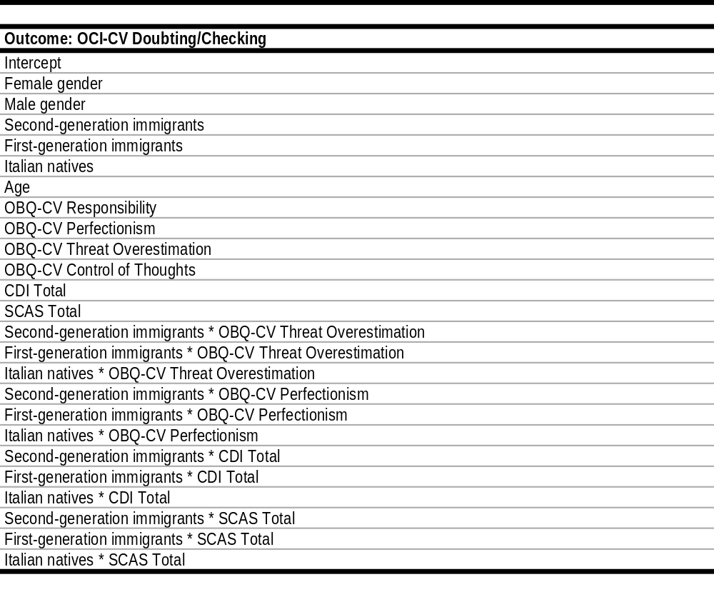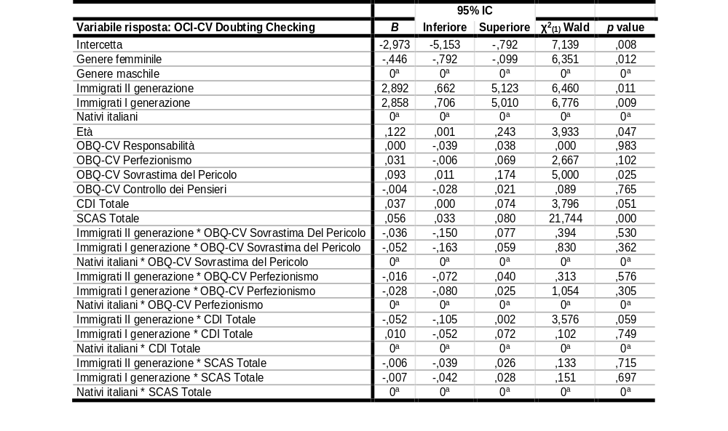
95% CI
Lower Upper
Note. CDI = Children’s Depression Inventory. OBQ-CV = Obsessive Belief Questionnaire-Child Version. OCI-CV = Obsessive Compulsive Inventory-Child Version. SCAS = Spence’s Children Anxiety Scale.

Table 4. Effects of immigrant status on obsessing.
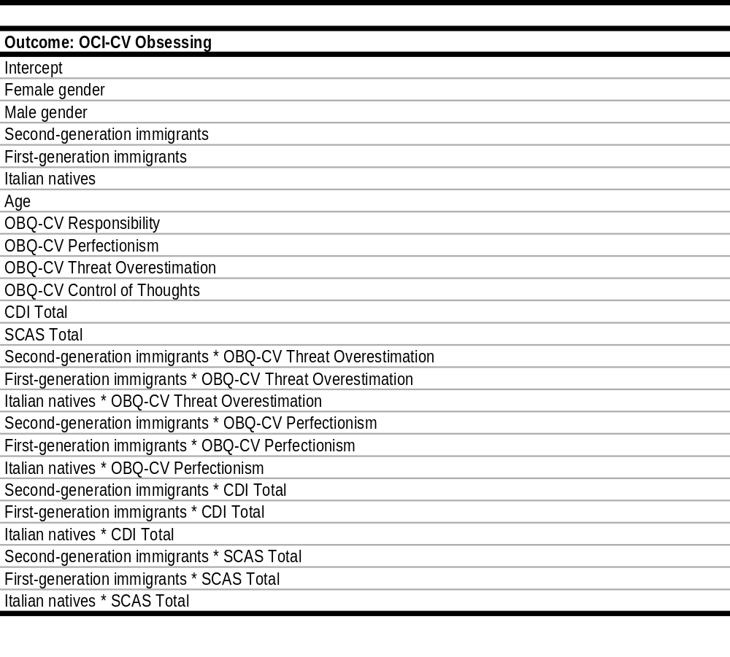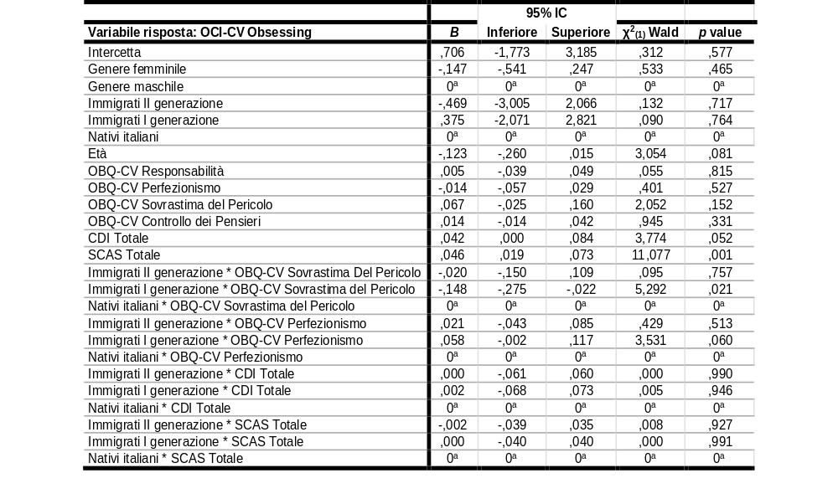
Lower Upper
Note. CDI = Children’s Depression Inventory. OBQ-CV = Obsessive Belief Questionnaire-Child Version. OCI-CV = Obsessive Compulsive Inventory-Child Version. SCAS = Spence’s Children Anxiety Scale.

Table 5. Effects of immigrant status on hoarding.
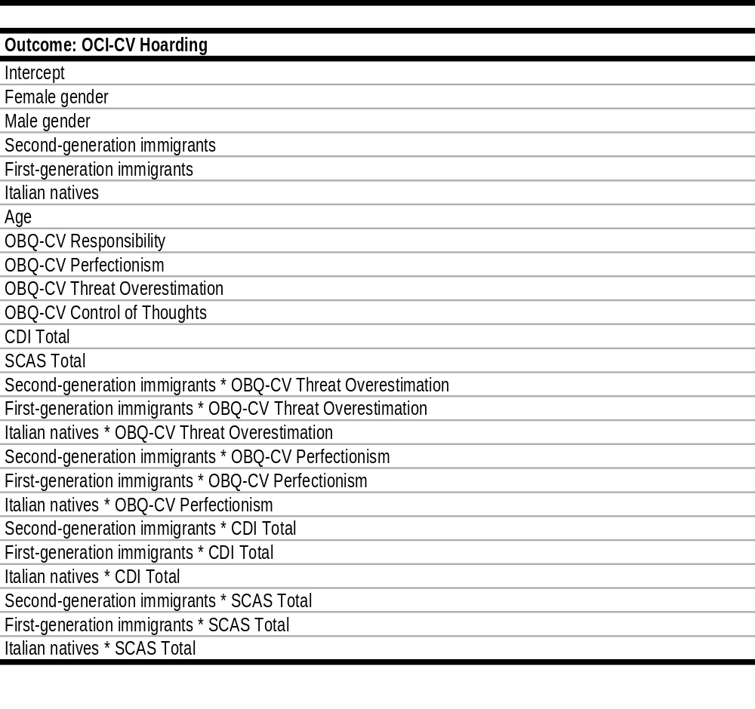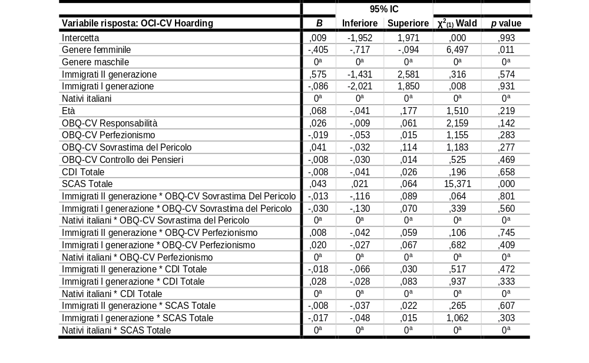
Lower Upper
Note. CDI = Children’s Depression Inventory. OBQ-CV = Obsessive Belief Questionnaire-Child Version. OCI-CV = Obsessive Compulsive Inventory-Child Version. SCAS = Spence’s Children Anxiety Scale.

Table 6. Effects of immigrant status on washing.
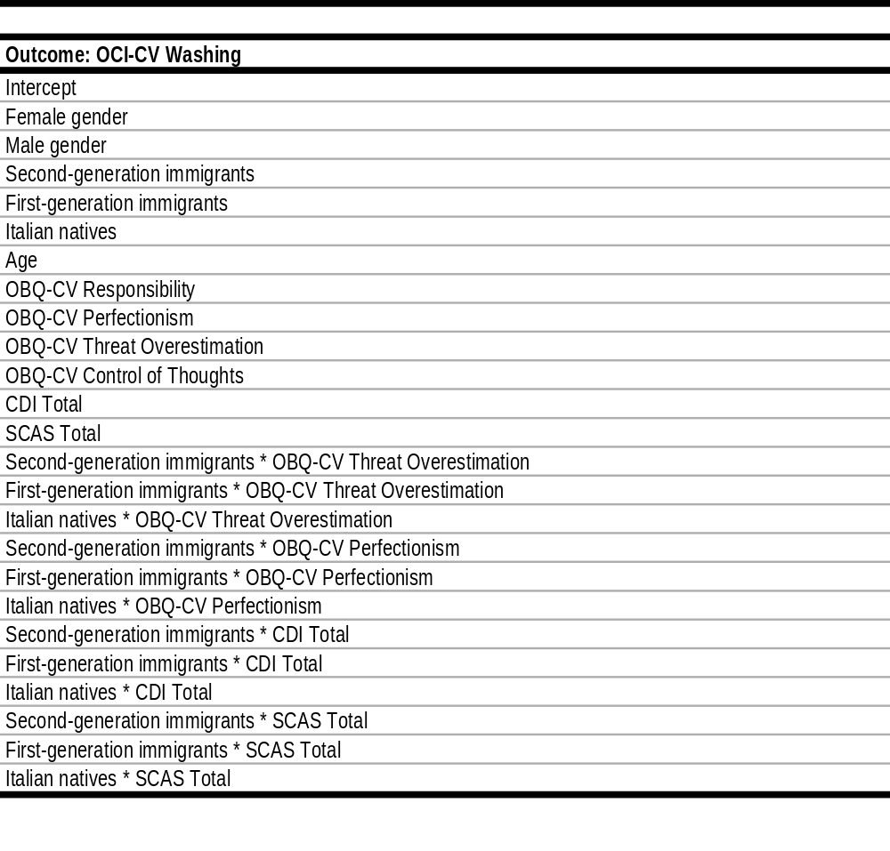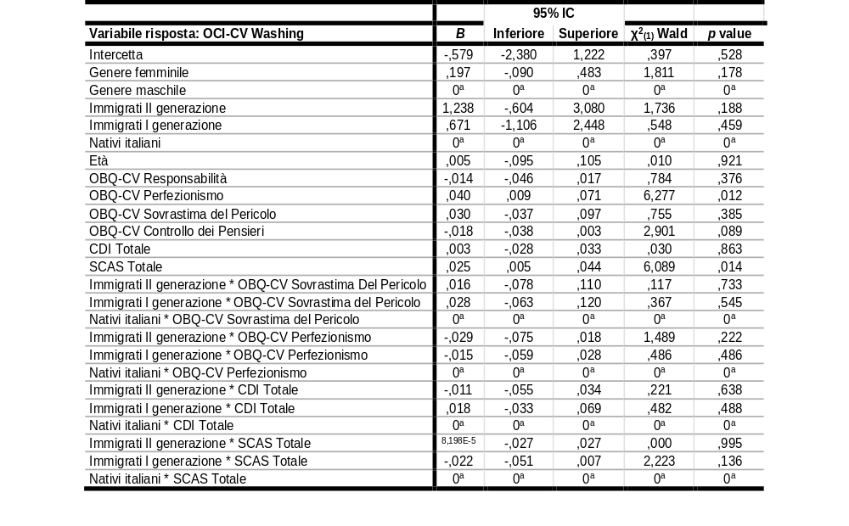
Lower Upper
Note. CDI = Children’s Depression Inventory. OBQ-CV = Obsessive Belief Questionnaire-Child Version. OCI-CV = Obsessive Compulsive Inventory-Child Version. SCAS = Spence’s Children Anxiety Scale.

Table 7. Effects of immigrant status on ordering.
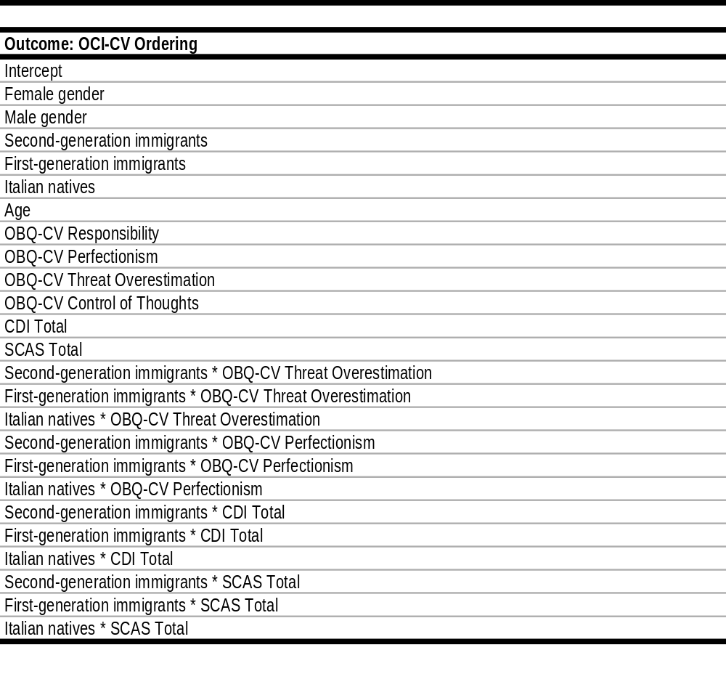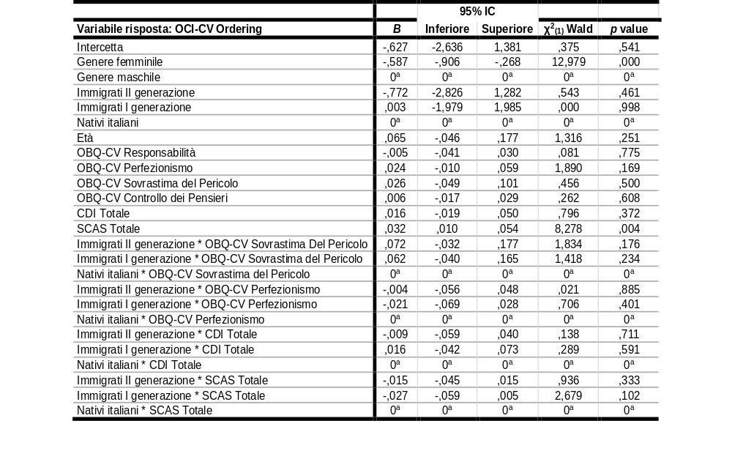
Lower Upper
Note. CDI = Children’s Depression Inventory. OBQ-CV = Obsessive Belief Questionnaire-Child Version. OCI-CV = Obsessive Compulsive Inventory-Child Version. SCAS = Spence’s Children Anxiety Scale.

Table 8. Effects of immigrant status on mental neutralizing.
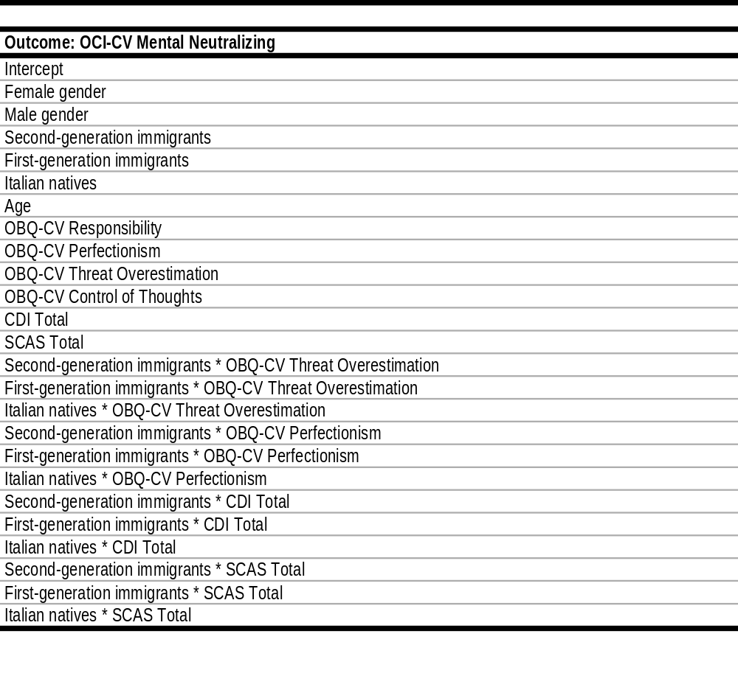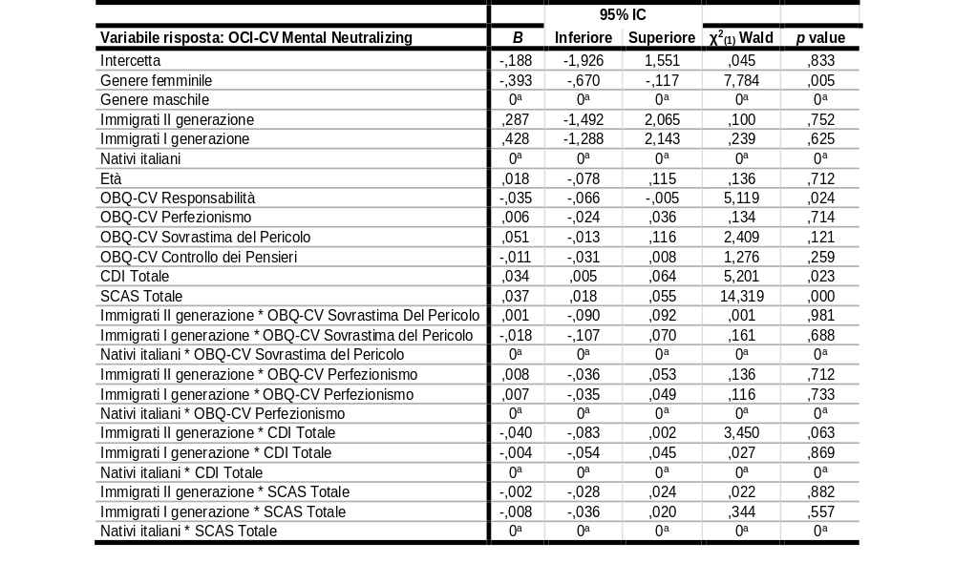
Lower Upper
Note. CDI = Children’s Depression Inventory. OBQ-CV = Obsessive Belief Questionnaire-Child Version. OCI-CV = Obsessive Compulsive Inventory-Child Version. SCAS = Spence’s Children Anxiety Scale.

