A novel Corchorus olitorius-derived biochar/Bi₁₂O₁₇Cl₂ photocatalyst for decontamination of antibiotic wastewater containing tetracycline under natural visible light

Mahmoud Samy¹, Mohamed Gar Alalm¹, Ribh S. abodlal², Ali El-Dissouky², Mohamed N. Khalil³, Ehab R El-Helow⁴, Tarek El-Sayed Khalil², Ahmed Tawfik³©
¹Department of Public Works Engineering, Faculty of Engineering, Mansoura University, Mansoura 35516, Egypt
²Chemistry Department, Faculty of Science, Alexandria University, Alexandria, Egypt
³Water Pollution Research Department, National Research, Centre, P.O. Box 12622, Giza, Egypt
⁴Department of Botany and Microbiology, Faculty of Science, Alexandria University,

The 1st, 3rd and 8th author is equally contributed

Supplementary Information

Text S1:
The photo-oxidation of TC was performed using the reactor in Fig. S1 that was constructed in Alexandria, Egypt (Latitude 30°52’, Longitude 29°35’). The polluted solution with a volume of 2.2 L was recirculated passing through six borosilicate tubes (diameter = 2.54 cm, length = 75 cm and area = 0.36 m²) via a pump. The tubes were fixed on a curved aluminum reflector with a radii of 9.2 cm with an inclination angle of 30° to utilize the largest portion of solar light and the presence of aluminum reflector confirms the illumination of the total area of the tubes by solar light. The tubes are made of borosilicate, and they are transparent to allow the passage of UV and visible light. The first 30 min of the reaction were performed without light (Dark) to achieve equilibrium of the adsorbed pollutant molecules on the catalyst’s surface. Normalization of the illumination time in all experiments to UV intensity of 30 w/m² was conducted according to eqs. (1, 2)
$$t_{30w,n}= t_{30w,n-1}+ {∆t}_{n}\left(\frac{UV}{30}\right)\left(\frac{V_{i}}{V_{t}}\right) (1)$$
${ ∆t}_{n}= t_{n}-t_{n-1} (2)$
where t_{n}: the experimental reaction time; UV: the average solar ultraviolet radiation (W/m²) during a period of ∆t_{n} , t_{30w}: the normalized illumination time which refers to a constant solar UV power of 30 W/m² (typical solar UV power on a perfectly sunny day around noon), V_{t}: the total reactor volume and V_{i}: the total irradiated volume.
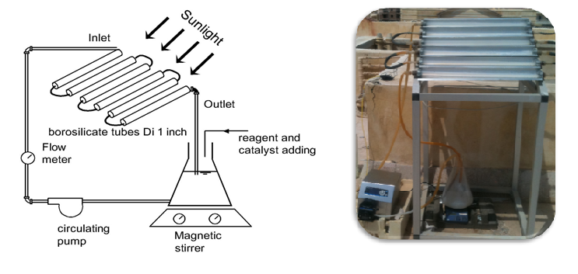
Fig. S1. Details of the photoreactor.
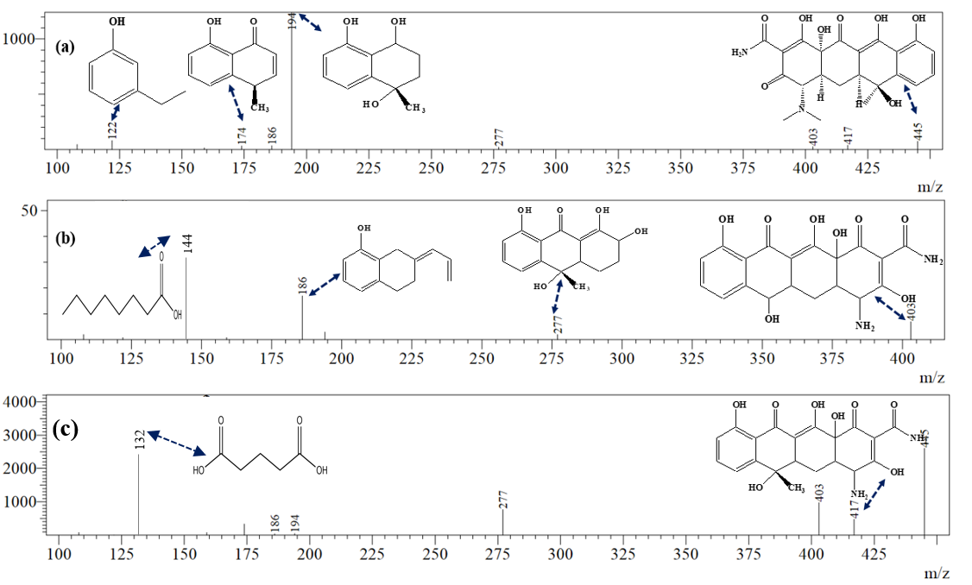

Fig. S2. m/z signal peaks of the generated by-products.

© Corresponding author: Ahmed Tawfik (prof.tawfik.nrc@gmail.com)

