Supplementary
Figure 1: STROBE diagram describing selection of sample and imputed sample.
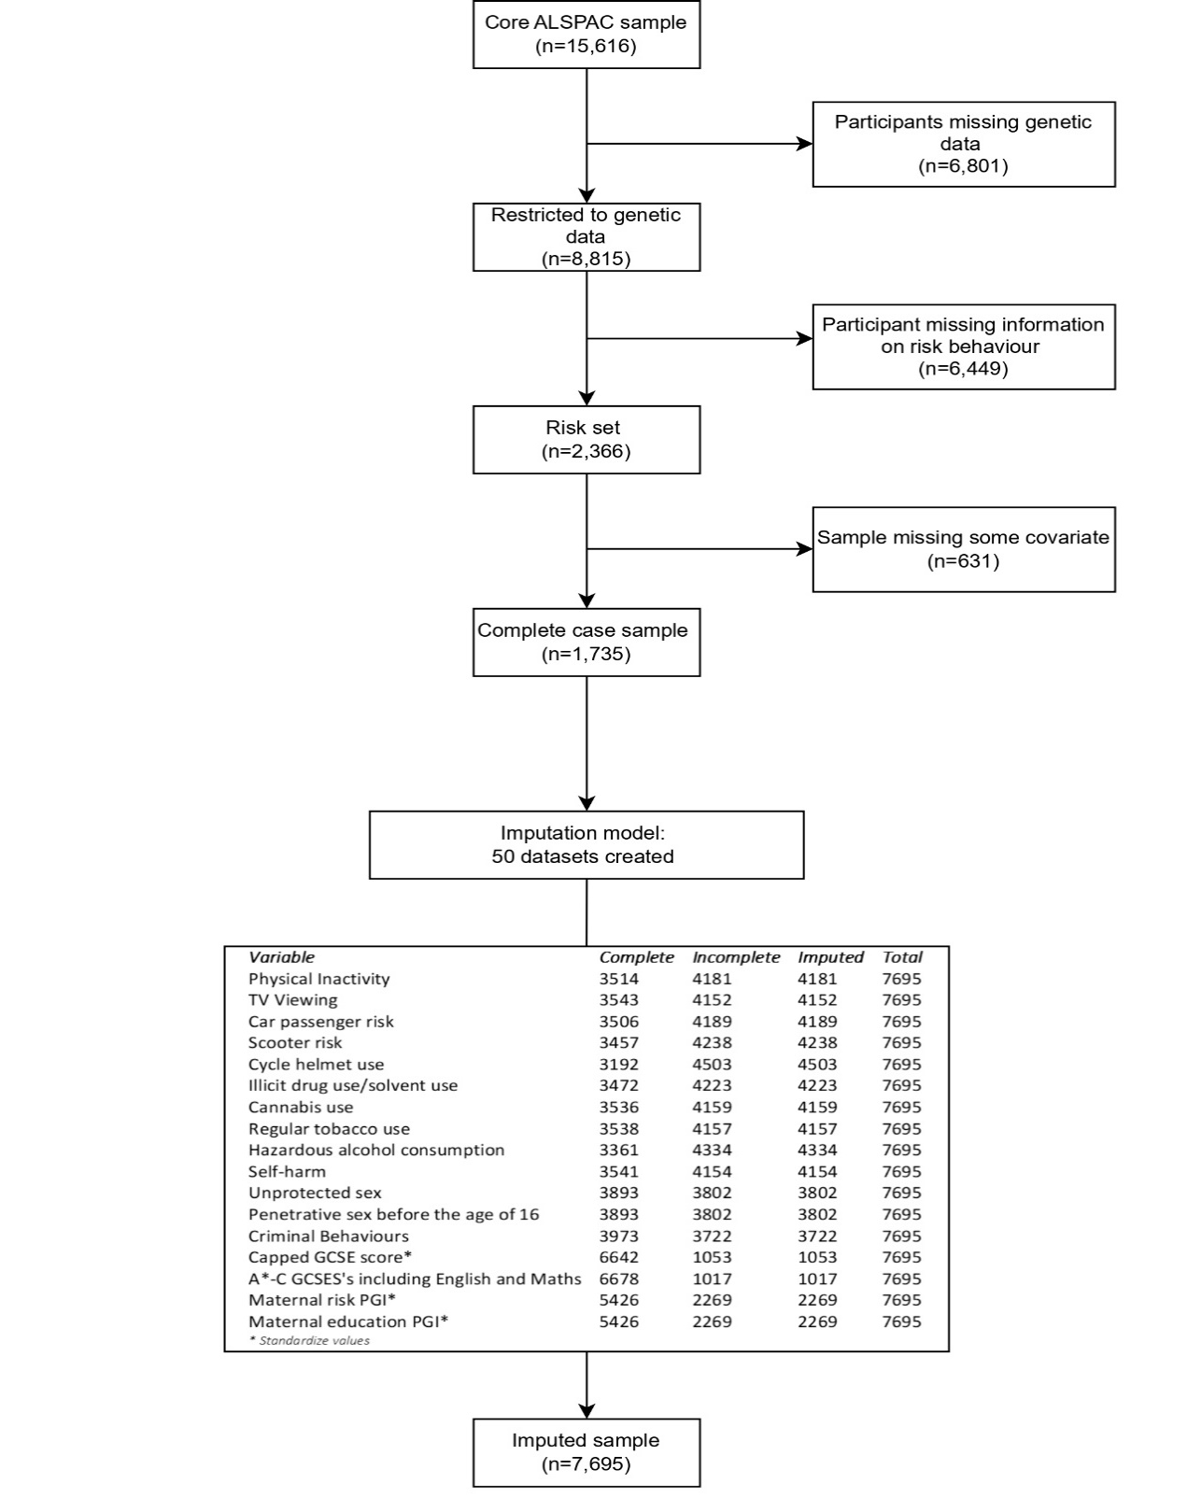

Table 1: Descriptive statistics for MRBs in complete case sample.
Multiple Risk Behaviours (MRBs) | n |  | % Engaging
Physical Inactivity | 3556 |  | 74%
TV Viewing | 3584 |  | 21%
Car passenger risk | 3547 |  | 30%
Scooter risk | 3497 |  | 20%
Cycle helmet use | 3227 |  | 24%
Illicit drug use/solvent use | 3512 |  | 8%
Cannabis use | 3578 |  | 10%
Regular tobacco use | 3579 |  | 12%
Hazardous alcohol consumption | 3399 |  | 36%
Self-harm | 3582 |  | 19%
Penetrative sex before the age of 16 | 3933 |  | 17%
Unprotected sex | 3933 |  | 3%
Criminal Behaviours | 4017 |  | 47%

Table 2: Comparison of observed characteristics between participants in the complete dataset (N=1,735) and incomplete dataset (N=15,616)
 |  | Complete dataset  N=1,735 |  | Incomplete dataset  N=15,616 |  | Test for difference
Continuous variables | Mean |  | Mean |  | T-test
MRB Index | 3.18 |  | 3.17 |  | -0.15
Capped GCSE score | 375.28 |  | 304.06 |  | -31.58
Maternal age | 29.72 |  | 27.71 |  | -16.95
Cognitive ability | 109.09 |  | 102.05 |  | -16.51
Categorical variables | % |  | % |  | Chi²
Achieved 5 or more A*- C GCSEs including English and maths |  |  |  |  | 739.55
No | 21.66 |  | 54.86
Yes | 78.34 |  | 45.14
Sex |  |  |  |  | 76.73
Male | 42.02 |  | 52.54
Female | 57.98 |  | 47.46
Maternal Education |  |  |  |  | 407.52
<O level | 13.86 |  | 33.18
O level | 34.22 |  | 34.72
A level | 30.92 |  | 20.75
Degree | 21.01 |  | 11.35
Housing Tenure |  |  |  |  | 343.38
Mortgage/owned | 89.94 |  | 70.28
Council rented | 3.90 |  | 16.20
Private/other rented | 6.15 |  | 13.52
Parent social class |  |  |  |  | 199.34
Professional | 19.06 |  | 12.10
Managerial and technical | 48.27 |  | 40.41
Skilled non-manual | 22.46 |  | 26.12
Skilled manual | 10.21 |  | 21.37

Table 3: Association of Capped GCSE score and score with an index of multiple risk behaviours, based on the complete case sample.
GCSE capped point score | Model 1  N = 2053 | Model 2  N=1879 |  | Model 3  N=1854 | Model 4  N=1736
 |  |  | 95% confidence intervals in brackets; p-values in parentheses.
MRB Index | -0.07 [-0.09, -0.05] | -0.06 [-0.07, -0.04] |  | -0.06 [-0.07, -0.04] | -0.06 [-0.07, -0.04]
Parental socioeconomic Position
Maternal Education ref: <O level
Sex ref: male
Housing tenure ref: Owned
Cognitive ability

A*-C GCSE's including English and Maths | Model 1  N=2053 | Model 2  N=1879 | Model 3  N=1854 | Model 4  N=1736
 | Exponentiated Coefficients. 95% confidence intervals in brackets; p-values in parentheses.
MRB Index | 0.86 [0.82, 0.91] | 0.87 [0.82, 0.91] | 0.83 [0.82, 0.92] | 0.86 [0.81, 0.91]
Parental socioeconomic Position
Maternal Education ref: <O level
Sex ref: male
Housing tenure ref: Owned
Cognitive ability
Table 4: Association of achieving five or more A*-C GCSE score with an index of multiple risk behaviours, based on the complete case sample.

Table 5: descriptive statistics for educational outcomes and exposure, MRB Index in complete case sample.
Variable | N | Mean | SD | Min | Max
Capped GCSE score | 6654 | 329.67 | 89.56 | 0 | 540
A*-C GCSES's including English and Maths | 6695 | 0.57 | 0.50 | 0 | 1
MRB Index | 2171 | 3.19 | 1.97 | 0 | 11

Table 6: Associations of probability of gaining 5 or more A*-C GCSEs including English and Maths with an index of multiple risk behaviours, based on imputed data (N=7,695)
A*-C GCSEs including English and Maths | Model 1 | Model 2 | Model 3 | Model 4
 | Exponentiated Coefficients. 95% confidence intervals in brackets; p-values in parentheses.
MRBS | 0.81 [0.78, 0.84] | 0.82[0.79, 0.86] | 0.83 [0.80, 0.86] | 0.81 [0.77, 0.84]
Parental socioeconomic Position
Maternal Education ref: <O level
Sex ref: male
Housing tenure ref: Owned
Cognitive ability

Figure 2: Association between the young person’s genetically instrumented multiple risk behaviours (MRB) index and the probability of gaining 5 or more A* - C GCSEs including English and Maths.
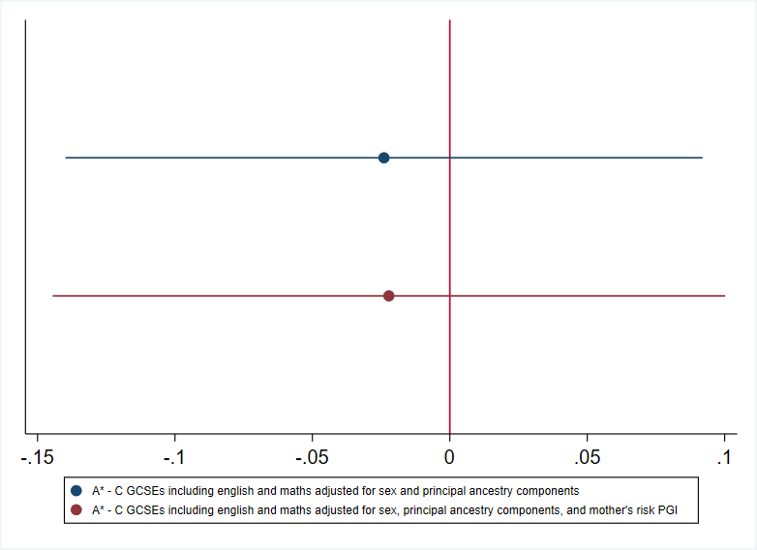

Figure 3: Association between the young person’s genetically-instrumented educational attainment (obtaining attaining five or more A*-C GCSEs including English and Maths), and their Multiple Risk Behaviours (MRB) Index.
