Supplementary Material:

1- Methods:

Modeling:
For modeling of the β₂AR-Gs^{GDP} and Gs^{GDP} initial structures, the coordinates of the Gs heterotrimer were extracted from the crystal structure of Gs^{GDP} (PDB-ID: 6EG8)¹⁶ and the coordinates of β₂AR were extracted from the β₂AR-T4L-GsαCT-CC (named β₂AR-α5-peptide complex) crystal structure (PDB-ID: 6E67)¹⁶. In the β₂AR, the C-terminus of TM5 and the N-terminus of TM6 was capped at K232 and F264, respectively. In Gs^{GDP}, C2, S2, A2 and L394, N341, C68 were capped at the N- and C-terminus in Gα, Gβ and Gγ subunits, respectively. The CHARMM-GUI builder⁵⁵ was used to model and embed the receptor into a pure 1-palmitoyl-2-oleyl-sn-glycero-3-phosphocholine (POPC) bilayer of approximately 150X150 Å². The palmitoyl group was added to β₂AR at C341 and N-palmitoyl was added to Gα, at G2, S-palmitoyl to Gα at C3, and S-geranylgeranyl to Gγ_{s} at C68. In both β₂AR and Gs^{GDP}, hydrogen atoms were added.
For the β₂AR-Gs^{GDP} simulations, the G protein was placed below the receptor with α5 in an orientation as the 14-mer-peptide derived from the C-terminus of α5, co-crystallized with the β₂AR (PDB id: 6E67)¹⁶. This way, binding of the two exposed α5 residues E392^{α5} and R389^{α5} of Gα to R131^{3.50} and D130^{3.49} of the receptor, establishing the key interactions of the β₂AR-α5-peptide structure, becomes possible even without the G protein having to make a major rotational movement. To provide sufficient space for structural adaptations that occur upon complex formation, in the initial model, the side chains of R389^{α5} and E392^{α5} were put at 23.5 and 15.0 Å away from the side chains of D130^{3.49} and R131^{3.50}, respectively. All residues were kept in their standard protonation states suggested by the CHARMM-GUI builder, except for Glu122, that was protonated⁵⁶. We started our simulations with the D130^{3.49}-R131^{3.50} ionic interaction preserved as in the crystal structure of the β₂AR complexed with a G-protein mimicking nanobody²⁸, in which the side chain of R131^{3.50} is held down toward the G protein by D130^{3.49}, to facilitate binding to the carboxyl-terminus L394^{α5} and the carboxy-group of E392^{α5}.
Simulation Setup:
Each system was solvated in a rectangular box of 150 Å side lengths for X and Y and 130 Å for Z with TIP3P water⁵⁷ and a concentration of 0.10 mol/l-1 Na+/Cl- ions. CHARMM36⁵⁸ and CHARMM36m⁵⁹ force fields were employed for lipids and proteins, respectively. The CgenFF⁶⁰ generalized force field was implemented to describe the β₂AR ligand BI-167107 (P0G). The β₂AR-Gs^{GDP} complex and Gs^{GDP} apo state contain about 300.000 and 180.000 atoms respectively. They were energy minimized with the steepest descents algorithm and 1000 kJ mol−1 nm−1 as the threshold. All systems were equilibrated with harmonic positional restraints applied to lipids and Cα atoms of the protein that were sequentially released in a series of equilibration steps. All non-biased simulations were performed using the Gromacs 2018.6 simulation package⁶¹. Our python-based analysis package (mdciao⁶²), VMD1.9⁶³, NGL⁶⁴ and MDsrv⁶⁵ were used to visualize/analyze all MD simulations. Production NPT simulations were performed at 310 K and 1 bar using the velocity-rescaling⁶⁶ thermostat and Parrinello-Rahman barostat⁶⁷ with a 2 fs integration time-step. Van der Waals interactions were gradually shifted to zero in the range between 10 to 12 Å. Long-range electrostatic interactions more than the cut-off value 12 Å were calculated using PME⁶⁸. Relevant hydrogen bonds lengths were constraint using the LINCS algorithm⁶⁹.
Analysis of the MD data
Analysis of the generated MD trajectories was carried out in several ways, principally via Python scripting in Jupyter Notebooks.
- Per-trajectory analysis: Selected residue-residue heavy-atom distances were computed and plotted using the MD analysis software mdciao⁶². These time-traces were then inspected individually, summarized as number of neighbors of a given residue at a given cutoff, or aggregated to number of residues participating in an interface. Interfaces are also represented with mdciao using so-called flareplots (or chord-diagrams) where the participation in the interface is broken down into the individual sub-domains of the β₂AR and the Gs^{GDP}. Further analysis (e.g. SASA, COM-distances) were carried out using MDTraj⁷⁰.
- Per-state analysis: Principal Component Analysis⁴³ ⁴⁴ as implemented in PyEMMA⁷¹ was used to analyze the movement of the α subunit of the Gs^{GDP} in both datasets β₂AR-Gs^{GDP} and Gs^{GDP}. First, all the geometries of the β₂AR-Gs^{GDP} dataset were aligned to the β₂AR at t=0, to be able to produce an average Gα structure. This average was then used as reference to align the geometries of the Gα of both the β₂AR-Gs^{GDP} and the Gs^{GDP} dataset, in which no β₂AR is present. Then, PCA was used on the Cartesian coordinates of the α-Carbon atoms of the Gα subunit of both datasets, yielding a common PC space in which global Gα motions can be mapped, regardless of whether the receptor is present or not. Both datasets appear plotted as a backdrop in the plane of the first two PCs in Extended Data Fig 3A-B. The Density Peak Algorithm⁷² was used to cluster the data.

Steered MD, Umbrella Sampling and Spawn Simulations
To estimate the energy needed for GDP dissociation from its binding pocket, we carried out (Table S 1) umbrella sampling⁷³ MD. The reaction coordinate, ξ, was chosen as the distance between the center of mass (COM) of the non-bridging oxygen atoms of α and β phosphate of GDP and the COM of Cα-atoms of the P-loop in Gs. For each PCA state, ξ was increased at a rate of .1 Å/ns from its original value (Table S 5) until 15 Å, considering the GDP dissociated from its original binding pocket at this distance. Then, to guarantee sampling in all relevant regions, geometries having ξ-values .05Å apart were selected. For each PCA state and ξ-value, called window, three independent 200-ns-long runs were generated, using a harmonic potential with a force constant of 1000 kJ.mol⁻¹Å⁻² to constrain ξ. Next, Weighted Histogram Analysis Method (WHAM)⁷⁴ was employed to connect separate windows to calculate the Potential-of-Mean-Force (PMF).
For moving ICL2 toward F376^{αs}, we used steered molecular dynamics⁷⁵. As a reaction coordinate, we selected the C_{α} atoms of F139^{ICL2}, F376^{αs}. Starting from the last frame of run 2 of the β₂AR-Gs^{GDP} simulations (Table S 1) we steered, at a rate of .1 Å/ns, the C_{α} atom of F139^{ICL2} toward F376^{α5} as close as 6 Å. In both cases, a harmonic potential with a force constant of 1000 kJ.mol⁻¹Å⁻² was used to steer the reaction coordinates. For the spawn simulations (Table S 1), we have selected two frames with a time-lag of 100 ns from 600 ns and 700 ns of run 2 of the β₂AR-Gs^{GDP} simulations for performing spawn simulations starting with random initial velocities. In the two selected snapshots, the TM6 is already kinked, allowing the carboxyl-terminus of α5 to climb the last rung of the lysine-ladder, and the ICL2 α5-β6 interface to form (Table S 1, Extended Data Fig 6B).
Radioligand competition binding for wt-β₂AR and mutants
The human β₂AR was cloned to pFastBac vector. The β₂AR mutants were generated by site-directed mutagenesis. The wt-β₂AR and mutants were then expressed in sf9 cells using the Bac-to-Bac expression system. Cell membrane preparation and DHA binding were performed as previously reported¹. In brief, 50 mL of cells expressing the appropriate receptor were harvested and resuspended with 8 mL lysis buffer (20 mM Tris, pH 7.5, 1 mM EDTA, supplemented with Protease Inhibitors). The cell lysate was then centrifuged at 800 rpm for 10 min. The membrane-containing supernatant was further centrifuged at 18,000 rpm for 30 min to collect the membrane pellets. The membrane pellets were resuspended with 1 mL binding buffer (20 mM Tris, pH 7.5, 100 mM NaCl, supplemented with Protease Inhibitors).
For the competition binding assay, 20 μL of the diluted membrane suspension was mixed with 10 μL of the cold ligand isoproterenol at various concentrations, then 20 μL of 10 nM [³H] DHA was added to the mixture, which was then diluted to a final volume of 100 μL using binding buffer (20 mM Tris, pH 7.5, 100 mM NaCl, 100 μM GTPγS and 0.5 mg/mL BSA) and added to a 96-well plate. The final comcentration of [³H] DHA is 2 nM. After incubation for 2 hours with constant shaking at 150 rpm, the membrane was collected by filtration using a Brandel 96-well harvester and washed for 3 times using ice-cold washing buffer (20 mM Tris, pH 7.5, 100 mM NaCl), and the membrane-containing filter paper was incubated with the solid scintillation mix for 5 min at 85 °C. Radioactivity was counted by Microbeta2 scintillation counter. Binding curves were fitted by GraphPad Prism 8.
cAMP assay of β₂AR WT and mutants
CRISPR/Cas9 edited triple knockout barr1/barr2/β₂AR HEK293A cells⁷⁶ were maintained in growth medium [D-MEM, Gibco 10566016; supplemented with 10% fetal bovine serum, Gibco 10270106; 1% sodium pyruvate, Gibco 11360039; 1% MEM non-essential amino acids, Gibco 11140068; and 1% penicillin–streptomycin Solution, Gibco 15140122] were transfected with the Epac1-based FRET cAMP biosensor cAMP biosensor as previously described⁷⁷. Following limited dilution cloning in growth medium containing 50 µg/ml zeocin, a single colony showing high fluorescence was picked and propagated and used for subsequent mutant testing.
β₂AR mutants (generated as described above) and wildtype (WT) receptors were subcloned into the mammalian expression vector pcDNA3.1(+)neo, and transfected into the cAMP biosensor cells essentially as described previously⁷⁸. In brief, cells were brought into suspension in growth medium at a density of 0.20 million cells/mL. For each 1 mL of cell suspension transfected, 3 µL FuGene6 (Promega E2692) in 57 µL OptiMEM (Gibco 51985) was incubated with a total of 1 µg expression vector DNA in 25 µL OptiMEM for 20 min at RT, before adding the mixture to the cell suspension. To obtain comparable surface expression levels of the WT and mutant receptors, the amount of DNA used for transfection for 1 mL cell suspension ranged from 0.03 to 0.8 µg and was supplemented with empty vector DNA to give a total amount of 1 µg DNA. Transfected cells were seeded at 100 µL pr. 96-well in a black poly-L-lysine coated 96-well plate (20.000 cells pr. well) and incubated for 48 hr before assaying. Prior to stimulation, cells were washed on 100 µL HBSS buffer (HBSS Gibco 14025, 20 mM HEPES pH 7.5, 1 mM CaCl2, 1 mM MgCl2, 0.1% BSA), and replaced with 50 µL HBSS buffer. To block b₁AR receptors 50 µL HBSS buffer containing CGP-12177 at a final concentration of 10 nM was added to each well, and after 15 min, ISO diluted to different concentrations in 50 µL HBSS buffer was added. The FRET ratio between CFP and YFP as a measure of cAMP formation was followed using an Envision plate reader.
The potency (EC₅₀) and maximal response (E_{max}) of ISO for the WT and each mutants was determined by non-linear regression after fitting the FRET ratio at 30 min as a function of the ISO concentration to a four-parameter logistic curve using GraphPad Prism.
Cell surface expression of β₂AR WT and mutants
Cell surface expression of WT and mutants was determined 48 hr after seeding the same transfected cells as above in white clear-bottom plates as described previously (PMID: 32732395). In brief, cells were washed once in DPBS, fixated with 4% paraformaldehyde in DPBS for 5 min, washed twice, blocked in 3% dry milk in DPBS for 30 min, and then incubated with anti-FLAG HRP-conjugated antibody in 3% dry milk in DPBS. Following washes of 4 times in 3% dry milk in DPBS and 4 times in DPBS, HRP substrate diluted in DPBS was added to enable quantification by measuring luminescence in an Envision Plate reader (Perkin Elmer). WT and mutant surface expression levels were calculated relative to the signal from an identically transfected FLAG-tagged WT condition.

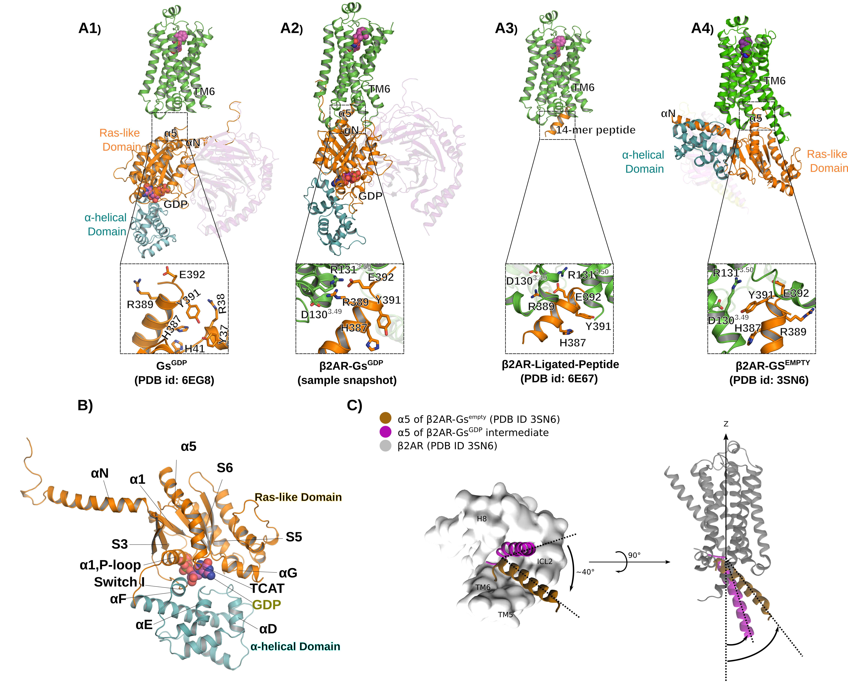
Extended Data Fig 1: Starting model and sample snapshots of the β₂AR-G_{s}^{GDP} simulations, together with overview of relevant crystal structures. A1) In the starting model, inactive Gs^{GDP} (PDB id: 6EG8) is placed below the receptor with α5 in an orientation as the 14-mer-peptide derived from the C-terminus of α5, co-crystallized with the β₂AR (PDB id: 6E67)¹⁶. Notably, Y391^{α5} and H387^{α5} that interact with the receptor in the crystal structure of β₂AR-Gs^{empty} (PDB id: 3SN6, inset A4) are still buried (inset A1), while E392^{α5} and R389^{α5} that bind to the receptor in β₂AR-Gs^{GDP} (inset A2) and in the β₂AR-α5-peptide complex¹⁶ (inset A3), are solvent exposed and ready to interact. To provide sufficient space for structural adaptations that occur upon complex formation, in the initial model, the side chains of R389^{α5} and E392^{α5} were put at 23.5 and 15.0 Å away from the side chains of D130^{3.49} and R131^{3.50}, respectively. A2) In the β₂AR-Gs^{GDP} complex, α5 adopts a similar orientation and binding mode as in the β₂AR-α5-peptide complex. A3) Crystal structure of the β₂AR-α5-peptide complex (PDB id: 6E67)¹⁶, without showing the stabilizing modifications. The minor deviations observed when comparing this complex with the β₂AR-Gs^{GDP} complex (inset A2), were expected, because of the stabilizing modifications of the β₂AR-α5-peptide complex. A4) In β₂AR-Gs^{empty} (PDB ID 3SN6) α5 binds differently to the receptor when compared to the previous complexes. The inset shows that Y391^{α5} and H387^{α5}, that are initially buried in Gs^{GDP} (inset A1), engage the receptor in the crystal structure of β₂AR-Gs^{empty}, while E392^{α5} and R389^{α5} that engage the receptor in the other two complexes, point away from the interface. B) G protein labels for subdomains as typically used in G-protein nomenclature (CGN²²). C) Different orientation of α5 (the remainder of the G protein is hidden) relative to the receptor in β₂AR-G_{s}^{GDP} when compared to β₂AR-G_{s}^{empty}. Top view of α5 from the cytoplasmic side reveals that α5 is rotated by ca. 40º when the two complexes are compared. The side view highlights the different binding angles of α5 relative to the membrane normal.

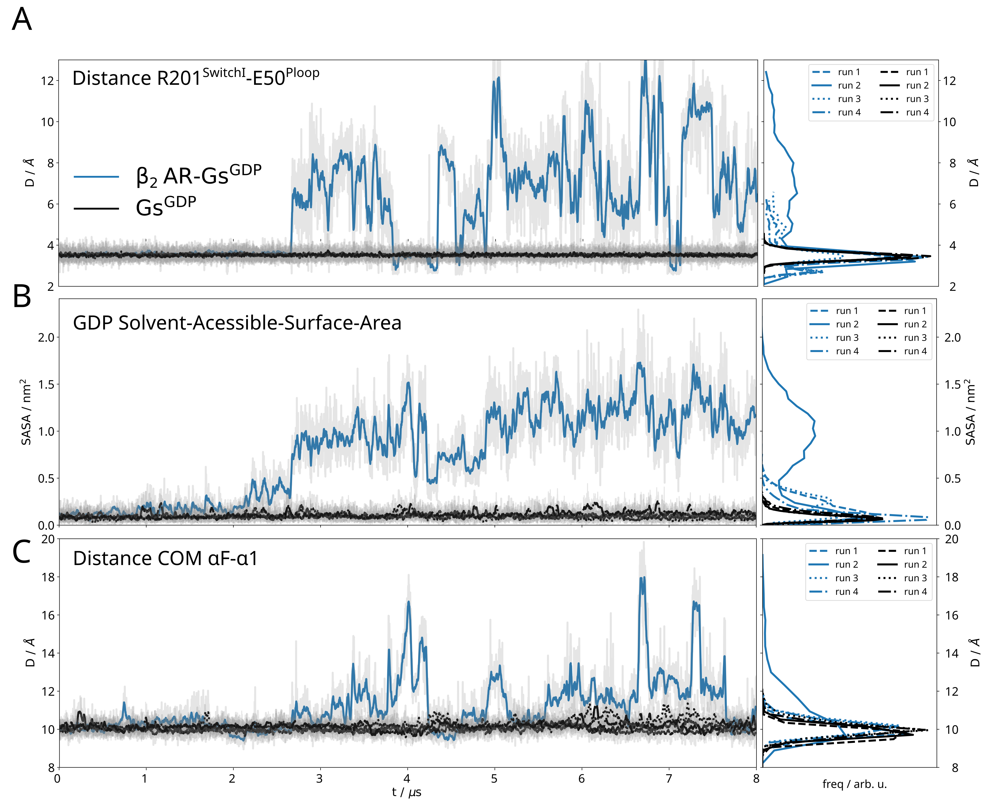

Extended Data Fig 2: Time-traces of selected parameters describing structural changes at the nucleotide binding pocket in the β₂AR-Gs^{GDP} simulations. As a reference, the same parameters are also shown for the Gs_{s}^{GDP} simulations. The panels on the left show the time-trace of run 2 of the β₂AR-Gs^{GDP} simulations (solid blue curve, example trajectory in Figure 2) and all runs of the Gs^{GDP} simulations (black curves, mostly invariant), whereas and the panel on the right shows the distributions for all runs of the β2AR-Gs^{GDP} and Gs^{GDP} simulations. A) R201^{SwitchI}-E50^{Ploop} residue-residue distance. All β₂AR-Gs^{GDP} simulations show increased fluctuations of this interaction compared with Gs^{GDP} simulations. B) Solvent-Accessible-Surface-Area, SASA, of GDP in the Gs nucleotide binding pocket. All β₂AR-Gs^{GDP} simulations show increased SASA compared with Gs^{GDP} simulations. C) Distance between the center of mass (COM) of the helices αF-α1, showing a clear increase only in run2 of the β₂AR-Gs^{GDP} simulations.

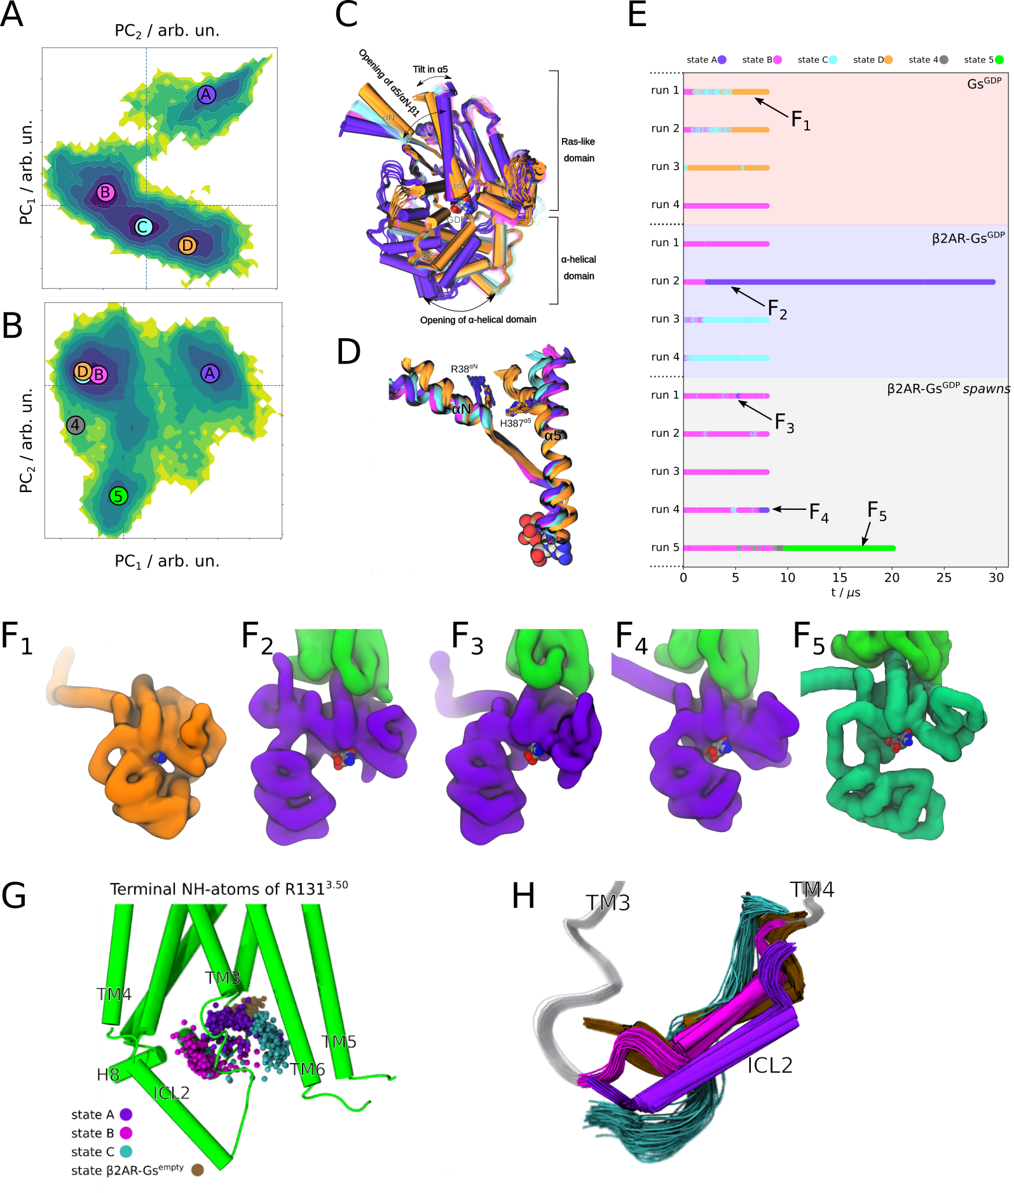
Extended Data Fig 3: Principal-Component-Analysis (PCA) of the pooled β₂AR-Gs^{GDP} and Gs^{GDP} simulation data reveals large scale conformational differences between individual PCA states. A) PCA of the β₂AR-Gs^{GDP} and of Gs^{GDP} simulations (Methods, Table S 1), clustered onto four main states, A, B, C, D, represented as circles overlaid on top of the 2D surface. In orange (bottom right) is the state that only appears in the Gs^{GDP} simulations, which displays the least αN-α5 opening (cf C, D). In purple (top right) is the state named β₂AR-Gs^{GDP} intermediate, in which we observe opening of the AHD. B) PCA of β₂AR-Gs^{GDP}, Gs^{GDP}, and β₂AR-Gs^{GDP} spawns simulations (Methods, Table S 1) in which two additional states (4 and 5) are visited. Please note that in B the x and y axes are swapped to visually conserve state A in the upper right corner of the 2D surface. C) Overlay of representative structures of the four of β₂AR-Gs^{GDP} states of panel A (same color-code as the circles) revealing differences in αN-α5 and in the AHD opening. D) Opening of the α5/αN-β1 scaffold upon formation of the β₂AR-Gs^{GDP} intermediate. Also highlighted is GDP (in VdW representation) at the base of the α5 helix. E) Color-coded time-traces of all trajectory data, mapping when each state is visited in each trajectory. The arrows indicate the timepoints from which the structures in F) origin. F1-F5) Left to right: representative structures for states D, A (three times) and 5, respectively, captured from the trajectories and frames indicated by the arrows of E). The opening of the Ras-AHD exposing the Gs^{GDP} binding pocket can be appreciated in F2-F5. However, whereas both β₂AR-Gs^{GDP} intermediates A (F2-F4) and 5 (F5) display large Ras-AHD openings, the way in which they open differs. G) Per-state, color-coded point-clouds of the terminal NH atoms of R131^{3.50} of the ionic-lock. H) Per-state, color-coded helical propensity of the ICL2, showing that it is most folded in the β₂AR-Gs^{GDP} intermediate.

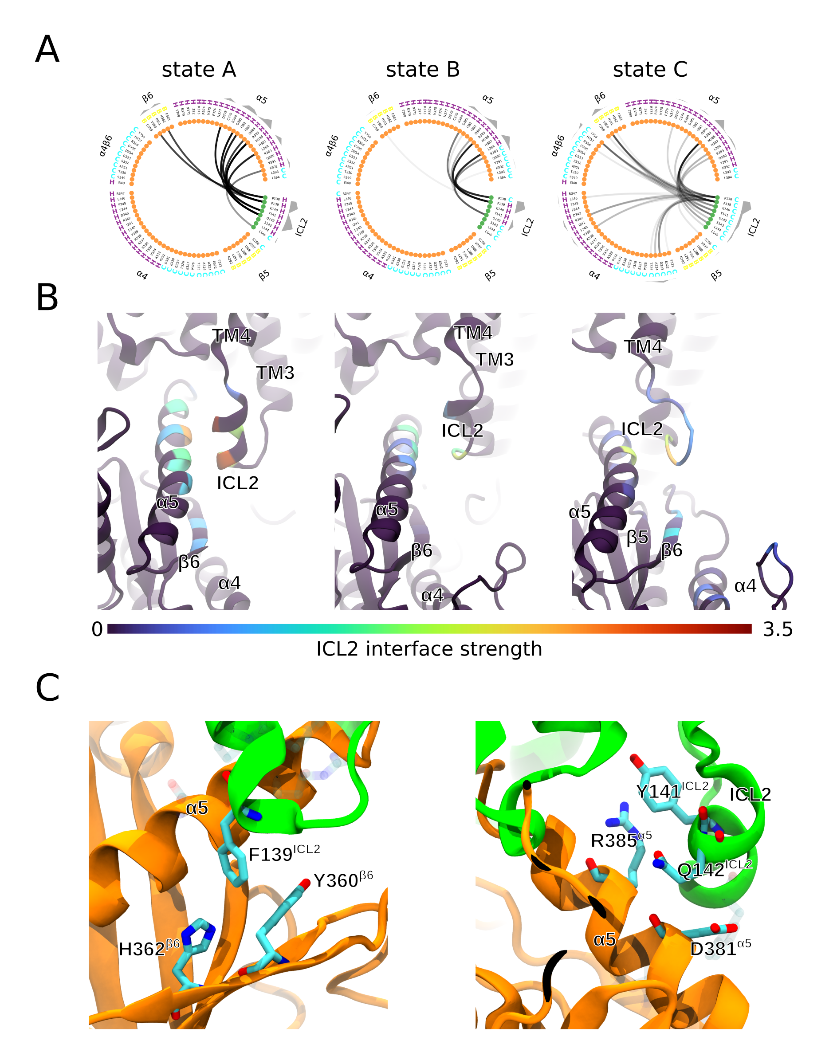
Extended Data Fig 4: Interface between ICL2 and Gs, for the PCA states A (β₂AR-Gs^{GDP} intermediate), B, and C (connecting states). A) Residue-residue contact frequencies (interaction cutoff 4Å) shown as circular flareplots. Residues are represented as dots in a circle and residue-residue contacts as black lines connecting them. The opacity of the line indicates the contact frequency. Moreover, each residue’s secondary structure is displayed with a letter (Helix, Beta-sheet, Coil) next to each dot. Finally, the sum of interactions (interface strength) for each residue is indicated in the outer gray ring, making it easier to locate where the interactions are concentrated, e.g. in the central region of α5 in state A, the β₂AR-Gs^{GDP} intermediate. B) Representative structures of states A, B, and C with the interface strength (sum of contact-frequencies per residue) overlaid as a heatmap. ICL2 engages the most with the middle part of α5 and β6 in state A (the β₂AR-Gs^{GDP} intermediate, on the left). C) Detailed view of the residue-residue interactions at the ICL2 α5/β6 interface in state A (the β₂AR-Gs^{GDP} intermediate).
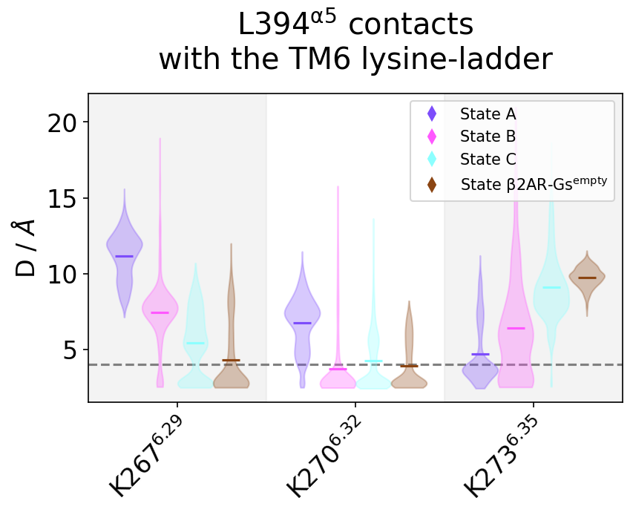
Extended Data Fig 5: Per-state violin-plots for the distance-distributions for the L394^{α5} with the TM6 lysine ladder K267^{6.29}, K270^{6.32}, and K273^{6.35}. K273 (bottom right), which lies deepest in the G protein binding pocket of the receptor, has the most contact for state A, the β₂AR-Gs^{GDP} intermediate, whereas there is none in β₂AR-Gs^{empty}.

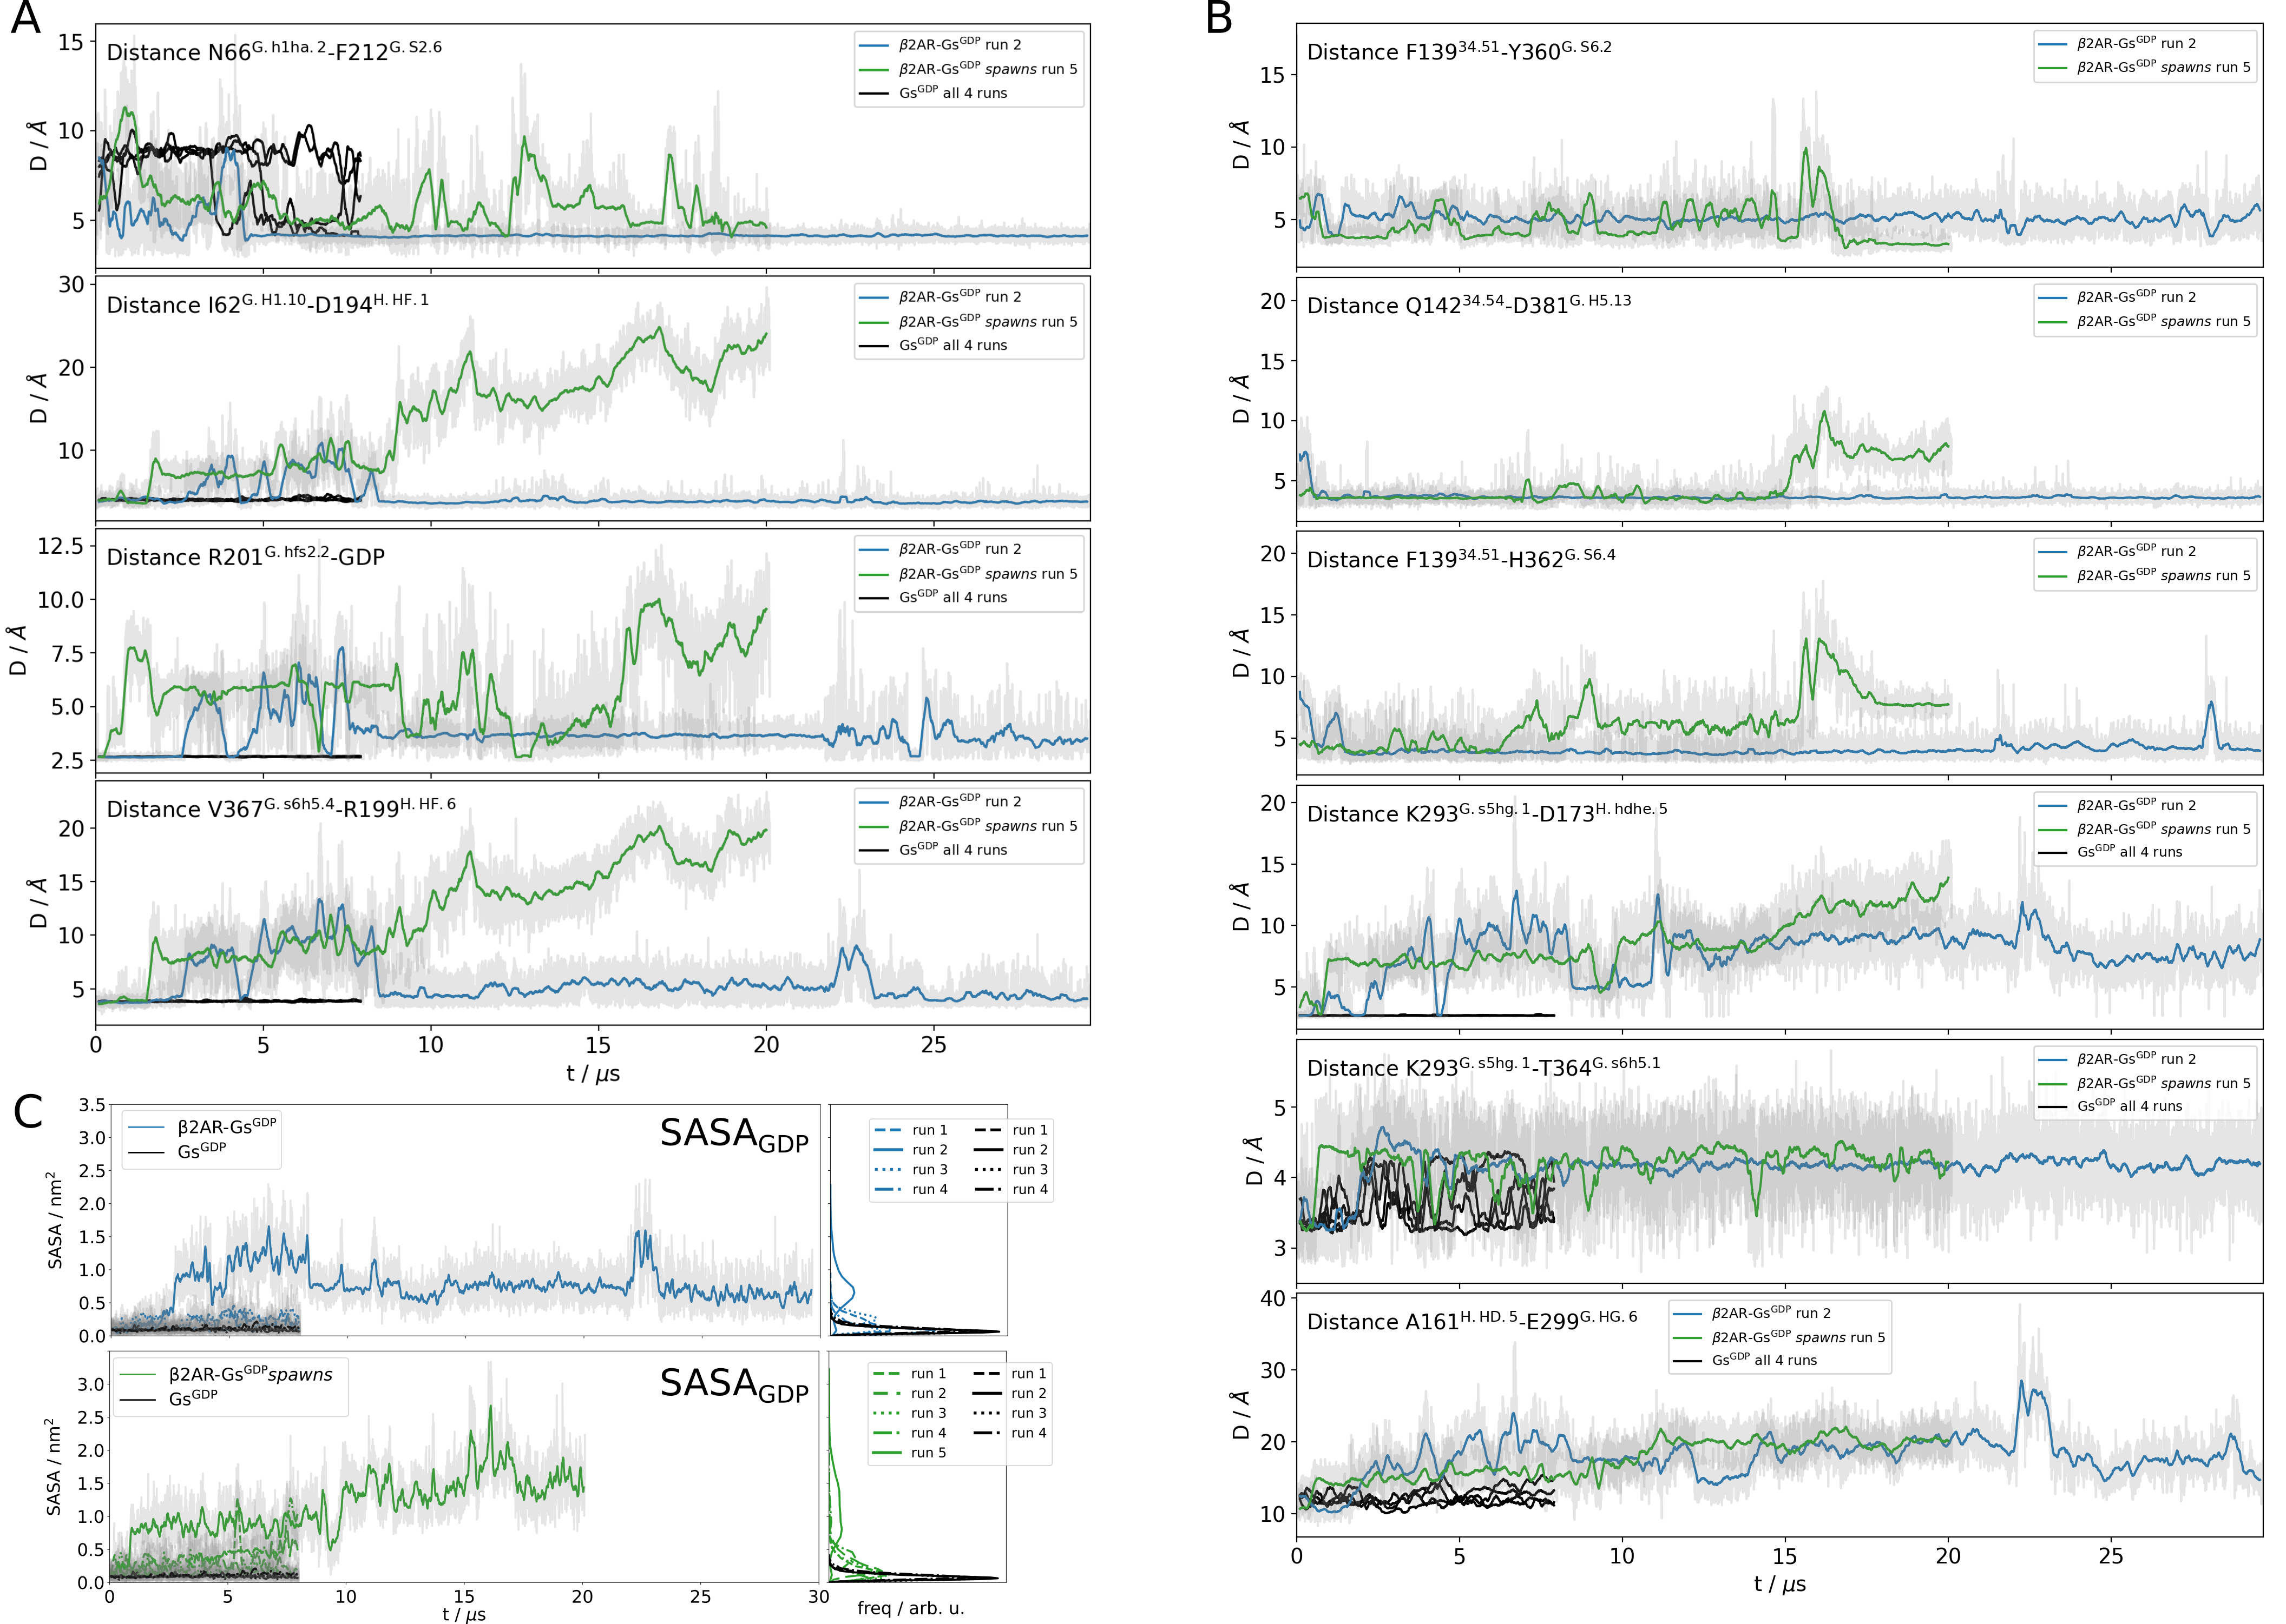
Extended Data Fig 6: Time-traces of selected parameters related to signal transfer (Extended Data Fig 7) for simulation runs of the β₂AR-Gs^{GDP} (run 2, blue), the β₂AR-Gs^{GDP}spawns (run 5, green) and all runs of the Gs^{GDP} simulations (black). A) Residue-residue distances involved in the suggested path 1 (Extended Data Fig 7), where a shift of F212^{β2} toward α1 leads breakage of αF-α1, switchI-GDP and TCAT (β6-α5 loop)-αF interactions (residues are tagged with their CGN-labels²²). B) Residue-residue distances involved in the suggested path 2, where ICL2 interacts with the middle of α5 and β6 (first three rows), leading to the displacement of αG (second three panels). Traces have been smoothed using a moving window of 100 ns, with the raw data shown as a gray backdrop for the blue and green (the backdrop of the black lines has been left out for clarity).C) Solvent-Accessible-Surface-Area, SASA (in nm²) of GDP for all runs of all simulations. The panels on the left show the SASA time-traces for all trajectories, while the panels on the right show the per-trajectory SASA distributions. Both in the time-traces and in the distributions, we see increased SASA when β₂AR is present. Moreover, we see sharp increases when the simulation enters the β₂AR-Gs^{GDP} intermediate state A (solid blue line, ca. 2 µs) and an even larger increase when entering the β₂AR-Gs^{GDP} intermediate state 5 (solid green line, ca 10 µs) (see Extended Data Fig 3E for state time traces).
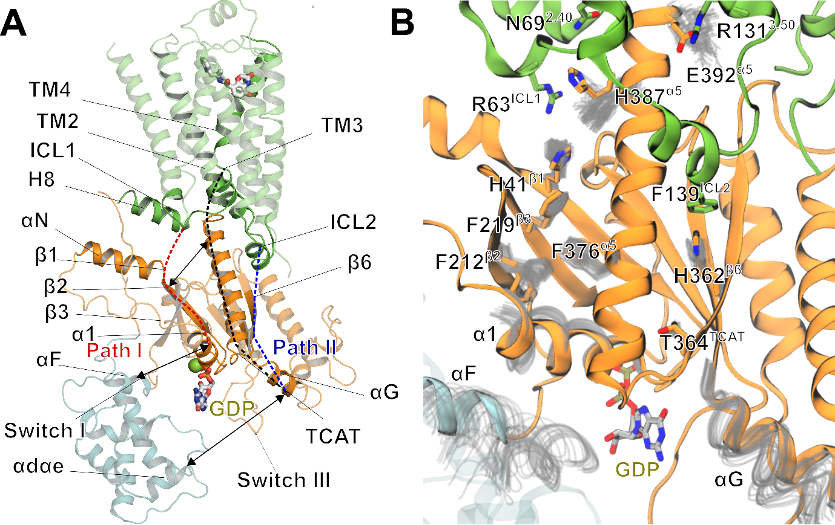
Extended Data Fig 7: Signal transfer from β₂AR to Gs^{GDP} A) Scheme of two putative signal transfer paths from the receptor to the nucleotide-binding pocket, centered at α5. B) Overlay of trajectory snapshots visualizing path 1. R63^{ICL1} interposes between the H387^{α5}-H41^{β1} π-π stacking interaction, distorting a network of aromatic residues of H41^{β1}, F212^{β2}, F219^{β3} and F376 ^{α5} that stabilizes the α5/αN-β1 scaffold in inactive Gs^{GDP}. Opening of the α5 and the αN-β1 junction, proposed to initiate GDP release¹⁰, allows F212^{β2} to make new contacts with α1 through a rotamer switch that attracts α1 (Extended Data Fig 6A). The α1 rearrangement distorts the α1-αF interaction breaking the contacts of αF with the TCAT motif (Extended Data Fig 6A). Since α1 and αF, via SwitchI, contact the α- and β-phosphate, mobilization of α1 and αF leads to destabilization of GDP. Path 2 arises from π-π interactions of F139^{ICL2} mainly with H362^{β6} (Extended Data Fig 4C, Extended Data Fig 6B), which is associated with breakage of a backbone hydrogen bonding interaction of the neighboring T364^{TCAT} with K293^{β5-αG}. The loss of the K293^{β5-αG}-D173^{αD-αE} lock (Extended Data Fig 6B) and of the K293^{β5-αG}-GDP interaction eventually mobilizes αG (Extended Data Fig 6), releasing the AHD from the Ras domain. Notably, the TCAT motif is affected by both pathways, suggesting that simultaneous activation of the pathways eventually breaks all initial interactions of the α-phosphate, the pentose sugar ribose, and some β-phosphate interactions to form the β₂AR-Gs^{GDP} intermediate (Figure 4C, Table S 6)²² ⁴⁰.

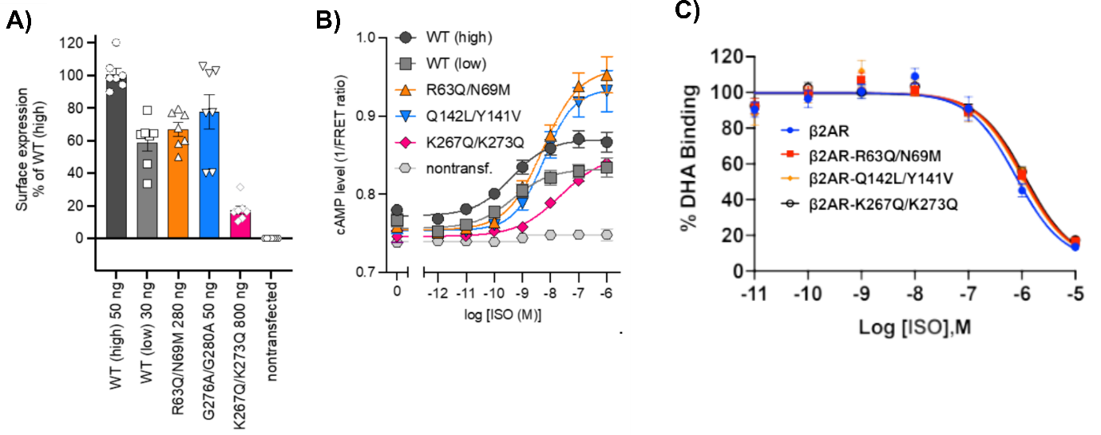
Extended Data Fig 8: Site-directed mutagenesis of residues participating in the β₂AR-Gs^{GDP} interface. A) Cell surface expression of FLAG-tagged WT β₂AR and mutants. The amount of transfected DNA was varied to obtain a similar surface expression level WT and mutants. FLAG-tagged WT β₂AR was expressed at two different levels. It was not possible to increase expression level of the K267Q/K273Q by increasing the DNA transfected further. Data are shown from n=7 independent experiments. B) Concentration response curves of cellular cAMP levels following 30 min stimulation with isoproterenol. CRISPR/Cas9 edited triple knockout barr1/barr2/β2AR HEK293A cells were transfected with FLAG-tagged WT β2AR or mutants. Data shown are from n=7 independent experiments. C) The β₂AR mutants show similar affinities towards the agonist isoprenaline compared to the wt β₂AR

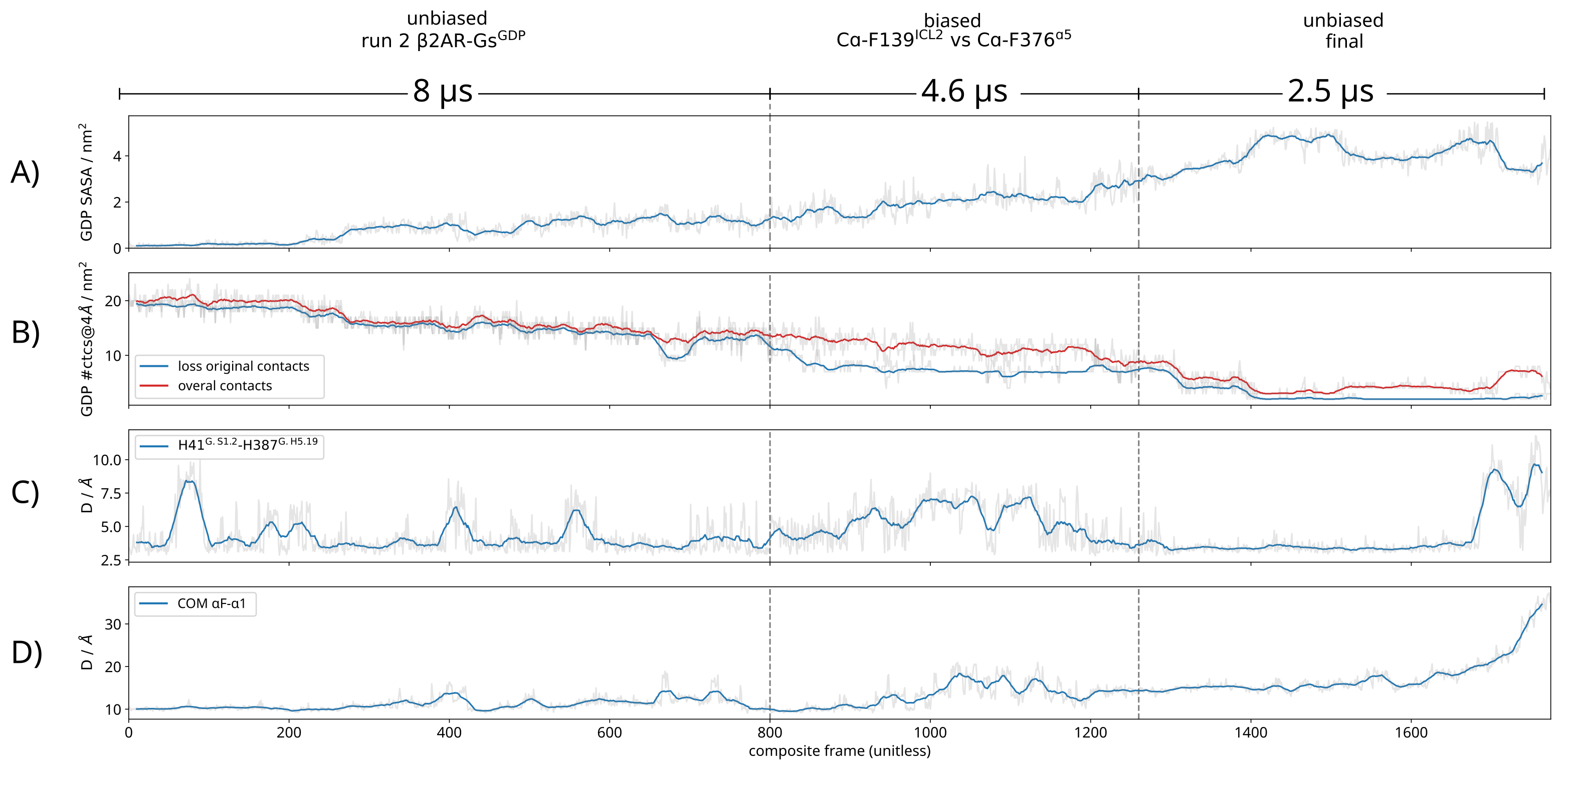
Extended Data Fig 9: Time-traces for selected parameters of a composite trajectory leading to GDP release. The composite trajectory consists of the most reactive run of the β₂AR-Gs^{GDP} simulations followed by a 4.5 µs biased simulation, followed by 2.5 µs unbiased simulation (Methods, Table S 1, movie 5). A) Increasing Solvent-Accessible-Surface-Area (SASA, in nm²) of GDP in the Gs^{GDP} nucleotide binding pocket. B) Decreasing number of GDP contacts (interaction cutoff is 4 Å). C) αN-α5 opening as tracked by the H41^{αN}-H387^{α5} interaction. D) αF-α1 distance, as tracked by the distance between their respective center of masses (COMs).

β2AR-Gs^{GDP}
replica/run | length / µs | prolonged | starting conformation | ref | receptor present | receptor ligand | nucleotide | bias
1 | 8 | no | - β2AR from PDB ID 6E67  - Gs from PDB ID 6EG8,  oriented as in 6E67 | this work | yes | BI-167107 | GDP | unbiased
2 | 32 | yes
3 | 8 | no
4 | 8 | no
Gs^{GDP}
replica/run | length / µs | prolonged | starting conformation | ref | receptor present | receptor ligand | nucleotide | bias
1 | 8 | no | PDB ID 6EG8 | this work | no | none | GDP | unbiased
2 | 8 | no
3 | 8 | no
4 | 8 | no
β2AR-Gs^{GDP} spawns
replica/run | length / µs | prolonged | starting conformation | ref | receptor present | receptor ligand | nucleotide | bias
1 | 8 | no | frame 700 ns of run 2 β2AR-Gs^{GDP} I | this work | yes | BI-167107 | GDP | unbiased
2 | 8 | no
3 | 8 | no
4 | 8 | no
5 | 20 | yes | frame 600 ns of run 2 β2AR-Gs^{GDP} I
β2AR-Gs^{GDP} biased
replica/run | length / µs | prolonged | starting conformation | ref | receptor present | receptor ligand | nucleotide | bias
1 | 4,6 | no | frame 8000 ns of run 2 of β2AR-Gs^{GDP} I | this work | yes | BI-167107 | GDP | yes  Cα-F139^{ICL2} vs. Cα-F376^{α5}
2 | 2,5 | no | last frame run 1 of β2AR-Gs^{GDP} III,  i.e. continuation of the row above | this work | yes | BI-167107 | GDP | unbiased
β2AR-Gs^{empty}
replica/run | length / µs | prolonged | starting conformation | ref | receptor present | receptor ligand | nucleotide | bias
1 | 3 | no | PDB ID 3SN6 | [45] | yes | BI-167107 | none | unbiased
2 | 3 | no
3 | 3 | no

Table S 1: Overview of all the MD simulations generated and used in this work.

A)
Average number of interface contacts (<4.0 Ang) per-residue
β2AR-Gs^{GDP} simulations |  |  |  |  |  | β2AR-Gs^{empty} simulations
β2AR residue | ctcs |  | Gs^{GDP} residue | ctcs |  | β2AR residue | ctcs |  | Gs^{empty} residue | ctcs
F139@34.51 | 2,1 |  | Y391@G.H5.23 | 2,8 |  | F139@34.51 | 4,4 |  | L393@G.H5.25 | 3,6
R63@12.49 | 1,6 |  | L394@G.H5.26 | 2,3 |  | Q229@5.68 | 3,7 |  | Q384@G.H5.16 | 3,3
R131@3.50 | 1,4 |  | L393@G.H5.25 | 2,1 |  | I135@3.54 | 3,2 |  | Y391@G.H5.23 | 3,0
P138@34.50 | 1,3 |  | R385@G.H5.17 | 1,9 |  | R239@ICL3 | 2,8 |  | R385@G.H5.17 | 2,6
F264@6.26 | 1,3 |  | E392@G.H5.24 | 1,7 |  | T274@6.36 | 2,1 |  | R380@G.H5.12 | 2,5
I334@8.52 | 1,3 |  | R356@G.h4s6.12 | 1,6 |  | P138@34.50 | 2,0 |  | L394@G.H5.26 | 2,5
Q142@34.54 | 1,1 |  | R38@G.hns1.2 | 1,5 |  | I233@5.72 | 1,9 |  | L388@G.H5.20 | 2,4
K270@6.32 | 1,1 |  | R389@G.H5.21 | 1,4 |  | K232@5.71 | 1,6 |  | E392@G.H5.24 | 2,3
K267@6.29 | 1,1 |  | L388@G.H5.20 | 1,3 |  | A134@3.53 | 1,6 |  | H387@G.H5.19 | 2,0
Q229@5.68 | 1,1 |  | Y358@G.h4s6.20 | 1,0 |  | K267@6.29 | 1,4 |  | D381@G.H5.13 | 1,9
E338@8.56 | 1,1 |  | D354@G.h4s6.10 | 0,8 |  | K270@6.32 | 1,4 |  | I383@G.H5.15 | 1,4
K232@5.71 | 0,9 |  | Q35@G.HN.52 | 0,8 |  | S236@5.75 | 1,3 |  | L346@G.H4.26 | 1,1
D331@8.49 | 0,9 |  | G355@G.h4s6.11 | 0,6 |  | E225@5.64 | 1,2 |  | T350@G.h4s6.3 | 1,1
S329@8.47 | 0,8 |  | Y360@G.S6.2 | 0,6 |  | R131@3.50 | 0,9 |  | Y358@G.h4s6.20 | 1,0
L266@6.28 | 0,8 |  | Q390@G.H5.22 | 0,5 |  | E237@5.76 | 0,9 |  | R38@G.hns1.2 | 1,0
P330@8.48 | 0,7 |  | D381@G.H5.13 | 0,5 |  | A271@6.33 | 0,9 |  | F376@G.H5.8 | 0,9
T274@6.36 | 0,6 |  | T350@G.h4s6.3 | 0,5 |  | A226@5.65 | 0,9 |  | H41@G.S1.2 | 0,8
I135@3.54 | 0,6 |  | Q31@G.HN.48 | 0,5 |  | T136@3.55 | 0,9 |  | V217@G.S3.1 | 0,7
A271@6.33 | 0,5 |  | H387@G.H5.19 | 0,5 |  | V222@5.61 | 0,8 |  | Q390@G.H5.22 | 0,6
T68@2.39 | 0,5 |  | I382@G.H5.14 | 0,4 |  | R328@7.55 | 0,8 |  | D354@G.h4s6.10 | 0,5
T66@2.37 | 0,5 |  | K34@G.HN.51 | 0,4 |  | Q142@34.54 | 0,7 |  | D343@G.H4.23 | 0,4

B)
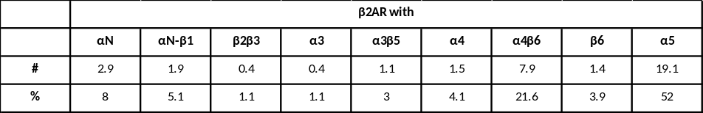
C)
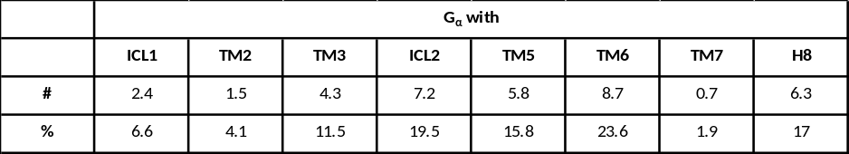
Table S 2: Average number of contacts between β₂AR and the G protein in different simulations. A) Frequencies of residue-residue contacts between receptor and G protein are computed using a distance cutoff of 4 Å, then aggregated per residue and sorted in descending order (only the first 20 shown). The residues on top of the table are those that most engage in the receptor G-protein interface. The heatmaps in Figure 3 A-B use these values to color-code the residues of the β2AR. B, C) Values of A) for the β₂AR-Gs^{GDP} simulations further aggregated to subdomains as absolute number of contacts (#) and as a total percentage (%).
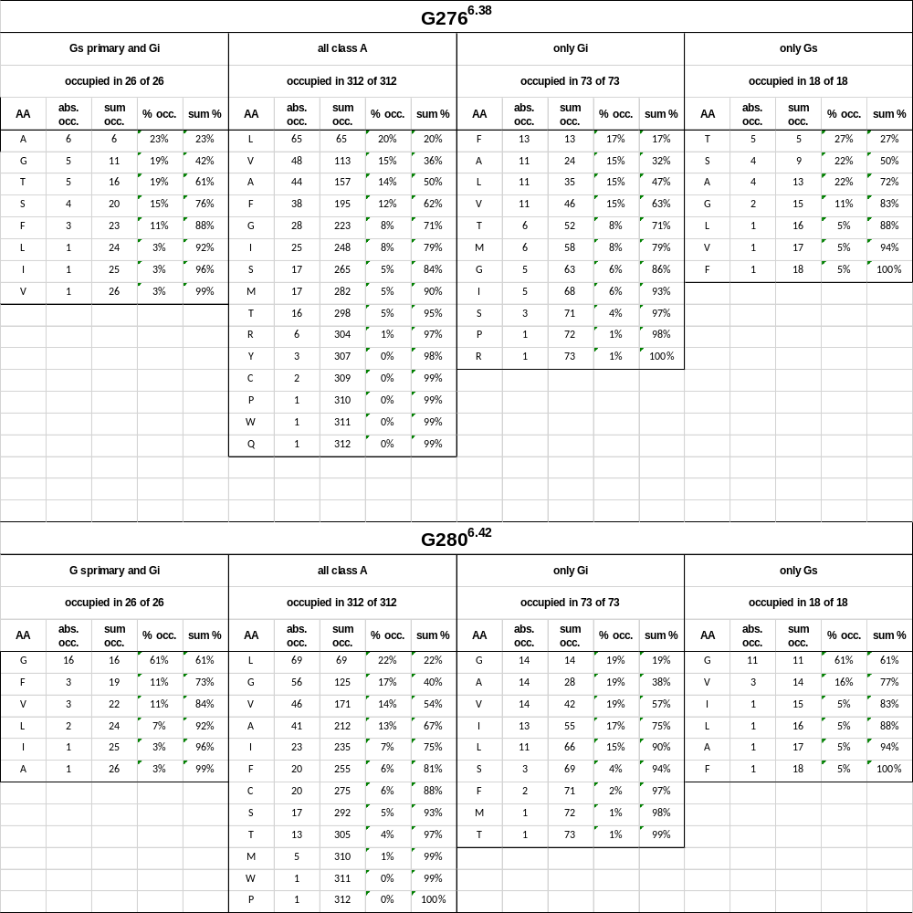
Table S 3: Conservation of β₂AR residues G276^{6.38} and G280^{6.42}, enabling the outward kink of TM6, across different sub-families of GPCRs. In position 276, we find amino acids with small chains to be overrepresented in receptors that couple to Gs, compared to all class A receptors, while at position 280 Glycine is clearly overrepresented. The categories, Gs primary and Gi, all class A, only Gi, only Gs, follow GPCRDB definitions (https://gpcrdb.org/alignment/targetselection).

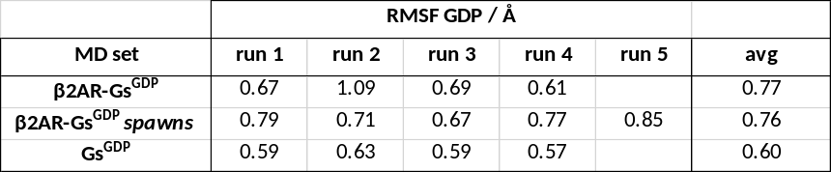
Table S 4: Root-mean-square-fluctuation (RMSF) of GDP in the Gs^{GDP} binding pocket.

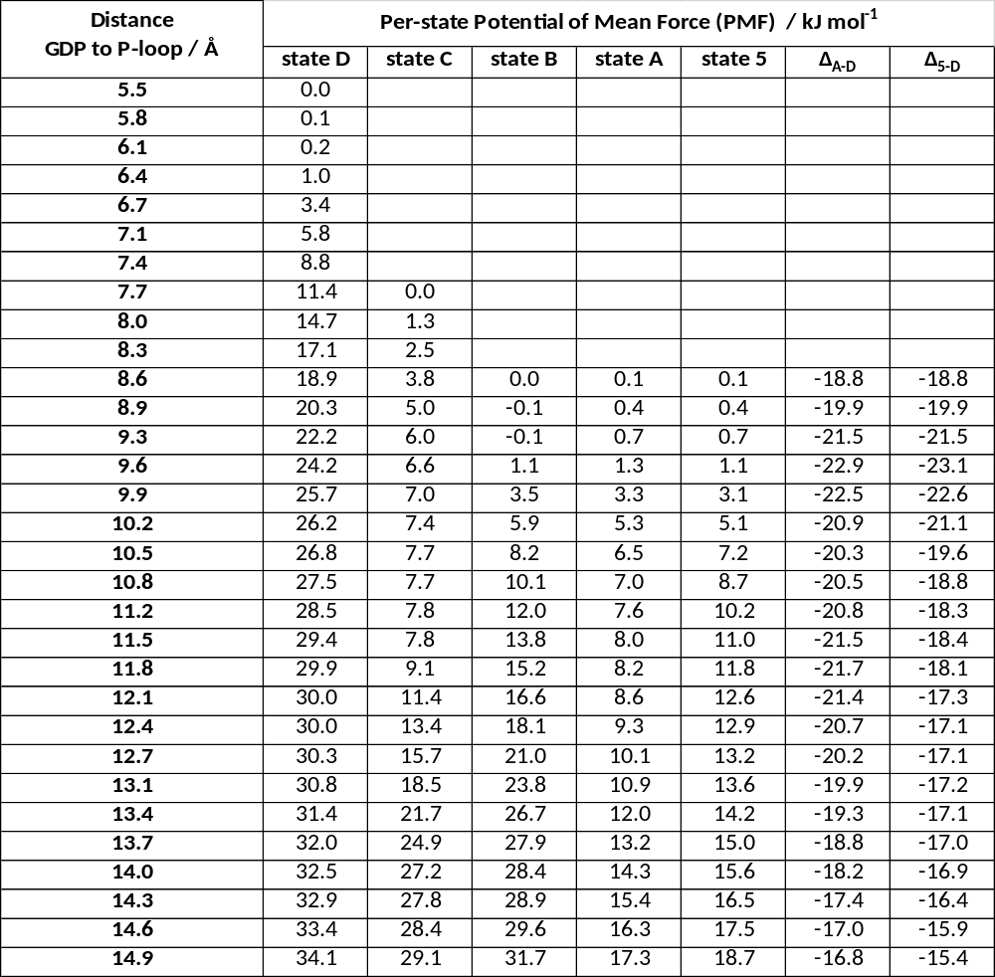
Table S 5: Potential-of-mean-force (PMF) values associated with the different umbrellas used to sample GDP dissociation from the Gs^{GDP} nucleotide-binding pocket. The starting geometries correspond to representative structures of the PCA states shown in Extended Data Fig 3. The last two columns represent difference (Δ) values to the reference, receptor-less state D.

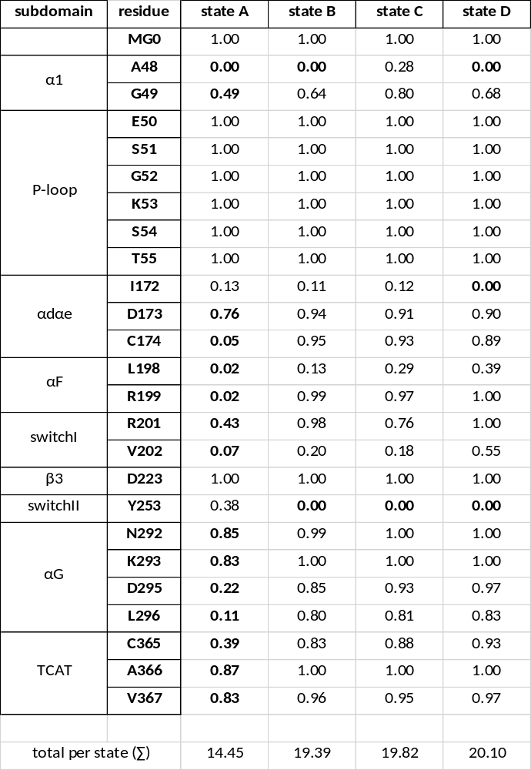
Table S 6: GDP contact frequencies in the nucleotide binding pocket reveal loss of contacts in the β2AR-Gs^{GDP} intermediate state (state A). Frequencies are computed per PCA state with a residue-residue distance cutoff of 4 Å. For each row, the lowest value (mostly in the “A” column) has been highlighted. The sum of neighbors (∑) is shown in the bottom row.

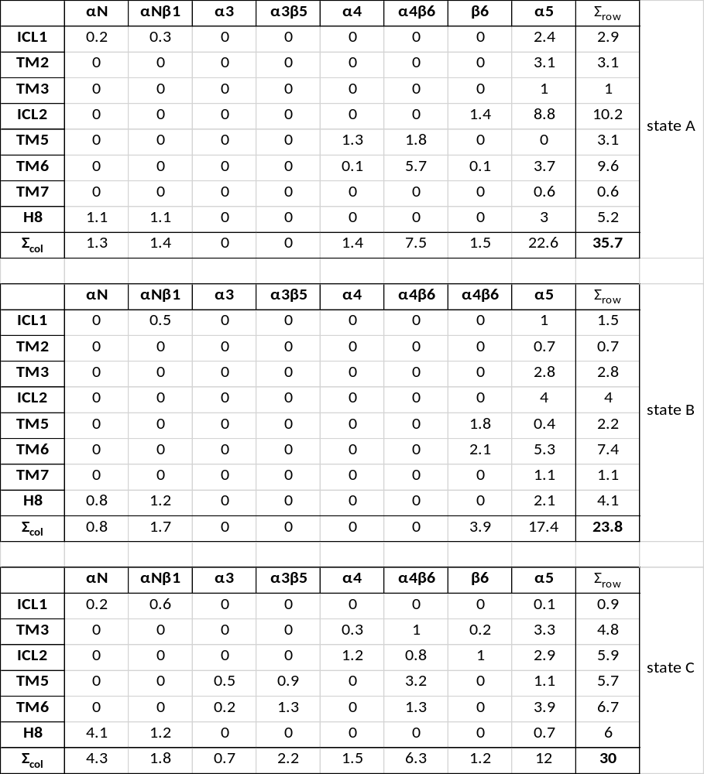
Table S 7: Coarse-Grained contact matrices reveal different engagement of receptor and G protein in β₂AR-Gs^{GDP} complexes. The matrices show the β₂AR-Gs^{GDP} interface of the states obtained from PCA using the amount of contacts (residue-residue distance cutoff of 4 Å between β₂AR and the Gs^{GDP}), coarse grained to their individual sub-domains. α5 participates in the interface with approx. 23 contacts in the β₂AR-Gs^{GDP} intermediate state A, whereas in state C, it only participates with approx. 12. Different modes of β₂AR-Gs^{GDP} engagement are clearly visible, e.g. state A heavily involves the ICL2 and TM6/TM6 regions, whereas the others do not. For each state, the cell on the bottom right is the sum over all rows (equal to to the sum over all contacts).

Supplementary Data 1. Movie File. Example trajectory (run 2) of the β₂AR-Gs^{GDP} simulations leading to the β₂AR-Gs^{GDP} intermediate. Can be viewed online here: https://proteinformatics.uni-leipzig.de/document_server/files/movie1-labeled.mp4
Supplementary Data 2. Movie File. Side-by-side comparison of example trajectory (run 2) of the β₂AR-Gs^{GDP} simulations and example trajectory (run 3) of the Gs^{GDP} simulations. Can be viewed online here: https://proteinformatics.uni-leipzig.de/document_server/files/movie2-labeled.mp4
Supplementary Data 3. Movie File. Side-by-side comparison of example trajectory (run 2) of the β₂AR-Gs^{GDP} simulations and example trajectory (run 3) of the Gs^{GDP} simulations, focusing on the Gs nucleotide binding-pocket. Can be viewed online here: https://proteinformatics.uni-leipzig.de/document_server/files/movie3-labeled.mp4
Supplementary Data 4. Movie File. Side-by-side comparison of example trajectory (run 2) of the β₂AR-Gs^{GDP} simulations and example trajectory (run 5) of the β₂AR-Gs^{GDP} spawns, both leading to β₂AR-Gs^{GDP} intermediates. Can be viewed online here: https://proteinformatics.uni-leipzig.de/document_server/files/movie4-labeled.mp4
Supplementary Data 5. Movie File. Composite trajectory leading to GDP release. Can be viewed online here: https://proteinformatics.uni-leipzig.de/document_server/files/movie5-labeled.mp4
Data Availability
Fully atomistic MD trajectories are available online for direct and interactive 3D visualization in web browser as mdsrv⁶⁵ sessions here:
- initial model of the β₂AR-Gs^{GDP} simulations:
https://proteinformatics.uni-leipzig.de/mdsrv.html?load=file://_b2AR-complex-intermediate/model.js

- representative run (run 2) of the β₂AR-Gs^{GDP} simulations:
https://proteinformatics.uni-leipzig.de/mdsrv.html?load=file://_b2AR-complex-intermediate/b2ar-gsgdp-intermediate.js

- representative run (run 5) of the β₂AR-Gs^{GDP} spawns:
https://proteinformatics.uni-leipzig.de/mdsrv.html?load=file://_b2AR-complex-intermediate/b2ar-gsgdp-intermediate-spawn.js

- representative run (run 2) of the Gs^{GDP} simulations:
https://proteinformatics.uni-leipzig.de/mdsrv.html?load=file://_b2AR-complex-intermediate/gsgdp.js

