Supplementary Material

Supplementary Text

Supplementary Text S1: Estimating the coefficient of thermal expansion of water
The volume change $∆V$ of the fluid associated with temperature changes $∆T$ is given by
$$\begin{aligned}∆V=α_{f}V_{0}∆T \#\left(S1\right)\end{aligned}$$
where $V_{0}$ is the original volume and $α_{f}$ is the coefficient of thermal expansion. Assuming the mass conservation within a system, the equation S1 can be rewritten by using the original volume $ρ_{0}$ and the original temperature $T_{0}$ and the final density $ρ_{1}$ and the final temperature $T_{1}$ ($∆T=T_{1}-T_{0}$) as follow:
$$\begin{aligned}\frac{ρ_{0}}{ρ_{1}}-1=α_{f}\left(T_{1}-T_{0}\right)\#\left(S2\right)\end{aligned}$$
Assuming the original temperature $T_{0}$ is 277 [K] (4 [℃]), the original water density $ρ_{0}$ is 1.00 [g/cm3], the final temperature $T_{1}$ is 337 [K] (60 [℃]), and the final density $ρ_{1}$ is 0.98338 [g/cm³], we then have the coefficient of thermal expansion of water as $α_{f}≈3.0×{10}^{-4}$ [1/K] (USGS, 2018).

Additional reference
U.S. Geological Survey (2018) Water Density by Water Science School, https://www.usgs.gov/special-topics/water-science-school/science/water-density Accessed 11 January, 2022.

Supplementary Figures and Tables
Supplementary Table S1. Summary of PALSAR-2 and Sentinel-1 data in this study.
Satellite/Sensor | Path | Geometry | #Data | #InSAR
ALOS-2/PALSAR-2 | 18 | Ascending  Right-looking | 16 | 101
ALOS-2/PALSAR-2 | 124 | Descending  Right-looking | 12 | 64
Sentinel-1 | 46 | Ascending  Right-looking | 74 | 176
Sentinel-1 | 141 | Descending  Right-looking | 69 | 172

Supplementary Table S2. Variance parameter of the dataset for the modeling.
Year | Path | Number of data | Sill variance [cm²] | Nugget variance [cm²] | Lag distance [km]
2015 | 18 | 229 | 1.52 | 0.21 | 2.31
2015 | 124 | 196 | 0.59 | 0.06 | 3.13
2019 | 18 | 277 | 0.90 | 0.21 | 4.22
2019 | 124 | 175 | 0.55 | 0.15 | 1.56

Supplementary Table S3. Prior range for solution spaces, best-fit parameter and standard deviation for an isotropic point source.
 | Local deformation |  |  | Far-field deformation
 | Search range | 2015 | 2019 | Search range | 2015
UTM Easting [m] | 433000, 434500 | 433674.06  [49.19] | 433692.56  [84.04] | 426000, 436000 | 433250.44  [367.11]
UTM Northing [m] | 4175000, 4176600 | 4175696.18  [57.84] | 4175749.32  [98.79] | 4172000, 4178000 | 4175307.76  [376.52]
Depth [m] | -1800, -500 | -1309.45  [67.87] | -1297.32  [99.04] | -500, 3000 | 944.77  [432.15]
Volume change [x10³ m³] | 0, 150 | 47.86  [10.26] | 76.12  [19.11] | 500, 3000 | 1414.98  [237.51]
RMSE [cm]/AIC |  | 0.94/347.74 | 1.23/950.91 |  | 0.66/219.53
Numbers within square brackets indicate standard deviations of a posterior distribution.

Supplementary Table S4. Prior range for solution spaces, best-fit parameter and standard deviation for a prolate ellipse source.
 | Local deformation |  |  | Far-field deformation
 | Search range | 2015 | 2019 | Search range | 2015
UTM Easting [m] | 433000, 434500 | 433709.79  [34.08] | 433692.41  [32.28] | 426000, 436000 | 432640.46  [516.08]
UTM Northing [m] | 4175000, 4176500 | 4175686.62  [39.10] | 4175748.87  [49.68] | 4172000, 4178000 | 4175657.78  [377.97]
Depth [m] | -1800, -500 | -1306.20  [46.10] | -1375.44  [46.91] | -1000, 2000 | 403.29  [395.70]
Pressure change [mu*10^-5 Pa] | 10, 1000 | 518.13  [201.77] | 554.81  [178.11] | 0, 150 | 37.48  [31.73]
a [m] | 0, 1000 | 383.09 [73.36] | 432.89  [75.15] | 0, 6000 | 3441.32 [821.00]
b/a | 0.0, 0.3 | 0.22 [0.04] | 0.21 [0.04] | 0.0, 0.3 | 0.18 [0.10]
Strike [deg.] | 10, 80 | 34.26 [15.35] | 27.16 [11.21] | 20, 110 | 75.76 [14.99]
Plunge [deg.] | -60, 20 | -43.97 [11.07] | -15.41 [12.18] | -20, 20 | 2.86 [8.12]
RMSE [cm]/AIC |  | 0.88/326.61 | 1.20/909.92 |  | 0.77/296.12
Numbers within square brackets indicate standard deviations of a posterior distribution.

Supplementary Table S5. Prior range for solution spaces, best-fit parameter and standard deviation for a rectangular opening source.
 | Local deformation |  |  | Far-field deformation
 | Search range | 2015 | 2019 | Search range | 2015
UTM Easting [m] | 433000, 434500 | 433450.13  [64.87] | 433519.41  [78.30] | 430000, 440000 | 435220.16  [499.34]
UTM Northing [m] | 4175000, 4176500 | 4175822.36  [76.19] | 4176061.82  [106.01] | 4172000, 4178000 | 4174231.92  [566.20]
Depth [m] | -1800, -500 | -1170.22  [67.14] | -1221.33  [101.64] | -1000, 2000 | 185.59  [700.42]
Strike [deg.] | 10, 100 | 29.69  [14.47] | 60.54  [14.19] | 180, 270 | 198.20  [11.35]
dip [deg.] | -20, 50 | 21.81 [6.44] | 7.04 [8.72] | -20, 20 | 5.81 [6.51]
Length [m] | 0, 200 | 61.42 [25.12] | 64.73 [32.00] | 0, 10000 | 3947.45 [1039.19]
Width/Length | 1, 20 | 5.78 [4.60] | 10.37 [4.26] | 0, 5 | 1.78 [0.81]
Open [m] | 0, 4 | 2.98 [0.63] | 1.81 [0.78] | 0, 0.2 | 0.05 [0.04]
RMSE [cm]/AIC |  | 1.02/422.32 | 1.26/963.70 |  | 0.56/165.30
Numbers within square brackets indicate standard deviations of a posterior distribution.

Supplementary Table S6. Offset of Sentinel-1 time-series subset for fitting the PALSAR-2 time-series.
 | Path 141 | Path 46
2017 | -0.45 | -1.14
2018 | -3.17 | -2.20
2019 | -7.77 | -10.61
2020 | -4.22 | -7.56

Supplementary Table S7. Root-mean-square errors and AIC for the modeling.
 | 2015 Local |  | 2019 Local |  | 2015 Broader
 | RMSE [cm] | AIC | RMSE [cm] | AIC | RMSE [cm] | AIC
Point | 0.94 | 347.7 | 1.23 | 950.9 | 0.66 | 219.5
Prolate | 0.88 | 326.6 | 1.20 | 909.9 | 0.77 | 296.1
Rectangular | 1.02 | 422.3 | 1.26 | 963.7 | 0.56 | 165.3
Numbers with underlines indicate root-mean squares errors and AIC values for the best-fit model geometry to the observation data.

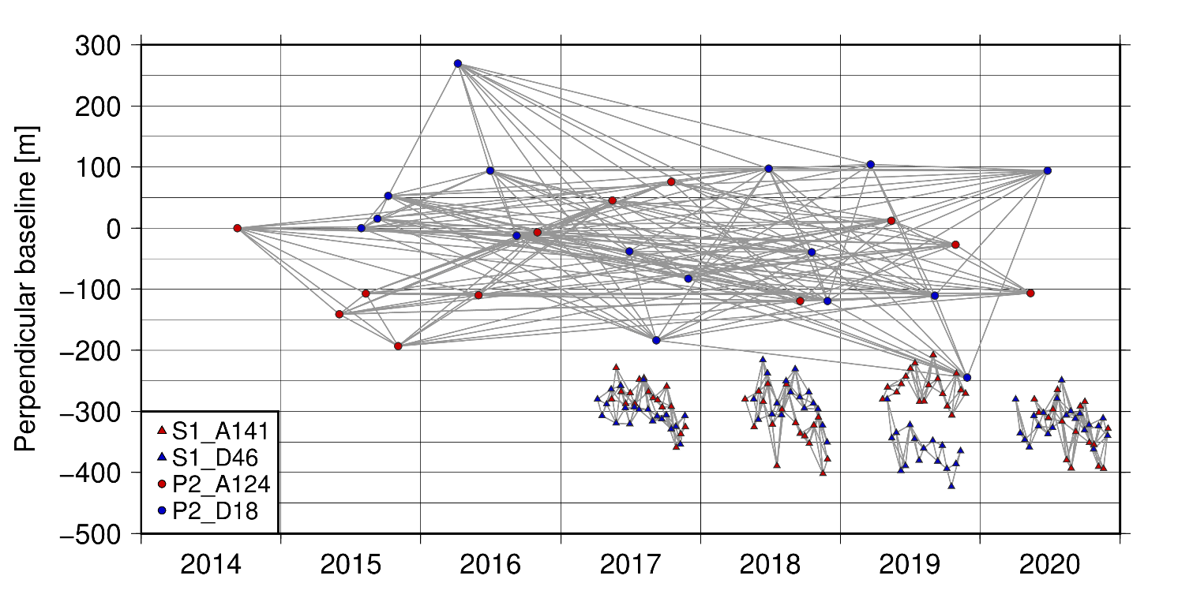
Supplementary Figure S1. Perpendicular plot of PALSAR-2 and Sentinel-1 data.

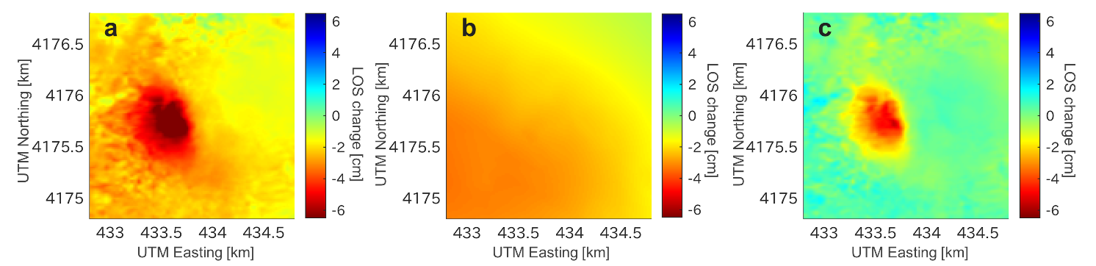
Supplementary Figure S2 Correction flow of the broader deformation in 2015 for extracting the local deformation signal for the modeling. (a) Original LOS change, (b) the best-fit broader deformation, and (c) the extracted LOS change.

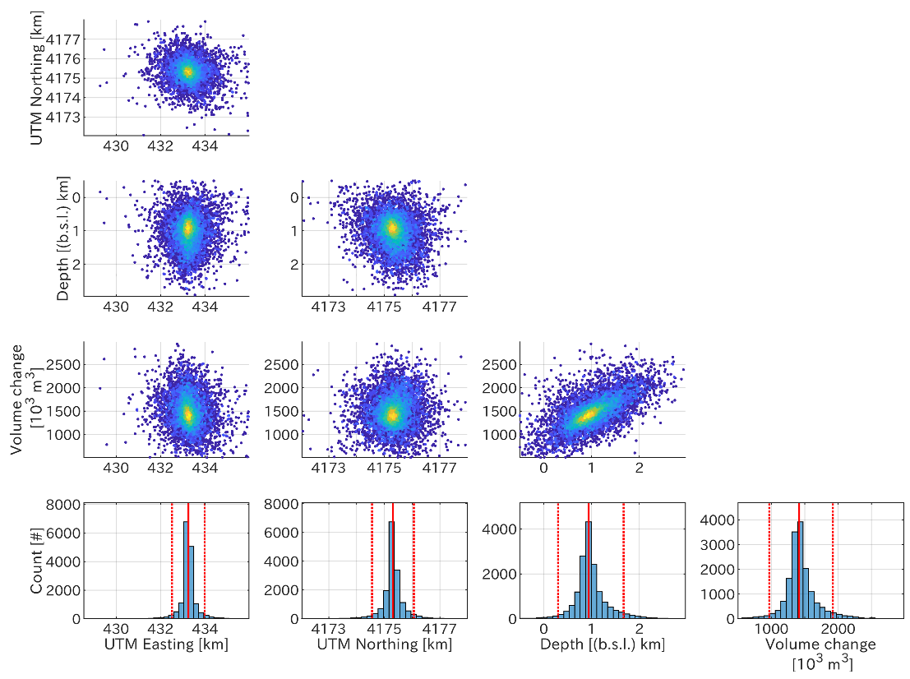
Supplementary Figure S3. Corner plot of parameter of an isotropic inflation source for the broader deformation in 2015. Red dashed and solid lines indicate the standard deviation and the median values of the posterior probability density function.

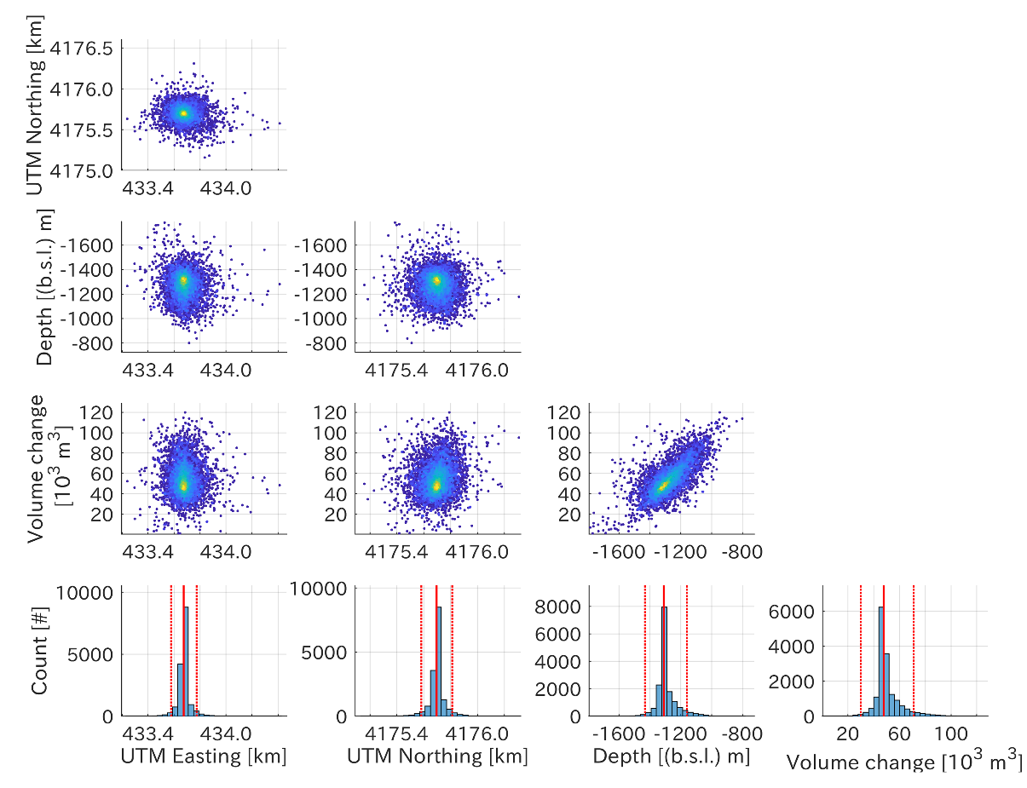
Supplementary Figure S4. Corner plot of parameter of an isotropic inflation source for the local deformation in 2015. Details are same in Supplementary Figure S3.

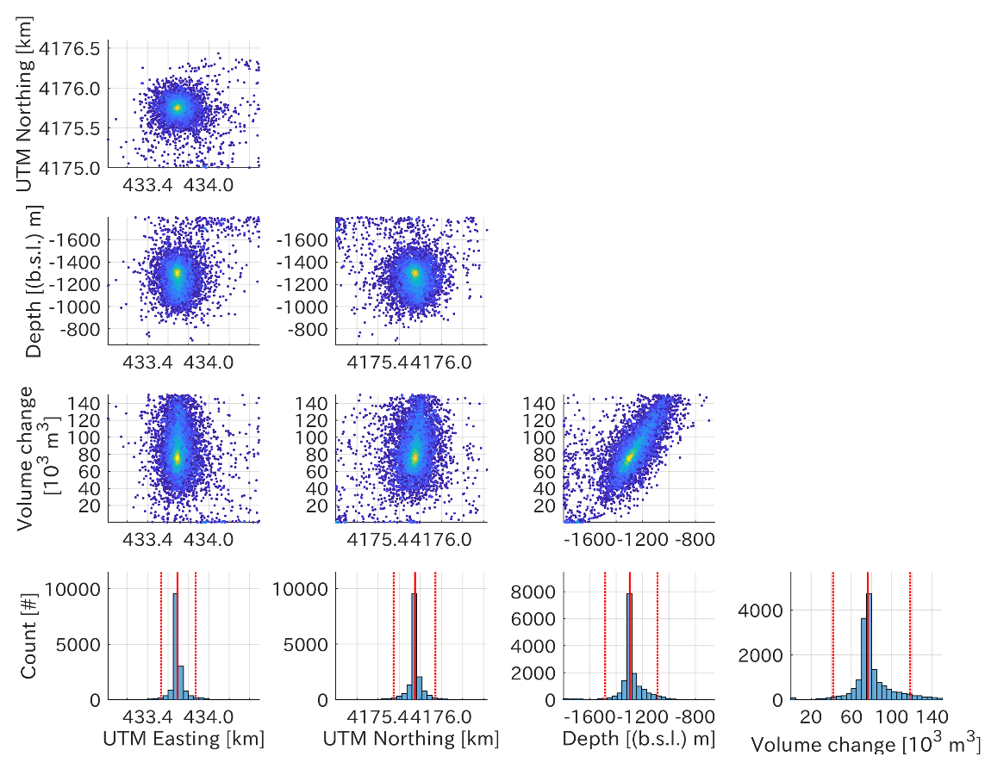
Supplementary Figure S5. Corner plot of parameter of an isotropic inflation source for the local deformation in 2019. Details are same in Supplementary Figure S3.

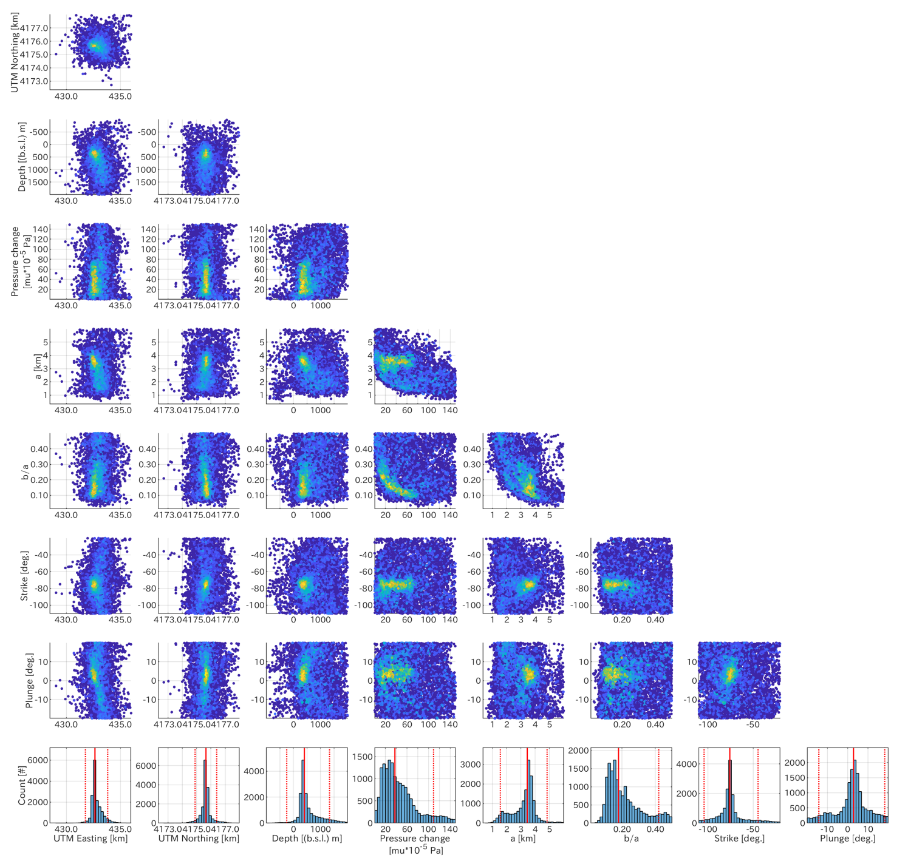 Supplementary Figure S6. Corner plot of parameter of a prolate ellipse source for the broader deformation in 2015. Details are same in Supplementary Figure S3.

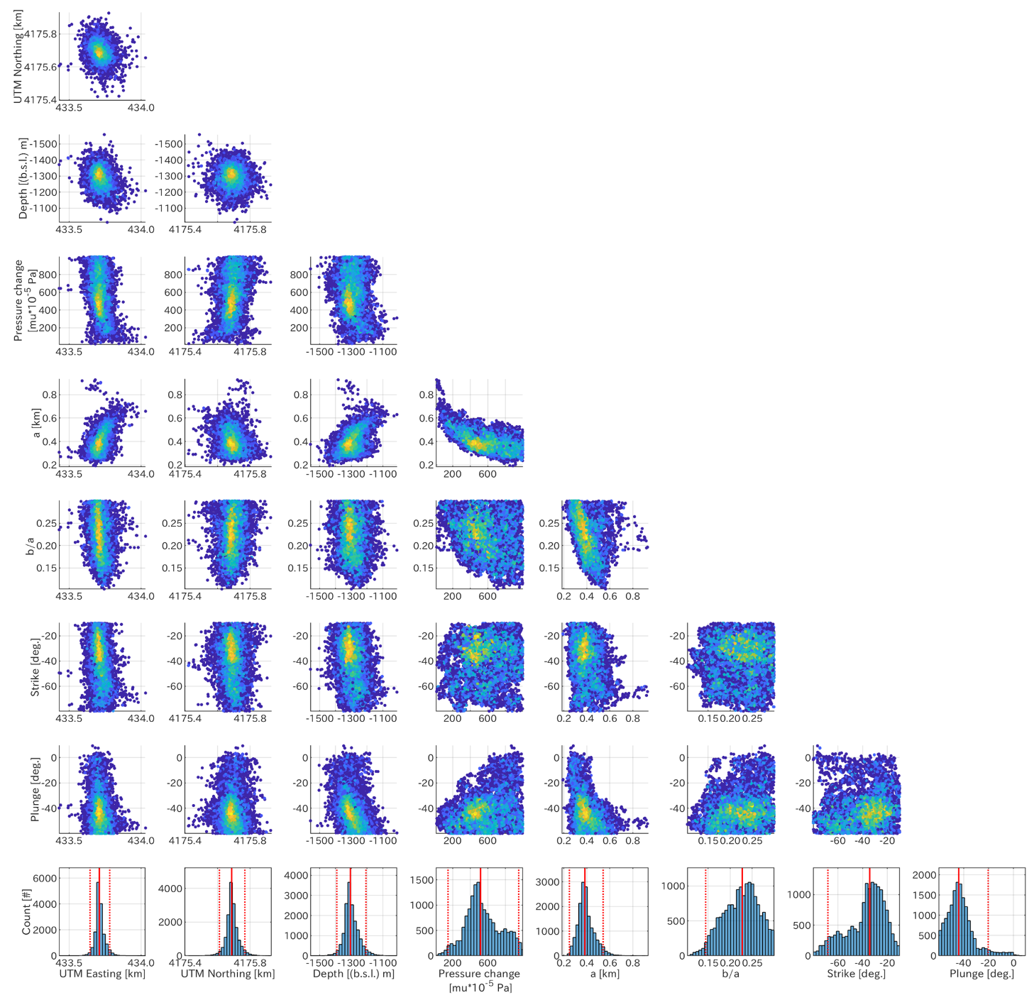
Supplementary Figure S7. Corner plot of parameter of a prolate ellipse source for the local deformation in 2015. Details are same in Supplementary Figure S3.

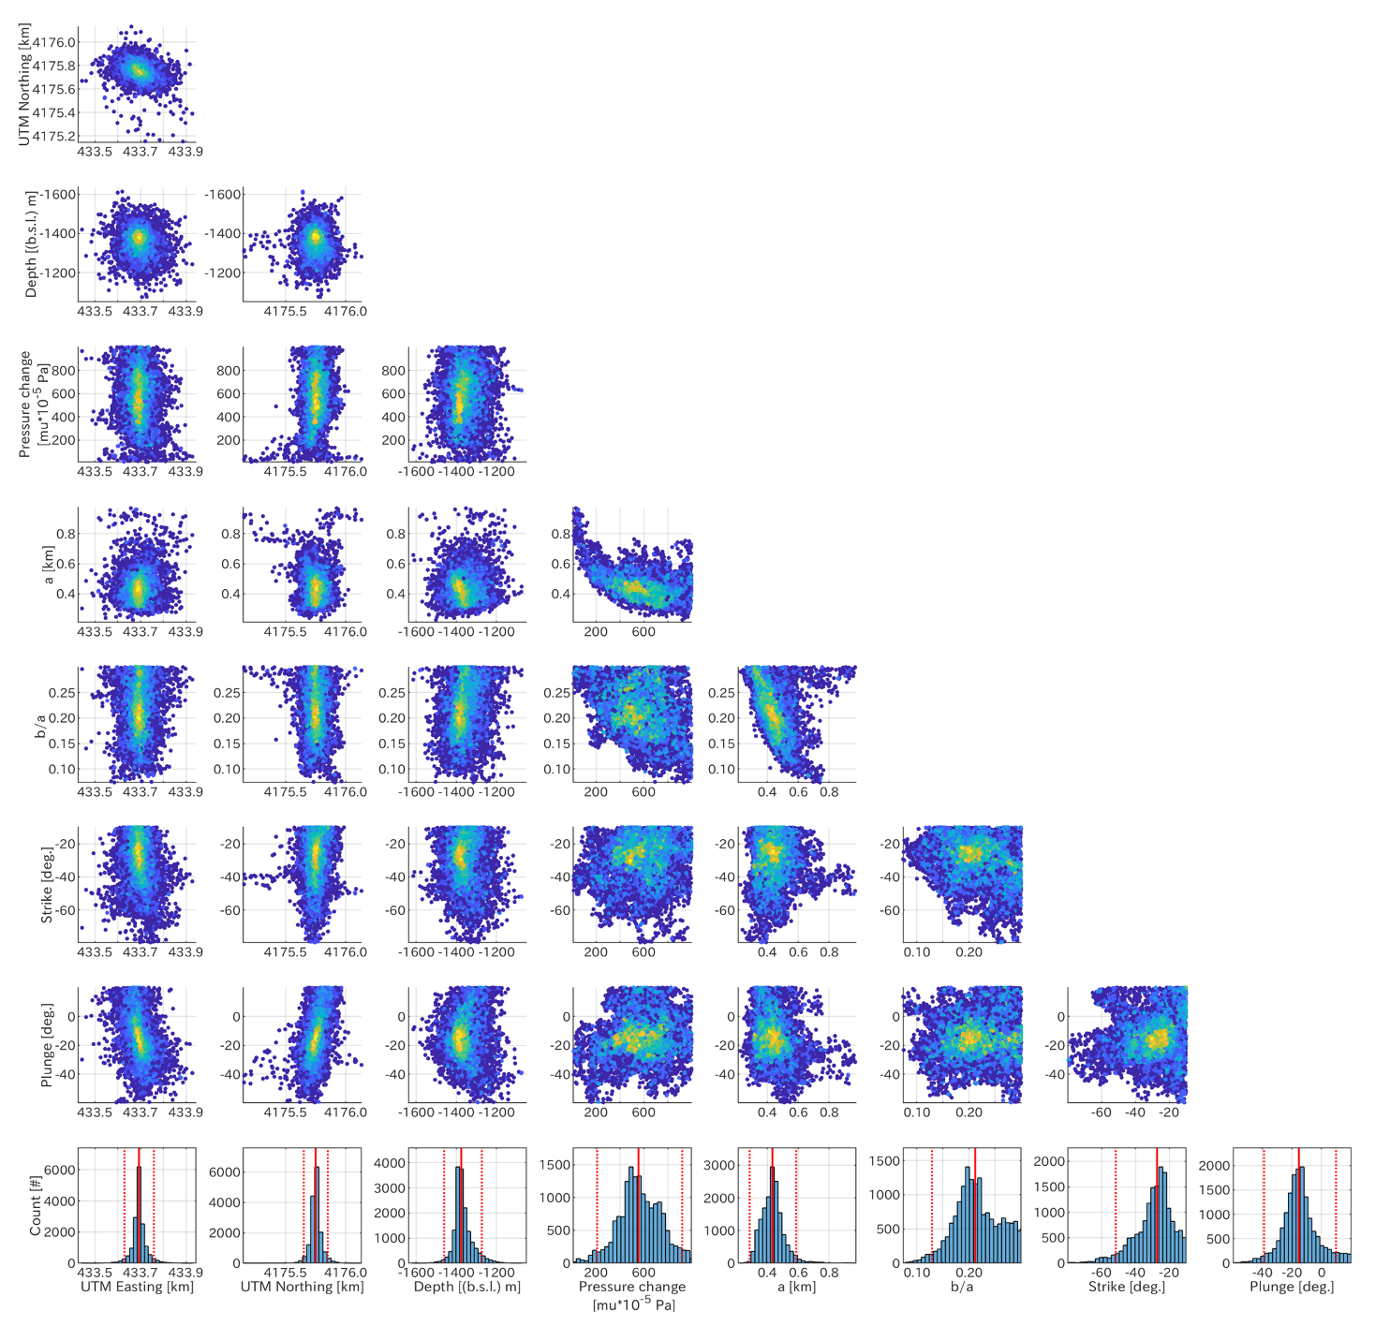
Supplementary Figure S8. Corner plot of parameter of a prolate ellipse source for the local deformation in 2019. Details are same in Supplementary Figure S3.

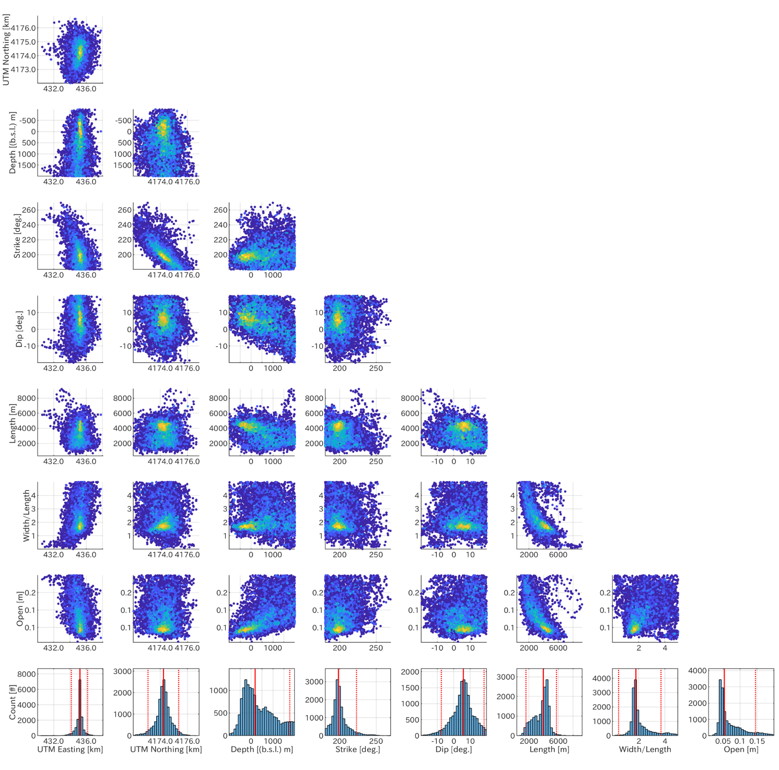
Supplementary Figure S9. Corner plot of parameter of a rectangular opening source for the broader deformation in 2015. Details are same in Supplementary Figure S3.

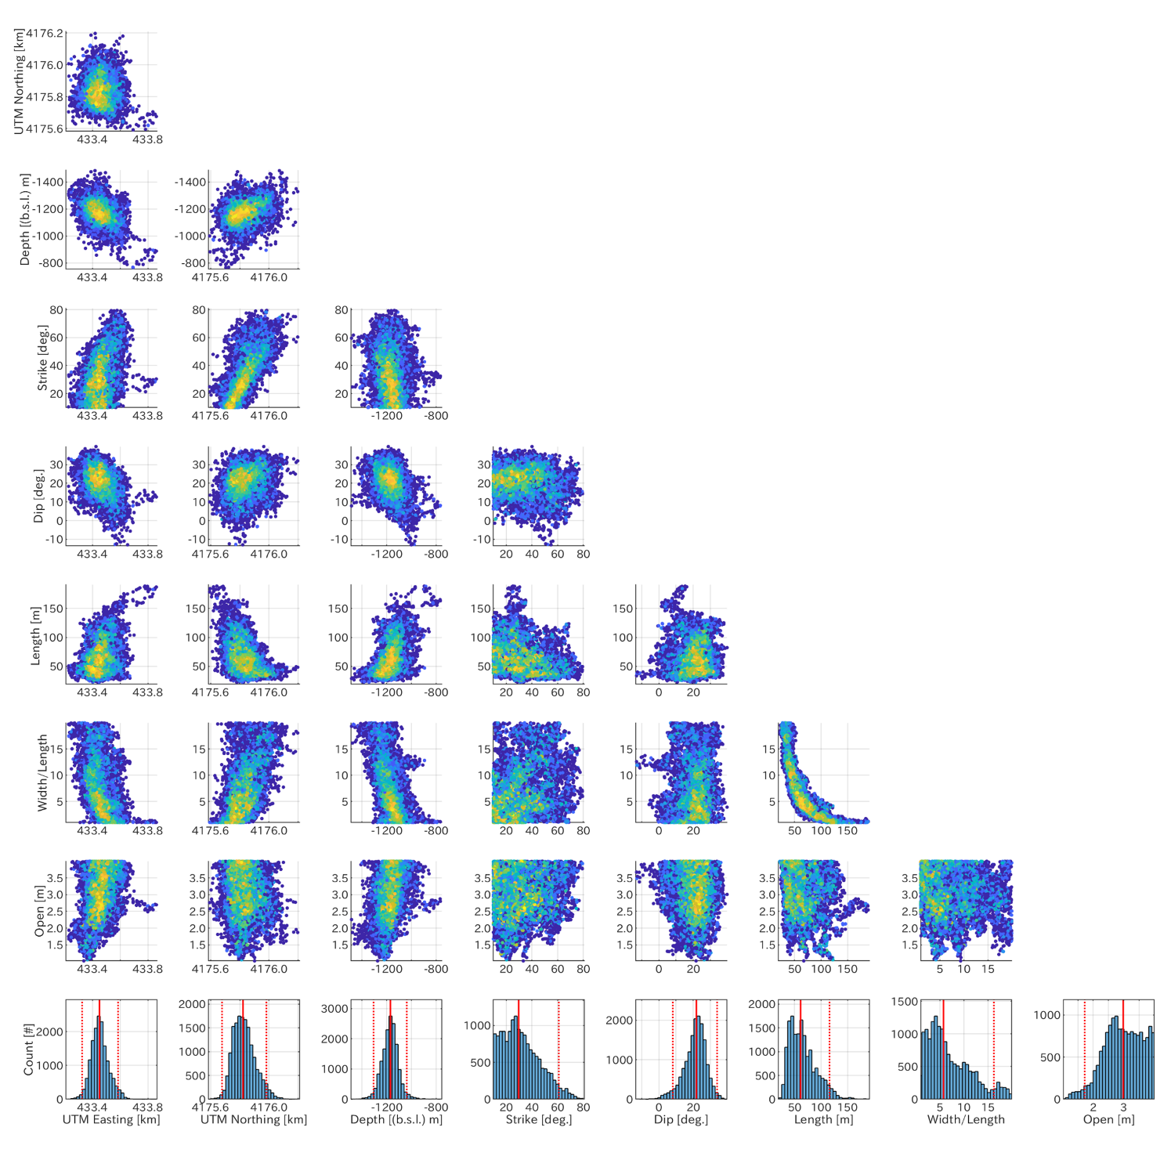
Supplementary Figure S10. Corner plot of parameter of a rectangular opening source for the local deformation in 2015. Details are same in Supplementary Figure S3.

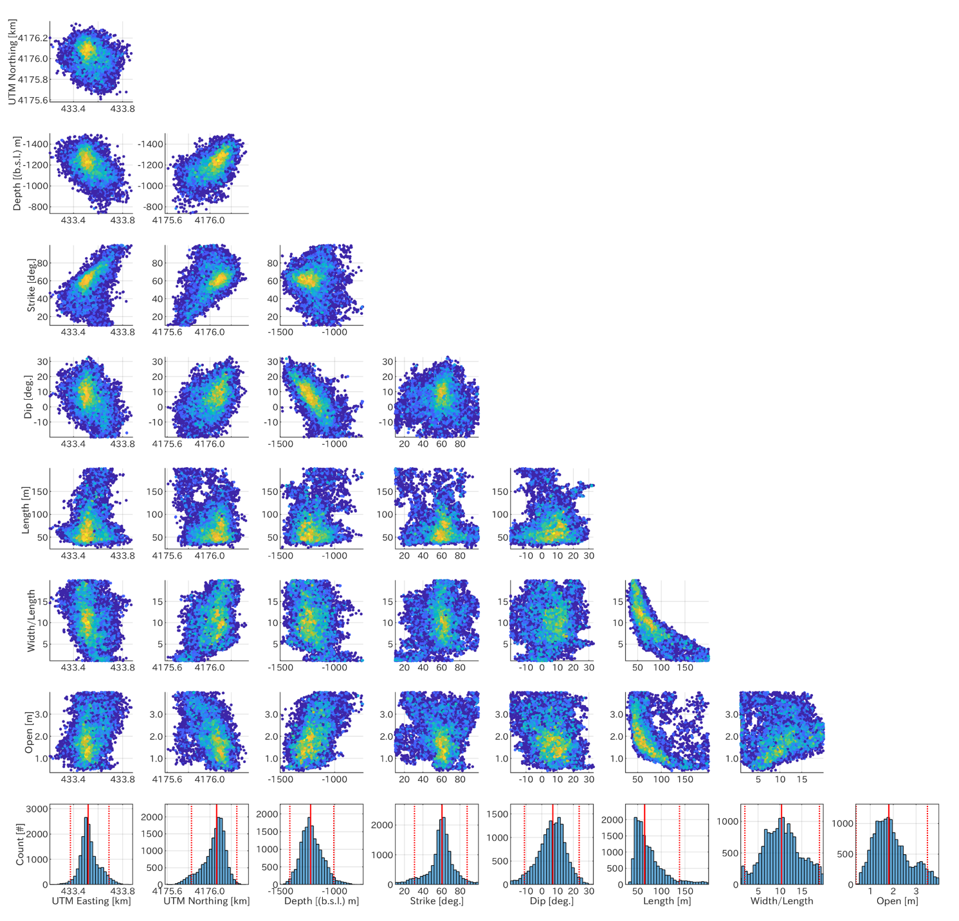
Supplementary Figure S11. Corner plot of parameter of a rectangular opening source for the local deformation in 2019. Details are same in Supplementary Figure S3.

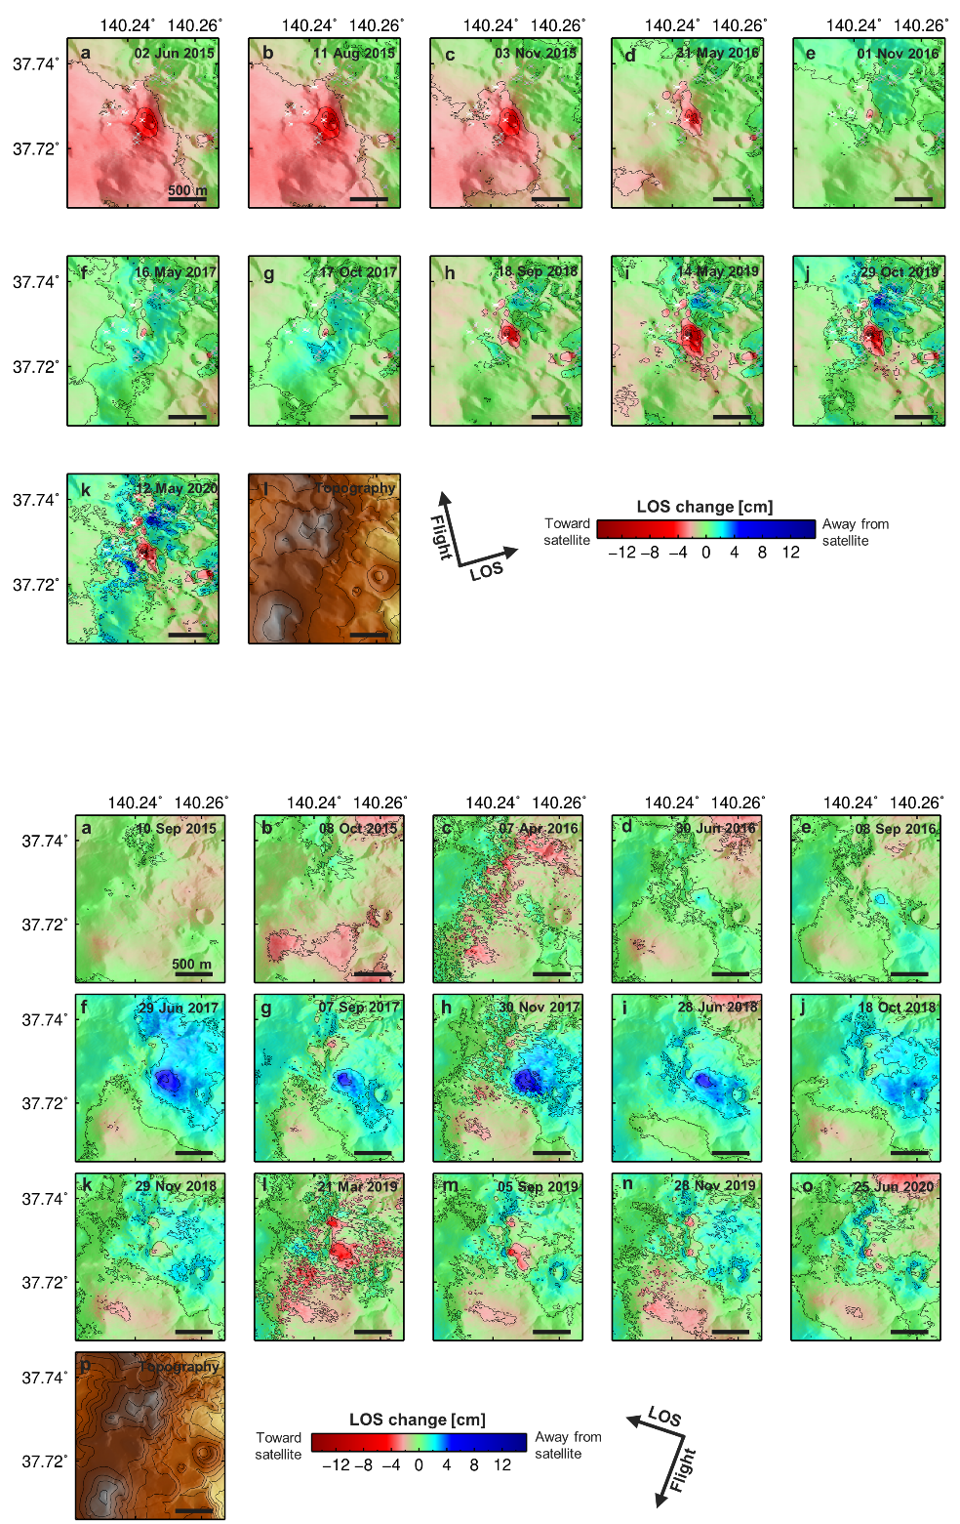
Supplementary Figure S12. Time-series of PALSAR-2 LOS change enlarged around the Oana crater. Positive value (blue) indicates displacements moving away from the satellite. Contours are set to 2 cm of interval. Dates on the top-right of each panel indicate the observation date. Each reference dates are 9 September 2014 and 30 July 2015 for Path 124 and 18, respectively.

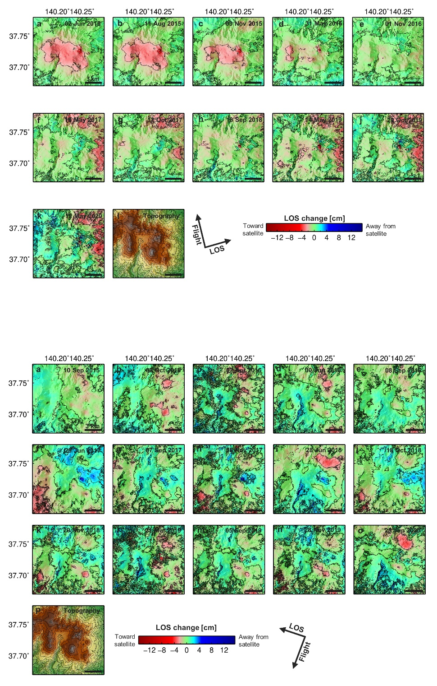
Supplementary Figure S13. Time-series of PALSAR-2 LOS change maps in the wider region. Details are same in Supplementary Figure S12.

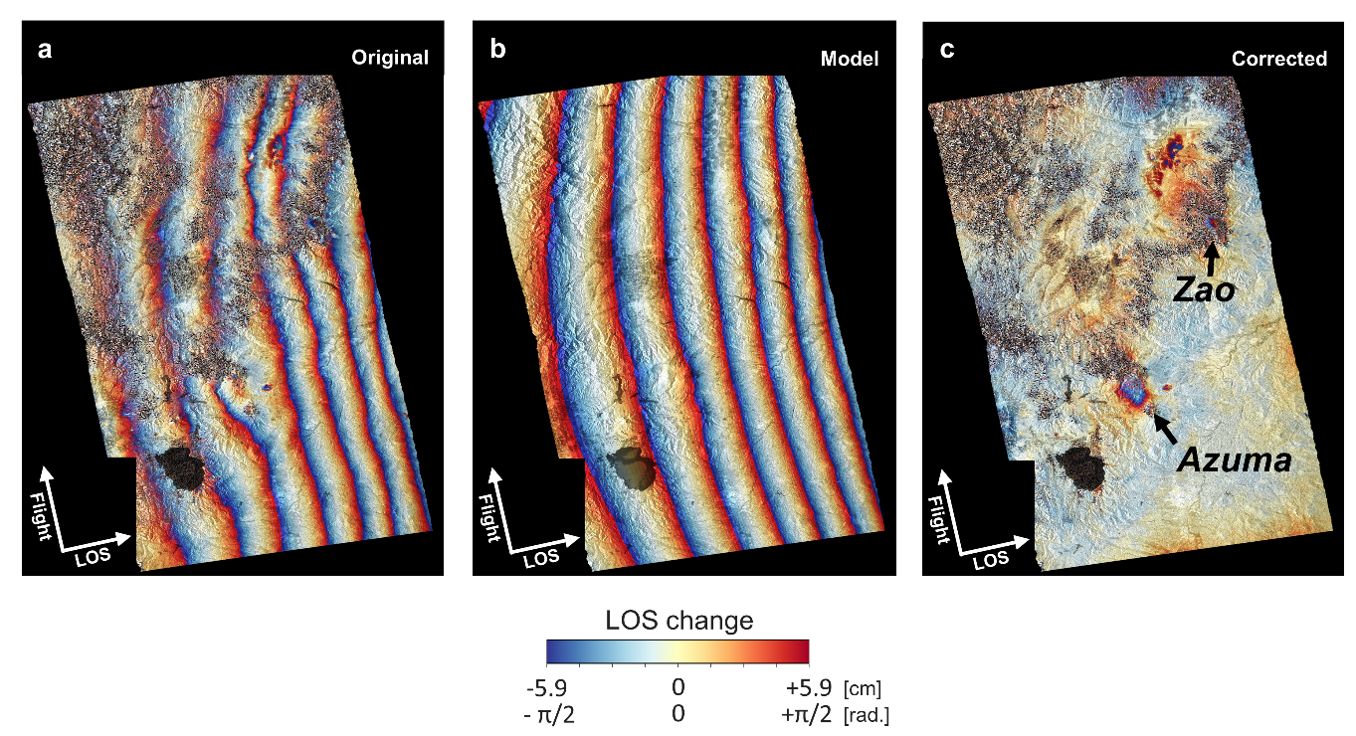
Supplementary Figure S14. Correction example of far-field deformation associated with the 2011 Tohoku-oki earthquake for extracting deformation signals on the Azuma and the Zao volcano. (a) Original PALSAR InSAR data between February 2, 2011–March 20, 2011. (b) Fitted quadratic plane. (c) Corrected InSAR data.

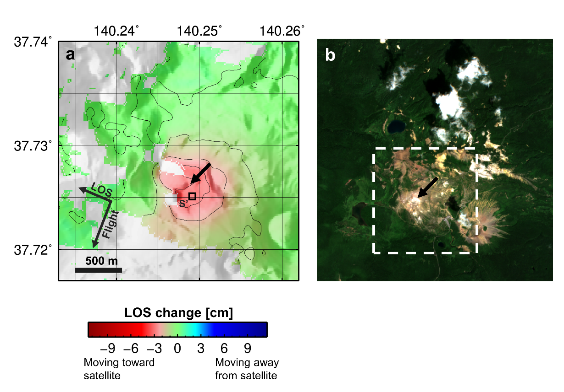
Supplementary Figure S15. Result of SAR time-series analysis of Sentinel-1 data. (a) Cumulative Sentinel-1 LOS change acquired from Path 46 in 2018. Black arrow indicates the position of the Oana crater. The data extracted region (Point S’) for the LOS change time-series is the same for PALSAR-2 LOS changes in Figure 2. Contour is set to 1 cm of interval. (b) True color image of Sentinel-2 image acquired on July 24, 2018.

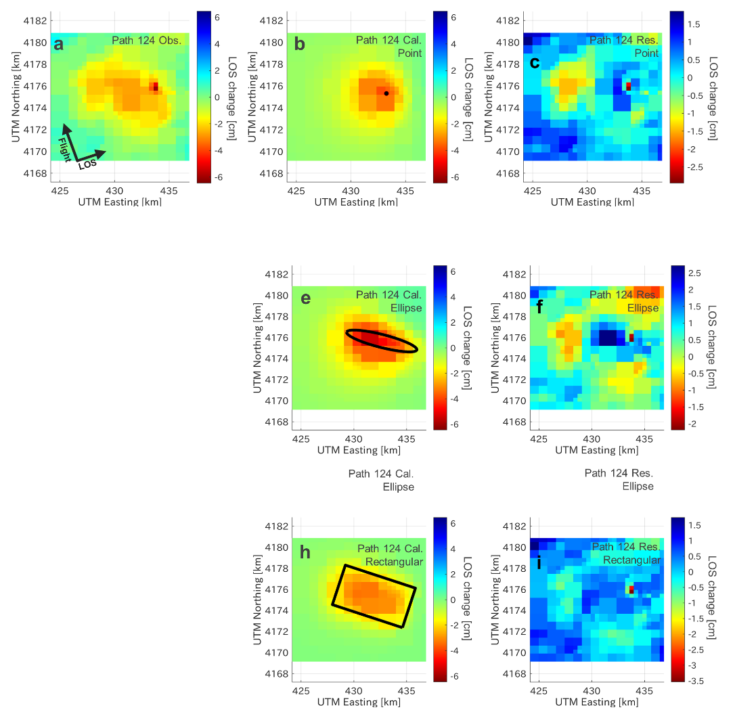
Supplementary Figure S16. Comparison of the observation, the best-fit calculation, and the residual for the broader deformation in 2015. (top) Modeling using the isotropic inflation source, (middle) a prolate ellipse source, and (bottom) the rectangular opening source, respectively. From the left column, the observation, the best-fit synthetic, and the residual are shown.

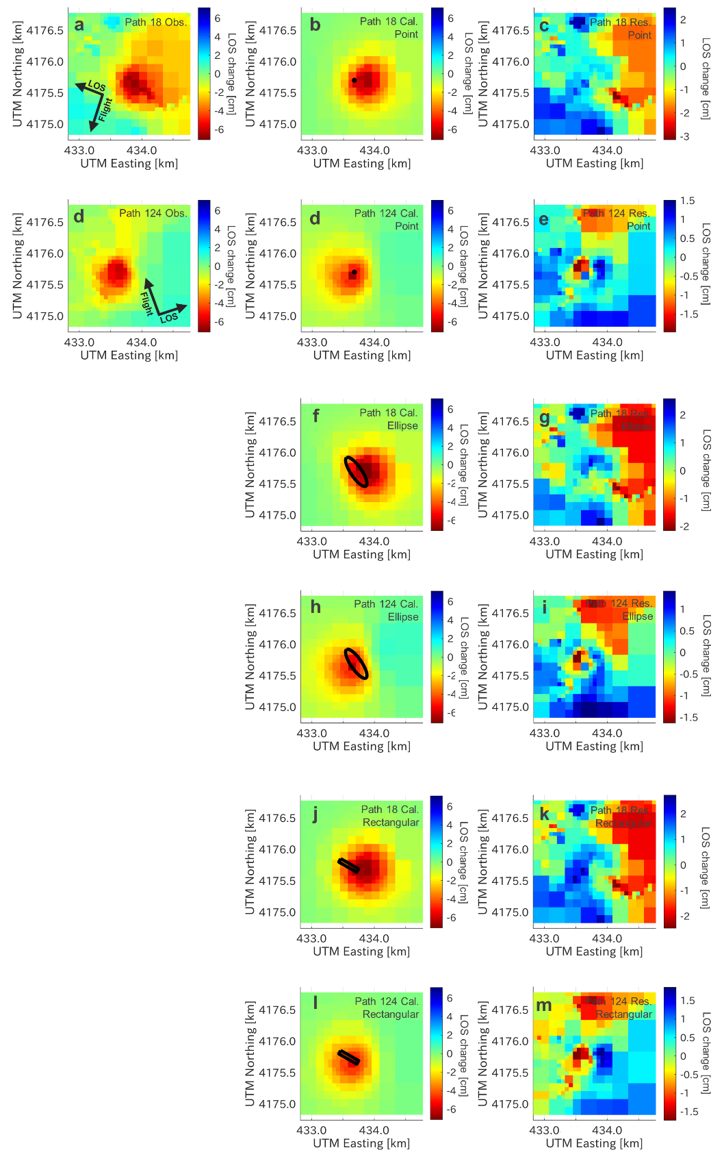
Supplementary Figure S17. Comparison of the observation, the best-fit calculation, and the residual for the local deformation in 2015. Details are same in Supplementary Figure S16.

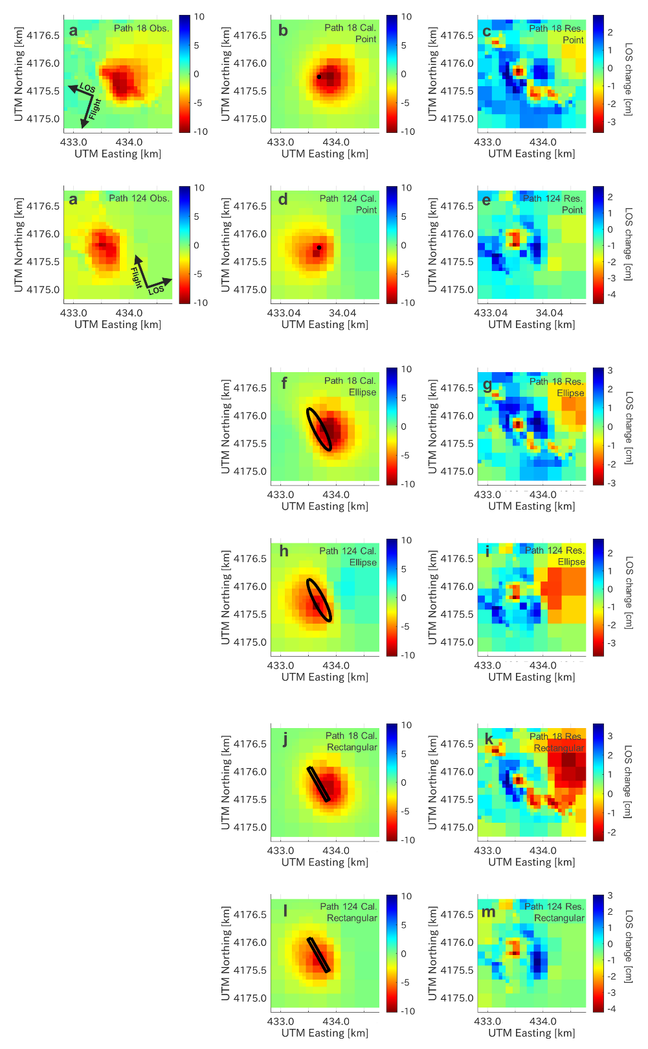
Supplementary Figure S18. Comparison of the observation, the best-fit calculation, and the residual for the local deformation in 2019. Details are same in Supplementary Figure S16.

