Extended Data

Extended Data Figure 1
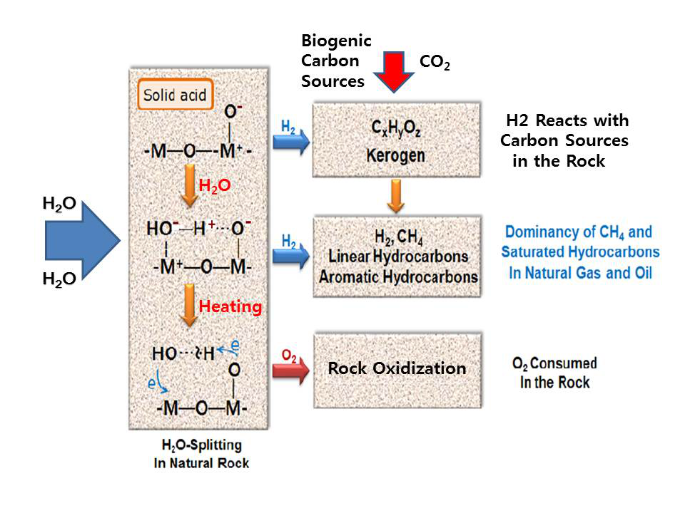
Extended Data Figure 1 Schematic diagram showing the hypothetical mechanism of hydrocarbon formation in the Earth subsurface with the aid of H₂O and geothermal energy; While H₂O is adsorbed on solid acids composing of natural rock, it forms a metastable structure doubly bonded by sharing a coordinate bond and a hydrogen bond with the solid acid. The electrons in the conduction band can exist in the solid acids, and the number of conduction electrons increases as temperature increases. The electrons moving freely in the conduction band of the solid acid can be transferred to the H₂O through the hydrogen bond, and a surplus electron in the H₂O can move back to the solid acid through the coordinate bond for neutralization. This electron exchange between H₂O and solid acid results in H₂O splitting by electrolysis, and eventually generates molecular H₂ and O₂. The free O₂ produced by H₂O splitting, however, would be appropriated by the oxidizing agent for the low oxidation state constituents of rock, such as Fe⁺² and C (carbon), while H₂ reacts with carbonaceous materials contained in the rock to produce CH₄ and various kinds of higher hydrocarbons. The higher hydrocarbons produced in the rock can further react with H₂ to become saturated hydrocarbons and then gradually convert to CH₄ in the rock, as shown in natural oil and gas.

Extended Data Figure 2
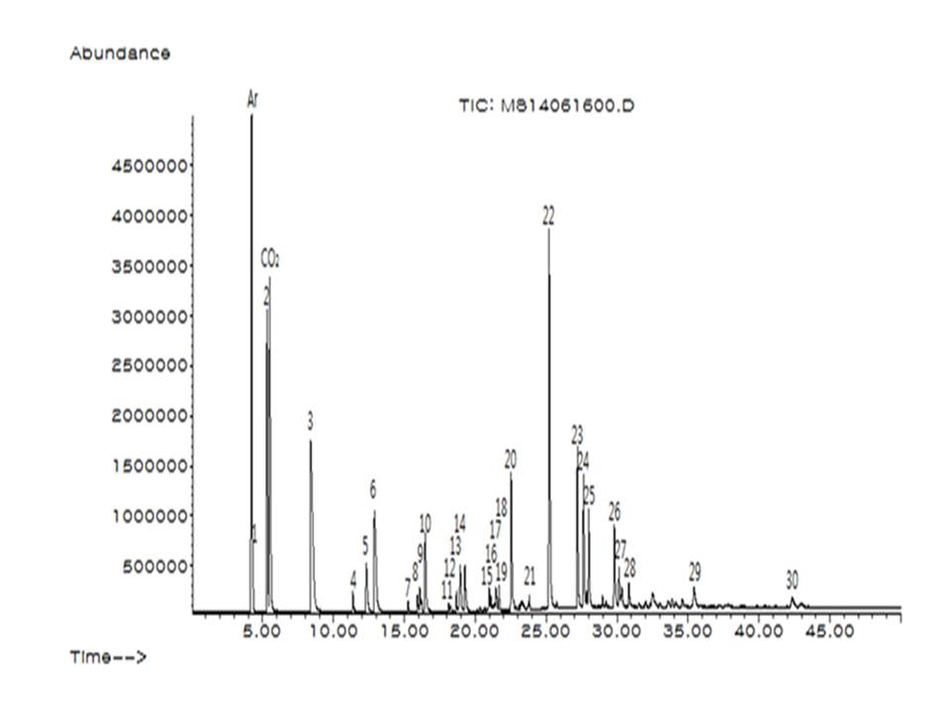

Extended data Figure 2 GC/MS chromatogram of the product formed in the reaction with H₂O and soybean oil on basaltic rock in the small reactor; The experiment was conducted at 673 K and 353 bar for 72 h.

Extended Data Figure 3
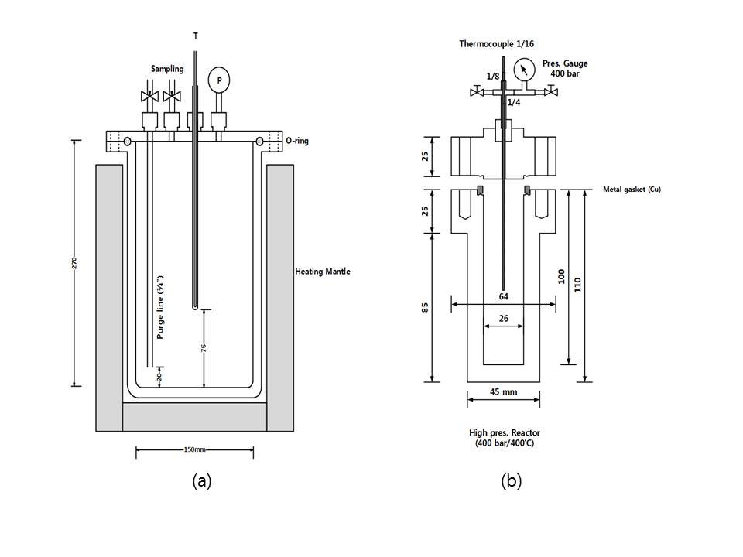

Extended Data Figure 3 Schematic drawings of (a) the large stainless steel batch reactor, (b) the small stainless steel batch reactor

