Muscularis macrophages controlled by NLRP3 maintain the homeostasis of excitatory neurons
Yunhuan Gao^{1,2,3*}, Yi Shi^{4*}, Ming Wei^{1,2,3}, Xiaorong Yang^{1,2,3}, Yang Hao^{1,2,3}, Haifeng Liu⁵, Yuan Zhang^{1,2,3}, Lu Zhou⁵, Gang Hu⁴ and Rongcun Yang^{1,2,3}

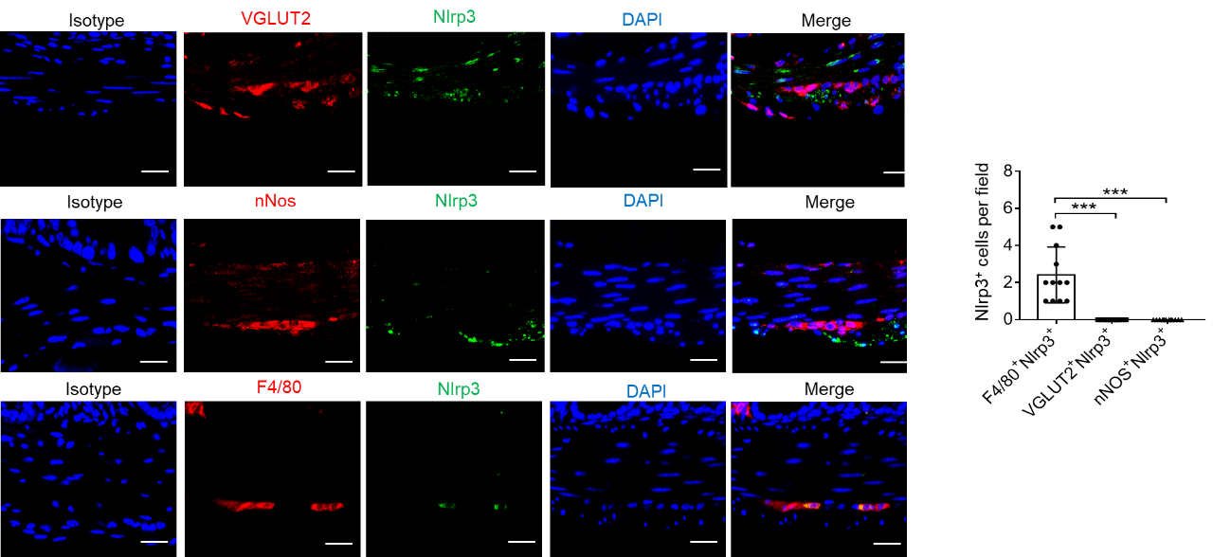

Fig. S1 VGLUT2⁺ and nNOS⁺ neurons do not express NLRP3. Immunostaining of NLRP3 (Nlrp3) in VGLUT2⁺, nNOS⁺ and F4/80⁺ cells in the ME of the colon sections from SPF mice. Histograms showed the percentage of NLRP3⁺ cells in VGLUT2⁺, nNOS⁺ and F4/80⁺ cells. Isotype, antibody controls. Scale bar=40 μm; Blue, DAPI. Student’s t-test, mean ±SD; *P < 0.05, **P < 0.01, ***P < 0.001.

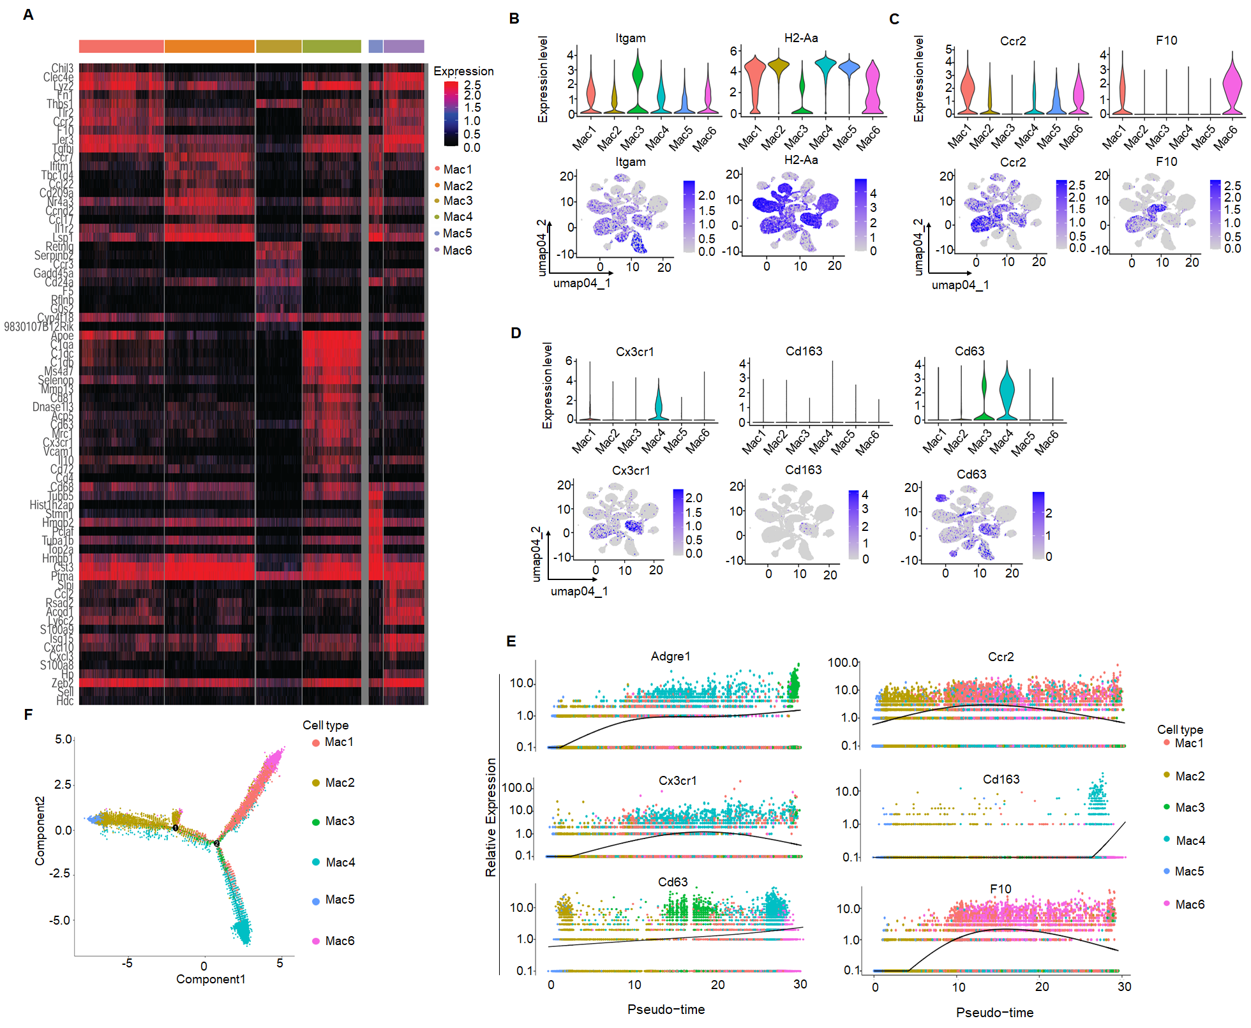

Fig. S2 Trajectory analyses of selected enriched genes from the macrophage subsets during their development. A Heatmap reporting top differentially expressed genes of each cluster in Fig. 3A. B-D Violin plots (upper) and feature plots (lower) showing gene expression level of reported canonical marker genes of macrophage subpopulations across different clusters. E Trajectory analyses of selected enriched genes from macrophage subsets during their development, which covers the whole process from inflammatory macrophages to resident macrophages. F. Developmental trajectory analysis of macrophage clusters with different cell clusters.

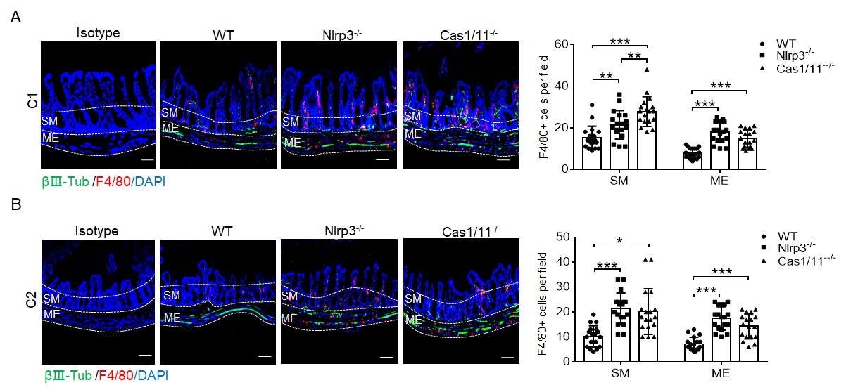
Fig. S3 Immunostaining for βIII-Tub, F4/80 and DAPI in the submucosa and muscularis externa of small intestinal (A) or colon (B) sections from CASPASE (CAS) 1/11 -/-, NLRP3 -/- and WT mice. Small intestinal and colon segments stained with anti-βIII-Tubulin (green) or anti-F4/80 (red) antibodies and DAPI (blue). Histograms showed the number of βIII-Tub⁺ and F4/80⁺ cell in the submuscula (SM) and muscularis externa (ME) per field (100 ×). Scale bar=100 μm; 3 fileds (100×) per mouse, n=6. ONE-way ANOVA Bonferroni’s Multiple Comparison Test; *P < 0.05, **P < 0.01, ***P < 0.001.

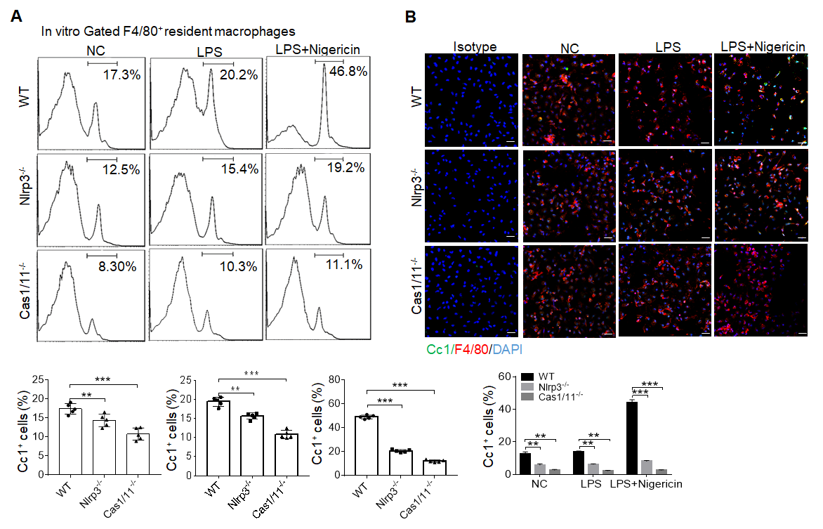
Fig. S4 Analyses of resident macrophages from the colon tissues of mice. A Flow cytometry of Cc1⁺cells in the gated F4/80⁺ resident macrophages from isolated immune cells of the colon tissues of WT, NLRP3 (Nlrp3) -/- and CASPASE (Cas) 1/11 -/- mice. B Immunostaining of Cc1, F4/80 and DAPI in isolated cells from the colon tissues of WT, NLRP3 (Nlrp3) -/- and CASPASE (Cas)-1/11 -/- mice. ONE-way ANOVA Bonferroni’s Multiple Comparison Test; *P < 0.05, **P < 0.01, ***P < 0.001.

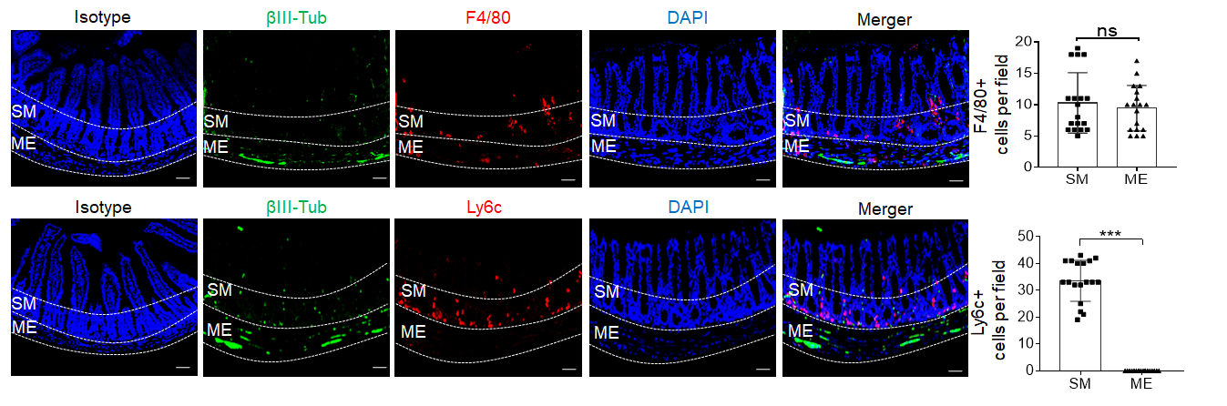
Fig. S5 Distribution of F4/80⁺ and Ly6C⁺macrophages in the colon tissues. Immunostaining of F4/80, Ly6c2, βIII-Tub and DAPI in whole mount colon sections from SPF mice. Histograms showed the number of F4/80⁺ and Ly6c2⁺ cells per field (100 ×) in the submucosa (SM) and muscularis externa (ME). Scale bar=100 μm; 3 fileds /mouse, n=6. Mann–Whitney U test; *P < 0.05, **P < 0.01, ***P < 0.001.

Fig. S6 Heatmap reporting top differentially expressed genes in each subset of resident macrophages (A), and enrichment analyses of signal pathways in different subpopulations of resident macrophages (B).

Fig. S7 A subset of c1qa⁺ cells exists in resident macrophage cluster. A Violin plots (upper) and feature plots (lower) showing gene expression level of marker genes in resident macrophages across different clusters of macrophages. B Feature plots (upper) and violin plots (lower) showing expression level of marker genes CD81, c1qa, c1qb and c1qc in different subpopulations of resident macrophages. C Feature plots (upper) and violin plots (lower) showing expression level of marker genes adgre1(F4/80), Cx3Cr1, CD63, Mrc-1(CD206) and IL-10 in different subpopulations of resident macrophages. D Immunostaining of c1qa/F4/80, adrb2/c1qa or c1qa/csf1r in submucosa and muscularis externa of colon sections. Scale bar=100 μM (SM+ME), 40 μM (SM) and 25 μM (ME); 3 fields per mouse, 3 ganglia in the myenteric plexus per mouse, n=6. DAPI, blue. E Immunostaining of c1qa/F4/80 and c1qa/CX3CR1 in isolated F4/80 macrophages by MicroBeads from the colon tissues of SPF mice. Scale bar=25 μM, n=6. F Immunostaining of adrb2/c1qa, c1qa/csf1r, and arg1/c1qa in isolated F4/80 macrophages by MicroBeads from the colon tissues of SPF mice. Scale bar=100 μM (SM+ME), 40 μM (SM) and 25 μM (ME), n=6; DAPI, blue; Mann–Whitney U test in D; Student’s t-test in E and F, mean ±SD. *P < 0.05, **P < 0.01, ***P < 0.001.

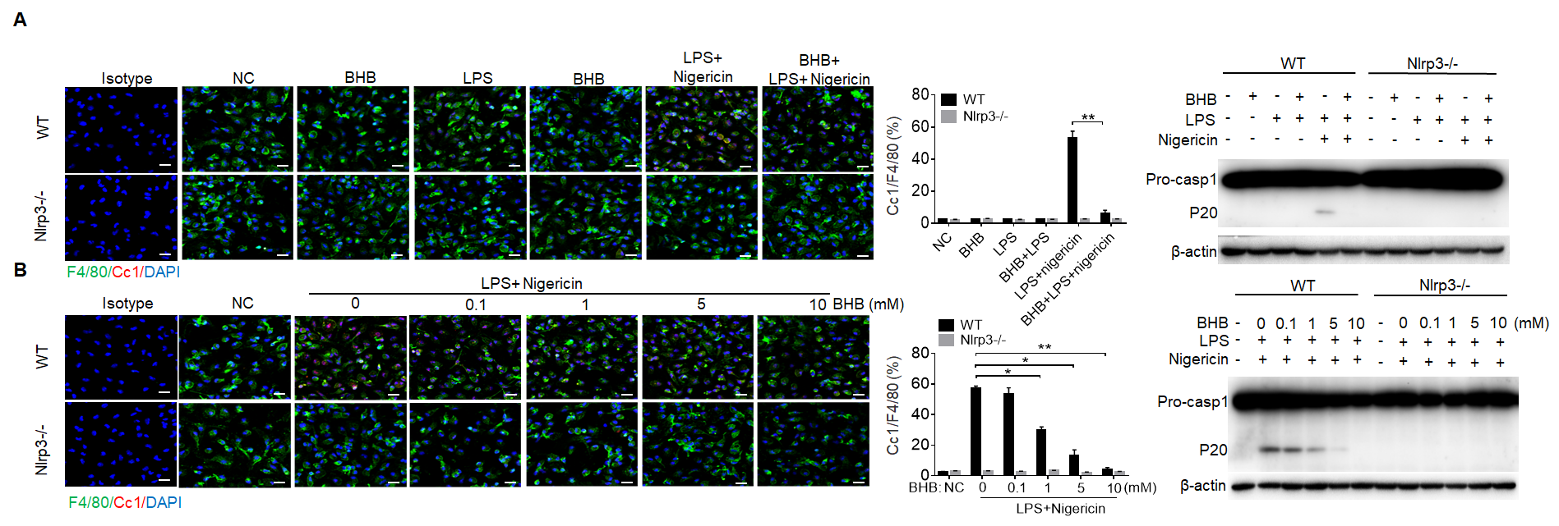

Fig. S8 BHB treated gut resident macrophages resist against pyroptosis. A Immunostaining for Cc1/F4/80 in BHB treated gut macrophages and immunoblotting of CASPASE 1 in the lysates of gut macrophages. Gut resident macrophages were isolated using anti-F4/80 MicroBeads. Scale bar=25μM. DAPI, blue. B Immunostaining of Cc1 and F4/80 in different concentrations of BHB treated gut macrophages and immunoblotting of CASPASE1 in the lysates of macrophages. Gut macrophages were isolated using anti-F4/80 MicroBeads. Scale bar=25μM. ONE-way ANOVA Bonferroni’s Multiple Comparison Test. *P < 0.05, **P < 0.01, ***P < 0.001.

Table S1. Reagents and oligoes used in this paper.
REAGENT or RESOURCE |  | SOURCE |  | IDENTIFIER
Antibodies
Percp-Cd11b M1/70 mouse | Biolegend |  | Cat: 101228
APC-CD45 30-F11 mouse | Biolegend |  | Cat: 103112
Percp-CD45 30-F11 mouse | Biolegend |  | Cat: 103132
PE-Ly6C mouse | Elabscience |  | Cat: E-AB-F1121D
APC-F4/80 BM8 mouse | Biolegend |  | Cat: 123116
PE-CD81 Eat2 mouse | BD Bioscience |  | Cat: 559519
APC-MHCII mouse | Elabscience |  | Cat: E-AB-F0990E
APC-CD81 Eat2 mouse | Biolegend |  | Cat: 104909
FITC-F4/80 BM8 mouse | Biolegend |  | Cat: 123108
Ly-6c (G-3) mouse | Santa |  | Cat: 10220
IL-10 (A-2) mouse | Santa |  | Cat: K0320
F4/80 (C-7) mouse | Santa |  | Cat: L3020
F4/80 mouse | RD |  | Cat: MAB5580
C1q-A (7HB) mouse | Santa |  | Cat: L1417
CD81 (B-11) mouse | Santa |  | Cat: L1820
βIII Tubulin (2G10) mouse | Abcam |  | Cat: Ab78078
Adrb2 mouse | Bioesn |  | Cat: BES2ER1
anti-CC1 mouse | Cell Signaling Technology |  | Cat: Asp296
Huc/d mouse | Abcam |  | Cat: Ab184267
Arg-1 mouse | Cell Signaling Technology |  | Cat: DEM3M
nNos mouse | ITI Biochem |  | Cat: ITI026657
Nlrp3 mouse | Affinity |  | Cat: DF7438
VGLUT2(8G9.2) mouse | Abcam |  | Cat: AB79157
ChAT mouse | Novus |  | Cat: NB110-89724
Caspase1/p20 antibody | Santa |  | Cat: sc-398715
βIII Tubulin mouse | Abcam |  | Cat: AB18207
β-Actin antibody mouse | Santa |  | Cat: sc-47778
Caspase1/p20/p10 | Protein tech |  | Cat: 22915-1-AP
Chemicals
Clodronate liposomes | Encapsula Nano Science |  | Cat: CLD8909-08302021
(R)-3-Hydroxybutanoic acid sodium | Sigma |  | Cat: 13613-65-5
Nigericin sodium | Selleckchem |  | Cat: S6653
Lipopolysaccharides | Sigma |  | Cat: 12181202
DMEM | Gibco |  | Cat: 11965118
Collagenase IV | Sigma |  | Cat: C5138
FBS | Gibco |  | Cat: 10099141
Dnase I | Solarbio |  | Cat: D8017
Percoll | Solarbio |  | Cat: P8370

