Supplementary appendix
- Search Strategies
An electronic search was performed, with no time or language restrictions, in the following electronic bibliographic databases: PubMed, EMBASE, Web of Science and Cochrane library, up to 0ctober 26, 2022.
1.1 Web of Science
1: TS=(obesity) results: 706827
2: TS= (temporomandibular joint disorders) results: 20136
3: #2 AND #1 results: 42
1.2 PubMed
"TMD"[All Fields] AND ("obeses"[All Fields] OR "obesity"[MeSH Terms] OR "obesity"[All Fields] OR "obese"[All Fields] OR "obesities"[All Fields] OR "obesity s"[All Fields])
1.3 Embase
No. Query Results Results
#3. #1 AND #2 50
#2. 'temporomandibular joint disorder' 16,568
#1. 'obesity'/exp 625,432
1.4 Cochrane library
ID Search Hits
#1 (obesity) (Word variations have been searched) 53474
#2 ("temporomandibular joint disorder") (Word variations have been searched) 1094
#3 #1 AND #2 2

Figures

Figure S1: Funnel plot in each subgroup based on BMI. (A) Obesity Ⅰ (BMI≥25) vs. normal weight (18.5≤BMI<23), (B)obesity Ⅱ (BMI≥30) vs. normal weight (18.5≤BMI<23), (C) obesity Ⅱ (BMI≥30) and obesity Ⅰ (25≤BMI<30), (D) obesity (BMI≥25) and non-obesity (BMI<25).
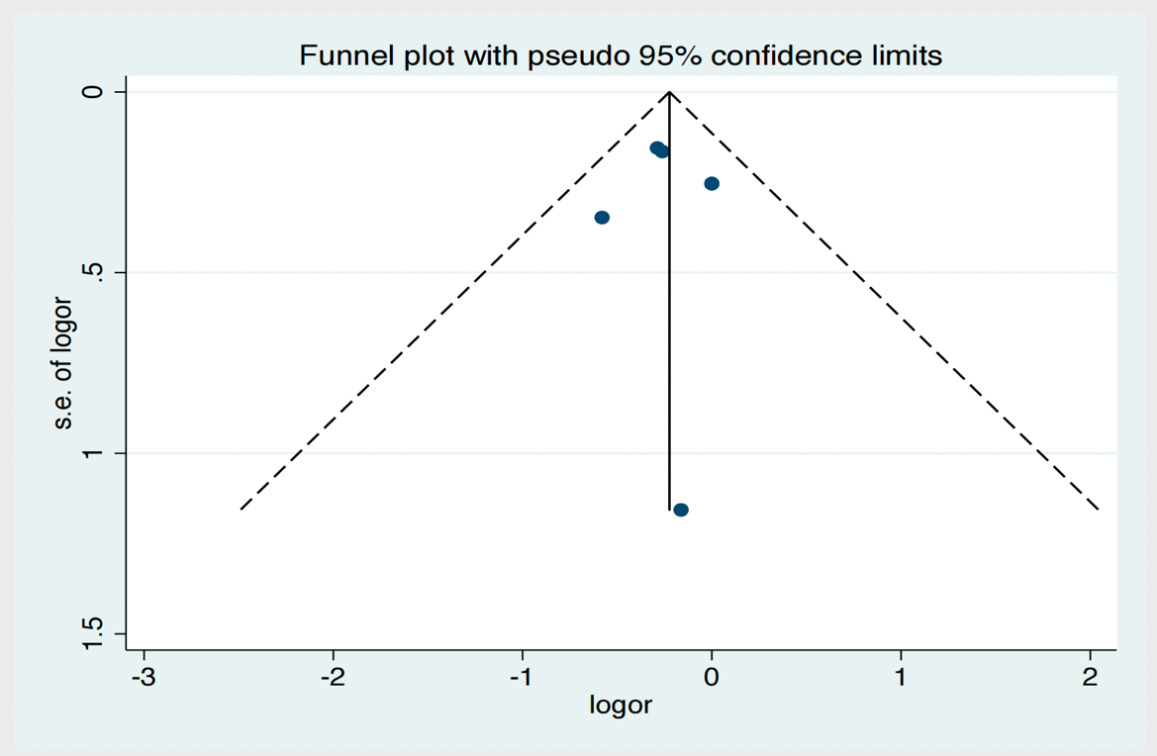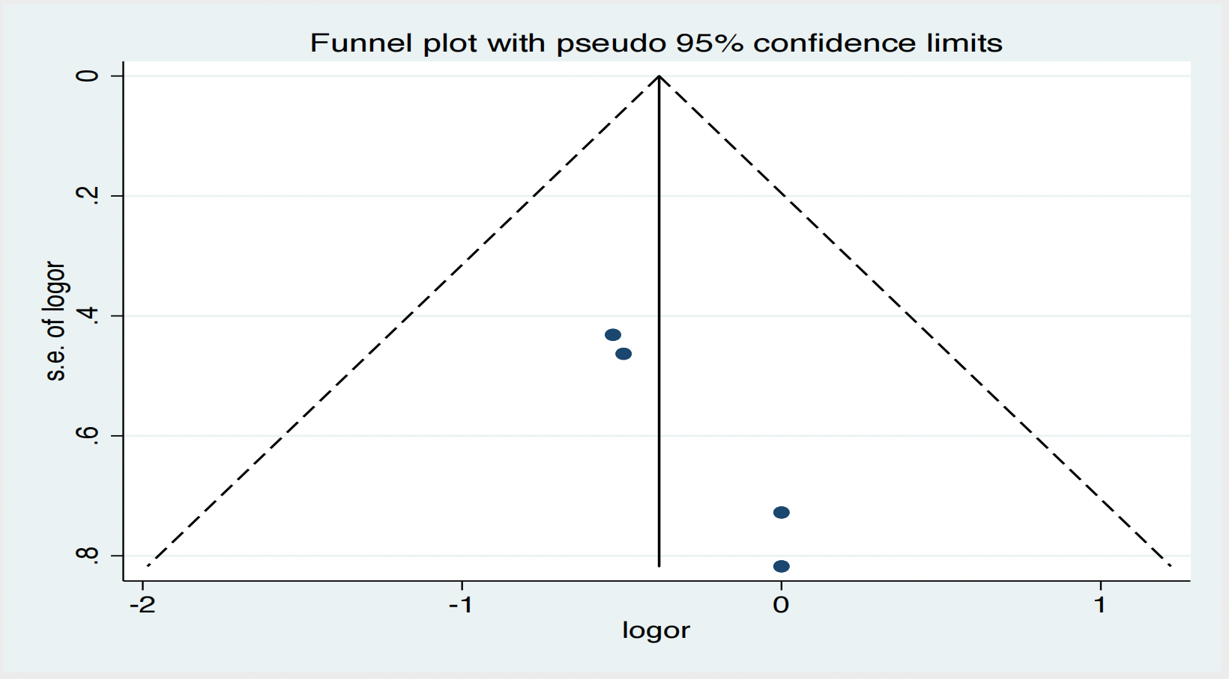
A B
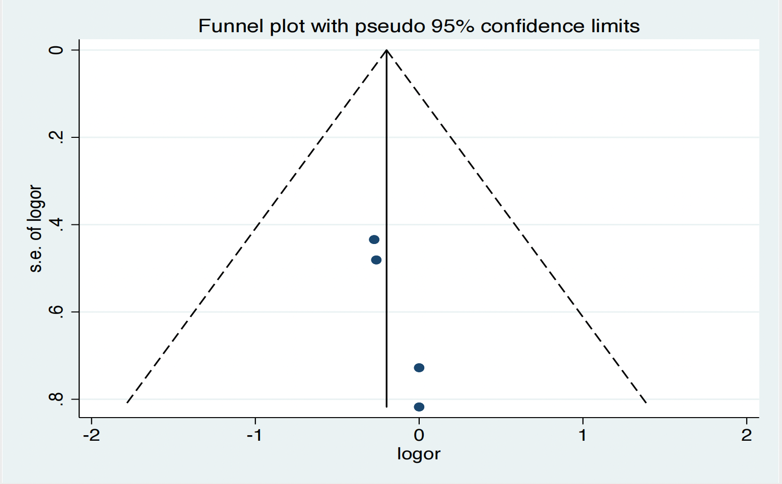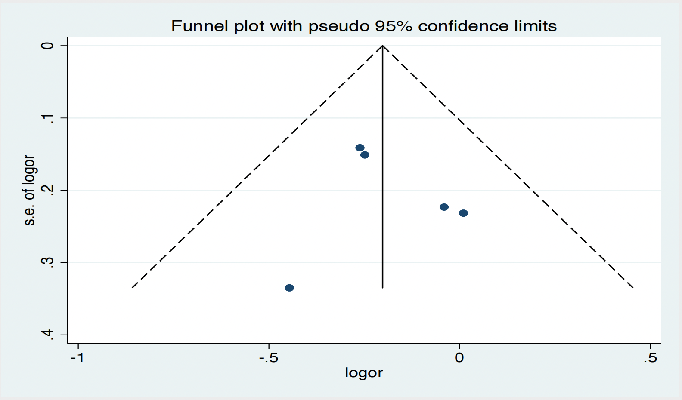
C D
Figure S2: The trim-and-fill method of funnel plot in each subgroup based on BMI. (A) obesity Ⅱ (BMI≥30) vs. normal weight (18.5≤BMI<23), (B) obesity Ⅱ (BMI≥30) and obesity Ⅰ (25≤BMI<30).
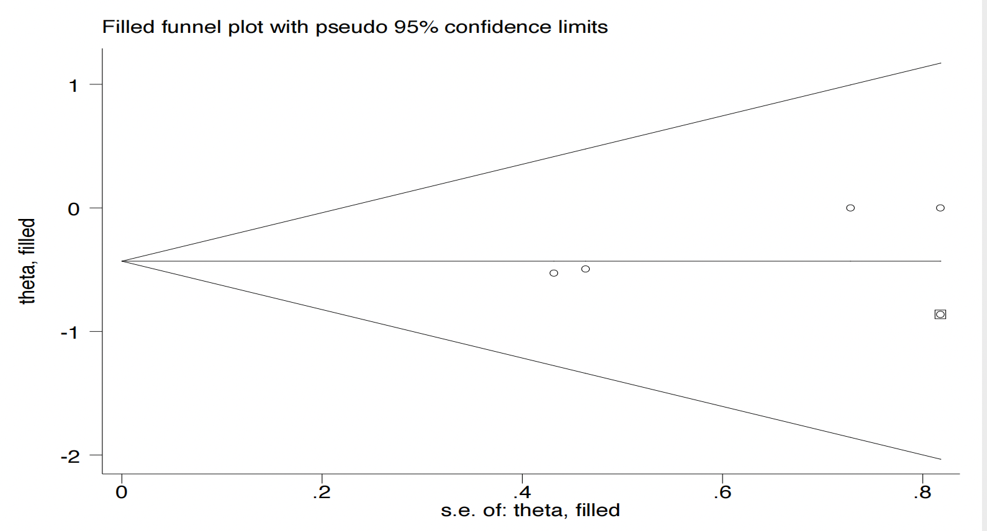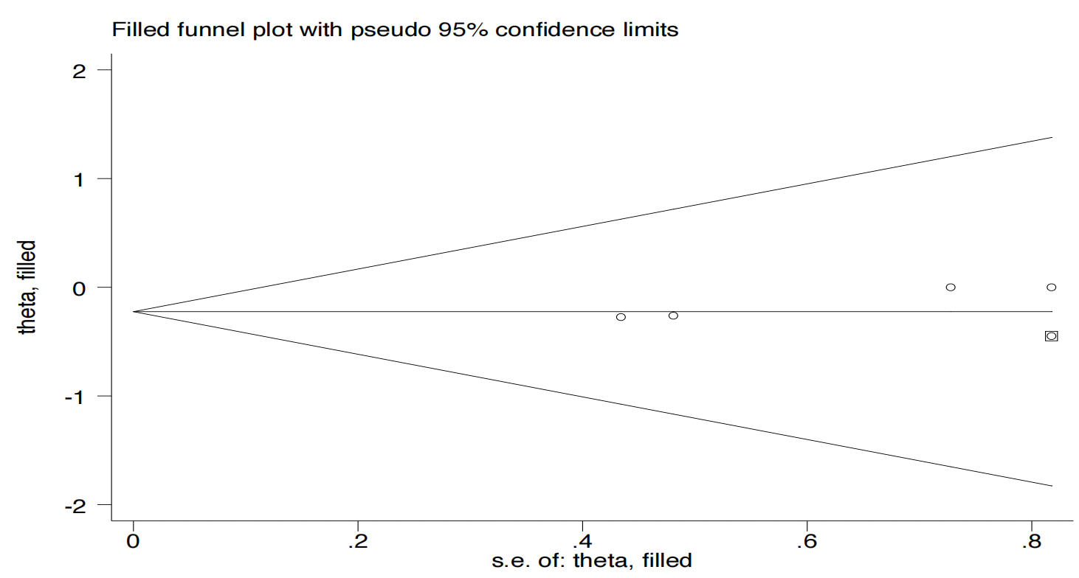
A B

Tables
Table S1. The result of Egger’s test for publication bias in each subgroup.
Subgroups | P value
BMI≥25 vs. 18.5≤BMI<23 | P=0.871
BMI≥30 vs. 18.5≤BMI<23 | P=0.013
BMI≥30 vs. 25≤BMI<30 | P=0.018
BMI≥25 vs. BMI<25 | P=0.758

