Transgenerational epigenetic inheritance mediated by the acetyltransferase MYS-2/MOF in the pathogenesis of Alzheimer’s disease

Yuhong Li^{1,2#}, Hua Bai^{1,3#}, Wenwen Liu^{1#}, Huan Gu¹, Tingting Wu⁴, Guolin Shi⁴, Man Zhu^{1,2}, Ninghui Zhao^{4,*}, Xiaowei Huang^{1,}*
- School of Medicine, and State Key Lab for Conservation and Utilization of Bio-Resources, Yunnan University, Kunming 650091, China
- College of Biological Resources and Food Engineering, Qujing Normal University, Qujing,655000, China
- School of Public Health, Kunming Medical University, Kunming, 650500, China
- Neurosurgery of the Second Hospital affiliated with Kunming Medical University, Kunming 650101, China

#Yuhong Li, Hua Bai and Wenwen Liu contribute equally to the paper
*Corresponding author: Xiaowei Huang xwhuang@ynu.edu.cn; Ninghui Zhao zhaoninghui@hotmail.com

Supplemental data

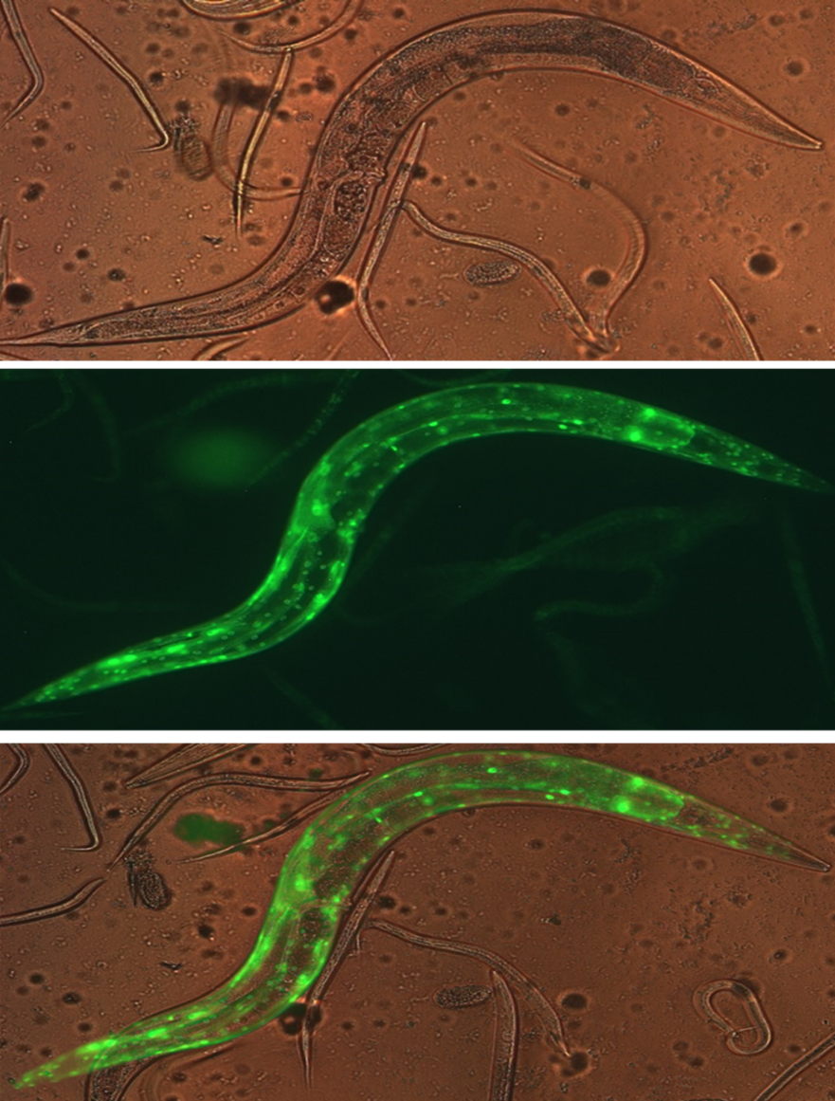
Figure S1. The acetyltransferase gene mys-2 was expressed ubiquitously within the whole body of C. elegans. Mys-2 promoter linked to the plasmid pPD95_79 that contained GFP in frame was microinjected into the CL4176 germline. The F1 generation that had GFP fluorescence was chosen to localize the expressional pattern of mys-2.

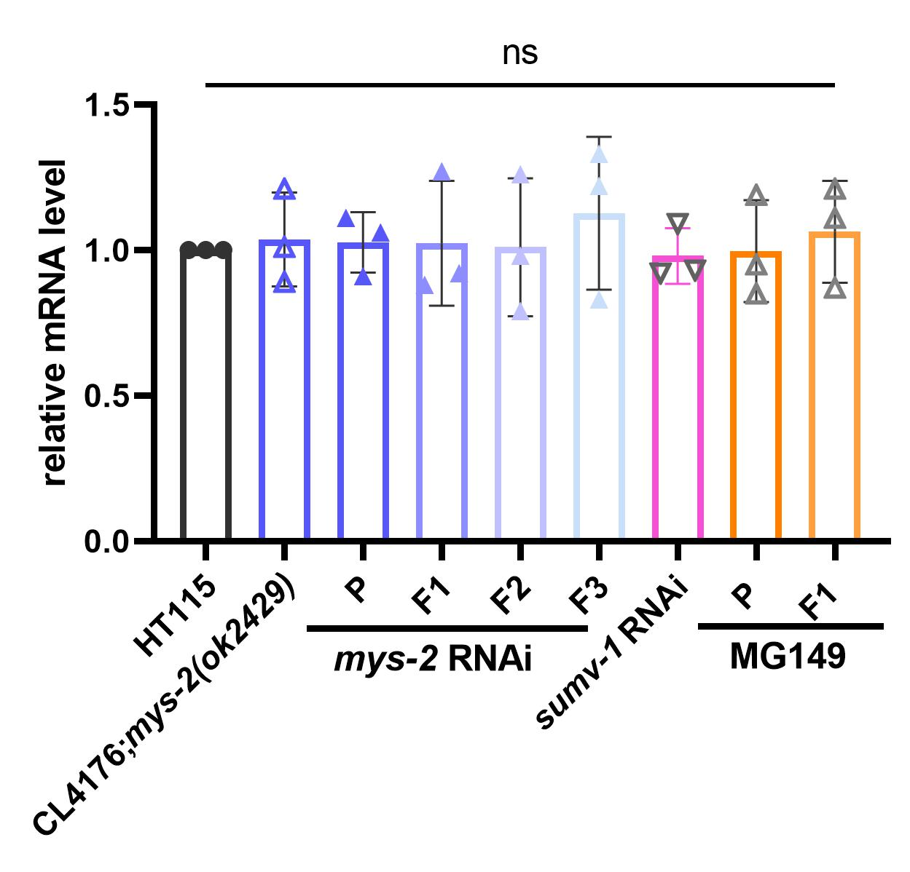
Figure S2. Quantitative PCR to determine the expression levels of Aβ1-42 in different conditions/lines. No significant differences were observed in Aβ expressions among CL4176:mys-2(ok2429), P generation treated with mys-2 RNAi, F1-F3 generations, sumv-1 RNAi, and MG149 treatment.

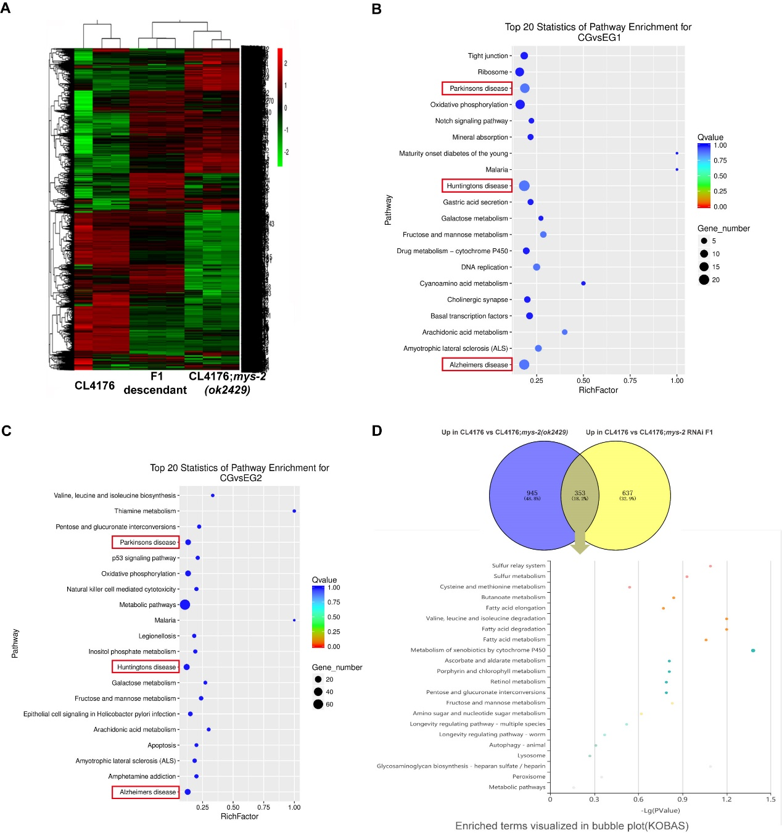
Figure S3. F1 progeny showed epigenetic memory as evidenced by similar gene expression patterns to the P generation.
(A) RNA-seq heatmap of differentially expressed genes（|log2Ratio|≥ 1 and q value≤0.05）in CL4176, CL4176:mys-2(ok2429), and F1 descendants whose P generation had been treated with mys-2 RNAi showed similar clusters of upregulated and downregulated genes. (B-C) KEGG pathway enrichment of the differentially expressed genes in CL4176 vs CL4176;mys-2(ok2429) (B) and CL4176 vs F1 descendants of the P generation treated with mys-2 RNAi (C). The horizontal axis represents significance of enrichment, and the longitudinal axis represents the enrichment terms. The size of each dot represents the number of genes contained in the corresponding term. (D) Venn diagram for the upregulated genes shared by the P and F1 generations. Enriched pathways involved in lysosomal activity, fructose/mannose metabolism, and fatty-acid metabolism.

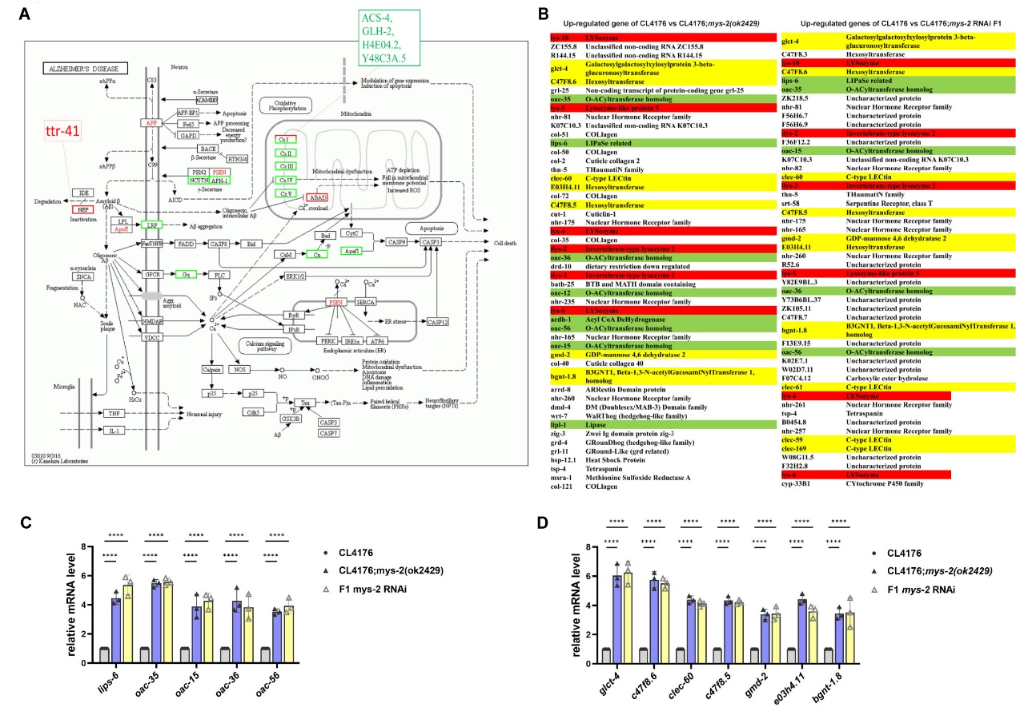
Figure S4. The expression levels of enriched pathways genes were similar between P and F1
(A) Differentially expressed genes related to AD pathogenesis pathway, including upregulated genes marked in red and downregulated genes marked in green. (B) Lists of the Top 50 upregulated genes in CL4176 vs CL4176:mys-2(ok2429) and CL4176 vs F1. Genes involved in lysosome activity were marked in red, the genes involved in fatty metabolism were marked in green, and the genes involved in sugar metabolism were marked in yellow. (C-D) Genes associated with fatty acid (C) and sugar (D) metabolism were compared between the CL4176:mys-2(ok2429) nematodes and F1 descendants. Three independent experiments were analyzed using two-way ANOVA followed by Dunnett’s multiple comparisons test.

Figure S5. Description of ChIP-sequencing data gene distribution. ChIP-seq peaks of MOF over all chromosomes.

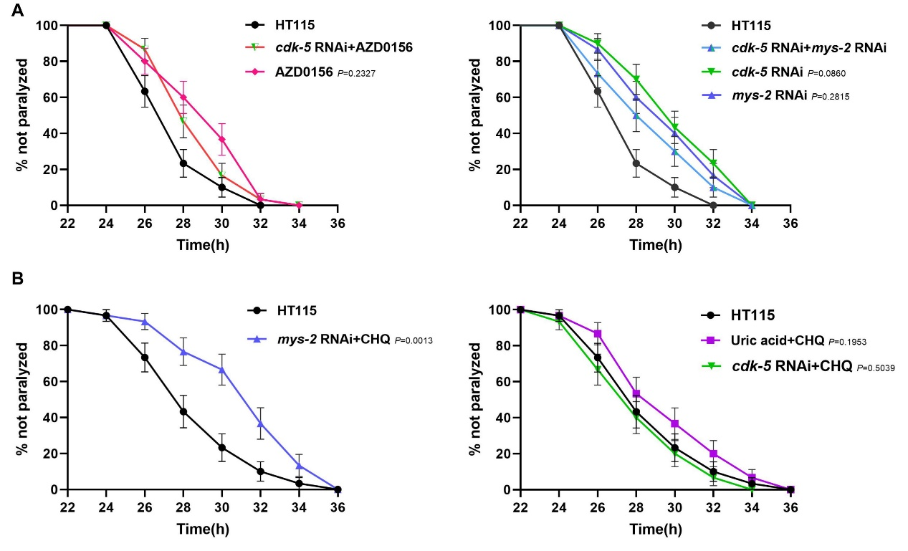
Figure S6. CDK-5, ATM, and Mys-2 function in the same signaling pathway in C. elegans.
(A) No cumulative effects were observed among the various genes. There were no significant differences observed between treatment with the ATM inhibitor AZD0156 and cdk-5 RNAi, and with AZD0156 treatment alone. Moreover, double RNAi of ckd-5 and mys-2 produced paralytic rates comparable to those observed with ckd-5 RNAi or mys-2 RNAi treatment alone. (B) The dominant phenotypes of downstream genes within the ROS/CDK-5/ATM signaling pathway (P value presented as the comparison with HT115).

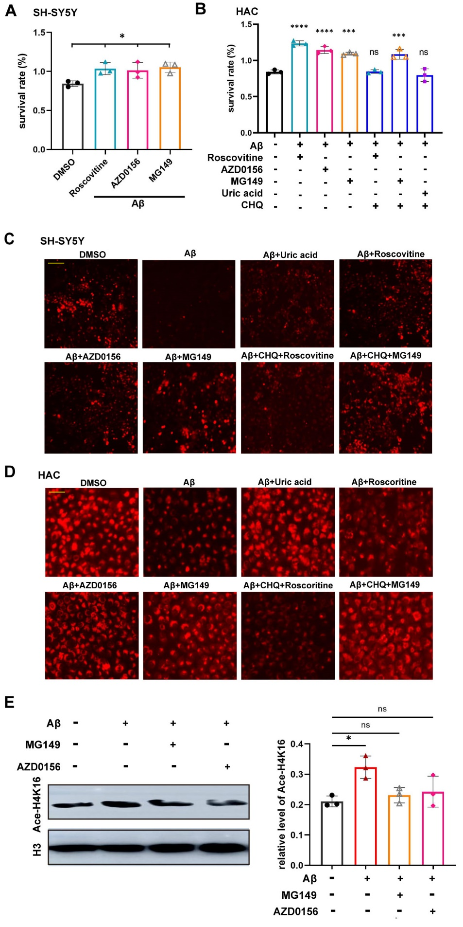
Figure S7. The mammalian homologs of CDK-5/ATM/MOF functioned in AD-like pathogenesis in HAC cell models.
(A) Treatment with specific inhibitors, such as roscovitine for CDK5, AZD0156 for ATM, and MG149 for MOF, increased cell survival rates in vitro. (B) The mammalian analogs of CDK-5, ATM, and MOF functioned in the same signaling pathway because the dominant phenotypes of downstream genes were observed in vitro. (C-D) The mammalian ROS/CDK-5/ATM/MOF signaling pathway modulated lysosome formation in SH-SY5Y (C) and HAC (D) cell lines. (E) Western blotting and quantification of H4K16ac in SH-SY5Y following addition of specific inhibitors, including MG149 for MOF and AZD0156 for ATM.

