Supplementary information for:
Ultra-Broadband Magneto-Optical Isolators and Circulators on Silicon Nitride
Wei Yan^{1,2}, Zixuan Wei^{1,2}, Yucong Yang^{1,2}, Di Wu^{1,2}, Zijian Zhang^{1,2}, Xiaoyi Song^{1,2}, Songgang Cai^{1,2}, Jun Qin^{1,2}, Longjiang Deng^{1,2} and Lei Bi^{1,2,*}
¹National Engineering Research Center of Electromagnetic Radiation Control Materials, University of Electronic Science and Technology of China, Chengdu 610054, China
²State Key Laboratory of Electronic Thin-Films and Integrated Devices, University of Electronic Science and Technology of China, Chengdu, 610054, China

*Corresponding author, E-mail: bilei@uestc.edu.cn

Contents:
S1. Characterization of silicon nitride broadband 3 dB directional couplers
S2. Wavelength dependence of the Faraday rotation of CeYIG films
S3. Fabrication tolerance of the ultra-broadband magneto-optical isolators
S4. Loss optimization of the broadband optical isolator
S5. Design of an O/C dual band optical isolator

S1. CHARACTERIZATION OF SILICON NITRIDE BROADBAND 3 dB DIRECTIONAL COUPLERS
The silicon nitride (SiN) based broadband 3 dB directional coupler for TM polarization was designed using the mode evolution principle [1]. Fig. S1 (a) shows the input and output cross-sectional structure of the proposed device. The thickness of the SiN waveguide was fixed at 400 nm. The space between the two SiN waveguides was maintained at 450 nm. Within a 500 μm long adiabatic taper, the widths of the two SiN waveguides slowly changed from 1300 nm and 700 nm to 1000 nm, respectively. The FDTD simulation of power transmission for the designed structure is shown in Fig. S1 (b). We further fabricated the device and measured the transmission spectra at the two output waveguides, as shown in Figure S1 (c). Experimental results showed that the device achieved 3 dB power splitting in the measured wavelength range from 1520 nm to 1610 nm. However, there was still a slight difference of about 0.3 dB between the output light powers of the two ports, which indicated that the splitting ratio of the two ports was approximately 0.48:0.52. The above splitting ratio limited the maximum isolation of the device to be 28 dB, which can be experimantally improved by further extending the length of the SiN adiabatic taper.
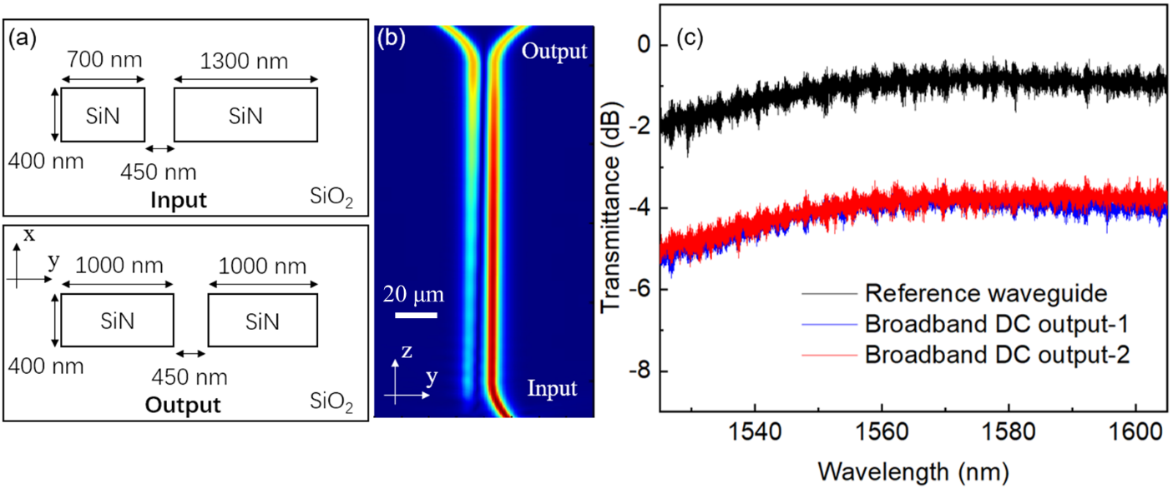
Fig. S1. (a) The input and output cross-sectional structure of the SiN broadband 3 dB directional coupler. (b) Simulated power transmission and (c) measured transmission spectra of the SiN broadband 3 dB directional coupler.

S2. WAVELENGTH DEPENDENCE OF THE FARADAY ROTATION OF CEYIG FILMS
We used COMSOL to calculate the wavelength dependence of the Faraday rotation of CeYIG based on the measured NRPS Δβ as shown in Fig. 2(c). The simulation model we built is shown in Fig. 2(a) in the manuscript. For each wavelength, we can get the off diagonal component γ of the permittivity tensor of CeYIG [2] by
where β is the propagation constant of the fundamental TM mode. ω is the angular frequency, ε₀ is the vacuum dielectric constant, N is the power flux along the light propagation direction, n₀ is the refractive index of CeYIG, H_{x} is the magnetic field along x direction.
After obtaining the the off diagonal component γ of the permittivity tensor of CeYIG, we can then calculate the Faraday rotation θ_{F} of CeYIG at each wavelength λ to be [3]
Repeating the simulation described above, we obtained the Faraday rotation of CeYIG thin films as a function of wavelength as shown in Fig. S2.
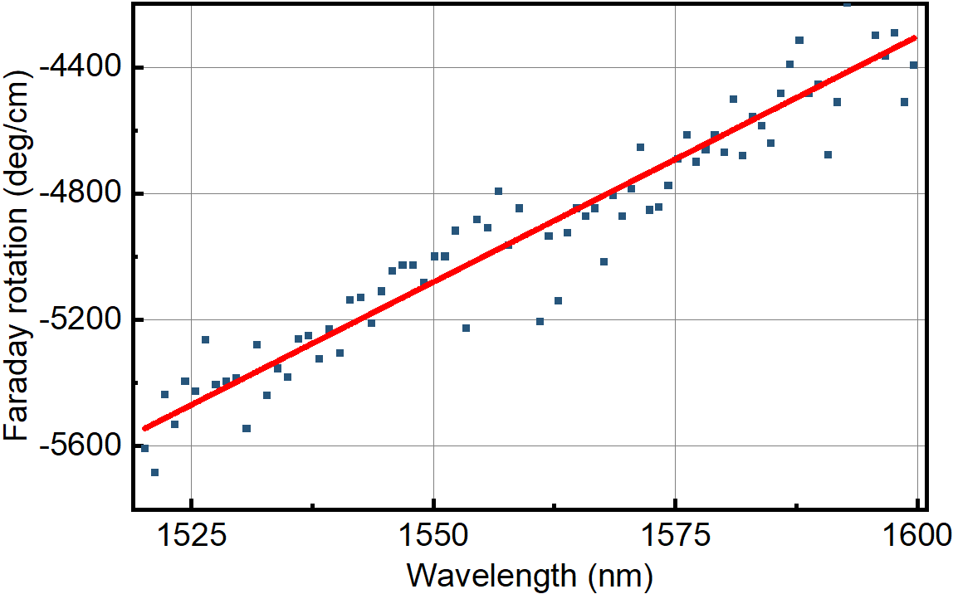
Fig. S2. Calculated Faraday rotation of CeYIG thin films as a function of wavelength.

S3. FABRICATION TOLERANCE OF THE ULTRA-BROADBAND MAGNETO-OPTICAL ISOLATORS
Fig. S3 (a) shows the measured transmission spectra of the fabricated Mach-Zehnder interferometer (MZI) structure before depositing YIG/CeYIG thin films, when the input light was coupled to one of the two input ports as described by
where E₁ and E₂ denote the electric field of the input light coupled to the two input ports. When the total phase difference between the two arms of the MZI is φ₂-φ₁=φ, the output of the MZI can be calculated to be
where θ is related to the optical beam splitting ratio. By simplifying the above formula, we can further obtain the output optical power P₃ and P₄ of the MZI to be
When the optical beam splitter can achieve perfect 3 dB splitting, that is $sinθ=cosθ=\sqrt{2}/2$. Then the above equations can be further simplified to
Based on the above theoretical analysis, we could acquire the approximate phase error of the fabricated MZI structure according to the measured transmission spectra in Fig. S3 (a).
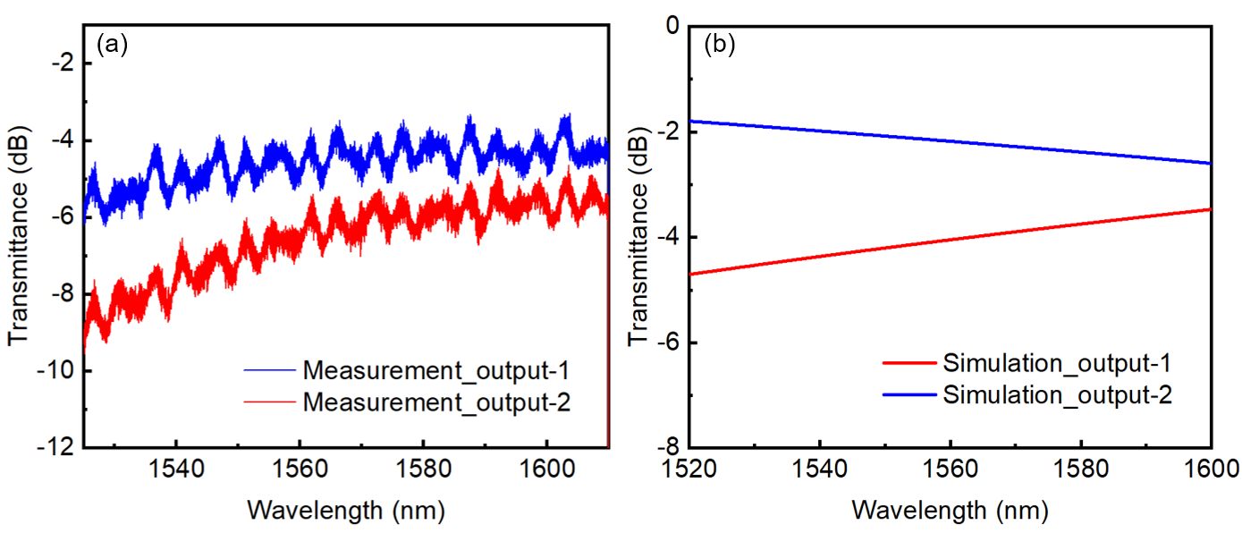
Fig. S3. (a) Measured and (b) simulated transmission spectra of the two outputs of the fabricated Mach-Zehnder interferometer (MZI) structure before depositing MO thin films.
In theoretical design, the output powers from the two ports of the MZI should be equal to each other at the center wavelength of 1550 nm before the growth of MO thin films, with reciprocal phase shift designed to be π/2. However, due to the fabrication error of the SiN waveguides in two arms, a difference of about 2 dB has been generated between the output powers of the two ports at the center wavelength. We first simulated the transmission spectra shown in Fig. S3 (b), and the output power of the two output ports is basically the same as that of Fig. S3 (a), where the overall loss of about 3-4 dB between the measurement and the simulation comes from the coupling loss between SiN waveguides and fibers. The simulation results show that the widths of the pair of SiN waveguides providing reciprocal phase shift changes from 500 nm and 1000 nm to about 450 nm and 980 nm due to the fabrication error, respectively.
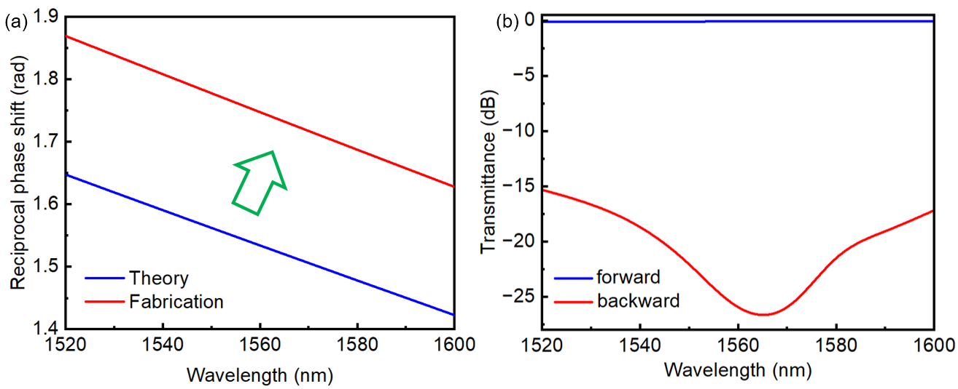
Fig. S4. (a) Schematic diagram of the designed reciprocal phase shift compared with the actual one due to the waveguide fabrication error. (b) The theoretical transmission spectra of the device after depositing MO thin films on the MZI structure with the fabrication error.
We also calculated the reciprocal phase shift corresponding to the transmission spectra in Fig. S3, as shown in Fig. S4 (a). The reciprocal phase shift of the fabricated device deviated by about 0.22 rad from the designed value as shown in Fig. S4 (a). As a result, after deposition of 50 nm YIG and 130 nm CeYIG thin films on the MZI structure analyzed above, the corresponding theoretical transmission spectra of the device can be simulated considering the limitation of the beam splitting ratio in Fig. S1, as shown in Fig. S4 (b). Obviously, when the discussed fabrication error occurs, the proposed MO isolator showed smaller bandwidth. The theoretical 20 dB isolation bandwidth was now less than 40 nm (1540 nm to 1580 nm wavelength), consistent with the experimental result.
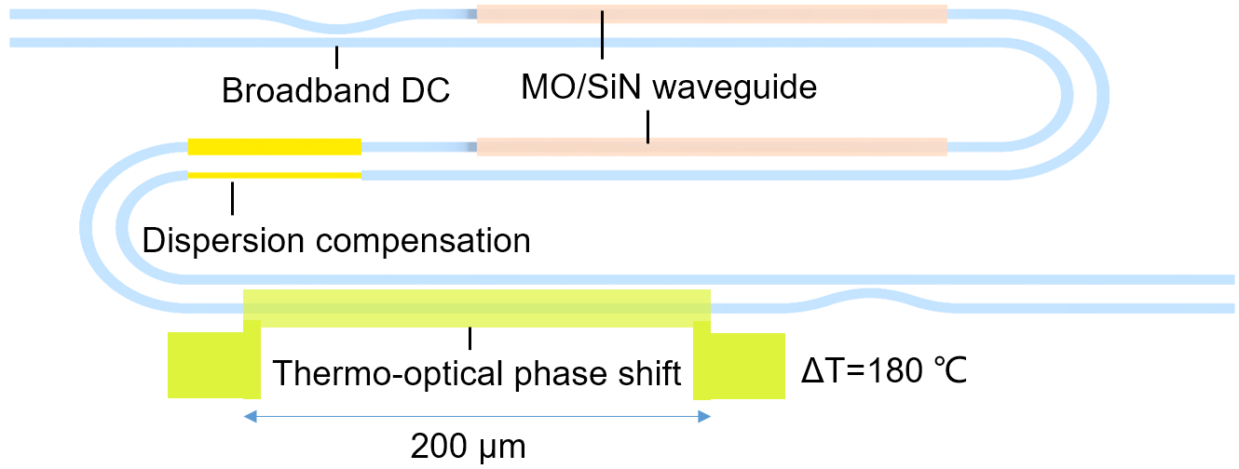
Fig. S5. Schematic diagram of the thermo-optical modulation structure in the SiN magneto-optical isolator.

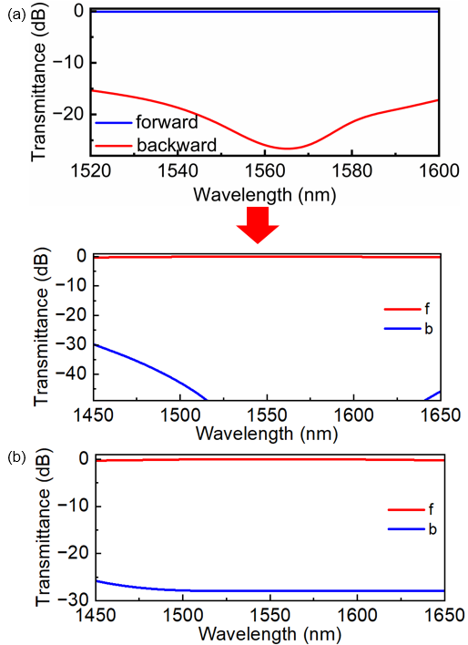
Fig. S6. Theoretical transmission spectra of the device before and after the thermo-optical modulation (a) with and (b) without the considersion of the limitations of the measured splitting ratio of the broadband 3 dB directional couplers.
In order to solve the phase mismatch problems caused by the above preparation errors and further increase the isolation bandwidth, an effective method is to adjust the Δφ(RPS) to match with the Δφ(NRPS) using thermo-optical modulation as shown in Fig. 5. Based on the phase in Fig. S4 (a), we need to perform thermo-optical modulation on the 200-micron-long silicon nitride waveguide with a temperature change ΔT=180 ℃. As a result, we can increase the reciprocal phase shift to 3π/2 at 1550 nm wavelength. We plot the theoretical transmission spectra of the device before and after the thermo-optical modulation in Fig. S6 (a). When considering the limitation of the beam splitting ratio in Fig. S1, the transmission spectra change correspondingly as shown in Fig. S6 (b). It can be indicated that when the Δφ(RPS) is rematched with the Δφ(NRPS), the device can still achieve a large isolation bandwidth.
S4. LOSS OPTIMIZATION DESIGNS
In Fig. 3(d), the forward transmission loss caused by non-zero phase difference reaches 0.8 dB in the wavelength range of 1440-1680 nm. To reduce the loss within the isolation bandwidth, we decreased the group delay value of the Δφ(RPS) at the expense of lower isolation ratio. The forward transmission loss was mainly due to the large group delay of Δφ(RPS)+Δφ(NRPS) in Fig. 3(c), which caused it to rapidly deviate from 0 rad. Therefore, we need to reduce the group delay requirement of Δφ(RPS), thereby slowing down the change of Δφ(RPS)+Δφ(NRPS) with wavelength. Fig. S7 shows the simulated 0.3 dB insertion loss bandwidth and 20 dB isolation bandwidth as a function of the group dalay of Δφ(RPS). It can be inferred that by reducing the group delay of Δφ(RPS), the insertion loss bandwidth of the device has been expanded, at the expense of decreased isolation bandwidth.
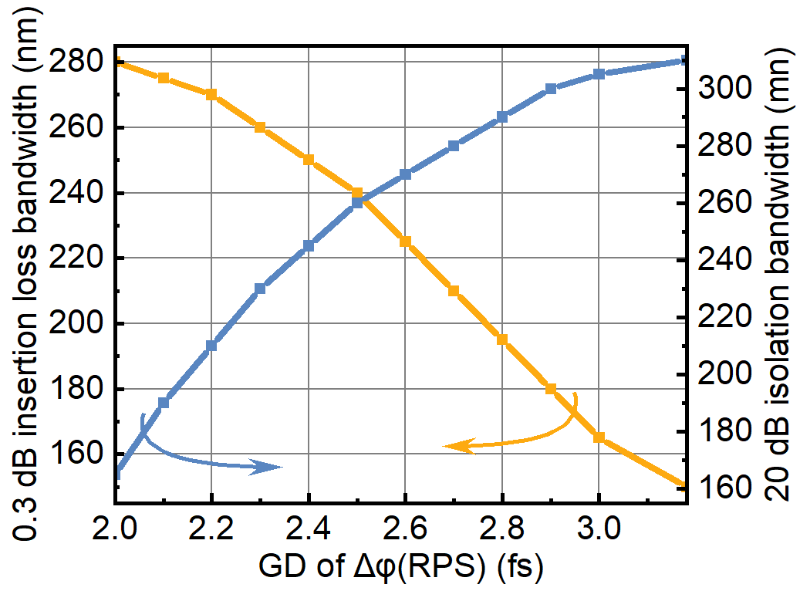
Fig. S7. Simulated 0.3 dB insertion loss bandwidth and 20 dB isolation bandwidth as a function of the group dalay of the reciprocal phase shift Δφ(RPS).
Compared to the group delay of 3.181 fs designed for the large isolation ratio, we reduced the group delay of Δφ(RPS) to 2.5 fs here as
Meanwhile, Δφ(RPS) and Δφ(NRPS) at 1550 nm need to meet
The calculated dispersion compensation waveguide structure was W₁=600 nm and L=7.6 μm. The corresponding Δφ(RPS) and Δφ(NRPS) can be found in Fig. S8.
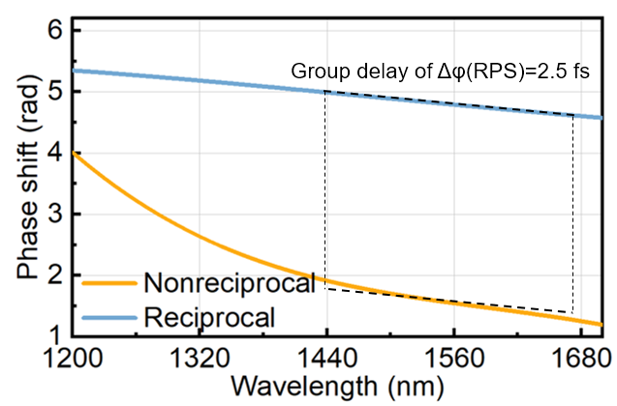
Fig. S8. Simulated reciprocal and nonreciprocal phase shift as a function of the wavelength in the loss optimization designs.
Based on the above phase shift, the simulated phase shift of the forward (Δφ(RPS)+Δφ(NRPS)) and backward (Δφ(RPS)-Δφ(NRPS)) transmission directions for the loss optimization design and the corresponding transmission spectra can then be obtained as shown in Fig. 5(a) and (b) in the manuscript.

S5. DUAL BAND OPTICAL ISOLATOR DESIGNS
To design of dual band optical isolator covering the O and C bands, we treated the isolation ratio as a priority in our design. We first shortened the length of the MO waveguide from 891.8 μm to 528.9 μm, so that Δφ(NRPS) at 1310 nm wavelength is π/2, which also reduces the magnitude of the change of Δφ(NRPS) between O and C bands, as shown in Fig. S9.
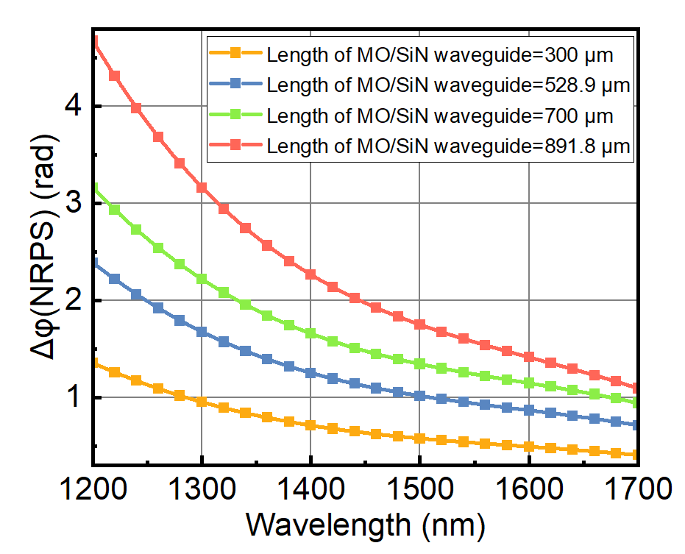
Fig. S9. Simulated nonreciprocal phase shift Δφ(NRPS) as a function of the wavelength under different lengths of the MO/SiN waveguide.
Firstly, we make that Δφ(RPS)±Δφ(NRPS) equal to π at both 1310 nm and 1550 nm wavelengths. In addition, to ensure the large isolation ratio in the wavelength range between 1310 nm and 1550 nm, we need to add two more conditions. That is Δφ(RPS)±Δφ(NRPS) also equals to π, and the group delay of Δφ(RPS)-Δφ(NRPS) equals to 0 at 1430 nm, which is located in the middle of 1310 nm and 1550 nm wavelength. As a result, the phase and group delay requirements that Δφ(RPS) and Δφ(NRPS) need to meet can be described as
In order to meet the above 4 conditions, we introduce four parameters W₁, W₂, L₁ and L₂ of the dispersion compensation structure to be solved. The phase Δφ(RPS) and Δφ(NRPS) obtained is shown in Fig. S10 after solving for eqns. (5)-(6) in the manuscript together with the above expressions. The obtained waveguide size parameters are W₁=950 nm, W₂=995 nm, L₁=200.18 μm, L₂=200.3 μm.
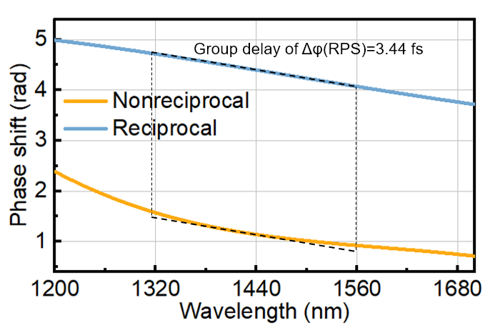
Fig. S10. Simulated reciprocal and nonreciprocal phase shift as a function of the wavelength in the dual band optical isolator designs.
Based on the above phase shift, the simulated phase shift of the forward (Δφ(RPS)+Δφ(NRPS)) and backward (Δφ(RPS)-Δφ(NRPS)) transmission directions for the loss optimization design and the corresponding transmission spectra can then be obtained as shown in Fig. 5(c) and (d) in the manuscript. While due to the large forward transmission phase mismatch around 1550 nm wavelength, the corresponding forward transmission loss reaches nearly 2 dB at 1550 nm wavelength. Better phase matching may be achieved by utilizing structures such as subwavelength waveguide gratings (SWG) [4] whose phase shift changes nonlinearly with wavelength.

REFERENCE
1. Wang Yun, Xu Luhua, Yun Han, Ma Minglei, Kumar Amar, El-Fiky Eslam, Li Rui, Abadiacalvo Nicolas, Chrostowski Lukas, Jaeger Nicolas A. F., and Plant David V., "Polarization-Independent Mode-Evolution-Based Coupler for the Silicon-on-Insulator Platform," IEEE Photonics Journal 10, 1-10 (2018).
2. Yan Wei, Yang Yucong, Liu Shuyuan, Zhang Yan, Xia Shuang, Kang Tongtong, Yang Weihao, Qin Jun, Deng Longjiang, and Bi Lei, "Waveguide-integrated high-performance magneto-optical isolators and circulators on silicon nitride platforms," Optica 7(2020).
3. Shoji Y., Miura K., and Mizumoto T., "Optical nonreciprocal devices based on magneto-optical phase shift in silicon photonics," Journal of Optics 18, 013001 (2016).
4. Halir Robert, Bock Przemek J., Cheben Pavel, Ortega‐Moñux Alejandro, Alonso‐Ramos Carlos, Schmid Jens H., Lapointe Jean, Xu Dan‐Xia, Wangüemert‐Pérez J. Gonzalo, Molina‐Fernández Íñigo, and Janz Siegfried, "Waveguide sub‐wavelength structures: a review of principles and applications," Laser & Photonics Reviews 9, 25-49 (2014).

