Supplementary Material for
Discerning the roles of various reactive oxygen species on PFOA degradation

Jin Yang¹, Ye Xiao^{*1,2}, Yue Wang¹, Qin Tang¹, Xiaomin Zhu¹, Weihua Zhang^{1,2}, Rongliang Qiu^{*1,2,3}

- Guangdong Provincial Key Laboratory of Environmental Pollution and Remediation Technology, Guangdong Provincial Engineering Research Center for Heavy Metal Contaminated Soil Remediation, School of Environmental Science and Engineering, Sun Yat-sen University, Guangzhou 510275, P. R. China;
- Guangdong Laboratory for Lingnan Modern Agriculture, Guangzhou 510642, P. R. China;
- Guangdong Provincial Key Laboratory of Agricultural & Rural Pollution Abatement and Environmental Safety, College of Natural Resources and Environment, South China Agricultural University, Guangzhou 510642, P. R. China;

* Corresponding author: Ye Xiao, Associate Professor, Sun Yat-sen University; Tel.: +86 15521052029; email: xiaoy299@mail.sysu.edu.cn
* Corresponding author: Rongliang Qiu, Professor, Sun Yat-sen University; Tel.: +86 13450420058; email: eesqrl@mail.sysu.edu.cn

Text S1. Chemicals and Reagents
Perfluorooctanoic acid (95% purity) was purchased from Sigma-Aldrich. H₂O₂ (30%, w/w) and dimethyl sulfoxide (DMSO, ≥99.9% purity) were obtained from Thermo Fisher Scientific. H₂SO₄ (98%) and HClO₄ (72%) were obtained from Xinhong Co., Ltd. (Guangzhou, China). All chemicals used in the experiments were used as received. NaOH (99.9% purity), FeSO₄·7H₂O (99% purity), NaClO₄·H₂O (98% purity), EDTA-2Na (99% purity), 1-Butanol (99.5%, purity), 2,2,6,6-tetramethyl-1-piperidinyloxy (TEMPO, 98%, purity), carbon nanotubes (CNT, >95%, multi-walled, ID: 2-5 nm, OD: <8 nm, Length: 10-30 um) and polyvinylidene fluoride (PVDF) were purchased from Macklin (Shanghai, China). Ethanol (EtOH, >95% purity), N-methyl-2-pyrrolidone (NMP, 99% purity), 5,5-dimethyl-1-pyrroline N-oxide (DMPO, 97%, purity), Hemin (95%, purity) and anthraquinone-2-sodium sulfonate (AQS, 99% purity) were purchased from Aladdin (Shanghai, China). Nitrotetrazolium blue chloride (NBT) was purchased from Solarbio (Beijing, China). Carbon paper (CP, TGP-H-060) was purchased from Toray (Japan). Boron-doped diamond (BDD) electrode was purchased from Baiqian Biotechnology Co., Ltd. (Shanghai, China). Experimental solutions were prepared using ultrapure water (>18.2 MΩ cm) from a Milli-Q system.

Text S2. PFOA degradation using catalytic H₂O₂ propagations (CHP)
PFOA degradation reactions by CHP were conducted at 25℃ in a 200 mL beaker. Typically, 5 mg/L of PFOA was added into the reaction solution. Homogeneous ·OH was generated by the Fenton reaction, with 2 mM Fe²⁺ slowly added to 1 M H₂O₂ at pH 3.5(Tang et al. 2012). O₂·⁻ was generated by a Fenton-like reaction at pH 9.5 in the presence of 1 M or 2 M H₂O₂, and 5 mM Fe³⁺-EDTA-2Na and 3 M ethanol was added to scavenge ·OH in the system. HO₂⁻ was generated by increasing the pH of the H₂O₂ solution (1 M or 2 M) to pH 12.8(Mitchell et al. 2014).

Text S3. PFOA degradation using electro-Fenton (EF) process
Electro-Fenton degradation of PFOA (5 mg/L) in a 10 mM NaClO₄ electrolyte was conducted in a one-compartment electrolytic cell using different cathodes. Pt and Ag/AgCl were served as anode and reference electrode, respectively. (1) Using Pt (effective area of 9.0 cm²) as the cathode, after 1 h electrolysis at a constant current density of 10 mA/cm², 2 mM Fe²⁺ and 1 M H₂O₂ were slowly added to the electrolyte and continued electrolysis for another 4 h at pH of 3.5 to produce ·OH in the EF process. (2) Similarly, 5 mM Fe³⁺-EDTA-2Na, 3 M ethanol, and 1 M H₂O₂ were slowly added to the electrolyte and continued electrolysis for another 4 h at pH of 9.5 to produce O₂·⁻. (3) Using AQS/CNT/CP (effective area of 9.0 cm²) as cathode, a constant current density of 10 mA/cm² was applied on the cathode for 5 h under a continuous air bubbling flow rate of 100 mL/min at pH of 9.5 to produce O₂·⁻ through in-situ ORR. (4) Using Pt (effective area of 9.0 cm²) as the cathode, and the electrolyte was 0.1 M NaOH. A constant current density of 10 mA/cm² was applied on the cathode for 5 h with 1 M H₂O₂ being added to the solution to produce HO₂⁻.
The AQS/CNT/CP electrodes were prepared according to the following procedure: 150 mg CNT and 300 mg AQS were put into a mortar grind and mix them thoroughly. The mixture was then placed in a vacuum drying oven at 200 ℃ for 12 h to prepare AQS functionalized CNT(AQS-CNT). Then, 10 mg AQS-CNT and 0.5 mg PVDF binder were added into NMP solvent and agitated for 3 h to form a uniform slurry. Subsequently, the slurry was evenly pasted on a cleaned carbon paper (3 × 3 cm²) and then dried at 110 °C for 12 h to obtain an electrode, which was termed as AQS/CNT/CP cathode.

Text S4. PFOA degradation using anodic oxidation process
The anodic oxidation of PFOA (5 mg/L) in 10 mM NaClO₄ at pH 3.5 was conducted in a one-compartment cell using Pt and Ag/AgCl as cathode and reference electrode, respectively. Pt and boron-doped diamond (BDD) electrode with effective area of 9.0 cm² were applied separately as anode to investigate the role of electrogenerated hydroxyl radical on PFOA degradation. The distance between cathode and anode was 20 mm. When Pt was used as the anode, a constant anode potential of +2.5 V or +6.5 V vs Ag/AgCl was applied on the anode for 5 h. When BDD electrode was used as the anode, a constant anode potential of +4.0 V vs Ag/AgCl was applied on the anode for 5 h.

Text S5. Analytical Methods
The concentrations of F⁻ were analyzed by a fluoride ion-selective electrode (9609 ionplus, Thermo Fisher Scientific) connected to a meter (Orion D10P-13, USA). 4 ml of the sample was mixed with 4 ml of total ionic strength adjustment buffer II (TISAB II) and stirred continuously until a stable value was recorded. Additional details of F⁻ measurements are provided in S5.1. The PFOA defluorination efficiency (%) was calculated as eq 1:
$\text{Defluorination efficiency }\left(\text{\%}\right)\text{=}\frac{{\text{[}{\text{F}}^{\text{-}}\text{]}}_{\text{released}}}{\text{Total }\left[\text{F}\right]\text{ originally in PFOA}}\text{ ×100}\text{\%}$ (1)
Total organic carbon (TOC) was measured using a TOC analyzer (Elemental, vario TOC). Electron paramagnetic resonance (EPR) experiments were conducted with an EPR spectrometer (Bruker EMX plus). The in-situ EPR technique was used to determine the active radicals produced in the reaction process using TEMPO and DMPO as trapping agents. Additional details of EPR measurements are provided in S5.2. All experiments were conducted in triplicate, and the statistical significance was determined by a t-test (p ≤ 0.05).
S5.1. Analysis of PFOA degradation byproducts F⁻
The fluoride ion-selective electrode (9609 ionplus, Thermo Fisher Scientific) was used to detect PFOA degradation by-products F⁻. F⁻ were directly calibrated using a meter with a millivolt mode: 1) adjust the meter to measure mV; 2) measure 4 mL of each of the 0.5, 1.0, 5.0 mg/L concentrated standards and 4 mL of TISAB II respectively, and add the standard and TISAB II to a 100 mL beaker, stir the solution thoroughly; 3) rinse the electrode with deionized water, blot dry and place into the beaker, measure in order from the less concentrated standard to the more concentrated standard. When a stable reading is displayed, record the mV value and corresponding standard concentration; 4) prepare a calibration curve using an electronic spreadsheet by graphing the log of the fluoride concentration against the millivolt value readings; 5) measure 4 mL of the sample and 4 mL of TISAB II and add the sample and TISAB II to a clean 100 mL beaker, stir the solution thoroughly. Rinse the electrode with deionized water, blot dry and place into the beaker. When a stable reading is displayed, record the mV value; 6) using the calibration curve prepared in step 4, determine the unknown concentration of the sample.
S5.2. Electron paramagnetic resonance
The electron paramagnetic resonance signals were recorded at ambient temperature (298K) with a Brucker EMX plus spectrometer. The conditions measurement was X Band. EPR measurements were conducted at a frequency of 9.8 GHz, with 100 kHz modulation frequency, 1.0 G modulation amplitude, 20 mW power, and 81.92 ms time constant.
- Homogeneous ·OH and O₂·⁻ generation measurement
The production of homogeneous ·OH and O₂·⁻ has been demonstrated by DMPO (5,5-dimethyl-1-pyrroline N-oxide) as a radical trapping agent. The production of ·OH and O₂·⁻ during catalytic H₂O₂ propagations and electro-Fenton (EF) process were measured by adding 10 μL DMPO (8.8 M) to the 500 μL sample. Each solution was analyzed by the EPR instrument.
- BDD(·OH) generation measurement
The BDD(·OH) generated on the BDD electrode surface was measured by adding 500 mM DMPO to the electrochemical system. Electrolysis of DMPO solution (500 mM) in NaClO₄ electrolyte was carried out using a one-compartment cell. BDD was used as the working electrode and Pt as a counter electrode. The solution was analyzed by the EPR instrument right after electrolysis for 1 min.
- BDD(h⁺) generation measurement
The production of BDD (h⁺, holes) has been demonstrated by TEMPO (2,2,6,6-tetramethylpiperidine-1-oxyl) as an h⁺ trapping agent. 10 mM n-butanol was added to scavenge homogeneous free ·OH and adsorbed ·OH. Electrolysis of TEMPO solution (5.88 mM) in NaClO₄ electrolyte was carried out using a one-compartment cell. BDD was used as the working electrode and Pt as a counter electrode. The initial EPR signal of the sample was measured before electrolysis, afterwards, the EPR signal after electrolysis is sampled for electrolysis for 1 min.

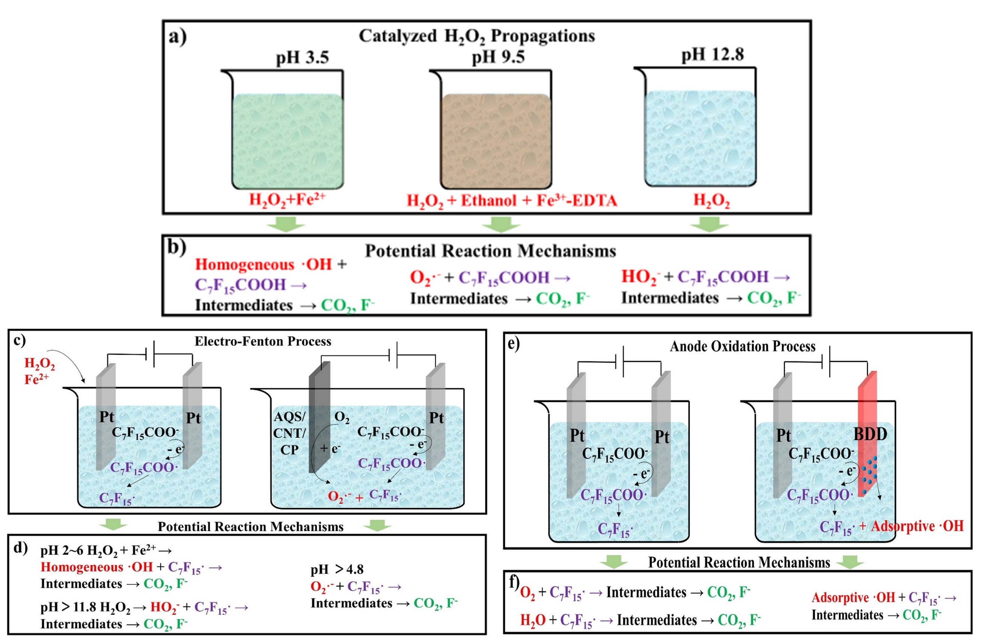
Figure S1. AOP and EAOP degradation PFOA produce ·OH, O₂·^{-,} and HO₂⁻. (a) PFOA degradation using catalyzed H₂O₂ propagations. (b) Potential attack mechanisms of ·OH, O₂·⁻ and HO₂⁻ may defluorinated C₇F₁₅COO⁻. (c) PFOA degradation using the electro-Fenton (EF) process. (d) Potential attack mechanisms of ·OH, O₂·⁻ and HO₂⁻ may defluorinated C₇F₁₅·. (e) PFOA degradation using an anodic oxidation process. (f) Potential anodic oxidation mechanism of PFOA.

Figure S2. CV curves of AQS/CNT/CP electrode at 20 mV/s. To explore the ORR activity of AQS/CNT/CP electrode, CV in an air-saturated solution was evaluated in an electrolyte solution of 0.1 M NaOH (pH=12.8). Figure S2 shows the CV profiles of an AQS/CNT/CP electrode, which displays pronounced single pairs of redox peaks at around −0.222/−0.106 V versus Ag/AgCl.

Table S1. Three AOP systems applied in this research for PFOA removal.
Serial number | Reaction system | Conditions | Target | ROS
1 | Catalytic H₂O₂ propagations | pH 3.5  H₂O₂+Fe²⁺ | C₇F₁₅COO– | ·OH
2 | Catalytic H₂O₂ propagations | pH 9.5  H₂O₂+Ethanol+Fe³⁺-EDTA | C₇F₁₅COO– | O₂·⁻
3 | Catalytic H₂O₂ propagations | pH 12.8  H₂O₂ | C₇F₁₅COO– | HO₂⁻
4 | Electro-Fenton (EF) process | pH 3.5 anode: Pt Cathode: Pt  H₂O₂+Fe²⁺ | C₇F₁₅· | ·OH
5 | Electro-Fenton (EF) process | pH 9.5 anode: Pt Cathode: Pt  H₂O₂+Ethanol+Fe³⁺-EDTA | C₇F₁₅· | O₂·⁻
6 | Electro-Fenton (EF) process | pH 9.5 anode: Pt Cathode: AQS/CNT/CP | C₇F₁₅· | O₂·⁻
7 | Electro-Fenton (EF) process | pH 12.8 anode: Pt Cathode: Pt  H₂O₂ | C₇F₁₅· | HO₂⁻
8 | Anodic oxidation process | pH 3.5 anode: Pt Cathode: Pt | C₇F₁₅· | H₂O  and O₂
9 | Anodic oxidation process | pH 3.5 anode: BDD Cathode: Pt | C₇F₁₅· | BDD(·OH)  BDD(h⁺)

Table S2 F⁻ recovery by fluoride ion-selective electrode (homogeneous free ·OH systems)
Reaction | Time (h) | F⁻ conc (mg/L) *
CHP: 1 M H₂O₂, 2 mM Fe²⁺, PFOA 5 mg/L, pH 3.5 | 0 | None detected
CHP: 1 M H₂O₂, 2 mM Fe²⁺, PFOA 5 mg/L, pH 3.5 | 5 | None detected
Electro-Fenton: 1 M H₂O₂, 2 mM Fe²⁺, PFOA 5 mg/L, anode: Pt, cathode: Pt, electrolyte: 10 mM NaClO₄ at pH 3.5 | 0 | None detected
Electro-Fenton: 1 M H₂O₂, 2 mM Fe²⁺, PFOA 5 mg/L, anode: Pt, cathode: Pt, electrolyte: 10 mM NaClO₄ at pH 3.5 | 5 | None detected
* Fluoride ion-selective electrode limit of detection for F⁻ < 0.02 mg/L

Table S3 F⁻ recovery by fluoride ion-selective electrode (homogeneous free O₂·⁻ systems)
Reaction | Time (h) | F⁻ conc (mg/L) *
CHP: 1 M H₂O₂, 5 mM Fe³⁺-EDTA, 3 M EtOH, PFOA 5 mg/L, pH 9.5 | 0 | 0.0351±0.000400
CHP: 1 M H₂O₂, 5 mM Fe³⁺-EDTA, 3 M EtOH, PFOA 5 mg/L, pH 9.5 | 5 | 0.0345±0.000289
CHP: 2 M H₂O₂, 5 mM Fe³⁺-EDTA, 3 M EtOH, PFOA 5 mg/L, pH 9.5 | 0 | 0.0394±0.000600
CHP: 2 M H₂O₂, 5 mM Fe³⁺-EDTA, 3 M EtOH, PFOA 5 mg/L, pH 9.5 | 5 | 0.0380±0.000378
Electro-Fenton: 1 M H₂O₂, 5 mM Fe³⁺-EDTA-2Na, 3 M ethanol, PFOA 5 mg/L, anode: Pt, cathode: Pt, electrolyte: 10 mM NaClO₄ at pH 9.5 | 0 | 0.0352±0.000200
Electro-Fenton: 1 M H₂O₂, 5 mM Fe³⁺-EDTA-2Na, 3 M ethanol, PFOA 5 mg/L, anode: Pt, cathode: Pt, electrolyte: 10 mM NaClO₄ at pH 9.5 | 5 | 0.0349±0.000622
Electro-Fenton: PFOA 5 mg/L, anode: Pt, cathode: AQS/CNT/CP, electrolyte: 10 mM NaClO₄ at pH 9.5 | 0 | None detected
Electro-Fenton: PFOA 5 mg/L, anode: Pt, cathode: AQS/CNT/CP, electrolyte: 10 mM NaClO₄ at pH 9.5 | 5 | None detected
* Fluoride ion-selective electrode limit of detection for F⁻ < 0.02 mg/L

Table S4 F⁻ recovery by fluoride ion-selective electrode (homogeneous free HO₂⁻ systems)
Reaction | Time (h) | F⁻ conc (mg/L) *
CHP: 1 M H₂O₂, PFOA 5 mg/L, pH 12.8 | 0 | None detected
CHP: 1 M H₂O₂, PFOA 5 mg/L, pH 12.8 | 5 | None detected
CHP: 2 M H₂O₂, PFOA 5 mg/L, pH 12.8 | 0 | 0.0242±0.000267
CHP: 2 M H₂O₂, PFOA 5 mg/L, pH 12.8 | 5 | 0.0208±0.000244
Electro-Fenton: 1 M H₂O₂, PFOA 5 mg/L, anode: Pt, cathode: Pt, electrolyte: 0.1 M NaOH | 0 | None detected
Electro-Fenton: 1 M H₂O₂, PFOA 5 mg/L, anode: Pt, cathode: Pt, electrolyte: 0.1 M NaOH | 5 | None detected
* Fluoride ion-selective electrode limit of detection for F⁻ < 0.02 mg/L

Table S5 F⁻ recovery by fluoride ion-selective electrode (anodic oxidation systems)
Reaction | Time (h) | F⁻ conc (mg/L) *
Anodic oxidation: anode: Pt, cathode: Pt, electrolyte: 10 mM NaClO₄ pH 3.5, anode potential of +2.5 V vs Ag/AgCl (current density 10 mA/cm²) | 0 | None detected
Anodic oxidation: anode: Pt, cathode: Pt, electrolyte: 10 mM NaClO₄ pH 3.5, anode potential of +2.5 V vs Ag/AgCl (current density 10 mA/cm²) | 5 | None detected
Anodic oxidation: anode: Pt, cathode: Pt, electrolyte: 10 mM NaClO₄ pH 3.5, anode potential of +6.5 V vs Ag/AgCl (current density 32 mA/cm²) | 0 | None detected
Anodic oxidation: anode: Pt, cathode: Pt, electrolyte: 10 mM NaClO₄ pH 3.5, anode potential of +6.5 V vs Ag/AgCl (current density 32 mA/cm²) | 5 | None detected
* Fluoride ion-selective electrode limit of detection for F⁻ < 0.02 mg/L

References
Mitchell, S.M., Ahmad, M., Teel, A.L. and Watts, R.J. (2014) Degradation of Perfluorooctanoic Acid by Reactive Species Generated through Catalyzed H2O2 Propagation Reactions. Environmental Science & Technology Letters 1(1), 117-121.
Tang, H.Q., Xiang, Q.Q., Lei, M., Yan, J.C., Zhu, L.H. and Zou, J. (2012) Efficient degradation of perfluorooctanoic acid by UV-Fenton process. Chemical Engineering Journal 184, 156-162.

