(Supplementary information)

Single PbS colloidal quantum dot transistor

Kenji Shibata,^{1,†} Masaki Yoshida,¹ Kazuhiko Hirakawa,^{2,3} Tomohiro Otsuka,^{4,5,6,7,8} Satria Zulkarnaen Bisri,^{9,10} and Yoshihiro Iwasa,^{9,11}

¹Department of Electrical and Electronic Engineering, Tohoku Institute of Technology, 35-1 Yagiyama, Kasumi-cho, Taihaku-ku, Sendai, 982-8577, Japan
²Institute of Industrial Science, University of Tokyo, 4-6-1 Komaba, Meguro-ku, Tokyo 153-8505, Japan
³Institute for Nano Quantum Information Electronics, University of Tokyo, 4-6-1 Komaba, Meguro-ku, Tokyo 153-8505, Japan
⁴Research Institute of Electrical Communication, Tohoku University, 2-1-1 Katahira, Aoba-ku, Sendai, 980-8577, Japan
⁵WPI Advanced Institute for Materials Research, Tohoku University, Sendai 980-8577, Japan
⁶Department of Electronic Engineering, Tohoku University, Aoba 6-6-05, Aramaki, Aoba-Ku, Sendai 980-8579, Japan
⁷Center for Science and Innovation in Spintronics, Tohoku University, 2-1-1 Katahira, Aoba-ku, Sendai 980-8577, Japan
⁸Quantum Functional System Research Group, RIKEN Center for Emergent Matter Science, 2-1 Hirosawa, Wako, Saitama 351-0198, Japan
⁹Emergent Device Research Team, RIKEN Center for Emergent Matter Science, 2-1 Hirosawa Wako, Saitama 351-0198, Japan
¹⁰Department of Applied Physics and Chemical Engineering, Tokyo University of Agriculture and Technology, 2-24-16 Naka-cho, Koganei-shi, Tokyo 184-8588, Japan
¹¹Department of Applied Physics and Quantum-Phase Electronics Center, University of Tokyo, Hongo, Bunkyo-ku, Tokyo, 113-8656, Japan
____________________
†Electronic address: kshibata@tohtech.ac.jp

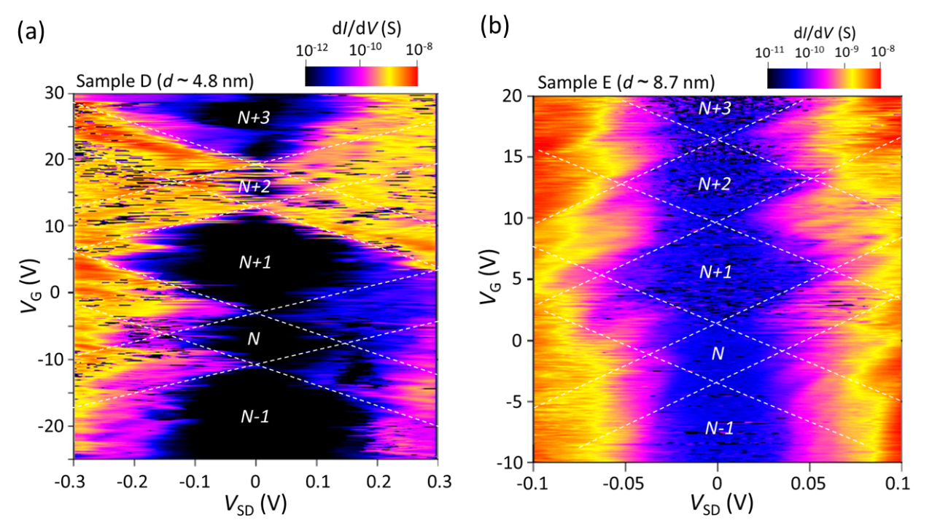

Supplementary Figure S1: Low-temperature transport properties for samples D and E.
Coulomb stability diagrams obtained for samples (a) D with d ~ 4.8 nm and (b) E with d ~ 8.7 nm. The number of confined electrons in the CQD is shown in each figure. The dashed lines are guides for the eyes.

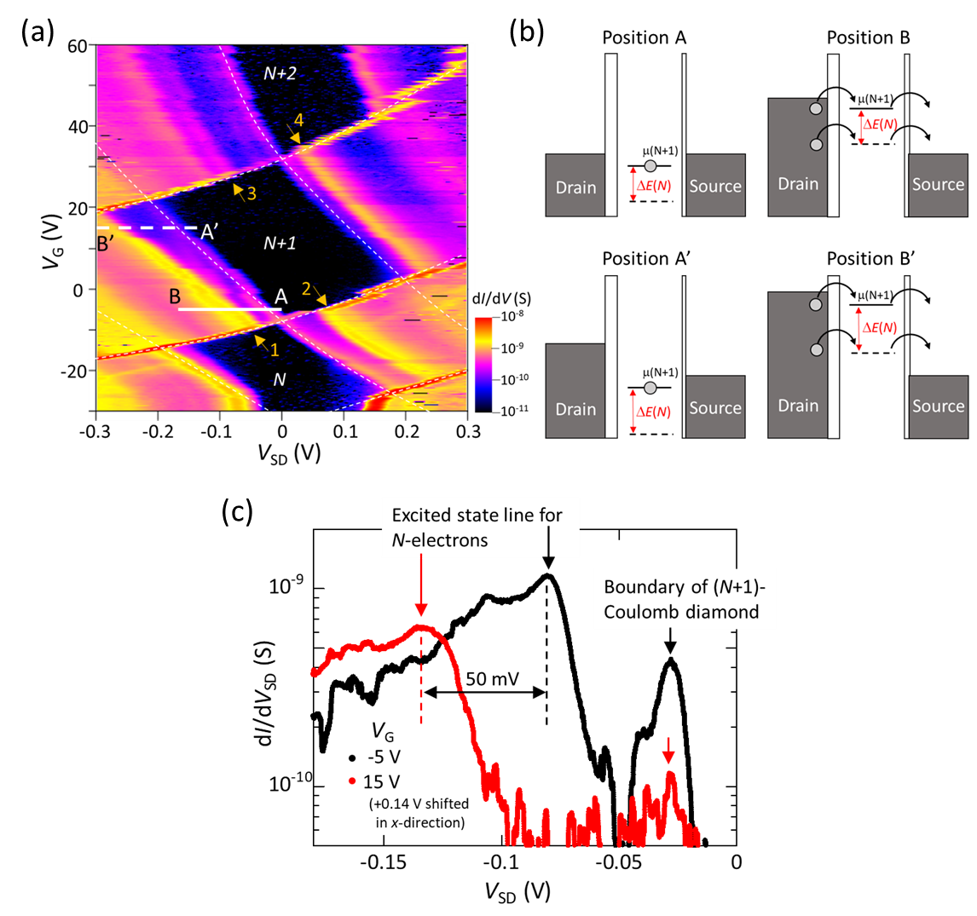

Supplementary Figure S2: Detailed analysis of the excited states in sample A.
(a) Coulomb stability diagram obtained for sample A. The positions of the excited-state lines are indicated by orange arrows with assigned numbers 1, 2, 3, and 4, which correspond to ΔE(N), ΔE(N+1)_{low}, ΔE(N+1)_{high}, and ΔE(N+2) in the main text, respectively. (b) Schematic illustrations of the band diagrams at positions A (upper left), B (upper right), A’ (lower left), and B’ (lower right) in (a), where μ(N+1) is the electrochemical potential for adding the (N+1)-th electron. ΔE(N) is the ground- to excited-state energy separation for N electrons. The dashed line indicates the electrochemical potential due to the excited state of N electrons. At positions B and B’, electrochemical potentials in the CQD are pushed up by the electric field from V_{SD} and enter the bias window with an increase in the negative V_{SD}, resulting in electrons being able to be transported through either the ground state of (N+1) electrons (solid line) or the excited state of N electrons (dashed line). (c) Differential conductance as a function of V_{SD} along the solid line AB (black curve, V_{G} = -5 V) and the dashed line A’B’ (red curve, V_{G} = 15 V). Data for V_{G} = 15 V are shifted by 0.14 V in the x-direction so that the conductance peaks determined by the boundary of the (N+1) Coulomb diamond match for comparison of the voltage spacing between the boundary of the (N+1) Coulomb diamond and the excited-state line of the N electrons. The voltage difference between the boundary of the (N+1) Coulomb diamond and the excited-state line of the N electrons shows a significant difference between the two datasets, indicating that ΔE(N) increases by ~50 meV with the increase in V_{G} from V_{G} = -5 V to 15 V. Such behavior is not observed in the positive V_{SD} region, probably because of the asymmetric tunnel coupling in this sample; the tunnel coupling to the source is strong, whereas that to the drain is weak, leading to the polarity-dependent appearance of the anomaly.

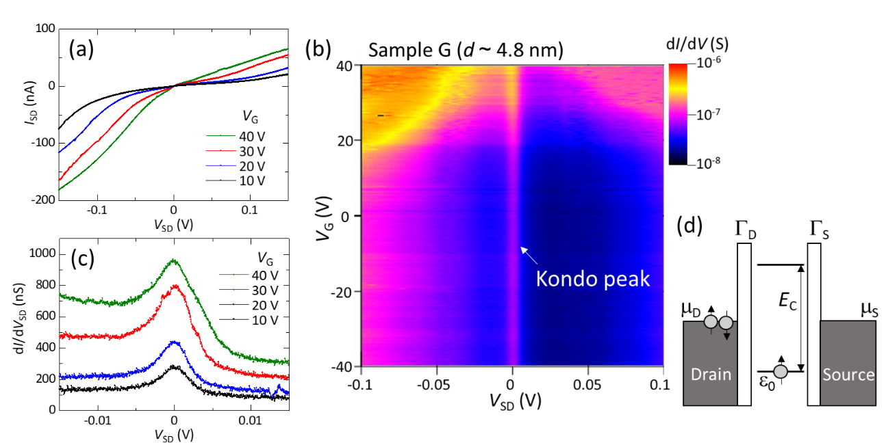

Supplementary Figure S3: Kondo effect in sample G (d ~ 4.8 nm) measured at T = 4 K.
(a) I-V curves plotted for various V_{G}. The conductance is almost one order of magnitude higher than that in sample F. (b) Coulomb stability diagram of sample G. A clear Kondo peak is observed at V_{SD} = 0 V. (c) Differential conductance as a function of V_{SD} (i.e., Kondo peak) plotted for various V_{G}. The width of the Kondo peak, w, depends on V_{G}; w becomes larger when V_{G} approaches the charge degeneracy point. Such behavior is known to be typical of the Kondo effect in quantum dot systems. From the width of the Kondo peak, the Kondo temperature T_{K} is estimated to be T_{K} ~50 K at V_{G} = 10 V and T_{K} ~80 K at V_{G} = 40 V. (d) Schematic band diagram of a quantum dot with one spin-degenerate energy level ε₀ occupied by a single electron, where Γ_{D} and Γ_{S} are the tunnel coupling energies to the drain and source electrodes, respectively. The energy states of the source and drain electrodes are filled up to electrochemical potentials μ_{D} and μ_{S}, respectively. The tunnel coupling energy, Γ, between the quantum dot and the source-drain electrodes is calculated by Γ = Γ_{D} + Γ_{S}, while the electrochemical potential of the source-drain electrodes at V_{SD} = 0 V is expressed as μ_{D} = μ_{S} = μ in the main text.

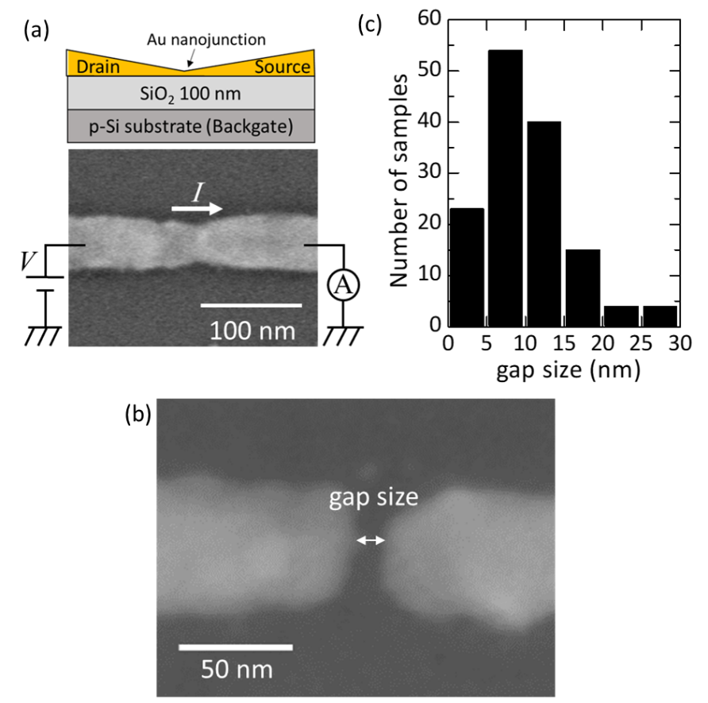

Supplementary Figure S4: Fabrication of nanogap source-drain electrodes by the EBJ method.
(a) Schematic cross-sectional image (upper) and SEM image (top view) of a sample with the experimental setup for the EBJ method (lower). (b) Typical nanogap source-drain electrode formed by the EBJ method. (c) Histogram of the fabricated nanogap sizes.

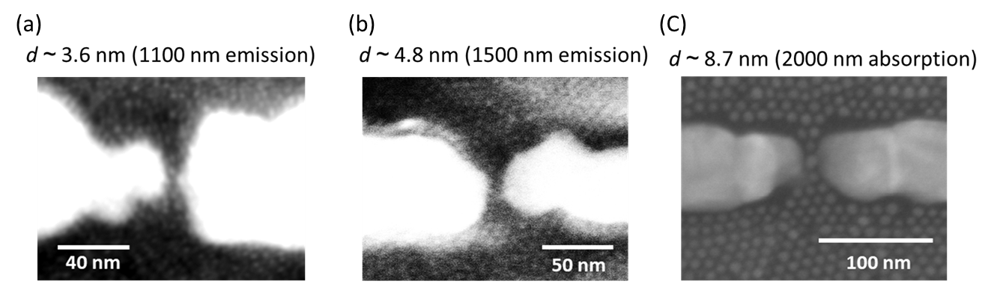

Supplementary Figure S5: SEM images of fabricated single-PbS-CQD transistors
SEM images of typical single-PbS-CQD transistors (top view) for diameter d values of (a) d = 3.6 nm, (b) d = 4.8 nm, and (c) d = 8.7 nm.

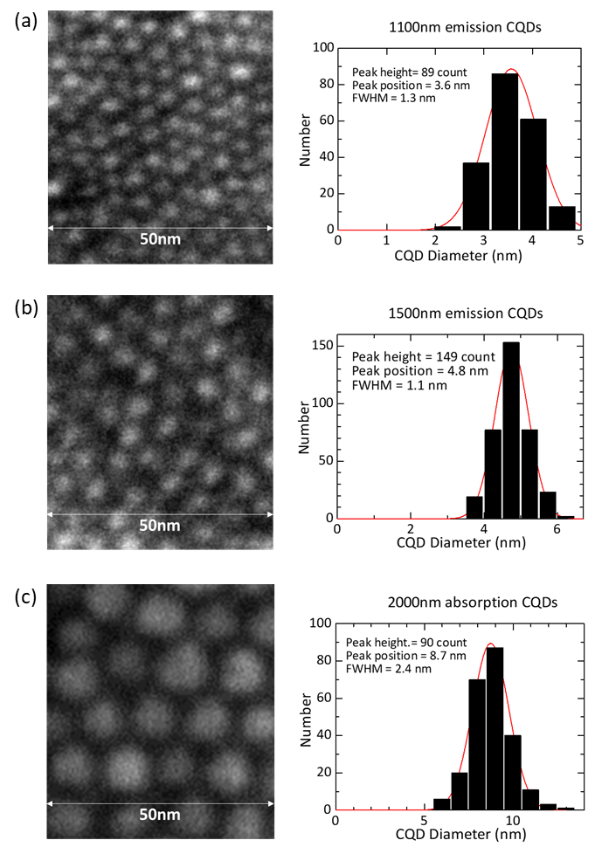

Supplementary Figure S6: Size distribution of PbS CQDs.
SEM image (left) and histogram of the diameters with the Gaussian result fitting shown as a red line (right) for oleic acid-capped PbS CQDs with (a) 1100 nm peak emission (d ~ 3.6 nm), (b) 1500 nm peak emission (d ~ 4.8 nm), and (c) 2000 nm peak absorption (d ~ 8.7 nm).

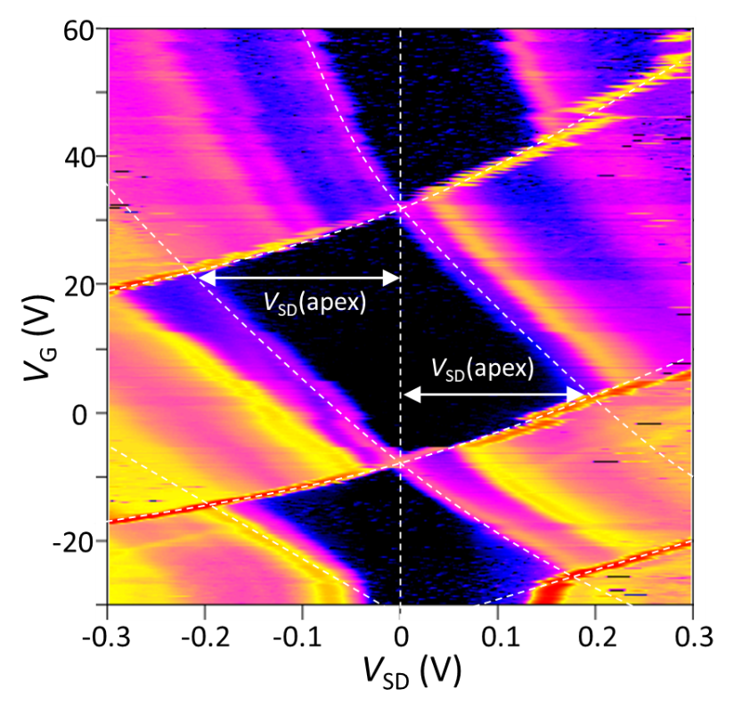

Supplementary Figure S7: Determination of E_{add} for each Coulomb diamond.
E_{add} for each Coulomb diamond is determined by e|V_{SD}(apex)|, where e is the elementary charge. When |V_{SD}(apex)| is polarity dependent, E_{add} is determined as the average of the two values.

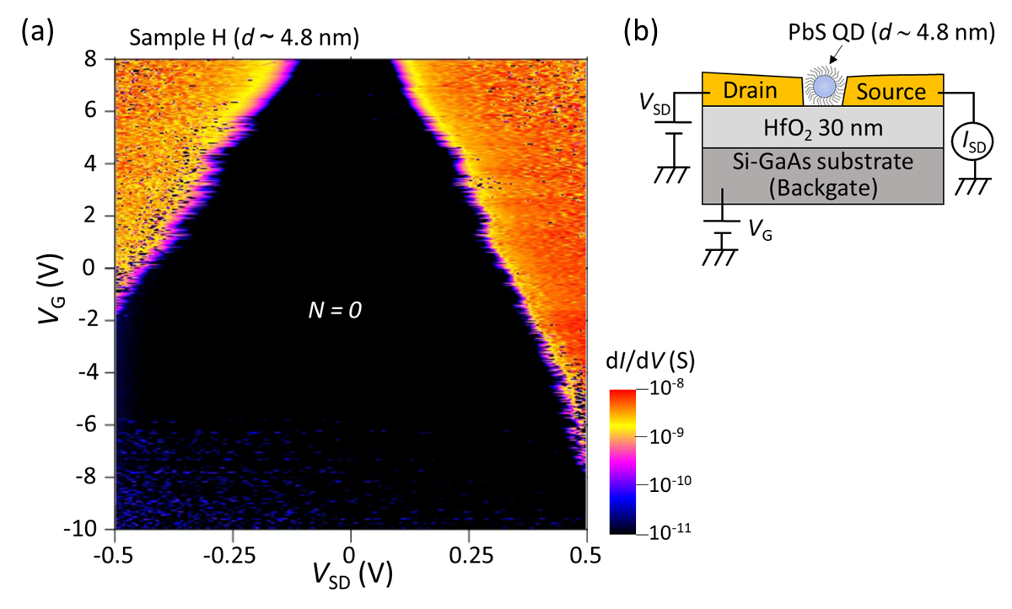

Supplementary Figure S8: Observation of the bandgap region.
(a) Coulomb stability diagram for PbS CQD sample H (d ~ 4.8 nm) with HfO₂ as the gate dielectric. We observed that the large Coulomb gap monotonically increases with increasing negative V_{G}, suggesting the bandgap region of the PbS CQD. Since the Coulomb gap decreases with increasing positive V_{G}, we are detecting the bandgap region near the conduction band edge. The reason for the bandgap observation in this sample is the slight difference in the amount of surface charges caused by the use of a different gate dielectric. (b) Schematic cross-sectional image of the PbS CQD sample with HfO₂ as the gate dielectric.

