Supporting Information

High-performance green moisture-electric generator based on supramolecular hydrogel with tens of milliamp electricity toward practical applications

Table of contents

Fig. S1. SEM morphology of PVA-AlgNa based hydrogel and EDS mapping for Ca and Na elements in yellow dotted box.
Fig. S2. The V_{oc} and I_{sc} of MEG with or without PEDOT:PSS pre-coated on bottom electrode at 22 ºC and 80% RH.
Fig. S3. a. V_{oc} of MEG unit under different relative humidity (10-90 % RH) at 22 ºC. b. V_{oc} of MEG unit under different temperature from -25 to 65 ºC at 80% RH. The size of one single MEG unit is 1 cm², unless otherwise stated.
Fig. S4. I_{sc} and V_{oc} of MEG units with different CaCl₂ concentration from 0 to 4.8 wt% under 80% RH.
Fig. S5. Stepwise current development under vacuum-on and off environment.
Fig. S6. a. Raman spectrum of the hydrogel. b. FTIR spectrum of hydrogel.
Fig. S7. 2D Raman mapping. a, The moisture capturing by top surface of PVA-AlgNa based hydrogel after exposing in air for 45 min. b, The moisture capturing by bottom surface of PVA-AlgNa based hydrogel with the same exposure time. c, The moisture capturing by top surface of PVA hydrogel after exposed in air for 45 min.
Fig. S8. Cross-sectional 2D Raman mapping of PVA-AlgNa based hydrogel with the depth after one week.
Fig. S9. In-situ FTIR spectrum tracking once the samples are exposed in the atmosphere (65% RH) versus time for PVA (a) and PVA-AlgNa based hydrogel (b).
Fig. S10. Chemical component characterization of detective Na⁺ ions variation between the two surfaces of MEG in different states. The Δc(Na) is defined as the Na element content at the top surface minus the content at the bottom surface of MEG.
Fig. S11. Schematic plot of the setup for the KPFM test. A piece of hydrogel absorbs moisture from its bottom side and the upper side is covered without wetting. The KPFM probe measures the nonwetting side with the time.
Fig. S12. Schematic plot of proposed working mechanism of MEG. a, The initial state. Ions pair are distributed along the thickness direction due to the weak internal electric field of asymmetrical structure at the initial state. b, Open voltage stage. After absorbing water molecules from air, positive ions transport from the top to the bottom side, resulting in a large open-circuit voltage. c, Short circuit stage. The reverse migration of ions is observed with short-circuit treatment.
Fig. S13. The fabrication process diagram of large-scale integration of MEG devices. (a) Preparation of PI substrate. (b) Laser printing of bottom electrodes with optimized laser power and writing speed. (c) Stencil printing of PEDOT: PSS ink on bottom electrode as carrier transport-assisting layer. (d) Dripping well-prepared hydrogel sequentially. (e) Placing and adhering top electrodes on the top of the hydrogel by end-to-end connection. The inset is the structure of enlarged 2-serial MEG units. The details can be found in the experimental section.
Fig. S14. Scheme of large-scale integration of parallel MEG bank.

Table S1. Surface area in each ESP range on the vdW surface for PVA.
Table S2. Surface area in each ESP range on the vdW surface for AlgNa.
Table S3. Surface area in each ESP range on the vdW surface for AlgCa.

Video S1. A MEG shirt worn on a sportsman charges a smart watch.
Video S2. A lamp bulb of 2.5 W is illuminated continuously by a large-scale MEGs bank with a 10*24 in parallel*serial combination.
Video S3. A LCD clock runs one month driven by a two-serial MEG bank.

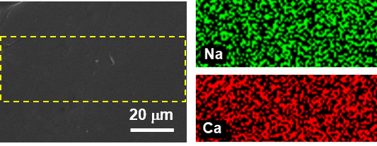
Fig. S1. SEM morphology of PVA-AlgNa based hydrogel and EDS mapping for Ca and Na elements in yellow dotted box.

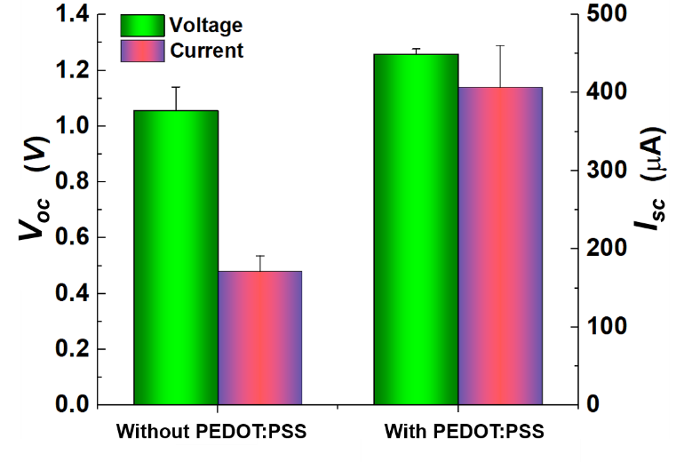
Fig. S2. The V_{oc} and I_{sc} of MEG with or without PEDOT:PSS pre-coated on bottom electrode at 22 ºC and 80% RH.

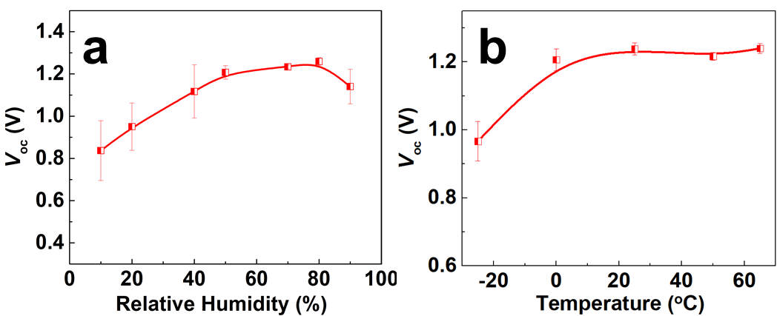
Fig. S3. a. V_{oc} of MEG unit under different relative humidity (10-90 % RH) at 22 ºC. b. V_{oc} of MEG unit under different temperature from -25 to 65 ºC at 80% RH. The size of one single MEG unit is 1 cm², unless otherwise stated.

As shown in Fig S3, the voltage outputs also increase, respectively, with increasing relative humidity and temperature until reaching a platform. When the relative humidity is higher than 90 %, the voltage slightly decreases, probably due to the affected moisture gradient by saturation. At a low temperature of -25 ºC, there still exists a voltage of ~0.9 V, demonstrating a wide environmental adaptability of the MEG unit.

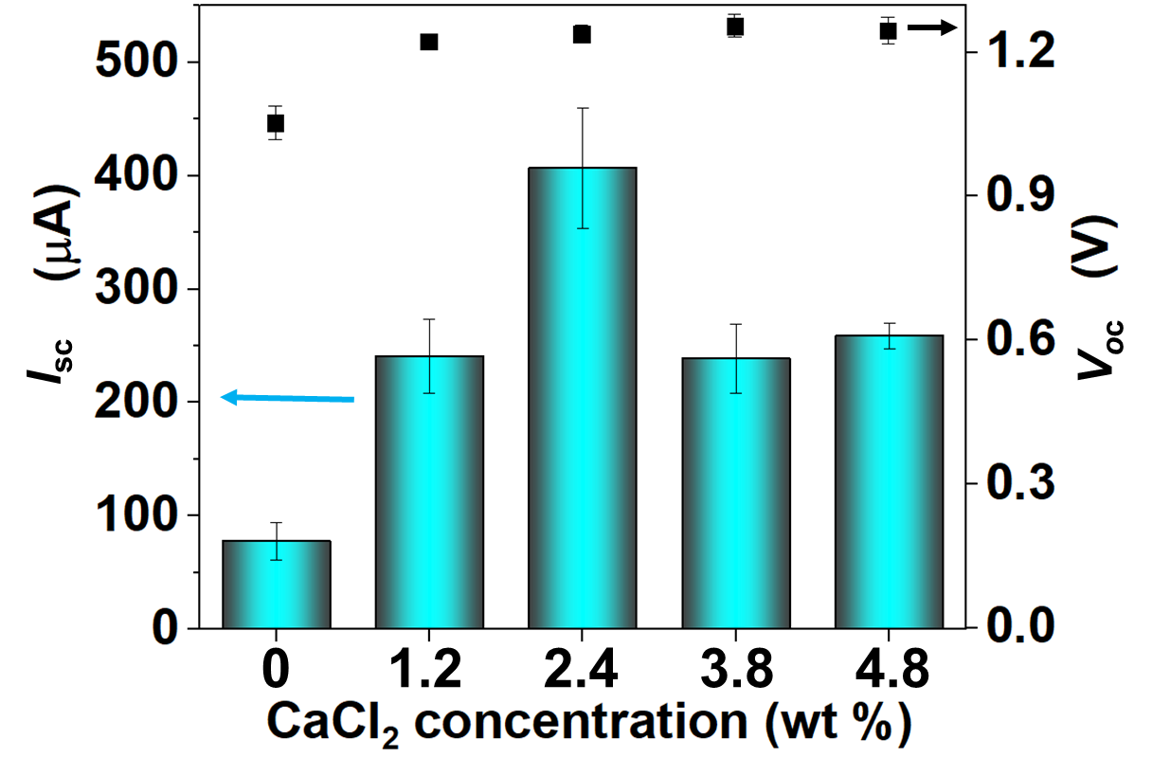
Fig. S4. I_{sc} and V_{oc} of MEG units with different CaCl₂ concentration from 0 to 4.8 wt% under 80% RH.

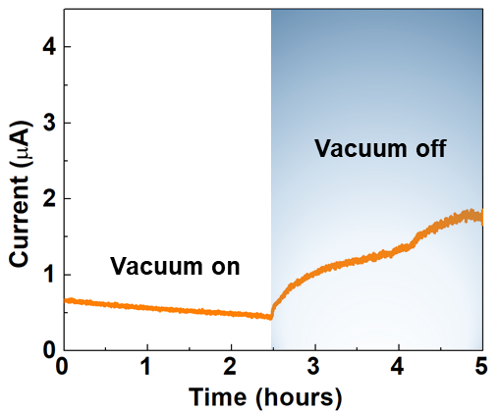
Fig. S5. Stepwise current development under vacuum-on and off environment.

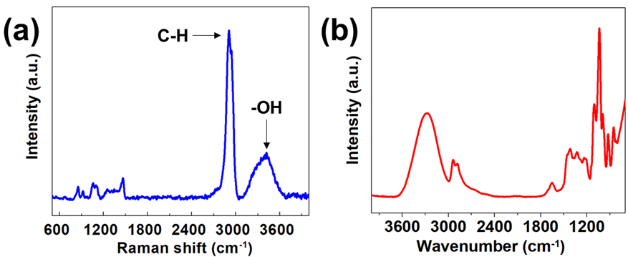
Fig. S6. a. Raman spectrum of the hydrogel. b. FTIR spectrum of hydrogel.

The Raman result shows that C-H bonds of stretching vibration area within 2800-3000 cm⁻¹ and O-H bonds of stretching vibration area within 3050-3650 cm⁻¹, where Raman band ratio O-H bonds/C-H bonds can be used to track the moisture absorption as shown in Fig. S7 and S8. The FTIR spectrum shows that 3280 cm⁻¹ is assigned as the O-H stretching absorption peak of hydrogel, which is closely related to the water absorption process. Thus the time-dependent FTIR was also used to track water absorption and diffusion process.

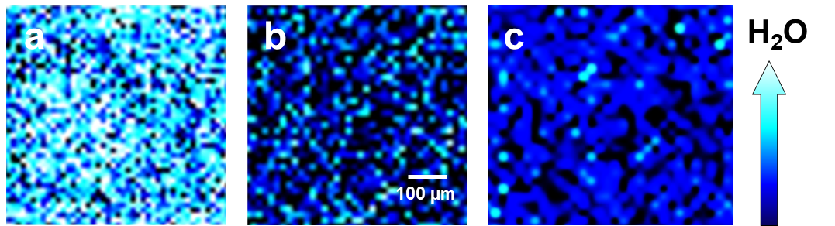
Fig. S7. 2D Raman mapping. a, The moisture capturing by top surface of PVA-AlgNa based hydrogel after exposing in air for 45 min. b, The moisture capturing by bottom surface of PVA-AlgNa based hydrogel with the same exposure time. c, The moisture capturing by top surface of PVA after exposed in air for 45 min.

In-situ Raman spectroscopy mapping was employed to track the sorption path of water molecules on hydrogel surfaces by detecting Raman band ratio O-H bond/C-H bond. Fig. S7 shows that the top surface of PVA-AlgNa based hydrogel has captured more water molecules than the bottom surface at the same exposure time, implying the existence of a built-in water gradient. Besides, the control sample PVA hydrogel shows low moisture intake capability than the PVA-AlgNa based hydrogel (Fig S7c).

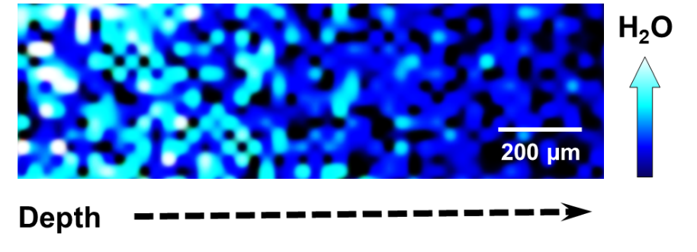
Fig. S8. Cross-sectional 2D Raman mapping of PVA-AlgNa based hydrogel with the depth after one week.

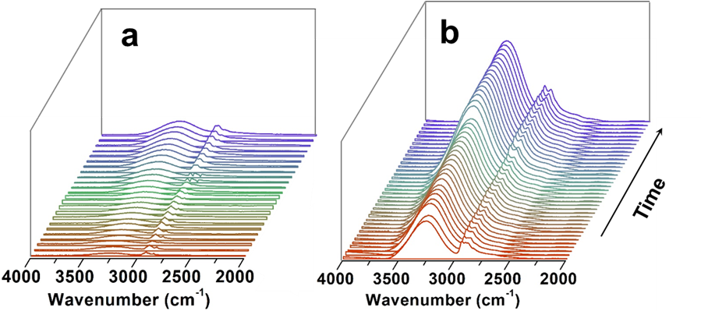
Fig. S9. In-situ FTIR spectrum tracking once the samples are exposed in the atmosphere (65% RH) versus time for PVA (a) and PVA-AlgNa based hydrogel (b).

There seems to be an obvious increase in ν (OH) band intensities for the MEG compared to the control sample (Fig. S9), suggesting a stronger moisture capturing ability of the MEG.

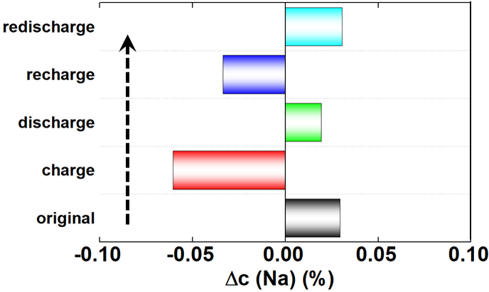
Fig. S10. Chemical component characterization of detective Na⁺ ions variation between the two surfaces of MEG in different states. The Δc(Na) is defined as the Na element content at the top surface minus the content at the bottom surface of MEG.

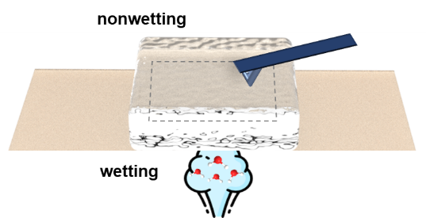
Fig. S11. Schematic plot of the setup for the KPFM test. A piece of hydrogel absorbs moisture from its bottom side and the upper side is covered without wetting. The KPFM probe measures the nonwetting side with the time.

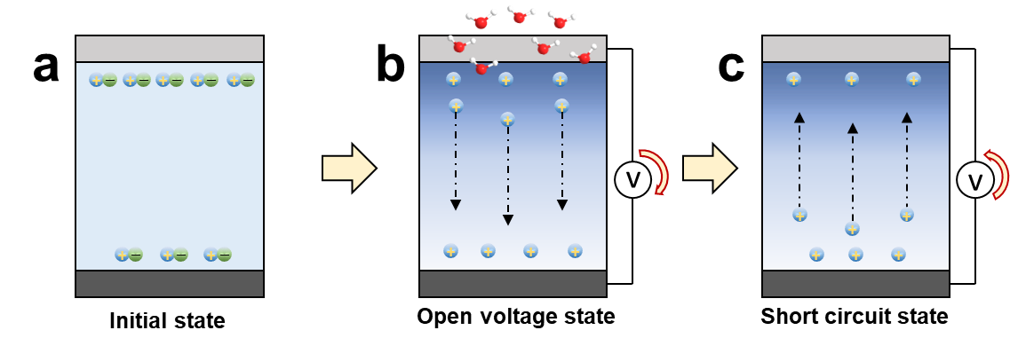
Fig. S12. Schematic plot of proposed working mechanism of MEG. a, The initial state. Ions pair are distributed along the thickness direction due to the weak internal electric field of asymmetrical structure at the initial state. b, Open voltage stage. After absorbing water molecules from air, positive ions transport from the top to the bottom side, resulting in a large open-circuit voltage. c, Short circuit stage. The reverse migration of ions is observed with short-circuit treatment.

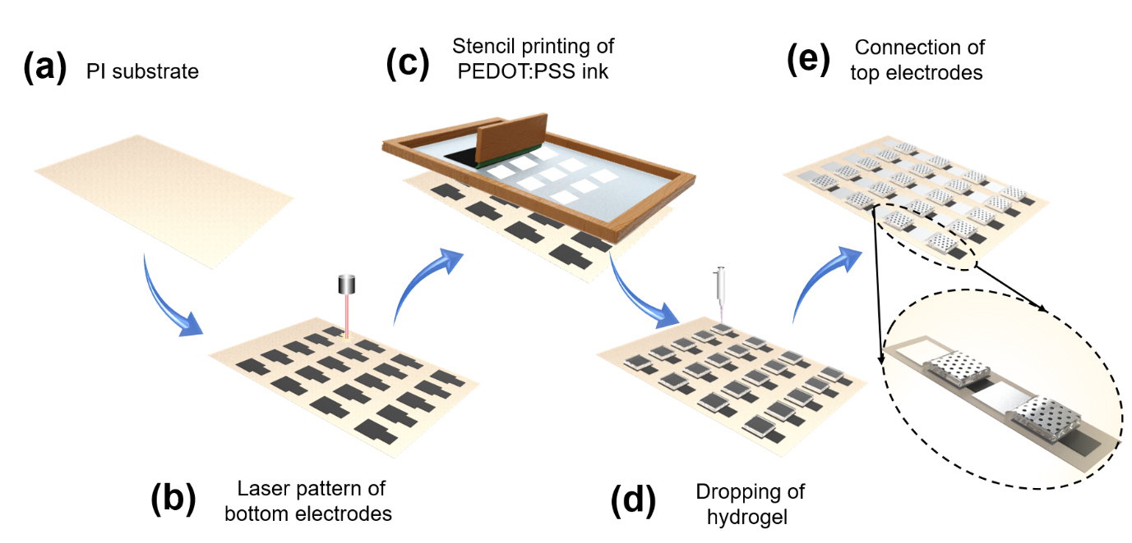
Fig. S13. The fabrication process diagram of large-scale integration of MEG devices. (a) Preparation of PI substrate. (b) Laser printing of bottom electrodes with optimized laser power and writing speed. (c) Stencil printing of PEDOT: PSS ink on bottom electrode as carrier transport-assisting layer. (d) Dripping well-prepared hydrogel sequentially. (e) Placing and adhering top electrodes on the top of the hydrogel by end-to-end connection. The inset is the structure of enlarged 2-serial MEG units. The details can be found in the experimental section.

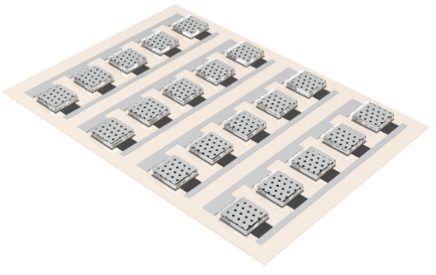
Fig. S14. Scheme of large-scale integration of parallel MEG bank.

Table S1. Surface area in each ESP range on the vdW surface for PVA.
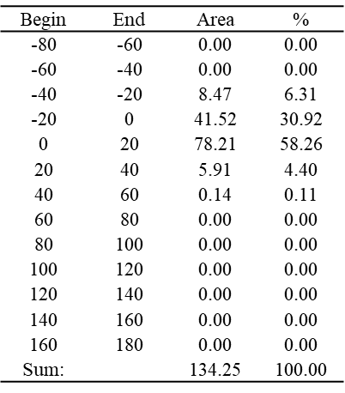

Table S2. Surface area in each ESP range on the vdW surface for AlgNa.
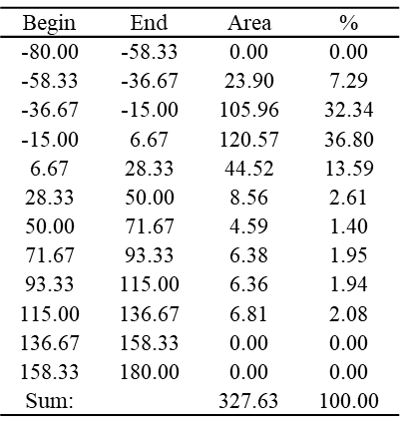

Table S3. Surface area in each ESP range on the vdW surface for AlgCa.
