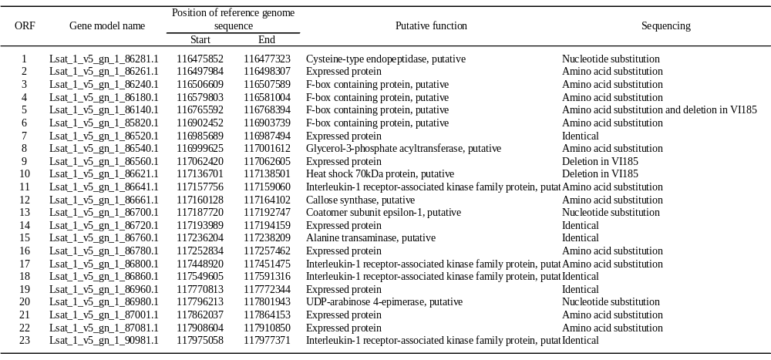
Table S1. Polymorphisms in the predicted genes between LG1_116453465 and LG1_117977450.
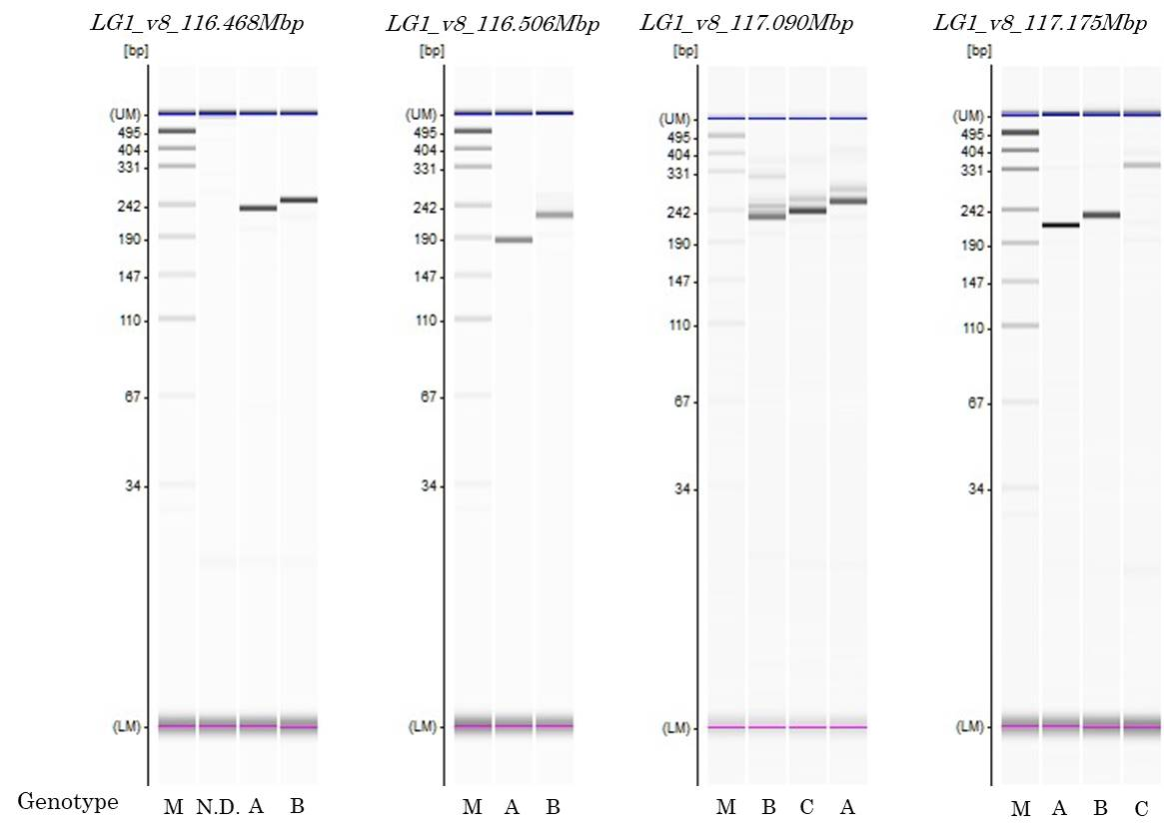
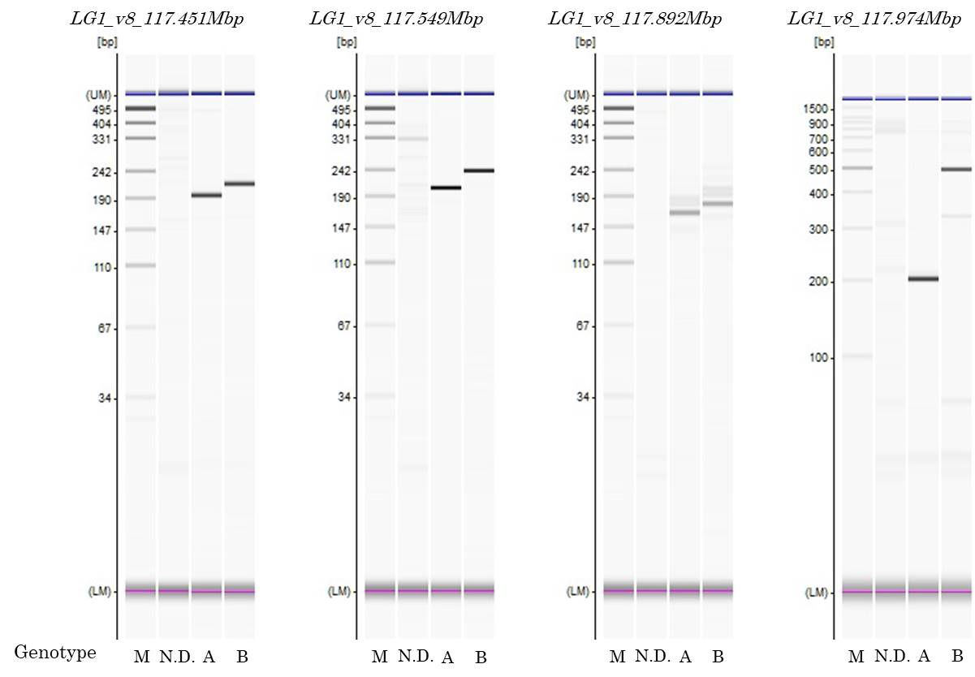
Fig. S1.
The genotype profiles of amplification products of PCR-based markers in qFOL1.2 by capillary electrophoresis on a MCE202 MultiNA.
“A” indicates the genotype of ‘VI185’. “B” indicates the genotype of ‘ShinanoGreen’. “C” indicates the genotype other than “A” or “B”. “N. D.” indicates No Band. “M” indicates ladder marker.

