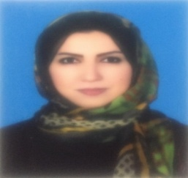
Amira Shafik received the B.Sc., M.Sc. degrees from Menouﬁa University, Menouf, Egypt, in 2001, 2010, respectively. She received her Ph.D from faculty of engineering, Minia University, Egypt, in 2022, Egypt. Her current research interests include signal processing , speaker recognition.

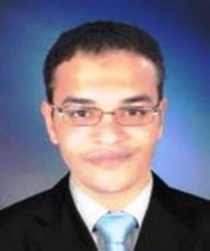
Ahmed Sedik received B.sc and M.Sc. of engineering, Faculty of Engineering, Tanta University, Egypt in 2012 and 2018 respectively. He is a teaching assistant at faculty of aritificial intelligence, Kafrelsheikh University. He received his Ph.D from faculty of engineering, Minia University, Egypt.

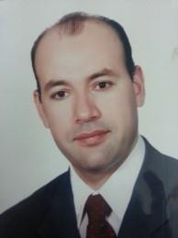
Ashraf A.M. Khalaf received his B.Sc. and M.Sc. degrees in electrical engineering from Minia University, Egypt, in 1989 and 1994 respectively. He received his Ph.D in electrical engineering from Graduate School of Natural Science and Technology, Kanazawa University, Japan, in March 2000. He is currently associate professor at electronics and communications engineering Department, Faculty of Eng., Minia University, Egypt.

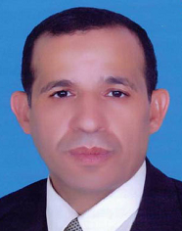
Prof. S. El-Rabaie (SM’92) was born in Sires Elian, Egypt, in 1953. He received the B.Sc. degree (with honors) in radio communications from Tanta University, Tanta, Egypt, in 1976, the M.Sc. degree in communication systems from Menouﬁa University, Menouf, Egypt, in 1981, and the Ph.D. degree in microwave Device engineering from Queen’s University of Belfast, Belfast, U.K., in 1986. In his doctoral research, he constructed a Computer-Aided Design (CAD) package used in nonlinear circuit simulations based on the harmonic balance techniques. Up to February 1989, he was a Postdoctoral Fellow with the Department of Electronic Engineering, Queen’s University of Belfast. He was invited as a Re-search Fellow in the College of Engineering and Technology, Northern Arizona University, Flagstaff, in 1992 and as a Visiting Professor at Ecole Polytechnique de Montreal, Montreal, QC, Canada, in 1994. He Has Authored and Co-authored of More Than 350 Papers and nineteen text Books. He was Awarded several Awards (Salah Amer Award of Electronics in 1993, The Best Researcher on (CAD) from Menoufia University in 1995). He acts as a reviewer and member of the editorial board for several scientific journals. He Has Shared in Translating the First Part of the Arabic Encyclopedia. Professor EL-Rabaie was the Head of the Electronic and Communication Engineering Dept., Faculty of Electronic Engineering, Menoufia University, then the Vice Dean of Postgraduate Studies and Research in the same Faculty. Prof. S. El-Rabaie is Involved now in Different Research Areas including CAD of Nonlinear Microwave Circuits, Nanotechnology, Digital Communication Systems, and Digital Image Processing. Now he is Reviewer of Quality Assurance and Accreditation of Egyptian Higher Education

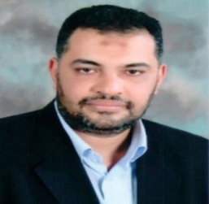
Fathi E. Abd El-Samie received the B.Sc.(Hons.), M.Sc., and Ph.D. degrees from Menouﬁa University, Menouf, Egypt, in 1998, 2001, and 2005, respectively. Since 2005, he has been a Teaching Staff Member with the Department of Electronics and Electrical Communications, Faculty of Electronic Engineering, Menouﬁa University. He worked as a researcher at KACST-TIC in Radio Frequency and Photonics for the e-Society (RFTONICs) from 2013 to 2015. He is a coauthor of several papers in international conference proceedings and journals, and several textbooks. His current research interests include image enhancement, image restoration, image interpolation, super-resolution reconstruction of images, data hiding, multimedia communications, medical image processing, optical signal processing, and digital communications. Dr. Abd El-Samie was a recipient of the Most Cited Paper Award from the Digital Signal Processing journal in 2008.

