Spatio-temporal Variability of Land Use/Cover in the Araucarias Biosphere Reserve, Chile: Management Guidelines for Sustainable Development.
ªNemo Ortega-Alul, ^{bc}Cristian Vergara-Fernandez, ^{d}Fabian Argandoña-Castro, ^{e}Natalia Gallardo-Alvarez

^{* a}Departamento de ingeniería forestal, Universidad de Cordoba, Cordoba, España

e-mail: nemo.ortega@conaf.cl
^{b}Departamento de Geología, Geografía y Medio Ambiente, Universidad de Alcalá de Henares, España. ^{c}Laboratorio de Planificación Territorial, Departamento de Ciencias Ambientales, Facultad de Recursos Naturales, Universidad Católica de Temuco, Temuco, Chile.
^{d}Doctorado en Ciencias Agropecuarias, Departamento de Ciencias Agropecuarias y Acuícolas, Facultad de Recursos Naturales, Universidad Católica de Temuco, Avda. Rudecindo Ortega, Temuco 02950, Chile
^{e}Departamento de Ciencias Forestales, Universidad de La Frontera, Temuco, Chile.

Supplementary data

Figure S1. Main land use/cover transitions recorded in the Core Area. Values in the middle squares represent the percentage of change in relation to the total area of the basin (1% = 312 hectares).

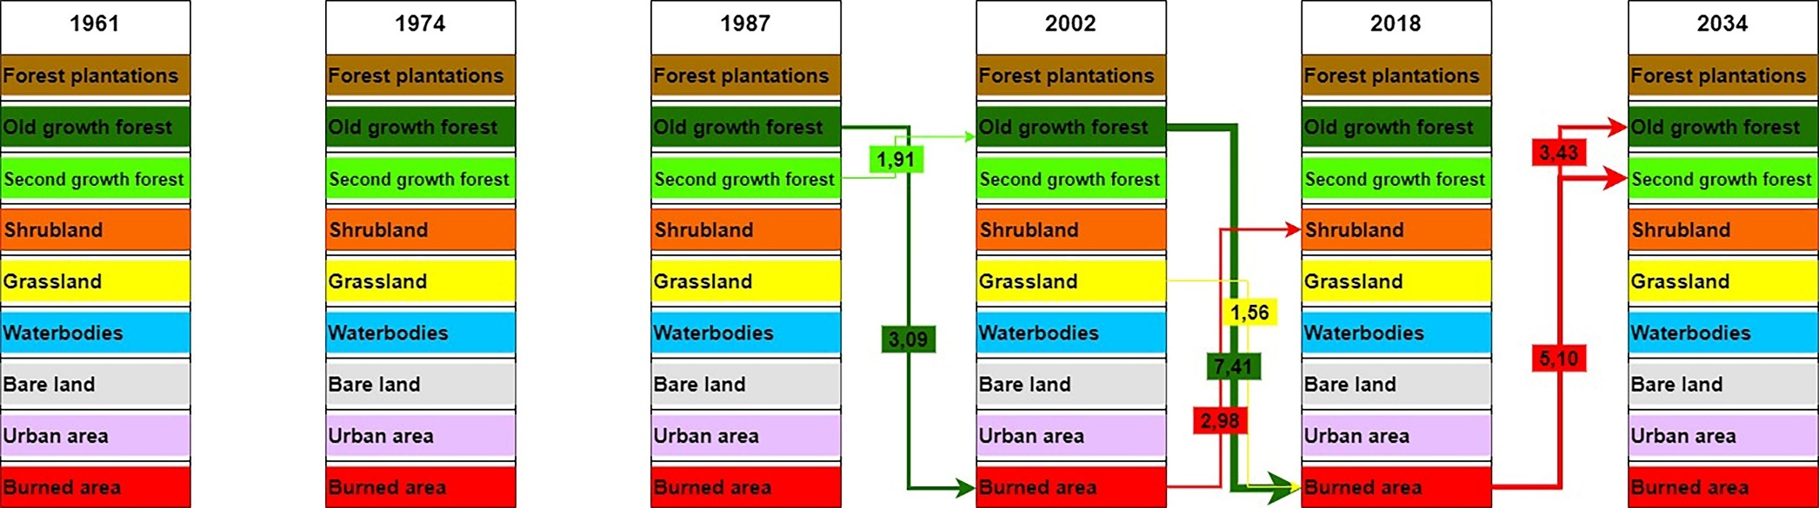

Figure S2. Main land use/cover transitions recorded in the Buffer Area. Values in the middle squares represent the percentage of change in relation to the total area of the basin (1% = 54 hectares).

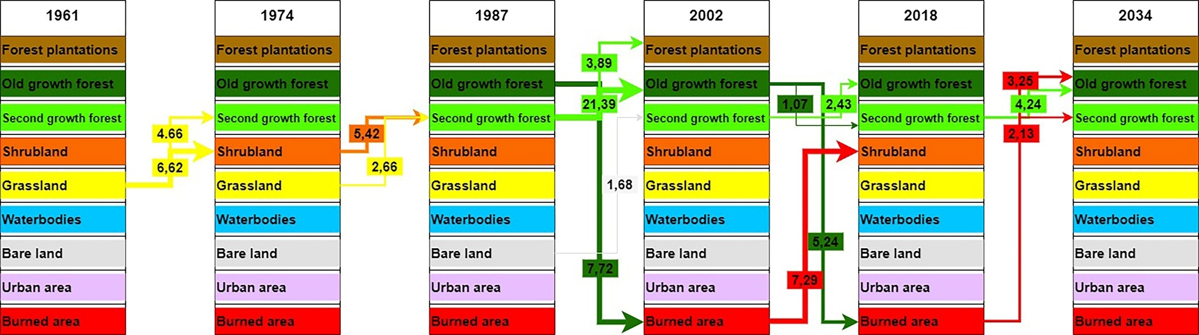

Figure S3. Main land use/cover transitions recorded in the Transition Area. Values in the middle squares represent the percentage of change in relation to the total area of the basin (1% = 39 hectares).

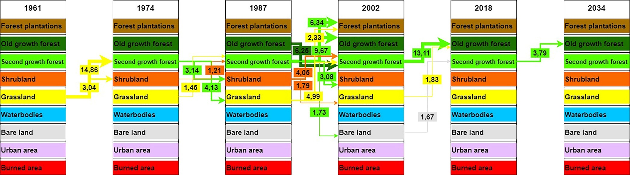
Table S1. Images used in this study

Fly/Image | Year | Scale | Operator
OEA | 1961 | 1:50.000 | Organization of American States, OEA
CONAF | 1974 | 1:20.000 | Servicio Aéreo Fotogramétrico (SAF)
CIREN-FACH | 1987 | 1:50.000 | Servicio Aéreo Fotogramétrico (SAF)
Landsat 5 | 2002 | 1:100000 | https://earthexplorer.usgs.gov/
Landsat 8 | 2018 | 1:100000 | https://earthexplorer.usgs.gov/

