Table: A comparison of final metal ion concentrations of Zn (II) ions using LCLB between the controlled and experimental groups using t-test

pH | pH values | Experimental | Control | t-stat | P- value
pH | 2 | 7.75±0.09 | 9.37±0.45 | 16.37 | <0.0005
pH | 3 | 6.8±0.56 | 9.23±0.03 | 34.72 | <0.0005
pH | 4 | 5.15±0.22 | 9.04±0.43 | 37.89 | <0.0005
pH | 5 | 4.55±0.06 | 8.88±0.18 | 47.84 | <0.0005
pH | 6 | 2.74±0.26 | 8.67±0.07 | 48.58 | <0.0005
pH | 7 | 3.84±0.48 | 8.8±0.82 | 48.48 | <0.0005
Biosorbent dose | Dose (g) | Experimental | Control | t-stat | P -value
Biosorbent dose | 1 | 2.89±0.41 | 9.28±0.09 | - | -
Biosorbent dose | 2 | 2.26±0.06 | 9.28±0.09 | - | -
Biosorbent dose | 3 | 1.86±0.15 | 9.28±0.09 | - | -
Biosorbent dose | 4 | 1.66±0.27 | 9.28±0.09 | - | -
Biosorbent dose | 5 | 1.49±0.08 | 9.28±0.09 | - | -
Contact time | Time (min) | Experimental | Control | t-stat | P- value
Contact time | 20 | 4.67±0.09 | 9.23±0.25 | 54.28 | <0.0005
Contact time | 40 | 3.51±0.18 | 8.97±0.59 | 105.64 | <0.0005
Contact time | 60 | 2.75±0.05 | 8.77±0.18 | 136.67 | <0.0005
Contact time | 80 | 2.16±0.08 | 8.49±0.61 | 98.43 | <0.0005
Contact time | 100 | 1.85±0.27 | 8.22±0.38 | 203.81 | <0.0005
Contact time | 120 | 1.85±0.27 | 8.12±0.74 | 142.34 | <0.0005
Metal ion concentration (MIC) | MIC (mg/L) | Experimental | Control | t-stat | P -value
Metal ion concentration (MIC) | 10 | 3.08±0.02 | 8.91±0.08 | 38.95 | <0.0005
Metal ion concentration (MIC) | 20 | 8.04±0.36 | 18.8±0.25 | 69.68 | <0.0005
Metal ion concentration (MIC) | 30 | 13.57±0.68 | 29.0±0.64 | 168.54 | <0.0005
Metal ion concentration (MIC) | 40 | 21.34±1.09 | 38.56±0.21 | 103.36 | <0.0005
Metal ion concentration (MIC) | 50 | 29.05±0.81 | 48.63±0.16 | 102.00 | <0.0005
Temperature | Temperature (K) | Experimental | Control | t-stat | P- value
Temperature | 298 | 2.75±0.63 | 9.06±0.08 | 87.31 | <0.0005
Temperature | 308 | 2.98±0.47 | 8.75±0.24 | 125.65 | <0.0005
Temperature | 318 | 3.54±0.38 | 8.68±0.75 | 38.74 | <0.0005
Temperature | 328 | 3.83±0.55 | 8.56±0.43 | 22.77 | <0.0005
Temperature | 338 | 4.33±0.12 | 8.83±0.67 | 17.24 | <0.0005

A t-test is based on a ‘null hypothesis’ which assumes that no disparity is present between control and experimental groups. If the t-stat has a very large value compared to the P-value or critical value, then ‘null hypothesis’ gets rejected and a remarkable disparity between the control and experimental groups is proven.

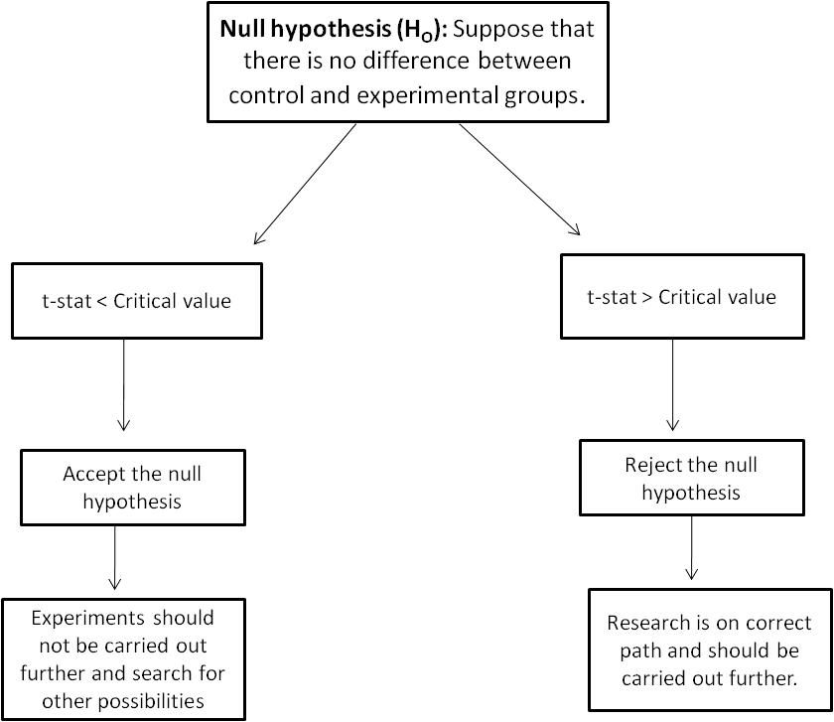

The above table depicts the outcomes of comparison between the experimental and controlled groups and t-stat and critical P values (<0.05) indicate that the hypothesis of ‘no difference between controlled and experimental groups’ was ‘wrong’ and there were substantial differences between both the groups. As a consequence, using LCLB for Zn (II) ions elimination yielded significant results, implying that the research was on the right track.

