Supplementary material
Supplement Figure 1. Survival analysis for ATF3 in BLCA (A), BRCA (B), KIRC (C), KIRP (D), LIHC (E), LUAD (F), LUSC (G), PRAD (H), READ (I), THCA (J) and UCEC(K) using the UALCAN database.

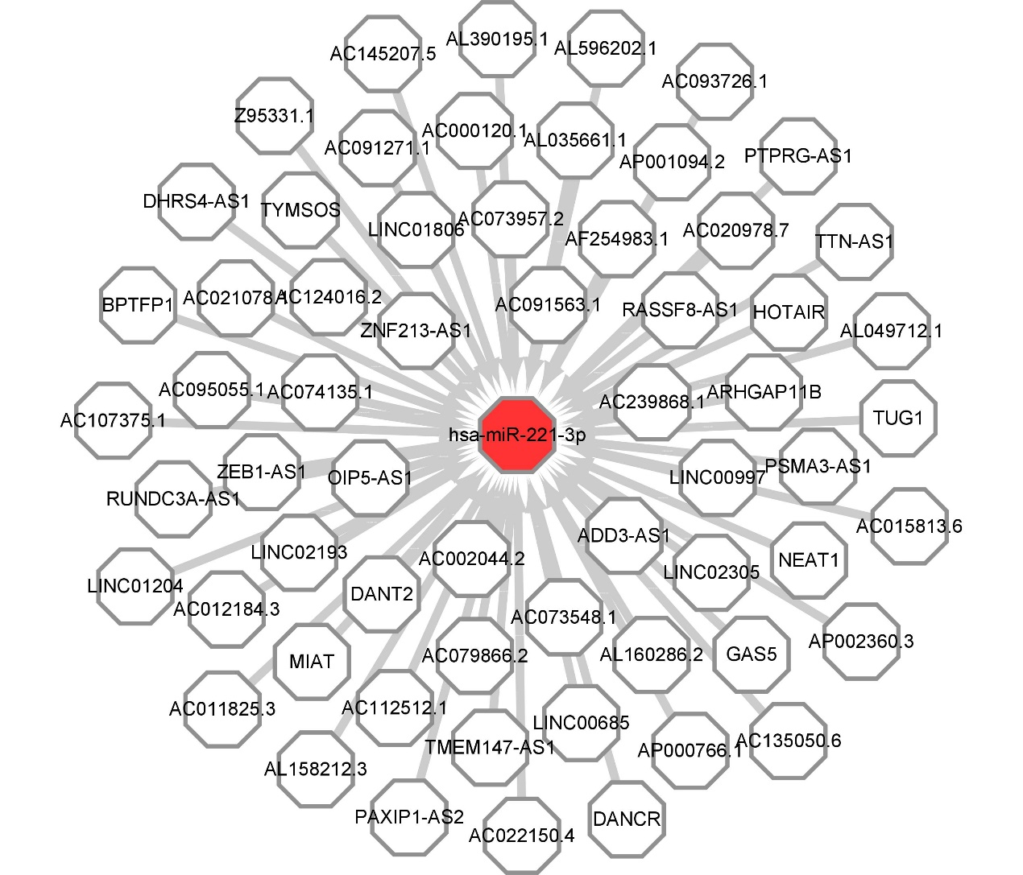
Supplement Figure 2. The lncRNA-hsa-miR-221-3p regulatory network established by Cytoscape software.

Supplement Figure 3. Expression analysis for upstream lncRNAs of hsa-miR-221-3p in ccRCC. (A-D) The expression of GAS5, AC095055.1, TUG1and ZEB1-AS1 in ccRCC and control normal samples determined by starBase database.

Supplement Table 1 Correlation analysis between lncRNA and hsa-miR-221-3p in ccRCC.
lncRNA | R | P
AC239868.1 | -0.045 | 3.06E-01
LINC01806 | 0.007 | 8.69E-01
TTN-AS1 | 0.003 | 9.49E-01
AC073957.2 | 0.000 | 1.00E+00
AC000120.1 | 0.007 | 8.74E-01
AC093726.1 | -0.044 | 3.23E-01
AC091563.1 | -0.156 | 3.80E-04
AC107375.1 | -0.045 | 3.10E-01
AL158212.3 | -0.005 | 9.19E-01
NEAT1 | 0.163 | 2.03E-04
AP002360.3 | -0.001 | 9.78E-01
RASSF8-AS1 | -0.001 | 9.90E-01
HOTAIR | -0.077 | 8.12E-02
PSMA3-AS1 | 0.032 | 4.72E-01
LINC02305 | 0.009 | 8.30E-01
ARHGAP11B | 0.026 | 5.59E-01
ZNF213-AS1 | -0.034 | 4.34E-01
AC135050.6 | 0.008 | 8.62E-01
AC020978.7 | 0.058 | 1.90E-01
AC012184.3 | 0.087 | 4.86E-02
LINC02193 | 0.062 | 1.61E-01
RUNDC3A-AS1 | 0.500 | 4.24E-34
AC015813.6 | -0.086 | 5.09E-02
BPTFP1 | -0.004 | 9.36E-01
AC145207.5 | -0.071 | 1.08E-01
AC011825.3 | -0.018 | 6.83E-01
AC074135.1 | 0.076 | 8.34E-02
AC022150.4 | -0.121 | 5.99E-03
AL049712.1 | -0.011 | 8.06E-01
AF254983.1 | 0.091 | 3.88E-02

Supplement Table 2 Top ten GO analysis of ATF3-interacting genes
 | Term | Fold Enrichment | P Value | Count
GO:0045944 | positive regulation of transcription from RNA polymerase II promoter | 9.92538 | 2.59E-10 | 13
GO:0000122 | negative regulation of transcription from RNA polymerase II promoter | 10.43069 | 1.14E-08 | 11
GO:0006357 | regulation of transcription from RNA polymerase II promoter | 6.926427 | 1.6E-08 | 13
GO:1990440 | positive regulation of transcription from RNA polymerase II promoter in response to endoplasmic reticulum stress | 305.6508 | 2.1E-07 | 4
GO:0071277 | cellular response to calcium ion | 49.83437 | 2.23E-06 | 5
GO:0006366 | transcription from RNA polymerase II promoter | 22.92381 | 3.84E-06 | 6
GO:0051591 | response to cAMP | 76.4127 | 1.61E-05 | 4
GO:0045893 | positive regulation of transcription, DNA-templated | 8.964618 | 6.42E-05 | 7
GO:0051726 | regulation of cell cycle | 14.50874 | 0.00028 | 5
GO:0070059 | intrinsic apoptotic signaling pathway in response to endoplasmic reticulum stress | 78.59592 | 0.000597 | 3

Supplement Table 3 Top ten KEGG analysis of ATF3-interacting genes
 | Term | Fold Enrichment | PValue | Count
hsa04380 | Osteoclast differentiation | 26.23713 | 9.35E-08 | 7
hsa04657 | IL-17 signaling pathway | 30.62328 | 7.22E-07 | 6
hsa04668 | TNF signaling pathway | 21.41807 | 5.4E-05 | 5
hsa04668 | MAPK signaling pathway | 9.791116 | 0.000185 | 6
hsa05031 | Amphetamine addiction | 27.81245 | 0.0003 | 4
hsa05166 | Human T-cell leukemia virus 1 infection | 10.80551 | 0.000751 | 5
hsa04210 | Apoptosis | 14.11073 | 0.002166 | 4
hsa05418 | Fluid shear stress and atherosclerosis | 13.80618 | 0.002306 | 4
hsa04932 | Non-alcoholic fatty liver disease | 12.38102 | 0.003143 | 4
hsa05030 | Cocaine addiction | 29.37335 | 0.004021 | 3

