Table S1. Different orientations of carbon monoxide and hydrogen adsorption in α bonding site in Cu₂(bmc)₄ and Zn₂(bmc)₄ clusters

Adsorption site |  | Cu₂(bmc)₄ | Zn₂(bmc)₄
α site | α₁ | 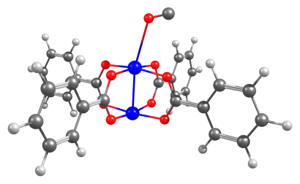 | 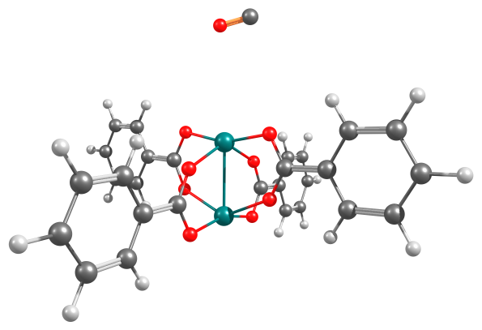
α site | α₃ | 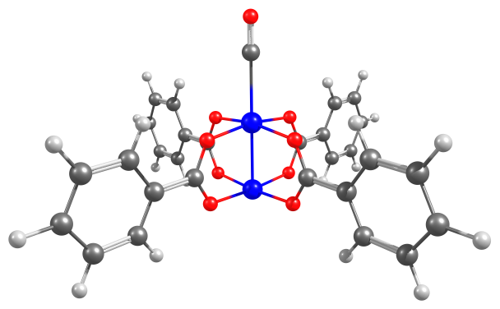 | 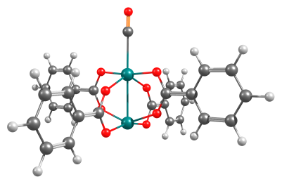
 | α₁ | 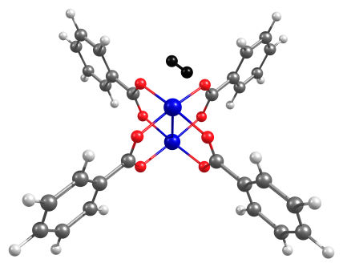 | 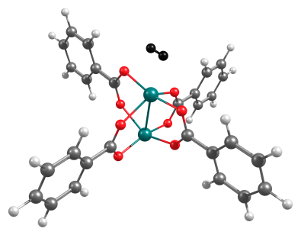
 | α₂ | 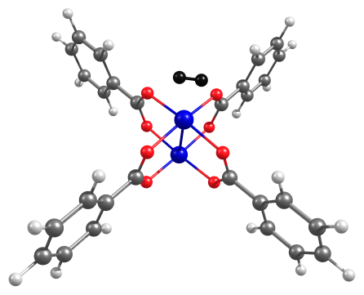 | 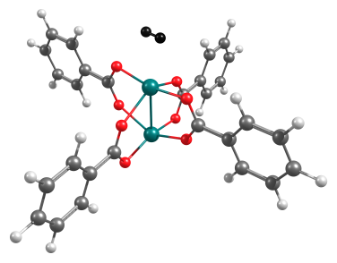
 | α₃ | 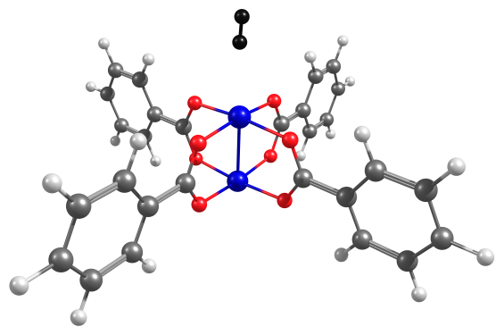 | 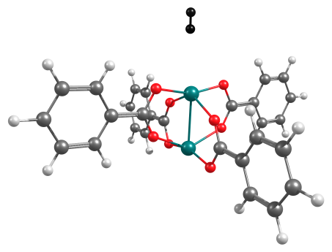
Table S2. Different orientations of adsorption of two molecules of carbon monoxide and hydrogen in the α site, in the spoke wheel cluster structures such as Cu₂(bmc)₄ and Zn₂(bmc)₄
Optimized adsorption geometry | Orientation | Structure/basis set
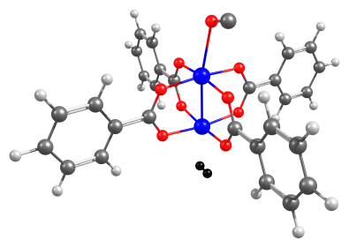 | $$α_{1}-α_{1}$$ | Cu₂(bmc)₄/def2-tzvp
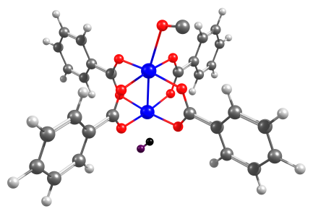 | $$α_{1}^{'}-α_{1}$$ | Cu₂(bmc)₄/def2-tzvp
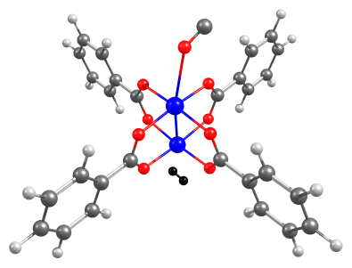 | $$α_{1}-α_{1}^{'}$$ | Cu₂(bmc)₄/def2-tzvp
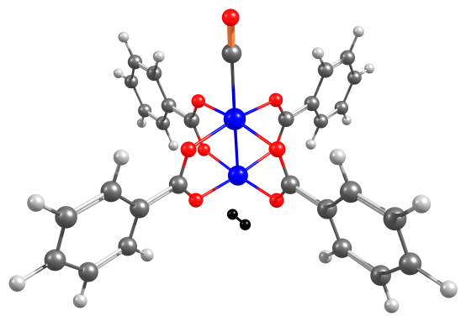 | $$α_{1}-α_{3}$$ | Cu₂(bmc)₄/def2-tzvp
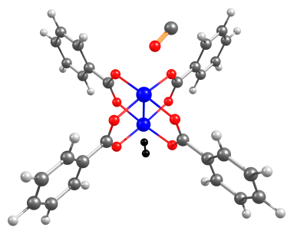 | $$α_{2}-α_{1}$$ | Cu₂(bmc)₄/def2-tzvp
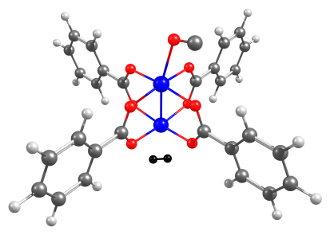 | $$α_{2}-α_{1}$$ | Cu₂(bmc)₄/def2-tzvp
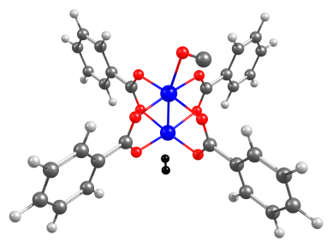 | $$α_{2}^{'}-α_{1}$$ | Cu₂(bmc)₄/def2-tzvp
 | $$α_{1}-α_{1}$$ | Cu₂(bmc)₄/def2-tzvp
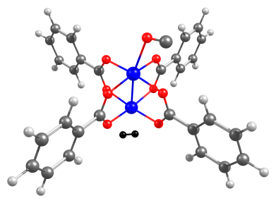 | $$α_{2}-α_{1}$$ | Cu₂(bmc)₄/def2-tzvp
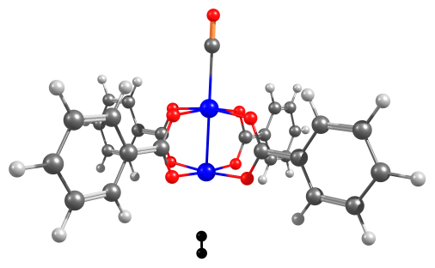 | $$α_{3}-α_{3}$$ | Cu₂(bmc)₄/def2-tzvp
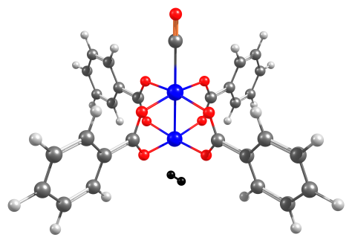 | $$α_{1}-α_{3}$$ | Cu₂(bmc)₄/def2-tzvp
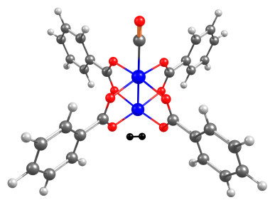 | $$α_{2}-α_{3}$$ | Cu₂(bmc)₄/def2-tzvp
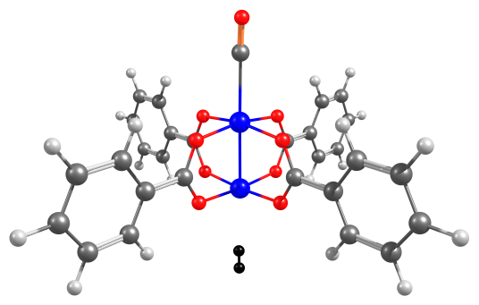 | $$α_{3}-α_{3}$$ | Cu₂(bmc)₄/def2-tzvp
Optimized adsorption geometry | Orientation | Structure/basis set
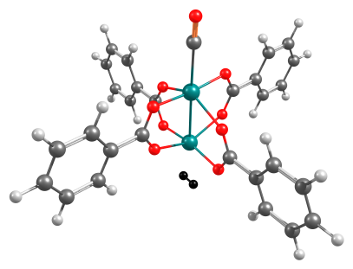 | $$α_{3}-α_{1}$$ | 1

Table 3. The values ​​related to the partial charge of hydrogen absorption in the Cu₂(bmc)₄ structure and in the bonding site α, in each of the α₁, α₂ and α₃ orientations.

H₂ - Cu₂(bmc)₄  ($α_{3}-orientation)$ | H₂ - Cu₂(bmc)₄  ($α_{2}-orientation)$ | H₂ - Cu₂(bmc)₄  ($α_{1}-orientation)$ | Cu₂(bmc)₄ | atom
0.6021 | 0.5170 | 0.5218 | 0.6178 | Cu (1)
0.6077 | 0.6163 | 0.6160 | 0.6178 | Cu (2)
-0.5073 | -0.5059 | -0.5053 | -0.5045 | O (1)
-0.4965 | -0.4919 | -0.4915 | -0.5045 | O (2)
-0.5067 | -0.5060 | -0.5062 | -0.5045 | O (3)
-0.4976 | -0.4921 | -0.4922 | -0.5045 | O (4)
-0.4963 | -0.4925 | -0.4940 | -0.5045 | O (5)
-0.5074 | -0.5061 | -0.5066 | -0.5045 | O (6)
-0.5081 | -0.5059 | -0.5049 | -0.5045 | O (7)
-0.4953 | -0.4920 | -0.4917 | -0.5045 | O (8)
0.0186- | 0.0318 | 0.0266 | - | H (1)
0.0233 | 0.0325 | 0.0351 | - | H (2)

Table 4. The values ​​related to the partial charge of hydrogen absorption in the Zn2(bmc)4 structure and in the α bonding site, in each of the α₁, α₂ and α₃ orientations.

H₂ - Zn₂(bmc)₄  ($α_{3}-orientation)$ | H₂ - Zn₂(bmc)₄  ($α_{2}-orientation)$ | H₂ - Zn₂(bmc)₄  ($α_{1}-orientation)$ | Zn₂(bmc)₄ | atom
0.6948 | 0.6630 | 0.6660 | 0.6149 | Zn (1)
0.5723 | 0.5842 | 0.5830 | 0.6161 | Zn (2)
-0.4728 | -0.4725 | -0.4725 | -0.4759 | O (1)
-0.4699 | -0.4725 | -0.4731 | -0.4737 | O (2)
-0.4697 | -0.4684 | -0.4671 | -0.4718 | O (3)
-0.4721 | -0.4729 | -0.4721 | -0.4743 | O (4)
-0.4668 | -0.4719 | -0.4717 | -0.4731 | O (5)
-0.4718 | -0.4720 | -0.4715 | -0.4756 | O (6)
-0.4690 | -0.4660 | -0.4659 | -0.4719 | O (7)
-0.4723 | -0.4722 | -0.4716 | -0.4752 | O (8)
0.0327 | 0.0214 | 0.0218 | - | H (1)
0.0449- | 0.0202 | 0.0213 | - | H (2)

Table 5. The values ​​related to the partial charge of carbon monoxide absorption in the Cu2(bmc)4 structure and in the α bonding site, in each of the 1α, 2α and 3α orientations.

CO - Cu₂(bmc)₄  ($α_{2}-orientation)$ | CO - Cu₂(bmc)₄  ($α_{1}-orientation)$ | Cu₂(bmc)₄ | atom
0.3048 | 0.2326 | 0.6178 | Cu (1)
0.2824 | 0.2678 | 0.6178 | Cu (2)
-0.3810 | -0.3790 | -0.5045 | O (1)
-0.3920 | -0.3782 | -0.5045 | O (2)
-0.3792 | -0.3790 | -0.5045 | O (3)
-0.3707 | -0.3783 | -0.5045 | O (4)
-0.3726 | -0.3780 | -0.5045 | O (5)
-0.3784 | -0.3789 | -0.5045 | O (6)
-0.3792 | -0.3789 | -0.5045 | O (7)
-0.3713 | -0.3781 | -0.5045 | O (8)
0.0394 | 0.1402 | - | C
0.0283- | 0.0453 | - | O

Table 6. The values ​​related to the partial charge of carbon-monoxide adsorption in the structure of Zn2(bmc)4 and in the α bonding site in each of the directions 1α, 2α and 3α

CO - Zn₂(bmc)₄  ($α_{2}-orientation)$ | CO - Zn₂(bmc)₄  ($α_{1}-orientation)$ | Zn₂(bmc)₄ | atom
0.7019 | 0.7390 | 0.6178 | Zn (1)
0.5642 | 0.5171 | 0.6178 | Zn (2)
-0.4727 | -0.4709 | -0.5045 | O (1)
-0.4695 | -0.4719 | -0.5045 | O (2)
-0.4705 | -0.4691 | -0.5045 | O (3)
-0.4784 | -0.4656 | -0.5045 | O (4)
-0.4671 | -0.4734 | -0.5045 | O (5)
-0.4717 | -0.4709 | -0.5045 | O (6)
-0.4696 | -0.4683 | -0.5045 | O (7)
-0.4747 | -0.4672 | -0.5045 | O (8)
0.0066 | 0.0901 | - | C
0.0001- | 0.0525 | - | O

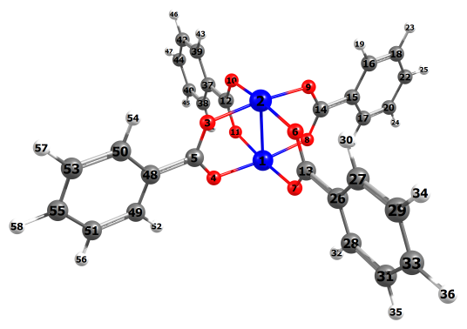  (a)  ))))) | 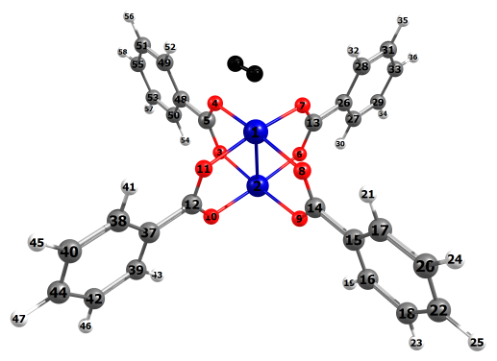  (b)  )))))  α₁
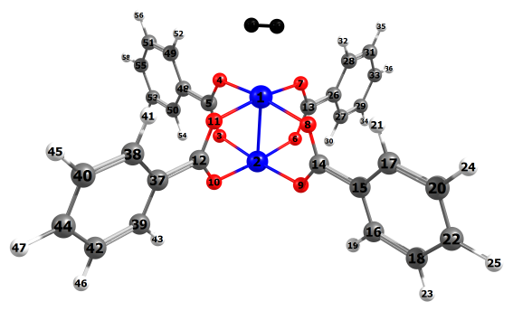  (c)  )))))  α₂ | 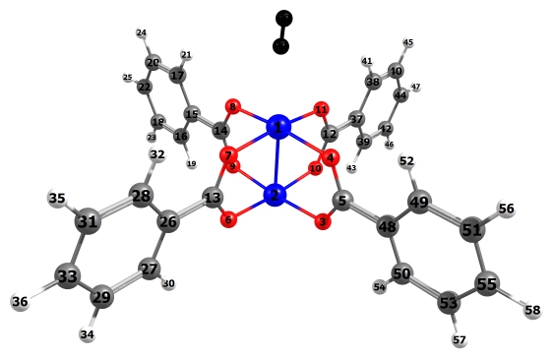  α₃  (d)  )))))

Fig. S1. Atom labels appeared in Tables S3 and S4 for atomic partial charges of H₂/D₂ adsorbed on the α site of Cu₂(bmc)₄ and Zn₂ (bmc)₄ paddle wheels in three different orientations. The C atoms are reported in gray; H atoms, in silver; O atoms, in red; Zn/Cu, in blue and H-H, in black.

