Description of the study area
Dire Dawa is a logistics hub for transportation of goods and cargo located 515km southeast of Addis Ababa (capital of Ethiopia) and 311km west of Djibouti (Fig. S1). Of its total population (445,050), 74% live in urban area which is only 2.3% of the 1,288 km² Dire Dawa territory (UN-HABITAT, 2008). The area has a warm and dry climate with low level of precipitation (annual rainfall of 623.6mm), and an annual temperature range of 32.0ºC maximum and 19.1ºC minimum. Malaria incidence has historically been low (an annual parasite clinical incidence of <5 per 1,000 people between 2014 and 2019), with strong seasonality (August to November being the peak season), and sympatric P. falciparum and P. vivax infections (DHIS2).

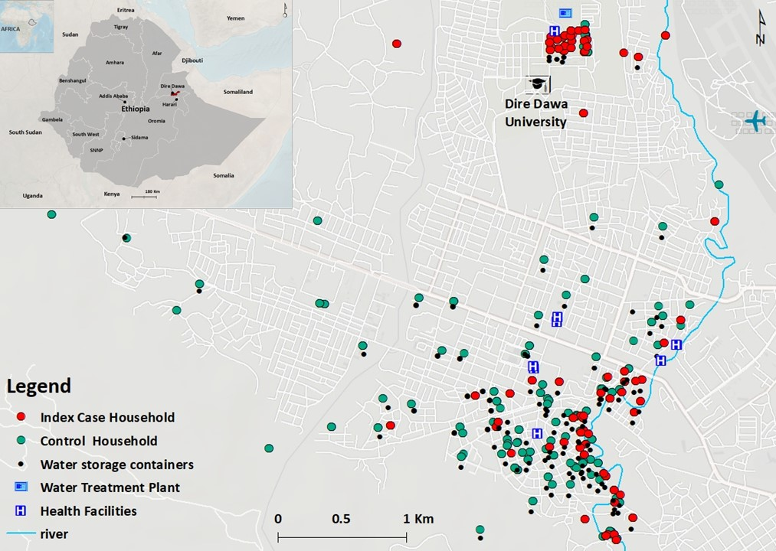 Figure S1: Location of cases, controls, water storage containers, water treatment plant, health facilities and other geographic features in Dire Dawa.

There are two public and five private hospitals, 15 health centers (funded publicly, 8 in the city and 7 in the rural areas), and 17 clinics (private) in the city. Four years of malaria data (January 2019 to May 2022) were collected from 34 private and public health facilities (Table S1). Goro health center and DDU students’ clinic were selected for the current study based on the highest number of cases they reported prior to the start of the study (January – February 2022). In fact, together, the two health facilities reported 56% of the total cases in the city in 2022 (January – May). As in all public universities in Ethiopia, students live within campus with full and shared accommodation provided by the government. At DDU, an average of six students of the same sex and year of study share a dormitory on a three story building that has an average of 67 dormitories. Routine healthcare service is provided in a university dedicated students’ clinic.

Table S1. Monthly total cases tested for malaria and positivity rate in Dire Dawa between January 2019 and May 2022, obtained from 34 public and private health facilities.

Months | Year, % (total positive/total tested)
Months | 2019 | 2020 | 2021 | 2022
January | 2.3(43/1884) | 5.1(153/3022) | 6.5(73/1131) | 9.9(371/3735)
February | 3.0(45/1507) | 5.3(152/2843) | 6.3(66/1044) | 12.5(432/3454)
March | 3.5(52/1476) | 7.0(187/2676) | 7.2(75/1048) | 9.6(368/3850)
April | 2.3(31/1374) | 11.6(190/1642) | 6.4(52/809) | 16.6(646/3902)
May | 2.4(34/1442) | 11.8(262/2212) | 6 .0(54/895) | 12.2(608/5003)
June | 3.6(74/2035) | 6.1(122/1995) | 9.0(131/1449) | -
July | 3.9(108/2747) | 6.5(164/2520) | 8.9(131/1474) | -
August | 3.1(123/3988) | 5.9(140/2382) | 9.8(176/1794) | -
September | 2.3(82/3574) | 6.4(190/2948) | 7.8(137/1756) | -
October | 6.3(165/2638) | 5.4(160/2948) | 10.6(183/1732) | -
November | 6.1(171/2790) | 3.4(92/2671) | 10.9(186/1712) | -
December | 5.5(211/3834) | 3.7(110/2992) | 12.3(253/2052) | -
Total | 3.9(1139/29289) | 6.2(1922/30851) | 9.0(1517/16896) | 12.2(2425/19944)

Study design and procedure
In order to ascertain the effect of exposure to An. stephensi on malaria, we employed a case control study where identification of cases was done prospectively in order to capture co-occurrent characteristics in terms of exposure and risk factors. We recruited consecutive patients with criteria described below in a 1:2 (one case: two controls) unmatched study design.

Recruitment of participants: Patients with (history of) fever that presented at the two health facilities and tested positive for malaria by microscopy were recruited as index cases (index) from April to July 2022. Febrile patients who attended the same clinic and tested negative for malaria were recruited as controls within 72 hours of when the index was identified. The index and controls were followed to their homes and their household members were tested for malaria and their households/dormitories were screened for Anopheles mosquitoes (larvae and adult). Detailed characteristics of study participants is presented in Table S2. It is noticeable that although the study was unmatched due to the difficulty in recruiting matched controls (to the cases) in geographical proximity of the cases, their general characteristics are very similar (Table S2 individual characteristics).

Sample size: We planned an unmatched case:control ratio of 1:2¹ with prospective case identification. The choice of the ratio was based on a logistic regression model aimed to detect an odds ratio of at least 2, assuming an exposure of 20% in controls at household level, where the exposure was the presence of An. stephensi. The power analysis was conducted in epiR package (R-cran software). An overall total sample size of N = 288 with 100 cases and 188 controls, was required to achieve a power of 70% for the study to be sufficiently powered to detect differences between the presence of malaria on An. stephensi exposure at household level. This was the selected stopping rule. The controls were selected from the same population as the cases and post-stratification applied². Data from cases and controls were reviewed regurarly, and final sample size was set to 290 with 101 cases and 189 controls. The recruitment of case-household and control-household members was done to include reactive case detection and improve the power of the study (and the OR minimum detection).

Ethical statement. Study protocol was approved by the Institutional Ethical Review Board of AHRI/ALERT Ethics Review Committee (AF-10-015.1, PO/07/19).

Table S2. Summary statistics of individual and household level characteristics for members of the cases and controls in the two settings in Dire Dawa.
Characteristics | CITY |  | UNIVERSITY
Characteristics | CASES | CONTROLS | CASES | CONTROLS
Characteristics | Individual characteristics
Number of participants | 173 | 350 | 163 | 266
Malaria incidence, %(n/N) | 42.1(72/173) | 2.3(8/350) | 42.9(70/163) | 5.3(14/266)
Male sex, %(n/N) | 47.9(83/173) | 45(157/349) | 100(163/163) | 100(266/266)
Age (years), median (IQR) | 23(14,35) | 22(11,35) | 22(21,23) | 21(20,22)
Travel history last month, %(n/N) | 9.3(16/173) | 9.5(33/349) | 9.8(16/163) | 6.4(17/266)
LLIN use, %(n/N) | 41.9(67/160) | 50.9(169/332) | 41.4(67/162) | 41.7(105/252)
Spray use, %(n/N) | 12.3(19/155) | 23.7(75/316) | 0.0(0/160) | 0.4(1/259)
Repellent use, %(n/N) | 25.3(39/152) | 21.3(68/320) | 0.0(0/163) | 0.0(0/266)
 | Household characteristics
Number of households (HH) | 48 | 109 | 53 | 80
Larvae positivity around HH, %(n/N) | 14.6(7/48) | 4.6(5/109) | 17.0(9/53) | 5.0(4/80)
Adult stephensi presence (indoor/outdoor), %(n/N) | 2.1(1/48) | 0.0(0/109) | 13.2(7/53) | 10.0(8/80)
An. stephensi positivity (larvae/Adult) %(n/N) | 16.7(8/48) | 4.6(5/109) | 30.0(16/53) | 15.0(12/80)
Livestock presence, %(n/N) | 31.9(15/47) | 38.3(36/94) | 0.0(0/53) | 0.0(0/80)
Average distance to river (m) | 666.9 | 488.9 | 385.3 | 394.8
Average distance to artificial containers (m) | 688.7 | 661.5 | 68.5 | 65.2
Eave opened, %(n/N) | 4.7(2/43) | 6.2(6/97) | 54.9(28/51) | 52.1(37/71)
Modal waterbody type | Stream | Stream | Pond | Pond
Water body presence in the neighborhood | 47.9(23/48) | 44.0(48/109) | 96.2(51/53) | 98.8(79/80)
IRS in the last 12 month | 2.3(1/44) | 0.0(0/104) | 26.9(14/52) | 13.2(10/76)

Blood samples collection: Finger prick blood samples (~0.5mL), collected in BD K₂EDTA Microtainer® tubes, were used to diagnose malaria using rapid diagnostic test (RDT) (ABBOTT BIOLINE Malaria Ag Pf/Pv HRP2/LDH, India) and microscopy, and to prepare dried blood spots (DBS) on 3MM Whatman filter paper (Whatman, Maidstone, UK). The remaining blood was separated into cell pellet and plasma. Slide films were confirmed by expert microscopists. Socio-demographic, epidemiological, intervention utilization, and history of travel and malaria were collected from all study participants.

Entomological surveys: Immature stages of Anopheles mosquitoes were surveyed within a 100-meter radius of the index and control houses/dormitories targeting both manmade water storage containers and natural habitats including river beds and stream edges. Each aquatic habitat was checked for 10 minutes from 9:00-11:00AM and 3:00-5:00PM for the presence of Anopheles mosquitoes’ larvae or pupae aiming for ten dips per habitat (using a standard dipper with 350ml capacity). Characteristics of water holding containers (permanency of habitat, lid status, purpose, volume, presence of shade, type, turbidity, temperature, and water source) were recorded for each habitat (Table S3). Adult mosquitoes were searched using Prokopack® aspirators for 10 minutes between 06:00 to 08:00 AM indoor, outdoor, and in animal shelters located within the compound of the household or inside and outside the dormitories at the university. Mosquito surveys (immature and adult) were done within 48-72 hours of when the index/control was recruited.
Conventional adult mosquito collection methods such as CDC light traps and pyrethrum spray sheet have limited sensitivity for this invasive species mainly related with its unique resting behaviour³. To supplement the evidence generated from the case control study and examine the resting sites of the adult Anopheles mosquitoes in detail in the study area, additional adult mosquito surveys were done targeting potential resting sites including animal shelters and manholes within the study time and area. Informed by these preliminary findings, surveys were systematized in three fortnightly rounds during the study period. In the city, households with (n=15) and without (n=15) animal shelters were included (Table S4). At DDU, two dormitory buildings which reported the highest number malaria cases and their surroundings were selected. Adult mosquitoes were surveyed indoor, outdoor, in animal shelters, overhead tanks, and manholes using Prokopack® aspirators for 10 minutes between 06:00 to 08:00 AM. Animal shelters were not available at DDU. Adult caught mosquitoes (sorted based on their abdominal status) and those raised from aquatic stages, were morphologically identified to the species level⁴. Anopheles mosquitoes were individually preserved in tubes that contained silica gel desiccant in zipped bags and transported to AHRI for further analysis. The global positioning system (GPS) coordinates of the households and immature and adult mosquito collection sites were recorded using GARMIN handheld GPS navigator (GARMIN GPSMAP 64S, Taiwan).

Table S3. Immature Anopheles mosquitoes collected during the case control study within 100 meter radius around the case and control households
Habitat | Anopheles positive habitats, n/N | An. stephensi | An. gambiae | An. pretoriensis | An. Turkudi
Cemented cistern | 1/4 | 23 | 0 | 0 | 0
Metal barrel | 1/86 | 6 | 0 | 0 | 0
Plastic Drum | 1/27 | 16 | 0 | 0 | 0
Plastic barrel | 12/238 | 230 | 0 | 0 | 0
Stream | 9/17 | 160 | 67 | 42 | 11
Ditch (Water leak) | 1/1 | 38 | 0 | 0 | 0
Jerrycan | 0/504 | 0 | 0 | 0 | 0
Water treatment plant | 1/1 | 101 | 0 | 0 | 0
Total |  | 574 | 67 | 42 | 11

Table S4. Adult mosquitoes collected in the case control and expanded surveys in Dire Dawa
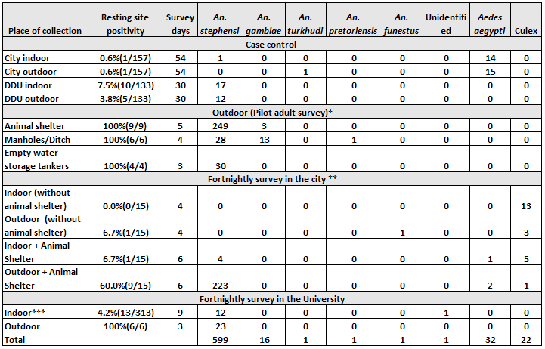
* Adult mosquitos collected from outside of houses involved in the case control study in Goro and Dire dawa university; **The expanded survey in the city was done in three rounds for each collection place; ***The expanded survey at DDU included an adult mosquito survey in four buildings that were fortnightly sampled .

Laboratory procedures
Genomic DNA was extracted from blood samples in EDTA tubes using the MagMAX™ magnetic bead technology DNA multi-sample kit on the KingFisher Flex robotic extractor machine (Thermo Fisher Scientific™). P. falciparum and P. vivax gene copies were quantified using a multiplex quantitative PCR (qPCR) targeting the 18S rRNA small subunit gene as described before^{5,6}.
Multiplexed amplicon sequencing was performed on qPCR positive samples with reagents and protocol as in Tessema et a. DNA was amplified for 15 or 20 cycles during multiplexed PCR, depending on parasitemia and ability to amplify, and for 15 cycles for indexing PCR. The primer pools used in this study comprised high-diversity microhaplotype targets (n=162), polymorphisms associated with drug resistance, and targets in and adjacent to pfhrp2 and pfhrp3 to assess for gene deletion (Primer pools 1A and 5 as described here)^{7,8}. Amplified libraries were sequenced in a NextSeq 2000 or a MiniSeq instrument using 150PE reads with 10% PhiX.
The heads and thoraces of wild caught adult mosquitoes bisected on the second and third leg under a stereo microscope⁹ were homogenized using 1mm Zirconium beads and a Mini-Bead Beater 96 (Bartlesville, OK, USA)¹⁰. The homogenate was used for DNA extraction and tested for Plasmodium infection using circumsporozoite (CSP) multiplex bead assay (targeting P. falciparum, P. vivax 210, and P. vivax 247)¹¹ after boiling at 100ºC on a thermocycler. Samples with higher mean fluorescence intensity (MFI) signal than the negative controls plus 3 standard deviations were re-run to confirm the observations. A PCR targeting the mitochondrial cytochrome oxidase I¹² and species specific 18S small ribosomal subunit¹⁰ genes were used for confirmation. A single-step multiplexed PCR, based on cytochrome b gene, was used to identify the blood-meal sources (included in the assay were dog, cow, goat, pig, or human) in the midgut of the mosquitoes¹⁴.

Data management
Data management: Study data collection tools (mobile application version 5.20.11) were prepared and managed using REDCap electronic data capture tools hosted at AHRI^{15,16}. CSV files exported from REDCap were analyzed using STATA 17 (StataCorp., TX, USA), RStudio v.2022.12.0.353, QGIS v.3.22.16 (QGIS Development Team, 2023. QGIS Geographic Information System. Open Source Geospatial Foundation Project), and GraphPad Prism 5.03 (Graph Pad Software Inc., CA, USA). All statistical analyses were performed in Rsoftware (4.12) with packages lme4 (generalized linear mixed models) and dcifer.

Bioinformatic analysis: Fastq files were subjected to filtering, demultiplexing and allele inference using a Nextflow-based pipeline. We used cutadapt to demultiplex reads for each locus based on the locus primer sequences (no mismatches or indels allowed), filter reads by length (100 base pairs) and quality (default NextSeq quality trimming). We used dada2 to infer variants and remove chimeras. Reads with a PHRED quality score of less than 5 were truncated. The leftmost base was trimmed and trimmed reads of less than 75 base pairs were filtered out. Default values were used for all other parameters. We then aligned alleles to their reference sequence and filtered out reads with low alignment. We masked homopolymers and tandem repeats to avoid false positives.

Genetic analysis: Pairwise relatedness analysis was performed on genotypes in diverse loci using Dcifer¹⁷ with default settings. Pairwise relatedness was only considered between samples where the lower confidence interval of estimated relatedness was greater than .1. Point estimates of pairwise relatedness that satisfied this threshold were then binned into low, medium, and high relatedness at greater than .2, .5, and .9 respectively. Samples were then clustered based on pairwise relatedness. Drug resistance marker genotypes were extracted from loci of interest. Diagnostic resistance (pfhrp2 deletions) flagged from drop in coverage in loci around pfhrp2 gene was extracted.

Epidemiological analysis: Continuous variables were presented as median and interquartile range (IQR). Tests of association between two categorical variables were performed using contingency tables. Mann-Kendall test was used to test for monotonic (increasing or decreasing) trends of malaria cases using the secondary data obtained from the private and public health facilities at the city and University.
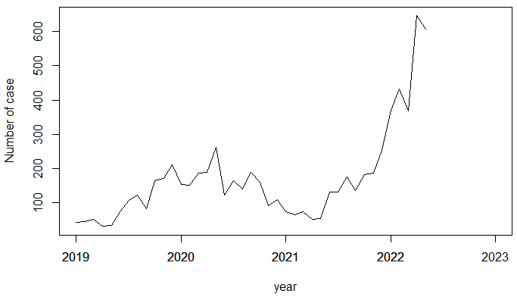
Figure S2. Monthly malaria positive case in Dire Dawa city from 2019-2022. The analysis was based on data collected from 34 private and public health facilities located in Dire Dawa. The data in 2022 included only up to May.

Analyses of case control study: The exposure histories of cases and controls were compared to examine the association between exposure and malaria infection (Table S5). The results demonstrated that members of the index cases and controls had different levels of exposure. Living closer to An. stephensi positive sites defined as larvae within 100m radius to the household and/or adult mosquitoes and waterbodies (both natural or manmade) were found as risk factors that strongly associated with being a member of the case household/dormitory. The odds of usage of spray among members of malaria cases were 58% lower than the odds of usage of spray among controls (ORs 0.42, 95% CI: 0.23-0.72 p<0.001). None of the other interventions were associated.

Table S5: Risk factors associated with malaria infection, case control analysis by chi-square test on malaria/exposure contingency tables.
Exposure | Category | OR (95% CI) | P value
Sex | Male | 2.2(1.43,3.39) | <0.001
Natural water body presence | presence | 1.6(1.18, 2.23) | 0.002
Spray use | yes | 0.4(0.23,0.72) | 0.001
An. stephensi larvae presence | presence | 5.0(2.77,9.35) | <0.001
An. stephensi adult presence | presence | 1.9(0.88,3.96) | 0.068
An. stephensi larvae/adult presence | presence | 3.8(2.34,6.31) | <0.001
LLIN use | yes | 0.8(0.61,1.07) | 0.125
Travel history in the last month | yes | 1.2(0.72,1.93) | 0.464
Eave opened | yes | 0.8(0.57,1.07) | 0.118
Livestock presence | presence | 1.2(0.88,1.72) | 0.254
Distance from manmade container | >100m | 0.7(0.53,0.95) | 0.018

Identification of household clusters of infection and impact of river and manmade water containers on malaria infections and An. stephensi presence (Figure 2 main text): As the dormitories within the university study site were located within a small area (20 buildings in 45,450m² area), clustering of prevalence data was assessed in the community only. The prevalence of malaria by RDT and/or microscopy was calculated for each household. Global and local Moran’s I calculations were used to find evidence of spatial autocorrelation within household prevalence data. Initially, neighborhood relationships were defined using distance-based weights, where it was assumed that areas further away are less influential than closer areas. At each pair of locations were applied a spatial weight. The statistical strength of association for global Moran’s I was calculated using Monte-Carlo methods, simulating a random distribution of the prevalence data 9,999 times. The Moran’s I from the real data was compared to the simulations and a pseudo-p value was used to assess the probability that we incorrectly reject the null hypothesis. The Euclidean distance from the river to every site where adult or larval An. stephensi were located were calculated in meters.

Multilevel logistic regression model for risk factors analysis (GLMM): To identify the association of An. stephensi and other risk factors for malaria positivity in Dire Dawa, we employed a multilevel logistic regression model with nested random effects¹⁸ to account for intra-class correlation (ICC) and quantify the variation in a parasite positive outcome that accounted for the household and case control group variances¹⁹ (nested random effects). The model has a binomial outcome represented by malaria positivity using RDT/microscopy. Geographic unit’s effects enable us to control for unknown variations by including them as random effects in the model¹⁹. Individuals living in the same household may share exposures that can determine similarities in malaria transmission as well as in the larger setting (city versus university).

Let $y_{ij}$ denote the malaria outcome of the$i^{th}$individual in the$j^{th}$ household or cluster, identified by the (RDT/microscopy) with probability $π_{ij},$where $y_{ij}$= 1 denotes the individual tested positive, while $y_{ij}$ = 0 denotes the individual tested negative for malaria. A multilevel logistic regression model with random effects for the outcome $y_{ij}$ is given by
$$logit\left(π_{ij}\right)={β_{0j}+βX}_{ij}+u_{j}$$

where$X_{ij}$= (1, x_{1ij}, ..., x_{pij}) is vector of p explanatory variables or covariates measured on the i individual and on the j household (cluster), $β$vector of fixed regression coefficients or parameters and $u_{j}$ is a random effect varying over household and case control.

Multilevel model results: Univariate GLMM was employed to reduce the number of explenatory factors to a manageable size. Household and case/control were included as nested random effects.. Only those risk factors with p-value lower than 0.1 were considered for multivariate analysis. The results from univariate (unadjusted) and multivariate (adjusted) generalized linear mixed models are shown in Table 1 of the main text. This table results show that four of the six individual and household level characteristics, namely site, sex, age in years and stephpos were statistically significantly associated with malaria infection of individuals living in the study area. Factors such as sex (OR 3.0, 95% CI 1.66-5.44, p=0.001) and being adult (above 15 years old OR 4.3, 95% CI 1.15-15.65, p=0.029) were risk factors associated with P. falciparum infection positivity whilst using sprays was found protective from malaria (OR 0.3, 95% CI 0.11-0.78, p=0.016). The results show that those individuals residing in households with An. stephensi positivity (larvae/adult/indoor/outdoor) had a higher risk of malaria infection at both individual (ORs 3.7, 95% CI: 1.65-6.47 p<0.001).

The estimated between nested household and case control variance for the final model was 1.06, which corresponds to ICC of 0.24. This implies that of the residual variation in malaria positivity outcomes of persons that were observed after adjusting for five individual and household level factors, 24.4 percent was due to systematic differences between household and case control, while the remaining 76.6 per cent was due to unmeasured differences between households and case control.

Reference
1 Smith, P. G. et al. Int. J. Epidemiol. 13, 1984.
2 Neuhäuser, M. et al. Stat. Med. 16, 1997.
3 Ahmed, A. et al. Acta Trop., 2022.
4 Coetzee, M. Malar. J. 19, 2020.
5 Hermsen, C. C. et al. Molecular and Biochemical Parasitology 118, 2001.
6 Wampfler, R. et al. PLoS One 8, 2013.
7 Tessema, S. K. et al. J. Infect. Dis., 2020.
8 Andres Aranda-Diaz, e. n. Multiplex Amplicons for Drug, Diagnostic, Diversity, and Differentiation HAplotypes via TargeTed Resequencing (MAD4HatTeR).
9 Foley, D. H. et al. Malar. J. 11, 2012.
10 Graumans, W. et al. Malar. J. 16, 2017.
11 Sutcliffe, A. C. et al. Malar. J. 20, 2021.
12 Echeverry, D. F. et al. Malar. J. 16, 2017.
13 Foley, D. H. et al. Malaria Journal 11, 2012.
14 Kent, R. J. et al. Am. J. Trop. Med. Hyg. 73, 2005.
15 Harris, P. A. et al. Journal of Biomedical Informatics 42, 2009.
16 Harris, P. A. et al. Journal of Biomedical Informatics 95, 2019.
17 Gerlovina, I. et al. Genetics 222, 2022.
18 Austin, P. C. et al. Canadian journal of public health 92, 2001.
19 Goldstein, H. et al., 2003.
20 Burnham, K. P. A practical information-theoretic approach, 1998.

