Supporting Information

Controlled tumor heterogeneity in a co-culture system by 3D bio-printed tumor-on-chip model
Nafiseh Moghimi,^{1,4} Seied Ali Hosseini,² Altay Burak Dalan ^{1,3}* Dorsa Mohammadizadeh,¹ Aaron Goldman,⁴ Mohammad Kohandel¹*
Department of Applied Mathematics, University of Waterloo, Waterloo, Canada,¹ Electrical Engineering Department, University of Waterloo, Waterloo, Canada,² Department of Medical Genetics, School of Medicine, Yeditepe University, Istanbul, Turkey,³ Department of Medicine, Harvard Medical School, Boston, MA, USA; Division of Engineering in Medicine, Brigham and Women's Hospital, Boston, MA, USA⁴
*correspondence to: nmoghimi@uwaterloo.ca

Table 1
Bioink | Pressure, Gauges (22G Nozzle) | Filament | Printability
Alg 1%/ Gel 4% (A1G4) | 20-30 KPa | Has nods with red nozzle, spreads with blue nozzle | Could not hold the structure, especially with blue nozzle
Alg 1%/ Gel 5% (A1G5) | 20-30 KPa | Has nods with red nozzle, spreads with blue nozzle | Could not hold the structure, especially with blue nozzle
Alg 4%/ Gel 4% (A4G4) | 60-70 KPa | smooth | Accurate printing
Alg 8%/ Gel 4% (A8G4) | 100-110 KPa | Very sharp and smooth | Accurate printing
Alg 4%/ Gel 8% (A4G8) | 130-140 KPa | Has nods | Lack of printing accuracy, too dense and difficult to print
Alg 1%/ Gel 8% (A1G8) | 70-80 KPa | smooth | Accurate printing
Alg 1%/ Gel 10% (A1G10) | 100-110 KPa | Has nods | Lack of printing accuracy

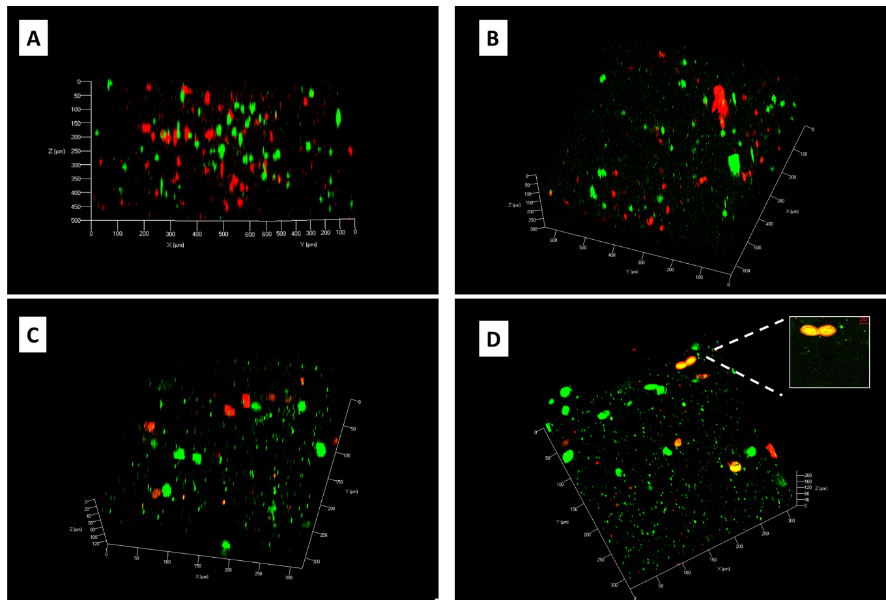
Figure 1S: Confocal image of the co-culture construct at (A) day 1, (B) day 10. (C) and (D) are the higher magnification of two different layer of the construct at day 10. MDA-MB-231 cells marked as green and MCF marked as red.

