Appendix Table of Contents

This supplementary material has been provided by the authors to give readers additional information about their work.

Supplementary Tables

- Supplementary Table 1. Summary of the clinical and laboratory criteria to establish definitive diagnosis, Rio de Janeiro, Brazil, October 2018-July 2019
- Supplementary Table 2. Demographic, clinical and laboratory characteristics of non-severe febrile participants, Rio de Janeiro, Brazil, October 25, 2018 – July 31, 2019
- Supplementary Table 3. The most common antibiotics prescribed among non-severe febrile patients and their classification according to the 2019 WHO Aware groups, Rio de Janeiro, Brazil, October 2018-July 2019
Supplementary Figures

- Supplementary Figure 1. Percentage of total antibiotic use among non-severe febrile patients by spectrum of antibiotic activity and appropriateness status, Rio de Janeiro, Brazil, October 2018-July 2019
- Supplementary Figure 2. Percentage of total antibiotic use by spectrum of antibiotic activity, facility type, and appropriateness status among non-severe febrile participants, Rio de Janeiro, October 2018-July 2019
- Supplementary Figure 3. Distribution of antibiotic prescription according to the reason why antibiotic prescription was considered inappropriate among non-severe febrile patients, Rio de Janeiro, October 2018-July 2019

Assessment of final diagnoses
Final diagnosis (in some cases, more than one) was retrospectively established based on all available clinical and laboratory data from the index and follow-visit, as was done by previous studies [D’Acremont V et al. N Engl J Med. 2014]. These criteria were applied to each participant.

Supplementary Table 1. Summary of the clinical and laboratory criteria to establish definitive diagnosis, Rio de Janeiro, Brazil, October 2018-July 2019

Syndromic diagnosis | Clinical presentations considered for the diagnosis | Additional criteria needed for a documented diagnosis (usually laboratory test or X-ray)
Malaria
Malaria | - All presentations | - Positive malaria RDT or blood smear
Typhoid
Typhoid | - All presentations | - Positive typhoid RDT OR blood or stool culture positive for Salmonella typhi
Meningitis
Meningitis | - Neck stiffness OR bulging fontanel OR Kerning/Brudzinski OR convulsions OR abnormal consciousness | - CSF culture positive for any microorganism potentially involved in meningitis other than typical contaminants  - Positive Crag test
Urinary tract infection
Urinary tract infection (i.e., pyelonephritis, cystitis) | - Dysuria, hematuria or polyuria | - Positive urine culture (non-contaminant bacteria with bacteria 10⁴ CFU/ml, other than mixed growth)
Skin, mucosal and osseous purulent infections
Significant skin infection (i.e., furunculosis, empyema, skin abscess, cellulitis, erysipelas) | - Pain, local swelling, local tenderness, refusal to move the affected limb/arm, visible localized wound  - Pus discharge | - Positive culture of pus or collected liquid
Gastroenteritis
Amoebic gastroenteritis | - Diarrhea ≥ 3 watery stools/day | - Stool direct examination positive for Amoeba
Bacterial gastroenteritis | - Diarrhea ≥ 3 watery stools/day | - Stool culture positive for enterotoxic Escherichia coli, Salmonella or Shigella spp.
Gastroenteritis of unknown origin | - Diarrhea ≥ 3 watery stools/day | - No Amoeba or bacteria on microscopy and culture
Viral gastroenteritis | - Diarrhea ≥ 3 watery stools/day | - Positive rota- or adenovirus RDT
Acute respiratory tract infections
Upper respiratory tract infection  (rhinitis, rhinosinusitis, pharyngitis, tonsillitis, acute otitis media) | - Rhinitis: cough, runny nose/Nasal discharge, mouth breathing  - Pharyngitis: cough, throat pain, difficulty in swallowing/ drooling of saliva. Pharyngeal erythema/inflammation  - Tonsillitis: throat pain OR pharyngeal redness AND enlarged tonsils. We subclassified tonsillitis into streptococcal and non-streptococcal aetiology according to GAS RDT results  - Acute otitis media: history of ear pain, auricular discharge OR bulging tympanum OR erythematous tympanum | - Nasopharyngeal swab positive for viruses  - GAS RDT positive
Lower acute respiratory tract infection  (bronchitis, bronchiolitis,  pneumonia) | - Bronchitis/bronchiolitis: cough or difficult breathing with abnormal breathing rate and abnormal chest auscultation (wheezing, rhonchi).  - Non-radiological pneumonia: Cough AND difficult breathing with fast breathing OR chest indrawing/nasal flaring/grunting OR dyspnoea OR abnormal chest auscultation (decreased or bronchial breath sounds, crackles, abnormal vocal resonance, pleural rub). No “primary end-point consolidation” on CXR OR CXR not interpretable OR CXR not done  Radiological pneumonia: Cough AND difficult breathing with fast breathing OR chest indrawing/nasal flaring/grunting OR dyspnoea OR abnormal chest auscultation (decreased or bronchial breath sounds, crackles, abnormal vocal resonance, pleural rub). “Primary end-point consolidation” on CXR visible. | - “Bronchitis” on CXR  - PCR positive for one or more virus(es) on nasopharyngeal swabs  - Positive Streptococcus pneumoniae antigen RDT on urine  - Chest X-ray showing conscript consolidation, lobular infiltrates or heterogeneous opacities
Non-infectious febrile illness
Non-infectious febrile illness | - All presentations | - No bacterial, viral or malaria parasite isolated, no specific positive tests OR laboratory tests results (during this study) do not fit with clinical picture and evolution
Systemic infection
Bacteremia | - All presentations | - Blood culture for bacteria other than typical contaminants (i.e., Coagulase negative-staphylococcus, Bacillus spp., viridans group streptococci, Corynebacterium spp., Propionibacterium spp., Micrococcus spp.)
Flaviviruses | - All presentations | - Concurrent antibodies for DENV ELISA and ZIKV ELISA
Dengue | - All presentations | - Presumptive dengue infection: positive DENV ELISA IgM and/or IgG assay without a reactivity for ELISA ZIKV IgM and/or IgG
Dengue | - All presentations | - Confirmed dengue infection: positive dengue PCR
Zika | - All presentations | - Presumptive zika infection: positive zika ELISA IgM and/or IgG assay without having a reactivity for DENV ELISA IgM and/or IgG
Zika | - All presentations | - Confirmed zika infection: positive zika PCR
Chikungunya | - All presentations | - Presumptive chikungunya infection: positive chikungunya IgM assay
Chikungunya | - All presentations | - Confirmed chikungunya infection: positive chikungunya PCR
Leptospirosis | - All presentations | - Positive microscopic agglutination test for Leptospira spp.
Syphilis | - All presentations | - Positive syphilis RDT
Rickettsiosis | - All presentations | - Positive PCR for Rickettsia

Supplementary Table 2. Demographic, clinical and laboratory characteristics among non-severe febrile illness participants, Rio de Janeiro, Brazil, October 25, 2018 – July 31, 2019
Characteristics | Total febrile population  (N=500)
Demographic variables
Female sex – no. (%) | 252 (50.4)
Age (years), median (IQR) | 26 (15-41)
Age (years) – no. (%)
≤ 15 | 77 (15.4)
16 – 26 | 85 (17)
27 - 40 | 279 (55.8)
≥ 41 | 59 (11.8)
Clinical variables
BMI (kg/m²), median (IQR) | 25.8 (20.1-29.8)
Mild upper arm circumference (cm) for those < 5 years, mean (±SD) | 176.4 (60.4)
Illness duration (days), median (IQR) | 3 (2-4)
Symptoms
Headache – no. (%) | 382 (76.4)
Photophobia – no. (%) | 137 (27.4)
Sore throat – no. (%) | 154 (30.8)
Rhinorrhea – no. (%) | 117 (23.4)
Cough – no. (%) | 179 (35.8)
Dysuria – no. (%) | 40 (8)
Diarrhea – no. (%) | 81 (16.2)
Joint pain – no. (%) | 272 (54.4)
Medical past history
Recent antibiotic use – no. (%) | 44 (8.8)
Comorbidities – no. (%) | 124 (24.8)
Vital signs
Temperature (°C), median (IQR) | 37.7 (36.7-38.4)
Heart rate(beats/min), mean (±SD) | 101 (21)
Respiratory rate (rate/min), median (IQR) | 21 (19-24)
Mean arterial pressure (mmhg), mean (±SD) | 83.5 (25.7)
Laboratory variables
WBC (cells/uL), median (IQR) | 7.280 (5.460-10.390)
Lymphocytopenia (10⁹ uL) – no. (%) | 246 (49.5)
Platelets (uL), median (IQR) | 243 (196.000-297.000)
Creatinine (mg/dl), median (IQR) | 0.84 (0.68-1.07)
Total bilirubin (mg/dl), median (IQR) | 0.39 (0.26-0.56)
CRP > 5 mg/dl – no. (%) | 318 (63.9)
BMI stands for body mass index; CRP C-reactive protein; IQR interquartile range; SD standard deviation WBC white blood count
Assessment of antibiotic appropriateness

All febrile visits that ended with at least one antibiotic prescribed were revisited and the main indication for antibiotic prescription identified. As there was no treatment guideline at study sites, we adopted the World Health Organization (WHO) Essential Medicines List (EML) recommendation for treatment of the most common infectious syndrome in primary care in low-and-middle-income countries. When guidelines did not mention a specific clinical syndrome, we followed the international guidelines such as Infectious Diseases Society of America (IDSA) and/or the European Society for Microbiology and Infectious Diseases (ECMIID) guidelines.

Appropriateness status | Evidence-based guidelines recommendations
Appropriate | Antibiotic prescription follows endorsed guidelines optimally, including antibiotic choice, dosage, route, and duration.
Inappropriate | Antibiotic prescription does not optimally follow endorsed guidelines, including antibiotic choice, dosage, route or duration. Here we include situations where antibiotic spectrum is excessively broad for the empirical treatment; there is spectrum overlap with another antibiotic; the pathogen is not covered according to the antimicrobial susceptibility test; or antibiotic is not indicated for the documented or presumed indication (i.e., arboviruses, viral pneumonia, common cold, bronchiolitis)

Classification of antibiotics according to the World Health Organization AWaRe groups
In 2019, the World Health Organization (WHO) Essential Medicines List (EML) Working Group classified antibiotics in the EML into three groups: Access, Watch, Reserve (AWaRe) to support members states to monitor antibiotic stewardship initiatives in order to curb an antimicrobial resistance crisis.
The Access group contains generally narrow-spectrum antibiotics recommended as first and second-choice for most common clinical infection syndromes. The Watch group contains generally broader spectrum antibiotic classes corresponding to the highest priority agents on the list of critically important antimicrobials drugs for human medicine. The Reserve group consists of last-resort antibiotics for targeted use in multidrug-resistant infections. The traffic light colors are generally displayed to represent each one of three groups – Green for the Access, amber for the Watch, and red for the Reserve antibiotics.
Anatomical Therapeutic Chemical (ATC) classification
Antibiotic drugs were coded on the basis of the ATC classification system. We included antibiotics classified as antibacterial for systemic use (ATC code: J01), including beta-lactamase sensitive penicillin’s (J01CE), penicillins with extended spectrum (J01CA), combinations of penicillins and beta-lactamase inhibitors (J01CR), macrolides (J01FA) and quinolones (J01MA). Prescriptions for antifungal (ATC code: J02), antiviral (ATC code: J05), and drugs for tuberculosis (ATC code: J04) treatment were excluded, as were antibiotics for topical use.

Antibiotic classification according to spectrum of activity
Following previous studies, we described the prescription of all systemic antibiotics into narrow-spectrum and broad-spectrum antibiotics. Narrow-spectrum antibiotics comprised penicillins (i.e., amoxicillin) and first-generation cephalosporins. Broad-spectrum antibiotics included penicillins with beta-lactamase inhibitor combinations (i.e., amoxicillin/clavulanic acid), macrolides, aminoglycosides, and third-generation cephalosporins. Prescriptions of both broad-spectrum and narrow-spectrum antibiotics in the same patient were considered broad-spectrum.

Supplementary Table 3. The most common antibiotics prescribed among non-severe febrile patients and their classification according to the 2019 WHO AWaRe groups, Rio de Janeiro, Brazil, October 2018-July 2019

Antibiotic | Class | ATC code | Category | Prescription rate in our cohort (%)
Amoxicillin | Beta-lactam | J01CA04 | Access | 24.3
Amoxicillin/clavulanic acid | Beta-lactam | J01CR02 | Access | 36.1
Azithromycin | Macrolide | J01FA10 | Watch | 13.8
Benzathine benzylpenicillin | Penicillin | J01CE08 | Access | 0.6
Cefalexin | 1st generation cephalosporin | J01DB01 | Access | 1.9
Ceftriaxone | 3rd generation cephalosporin | J01DD04 | Watch | 1.9
Ciprofloxacin | Fluoroquinolone | J01MA02 | Watch | 12.5
Clindamycin | Lincomycin | J01FF01 | Access | 1.3
Metronidazole | Nitroimidazole | P01AB01 | Access | 1.9
Sulfamethoxazole/trimethoprim | Sulfonamide | J01EE01 | Access | 7.8
ATC stands for Anatomical Therapeutic Chemical

Statistical analysis

Binary logistic regression model

First, we estimated the unadjusted Odds Ratio (OR) for inappropriate antibiotic prescription by comparing several covariates and tested them with Fisher’s Exact Probability test and Likelihood ratio Chi-Square. Then, we conducted a backward stepwise logistic regression by a likelihood-ratio test, including all covariates in the initial model and sequential subtracting the covariates that did not aggregate much for the overall model performance. Goodness-of-fit was tested with Chi-square and Hosmer and Lemeshow tests. We evaluated for evidence of collinearity among the predictors with Pearson correlation test, Tolerance and Variance inflation factor. A 2-sided p-value less than 0.05 was considered statistically significant.
All statistical analyses were performed using SPSS software, version 26 (IBM, Chicago, Illinois, USA) and Tableau Desktop, version 2020.4.2 (Tableau, Seattle, Washington, USA).

Poisson regression model

A Poisson regression model of the number of antibiotic prescriptions over time was produced to obtain the incidence rate ratios (IRRs) and 95% confidence intervals (CI). As the mean and variance of the dependent variable were equal, Poisson regression was deemed suitable. We chose a backward selection algorithm given the same chance of all variable to enter in the model, without chosen a priori any factor to be included. Then, covariates were tested for interaction and confounding effect. Goodness-of-fit for the final model was tested with deviance, degree of freedom, Pearson Chi-Square, and Likelihood ratio Chi-Square. Statistical significance was declared at alpha equals 0.05.
Trend lines model
We estimated a time-series regression model to test whether a linear trend of total antibiotic prescription rate occurred throughout the time (in months). We began by creating a line chart of the time. Then, a regression model included the independent variable (time in months) and the dependent variable the number of antibiotic prescriptions was calculated. The coefficient of time for appropriate and inappropriate prescriptions was equal to 0.03 (p-value= 0.05) and 0.06 (p-value = 0.05), respectively.
Regression Statistics for the linear trend model

Number of modeled observations | 20
Model degrees of freedom | 4
Residual degrees of freedom | 16
SSE (sum squared error) | 686.7
MSE (mean squared error) | 42.91
R-Squared: | 0.51
Standard error | 6.55
p-value | 0.007

Supplementary Figure 1. Percentage of total antibiotic use among non-severe febrile patients by spectrum of antibiotic activity and appropriateness status, Rio de Janeiro, Brazil, October 2018-July 2019

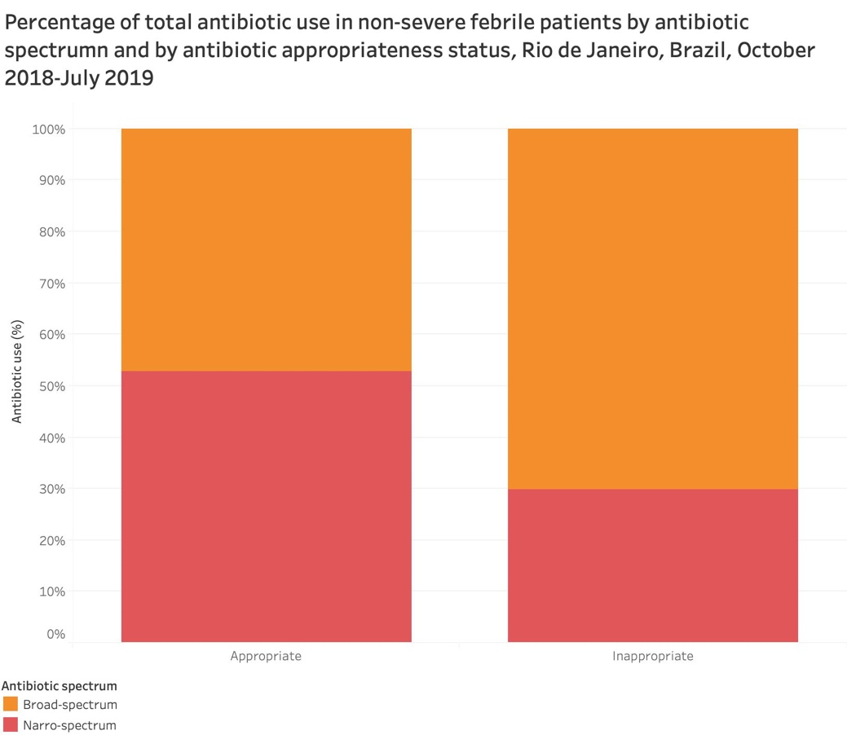

Supplementary Figure 2. Percentage of total antibiotic use among non-severe febrile patients by WHO AWaRe classification, facility type, and appropriateness status, Rio de Janeiro, Brazil, October 2018-July 2019

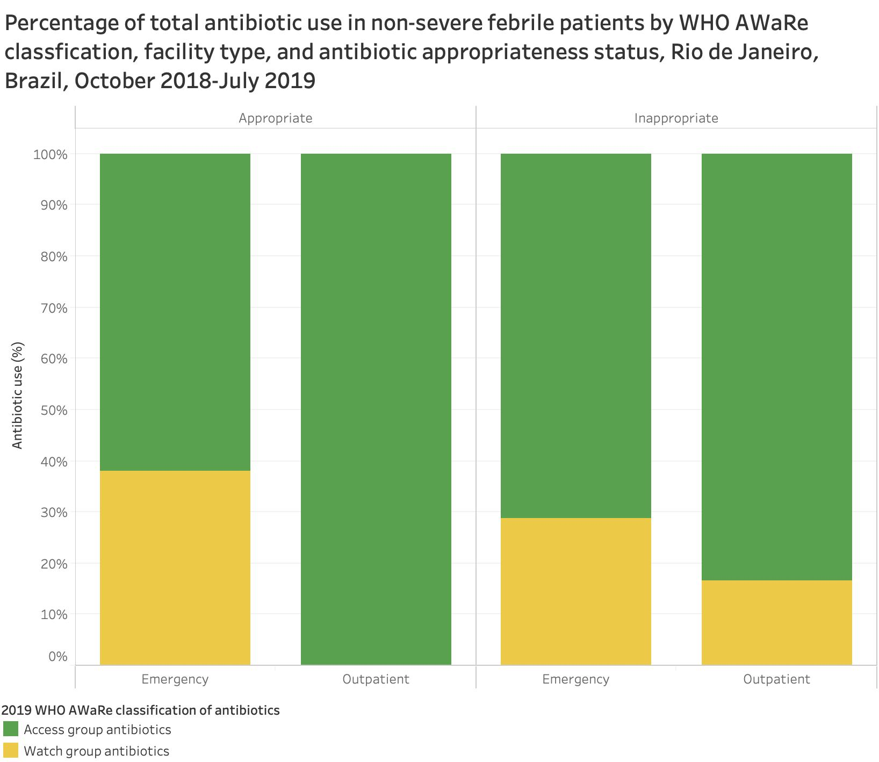

Supplementary Figure 3. Distribution of antibiotic prescription according to the reason why antibiotic prescription was considered inappropriate among non-severe febrile patients, Rio de Janeiro, October 2018-July 2019

