Supplementary Information

TcrXY is an acid-sensing two-component transcriptional regulator of Mycobacterium tuberculosis and a novel target for enhanced TB therapy

Miljan Stupar, Lendl Tan, Edward D. Kerr, Christopher J. De Voss, Brian M. Forde, Benjamin L. Schulz and Nicholas P. West.

Supplementary Figures 1-10

Supplementary Tables 4-6

Supplementary Methods

Supplementary References
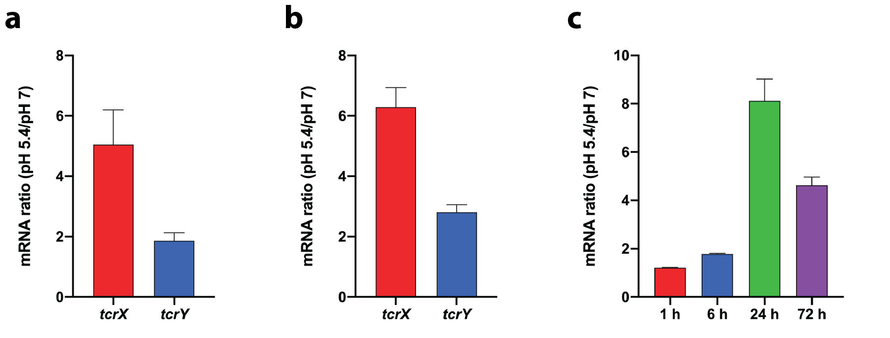

Supplementary Figure 1: tcrXY mRNA is induced at acidic pH.
a, tcrXY is induced in Mtb cultured in acidified minimal media. H37Rv was cultured in pH 7 or pH 5.4 minimal media for 24 hours and mRNA levels compared by qRT-PCR. Each bar represents the mean fold-change from four technical replicates. Error bars denote SD. b, tcrXY is induced in Mtb cultured in acidified 7H9 complete media. H37Rv was cultured in pH 7 or pH 5.4 nutrient-rich media for 24 hours and mRNA levels compared by qRT-PCR. Each bar represents the mean fold-change from four technical replicates. Error bars denote SD. c, tcrX mRNA levels reach their maximum after 24 h in acidic pH. H37Rv was cultured in pH 7 or pH 5.4 minimal media for the indicated time point and mRNA levels compared by qRT-PCR. Each bar represents the mean fold-change from four technical replicates. Error bars denote SD.
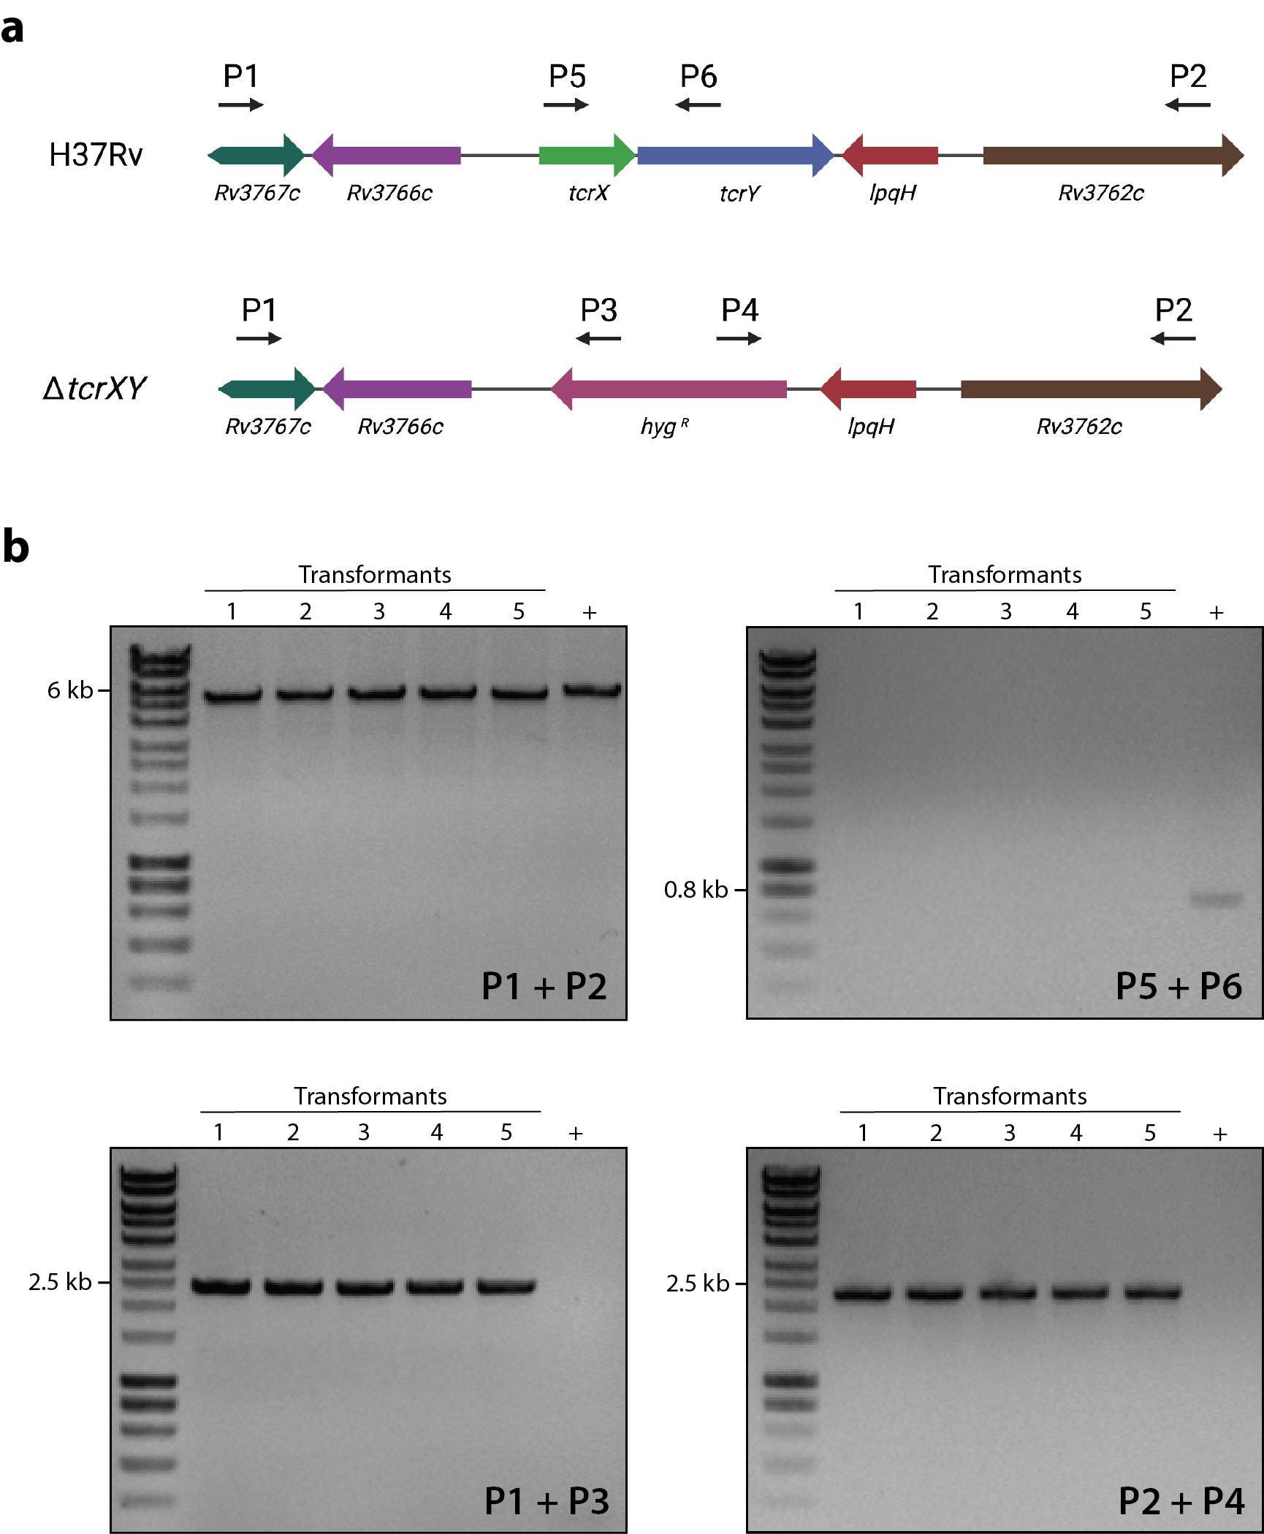

Supplementary Figure 2: Screening of colony transformants for allelic replacement of tcrXY in Mtb H37Rv.
a, Schematic of tcrXY locus depicting genomic architecture in Mtb H37Rv or expected ΔtcrXY mutant. Primer sets used for screening and confirmation of successful allelic exchange of a hygromycin resistance cassette (hyg^{R}) are shown. b, PCR screen using gDNA extracted from five colony transformants for successful allelic replacement of the tcrXY operon. In each image, lanes marked 1-5 represents the five corresponding colony transformants. “+” represents gDNA extracted from wild-type H37Rv. Expected products: P1+P2 (H37Rv: 5514-bp; ΔtcrXY: 5226-bp); P5+P6 (H37Rv: 763-bp; ΔtcrXY: none); P1+P3 (H37Rv: none; ΔtcrXY: 2353-bp); P2+P4 (H37Rv: none; ΔtcrXY: 2182-bp). Transformant “1” was the mutant used for all subsequent experiments described in this study.

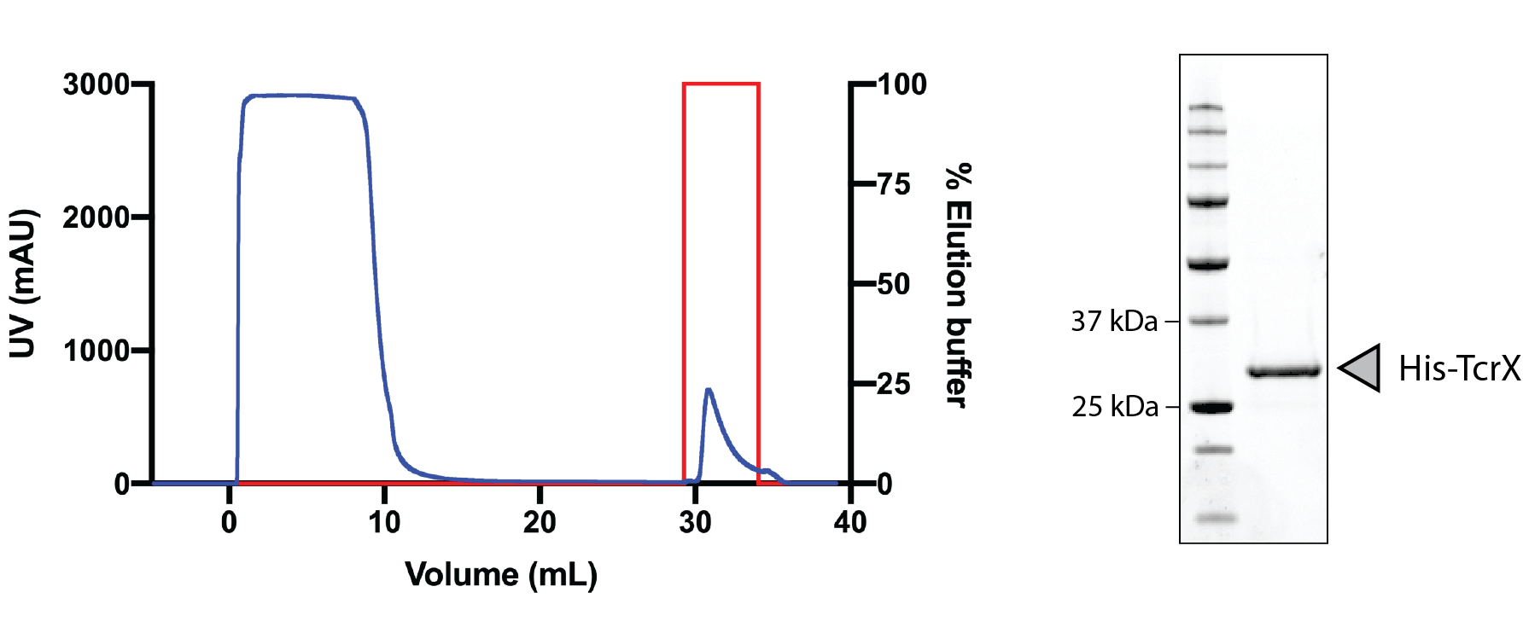

Supplementary Figure 3: Purification of Mtb TcrX.
Purification of 10xHis-TcrX by immobilised metal affinity chromatography. Graph (left) depicts UV chromatogram (blue) demonstrating successful purification of 10xHis-TcrX, using a HiTrap TALON crude column on an ÄKTApure fast-protein liquid chromatography system. The column was washed extensively, and protein eluted off the column using Elution buffer (red). Image (right) demonstrates purity of 10xHis-TcrX by 12% SDS-PAGE. Theoretical molecular weight, 31 kDa.
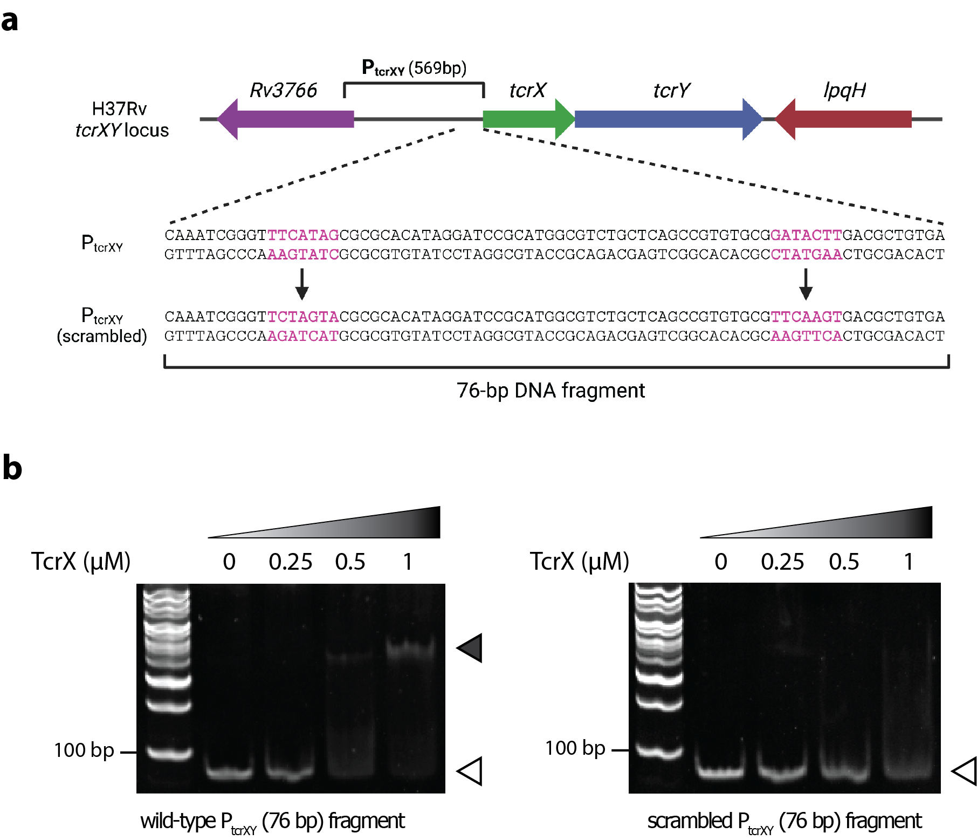

Supplementary Figure 4: A 7-bp mirror repeat in P_{tcrXY} is required for TcrX binding.
a, Schematic representation of putative TcrX binding site in the P_{tcrXY} fragment, and derivation of the P_{tcrXY}(scrambled) fragment. b, Sequence scrambling of a 7-bp repeat in P_{tcrXY} abolishes TcrX-DNA binding. Gel images show an EMSA of purified TcrX with indicated 76-bp DNA fragment from (a). Increasing TcrX concentrations are depicted with each lane, against a constant quantity of DNA (100 ng). Open arrow, free DNA; filled arrow, TcrX-DNA complex. First lane, 1-kb DNA reference ladder. The EMSA was performed twice with parallel results.
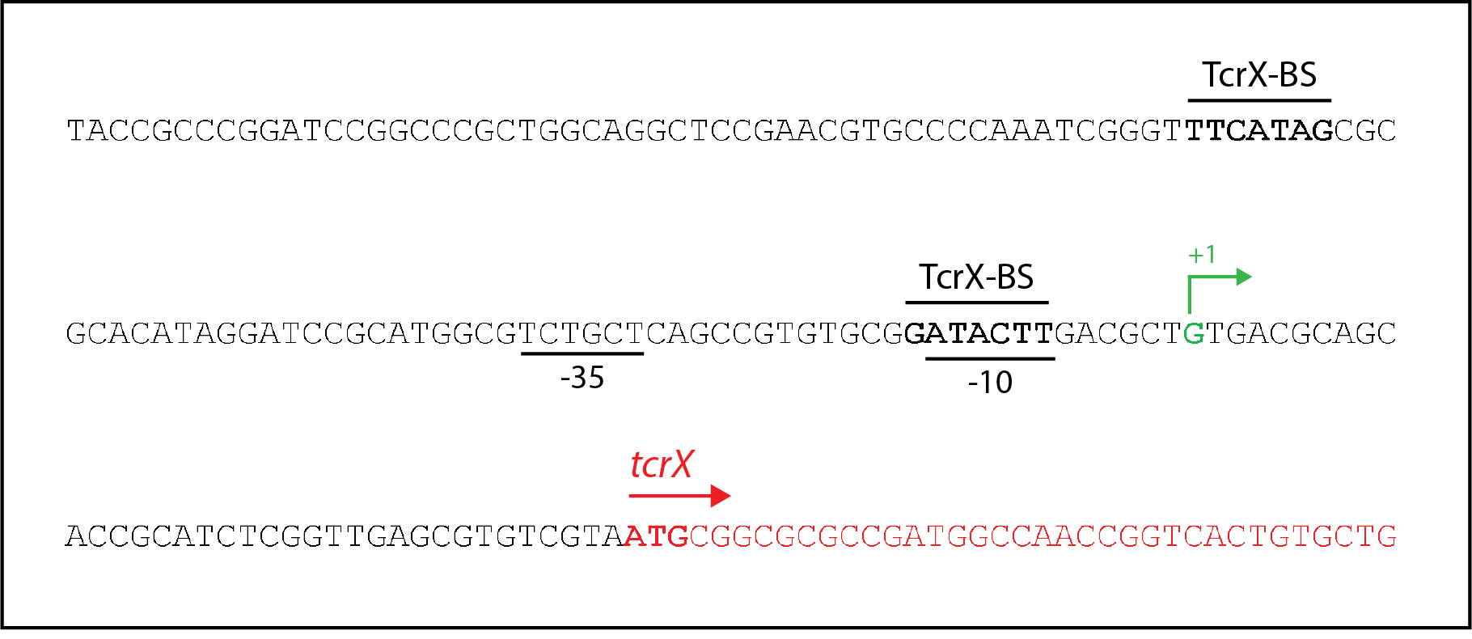

Supplementary Figure 5: Promoter region of tcrX in Mtb H37Rv.
Diagram depicting proposed tcrXY promoter structure. The putative TcrX binding site (TcrX-BS) is a mirror repeat spaced 42-bp apart, initially proposed by Bhattacharya and Das (2011)¹ but incorrectly described as an inverted repeat. The putative transcription start site (+1) was determined from Shell et al. (2015)². Putative -35 and -10 promoter sites and ATG translational start site are indicated accordingly.
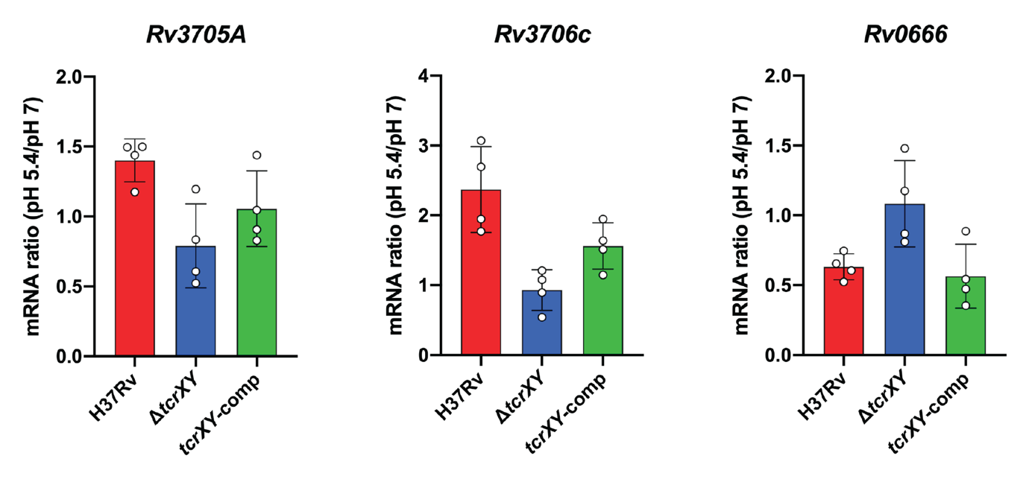
Supplementary Figure 6: qRT-PCR confirmation of top differentially expressed genes in a ΔtcrXY mutant.
Rv3705A, Rv3706c and Rv0666 mRNA induction at acidic pH. Indicated strains were cultured in pH 7 or pH 5.4 minimal media for 24 hours and mRNA levels compared by qRT-PCR. Each bar represents the mean fold-change from four biological replicates (open circle). Error bars denote SD.
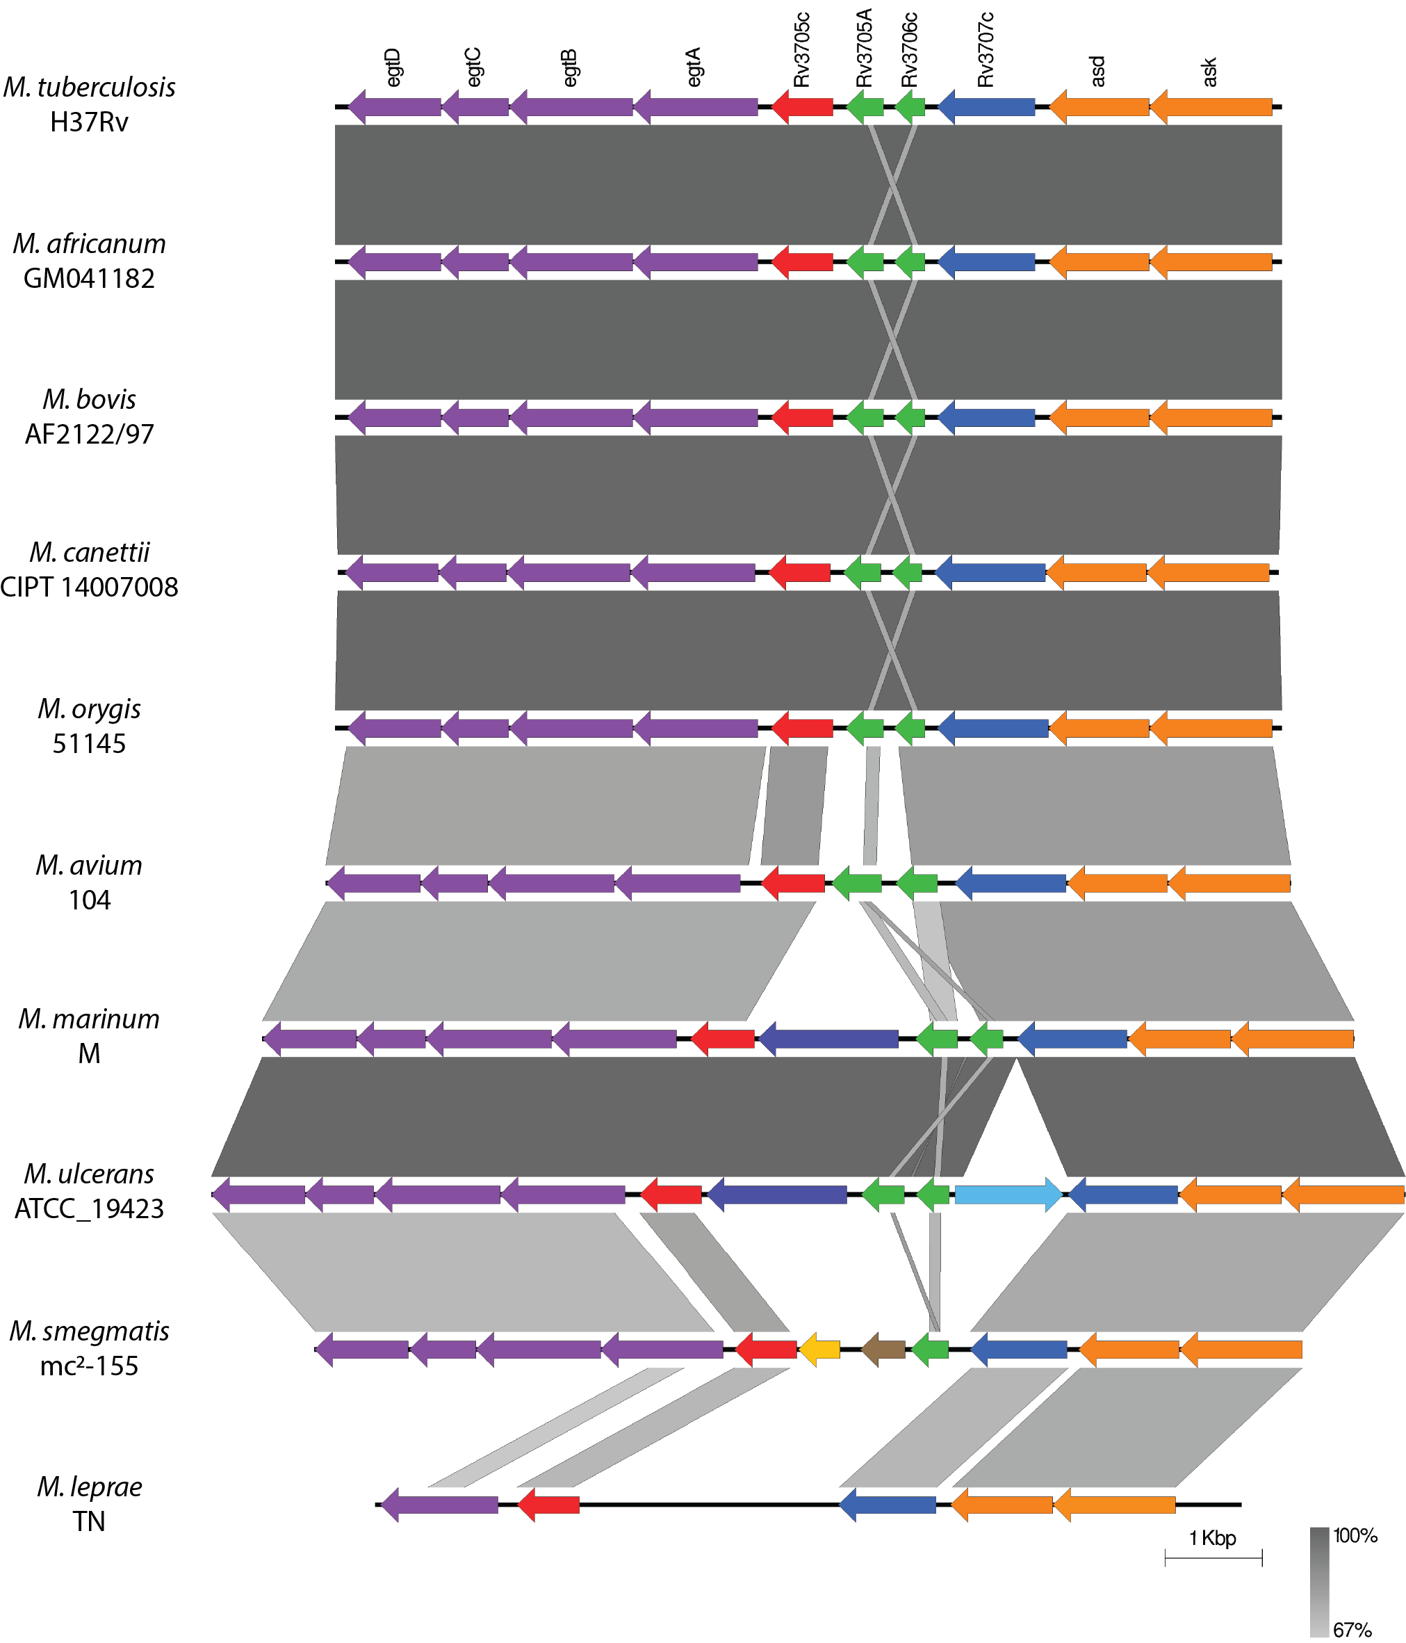

Supplementary Figure 7: Synteny in the Rv3706c-Rv3705A locus.
BLASTn alignment depicts the level of nucleotide sequence conservation (grey shading), amongst Rv3706c-Rv3705A (green), Rv3705c (red), Rv3707c (blue), ergothioneine biosynthesis cluster (purple), aspartate catabolism gene cluster (orange). Reference genomes were acquired from NCBI: M. tuberculosis H37Rv (NC_000962.3), M. africanum GM041182 (FR878060.1), M. bovis AF2122/97 (LT708304.1), M. canettii CIPT14007008 (FO203508.1), M. orygis 51145 (NZ_CP063804.1), M. avium 104 (CP000479.1), M. marinum M (CP000854.1), M. ulcerans ATCC_19423 (NZ_CP092429.2), M. smegmatis mc²-155 (CP001663.1), M. leprae TN (AL450380.1). Figure was constructed using EasyFig³.

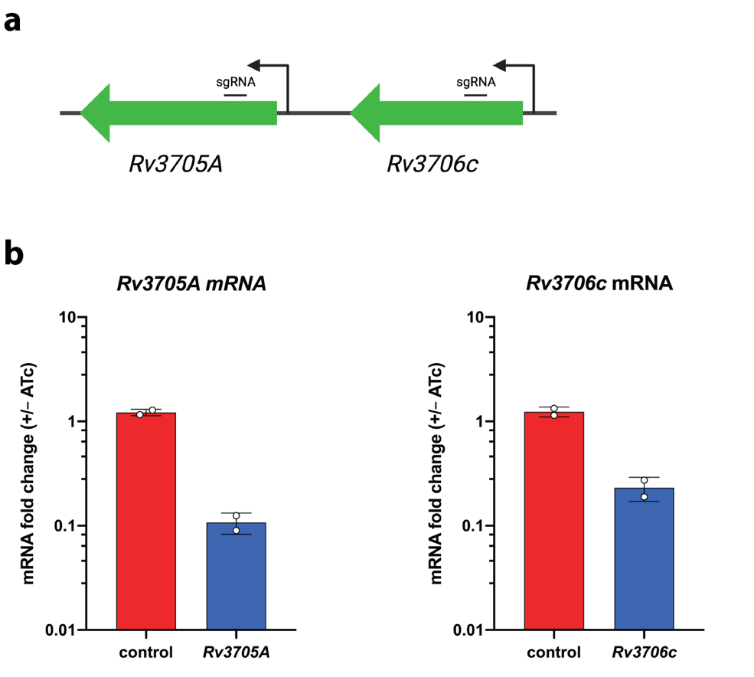

Supplementary Figure 8: Construction of CRISPRi-Rv3706c and CRISPRi-Rv3705A.
a, Silencing of Rv3706c and Rv3705A using CRISPRi, to generate the CRISPRi mutants, CRISPRi-Rv3706c and CRISPRi-Rv3705A. sgRNA target site is indicated. b, Rv3706c and Rv3705A knockdown using CRISPRi. The CRISPRi mutants were cultured in the presence or absence of ATc in 7H9 media for 72 hours and mRNA levels compared by qRT-PCR. Each bar represents the mean fold-change from two biological replicates (open circle). Error bars denote SD.
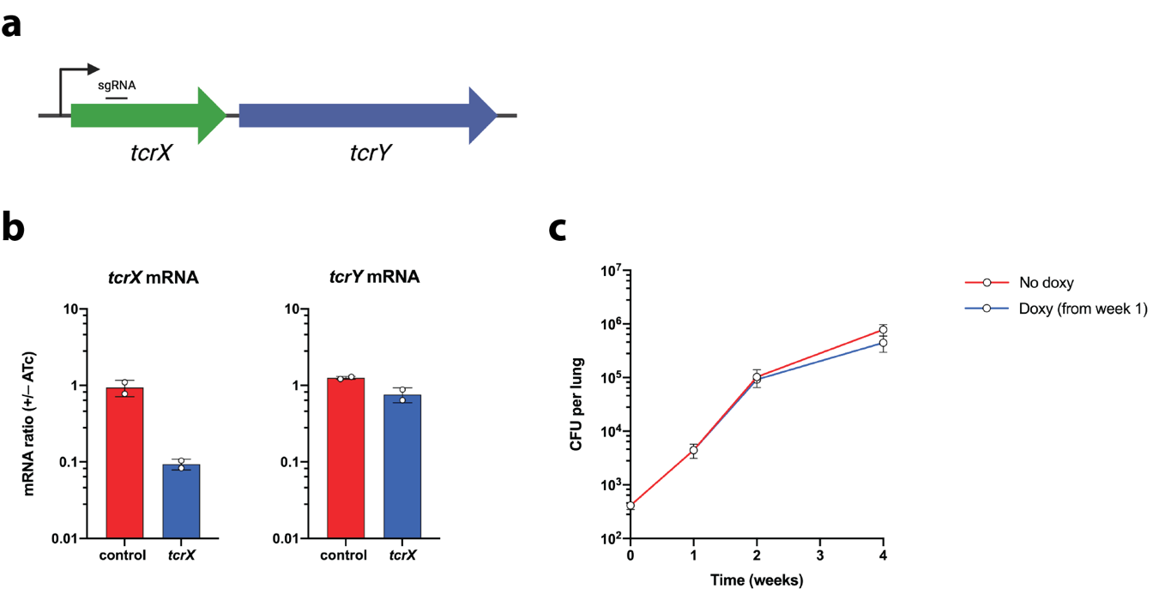

Supplementary Figure 9: Construction of CRISPRi-tcrX and growth during acute lung infection.
a, Silencing of tcrX using CRISPRi, to generate the CRISPRi mutant, CRISPRi-tcrX. sgRNA target site is indicated. b, tcrXY knockdown using CRISPRi. The CRISPRi-tcrX mutant was cultured in the presence or absence of ATc in 7H9 media for 72 hours and mRNA levels compared by qRT-PCR. Each bar represents the mean fold-change from two biological replicates (open circle). Error bars denote SD. c, CRISPRi-mediated tcrX silencing in Mtb during acute lung infection. Female C57BL/6 mice were infected with < 500 CFU of CRISPRi-tcrX by low-dose aerosol, and the infectious dose was confirmed from two mice on day 1. Each time point then represents mean recovered CFU from each lung from four mice, with error bars denoting SD. CRISPRi was induced by administration of doxycycline (1 mg/mL in 5% sucrose, delivered as drinking water ad libitum) from week 1 post-infection. Statistical analysis between no doxy and doxy groups was performed using an unpaired two-tailed t-test at week 2 and week 4, with no significant comparisons observed.
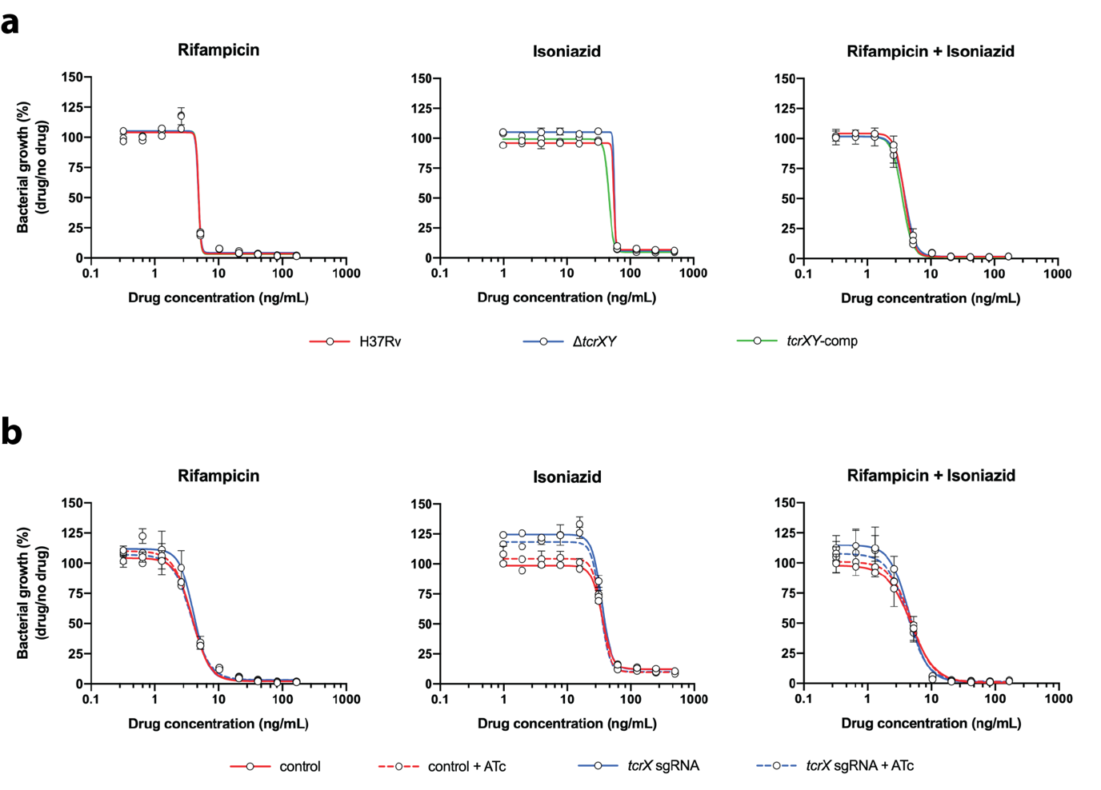

Supplementary Figure 10: Drug susceptibility profiling of Mtb tcrXY mutants.
a, Dose-response curves to rifampicin, isoniazid, or a combination of rifampicin and isoniazid, of H37Rv, ΔtcrXY and tcrXY-comp, in standard nutrient-rich 7H9 liquid culture. Data is shown as mean with SD from three parallel cultures. b, Dose-response curves to rifampicin, isoniazid, or a combination of rifampicin and isoniazid, of CRISPRi-tcrX and an empty-vector control, in standard nutrient-rich 7H9 liquid culture. Data is shown as mean with SD from three parallel cultures. Cultures were pre-depleted with anhydrotetracycline (ATc) for 3 days prior, and maintained in the culture medium for the duration of the assay.
Supplementary Table 4: Description of plasmids used in this study.
Plasmid name | Description | Source
pMV206 | Promoterless E. coli-mycobacterial shuttle vector; MCS; OriE; OriM; Km^{R} | Stover et al. (1991)⁴
pMV306 | Promoterless E. coli-mycobacterial shuttle vector; MCS; OriE; L5 int; Km^{R} | Stover et al. (1991)⁴
Reporter constructs
pDual206 | pMV206 containing promoter-less mCherry and P_{rpoB}-gfp promoter-reporter fusion | This study
pDual306 | pMV306 containing promoter-less mCherry and P_{rpoB}-gfp promoter-reporter fusion | This study
pDual306-control | pDual306 containing P_{control} promoter-reporter fusion | This study
pDual206-tcrXY | pDual206 containing P_{tcrXY} promoter-reporter fusion | This study
pDual306-tcrXY | pDual306 containing P_{tcrXY} promoter-reporter fusion | This study
pDual306-tcrXY(scramble) | pDual306 containing P_{tcrXY} (scrambled) promoter-reporter fusion | This study
pDual206-Rv3706c | pDual206 containing P_{Rv3706c} promoter-reporter fusion | This study
pDual306-Rv3706c | pDual306 containing P_{Rv3706c} promoter-reporter fusion | This study
Genetic knockouts
pJV53 | Recombineering vector encoding Che9c mycobacteriophage recombinases; OriE; OriM; Km^{R} | van Kessel and Hatfull (2007)⁵
pYUB854 | Mycobacterial suicide vector; OriE; Hyg^{R}; two MCS | van Kessel and Hatfull (2007)⁵
pYUB854-tcrXY | pYUB854 encoding 1-kb tcrXY flanking sequences | This study
Complementation constructs
pMV306-tcrXY | pMV306 containing tcrXY coding region under the control of P_{tcrXY} | This study
pMV306-tcrX(D54A)Y | pMV306 containing tcrXY coding region, with TcrX(D54A) substitution, under the control of P_{tcrXY} | This study
pMV306-tcrXY(H265Q) | pMV306 containing tcrXY coding region, with TcrY(H256Q) substitution, under the control of P_{tcrXY} | This study
CRISPRi constructs
PLJR965 | Mycobacterial CRISPR interference vector, inducible TetR system, OriE; L5 int; Km^{R} | Rock et al. (2017)⁶
PLJR965-tcrX | PLJR965 containing tcrX sgRNA | This study
PLJR965-Rv3706c | PLJR965 containing Rv3706c sgRNA | This study
PLJR965-Rv3705A | PLJR965 containing Rv3705A sgRNA | This study
Abbreviations: OriE, E. coli origin of replication; OriM, mycobacterial origin of replication; Km^{R}, kanamycin resistance marker; Hyg^{R}, hygromycin resistance marker; MCS, multiple cloning site, L5 int; mycobacteriophage L5 integration cassette.
Supplementary Table 5: List of oligonucleotides used in this study.
Name |  | Sequence
Construction of pDual206
wpr780 |  | TCTTTAAATCTAGATCAGAAGGAGAAGATGGTG
wpr781 |  | GCAGCTGGATCCATGGATCTTACTTGTACAGCTCGTC
wpr759 |  | GCAGAATTCGAAGCTGAAGGAGATATACATATGAG
wpr760 |  | CGACATCGATAAGCTTTATTTGTATAGTTCATCC
wpr865 |  | AGTAAGATCCATGGATCGAGAAGGCCGGTTTCACC
wpr866 |  | TTCTGCAGCTGGATCGAAGGGCCGCTACCTGAAG
wpr765 |  | TCCAGCTGCAGAATTTCCATCTGGAGCTACTGC
wpr766 |  | CTTCAGCTTCGAATTGATGCATCCTTCCAGCAC
Construction of pDual306
wpr883 |  | CGGTACCAGATCTTTAAATCTAG
wpr604 |  | GTCGACATCGATAAGCT
Construction of pDual206-tcrXY, pDual306-tcrXY and pDual306-tcrXY(scrambled)
wpr783 |  | GATCTTTAAATCTAGGACGGGCGTAGGTGTAGAC
wpr784 |  | TTCTCCTTCTGATCTAGTACGACACGCTCAACCGAG
Construction of pDual206-Rv3706c and pDual306-Rv3706c
wpr1454 |  | GATCTTTAAATCTAGAGATGAGCATCCGTCAGATC
wpr1455 |  | GATCTTTAAATCTAGCTCACAGCTGCTACATAAGG
Construction of pDual306-control
wpr875 |  | GATCTTTAAATCTAGGACTCCTTGACGTCCAGAC
wpr876 |  | TTCTCCTTCTGATCTAGGCTTGTCGACGTCAAACTC
Construction of pET19b-TcrX
wpr663 |  | ATATGCTCGAGGATCTTGAGAATCTTTATTTTCAGGGC  ATGCGGCGCGCCGATGG
wpr664 |  | GTTAGCAGCCGGATCCTAGCGGGCCGGCTTGAGC
Construction of pYUB854-tcrXY
len41 |  | TAGGATACACCGGTTCTAGTACGACACGCTCAACCGAG
len30 |  | AGCTCACCTAGGTATCTAGCGGTTTGTTCTTCGTCGGTG
len33 |  | ACGCGCACCATGGGAAGCTGCCTGACTGCCCGGCTC
prw4 |  | CTGGATCCACGAAGCTGTGGGCGCGATACAAGTCC
Construction of pMV306-tcrXY
wpr617 | TACCAGATCTTTAAATCTAGGACGGGCGTAGGTGTAGAC
wpr619 | CTGGATCCATGGATATCTAGGCCGAAGCGACCAAATTC
Construction of pMV306-tcrX^{D54A}Y
wpr723 | CAGCGGCCCGCTGTGGTTG
wpr724 | CAACCACAGCGGGCCGCTG
Construction of pMV306-tcrXY^{H256Q}
wpr725 | CGATGCCAGTCAGGAACTGC
wpr726 | GCAGTTCCTGACTGGCATCG
Construction of PLJR965-tcrX
wpr1045 | CAGTGATAGATATAATCTGGGAATGCCATGGACACCATCTCGG
wpr1046 | TCTTTCGAGTACAAAAACCCGAGATGGTGTCCATGGCAT
Construction of PLJR965-Rv3706c
wpr1507 | CAGTGATAGATATAATCTGGGAGCTTGCCGAGGATATAGCCGGT
wpr1508 | TCTTTCGAGTACAAAAACACCGGCTATATCCTCGGCAAGC
Construction of PLJR965-Rv3705A
wpr1509 | CAGTGATAGATATAATCTGGGAGCCCGAGAACCAACGCGCCAGA
wpr1510 | TCTTTCGAGTACAAAAACTCTGGCGCGTTGGTTCTCGGGC
PCR confirmation of ΔtcrXY
P1 | CCAAGCTGGTCGAAACTGAG
P2 | CCTTCACGTTATGGCTGACC
P3 |  | AGTACGGGGTTGGTGCTC
P4 |  | GAACTGCTCGCCTTCACC
P5 |  | TTGTGCTCGACGTGATGTTG
P6 |  | GGATGTAGTTGTGCGTCTCG
EMSA of P_{tcXY} (76-bp)
wpr1480 |  | CAAATCGGGTTTCATAGCG
wpr1481 |  | TCACAGCGTCAAGTATCC
wpr1482 |  | CAAATCGGGTTCTAGTACGC
wpr1483 |  | TCACAGCGTCACTTGAAC
EMSA of P_{Rv3706c} (459-bp)
wpr1490 |  | AGATGAGCATCCGTCAGATC
wpr1491 |  | GATGCCTTGGCAAACAGTAAC
Legend: Underlined, homologous regions for HAC; blue text, TEV protease site; red text, mutations.
Supplementary Table 6: List of qRT-PCR primers used in this study.
Name | Sequence
rpoB
wpr884 | TCGTTTCGACGATGTCAAGG
wpr885 | GTCATCATCGGGAAGTCACC
tcrX
wpr890 | TGATGTTGCCTGACATGAGC
wpr891 | CAACCCAGCTATACGATCTTCC
tcrY
wpr980 | CGCTCGGTGTTGATGTATCC
wpr981 | CCGACCGGATGTAGTTGTG
Rv3706c
wpr1406 | GCGACACATGAGTGAAACATC
wpr1407 | GAGGATATAGCCGGTGAAGAAG
Rv3705A
wpr1412 | TGATCGTGGCCGGAATTG
wpr1413 | GGTGGTAATAGCGGTGGTAAG
Rv0666
wpr1418 | GTGTGGGTCCAGCTTTGTT
wpr1419 | TCAATCCGCCGTGCAAC

Supplementary Methods
Cloning of mycobacterial recombineering plasmids.
Plasmid pYUB854-tcrXY was constructed by PCR amplifying a 1-kb region upstream of tcrX from H37Rv gDNA using primers len41 and len30, and downstream of tcrY using primers len33 and prw4, and cloning into XbaI and HindII sites of pYUB854, respectively. The tcrXY allelic exchange cassette was PCR amplified from pYUB854-tcrXY using primers len41 and prw4.

Cloning of complementation plasmids.
Complementation plasmid pMV306-tcrXY was constructed by PCR amplifying the tcrXY allele under the control of its endogenous promoter (P_{tcrXY}) from H37Rv gDNA using primers wpr617 and wpr619 and cloning into XbaI site of pMV306. Plasmid pMV306-tcrX^{D54A}Y was constructed by PCR using pMV306-tcrXY as a template with mutagenic primers wpr723 and wpr724. Plasmid pMV306-tcrXY^{H256Q} was constructed by PCR using pMV306-tcrXY as a template with mutagenic primers wpr725 and wpr726.

Cloning of reporter constructs.
Reporter constructs were all derived from vectors pDual206 or pDual306. To construct pCherry, mCherry was PCR amplified using primers wpr780 and wpr781 and cloned into the EcoRV site of pMV206. Reporter gfp was PCR amplified using primers wpr759 and wpr760 and cloned into the HindIII site of pCherry to construct pCherryGFP. The mmaA4 transcriptional terminator from Mtb H37Rv was PCR amplified from gDNA using primers wpr865 and wpr866 and cloned into BamHI of pCherryGFP to construct pCherry-term-GFP. Finally, to construct pDual206, the rpoB promoter in Mtb H37Rv was PCR amplified from gDNA using primers wpr765 and wpr766 and cloned into the EcoRI site of pCherry-term-GFP. pDual306 was constructed by cloning the mCherry-terminator-P_{rpoB}-gfp transcriptional fusion construct from pDual206 using primers wpr883 and wpr604 into EcoRV/HindIII of pMV306.

Plasmids pDual206-tcrXY and pDual306-tcrXY were constructed by PCR amplifying P_{tcrXY} from H37Rv gDNA using primers wpr783 and wpr784 and cloning into XbaI of pDual206 and pDual306, respectively. Plasmid pDual306-tcrXY(scrambled) was constructed by PCR amplifying P_{tcrXY}(scrambled) from a custom synthesised gene block (Integrated DNA technologies) using primers wpr783 and wpr784 and cloning into XbaI of pDual306. The reporter plasmids pDual206-Rv3706c and pDual306-Rv3706c were generated by PCR amplifying P_{Rv3706c} using primers wpr1454 and wpr1455 from H37Rv gDNA and cloning into the XbaI site of pDual206 and pDual306, respectively.

Whole genome sequencing and analysis.
Mtb H37Rv or ΔtcrXY were harvested at mid-log growth phase (~ 10⁹ CFU) by centrifugation and then resuspended in 5 mL of TE buffer. The cell suspensions were combined with an equal volume of chloroform:methanol (2:1) and then incubated with rocking for 45 minutes at room temperature. Samples were collected by centrifugation (2500 x g, 20 minutes, 4ºC), supernatant discarded, and the residual pellet dried under N₂ gas. The dried pellet was resuspended in 3 mL of TE buffer, and cell lysis performed using 400 μg/mL of lysozyme (Sigma) with overnight incubation at 37ºC. Sodium dodecyl sulfate (SDS) was added to a final concentration of 1%, and samples digested with 100 μg/mL of proteinase K (Qiagen) and 10 μg/mL of RNase A (Thermo Fisher) at 55ºC for 3 hours. An equal volume of phenol:chloroform:isoamyl alcohol (24:24:1) was added to the cell lysate and incubated with rocking for 30 minutes. The aqueous phase was collected following centrifugation (2500 x g, 30 minutes, room temperature), and genomic DNA (gDNA) precipitated by the additional of 0.1 volume of 3 M sodium acetate and 1 volume of isopropanol. The pellet was washed twice with 70% ethanol, air dried, and then resuspended in 0.2 mL of TE buffer. Final gDNA clean-up was performed using a Genomic DNA Clean & Concentrator kit (Zymo Research).

Extracted gDNA was analysed by whole genome sequencing using both short- and long-read platforms. For short-read sequencing, gDNA was sequenced on the NovaSeq6000 (Illumina) using NovaSeq6000 SP kit v1.5 (2 x 150-bp paired end chemistry), in the Australian Centre for Ecogenomics at The University of Queensland. Trimmomatic (v0.36)⁷ was used for filtering the raw reads, with the quality of the reads assessed before and after filtering using FastQC (v0.11.5) (https://www.bioinformatics.babraham.ac.uk/projects/fastqc/). For long-read sequencing, gDNA was loaded onto a single FLO-MIN106 flow cell using the rapid barcode sequencing kit (SQK-RBK004) as per manufacturer’s recommendation with the following adjustments: the barcoded DNA was pooled without a concentration step using AMPure XP beads prior to sequencing. Barcodes and adaptors were trimmed using Porechop (v0.2.3_seqan2.1.1) (https://github.com/rrwick/Porechop). A hybrid genome assembly was generated using Flye (v2.5)⁸ as implemented in MicroPIPE⁹.

TcrX purification.
Full-length TcrX corresponding to amino acids 1-234 was overexpressed in E. coli BL21[DE3] as a 10xHis-fusion protein using a pET19b expression plasmid (Novagen). The protein was co-expressed with GroEL and GroES chaperones, expressed from plasmid pGTf2 using 20 ng/mL tetracycline as inducer. After overnight induction with 0.5 mM IPTG at 16ºC (with shaking at 120 rpm), bacteria were harvested by centrifugation (4500 x g, 45 minutes, 4ºC) and either stored at -20ºC or used immediately for protein purification. Cell pellets were resuspended in Buffer A (50 mM Tris-HC pH 8, 500 mM NaCl, 10 mM imidazole, 10% glycerol) supplemented with cOmplete EDTA-free protease inhibitors (Roche) and lysed by sonication. The cell lysate was clarified by centrifugation (50,000 x g, 1 hour, 4ºC) and injected onto a 1 mL HisTrap HP column (Cytiva) using an ÄKTApure fast protein liquid chromatography (FPLC) system maintained at 4ºC. The column was washed extensively with Buffer A, and eluted using Buffer B (50 mM Tris-HCl pH 8, 500 mM NaCl, 300 mM imidazole, 10% glycerol). Purified 10xHis-TcrX was dialysed into Storage Buffer (50 mM Tris-HCl pH 8, 500 mM NaCl, 25% glycerol), concentrated using an Amicon Ultra-4 mL centrifugal filter (Merck), snap-frozen in liquid nitrogen and stored at -80ºC.

Drug susceptibility profiling.
The minimum inhibitory concentration (MIC) of rifampicin and isoniazid against Mtb was determined using a resazurin reduction microplate assay. Drugs were serially diluted across a 96-well microtiter plate in 7H9S culture media (7H9 supplemented with 10% OADC, 0.5% glycerol, 0.05% Tween-80 and 1% tryptone). All bacteria were prepared to mid-log growth phase in 7H9S medium, prior to the generation of a single cell suspension by slow centrifugation (800 x g, 8 min) and adjusted to 2x10⁴ CFU/mL (OD₆₀₀ 0.001). All drugs were dissolved in dimethyl sulfoxide (DMSO), and the final DMSO concentration was < 0.1%. CRISPRi mutants were induced with 200 ng/mL ATc for 3 days prior to the assay, and ATc (200 ng/mL) was maintained in the culture medium for the duration of the assay. The plates were incubated for 6 days at 37ºC, before the addition of 30 μL of a 0.02% resazurin solution and 12.5 μL of a 20% Tween-80 solution. Plates were further incubated for 24 hours to allow for colour development. Sample fluorescence was measured on a Fluorostar Omega fluorescent plate reader (BMG) (excitation 530 nm, emission 590 nm). Percent fluorescence relative to the positive control wells (bacteria without compound) minus the negative control wells (media only) was plotted for the determination of the MIC (i.e., the lowest concentration at which the percentage inhibition was 90% or greater).
Supplementary References
1. Bhattacharya, M. & Das, A.K. Inverted repeats in the promoter as an autoregulatory sequence for TcrX in Mycobacterium tuberculosis. Biochem Biophys Res Commun 415, 17-23 (2011).
2. Shell, S.S. et al. Leaderless transcripts and small proteins are common features of the mycobacterial translational landscape. PLoS Genet 11, e1005641 (2015).
3. Sullivan, M.J., Petty, N.K. & Beatson, S.A. Easyfig: a genome comparison visualizer. Bioinformatics 27, 1009-10 (2011).
4. Stover, C.K. et al. New use of BCG for recombinant vaccines. Nature 351, 456-60 (1991).
5. van Kessel, J.C. & Hatfull, G.F. Recombineering in Mycobacterium tuberculosis. Nat Methods 4, 147-52 (2007).
6. Rock, J.M. et al. Programmable transcriptional repression in mycobacteria using an orthogonal CRISPR interference platform. Nat Microbiol 2, 16274 (2017).
7. Bolger, A.M., Lohse, M. & Usadel, B. Trimmomatic: a flexible trimmer for Illumina sequence data. Bioinformatics 30, 2114-20 (2014).
8. Kolmogorov, M., Yuan, J., Lin, Y. & Pevzner, P.A. Assembly of long, error-prone reads using repeat graphs. Nat Biotechnol 37, 540-546 (2019).
9. Murigneux, V. et al. MicroPIPE: validating an end-to-end workflow for high-quality complete bacterial genome construction. BMC Genomics 22, 474 (2021).

