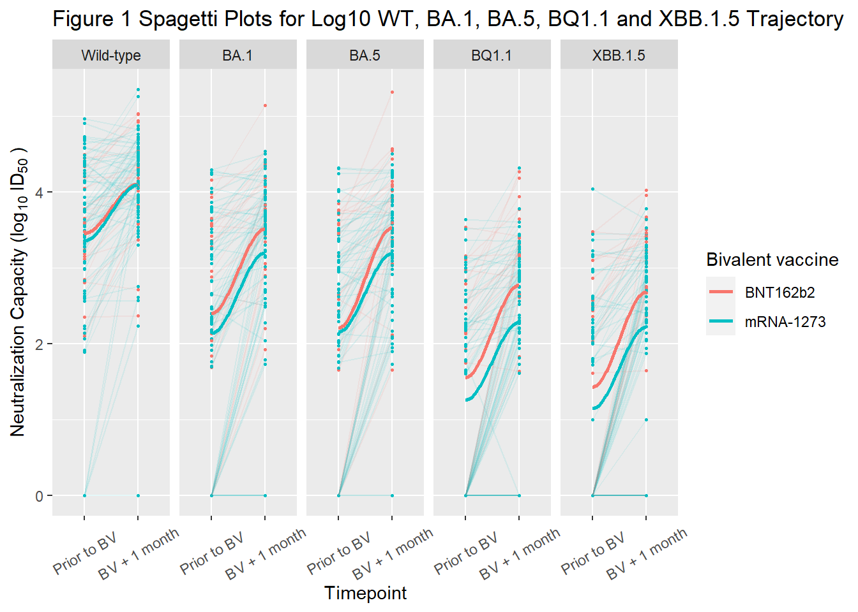
Extended Data Fig 1 | Neutralizing antibody trajectories for wild-type, BA.1, BA.5, BQ.1.1, and XBB.1.5 subvariants prior to and one month following bivalent vaccination with or BNT162b2 BA.4/5 (n=26) or mRNA-1273 BA.1 (n=72). Differences by vaccine type were not statistically different by vaccine type after adjustment for baseline neutralizing antibody levels, anti-nucleocapsid positivity, patient type, and number of vaccine doses: wild-type (P=0.48), BA.1 (P=0.21), BA.5 (P=0.069), BQ.1.1 (P=0.10), nor XBB.1.5 (P=0.099). Dots represent individual serum samples collected (n=98 for each time point).

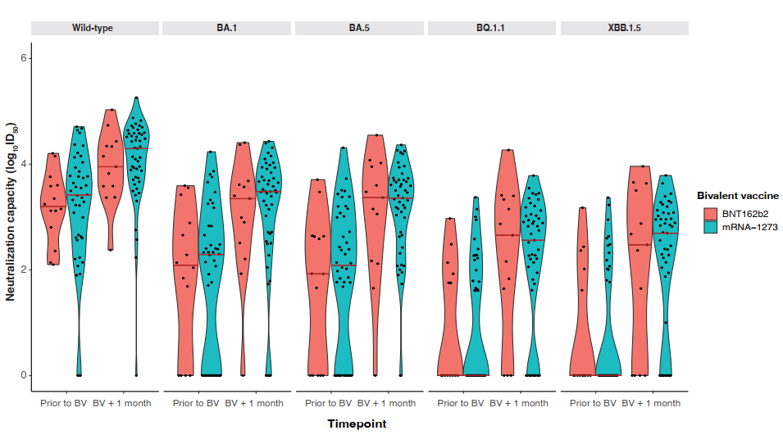Extended Data Fig 2 | Neutralizing antibodies against wild-type, BA.1, BA.5, BQ.1.1, and XBB.1.5 by bivalent vaccine type: BNT162b2 BA.4/5 (n=14) versus mRNA-1273 (n=44) after exclusion of participants with a positive anti-nucleocapsid antibody. Solid red line indicates median level. Dots represent individual serum samples collected (n=58).

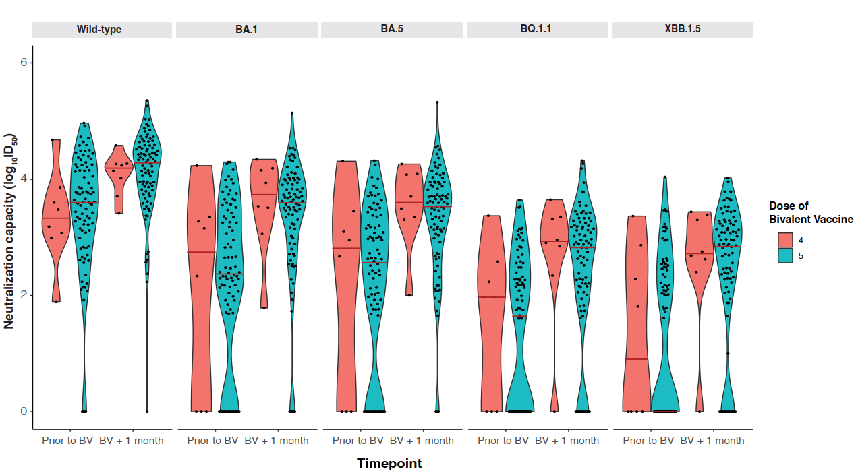

Extended Data Fig 3 | Difference in neutralizing antibodies against wild-type, BA.1, BA.5, BQ.1.1 by total number of COVID-19 vaccine doses. There was no significant difference in neutralizing antibodies against any subvariant in those receiving 4 (n=8) versus 5 doses (n=90). Solid red line indicates median level. Dots represent individual serum samples collected (n=98 for each timepoint).

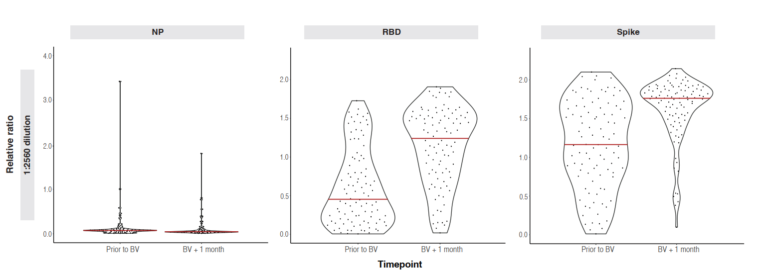

Extended Data Fig 4 | SARS-CoV-2 IgG nucleocapsid, RBD and Spike Binding Antibody Response. Dots represent individual serum samples collected (n=98 for each timepoint). Solid red line indicates median level. Antibody levels are reported as relative ratios to synthetic standards. Upper limits of the linear range for the relative ratio is 2 for nucleocapsid, 1.2 for RBD and 1.2 for Spike. Abbreviations: BV, bivalent; N, nucleocapsid protein; RBD, receptor binding domain.

Extended Data Table 1 | Baseline characteristics by bivalent vaccine type

 | No. (%)
Characteristic | Total (n=98) | mRNA-1273 (BA.1)  (n=72) | BNT162b2 (BA.4/BA.5)  (n=26)
Demographics
Age, median (IQR), y | 70 (61, 77) | 69 (61, 75) | 70 (62, 78)
Sex (Female) | 34 (35) | 21 (29) | 13 (50)
Race
Asian | 26 (27) | 20 (28 | 6 (23)
Black | 7 (7) | 6 (8) | 1 (4)
Caucasian | 38 (39) | 33 (46) | 5 (19)
Other/unknown | 27 (28) | 13 (18) | 14 (54)
Patient type
Dialysis | 83 (85) | 57 (79) | 26 (100)
Kidney transplant | 15 (15) | 15 (21) | 0 (0)
Cause of chronic kidney disease
Diabetes | 29 (30) | 22 (31) | 7 (27)
Glomerulonephritis | 21 (21) | 13 (18) | 8 (31)
Hypertension | 15 (15) | 11 (15) | 4 (15)
Other | 33 (33) | 26 (36) | 7 (27)
Prior COVID-19 (RT-PCR or RAT) | 25 (26) | 19 (26) | 6 (23)
Vaccine Type
Dose 1
ChAdOx1 | 3 (3.1) | 2 (2.8) | 1 (3.8)
mRNA-1273 | 36 (37) | 35 (49) | 1 (3.8)
BNT162b2 | 59 (60) | 35 (49) | 24 (92)
Dose 2
ChAdOx1 | 3 (3.1) | 2 (2.8) | 1 (3.8)
mRNA-1273 | 40 (41) | 39 (54) | 1 (3.8)
BNT162b2 | 55 (56) | 31 (43) | 24 (92)
Dose 3
mRNA-1273 | 56 (57) | 45 (62) | 11 (42)
BNT162b2 | 42 (43) | 27 (38) | 15 (58)
Dose 4
mRNA-1273 | 65 (66) | 56 (78) | 9 (35)
BNT162b2 | 26 (27) | 10 (14) | 16 (62)
mRNA-1273 Bivalent (BA.1) | 6 (6.1) | 6 (8.3) | 0 (0)
BNT162b2 Bivalent (BA.4/BA.5) | 1 (1.0) | 0 (0) | 1 (3.8)
Dose 5
mRNA-1273 Bivalent (BA.1) | 66 (73) | 66 (100) | 0 (0)
BNT162b2 Bivalent (BA.4/BA.5) | 24 (27) | 0 (0) | 24 (100)
Bivalent vaccine dose number
Dose 4 | 8 (8.2) | 3 (4.1) | 5 (20)
Dose 5 | 90 (92) | 70 (96) | 20 (80)
Comorbidities
Chronic obstructive pulmonary disease | 8 (8.2) | 5 (6.9) | 3 (12)
Coronary artery disease | 14 (14) | 7 (9.7) | 7 (27)
Congestive heart failure | 15 (15) | 10 (14) | 5 (19)
Cerebrovascular disease | 10 (10) | 7 (9.7) | 3 (12)
Hypertension | 80 (82) | 55 (76) | 25 (96)
Malignancy | 9 (9.7) | 7 (9.7) | 2 (9.5)
Peripheral vascular disease | 8 (8.2) | 6 (8.3) | 2 (7.7)
Immunosuppression | 17 (17) | 16 (22) | 1 (3.8)
Prednisone | 16 (16) | 15 (100) | 1 (100)
Mycophenolic acid | 12 (12) | 12 (100) | 0 (0)
Calcineurin inhibitor | 16 (16) | 16 (100) | 0 (0)

Extended Data Table 2 | Neutralizing and total antibody levels in overall cohort prior to and following bivalent vaccination

Variable | Pre-Bivalent  (n= 98)* | Post-Bivalent  (n= 98) | Overall  (n= 196)
Wild-type neutralization | 93 (95%) | 97 (99%) | 190 (97%)
Wild-type log₁₀ ID50 | 3·59 (2·99, 4·15) | 4·25 (3·81, 4·54) | 3·93 (3·37, 4·42)
BA.1 neutralization | 74 (76%) | 91 (93%) | 165 (84%)
BA.1 log₁₀ ID50 | 2·37 (1·69, 3·35) | 3·59 (2·92, 3·98) | 3·23 (2·19, 3·76)
BA.5 neutralization | 73 (74%) | 94 (96%) | 167 (85%)
BA.5 log₁₀ ID50 | 2·61 (0·41, 3·20) | 3·53 (3·00, 3·92) | 3·13 (2·09, 3·70)
BQ.1.1 neutralization | 54 (55%) | 82 (84%) | 136 (69%)
BQ.1.1 log₁₀ ID50 | 1·70 (0·00, 2·38) | 2·86 (2·06, 3·23) | 2·23 (0·00, 2·98)
XBB.1.5 neutralization | 47 (48%) | 79 (81%) | 126 (64%)
XBB.1.5 log₁₀ID50 | 0·00 (0·00, 2·45) | 2·83 (2·05, 3·24) | 2·28 (0·00, 3·02)
Anti-RBD IgG, relative ratio | 0·45 (0·18, 0·97) |  | 0·84 (0·33, 1·44)
  1·24 (0·80, 1·53)
Anti-Spike IgG, relative ratio | 1·16 (0·77, 1·65) | 1·76 (1·52, 1·86) | 1·56 (1·01, 1·81)
Anti-N positive | 40 (41%) | 36 (37%) | 76 (39%)
*Median (IQR); n (%)
Abbreviations: Anti-N, anti-nucleocapsid, anti-RBD, anti-receptor binding domain; Relative ratios above 1·2 may be underestimated due to assay saturation.

Extended Data Table 3 | Fold decrease in neutralization in comparison to wild-type (D614G)
 | Pre-Bivalent  mRNA-1273  (n=72) | Post Bivalent  mRNA-1273  (n=72) | Pre-Bivalent  BNT162b2 (n=26) | Post Bivalent  BNT162b2  (n=26) | Total  (n=196)
Median BA.1 Fold Decrease [IQR]* | 12.2 (60.4) | 5.58 (9.3) | 7.2(31.7) | 3.74 (5.1) | 7.3 (17.5)
Median BA.5 Fold Decrease [IQR] | 12.8 (37.9) | 7.6 (12.4) | 9.1 (99.1) | 3.1 (5.1) | 8.3 (19.2)
Median BQ.1.1 Fold Decrease [IQR] | 85.4 (436.4) | 39.0 (92.1) | 45.5 (510.4) | 17.6 (25.5) | 45.8 (170.3)
Median XBB.1.5. Fold Decrease [IQR] | 108.3 (1282.7) | 42.3 (60.5) | 74.5 (1140.6) | 18.7 (25.9) | 48.2 (376.7)

* Fold changes are expressed in comparison to wild-type (D614G) ancestral SARS-CoV-2.

Extended Data Table 4 | Neutralizing antibody capacity against wild-type, B.1.1.529 Omicron subvariants following bivalent mRNA COVID-19 vaccination by bivalent vaccine type

Variable | Overall  (n = 98)* | mRNA-1273  (n= 72)* | BNT162b2  (n= 26)*
Wild-type neutralization | 97 (99%) | 71 (99%) | 26 (100%)
Wild-type log₁₀ ID50 | 4.25 (3.81, 4.54) | 4.25 (3.81, 4.56) | 4.22 (3.85, 4.43)
BA.1 neutralization | 91 (93%) | 66 (92%) | 25 (96%)
BA.1 log₁₀ ID50 | 3.59 (2.92, 3.98) | 3.54 (2.78, 3.93) | 3.73 (3.13, 4.16)
BA.5 neutralization | 94 (96%) | 69 (96%) | 25 (96%)
BA.5 log₁₀ ID50 | 3.53 (3.00, 3.92) | 3.48 (2.72, 3.73) | 3.80 (3.35, 4.08)
BQ.1.1 neutralization | 82 (84%) | 59 (82%) | 23 (88%)
BQ.1.1 log₁₀ ID50 | 2.86 (2.06, 3.23) | 2.71 (1.99, 3.12) | 3.16 (2.62, 3.41)
XBB.1.5 neutralization | 79 (81%) | 57 (79%) | 22 (85%)
XBB.1.5 log₁₀ID50 | 2.83 (2.05, 3.24) | 2.69 (1.93, 3.13) | 3.16 (2.52, 3.49)
COVID-19 vaccine dose number
4 | 8 (8.2%) | 6 (8.3%) | 2 (7.7%)
5 | 90 (92%) | 66 (92%) | 24 (92%)
Prior COVID-19 | 25 (26%) | 19 (26%) | 6 (23%)
* n (%); Median (IQR)

Extended Data Table 5 | Neutralizing antibody capacity against wild-type, B.1.1.529 Omicron subvariants following bivalent mRNA COVID-19 vaccination by number of total vaccine doses

Variable | Overall  (n= 98)* | Four Doses  (n=8)* | Five Doses  (n=90)*
Wild-type neutralization | 97 (99%) | 8 (100%) | 89 (99%)
Wild-type log₁₀ ID50 | 4.25 (3.81, 4.54) | 4.19 (3.94, 4.26) | 4.28 (3.81, 4.55)
BA.1 neutralization | 91 (93%) | 8 (100%) | 83 (92%)
BA.1 log₁₀ ID50 | 3.59 (2.92, 3.98) | 3.74 (3.40, 4.16) | 3.59 (2.89, 3.97)
BA.5 neutralization | 94 (96%) | 8 (100%) | 86 (96%)
BA.5 log₁₀ ID50 | 3.53 (3.00, 3.92) | 3.60 (3.34, 4.08) | 3.53 (2.94, 3.90)
BQ.1.1 neutralization | 82 (84%) | 7 (88%) | 75 (83%)
BQ.1.1 log₁₀ ID50 | 2.86 (2.06, 3.23) | 2.93 (2.72, 3.33) | 2.82 (2.02, 3.21)
XBB.1.5 neutralization | 79 (81%) | 7 (88%) | 72 (80%)
XBB.1.5 log₁₀ID50 | 2.83 (2.05, 3.24) | 2.72 (2.57, 3.32) | 2.84 (1.97, 3.23)
Bivalent Vaccine Type
mRNA-1273 | 72 (73%) | 6 (75%) | 66 (73%)
BNT162b2 | 26 (27%) | 2 (25%) | 24 (27%)
Patient Type
HD | 83 (85%) | 8 (100%) | 75 (83%)
Kidney Transplant | 15 (15%) | 0 (0%) | 15 (17%)
Prior COVID-19 | 25 (26%) | 5 (62%) | 20 (22%)
* n (%); Median (IQR)
Abbreviations: HD, hemodialysis.

Extended Data Table 6 | Neutralizing antibody capacity against wild-type, B.1.1.529 Omicron subvariants following bivalent mRNA COVID-19 vaccination by COVID-19 status

Variable | Overall  (n = 98)* | No COVID-19  (n= 73)* | Prior COVID-19  (n=25)*
Wild-type neutralization | 97 (99%) | 73 (100%) | 24 (96%)
Wild-type log₁₀ ID50 | 4.25 (3.81, 4.54) | 4.27 (3.79, 4.59) | 4.22 (3.93, 4.42)
BA.1 neutralization | 91 (93%) | 67 (92%) | 24 (96%)
BA.1 log₁₀ ID50 | 3.59 (2.92, 3.98) | 3.52 (2.71, 3.93) | 3.82 (3.51, 4.00)
BA.5 neutralization | 94 (96%) | 69 (95%) | 25 (100%)
BA.5 log₁₀ ID50 | 3.53 (3.00, 3.92) | 3.37 (2.67, 3.88) | 3.70 (3.53, 3.95)
BQ.1.1 neutralization | 82 (84%) | 58 (79%) | 24 (96%)
BQ.1.1 log₁₀ ID50 | 2.86 (2.06, 3.23) | 2.68 (1.74, 3.18) | 3.03 (2.63, 3.29)
XBB.1.5 neutralization | 79 (81%) | 56 (77%) | 23 (92%)
XBB.1.5 log₁₀ID50 | 2.83 (2.05, 3.24) | 2.71 (1.65, 3.24) | 3.02 (2.56, 3.30)
Dose Bivalent Vaccine
4 | 8 (8.2%) | 3 (4.1%) | 5 (20%)
5 | 90 (92%) | 70 (96%) | 20 (80%)
Bivalent Vaccine Type
mRNA-1273 | 72 (73%) | 53 (73%) | 19 (76%)
BNT162b2 | 26 (27%) | 20 (27%) | 6 (24%)
* n (%); Median (IQR)

Extended Data Table 7 | Neutralizing antibody capacity against wild-type, B.1.1.529 (Omicron subvariants following bivalent mRNA COVID-19 vaccination by patient type

Variable | Overall  (n= 98)* | HD  (n= 83)* | Kidney Transplant  (n=15)*
Wild-type neutralization | 97 (99%) | 82 (99%) | 15 (100%)
Wild-type log₁₀ ID50 | 4.25 (3.81, 4.54) | 4.27 (3.79, 4.57) | 4.10 (3.84, 4.38)
BA.1 neutralization | 91 (93%) | 78 (94%) | 13 (87%)
BA.1 log₁₀ ID50 | 3.59 (2.92, 3.98) | 3.65 (3.11, 4.00) | 3.15 (2.44, 3.63)
BA.5 neutralization | 94 (96%) | 80 (96%) | 14 (93%)
BA.5 log₁₀ ID50 | 3.53 (3.00, 3.92) | 3.59 (3.11, 3.95) | 3.13 (2.61, 3.52)
BQ.1.1 neutralization | 82 (84%) | 73 (88%) | 9 (60%)
BQ.1.1 log₁₀ ID50 | 2.86 (2.06, 3.23) | 2.91 (2.16, 3.27) | 2.21 (0.00, 2.75)
XBB.1.5 neutralization | 79 (81%) | 69 (83%) | 10 (67%)
XBB.1.5 log₁₀ID50 | 2.83 (2.05, 3.24) | 2.88 (2.29, 3.28) | 2.06 (0.00, 2.76)
Dose Bivalent Vaccine
4 | 8 (8.2%) | 8 (9.6%) | 0 (0%)
5 | 90 (92%) | 75 (90%) | 15 (100%)
Bivalent Vaccine Type
mRNA-1273 | 72 (73%) | 57 (69%) | 15 (100%)
BNT162b2 | 26 (27%) | 26 (31%) | 0 (0%)
Prior COVID-19 | 25 (26%) | 23 (28%) | 2 (13%)
* n (%); Median (IQR)
Abbreviations: HD, hemodialysis.

