Supplementary Information

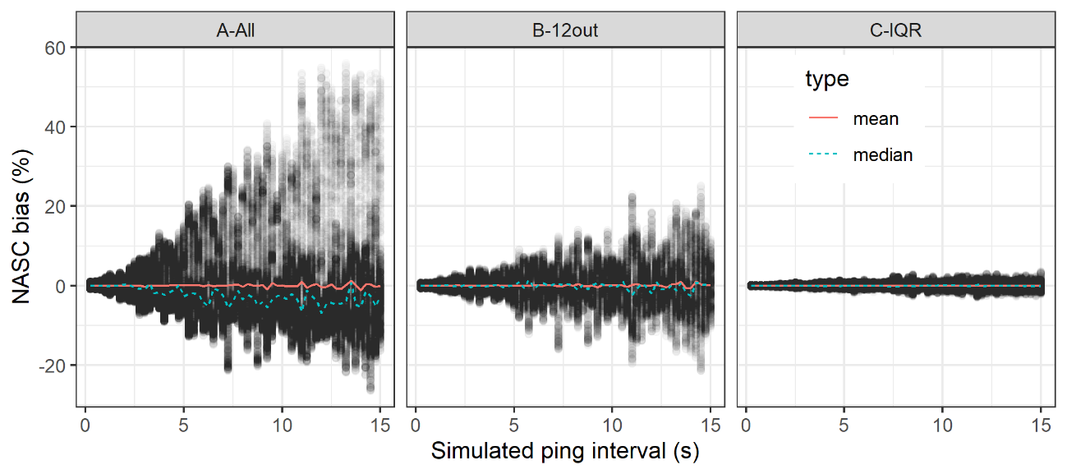
Figure S1. Scatterplot of mean resampled NASC bias as a function of simulated ping interval in a resampling exercise conducted in a single stratum to analyze the effect of extreme values (“outliers”). The lines (colored in the online version) show the mean and median of the mean resampled NASC biases at each pint interval. (A) Graph done using all the data. The spread of the points shows a clear increase of uncertainty with ping interval. The mean values remain constant, but the decrease of the median values shows the increase of underestimation bias with increasing pint interval. (B) The same graph showing the result of the analysis after removing the highest 12 values (0.011% of the data). The uncertainty increases with ping interval at a slower pace, and the decrease of the median (as an indication of the likelihood of underestimation bias) is highly reduced. (C) The same graph after removing outliers according to the IQR criterion. The uncertainty still increases with ping interval, although at a considerably slower pace than the other two cases, and the bias is practically removed. For details on this resample analysis see the preprint of an earlier version of this study in the following link:
https://www.researchgate.net/publication/365002487_Impact_of_ping_interval_and_data_heterogeneity_on_acoustically_based_abundances.

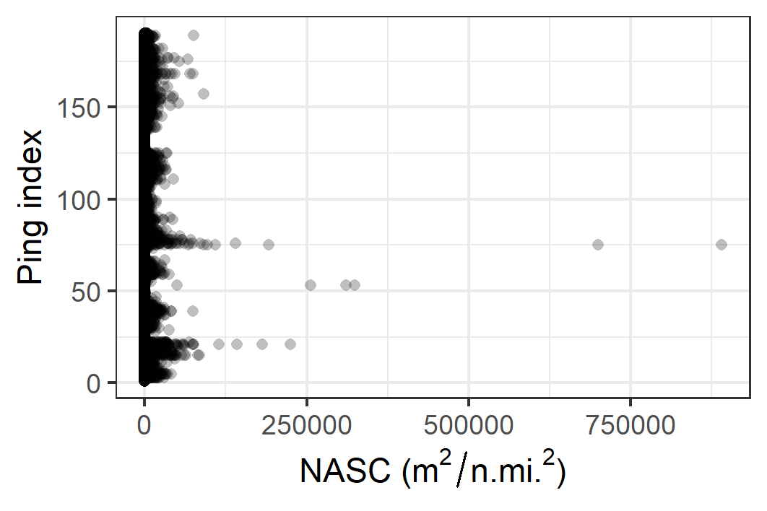
Figure S2. Dot-plot showing the statistical distribution of the data corresponding to the single stratum resampling analysis referred to in Figure S1. The figure shows the skewed nature of fisheries acoustics data, with the great majority of values close to zero and a few extremely large ones that dominate the distribution.

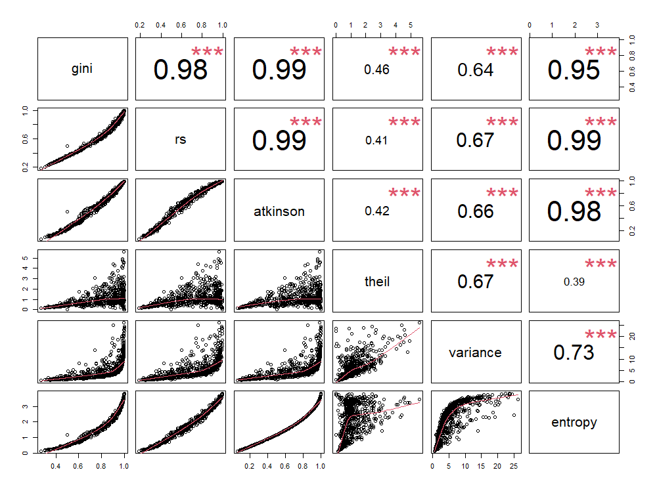
Figure S3. Pair-plot showing correlation between pairs of heterogeneity indices. The numbers mark the correlation coefficient plus the significance (*** meaning highly significant correlation between all of them). The lower-left panels present scatterplots between the variables with smoothers.

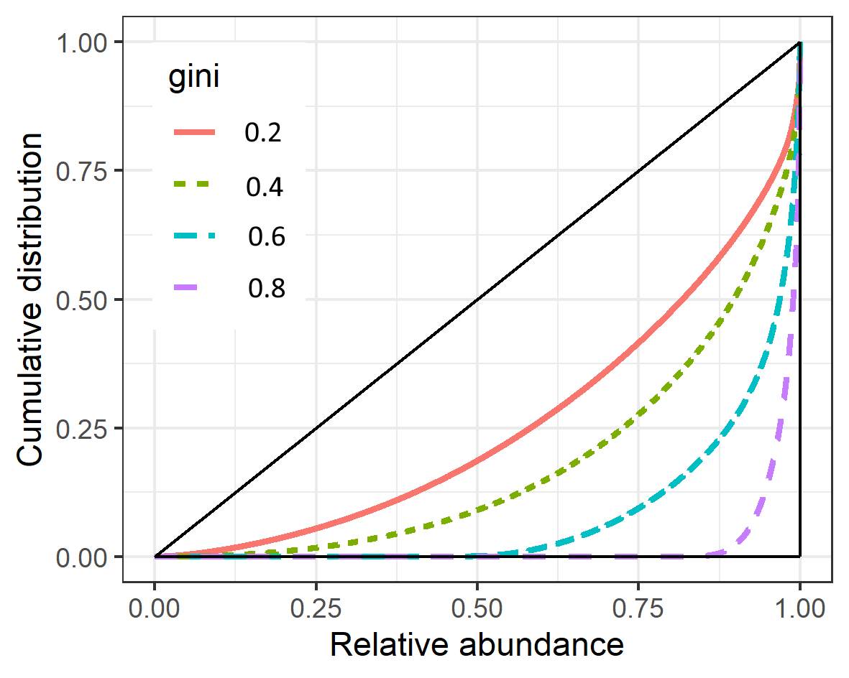
Figure S4. Example of Lorenz curves (curved lines) for some real transects used in the analysis, each having different heterogeneity values given by the Gini index.

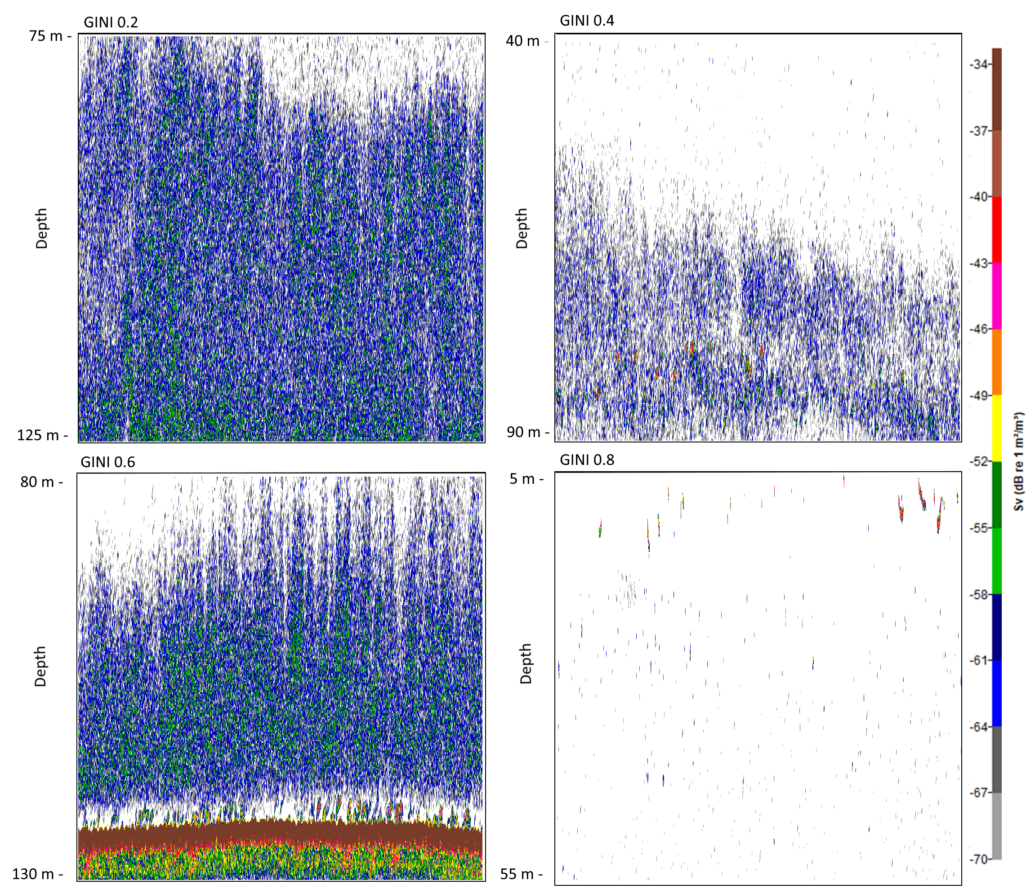
Figure S5. Examples of echograms of different acoustic aggregation typologies showing 50 m x 2 km at -70 dB threshold, and their corresponding heterogeneity levels according to the Gini index value.

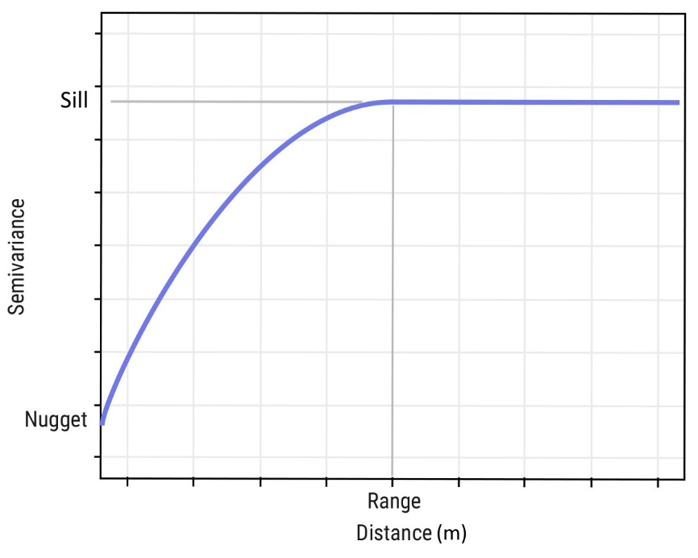
Figure S6. Illustration of a generic variogram, as well as the features (Sill, Range and Nugget) summarizing the spatial autocorrelation of the data.

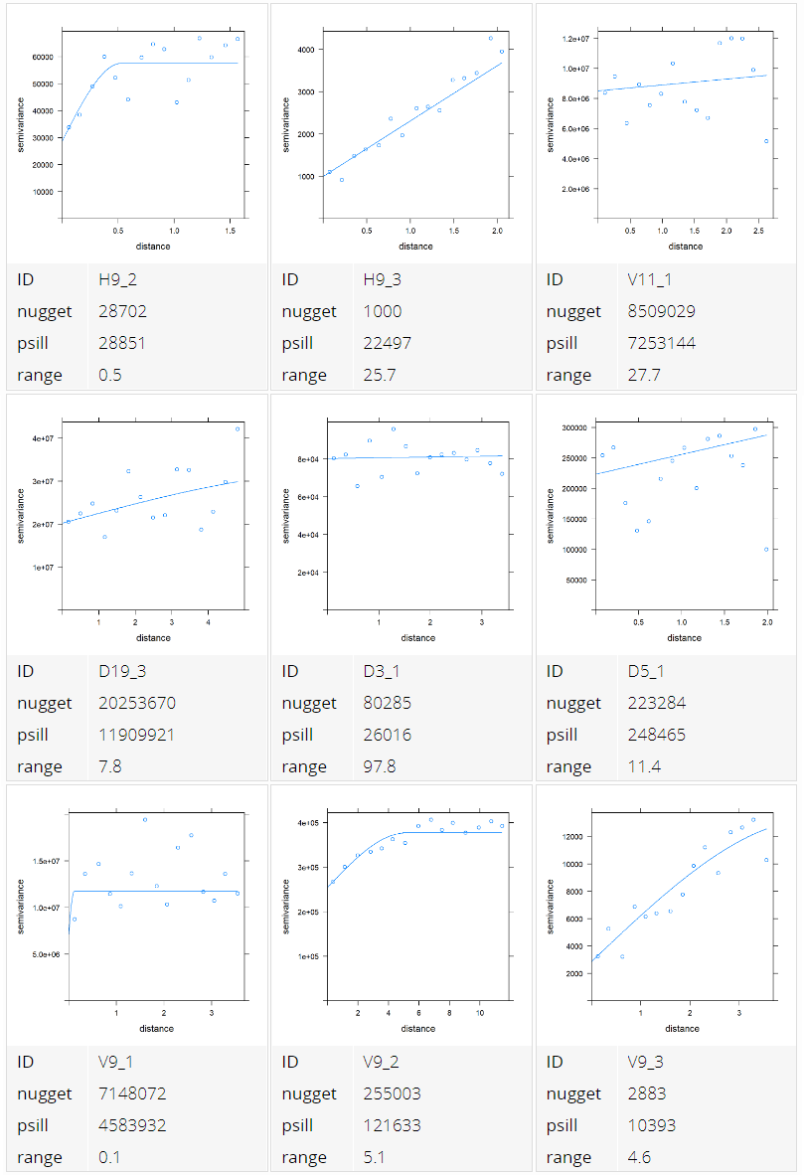
Figure S7 Examples of experimental semivariograms of a sample of transects from the empirical acoustic data, showing the nugget, sill and range values extracted from each variogram. The examples were chosen to cover a range of different autocorrelation levels, low (D3_1, V9_1, D19_3), medium (H9_2, V9_2, D5_1, V11_1) and high (V9_3, H9_3).
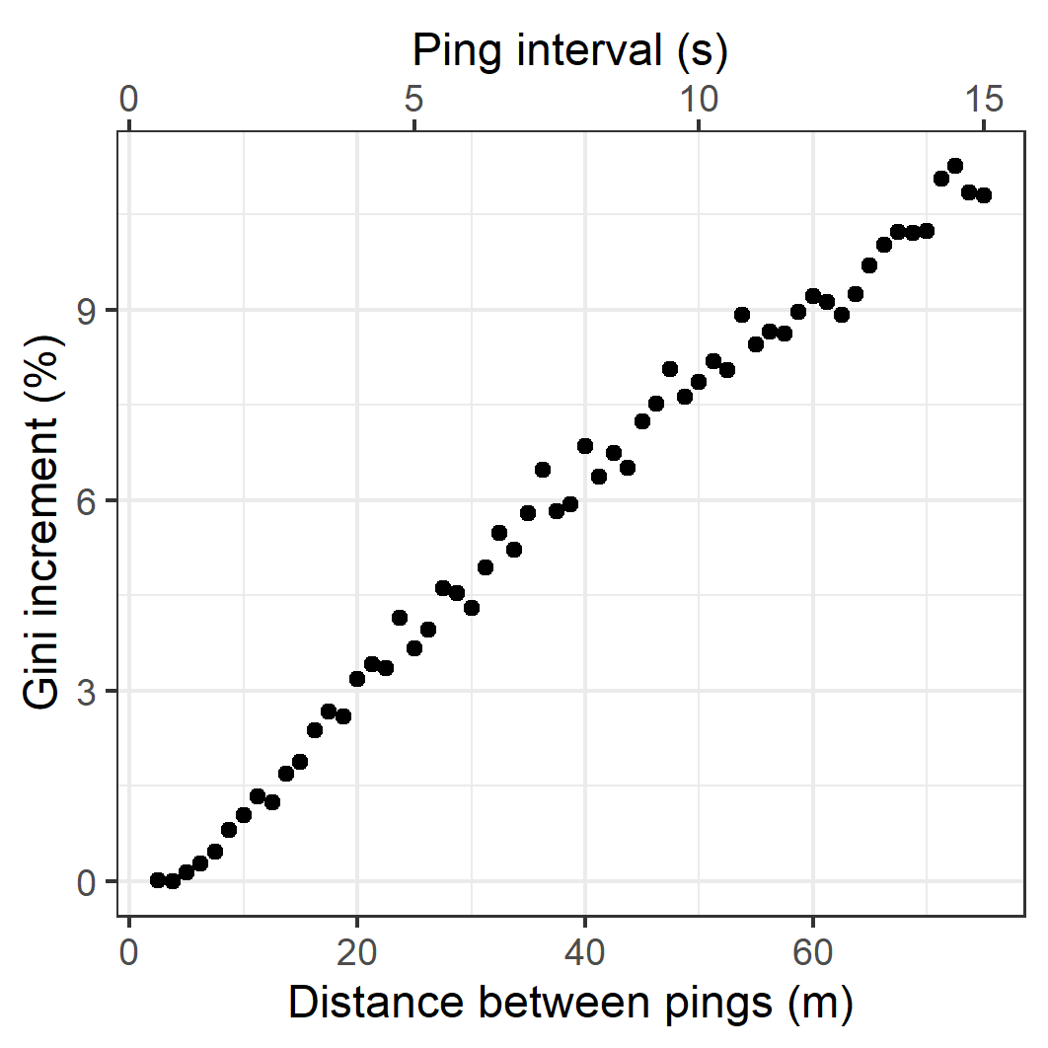
Figure S8. Increase in the Gini index with the ping distance, provided as a percentage with respect to the index at the original ~2.5 m distance.

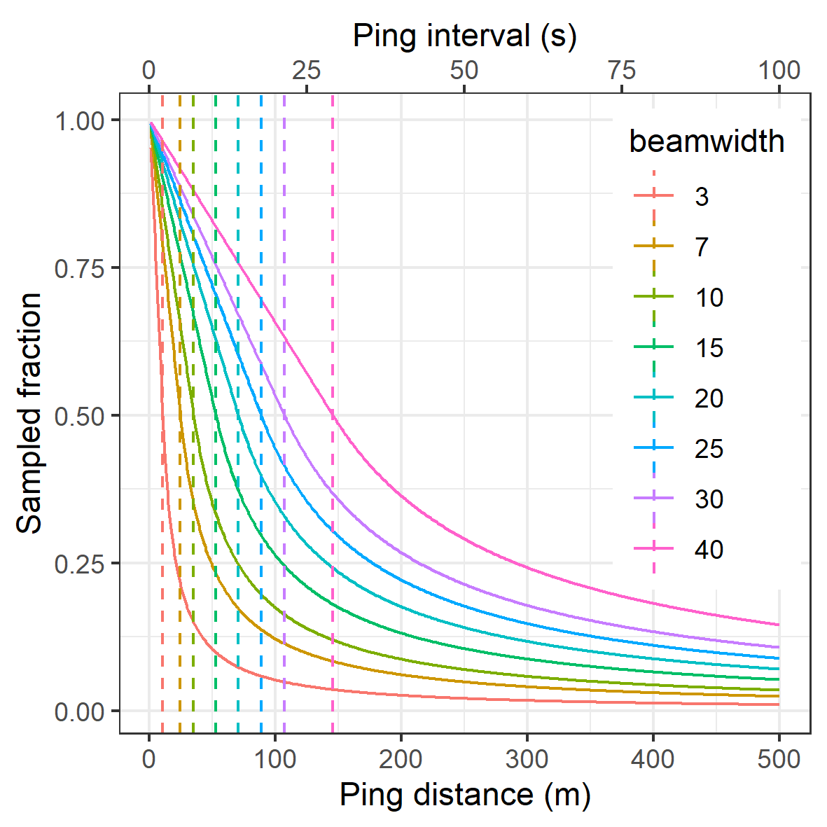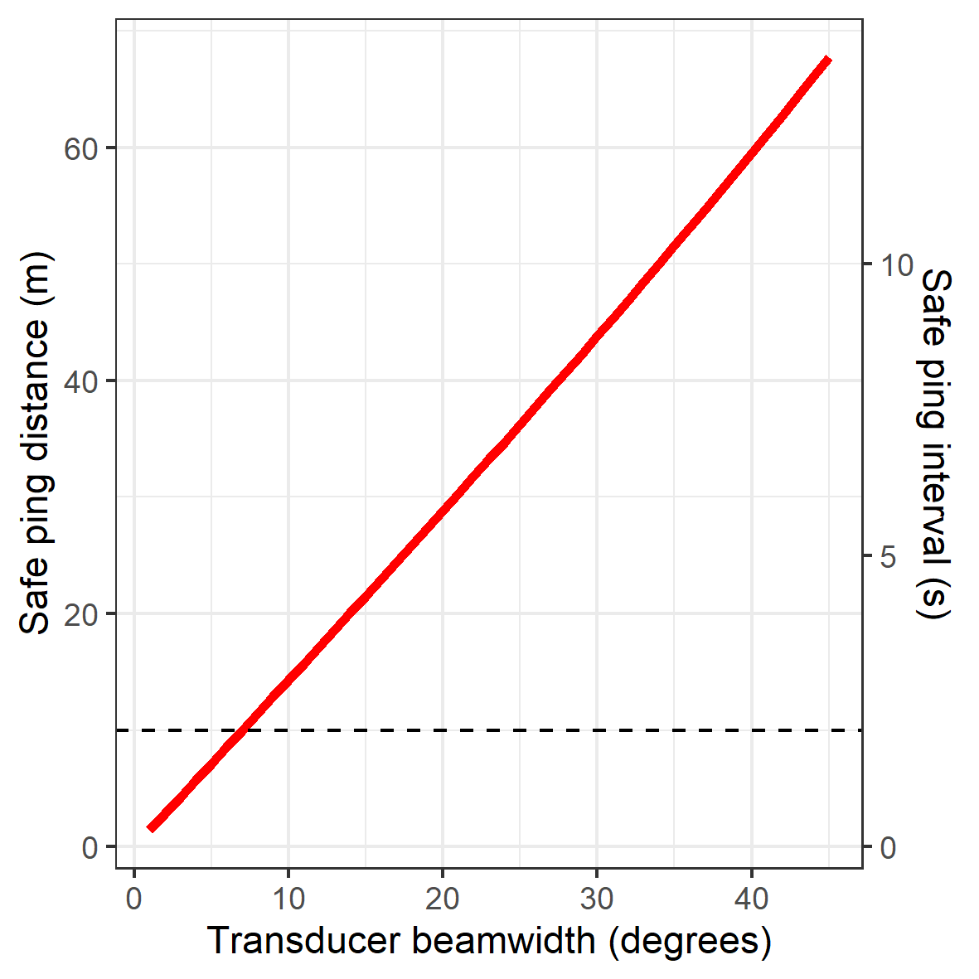
Figure S9. Left panel: Relationship between along-transect sampled fraction and pinging resolution for different common transducer beamwidths (in degrees). As the transducer beamwidth increases, the sampled fraction increases for the same ping distance, thus making it less likely to be biased. Right panel: As a result of the increased sample fraction with transducer beamwidth, the "safe” ping resolution (maximum ping distance at which the risk of underestimation is low, established at ~12.5 m for a 7° beamwidth, marked with a horizontal dashed line) increases with wider angle transducers.

