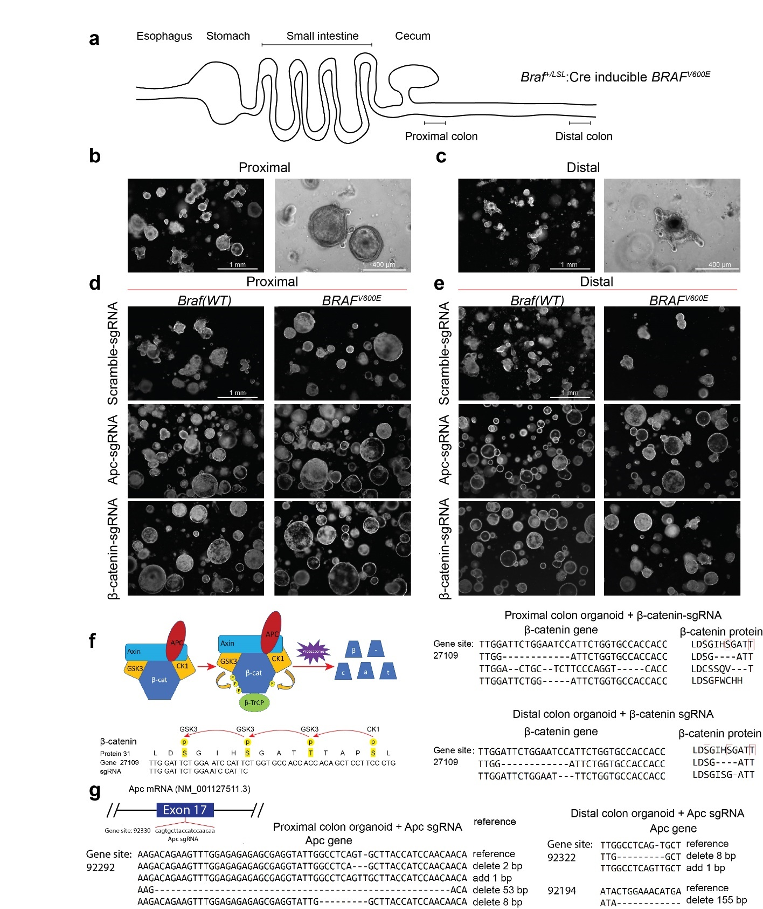
Figure S1. Design of targeted mutations in Apc and Ctnnb1 (β-catenin) and morphology of proximal and distal colon organoids upon abnormal Wnt-pathway activation, related to Figure 1.
(a) Schematic representation of the anatomic location of Braf^{+/V600E_LSL} loci containing mouse from which proximal and distal colon organoids were isolated.
(b and c) Representative images of proximal colon organoid (b) growing into larger structures with small buds, while distal colon organoids (c) with more budded protrusions.
(d and e) Representative images of proximal (d) and distal (e) colon organoids edited by Apc-sgRNA or β−catenin-sgRNA, with or without induction of BRAF^{V600E}.
(f) Schematic representation of β-catenin destruction complex which can phosphorylate four of the N-terminal amino acids of β-catenin protein step by step (left). Subsequently the phosphorylated β-catenin is lysed by proteasome. sgRNA targeting the exon 1 of Ctnnb1 gene encoding β-catenin resulted in deletion of the phosphorylation site and thus blocking the lysis process stimulated by β-catenin destruction complex, followed by the abnormal continuous activation of Wnt-pathway. Sanger sequence results in the right panel shows the resulting mutations and the corresponding amino acid sequence in proximal and distal organoids.
(g) Similar to F, sgRNA targeting exon 17 in Apc and the resulting mutations and the corresponding amino acid sequence in proximal and distal organoids.

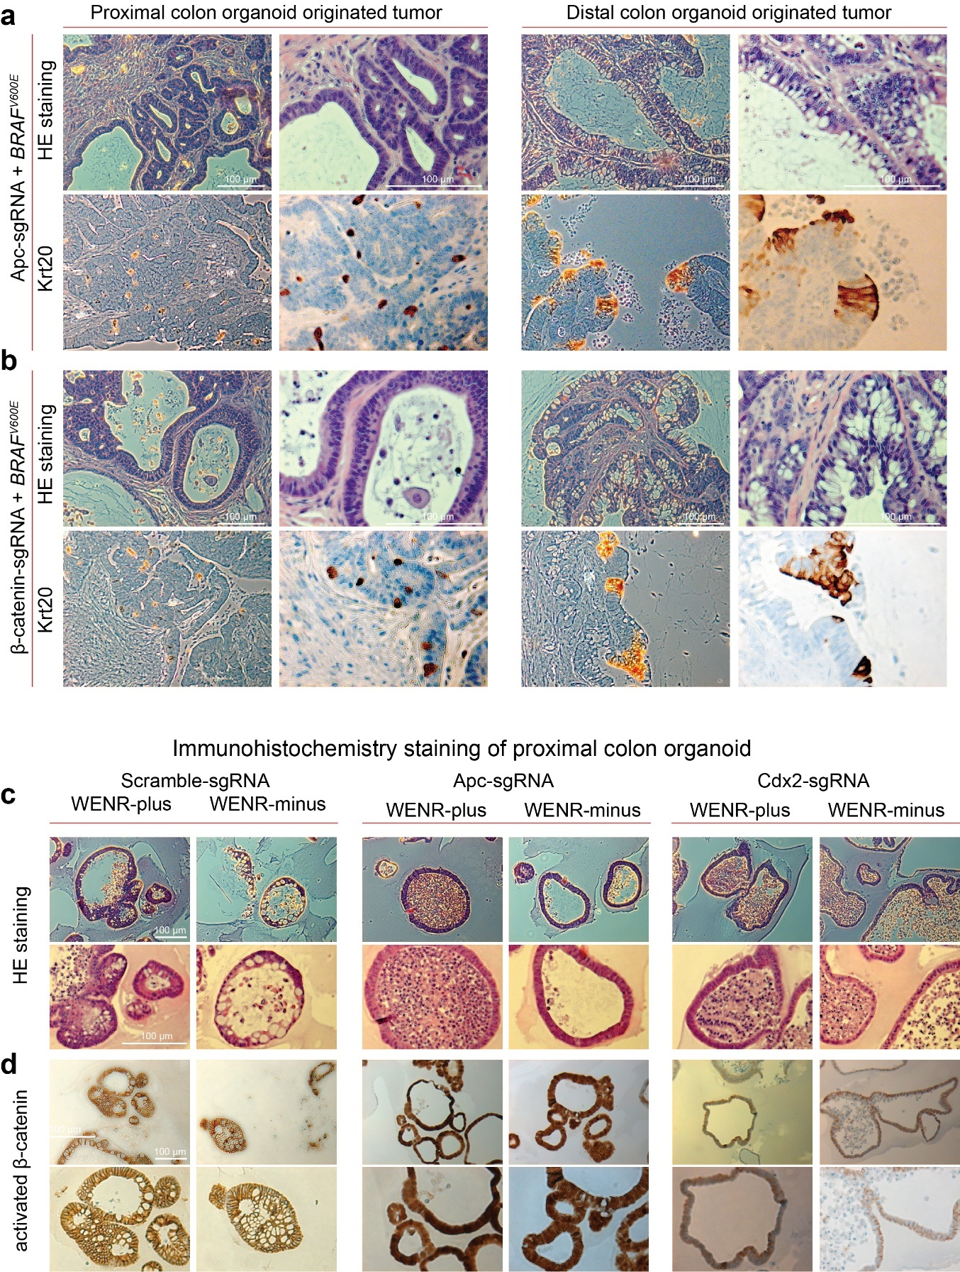
Figure S2. Proximal and distal colon stem cells show differences in tumors driven by BRAF^{V600E} in the context of abnormal Wnt pathway activation.
(a-b) Representative H&E and immunohistochemistry staining (Krt20) of tumors growing as xenografts derived from proximal (left) and distal (right) colon organoids with BRAF^{V600E} combined with Apc mutation (a) or β-catenin mutation (b).
(c) Representative H&E staining of proximal colon organoids with Scramble-sgRNA, Apc-sgRNA and Cdx2-sgRNA separately cultured in WENR-plus or -minus medium.
(d) Representative immunohistochemistry staining using activated β-catenin (d) antibody separately for proximal colon organoid treated with Scramble-sgRNA, APC-sgRNA, and Cdx2-sgRNA separately cultured in WENR-plus or -minus medium.

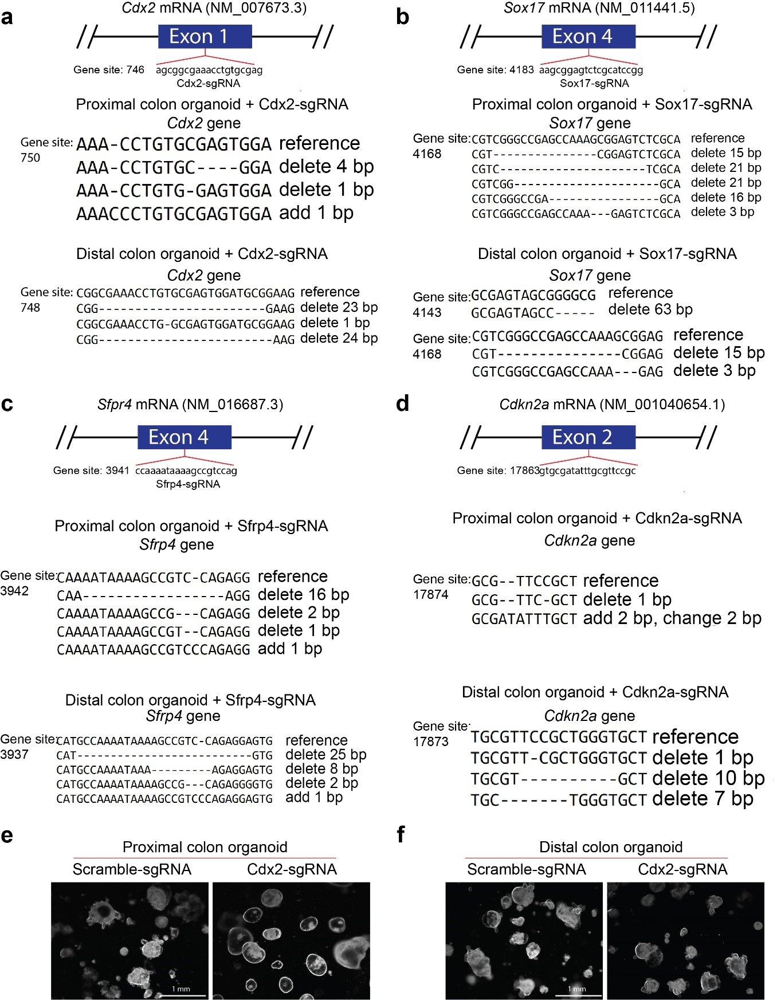
Figure S3. Validation of CRISPR/Cas9 mediated targeted gene mutation in the proximal and distal colon organoids transduced with Cdx2-sgRNA and gross morphological differences in the corresponding organoids.
(a-d) Schematic diagrams of the sequence for Cdx2-sgRNA (a), Sox17-sgRNA (b), Sfrp4-sgRNA (c) and Cdkn2a-sgRNA (d), and Sanger sequencing results showing corresponding gene mutations in the selected organoids.
(e-f) Representative images of the proximal (e) and distal (f) colon organoids with Scramble-sgRNA and Cdx2-sgRNA separately.
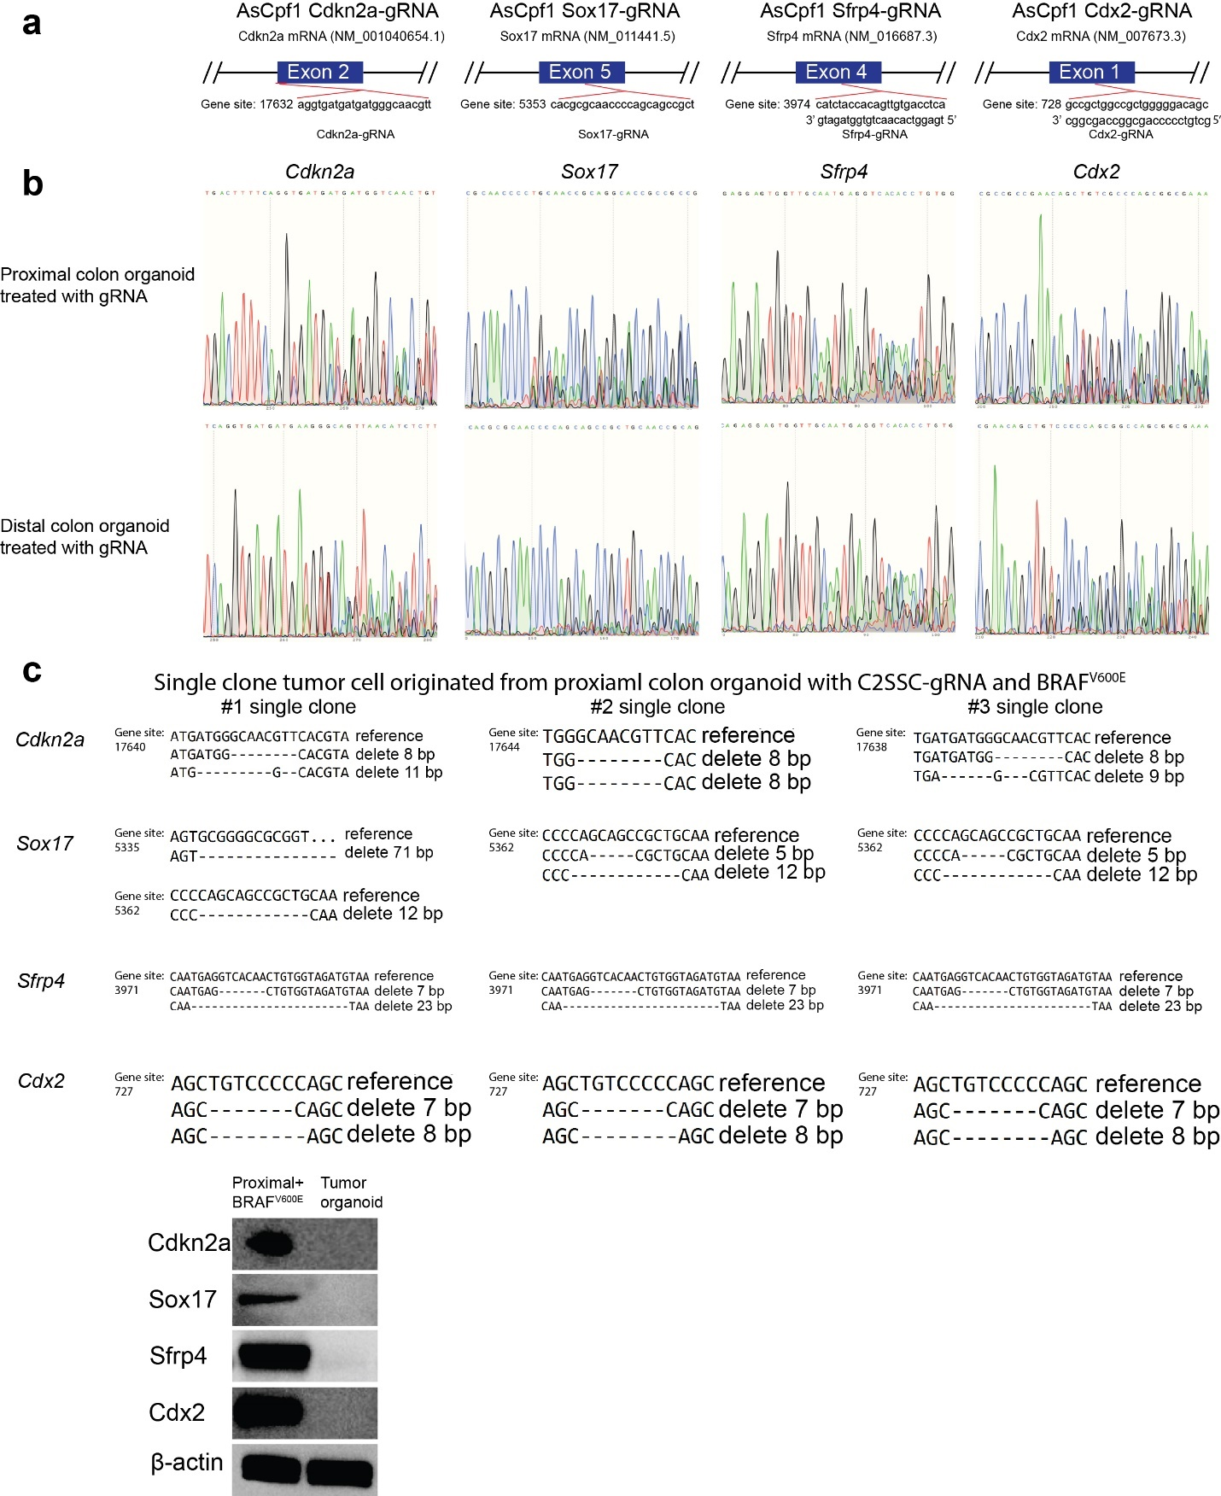
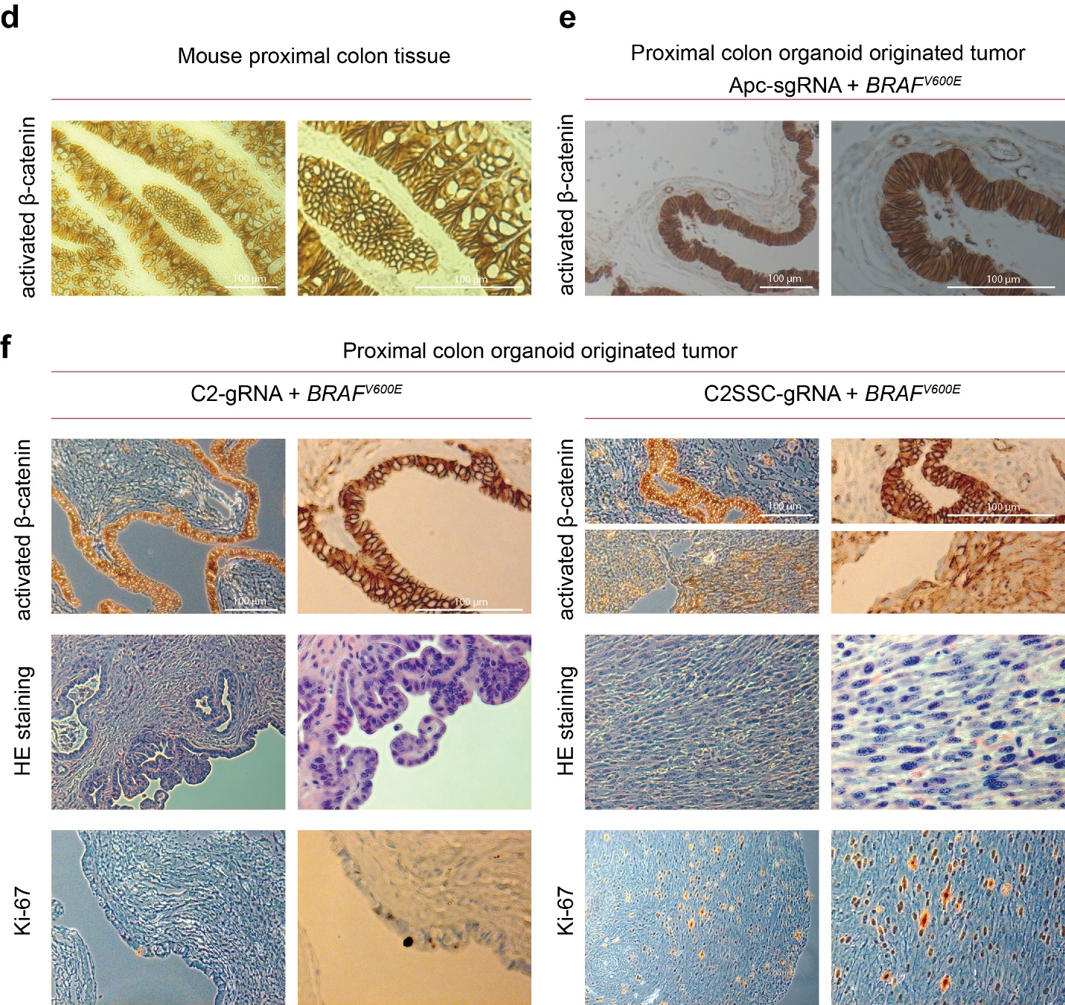

Figure S4. Design and validation of Cdkn2a, Sox17, Sfrp4, and Cdx2 guide RNAs for CRISPR-AsCpf1 approach, and tumors derived from proximal colon organoids in the context of combination of Cdx2 mutation and BRAF^{V600E} do not show canonical Wnt-activation.

(a) Schematic diagrams showing the exon in Cdkn2a, Sox17, Sfrp4, and Cdx2 targeted by corresponding guide RNAs using CRISPR-Ascpf1.
(b) Sanger sequence results checking efficiency of gene editing of Cdkn2a-gRNA, Sox17-gRNA, Sfrp4-gRNA and Cdx2-gRNA in proximal and distal colon organoids.
(c) Sanger sequencing results showing the mutations in Cdkn2a, Sox17, Sfrp4 and Cdx2 in three of single cell derived organoids that were generated from the tumor cells derived from proximal colon organoids edited with C2SSC-gRNA in the context of BRAF^{V600E}. Western-blot results (bottom panel) showing Cdkn2a, Sox17, Sfrp4 and Cdx2 are abolished in #1 single clone tumor cell derived organoids, while positive in proximal colon organoid with BRAF^{V600E}.
(d) Representative immunohistochemistry staining using activated β-catenin antibody in mouse proximal colon tissue.
(e) Representative immunohistochemistry staining using activated β-catenin antibody in tumor derived from proximal colon organoid with Apc mutation in the context of BRAF^{V600E}.
(f) Representative H&E staining and immunohistochemistry (activated β-catenin, Ki-67) images of the xenograft implants from proximal colon organoids edited with C2-gRNA (forming nodular growth at implanted site) or with C2SSC-gRNA (forming tumor growth at implanted site) in the context of BRAF^{V600E}.

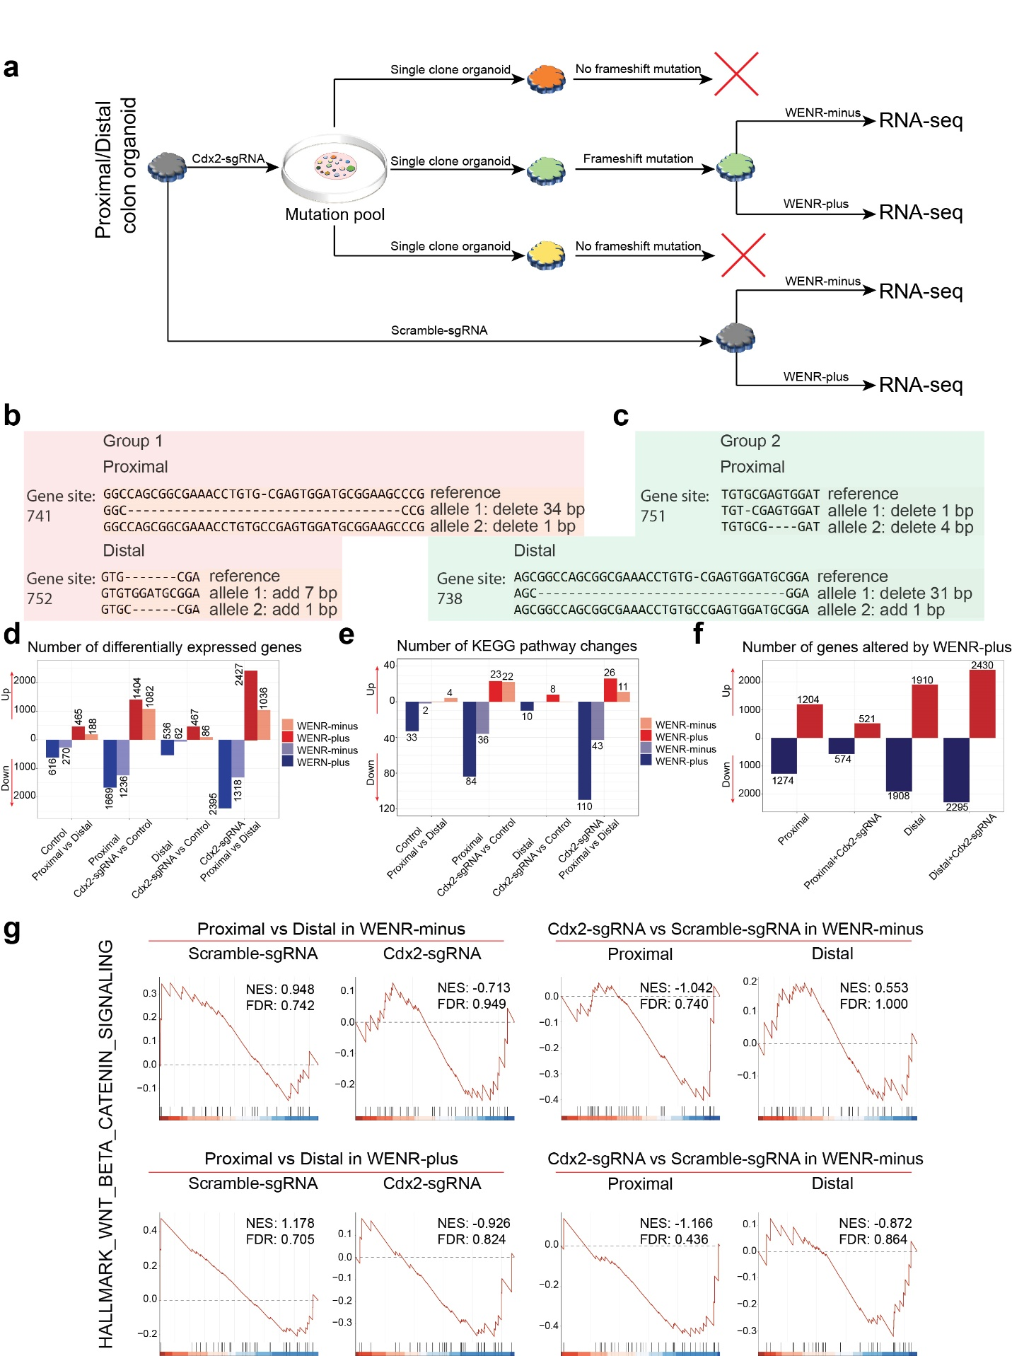
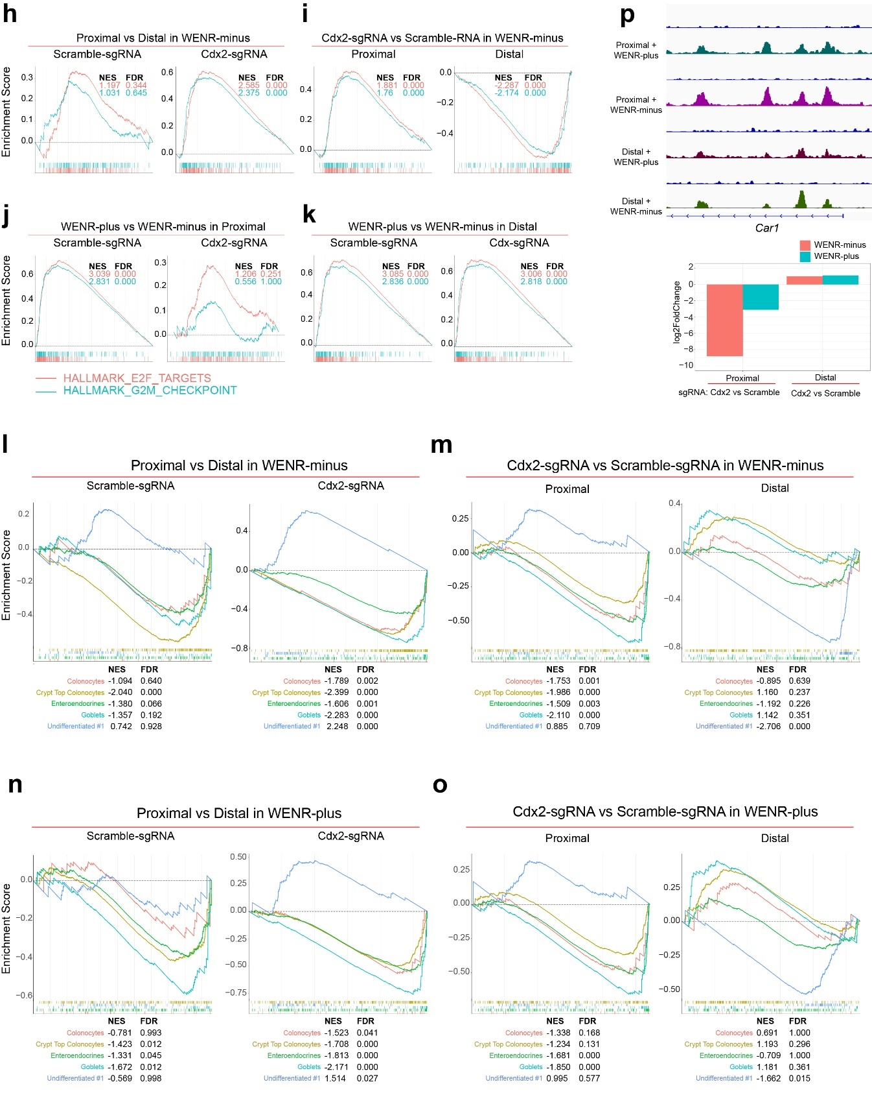
Figure S5. Gene expression (RNA-seq) analysis of proximal and distal organoids with Cdx2 loss.
(a) Schematic diagram showing how proximal and distal colon organoids with Cdx2 loss (Cdx2-sgRNA) for obtained for RNA-seq.
(b-c) Sanger sequence results showing frameshift mutation in both alleles of the biological replicates (derived from independent mice) of proximal and distal colon organoids used for the RNA-seq analyses.
(d) As compared with distal colon organoids, Cdx2 loss (Cdx2-sgRNA) in proximal organoids results in greater number of genes with altered expression in both WENR-plus or -minus medium.
(e) As compared with distal colon organoids, Cdx2 loss (Cdx2-sgRNA) in proximal organoids results in greater number of altered KEGG pathways in both WENR-plus or -minus medium.
(f) As compared with the corresponding distal colon organoids, the number of genes with altered expression is fewer in Cdx2 loss (Cdx2-sgRNA) proximal colon organoid when translocated from WENR-plus to -minus medium, as compared with control proximal organoid, distal colon organoid with or without Cdx2 loss.
(g) GSEA analysis showing that Cdx2 deficiency (Cdx2-sgRNA) does not influence the Wnt pathway significantly in both WENR-plus or -minus medium.
(h) GSEA results for E2F targets and G2M checkpoint genes obtained by comparing gene expression in proximal organoids compared to distal organoids with Cdx2-sgRNA (right panel) or control (Scramble-sgRNA) (left panel). These pathways are upregulated in Cdx2 deficient proximal organoids growing in WENR-minus medium.
(i) GSEA results for E2F targets and G2M checkpoint genes obtained by comparing gene expression in proximal and distal organoids with Cdx2 loss to their respective controls (Scramble-sgRNA). These pathways are specifically upregulated in proximal organoids upon Cdx2-KO while distal organoids show downregulation of these pathways. Organoids are grown in WENR-minus medium.
(j) For proximal organoids, GSEA results from comparing gene expression in Cdx2 deficient (Cdx2-sgRNA) and control (Scramble-sgRNA) proximal organoids grown in WENR-plus vs. WENR-minus medium, showing that exogenous Wnt-factors is required for upregulation of these pathways in control proximal organoids but these factors are expressed to similar levels in Cdx2 deficient proximal organoids grown in the presence (WENR-plus) or absence (WENR-minus) of Wnt-factors.
(k) Same comparisons as in J but for distal organoids showing exogenous Wnt-factors significantly upregulates these pathways in both control and Cdx2 deficient (Cdx2-sgRNA) organoids.
(l-o) GSEA results for gene expression signatures for the stem cell and differentiated cell types in the colon epithelium. Gene expression signatures of following cell types shown: stem cells (Undifferentiated #1) and differentiated cell types (colonocytes, crypt top colonocytes, enteroendocrine and goblet cells). (l) GSEA results from comparing gene expression in proximal organoids compared to distal organoids upon Cdx2 loss (Cdx2-sgRNA) (right panel) or control treatment (Scramble-sgRNA) (left panel) showing upregulation of stem cells (Undifferentiated #1) signature in proximal organoids with Cdx2 loss growing in WENR-minus medium. (m) GSEA results from comparing gene expression in proximal and distal organoids with Cdx2 loss to their respective controls (Scramble-sgRNA). Compared to control, Cdx2 deficient proximal organoids grown in WENR-minus medium show significant downregulation of differentiated cell signatures. In contrast, Cdx2 loss does not affect these gene signatures in distal organoids grown in WENR-minus medium, but results in downregulation of stem cell signature. (n) Same comparison as in (l) but for organoids grown in WENR-plus medium. Proximal organoids inherently show reduced signatures for differentiated cells compared to distal organoids as seen in control (Scramble-sgRNA, left panel) organoids, and these signatures are further downregulated upon Cdx2 loss (right panel). (o) Same comparison as in (m) but for organoids grown in WENR-plus medium. Cdx2 deficient proximal organoids show only marginal downregulation (NES values compared to (m)) of the differentiated cells gene signatures in the presence of Wnt-factors in medium (WENR-plus). In contrast, in distal organoids Cdx2 loss results in downregulation of stem cell signature even in the presence of Wnt-factors in medium (WENR-plus).
(p) Top panel shows ChIP-seq enrichment traces showing Cdx2-binding in the Car1 gene locus for proximal and distal colon organoid cultured in WENR-plus or -minus medium. Bottom panel shows histogram summarizing Car1 mRNA expression changes in Cdx2 deficient (Cdx2-sgRNA) versus control (Scramble-sgRNA) proximal and distal colon organoids cultured in WENR-plus or -minus medium.

