Supplementary Table 1. Multivariate Cox Analysis of Overall Survival
Characteristics | HR | 95% CI | P
Age (yrs.) | 1.01 | 0.99-1.03 | 0.426
Multicentric growth | 1.95 | 1.09-3.48 | 0.024
Resection vs. biopsy | 0.52 | 0.30-0.91 | 0.021
Radiotherapy completed | 0.29 | 0.15-0.56 | <0.001
Chemotherapy | 0.31 | 0.15-0.63 | 0.001
HR – Hazard Ratio; 95%CI – 95% confidence Interval

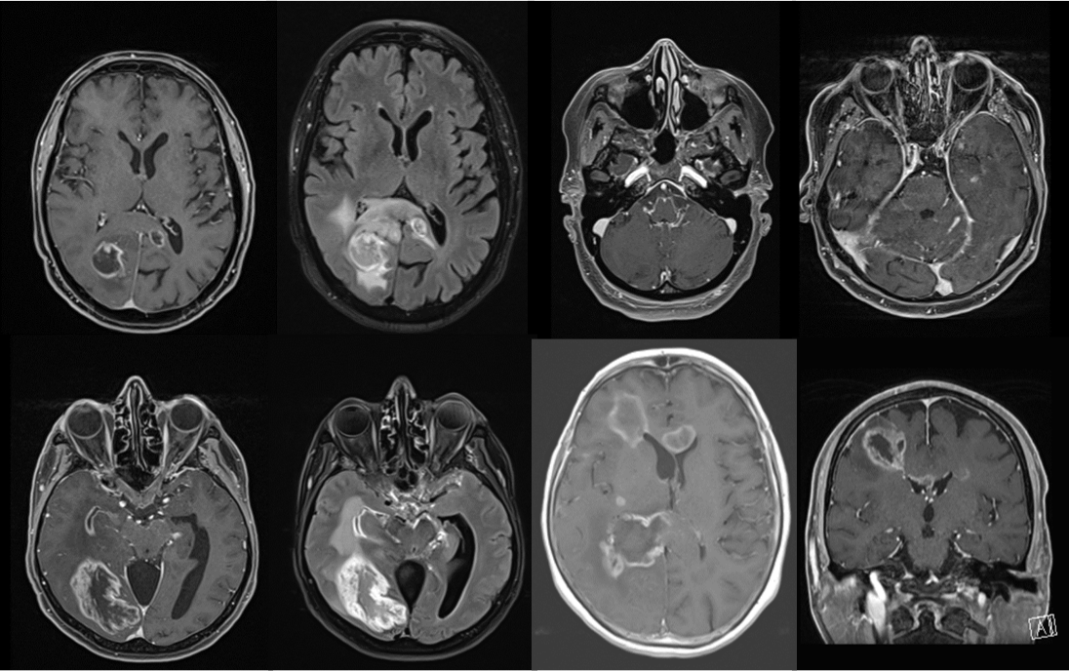
Supplementary Fig. 1 a-d Spread patterns in 2 different patients with mGBM. a (T1 with contrast) and b (FLAIR) multifocal glioblastoma with lesions in both hemispheres, pericallosal and periventricular spread (lesions within 1 cm of the ventricular system and the corpus callosum). c (T1 with contrast) and d (FLAIR) bilateral, subependymal and subarachnoidal spread (diffuse leptomeningeal contrast enhancement along the surface of the mesencephalon). e (T1 with contrast) subarachnoid spread: diffuse perimesencephalic enhancement. f (T1 with contrast) subarachnoid spread along the cerebellar fissures and two periventricular lesions (“periventricular spread”). g (T1 with contrast) and h (T1 with contrast) two different cases with multiple lesions: bilateral, periventricular, pericallosal and subependymal spread patterns.

h
g
a
b
c
dD
e
f

