Text S1 – Text supplement corresponding to section 2.1 Study sites
Botanically the peat types differ between the sites. (Zegveld is dominated by wood-peat, Rouveen by sedge-peat, Assendelft by a mixture of reed and sedge and Aldeboarn by more mesotropic/oligotropic peat containing remnants of mosses, Eriophorum and heather (Erica). Hydrologically, Assendelft is characterized by upward seepage of brackish water (mean EC within measuring period at 120 cm depth = 2.5 mS cm−1) and a clayey peat topsoil of 30 cm. Rouveen consists of strong upward seepage of fresh water (mean EC = 0.6 mS cm-1) and has a 35 cm clay topsoil. The upward seepage is responsible for year-round near-surface groundwater levels. Aldeboarn is characterized by a 50 cm thick clay topsoil horizon and downward seepage. Zegveld is characterized by a lower amount of clay in the profile and limited downward seepage. The topsoil in Vlist consists of clayey peat or peaty clay in the top 40 cm and slight downward seepage.

Text S2 - Text supplement corresponding to section 2.3 Porewater composition
The pH of the samples was determined using a standard Ag/AgCl₂ electrode connected to a Radiometer (Copenhagen, Type TIM840). Concentrations of nitrate (NO₃⁻) and ammonium (NH₄⁺) were determined colorimetrically on a Seal auto-analyser III using salicylate reagent and hydrazine sulfate, respectively, whereas concentrations of chloride (Cl⁻) were determined colorimetrically on an auto-analyser (Bran+Luebbe ΙΙI system) using mercury(II)cyanide. Acidified samples (0.1 ml (65%) HNO₃⁻) were analysed for Fe(II), Mn(II), total phosphorus (P) and S using inductively coupled spectrometry (ICP-OES, ICAP 6300, Thermo Fisher Scientific of, ARCOS MV, Spectro). Since S is predominantly present as SO₄²⁻, total S in the porewater was used as a proxy for SO₄²⁻ concentrations. The shift in ratio of SO₄²⁻ to Cl⁻ (mol:mol) away from a standard marine mass ratio (0.14) was calculated to determine long-term SO₄²⁻ reduction rates (Appelo & Postma, 2004). Concentrations of CH₄ and H₂S were measured in the headspace of the exetainers (after removing the vacuum with N₂ gas and equilibrating) using a 7890B gas chromatograph (Agilent Technologies, Santa Clara, USA) equipped with a Carbopack BHT100 glass column (2 m, ID 2 mm), flame ionization (FID), and flame photometric detector (FPD) and corrected using the gas solubility constant (Sander, 2015).

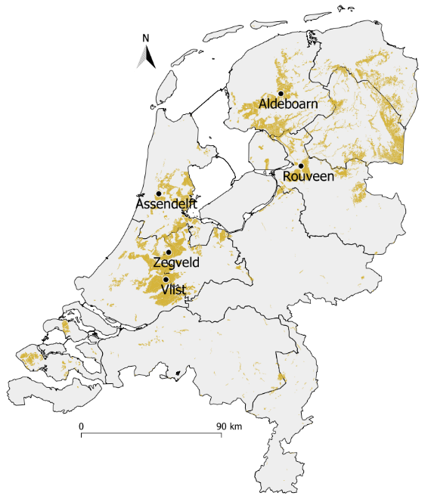
Figure S1 – Peat soils in the Netherlands (highlighted) with the five research locations (Basisregistratie Ondergrond, 2018; Esri Nederland, 2021).
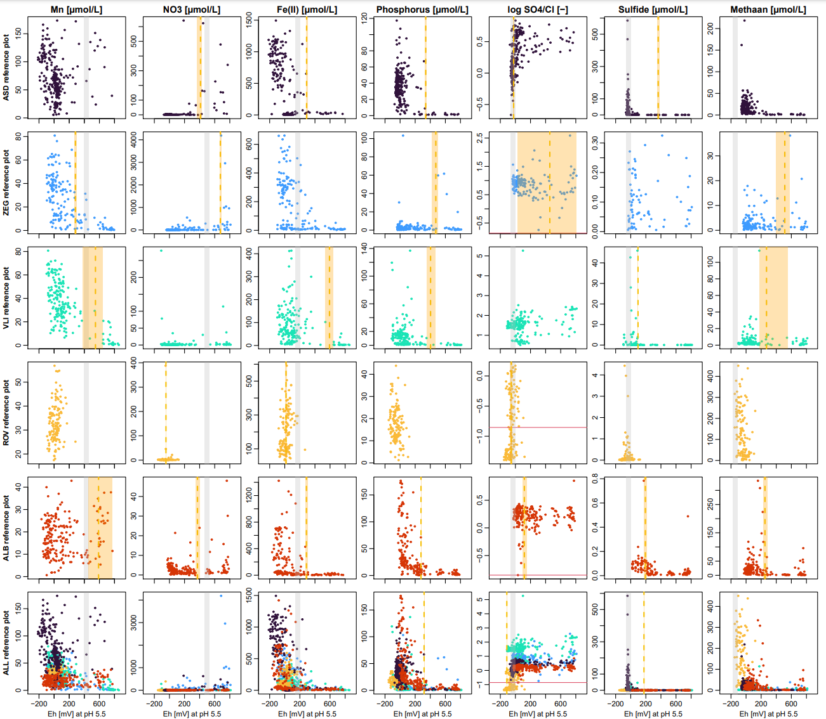
Figure S2 – Eh (mV, x-axis) plotted against concentration of electron acceptors, reduced products of electron acceptors or phosphorus (y-axis and columns) for the reference locations (rows) at depths of 45 and 75 cm. Orange zones represent the Eh breakpoint range that was found with the mean breakpoint depicted as a dashed orange line. Grey zones illustrate the ranges in Eh for reduction each electron acceptor that is related to the plotted solute that were found in the literature and normalized to pH 5.5 (Table 1). Note different y-axis scales.
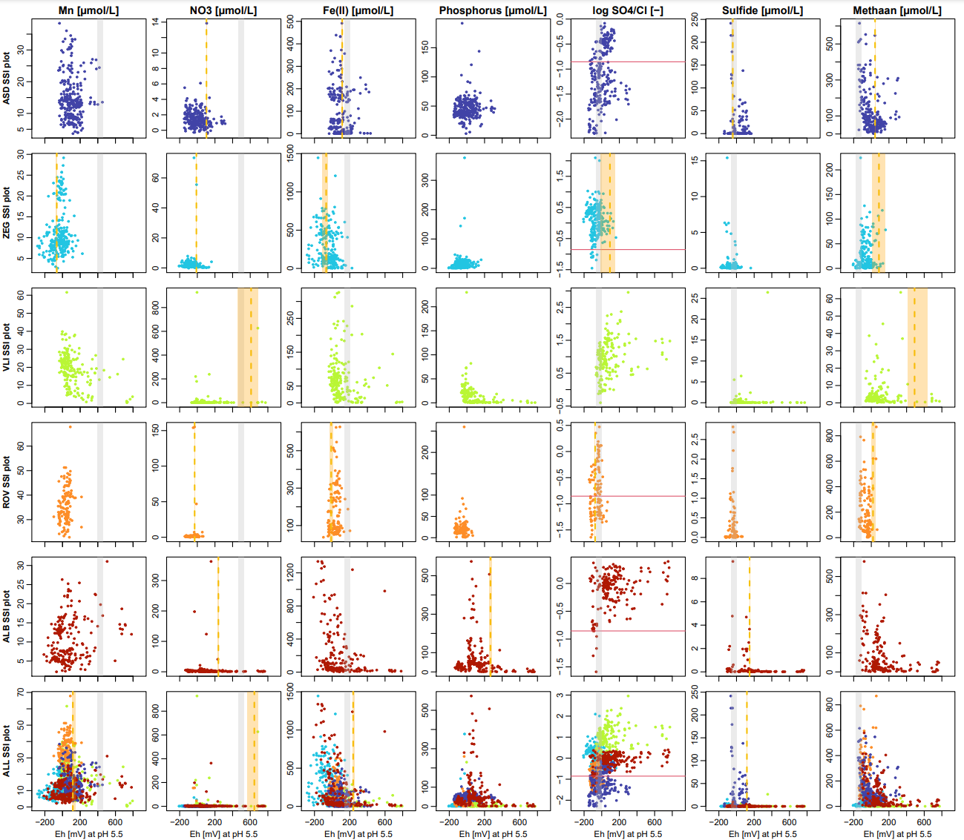
Figure S3 – Eh (mV, x-axis) plotted against concentration of electron acceptors, reduced products of electron acceptors or phosphorus (y-axis and columns) for the SSI locations (rows) at depths of 45 and 75 cm. Orange zones represent the Eh breakpoint range that was found with the mean breakpoint depicted as a dashed orange line. Grey zones illustrate the ranges in Eh for reduction each electron acceptor that is related to the plotted solute that were found in the literature and normalized to pH 5.5 (Table 1). Note different y-axis scales.

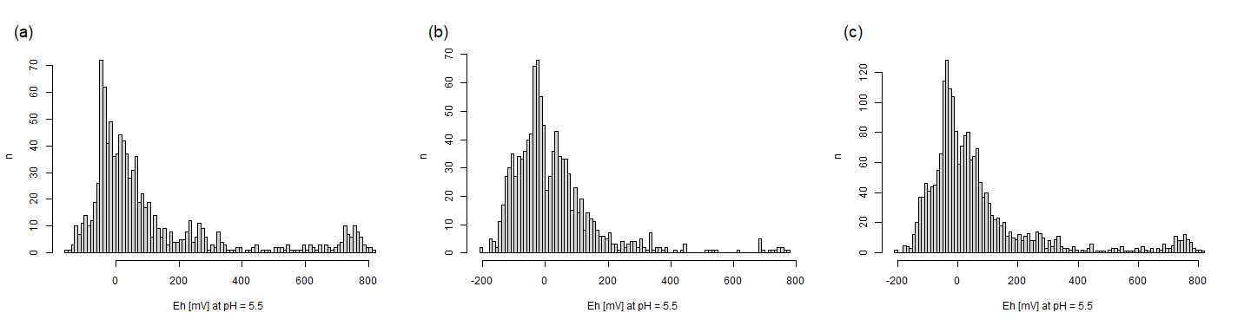
Figure S4 – Histogram of occurrence of Eh (mV) at pH = 5.5. during porewater sample events in (a) reference, (b) SSI and (c) all plots.

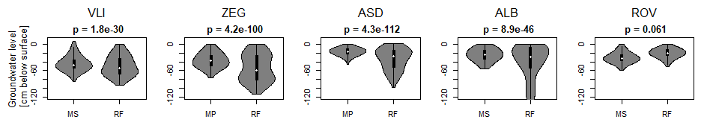
Figure S5 – Violin plots of groundwater level measurements (cm below surface) at RF and MS/MP for each location. The SSI groundwater measurement at a distance of 1 or 1.5 meter perpendicular to the drain was used. Abbreviations: VLI = Vlist, ZEG = Zegveld, ASD = Assendelft, ALB = Aldeboarn, ROV = Rouveen, RF = reference, MS/MP = SSI. Above each plot, the p values of the Levene test is given; p values closer to 0 indicate that the variance of both groups (RF and MS/MP) is more likely to be different. For all locations except Rouveen the variance in measured groundwater level is higher.

Figure S6 – (a) Sulfide and iron(II), (b) methane and iron(II) and (c) methane and sulfide concentrations for all pore water samples.

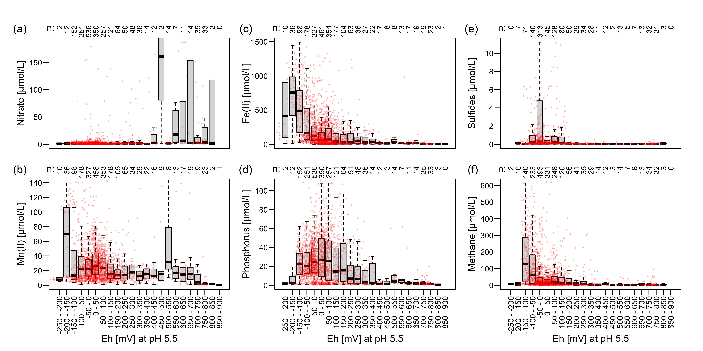
Figure S7 – Boxplots of (a) nitrate, (b) Mn(II), (c) Fe(II), (d) phosphorous, (e) sulfides and (f) methane concentrations along the Eh spectrum (normalized for pH 5.5) for all study sites. Above each boxplot n is given. Y-axis limitation may exclude outliers.

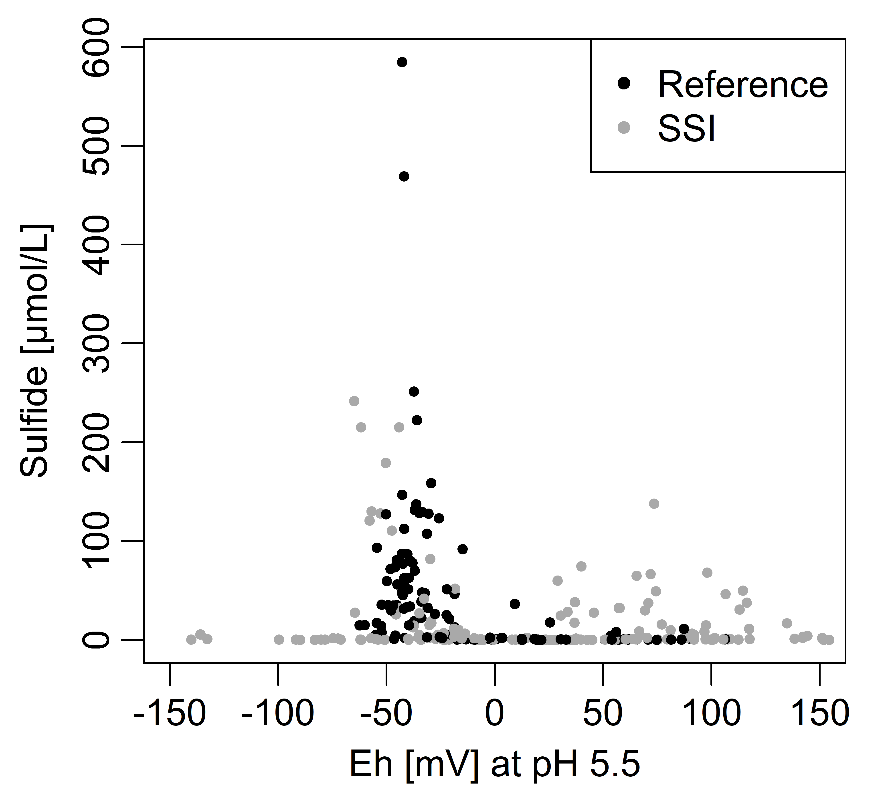
Figure S8 – Distinct pattern of sulfide abundance over Eh (mV) in Assendelft with peaking concentrations between an Eh of -60 and -10 mV.

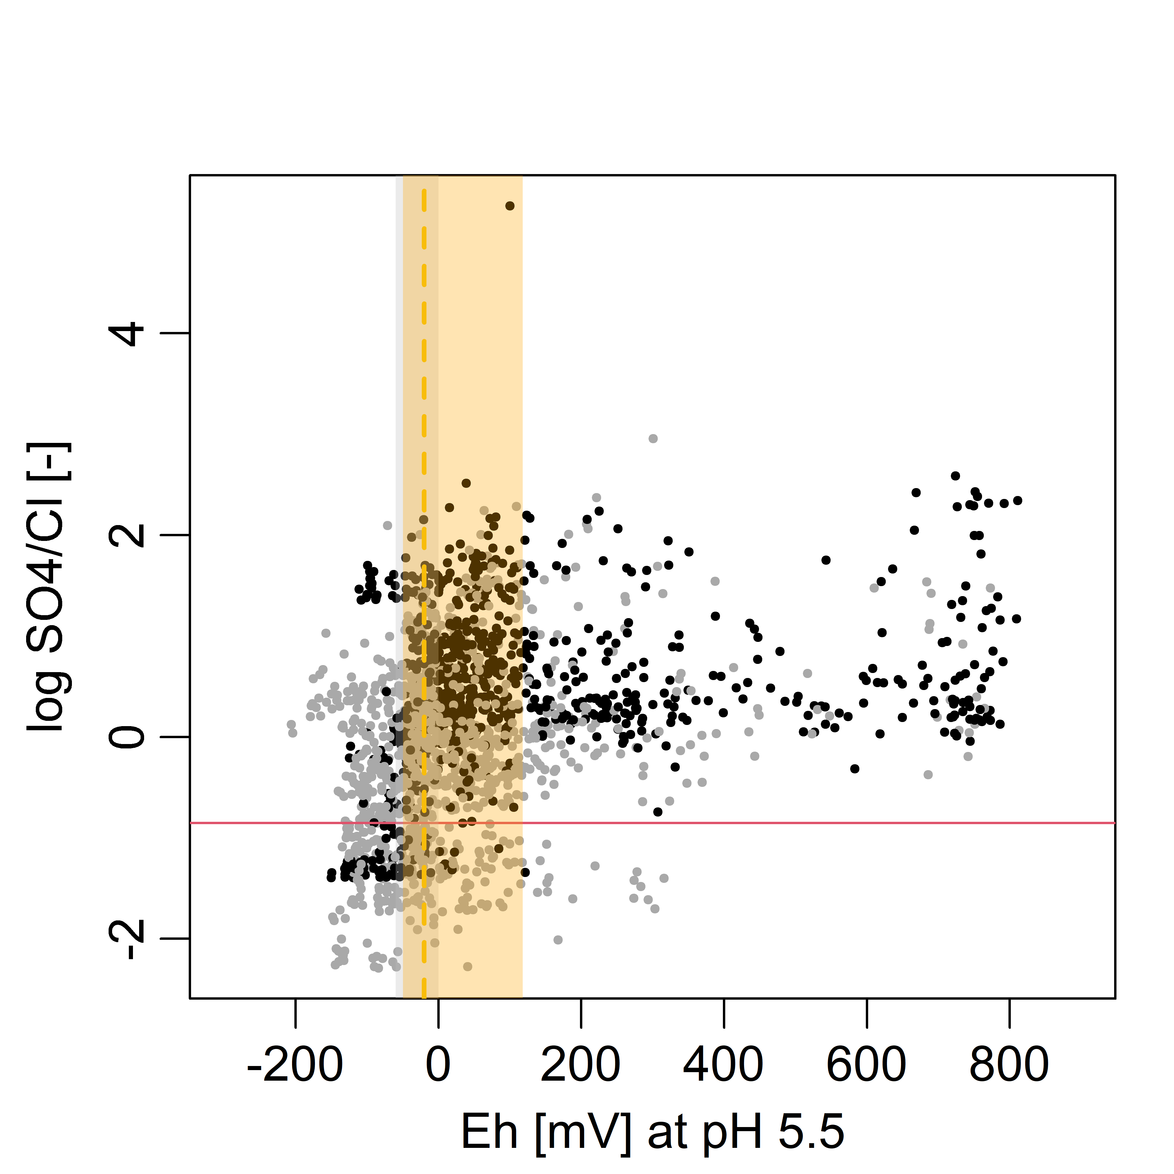
Figure S9 – Log of the ratio of SO₄-²⁻ and Cl⁻. The horizontal red line in the plot at the threshold 0.14 indicates long term reduction of sulphate.
Figure S10 – Chemical composition boxplots per location and depth. RP stands for a reference plot, MS or MP stands for an SSI plot. Colors represent different depths (45 and 75 cm).

Figures S11-S20 – Metabolic depth (y-axis) zonation with dominant oxidizing agent (the product in the case of CH₄) over time (x-axis) based on Eh (pH = 5.5) at all research plots. The black line represents measured groundwater levels. The SSI redox probe and groundwater measurement were located at a distance of 1 or 1.5 meter perpendicular to the drain. Eh measuring depths are depicted with horizontal dashed lines. Abbreviations: VLI = Vlist, ZEG = Zegveld, ASD = Assendelft, ALB = Aldeboarn, ROV = Rouveen, RF = reference, MS/MP = SSI. Each color reflects a different metabolic state, as in Fig. 6.
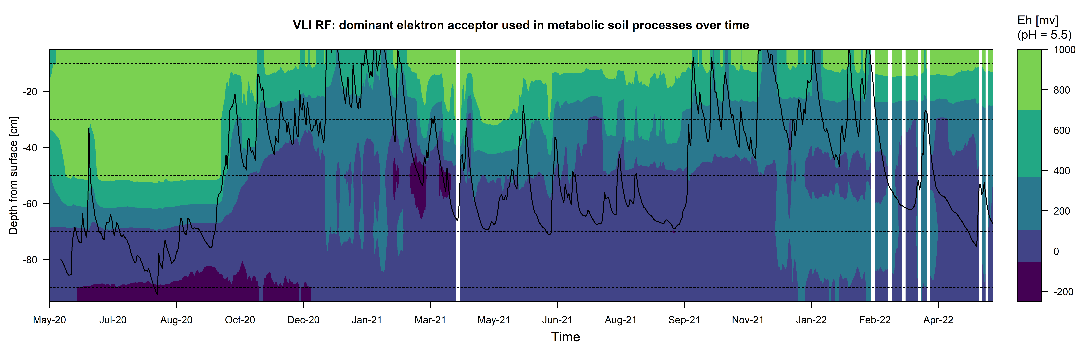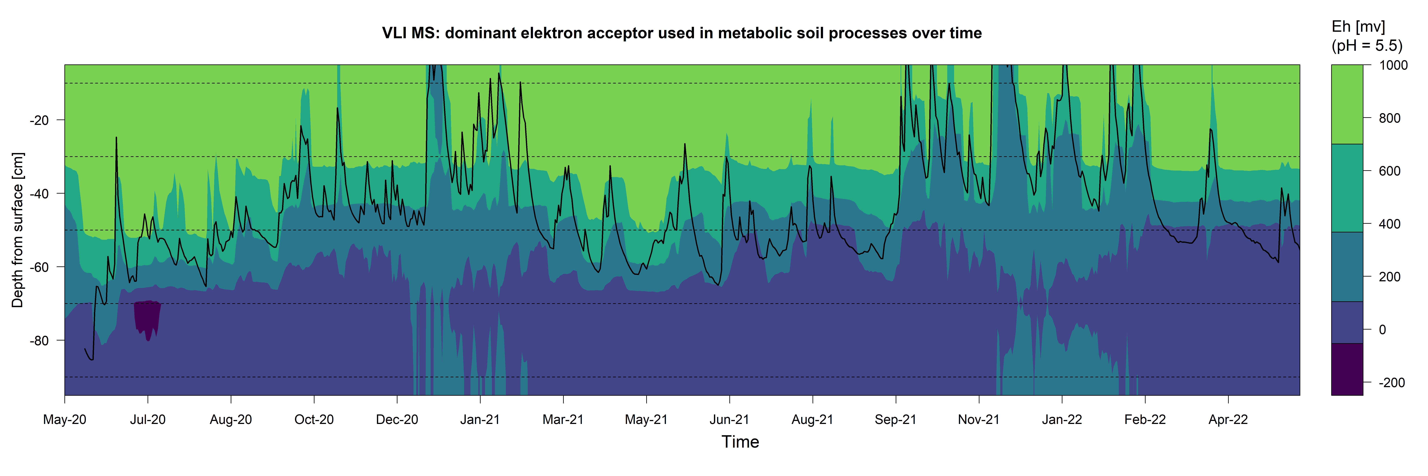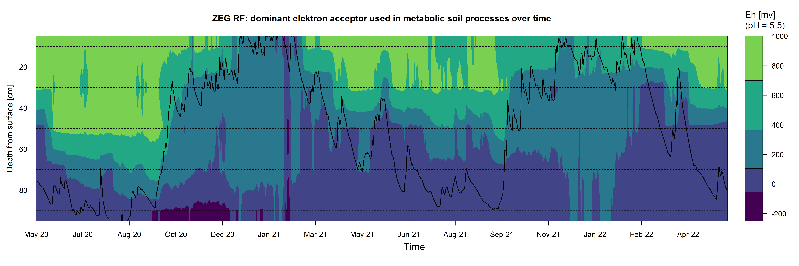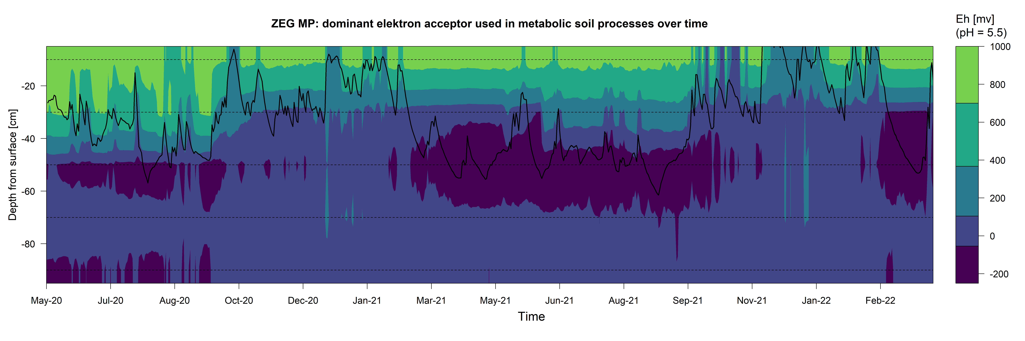
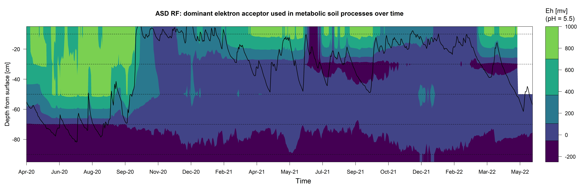

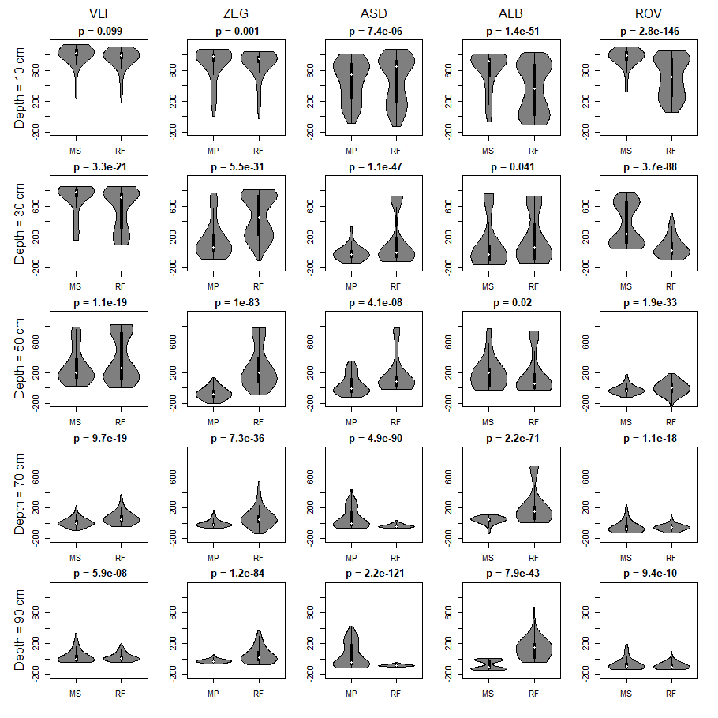
Figure S21 – Violin plots of Eh measurements (mV) at RF and MS/MP at each location and depth. The SSI redox probe was located at a distance of 1 or 1.5 meter perpendicular to the drain. Abbreviations: VLI = Vlist, ZEG = Zegveld, ASD = Assendelft, ALB = Aldeboarn, ROV = Rouveen, RF = reference, MS/MP = SSI. Above each plot, the p values of the Levene test is given; p values closer to 0 indicate that the variance of both groups (RF and MS/MP) is more likely to be different. In Vlist and Zegveld, the variance is clearly higher in the RF plot. This is also true for the topsoil (50 cm and above) in Assendelft and subsoil (70 cm and below) in Aldeboarn. In the subsoil in Assendelft we find a higher Eh variance for the SSI parcel which could be due to the impact of drain water.

Figure S22 – Summary of all interpreted Eh (at pH = 5.5) measurements for the reference (RF) and SSI (MS/MP) plots at all measured depths over the complete timeseries (S10-19). Colors represent dominant metabolic state of the soil (Table 2): blue for oxygen reduction, orange for manganese and nitrate reduction, red for iron reduction, green for sulfate reduction and black for methanogenesis.

