Supplementary materials for:
Alteromonas salexigens sp.nov., isolated from coastal seawater
Liping Sun¹, Xinyuan Hu¹, Qin Wang¹, Huijing Niu¹, Caixia Pei¹, Yi Li^{2*}, Chengqiang Xia^{1*}.
¹College of Animal Science, Shanxi Agricultural University, Taigu, Shanxi, 030801, China
²College of Life Sciences, Shanxi Agricultural University, Taigu, 030801, China

*Correspondence:
Chengqiang Xia
College of Animal Science, Shanxi Agricultural University, Taigu 030801, China;
Tel: 86-354-6288335; Fax: 86-354-6288335; E-mail: xiachengqiang126@163.com
Yi Li
College of Life Sciences, Shanxi Agricultural University, Taigu 030801, China;
Tel: 86-354-6286098; Fax: 86-354-6286098; E-mail: liyi@sxau.edu.cn

Table S1 Genomic features of strain ASW11-19^{T} and closely related species of the genus Alteromonas.
Strains: 1, Alteromonas salexigens ASW11-19^{T}; 2, Alteromonas profundi 345S023^{T}; 3, Alteromonas hispanica F32^{T}; 4, Alteromonas fortis 1^{T}; 5, Alteromonas genovensis LMG 24078^{T}.

Genomic characteristics | 1 | 2 | 3 | 4 | 5
Size(bp) | 3 547 440 | 4 391 362 | 4 068 222 | 4 665 060 | 4 071 069
DNA G+C contents (mol%) | 44.4 | 44.4 | 43.8 | 43.9 | 44.3
Contig N50 | 503 268 | 129 189 | 307 433 | 820 233 | 340 293
Contig L50 | 3 | 11 | 4 | 2 | 5
Number of contigs | 18 | 103 | 33 | 7 | 37
Number of coding sequences | 3228 | 4085 | 3669 | 4126 | 3674
Number of RNAs | 62 | 69 | 71 | 76 | 72
Subsystem feature counts
Cofactors, vitamins, prosthetic groups, pigments | 130 | 138 | 131 | 138 | 132
Virulence, disease and defense | 35 | 65 | 32 | 35 | 33
Membrane transport | 70 | 91 | 104 | 138 | 100
Potassium metabolism | 9 | 6 | 7 | 8 | 7
RNA metabolism | 49 | 50 | 48 | 51 | 48
DNA metabolism | 72 | 69 | 79 | 81 | 80
Protein metabolism | 184 | 183 | 201 | 190 | 195
Regulation and cell signaling | 19 | 27 | 34 | 34 | 29
Secondary metabolism | 4 | 4 | 4 | 4 | 4
Fatty acids, lipids, and isoprenoids | 53 | 73 | 64 | 66 | 63
Nitrogen metabolism | 8 | 9 | 9 | 10 | 8
Respiration | 52 | 75 | 60 | 71 | 52
Stress response | 74 | 73 | 90 | 105 | 78
Metabolism of aromatic compounds | 12 | 16 | 13 | 16 | 14
Amino acids and derivatives | 264 | 289 | 284 | 284 | 271
Sulfur metabolism | 3 | 5 | 4 | 10 | 4
Phosphorus metabolism | 25 | 26 | 29 | 27 | 28
Carbohydrates | 118 | 173 | 171 | 159 | 175

Table S2 Genome predicts CAZymes of strain ASW11-19^{T} and closely related species of the genus Alteromonas.
Strains: 1, Alteromonas salexigens ASW11-19^{T}; 2, Alteromonas profundi 345S023^{T}; 3, Alteromonas hispanica F32^{T}; 4, Alteromonas fortis 1^{T}; 5, Alteromonas genovensis LMG 24078^{T}.
The number of families are given in parentheses.

Number of genes | 1 | 2 | 3 | 4 | 5
GHs | 27 (12) | 32 (17) | 36 (18) | 32 (15) | 44 (21)
CEs | 10 (5) | 8 (6) | 7 (4) | 9 (4) | 13 (5)
GTs | 24 (12) | 32 (12) | 20 (12) | 27 (10) | 33 (10)
AAs | 6 (3) | 8 (5) | 5 (4) | 4 (3) | 6 (3)
CBMs | 5 (3) | 4 (4) | 4 (3) | 5 (4) | 5 (3)
PLs | 1 (1) | 7 (4) | 1 (1) | 4 (4) | 7 (3)
Total | 73 | 91 | 73 | 81 | 108
GHs, glycoside hydrolases; GTs, glycosyltransferases; CEs, carbohydrate esterases; AAs, auxiliary activities; CBMs, carbohydrate-binding modules; PLs, polysaccharide lyases.
The number of families are given in parentheses.

Table S3 ANI and dDDH value of strain ASW11-19^{T} and closely related species of the genus Alteromonas.
Strains: 1, Alteromonas salexigens ASW11-19^{T}; 2, Alteromonas profundi 345S023^{T}; 3, Alteromonas hispanica F32^{T}; 4, Alteromonas fortis 1^{T}; 5, Alteromonas genovensis LMG 24078^{T}; 6, Alteromonas halophila JSM 073008^{T}.

dDDH (%)  ANI (%) | 1 | 2 | 3 | 4 | 5 | 6
ASW11-19^{T} | − | 19.0 | 19.3 | 20.0 | 19.6 | 19.4
345S023^{T} | 70.7 | − | 20.3 | 21.0 | 20.4 | 19.9
F32^{T} | 70.8 | 73.2 | − | 21.3 | 23.4 | 20.4
1^{T} | 71.4 | 73.6 | 74.8 | − | 21.2 | 21.1
LMG 24078^{T} | 71.0 | 73.3 | 78.7 | 74.8 | − | 20.0
JSM 073008^{T} | 72.4 | 70.7 | 70.6 | 71.2 | 70.6 | −

Fig. S1 Neighbor-joining phylogenetic tree based on 16S rRNA gene sequences showing the phylogenetic positions of strain ASW11-19^{T} (in bold) and other related taxa. Bootstrap values (expressed as percentages of 1000 replications) of >50% are shown at branch points. Filled circles indicate branches that were also recovered in both maximum-likelihood and minimum-evolution trees. Bar, 0.01 substitutions per nucleotide position.

Fig. S2 Minimum-evolution phylogenetic tree based on 16S rRNA gene sequences showing the phylogenetic positions of strain ASW11-19^{T} (in bold) and other related taxa. Bootstrap values (expressed as percentages of 1000 replications) of >50% are shown at branch points. Filled circles indicate branches that were also recovered in both maximum-likelihood and neighbor-joining trees. Bar, 0.01 substitutions per nucleotide position.

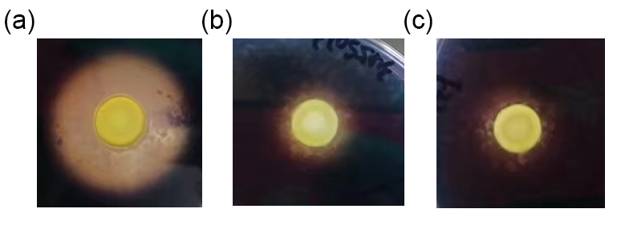
Fig. S3 Phenotype observation of strain ASW11-19^{T} (a), Alteromonas profundi MCCC 1K04570^{T} (b) and Alteromonas hispanica LMG 22958^{T} (c) on 0.5% starch plates after staining by I₂-KI solution.

Fig. S4 Maximum-likelihood phylogenetic trees based on 1560 OCs sequences showing relationships between strain ASW11-19^{T} (in bold) and related species in the family Alteromonadaceae. Bar, 0.05 substitutions per amino acid position.

Fig. S5 Neighbor-joining phylogenetic trees based on 1560 OCs sequences showing relationships between strain ASW11-19^{T} (in bold) and related species in the family Alteromonadaceae. Bar, 0.05 substitutions per amino acid position.

Fig. S6 Minimum-evolution phylogenetic trees based on 1560 OCs sequences showing relationships between strain ASW11-19^{T} (in bold) and related species in the family Alteromonadaceae. Bar, 0.05 substitutions per amino acid position.

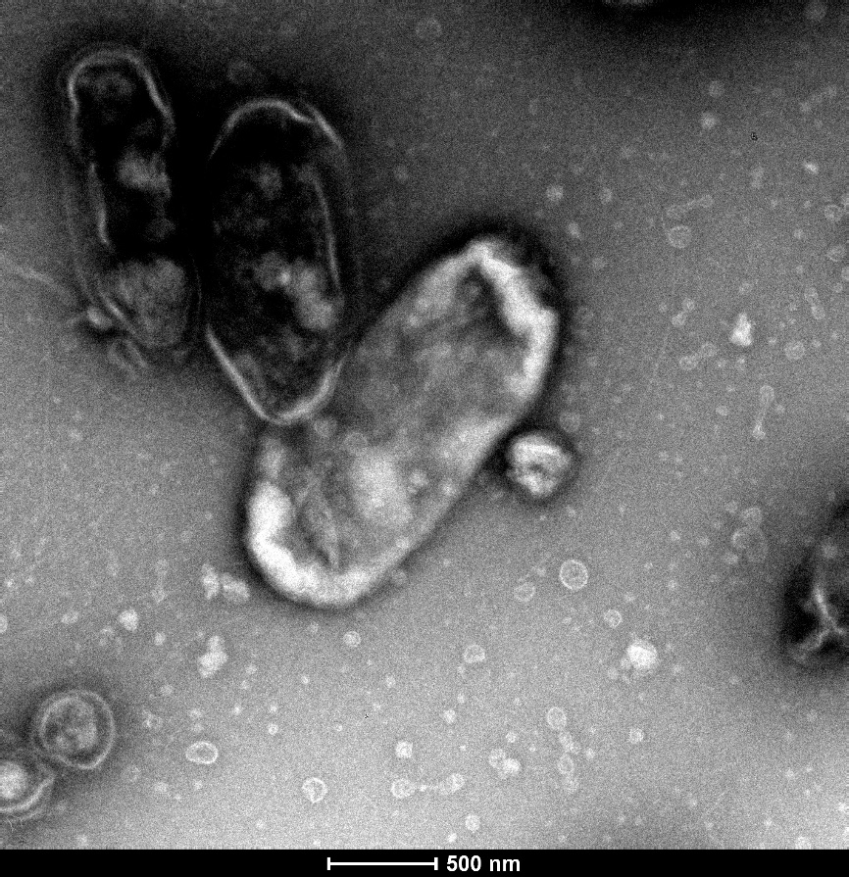
Fig. S7 Transmission electron microscope images of cells of strain ASW11-19^{T}. Bar, 0.5 µm.

Fig. S8 Two-dimensional TLCs of polar lipids of strains ASW11-19^{T} (a, b and c), Alteromonas profundi MCCC 1K04570^{T} (d, e and f); Alteromonas hispanica LMG 22958^{T} (g, h and i). Which were respectively stained with ethanolic molybdophosphoric acid (a, d and g), Zinzadze reagent (b, e and h) and ninhydrin (c, f and i). PE, phosphatidylethanolamine; phosphatidylglycerol (PG) and phospholipid (PL) L, 1–2, unidentified lipids.

