Supplementary material
Appendix 1. A priori assumption using direct acyclic graph (DAG) for the link between 4Ps inclusion and malnutrition in children and adolescents.
The Direct Acyclic Graph (Figure S1) was mapped, using a web-browser software called dagitty, to determine a priori assumptions about the relationships between CCTs and child nutrition outcomes and to identify confounding variables that require conditioning during data analysis. The DAG-implied adjustment sets for estimating such causal effect are socio-cultural status (SCS), socio-demographic status (SDS), socio-economic status (SES). More precisely, SCS was assessed through data on participant’s ethnicity, religion, and their mother tongue, while data on SDS includes child’s sex and child’s age, child’s grade level, school division, attending school, rural vs urban area, and province. However, data on SES were not obtained since data shared and collected by the representative schools were limited.

Figure S1. Direct acyclic graph on the causal relationship between conditional cash transfers and child nutritional status
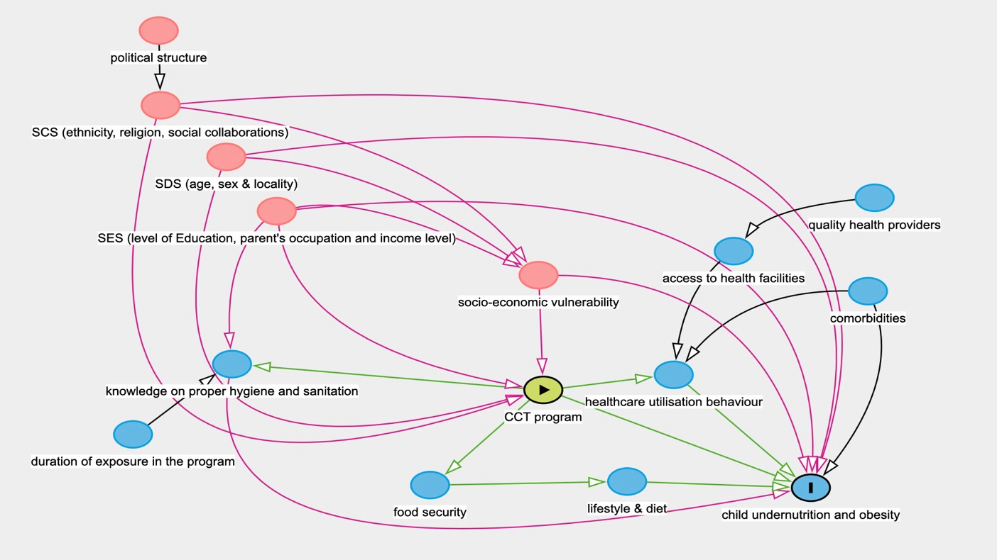

Appendix 2. Results from the quantitative analyses
Table S1. Nutritional status of school children and year of measurement by age group
 | Children aged 3 to 5 years | Children aged 6 to 10 years | Children aged 11 to 19 years
All children | (N= 306) | (N=3277) | (N=1524)
Age, years | 4.60 (0.46)ª | 8.14 (1.72)ª | 13.4 (1.92)ª
Nutritional status §
Stunting | 0 | 209 (6.4%) | 404 (26.5%)
Wasting | 61 (19.9%) | 310 (9.5%) | 107 (7.0%)
Overweight or obesity | 19 (6.2%) | 604 (18.4%) | 216 (14.2%)
Concurrent stunting & wasting,  Overweigh or obesity | 0 | 52 (1.6%) | 89 (5.8%)
Weight, kg | 17.0 (3.50) ª | 26.4 (8.65) ª | 41.0 (9.21) ª
Height, m | 1.09 (0.07) ª | 1.27 (0.12) ª | 1.47 (0.09) ª
BMI, kg/m² | 14.2 (2.02) ª | 16.0 (3.00) ª | 18.7 (3.00) ª
Weight-for-age z* (WAZ) | -0.299 (1.42) ª | -0.196 (1.51) ª | NA
Height-for-age z* (HAZ) | 0.517 (1.64) ª | -0.085 (1.37) ª | -1.25 (1.71) ª
BMI-for-age z* (BAZ) | -0.946 (1.50) ª | -0.251 (1.52) ª | -0.235 (1.25) ª
Year of measurement
2016 | .. | 2 | 67
2017 | 32 | 114 | 203
2018 | 49 | 335 | 394
2019 | 160 | 2605 | 583
2020 | 62 | 161 | 8
2021 | .. | 14 | 256
ª Data are mean (SD). BMI= Body Mass Index. z= Z scores. *Standardize Weight-for-age, Height-for-age, and BMI-for-age scores calculated according to WHO Child Growth Standard for aged 5 to 19 years of age and 5 below. § Proportions of children with malnutrition were calculated by dividing the total number of cases (with stunting, wasting, overweight/obesity, or DBM) by the total number of 4Ps or non-4Ps children x 100

The standard deviation for school’s random intercept indicated that the odds of stunting among children in school varied around the average intercept (-6.082) by about 0.389 unit for model 1 and about 0.256 unit for model 2 (Table 4).
Table S2. Mixed effects logistic for stunting among children aged between 3 and 19 in Caraga Region.
 | Model 1_{s} |  |  |  | Model 2_{s}
Parameter | Est. | SE | p | OR (CI) | Est. | SE | p | AOR (CI)
Fixed effects:
Intercept | -6.082 | 0.427 | <0.001* | 0.0001 | -5.976 | 0.490 | <0.001* | 0.0002
Inclusion to 4Ps
Non-4Ps |  |  |  | reference |  |  |  | reference
4Ps | 0.207 | 0.103 | 0.044* | 0.81 (0.66-0.96) | 0.360 | 0.145 | 0.0133* | 0.70 (0.52, 0.93)
Sex (Female) | -0.226 | 0.093 | 0.015* | 0.80 (0.66-0.96) | -0.221 | 0.093 | 0.018* | 0.80 (0.67-0.96)
Age | 0.390 | 0.024 | <0.001* | 1.48(1.41-1.55) | 0.397 | 0.025 | <0.001* | 1.49 (1.41-1.56)
Ethnicity
Major tribes |  |  |  |  | 0.491 | 0.212 | 0.020* | 1.63 (1.08-2.47)
Minor tribes |  |  |  |  | -0.332 | 0.179 | 0.063 | 0.72 (0.50-1.01)
Non-indigenous |  |  |  |  |  |  |  | reference
Province
Agusan del Norte |  |  |  |  |  |  |  | reference
Agusan del Sur |  |  |  |  | 0.306 | 0.480 | 0.523 | 1.36 (0.53-3.48)
Surigao del Norte |  |  |  |  | 0.445 | 0.554 | 0.421 | 1.56 (0.53-4.62)
Surigao del Sur |  |  |  |  | -0.206 | 0.450 | 0.647 | 0.81 (0.34-1.96)
Interaction~ 4Ps*Province
4Ps: Agusan del Norte |  |  |  |  |  |  |  | reference
4Ps: Agusan del Sur |  |  |  |  | -0.898 | 0.285 | 0.001* | 2.45 (1.40-4.30)
4Ps: Surigao del Norte |  |  |  |  | 0.006 | 0.371 | 0.986 | 0.99 (0.48-2.06)
4Ps: Surigao del Sur |  |  |  |  | 0.001 | 0.267 | 0.995 | 0.99 (0.59-1.69)
Random effects:
Groups  .. |  | Var | Std. dev | N group | Var | Std. dev | N group | pª Model 2
Year measured (intercept)  (Intercept) |  | 0.389 | 0.624 | 6 | 0.256 | 0.534 | 6
School (intercept)  (Intercept) |  | 0.239 | 0.489 | 10 | 0.252 | 0.502 | 10
AIC |  | 3184 |  |  | 3182 |  |  | 0.021*
p= p-value, ª ANOVA, Est= estimate, SE= standard error, OR= odds ratio, CI= confidence interval, Var= Variance, Std. dev= standard deviation

The standard deviation for school’s random intercept indicated that the odds of DBM among children in school varied around the average intercept (-6.077) by about 0.619 unit for model 1 (Table 5). In model 2_{D,} increasing age of the child contributes positively to the odds of DBM by 1.28 times. This means, for every unit increase in the age of the child, the likelihood of DBM also increased by 28%.

Table S3. Mixed effects logistic for DBM in children and adolescents
 | Model 1_{D} |  |  |  | Model 2_{D}
Parameter | Est. | SE | p | OR (CI) | Est. | SE | p | AOR (CI)
Fixed effects:
Intercept | -6.077 | 0.585 | <0.001* | <0.01 | -5.911 | 0.501 | <0.001* | 0.0 (0.0,0.1)
Inclusion to CCT
Non-4Ps |  |  |  | reference |  |  |  | reference
4Ps | 0.058 | 0.197 | 0.770 | 0.94 (0.64, 1.39) | -0.055 | 0.195 | 0.777 | 1.05 (0.72,1.55)
Sex (Female) | -0.128 | 0.175 | 0.466 | 0.88 (0.62, 1.24) | -0.132 | 0.176 | 0.451 | 0.87 (0.62,1.24)
Age | 0.255 | 0.040 | <0.001* | 1.29 (1.19, 1.39) | 0.251 | 0.038 | <0.001* | 1.28 (1.19, 1.39)
Ethnic group
Major tribes |  |  |  |  | 0.382 | 0.327 | 0.243 | 1.46 (0.77, 2.78)
Minor tribes |  |  |  |  | 0.473 | 0.255 | 0.064 | 1.60 (0.97, 2.64)
Non-indigenous |  |  |  |  |  |  |  | reference
Province
Agusan del Norte |  |  |  |  |  |  |  | reference
Agusan del Sur |  |  |  |  | -0.646 | 0.369 | 0.080 | 0.52 (0.25,1.08)
Surigao del Norte |  |  |  |  | 1.117 | 0.259 | <0.001* | 3.05 (1.84, 5.08)
Surigao del Sur |  |  |  |  | -0.990 | 0.398 | 0.013* | 0.37(0.17, 0.81)
Random effects:
Groups |  | Var | Std. dev | N group | Var | Std. dev | N group | pª Model 2
School (intercept) |  | 0.619 | 0.787 | 10 | 0 | 0 | 10
AIC |  | 1183 |  |  | 1172 |  |  | <0.001*
p= p-value, ª ANOVA, Est= estimate, SE= standard error, OR= odds ratio, CI= confidence interval, Var= Variance, Std. dev= standard deviation

