Additional file 5 - figures
Subgroup analyses
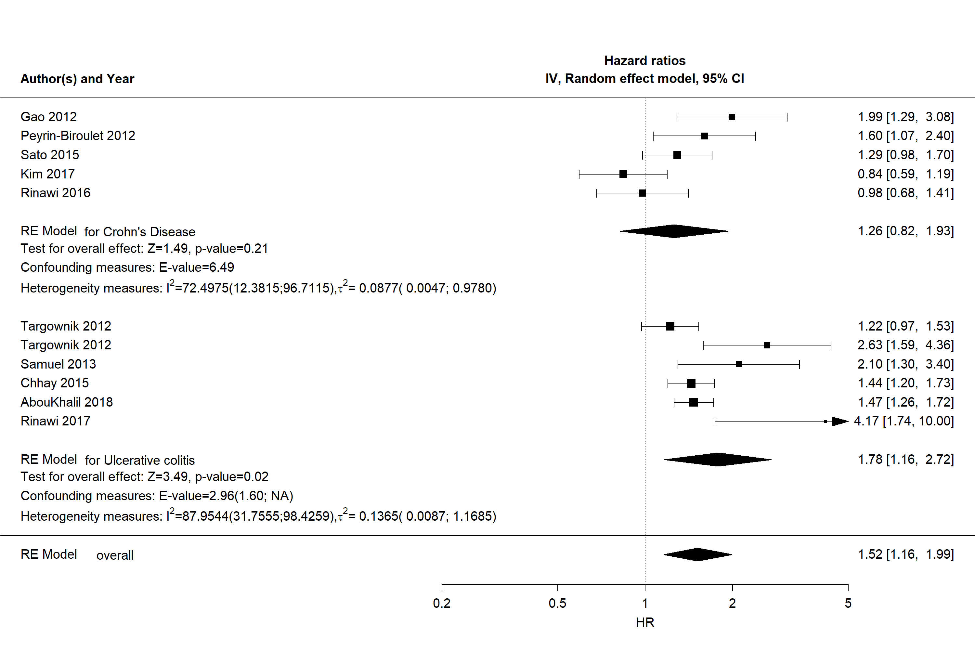
Figure A1. Forest plot of subgroup (CD/UC) meta-analysis of HRs for risk of surgery
Forest plot of RE model subgroup meta-analysis of HRs for risk of surgery in men compared to women with IBD by IBD subtype. Reference: women. Abbreviations: HR, hazard ratio; IBD, inflammatory bowel disease; NA, not applicable; RE, random effects

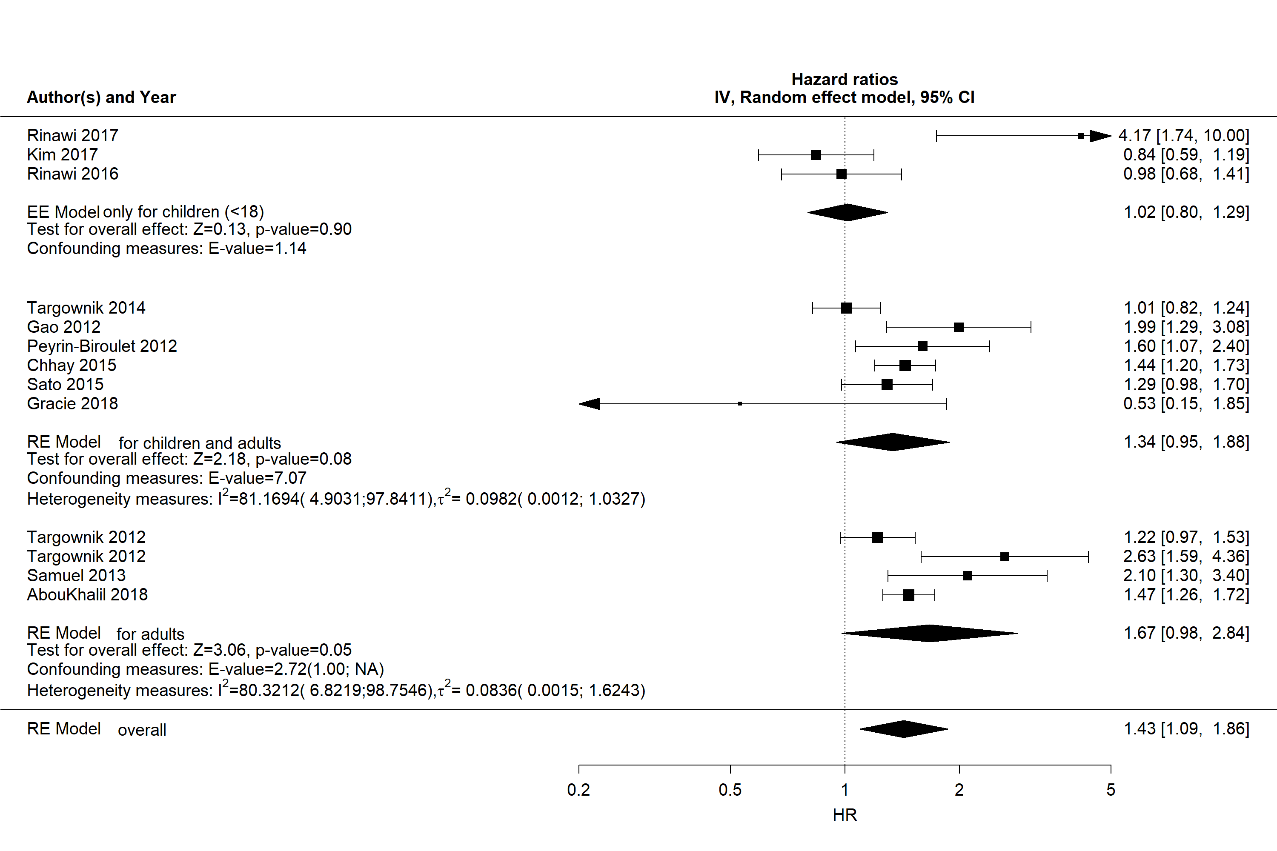
Figure A2. Forest plot of subgroup (children/adults) meta-analysis of HRs for risk of surgery
Forest plot of RE model subgroup meta-analysis of HRs for risk of surgery in men compared with women with IBD by children and adults subgroups. Reference: women. Abbreviations: HR, hazard ratio; IBD, inflammatory bowel disease; NA, not applicable; RE, random effects

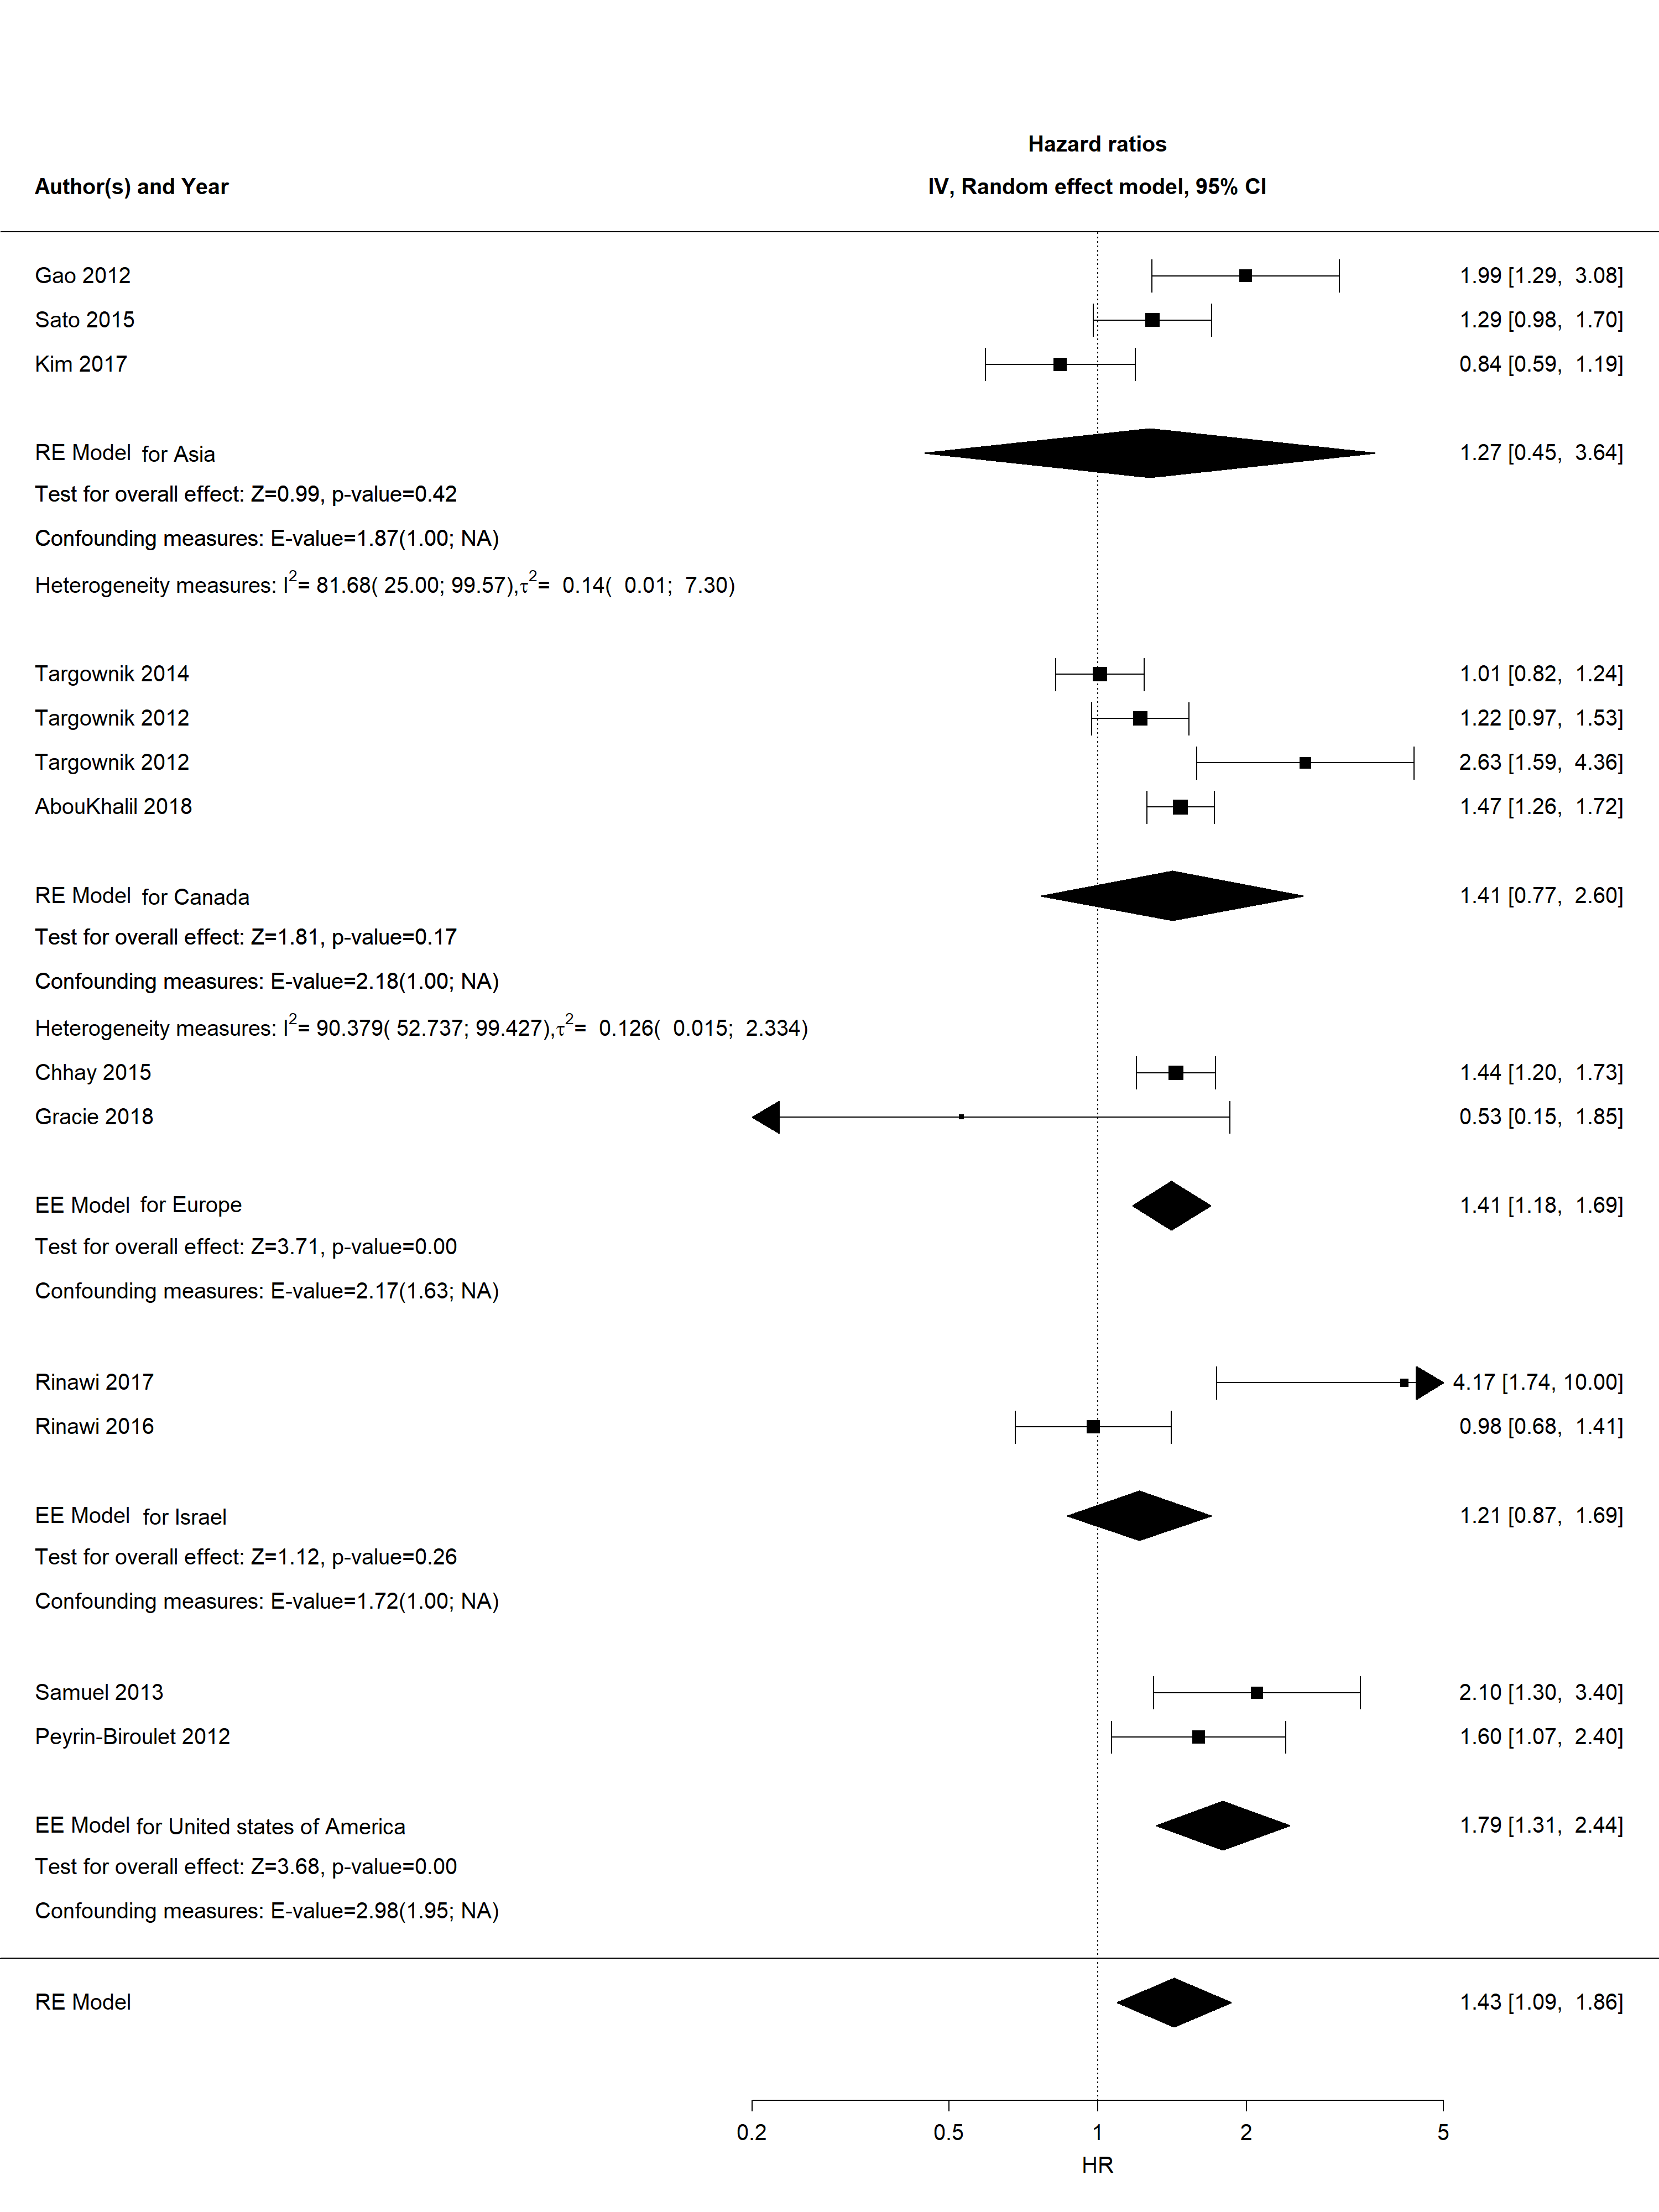
Figure A3. Forest plot of subgroup (country) meta-analysis of HRs for risk of surgery
Forest plot of RE model subgroup meta-analysis of HRs for risk of surgery in men compared with women with IBD by country. Reference: women. Abbreviations: HR, hazard ratio; IBD, inflammatory bowel disease; NA, not applicable; RE, random effects

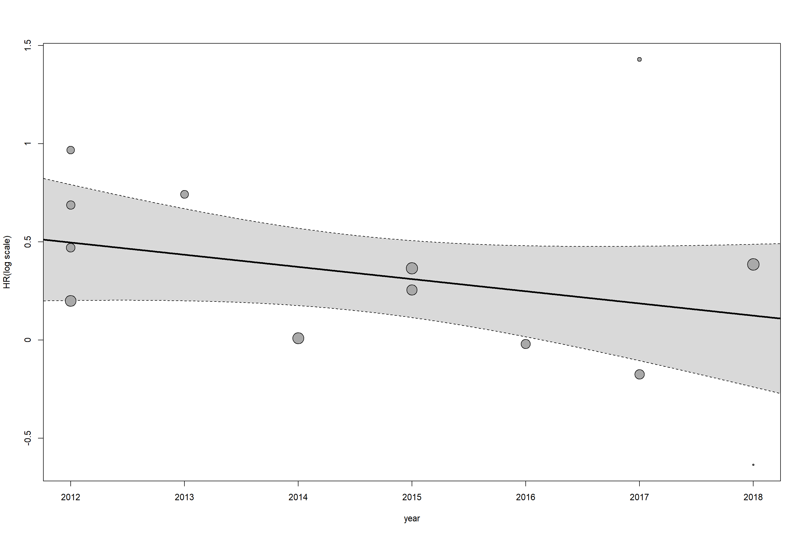
Figure A4. Meta-regression of log HRs for risk of surgery by study publication year
Meta-regression of log HRs for risk of surgery in men compared with women with IBD by study publication year. Reference: women. Abbreviations: HR, hazard ratio; IBD, inflammatory bowel disease

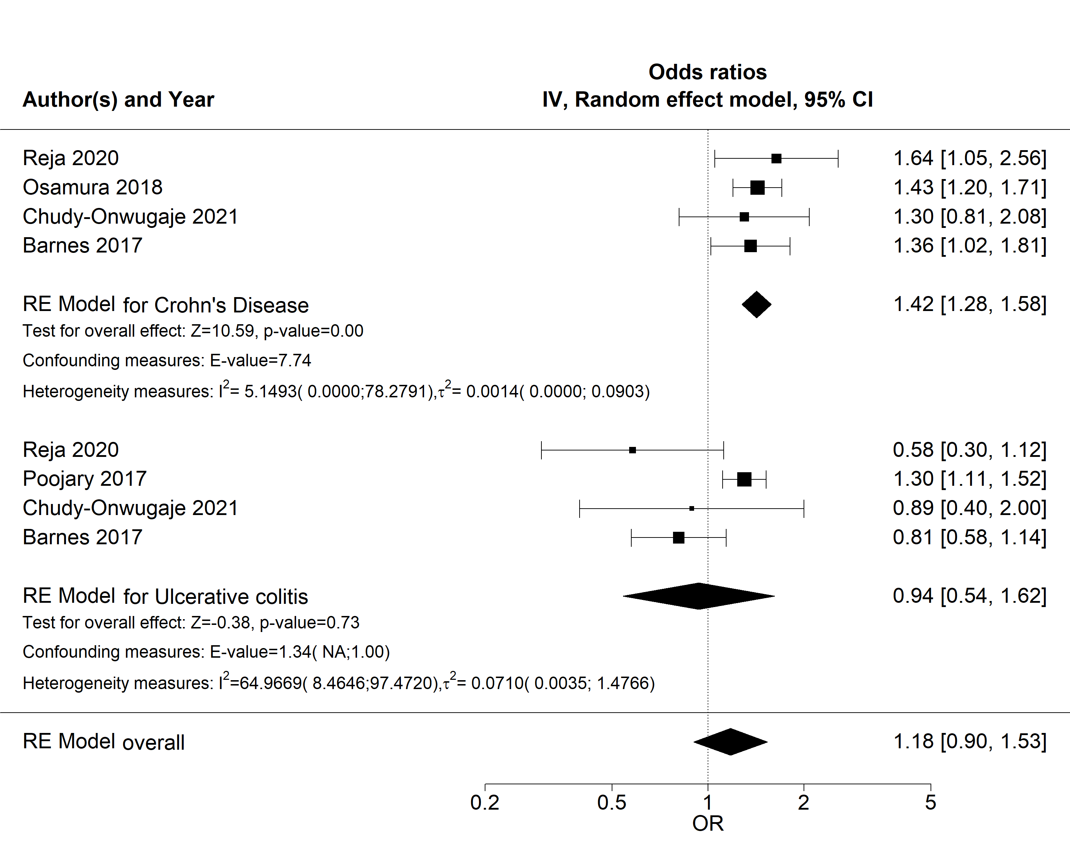
Figure A5. Forest plot of subgroup (CD/UC) meta-analysis of ORs for risk of hospitalization
Forest plot of RE model subgroup meta-analysis of ORs for risk of hospitalization in men compared to women with IBD by IBD subtype. Reference: women. Abbreviations: OR, odds ratio; IBD, inflammatory bowel disease; NA, not applicable; RE, random effects

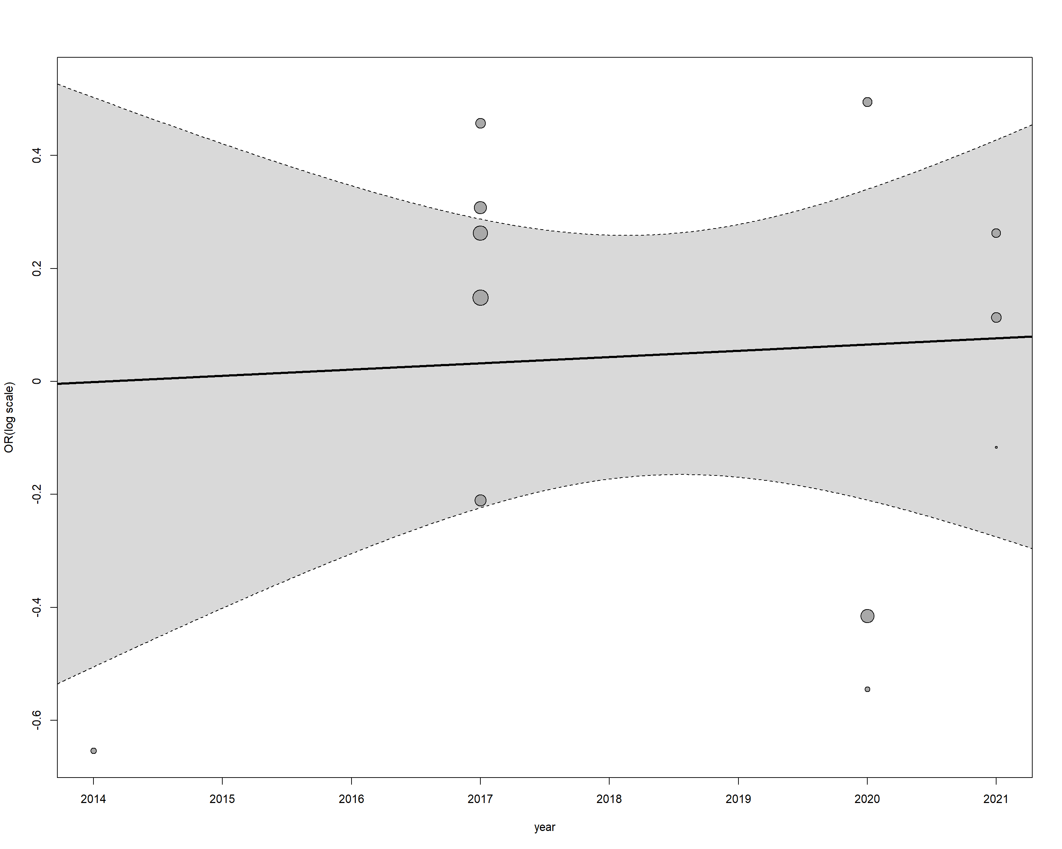
Figure A6. Meta-regression of log ORs for risk of hospitalization by study publication year
Meta-regression of log ORs for risk of hospitalization in men compared with women with IBD by study publication year. Reference: women. Abbreviations: OR, odds ratio; IBD, inflammatory bowel disease

Sensitivity analyses and publication bias
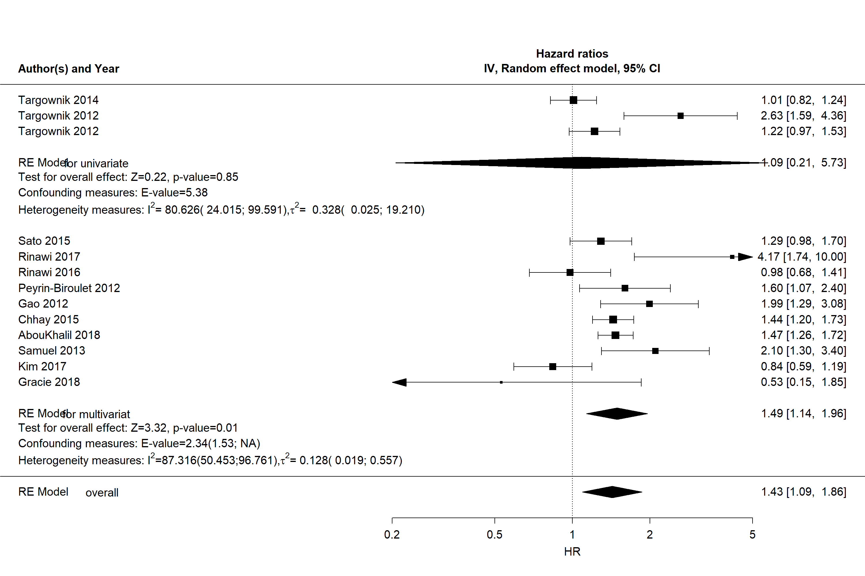
Figure A7. Forest plot of subgroup (univariate/multivariate) meta-analysis of HRs for risk of surgery
Forest plot of RE model subgroup meta-analysis of HRs for risk of surgery in men compared with women with IBD by univariate/multivariate subgroups. Reference: women. Abbreviations: HR, hazard ratio; IBD, inflammatory bowel disease; NA, not applicable; RE, random effects

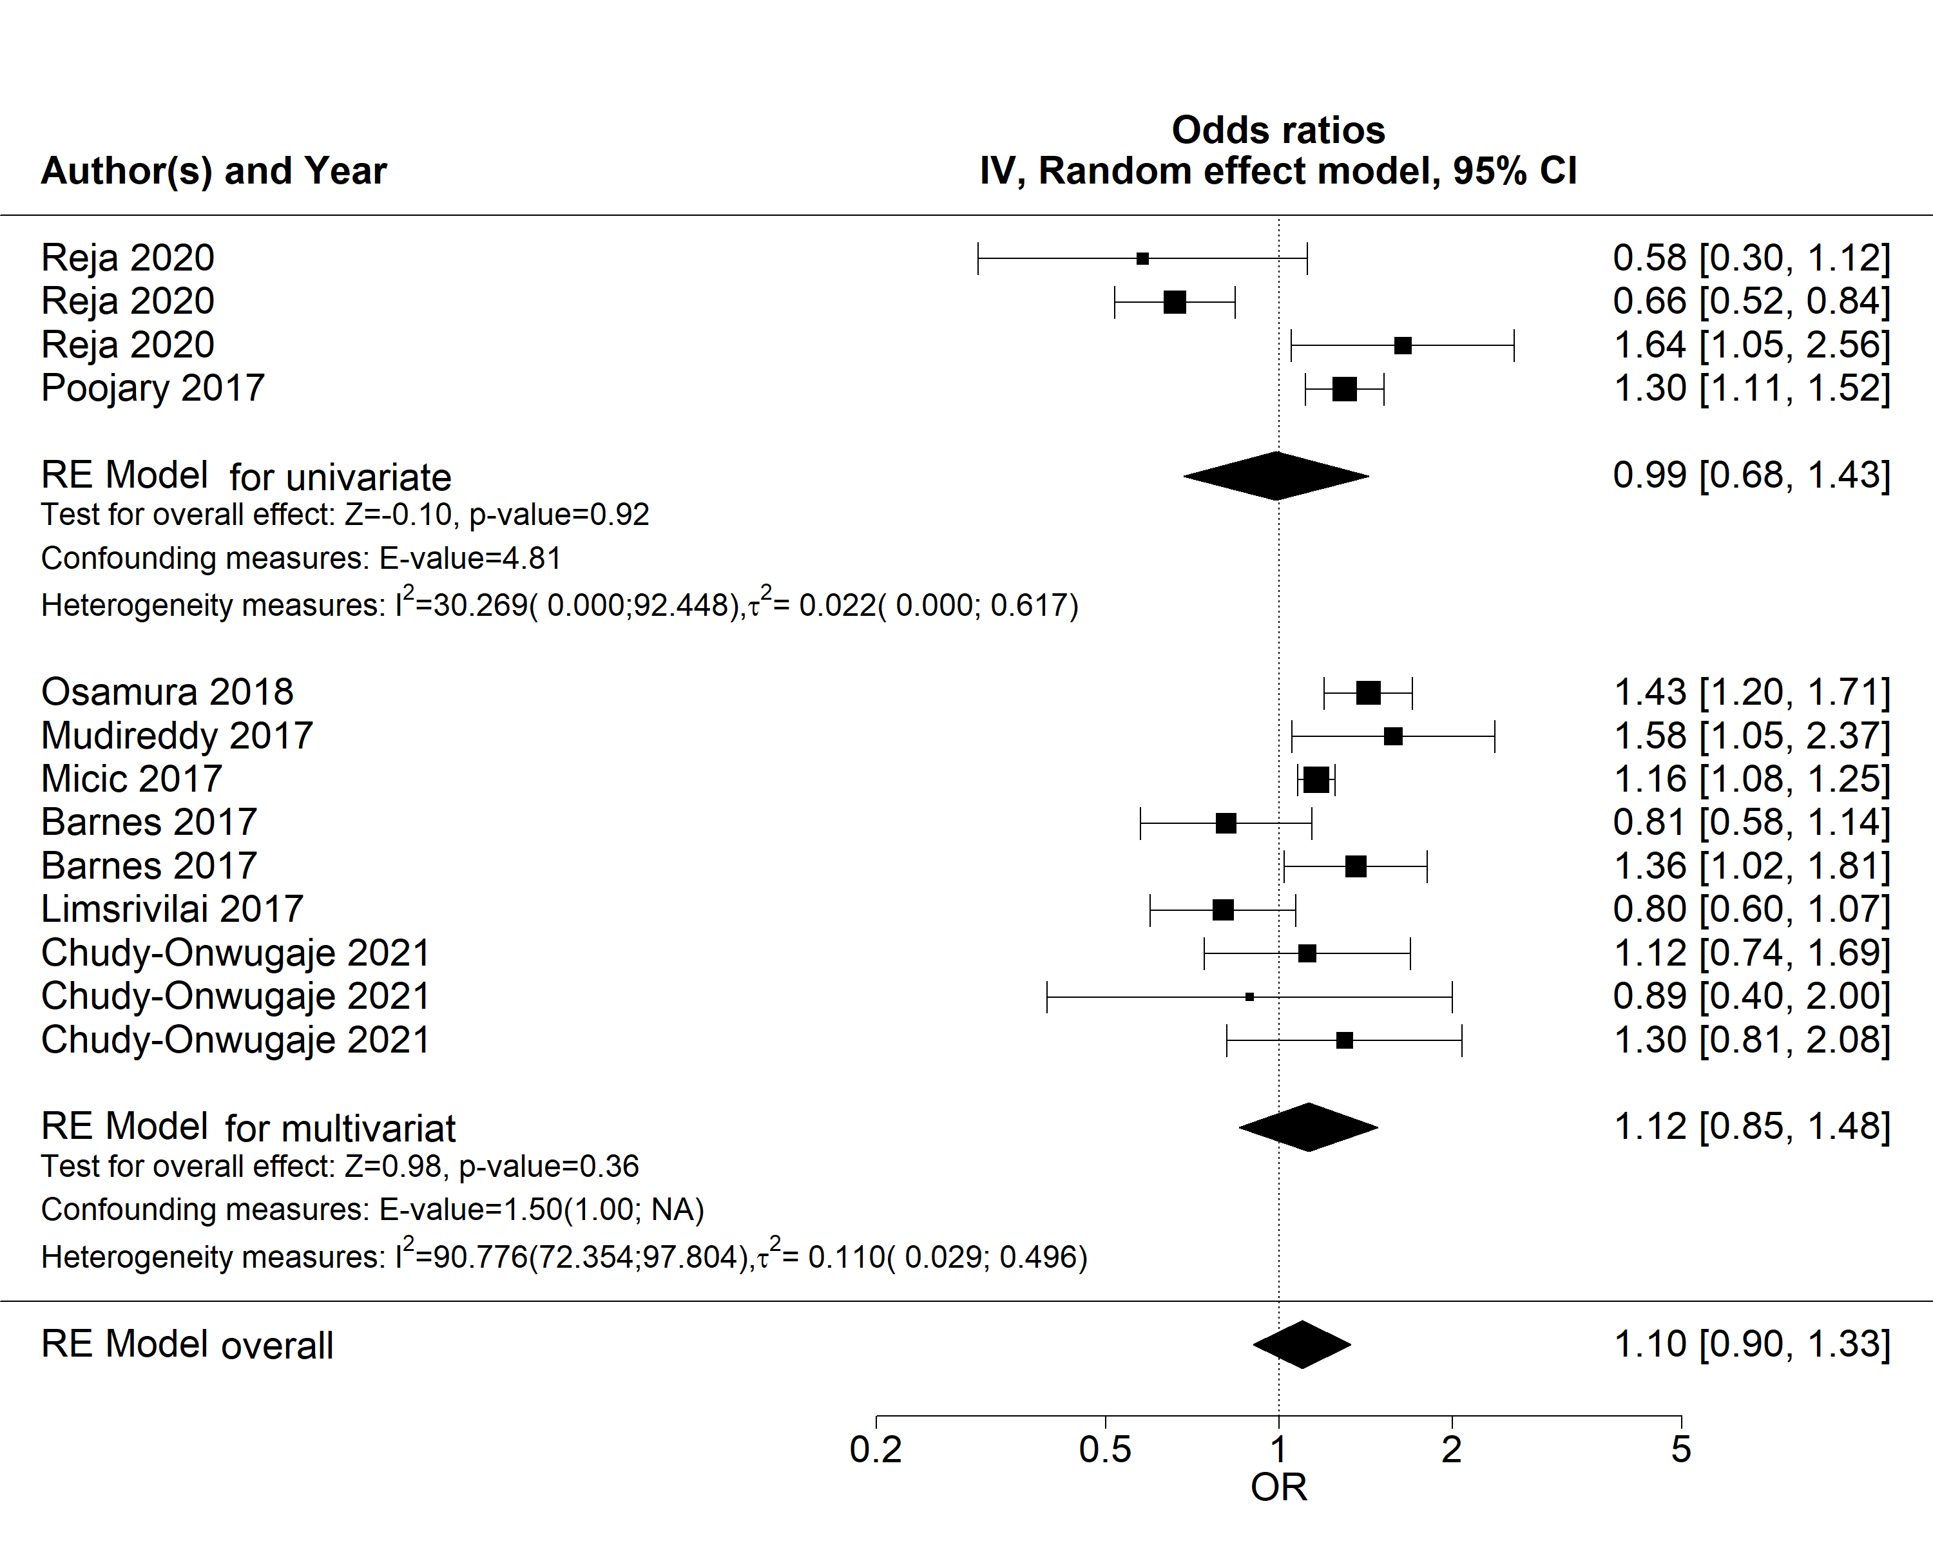
Figure A8. Forest plot of subgroup (univariate/multivariate) meta-analysis of ORs for risk of hospitalization
Forest plot of RE model subgroup meta-analysis of ORs for risk of hospitalization in men compared with women with IBD by univariate/multivariate subgroups. Reference: women. Abbreviations: OR, odds ratio; IBD, inflammatory bowel disease; NA, not applicable; RE, random effects

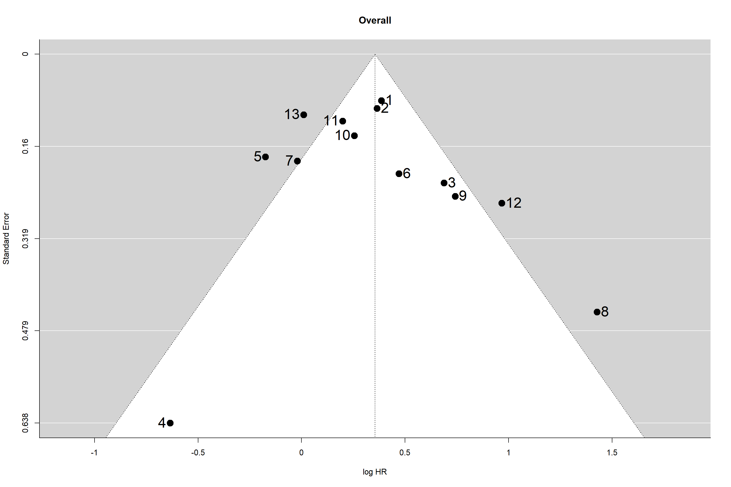
Figure A9. Funnel plot of the meta analysis of published studies on surgery
Each plotted point represents the standard error and log(HR) for male patients compared to female patients for a single study. The white triangle represents the region where 95% of the data points would lie in the absence of publication bias. The vertical line represents the average log(HR) estimate found in the meta-analysis. Abbreviations: HR, hazard ratio

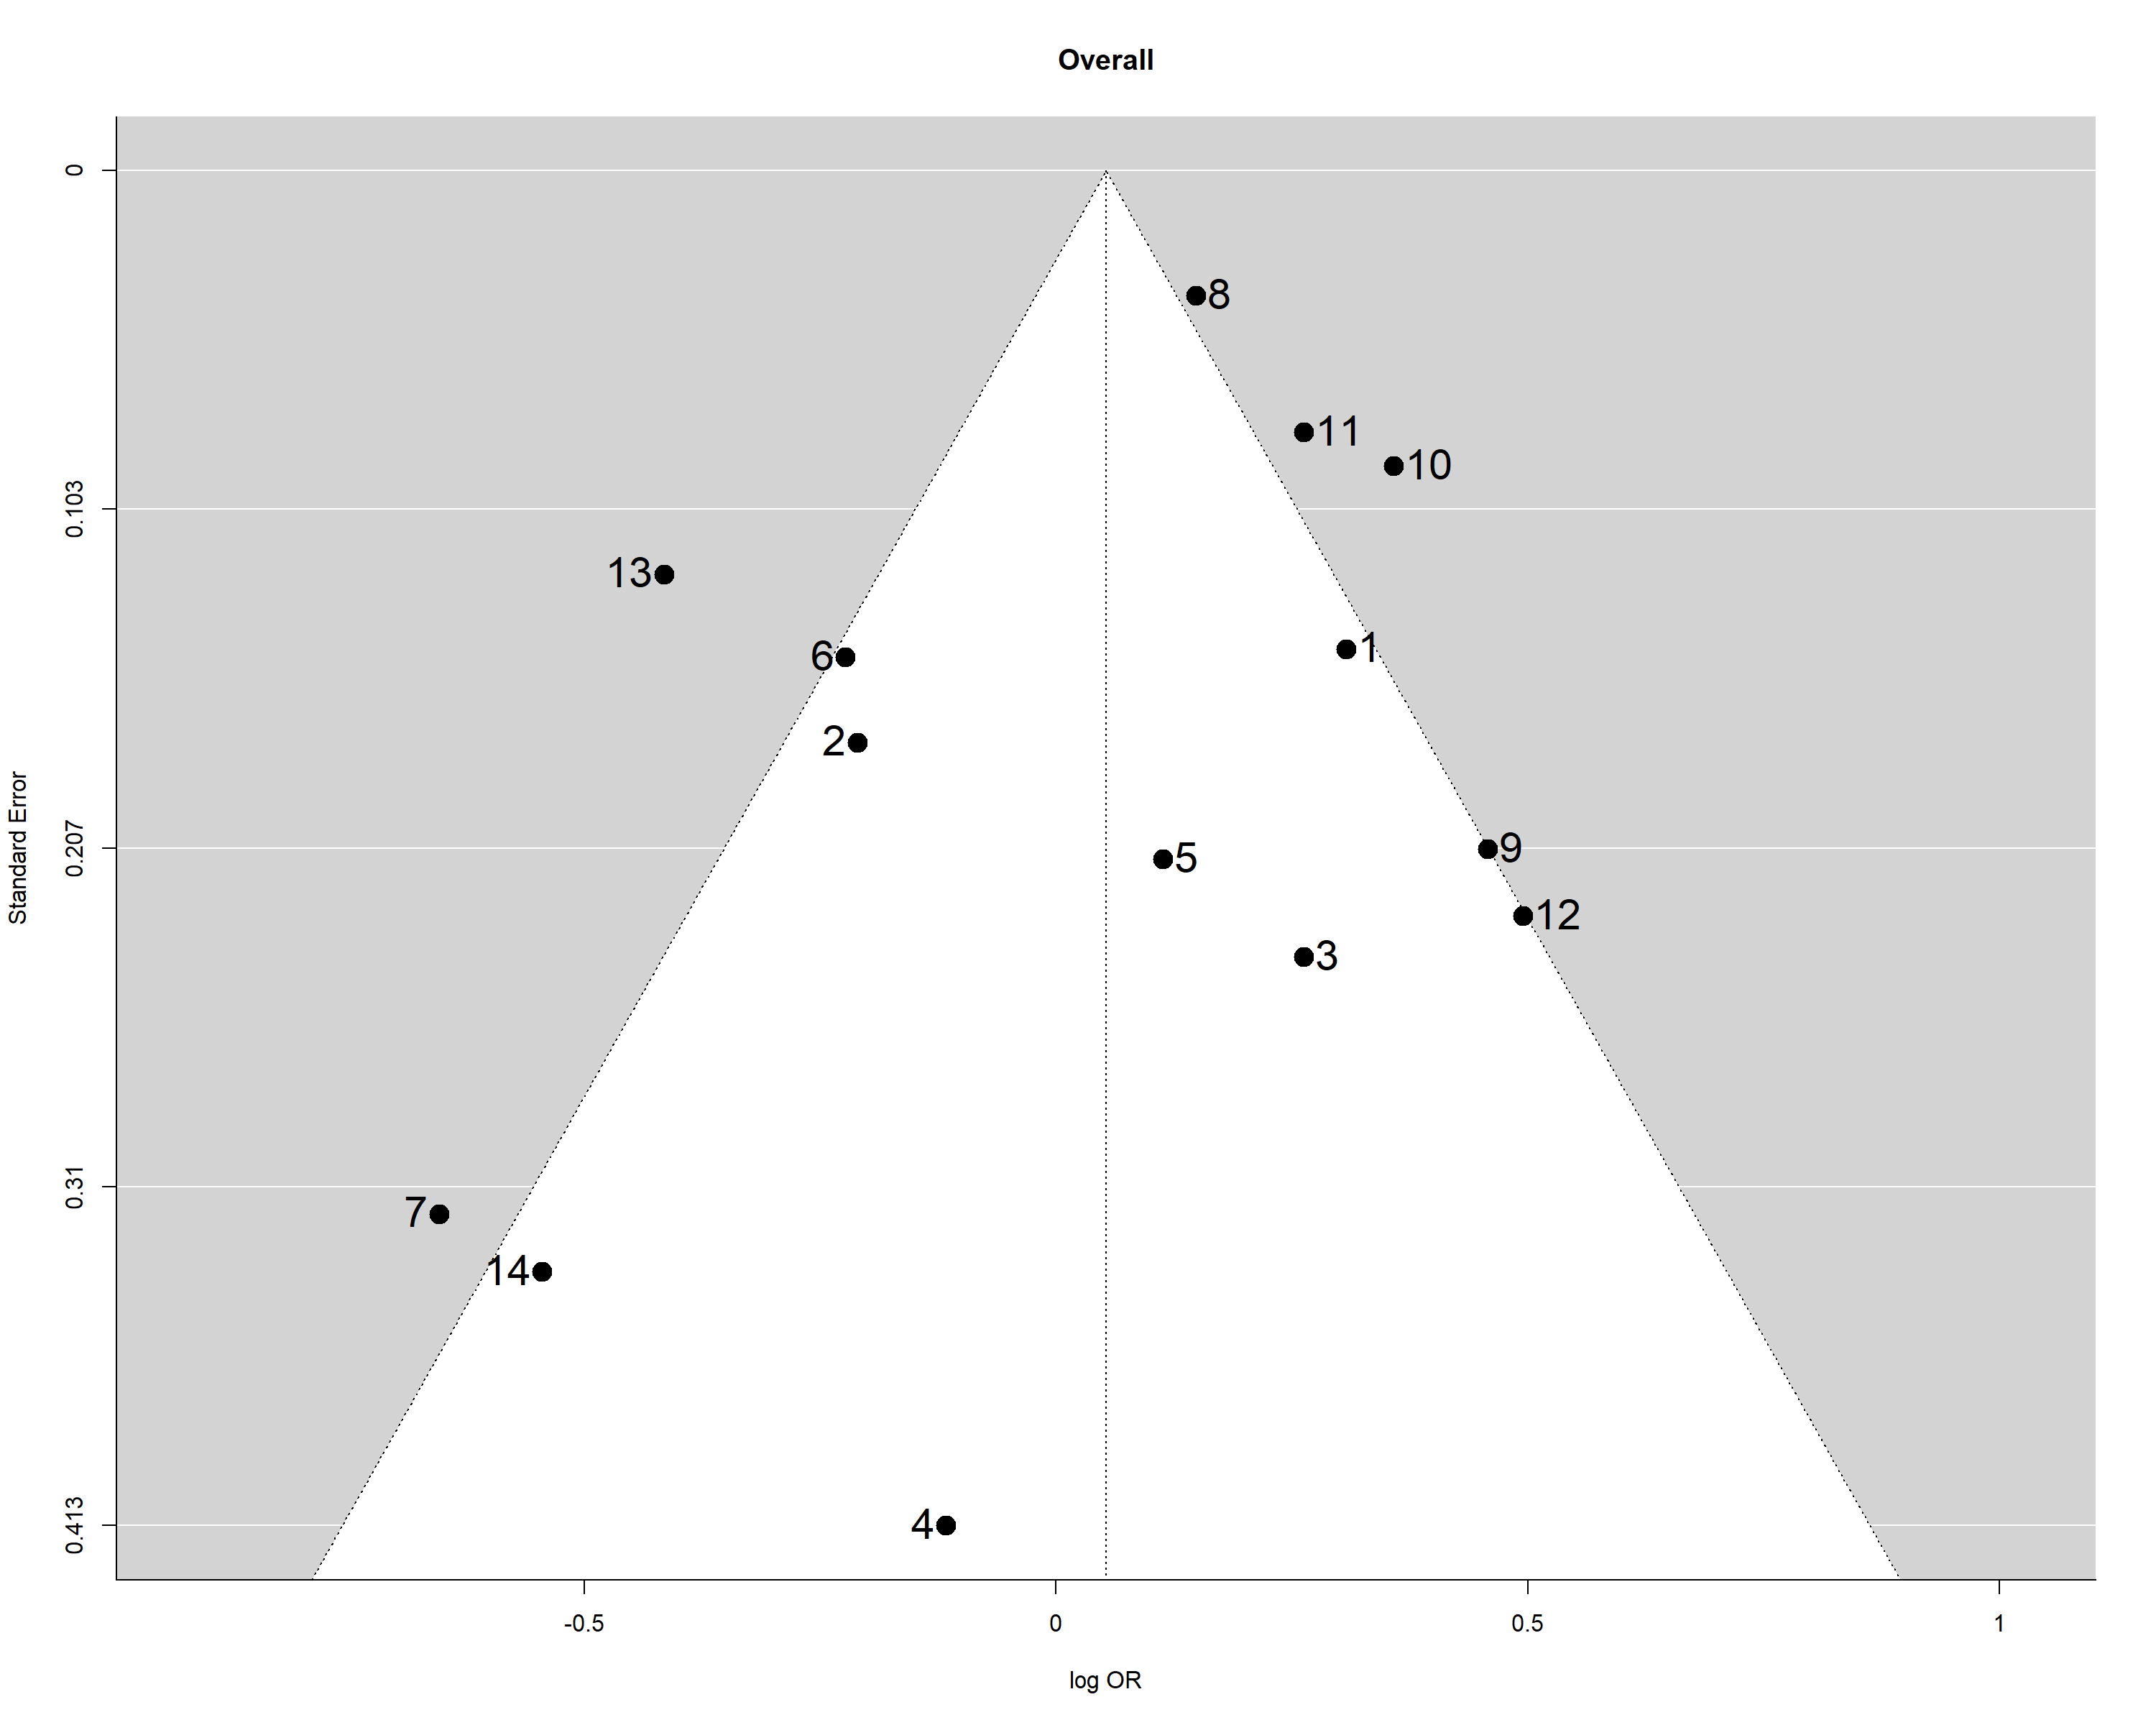
Figure A10. Funnel plot of the meta analysis of published studies on hospitalization.
Each plotted point represents the standard error and log(OR) for male patients compared to female patients for a single study. The white triangle represents the region where 95% of the data points would lie in the absence of publication bias. The vertical line represents the average log(OR) estimate found in the meta-analysis. Abbreviations: OR, odds ratio

