A new formula for estimating insertion length of umbilical catheters in neonates: an observational study
Jenny Webb, Sian Elliott, W. John Watkins, Laura Stuttaford, Sujoy Banerjee, Babatunde Kayode-Adedeji, Gautam Bagga, Mallinath Chakraborty
Supplementary Information

Regression plots for UACs
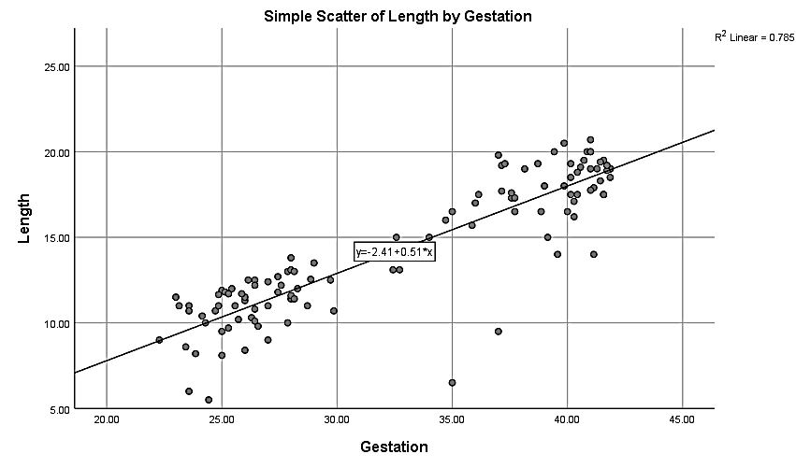
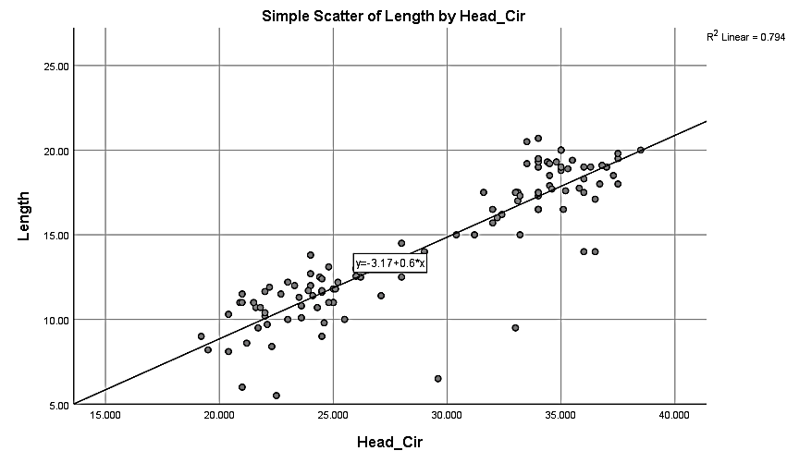
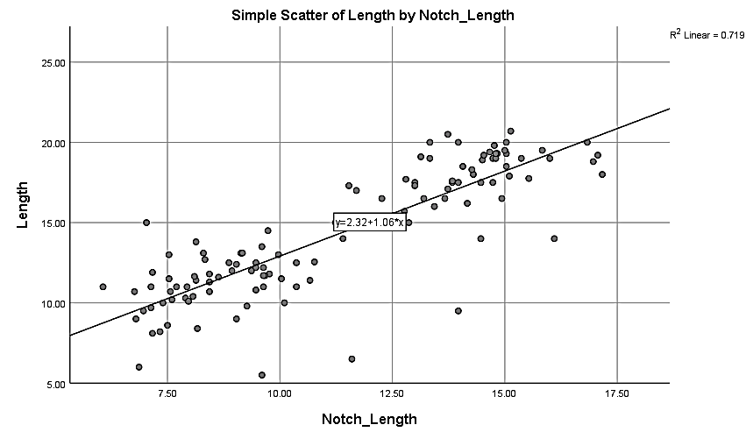
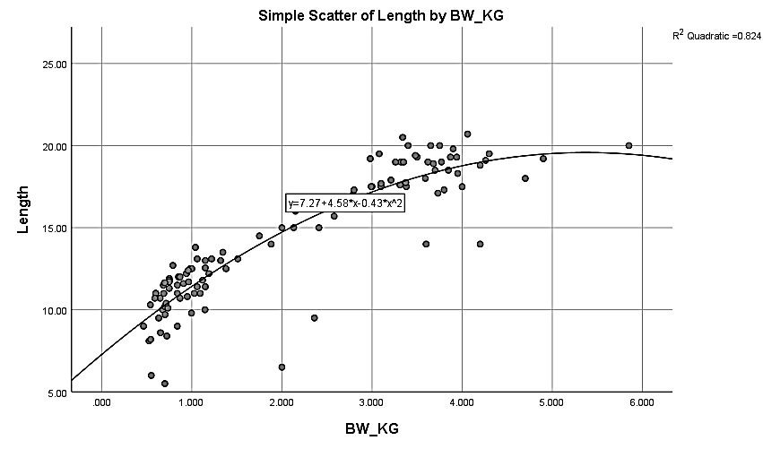

Regression plots for UVCs
