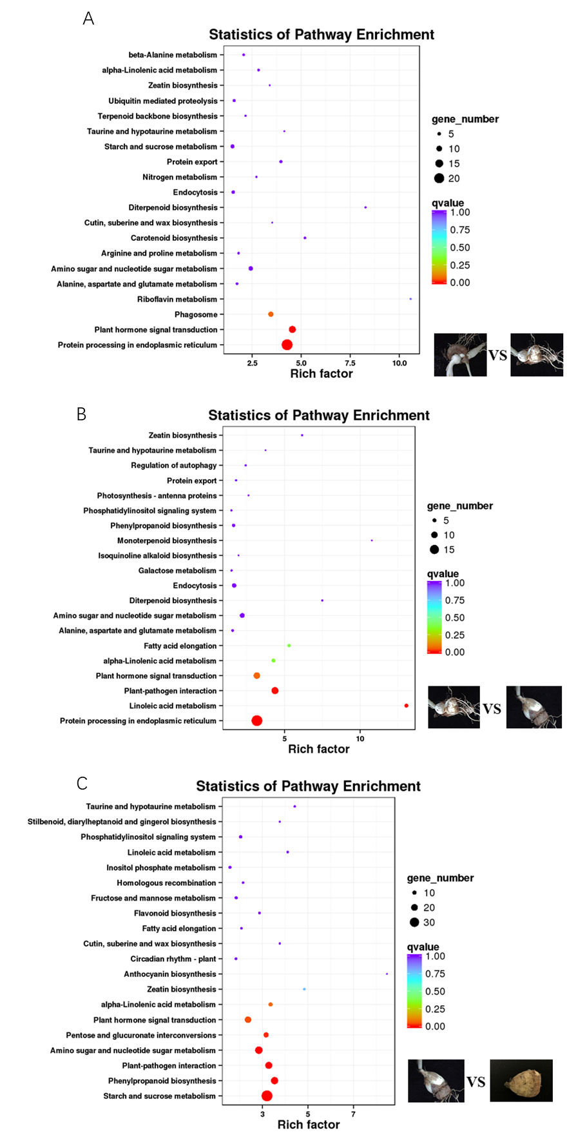
Fig.S3 KEGG pathway enrichment analysis of differentially expressed genes (DEGs). A: 60 d vs. 90 d; B: 90 d vs. 120 d; C: 120 d vs. 190 d; Rich factor: the ratio of the number of DEGs to all unigenes enriched in each pathway

