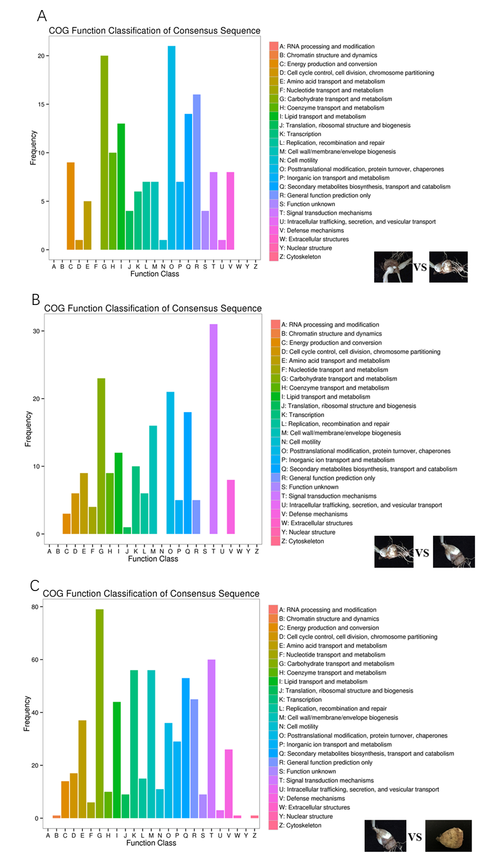
Fig. S2 COG function classification of differentially expressed genes. A: 60 d vs. 90 d; B: 90 d vs. 120 d; C: 120 d vs. 190 d

