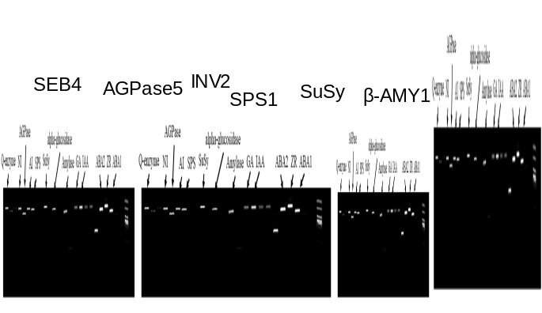
Fig. S4 Real-time PCR analysis of the six selected genes of key enzymes involved in starch and sucrose metabolism. SEB: starch branching enzyme; AGPase: adenosine diphosphoglucose pyrophosphorylase; INV: invertase; SPS: sucrose phosphate synthase; SuSy: sucrose synthase; β-AMY: β-amylase

