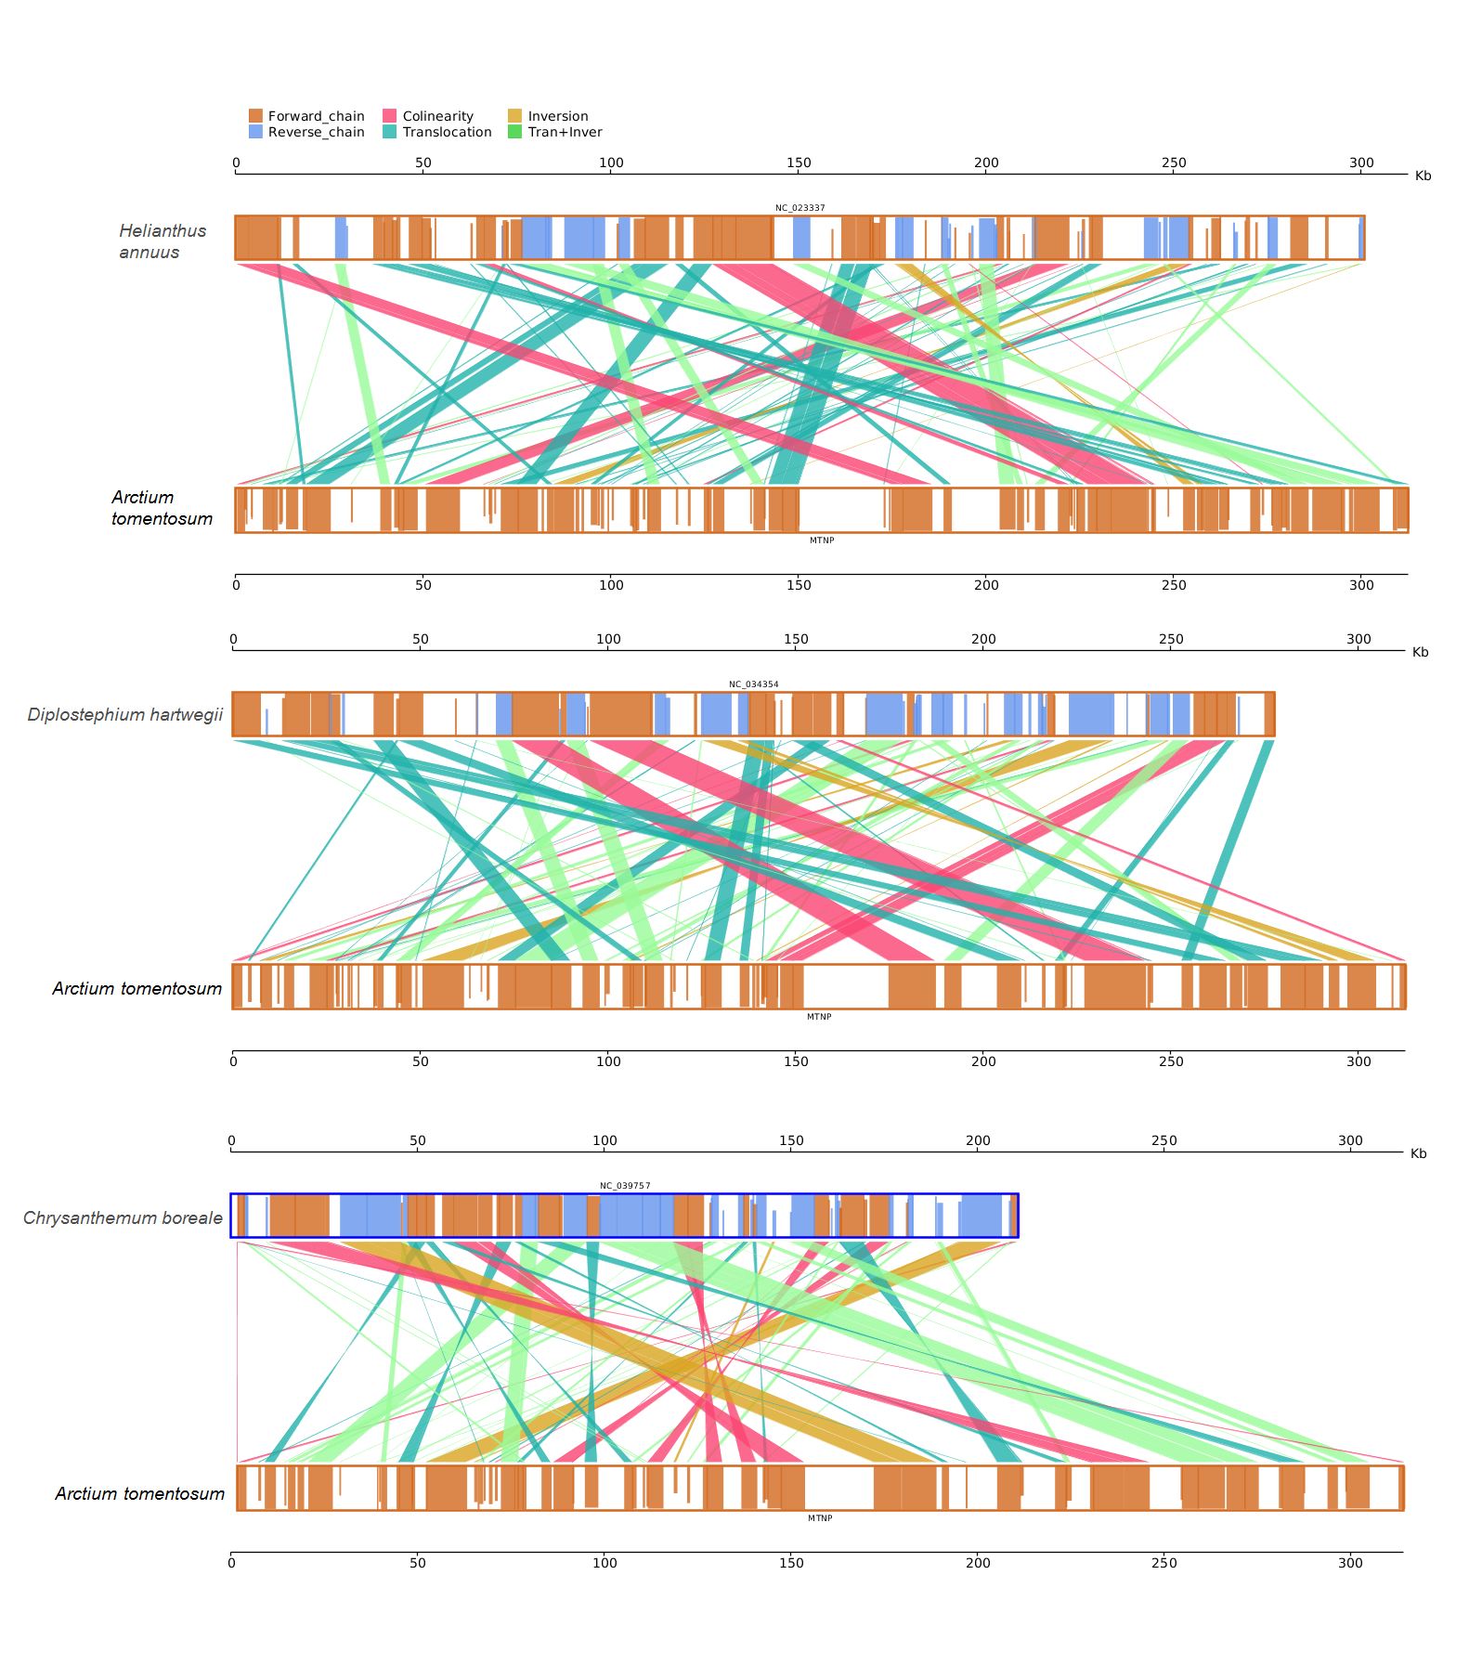Figure S2. Collinear relationship between mitochondrial genomes of A. tomentosum and other three Asteraceae plants, respectively.

