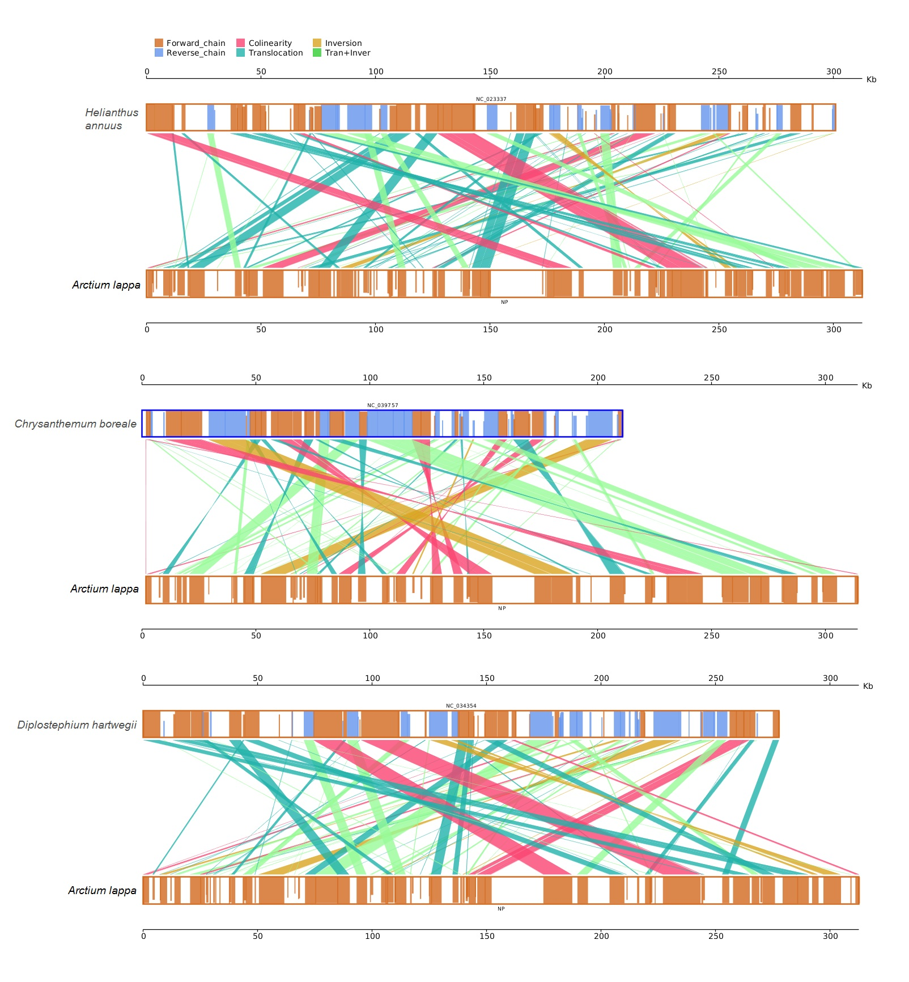Figure S1. Collinear relationship between mitochondrial genomes of A. lappa and other three Asteraceae plants, respectively.

