Supplementary Figures

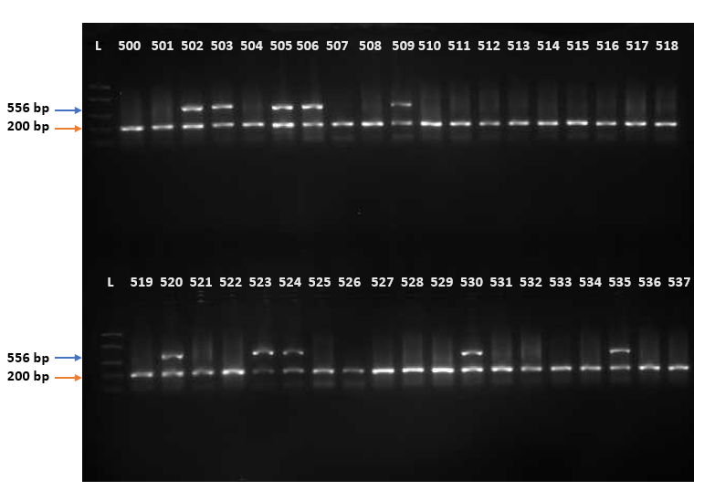
Supplementary fig 1: PCR amplicons. The ruler ladder (L) indicates the sizes of the amplicons. The transgene bands were 556 bp (blue arrow) and the internal positive control bands were 200 bp (blue arrow).

