Supplementary Materials for
A wearable stethoscope for accurate real-time lung sound monitoring and automatic wheezing detection based on an AI algorithm
Kyoung-Ryul Lee ^{1†}, Taewi Kim^{2†}, Sunghoon Im^{2†}, Yi Jae Lee¹, Seongeun Jeong¹, Hanho Shin¹, Minho Kim², Jin Goo Lee², Dohyeong Kim⁴, Gil-Soon Choi⁵, Daeshik Kang^{2*}, SungChul Seo^{3*} and Soo Hyun Lee^{1*}
¹ Center for Biomicrosystems, Brain Science Institute, Korea Institute of Science and Technology, Seoul 02792, Korea
² Department of Mechanical Engineering, Ajou University, Suwon 16499, Korea
³ Department of Nano, Chemical and Biological Engineering, Seokyeong University, Seoul 02713, Korea
⁴ School of Economic, Political and Policy Sciences, The University of Texas at Dallas, Richardson, TX 75080, USA
⁵ Department of Internal Medicine, Kosin University College of Medicine, Busan 49267, Korea
† These authors contributed equally to this work.
*Corresponding author. Tel.: +82-2-958-6755; fax: +82-2-958-6910,
E-mail address: shleekist@kist.re.kr

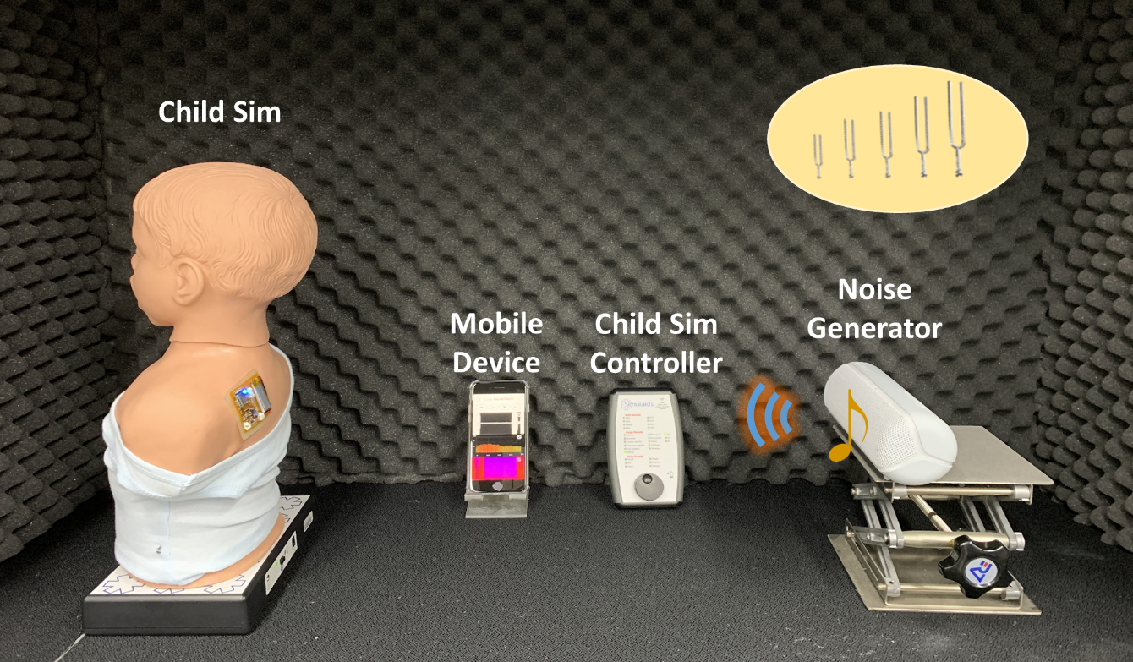
Figure S1 Photograph of experimental set-up

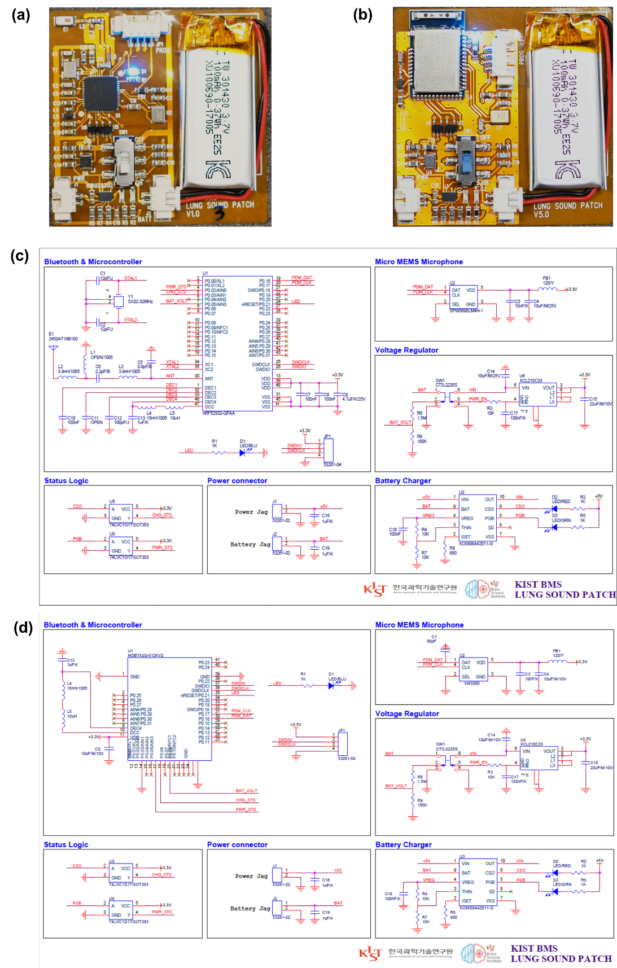
Figure S2 Schematic illustration of LSMP with different antenna type (a) photo of LSMP sensor with external antenna type (b) photo of LSMP sensor with embedded antenna type (c) circuit schematic of LSMP sensor with external antenna type (d) circuit schematic of sensor with embedded antenna type

SI Section 1: Performance assessment of LSMP
1.1 Auscultation performance assessment with a child heart and lung sound trainer simulator
For the assessment of auscultation characteristics, it is necessary to evaluate the acoustic characteristics of several breathing sounds. In practice, auscultation using a microphone sensor consists of a data stream from which physiological information could theoretically be extracted from the various biological acoustic signals. In fact, various symptoms can be classified through the analysis of recorded lung sounds using an electronic stethoscope (E-stethoscope), and various studies are underway ^{1, 2}.
One of the ways in which we sought to assess the suitability of our device was to record the auscultation waveforms corresponding to a variety of breathing conditions and compare them to the signals recorded from a reference device, the E-stethoscope (Littmann3200, 3M). To this end, we artificially generated them with the Child Sim, then measured and analyzed them with the E-stethoscope and LSMP, respectively. To compare the characteristics of the signals recorded by the LSMP with those of a conventional device, the same sounds were recorded from the Child Sim using an E-stethoscope on extend mode (20 to 2000 Hz) and extracted as a wave file through the Littmann heart and lung visualization software (Littmann StethAssist, 3M) for data analysis. Figure S3(a-c) shows the time-intensity plots from the E-stethoscope, and Figure S3(d-f) shows the corresponding FFT data. Comparing the time-intensity results from the E-stethoscope and LSMP, the data from the E-stethoscope are unclear due to the presence of noise. Because it is difficult to assess the frequency distribution of the bioacoustics signal from time-series analysis, we calculated the fast Fourier transform (FFT) of the waveforms of the normal breathing sound, wheezing sound, and crackles generated by the Child Sim with a Hanning window function and 50% overlap, and plotted the results in Figure S3(d-f), respectively. FFT analysis revealed that the E-stethoscope data contain unexpected noise from its extended mode. Figure S3(g-i) shows the recorded signals from the LSMP corresponding to a normal breathing sound, a wheezing sound, and crackles generated by the Child Sim, respectively, as a time-intensity plot covering two breathing cycles. According to the time-intensity plot (Figure S3(g)), the inhalation and exhalation intensities during normal breathing appear to inhale is slightly smaller than exhale. During wheezing, the intensity and duration of inhalation are decreased compared to normal breathing, while the intensity of the exhalation is increased remarkably (Figure S3(h)); specifically, there is an approximately 4 to 5 times difference in the intensity between inhalation and exhalation. Wheezing mainly occurs in the bronchi due to airflow restriction from airway limitation caused by asthma and COPD. For this reason, the characteristic waveform of a wheeze appears mainly in exhalation rather than inhalation ³.
Crackles exhibit the opposite acoustic characteristics of the wheezing sound; that is, the inhalation occurs over a shorter duration and is of greater intensity than the exhalation. Crackles can be divided into fine and coarse signals and are caused by COPD, pulmonary fibrosis, and pneumonia. They are a discontinuous sound produced by the temporary opening of the airway that has been blocked by sputum or inflammation and is characterized mainly by inhalation. In the case of breathing with crackle sounds, which are bubble-like cavities filled with fluid, the intensity and duration of the inhale are noticeably larger than those of normal breathing, and the intensity of the exhale decreases (Figure S3(i)).
Figure S3(j-l) shows the fast Fourier transform (FFT) of the waveforms of the normal breathing sound Figure S3(j), wheezing sound Figure S3(k), and crackles Figure S3(l) generated by the Child Sim, respectively, over two breathing cycles. In the case of normal breathing, as shown in Figure S3(j), there is no characteristic region in the frequency domain for either inhalation or exhalation. Alternatively, in the case of wheezing, as shown in Figure S3(k), a spectral response appears for the exhalation, a high-intensity, sharp peak at approximately 280 Hz ⁴. This is a typical characteristic of monophonic wheezing, a typical symptom of asthma patients as a result of airway obstruction due to small airway deformity, and thus was expected from our analysis.
On auscultation, crackles may sound like bubbling, rattling, or clicking. Unlike wheezing, this is a nonmusical (discontinuous, short, explosive) sound that is audible when there is liquid in the air sacs of the lungs. Crackles occur within a very short duration (approximately 5 ms to 15 ms) due to the mechanism of sound production, which is caused by the explosive opening of small airways. Fine crackles show weak feature points at 650 Hz and coarse crackles at 350 Hz. Given these characteristics, the crackles sound shown in Figure S3(l) produced by the Child Sim and recorded by the LSMP can be classified as coarse crackles ⁵. Figure S4 shows the characterization of additional adventitious sounds, including pleural rub, stridor, and pneumonia, generated by the Child Sim according to the LSMP and E-stethoscope. These examples demonstrate that the developed LSMP device is capable of extracting cleaner (less noisy) signals than the E-stethoscope for a variety of different auscultation sounds produced under different clinical conditions. We confirmed that normal breathing and different adventitious breathing sounds can be classified by evaluating the auscultation performance of the LSMP and an E-stethoscope using a child heart and lung sound trainer simulator.
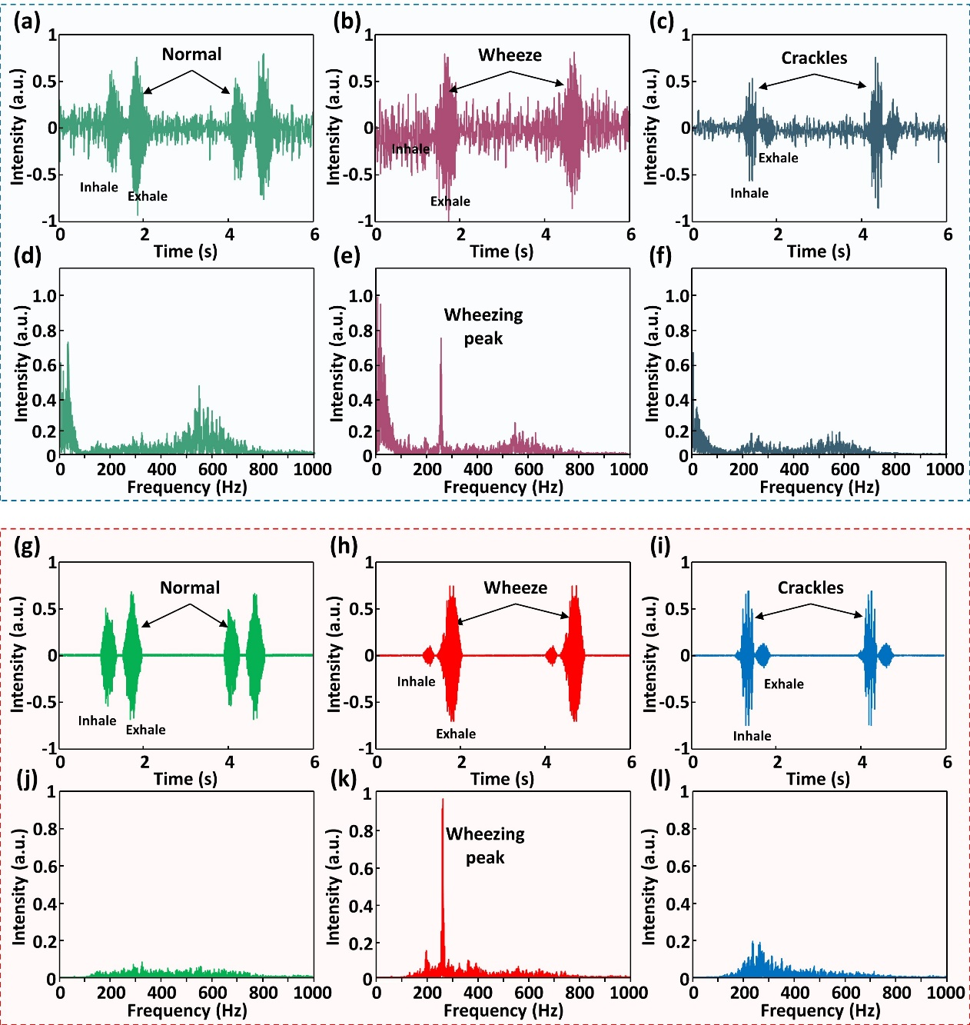
Figure S3 Characterization of the E-stethoscope using the Child Sim (a,b,c) time-intensity analysis of the measured normal, wheeze and crackles sound (d,e,f) power spectrum analysis of normal, wheeze, crackles (g-l) compared data with same experimental set-up on LSMP.

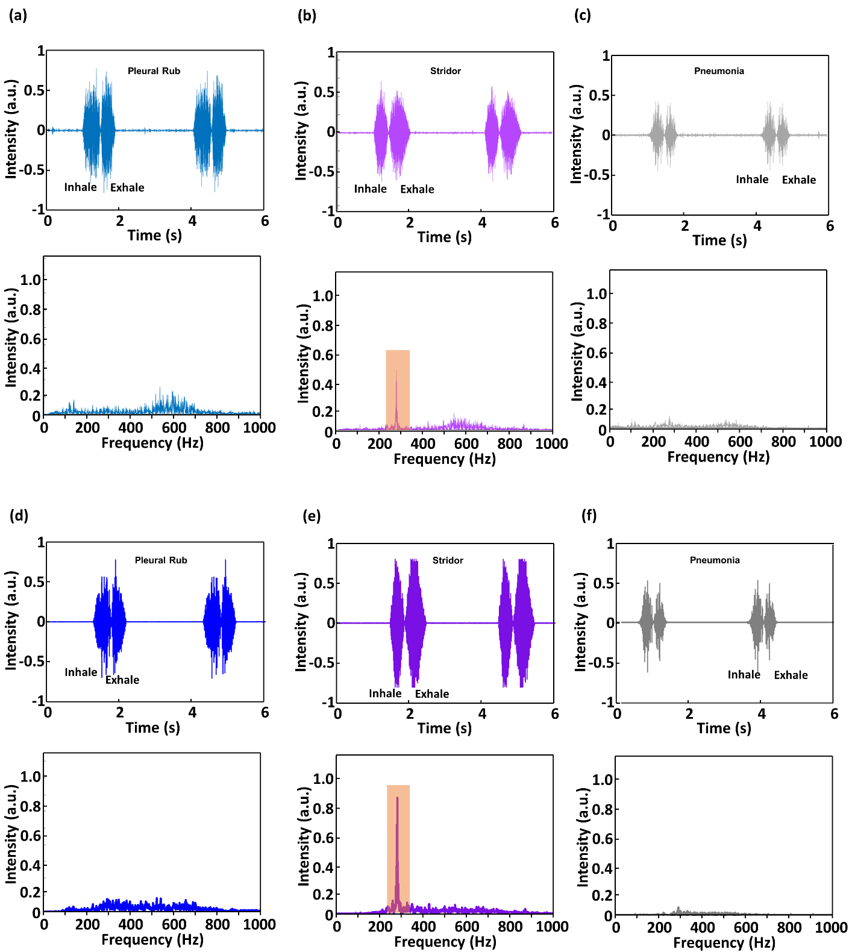
Figure S4 Lung sound characterization using the Child Sim. time-intensity and power spectrum analysis of Pleural Rub, Stridor and Pneumonia shows Littmann E-stethoscope results (a,b,c) and LSMP results (d,e,f).

SI Section 2: AI algorithm-based lung sound analysis
We conducted a simple demonstration to show how machine learning can be used with our system to classify breathing sounds. Machine learning is an effective tool for end-to-end classification of sounds, and we just need a well-structured model and raw data. First, we performed data augmentation on a minimal set of data to generate a sufficient amount of data to train the model. With this method, the trained model could cover various types of lung sound. Child Sim, R.A.L.E.Ⓡ Repository⁶ and Littmann lung sounds^{7, 8} are used as a standard database for these learning data, an example of which is shown in Figure 5(a). The constructed database consists of 18 types of normal and 11 types of wheezing breathing sounds that were extracted. Since the length of respiration varies from person to person and changes depending on the patient’s condition, we modified the length of the extracted sound, representing changes from 1x speed to 0.5x speed in 0.1x decrements, as shown in Figure 5(b). Then, a 0.6 second window was moved along the modified data in 0.06 second increments; for each window, the data were extracted and converted into Log-Mel spectrogram images visualizing the information of time and frequency features, as shown in Figure 5(c). Compared with the Mel spectrogram, the Log-Mel spectrogram is closer to human hearing and the calculation formula is shown in Figure S6. In this way, we augmented the original 29 samples into 1637 samples (839 normal breathing samples, 798 wheezing sound samples) of input data. Figure 5(d) shows the flow of the data processing in the deep learning architecture. Images of the Log-Mel spectrogram are resized to 64×64 pixels and used for training input. The model consists of two sets of convolutional neural network blocks with one max pooling layer and one dropout layer in each. We used max-pooling for computational efficiency and memory saving, and a dropout layer for preventing overfitting. And as the output layer, we used the SoftMax function because the sum value of output (=1) can be effectively utilized in our counting algorithm. The model uses binary cross-entropy as the loss function and Adaptive Moment Estimation (Adam) as the optimizer. Training data and validation data were divided at a ratio of 8:2 from learning data; additional details of the model architecture and the data splitting are shown in Figures 5(a) and S6(b), respectively. The performance in classifying the 0.6 second pieces of normal and wheezing sounds is depicted as a confusion matrix in Figure S5(c). The receiver operating characteristic (ROC) curve of the trained model, depicted in Figure 5(e) and Figure S7, indicates that the model had excellent training efficiency.
We use prediction values for the ‘wheeze’ label. The raw data of the COPD patient’s lung sounds were sliced with a fixed 0.6 second window taken every 0.06 seconds; these segments were then input into the model to calculate the predicted values for each continuous, sliced segment of the lung sound. The prediction resolution was sufficiently high to detect normal and wheezing sounds in one breath cycle. Because the trained model predicts the incoming signals every 0.06 seconds, we included an algorithm to count the number of wheezing events. The predicted values range between 0.0 and 1.0, indicating how close the input data are to a wheezing sound; a value of 1.0 indicates a wheeze, and a value of 0.0 indicates normal breathing. We set the thresholds for wheezing and normal breathing to 0.9 and 0.1 respectively for the values are the appropriate hyperparameters for the model’s high prediction accuracy; in this way, when the predicted value dropped from 0.9 (wheezing) to 0.1 (normal breathing), the AI counted a single wheezing event.

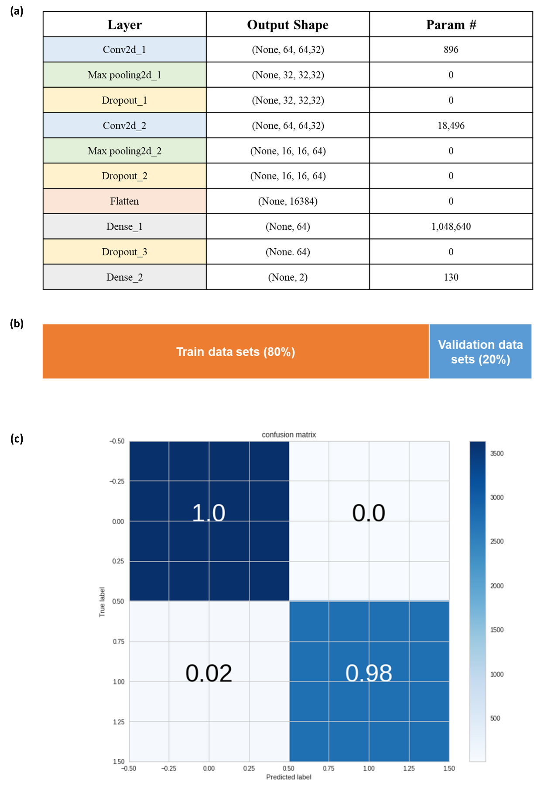
Figure S5 Deep learning architecture and Test and split ratio (a) Summary of used deep learning architecture. (b) Train test split ratio of income data. (c) Confusion matrix of trained model

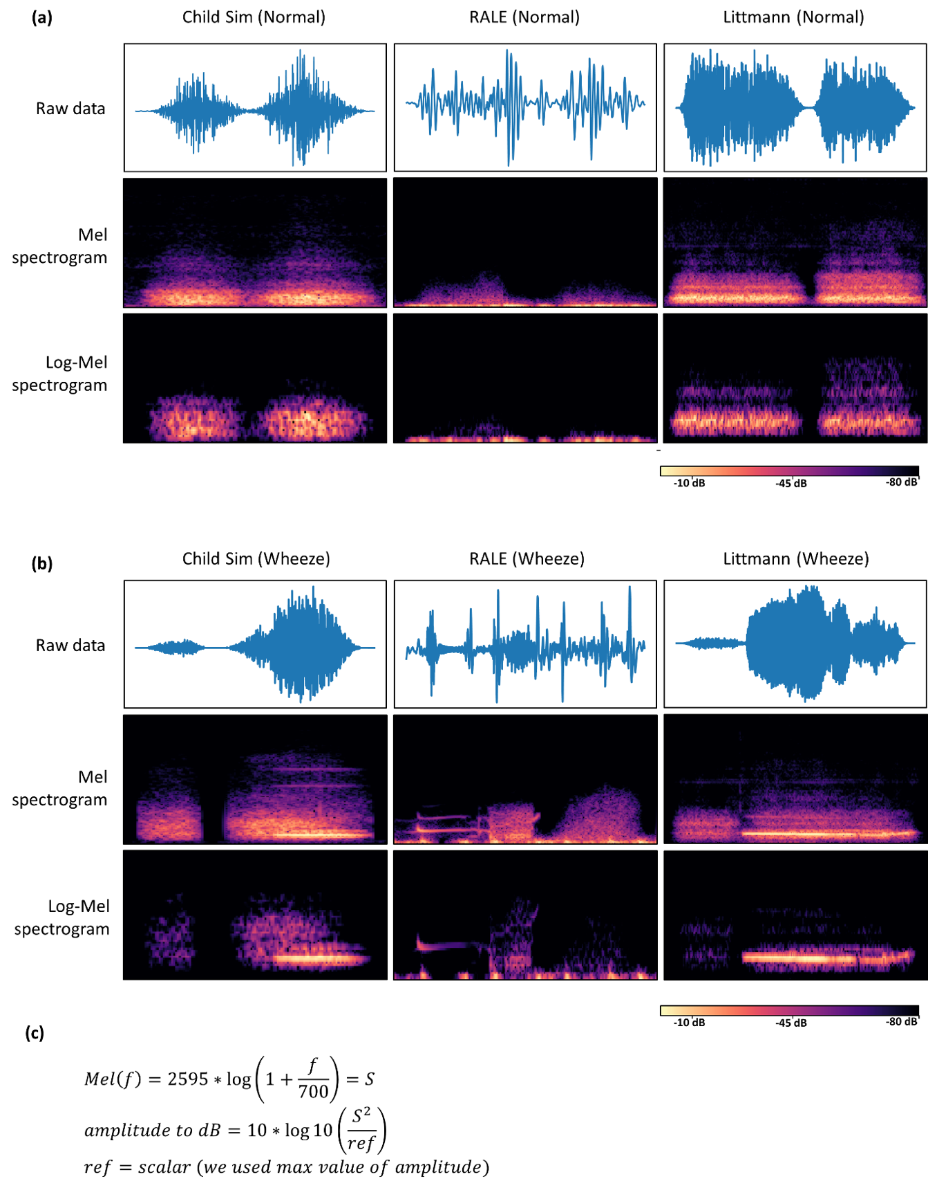

Figure S6 Comparing Mel spectrogram and Log-Mel spectrogram (from Child Sim, RALE, Littmann database) (a) Raw data of normal sound and the below are conversion into Mel spectrogram and log-Mel spectrogram. (b) Raw data of wheeze sounds and the below are conversion into mel spectrogram and log-Mel spectrogram. (c) Calculation of log-mel from mel values.
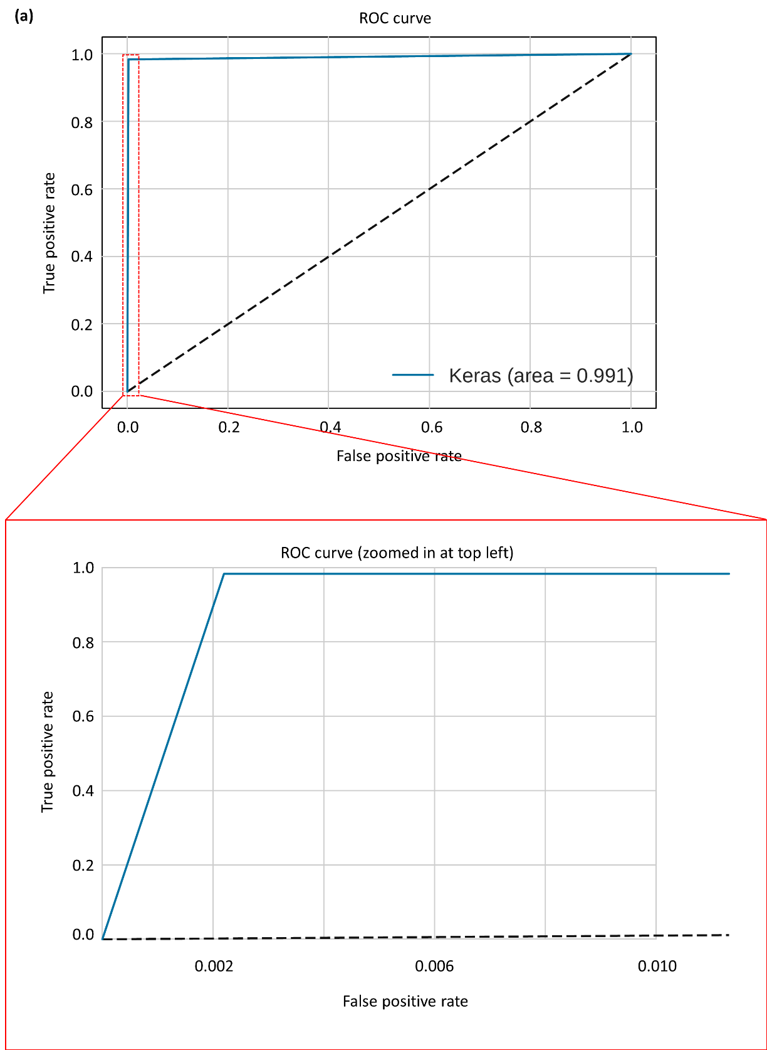
Figure S7 ROC curve (a) ROC curve of built model. Below is the zoomed window in the range of 0 to 0.01 from False positive rate

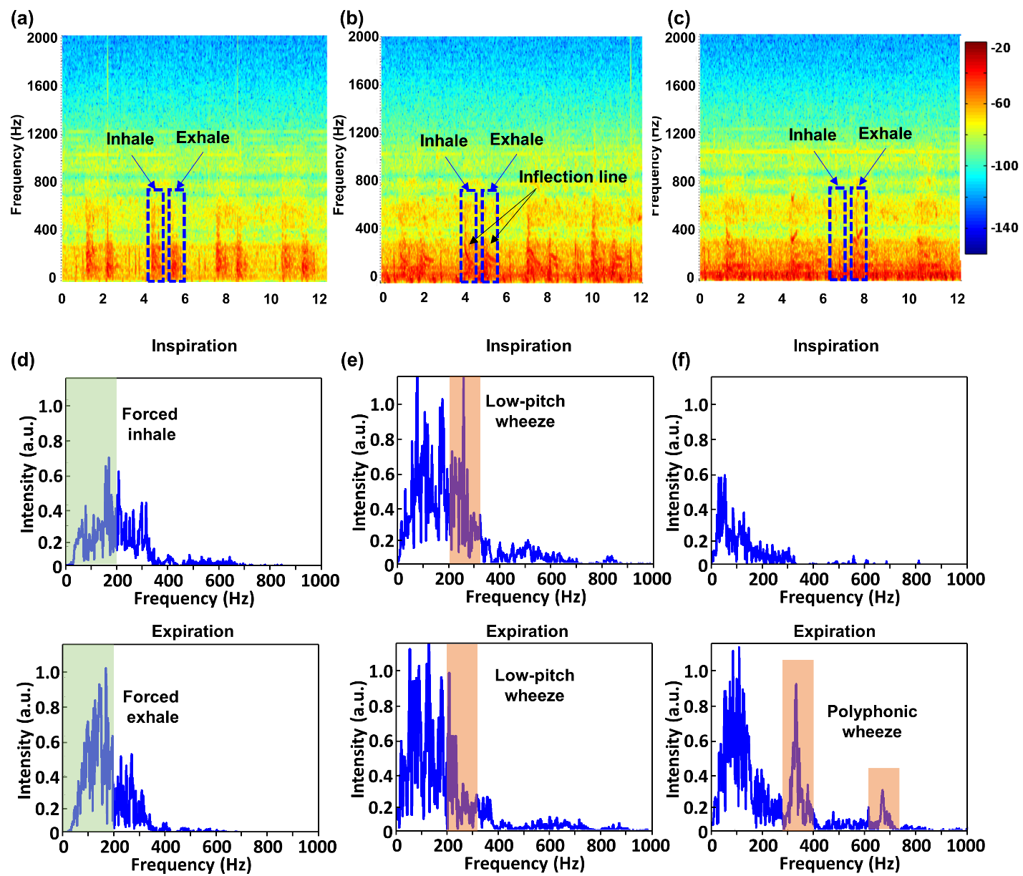
Figure S8 Clinical long-term study on elderly COPD patient with LSMP (a-c) spectrograms information corresponding to normal and abnormal breathing (d-f) representative STFT results in case of inspiration and expiration, respectively.
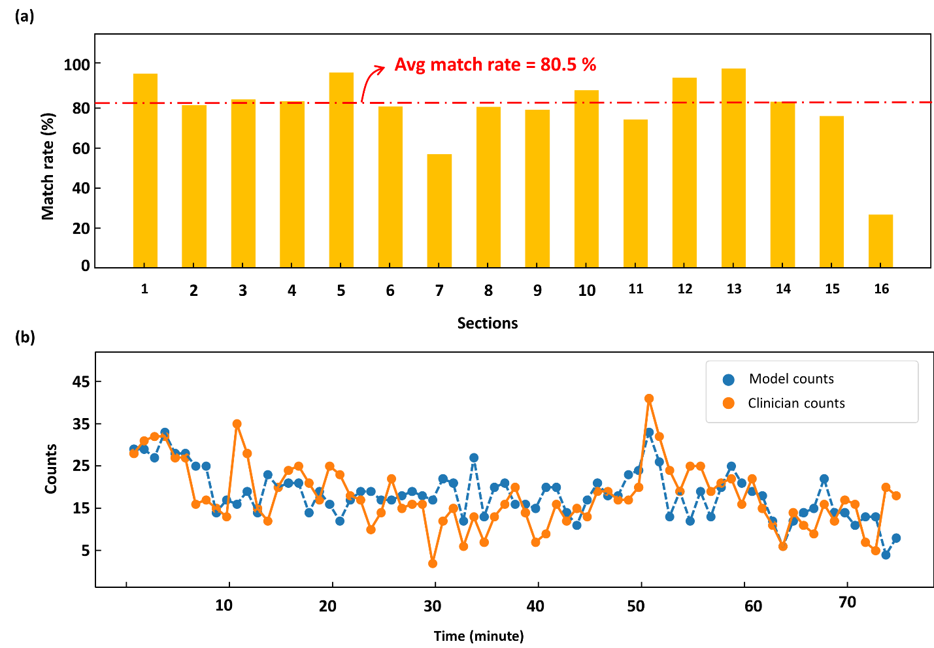
Figure S9 Comparing graph of match rate and 1 minute trajectory (a) Match rate of 16 sections. The length of time for section is 5 minutes. The average of entire match rate is about 80.5%. For the section 7 and 16, low match rate is originated from the noise such as barking, human talking. Especially for section 16, because it is last section of the recordings, there were more noisy sounds such as nurse’s voices. Furthermore, because denominator of the match rate is too small (< 20) the few small errors (<10) made the match rate seems bigger. (b) AI counts and Clinician counts comparing by 1 minute counting.
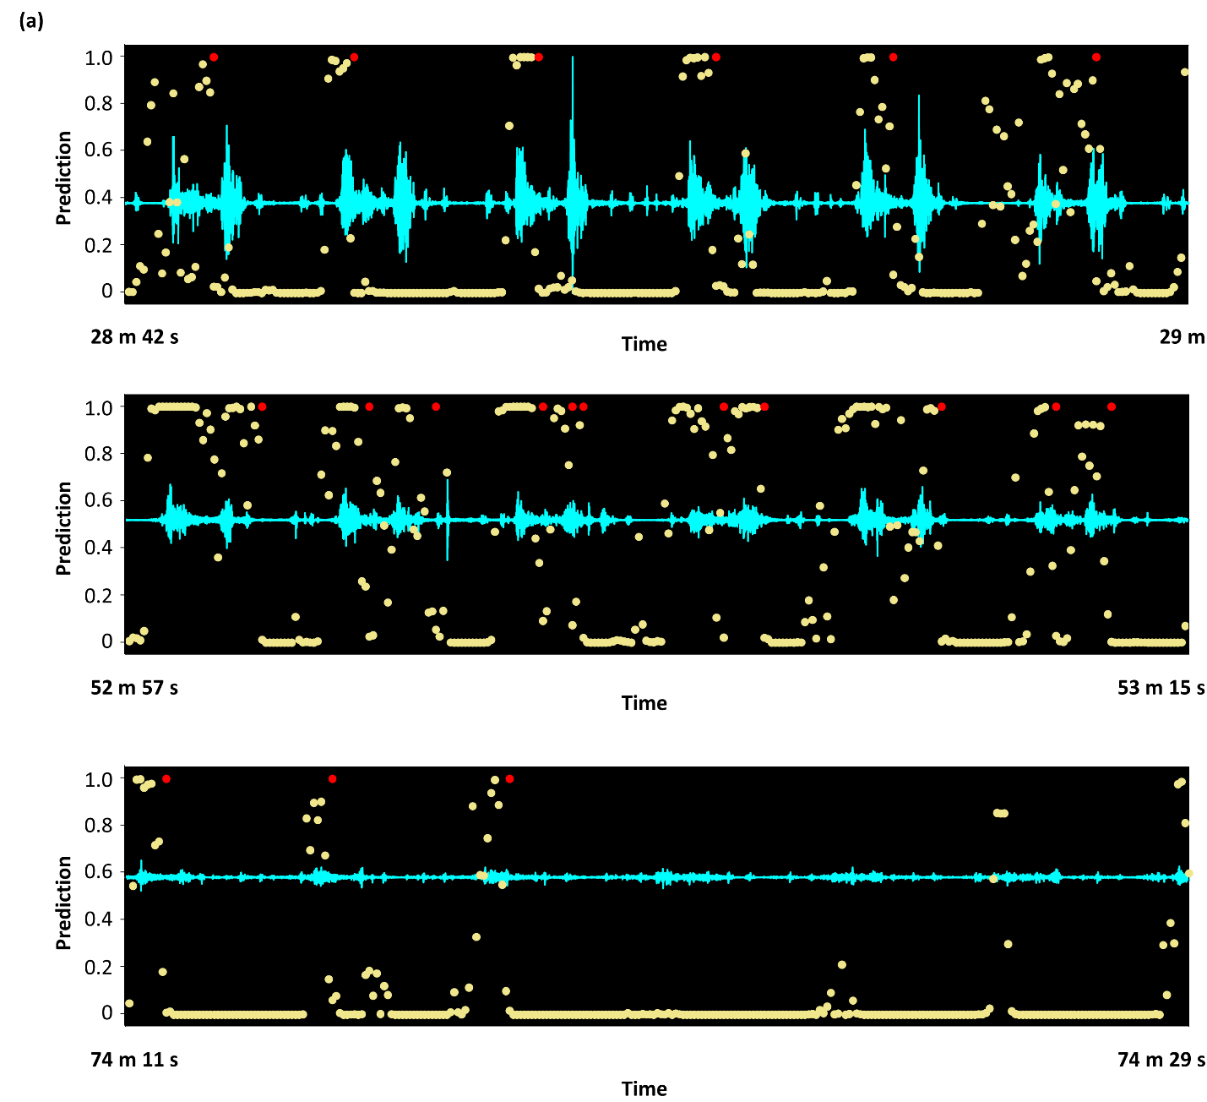
Figure S10 Predicting results of clinical raw data (a) Clinical raw acoustic data and model prediction comparing of 3 extracted regions. All the region’s total time is 18sec and the begin points are 28min 42sec, 52min 57sec and 74min 11sec, each. Yellow dots infer the prediction value of model and red dots are the marks of event count timing.

Table S1 Component list of LSMP
No. | Description | Part | Specification | Quantity | Reference
1 | CAPACITOR | 56 pF | SM/1608 | 1 | C1
2 | CAPACITOR | 10 $μ$F | SM/1608 | 1 | C3
3 | CAPACITOR | 100 nF | SM/1608 | 2 | C16 C17
4 | CAPACITOR | 1 $μ$F | SM/1608 | 3 | C13 C18 C19
5 | CAPACITOR | 10 $μ$F | SM/1608 | 3 | C4 C9 C14
6 | CAPACITOR | 22 $μ$F | SM/1608 | 1 | C15
7 | RESISTOR | 680 | SM/1608 | 1 | R8
8 | RESISTOR | 1K | SM/1608 | 3 | R1 R2 R5
9 | RESISTOR | 10K | SM/1608 | 3 | R3 R4 R7
10 | RESISTOR | 180K | SM/1608 | 1 | R9
11 | RESISTOR | 1.5M | SM/1608 | 1 | R6
12 | INDUCTOR | 15 nH | SM/1005 | 1 | L4
13 | INDUCTOR | 10 $μ$H | SM/1608 | 1 | L5
14 | LED | BLU | SM/1608 | 1 | D1
15 | LED | RED | SM/1608 | 1 | D2
16 | LED | GRN | SM/1608 | 1 | D3
17 | FERRITE BEAD | 120/Y | SM/1608 | 1 | FB1
18 | BLE MODULE | MDBT42Q | RAYTAC | 1 | U1
19 | MIC | VM3000 | Vesper | 1 | U2
20 | CHARGER | XC6806 | LGA-10B01 | 1 | U3
21 | REGULATOR | XCL210 | CL-2025-02 | 1 | U4
22 | LOGIC IC | Buffer | SOT353 | 2 | U5 U6
23 | SWITCH | DPDT | ZX ELECTRO | 1 | SW1
24 | CONNENCTOR | 2 pin | MOLEX | 2 | J1 J2
25 | CONNENCTOR | 4 pin | MOLEX | 1 | JP1
26 | BATTERY | 100 mAh | TW301430 | 1 | Batt1

1. Shah MA, Shah IA, Lee DG, Hur S. Design Approaches of MEMS Microphones for Enhanced Performance. J Sensors 2019, (2019).

2. Lee K, et al. Mechano-acoustic sensing of physiological processes and body motions via a soft wireless device placed at the suprasternal notch. Nat Biomed Eng 4, 148-158 (2020).

3. Jeong H, et al. Differential cardiopulmonary monitoring system for artifact-canceled physiological tracking of athletes, workers, and COVID-19 patients. Sci Adv 7, (2021).

4. Bhaskar A. A simple electronic stethoscope for recording and playback of heart sounds. Adv Physiol Educ 36, 360-362 (2012).

5. Yilmaz G, et al. A Wearable Stethoscope for Long-Term Ambulatory Respiratory Health Monitoring. Sensors-Basel 20, (2020).

6. Owens D. RALE lung sounds 3.0. CIN: Computers, Informatics, Nursing 5, 9-10 (2002).

7. Fraiwan M, Fraiwan L, Khassawneh B, Ibnian A. A dataset of lung sounds recorded from the chest wall using an electronic stethoscope. Data Brief 35, 106913 (2021).

8. 3M Littmann 2018 Basic lung sounds tutorial.) (2018).

