Supplementary Table 1. 80 clinical features for the development of a prediction model.
 | Feature
Clinical features | Gender
Clinical features | Age
Clinical features | Age of diagnosis
Clinical features | Number of American College of Rheumatology classification criteria satisfied at first diagnosis
Clinical features | Physician`s visual analogue scale
Clinical features | Height
Clinical features | Weight
Clinical features | Body mass index
Clinical features | Waist Circumference
Clinical features | Hip Circumference
Clinical features | Blood pressure
Clinical features | Presence of tender joint
Clinical features | Presence of swollen joint
Clinical features | Number of tender joints
Clinical features | Number of swollen joints
Clinical features | Family history of rheumatoid arthritis
Clinical features | Compliance with dose
Clinical features | Adverse drug effect
Clinical features | Combined diseases (Cardiovascular system, respiratory system, digestive system, renal urinary system, other diseases)
Clinical features | Rheumatoid arthritis with surgical experience
Clinical features | Fracture history
Clinical features | Monthly income
Clinical features | Marital status
Clinical features | Education
Clinical features | Regular exercise
Clinical features | Current smoking status
Clinical features | Current alcohol drinking
Clinical features | Morning stiffness
Clinical features | Patient pain assessment
Clinical features | Use of alternative medicines
Clinical features | Menopause
Clinical features | Disease activity score
Clinical features | Health assessment questionnaire
Clinical features | Euroqol-5 dimension
Medication | Methotrexate
Medication | Hydroxychloroquine
Medication | Sulfasalazine
Medication | Leflunomide
Medication | Bucillamine
Medication | Mizoribine
Medication | Tacrolimus
Medication | Azathioprine
Medication | Cyclosporine
Medication | Oral glucocorticoid
Laboratory results | White blood cell
Laboratory results | Hemoglobin
Laboratory results | Hematocrit
Laboratory results | Platelet
Laboratory results | Alanine aminotransferase
Laboratory results | Aspartate aminotransferase
Laboratory results | Alkaline Phosphatase
Laboratory results | Blood urea nitrogen
Laboratory results | Creatinine
Laboratory results | Total cholesterol
Laboratory results | Erythrocyte sedimentation rate
Laboratory results | C-Reactive protein

Supplementary Figure 1. Distribution of some representative dimensionally reduced variables of the control and osteoporosis group after principal component analysis.

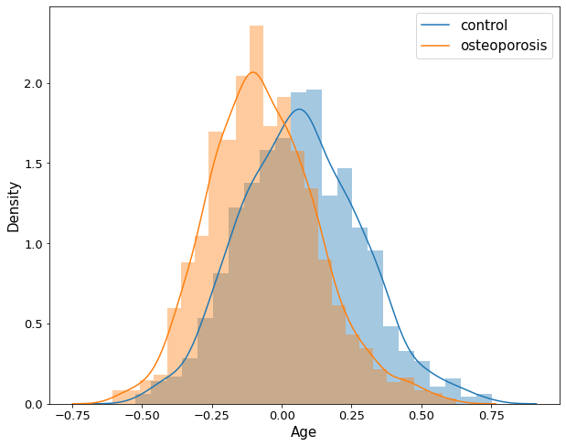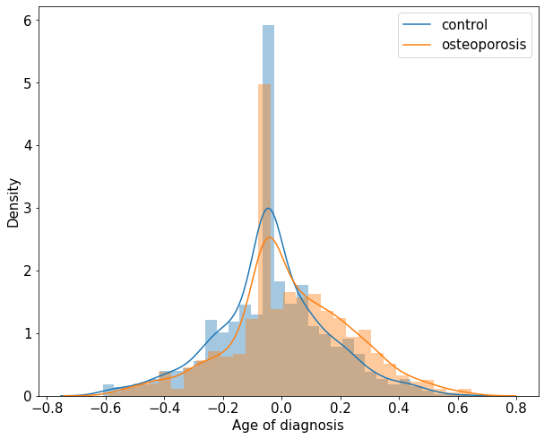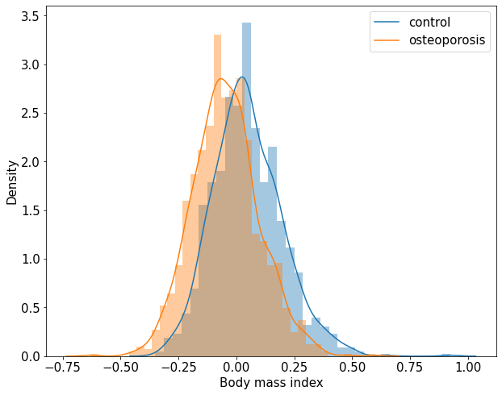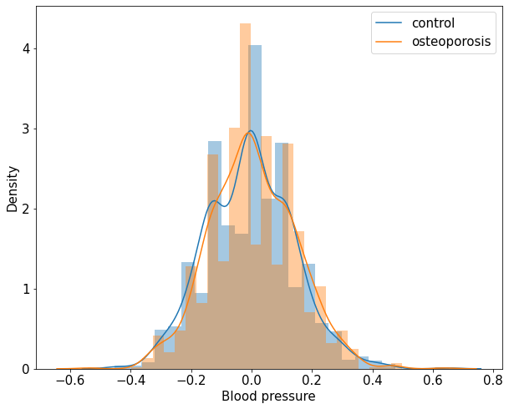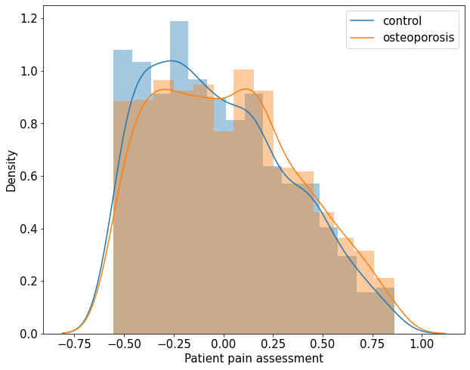

Supplementary Figure 2. Top 20 features derived from the Random Forest model.
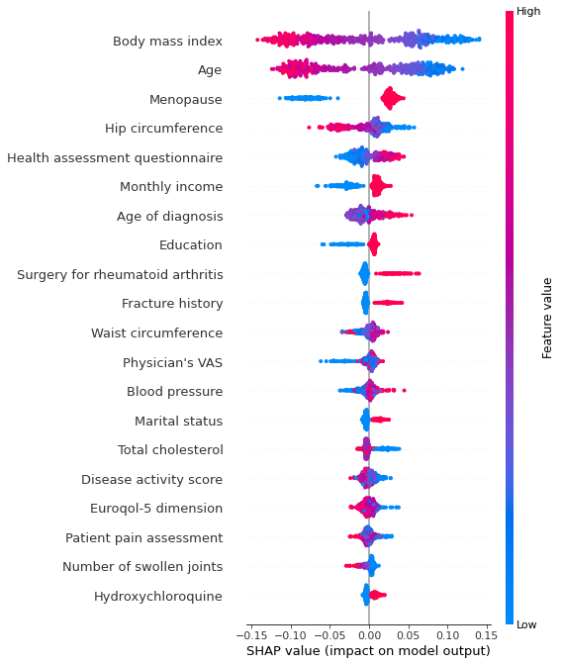

Supplementary Figure 3. Top 20 features derived from the LightGBM model.
