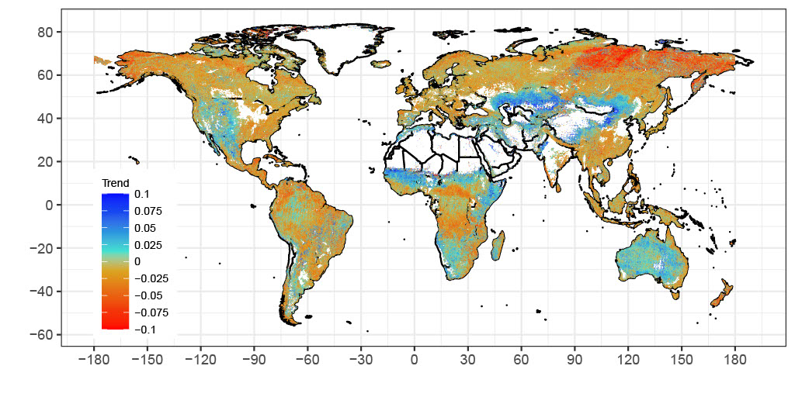 Extended Data Fig. 1. The estimated trend (‰ year⁻¹) of Landsat-derived δ¹⁵N globally. For clarity, the data is filtered to remove areas with high human impacts and water/snow signal following Fig. 2. In rare cases where the trend is > 0.1 (0.4% of the data) and < -0.1 (1.2% of the data), colour does not change beyond the legend range.

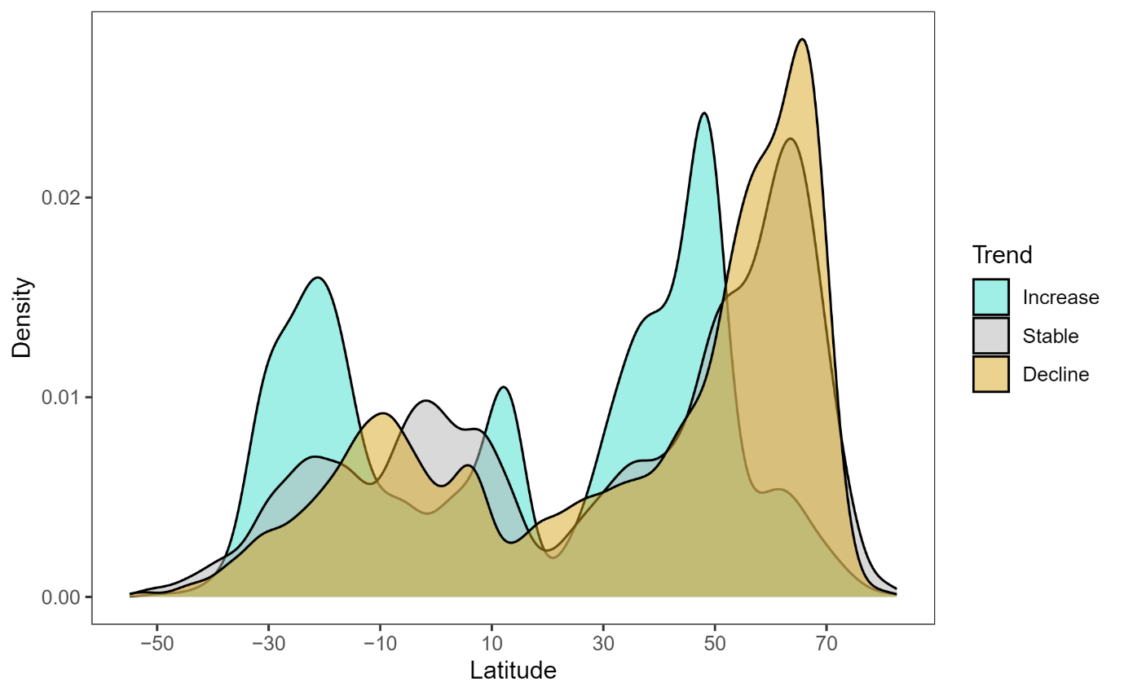Extended Data Fig. 2. The density distribution of Landsat-derived δ¹⁵N trend by latitude. The colour scheme matches Fig. 2. Only the 977,740 pixels at 0.1° resolution after land cover filtering are shown (Fig 2b).

