Supplementary materials
Table S1. Trend of derived δ¹⁵N (all values have units of ‰ yr⁻¹) for each land cover type (LCT) ordered by median. Abbreviations of LCTs match Fig 1. Five LCTs were excluded to minimise human impacts and water/snow signal (see methods).

LCT | Quantile_5% | Median | Quantile_95%
DBF | -0.04837 | -0.02111 | 0.00712
SAV | -0.06451 | -0.01994 | 0.02197
WSA | -0.05162 | -0.01774 | 0.01532
DNF | -0.05135 | -0.0166 | 0.00978
FOR | -0.04526 | -0.01649 | 0.01152
ENF | -0.04297 | -0.01419 | 0.01736
CSH | -0.08718 | -0.01385 | 0.04351
EBF | -0.04649 | -0.01355 | 0.01978
BAR | -0.06568 | 0.00339 | 0.08857
OSH | -0.0433 | 0.004044 | 0.04454
GRA | -0.04396 | 0.004329 | 0.05822

Table S2. List of datasets used herein. The numbers of observations and sites are data used herein post filtering.

Dataset | Observations | Sites | Coverage | References
Craine | 39,785 | 5,222 | Global | Craine et al., 2018
Neon | 1,642 | 723 | North America | NEON, 2022
AusTraits | 174 | 1 | Australia | Falster et al., 2021
SC | 371 | 138 | Southeast China | Tang et al., 2022
NC | 851 | 26 | North China | Wang et al., 2014
Total | 42,824 | 6,111

Table S3. Random forest performance with different predictors from the model with lowest root mean square error (RMSE; in unit ‰) of the ten-fold cross validation.

Predictors | RMSE | R²
Reflectance | 1.83 | 0.77
Reflectance + MAP + MAT | 1.92 | 0.74
Reflectance + MAP + MAT + Mycorrhizae | 1.79 | 0.78
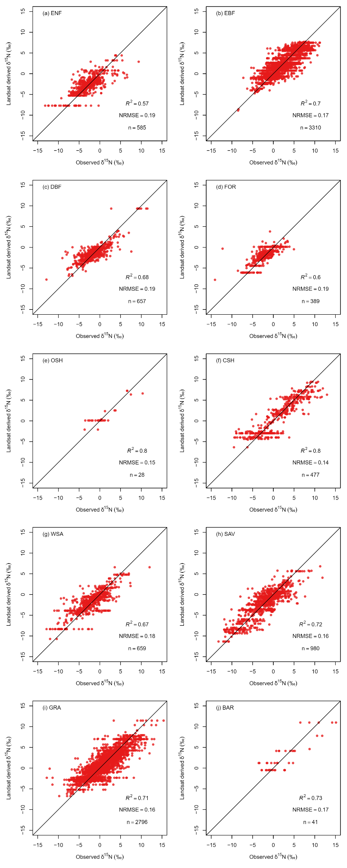
Fig S1. The Landsat-derived δ¹⁵N evaluated against independent ground-based observations by land cover types (LCTs). Abbreviations of LCTs match Fig 1. R² is from linear regression between Landsat-derived and observed δ¹⁵N. The black lines show the 1:1 ratio. n is the number of individual observations. Normalised root mean square error (NRMSE) is calculated by 5% and 95% of the observations. The order of LCTs follows descending tree cover.
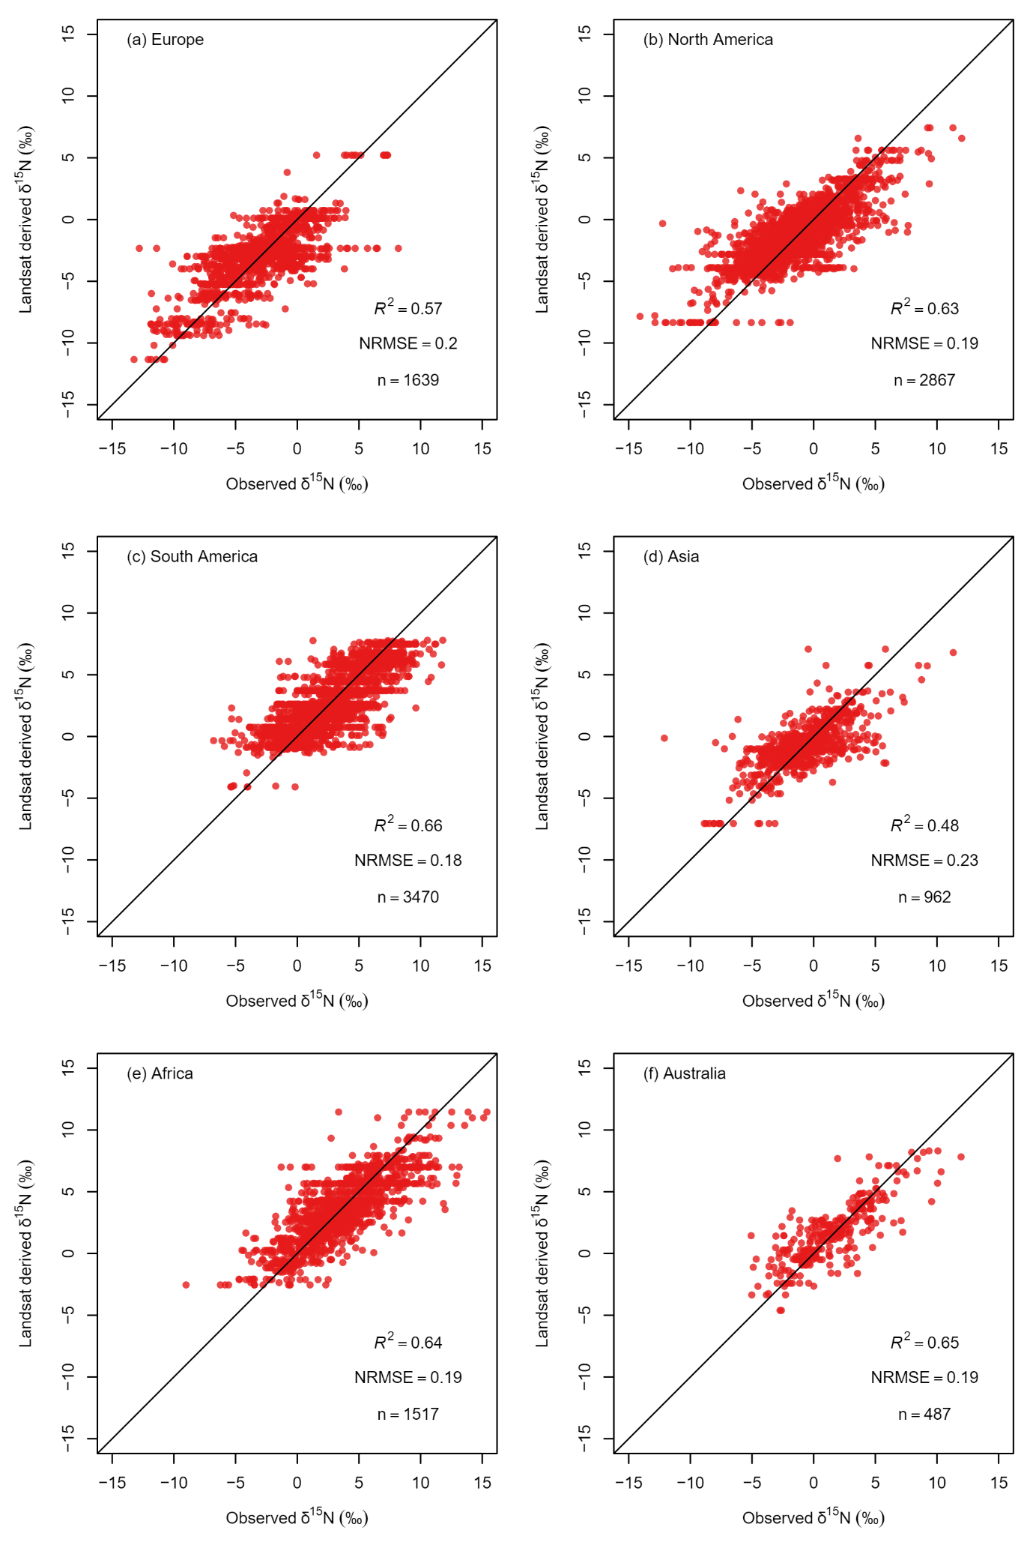

Fig S2. The Landsat-derived δ¹⁵N evaluated against independent ground-based observations by each continent. R² is from linear regression between Landsat-derived and observed δ¹⁵N. The black lines show the 1:1 ratio. n is the number of individual observations. Normalised root mean square error (NRMSE) is calculated by 5% and 95% of the observations. The order of LCTs follows descending tree cover.
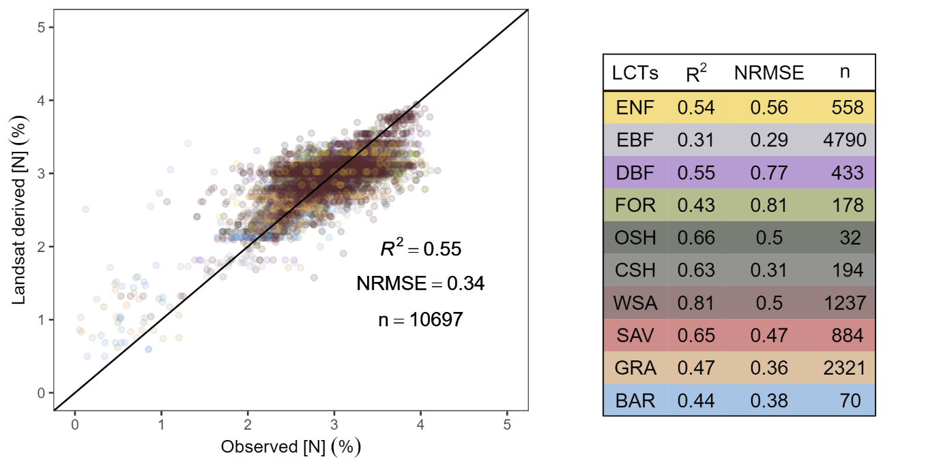
Fig S3. Landsat-derived N concentration ([N]) evaluated against independent [N] observations in log scale. Model prediction and observations of plant [N] were log-transformed. Abbreviations of land cover types (LCTs) match Fig 1. R² is from linear regression between derived and observed δ¹⁵N. Normalised root mean square error (NRMSE) is calculated by 5% and 95% of the observations. n is the number of individual observations. The black lines show the 1:1 ratio.

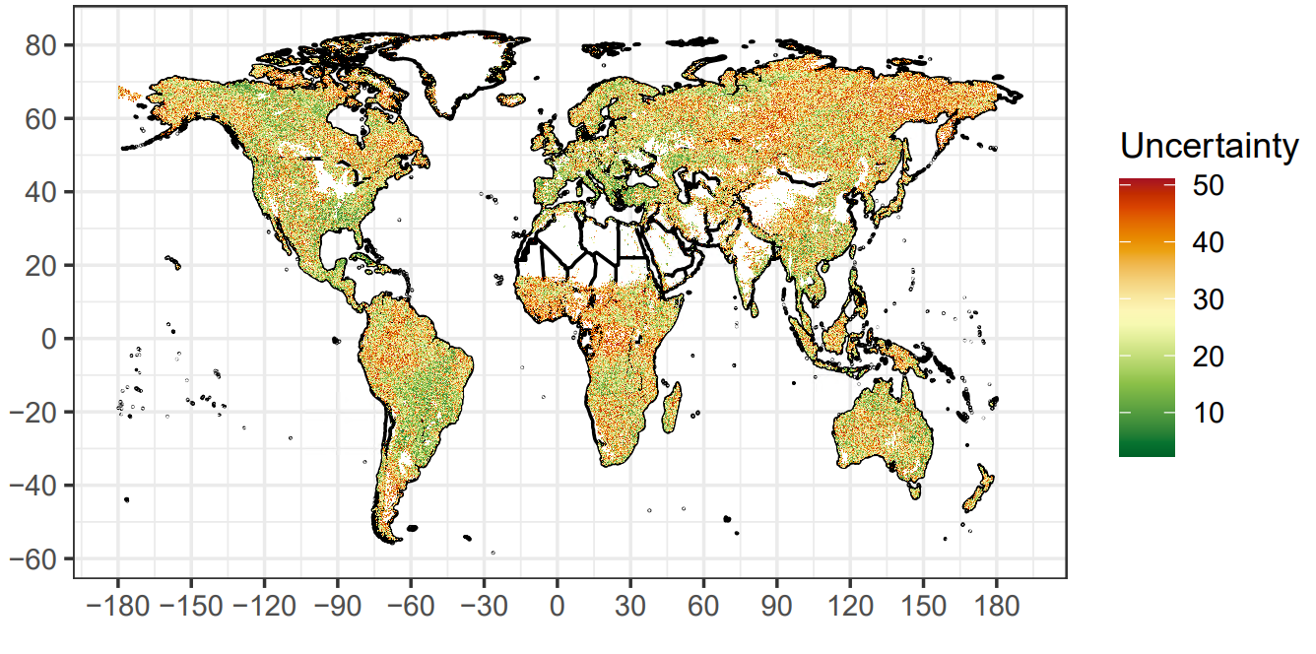
Fig S4. The relative prediction uncertainty (%) of the global trend of derived δ¹⁵N for pixels with significant trends (585,564 pixels). The uncertainty is calculated as the standard error of the trends divided by the trend times 100.
Fig S5. The Landsat-derived δ¹⁵N evaluated against independent ground-based observations by each land cover type (LCT). Abbreviations of LCTs match Fig 1. This training and evaluation used independent random sites. Slopes and R² are from linear regression between derived and observed δ¹⁵N. The black lines show the 1:1 ratio. n is the number of individual observations. The order of LCTs follows descending tree cover.

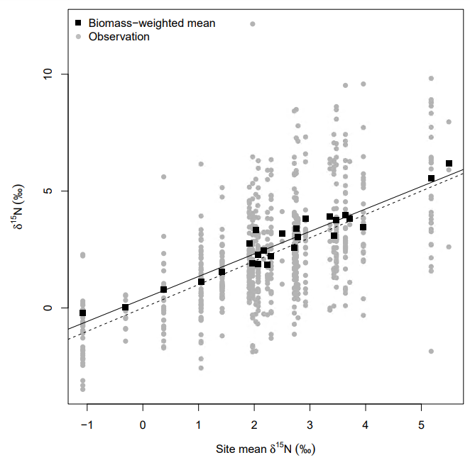
Fig S6. The mean δ¹⁵N of each site compared almost 1:1 to the biomass-weighted mean. The dashed line is 1:1. The black line if the linear regression between mean and biomass-weighted mean. The grey dots are the individual observations.

